Subdivision of superior longitudinal fasciculus in human neonatal brain

Wenjia Liang^{1,2}, Qiaowen Yu³, Wenjun Wang^{1,2}, Thijs Dhollander⁴, Emmanuel Suluba^{1,2}, Zhuoran Li⁵, Feifei Xu^{1,2}, Yang Hu^{1,2}, Yuchun Tang^{1,2}*, Shuwei Liu^{1,2}*

¹ Department of Anatomy and Neurobiology, Research Center for Sectional and Imaging Anatomy, Shandong Provincial Key Laboratory of Mental Disorder, Key Laboratory of Digital Human and Clinical Anatomy in Universities of Shandong Province, School of Basic Medical Sciences, Cheeloo College of Medicine, Shandong University, Jinan, Shandong, 250012, China
² Institute of Brain and Brain-Inspired Science, Shandong University, Jinan, Shandong, 250012, China
³ Department of Medical Imaging, Shandong Provincial Hospital, Cheeloo College of Medicine, Shandong University, Jinan, Shandong, 250012, China
⁴ Developmental Imaging, Murdoch Children's Research Institute, Melbourne, Victoria, Australia
⁵ Department of Ultrasound, Shandong Provincial Hospital, Cheeloo College of Medicine, Shandong University, Jinan, Shandong, 250012, China

* Corresponding author
E-mail address: tyc@sdu.edu.cn( Yuchun Tang), liusw@sdu.edu.cn (Shuwei Liu)

Supplementary Material (SM)

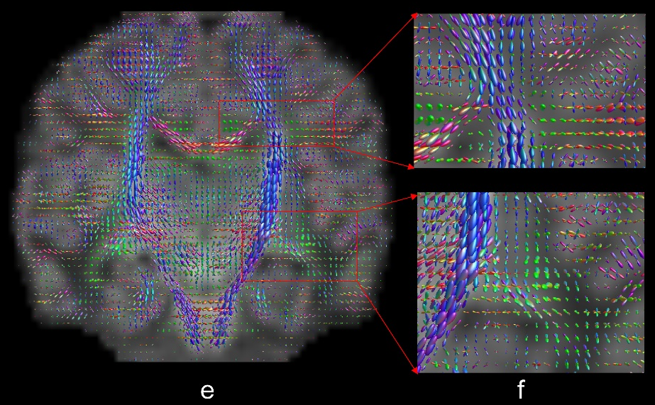

SM-Fig. 1 WM-FOD map in axial(a,b), sagittal(c,d) and coronal(e,f) view
SM-Fig. 2 Cortical ROIs based on the newborn AAL template. (a-c) 90 anatomical regions of the brain in axial, coronal and sagittal positions, with different colors representing different anatomical regions. (d) a three-dimensional view of some ROIs

SM-Fig. 3 DTI and NODDI metrics' values of whole brain in each individual. We selected four individuals of different ages for the presentation

