Supplementary material
Modeling the Future Distribution of Aedes aegypti and Ae. albopictus in China: Implications of Climate Change
Qing Tong^{1,2}*, Ming-da Xu¹, Xin-zhou Long¹, Jia-qi Zheng², Xiao-yun Han¹, Li-yong Cui²*
1 School of Biology and Agriculture, Jiamusi University, Jiamusi, 154007, China
2 Hejiang Forestry Research Institute of Heilongjiang Province, Jiamusi 154002, China
* Correspondence:
Qing Tong, lxixl@126.com
Li-yong Cui, cuiliy@163.com
Word count: 8300
Number of figures: 7

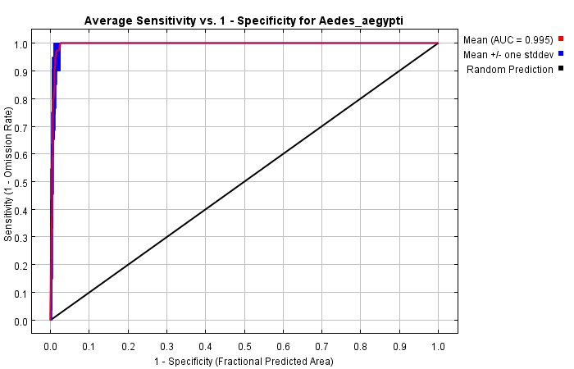
Fig. S1. Reliability test of the distribution model created for Ae. aegypti.
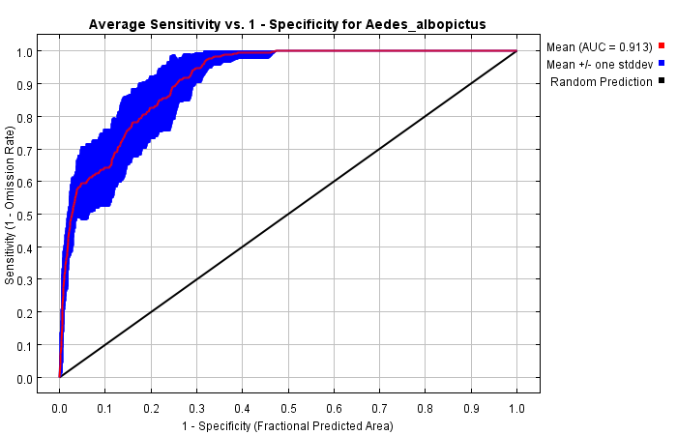
Fig. S2. Reliability test of the distribution model created for Ae. albopictus.

Table Data source and occurrence
Species | Longitude | Latitude | Location | Date | Literature Source | Link
Aedes aegypti | 98.5833 | 24.4707 | Lahuai village, Mangshi, Dehong prefecture, Yunnan province | 2010 | Survey of Aedes aegypti distribution in Mangshi, Yunnan | http://www.bmsw.net.cn/EN/abstract/abstract13842.shtml
Aedes aegypti | 109.8473 | 20.5573 | Wushi county, Leizhou, Zhanjiang, Guangdong province | 2006 | Investigation of Distribution,Ecological Status,Density and Seasonal Growth-decline of Aegypti in Leizhou Peninsula | http://www.en.cnki.com.cn/Article_en/CJFDTOTAL-GJWJ200706011.htm
Aedes aegypti | 109.7597 | 20.7629 | Qishui county, Leizhou, Zhanjiang, Guangdong province | 2013 | Relationship between insecticide resistance and kdr mutations in the dengue vector Aedes aegypti in Southern China | https://parasitesandvectors.biomedcentral.com/articles/10.1186/s13071-015-0933-z
Aedes aegypti | 97.8877 | 24.0309 | Jinghan, Mengmao county, Ruili, Dehong prefecture, Yunnan province | 2013 | Relationship between insecticide resistance and kdr mutations in the dengue vector Aedes aegypti in Southern China | https://parasitesandvectors.biomedcentral.com/articles/10.1186/s13071-015-0933-z
Aedes aegypti | 100.79 | 22.01 | Dadugang farm, Jinghong, Xishuangbanna prefecture, Yunnan province | 2014 | Distribution survey on Aedes aegypti in the border areas of Yunnan province, China | http://www.bmsw.net.cn/EN/abstract/abstract14547.shtml
Aedes aegypti | 101.5646 | 21.4592 | Mengla county, Xishuangbanna prefecture,Yunnan province | 2014 | Distribution survey on Aedes aegypti in the border areas of Yunnan province, China | http://www.bmsw.net.cn/EN/abstract/abstract14548.shtml
Aedes aegypti | 100.4525 | 21.9573 | Menghai county, Xishuangbanna prefecture,Yunnan province | 2014 | Distribution survey on Aedes aegypti in the border areas of Yunnan province, China | http://www.bmsw.net.cn/EN/abstract/abstract14549.shtml
Aedes aegypti | 97.9319 | 24.7052 | Pingyuan town, Yingjiang county, Dehong prefecture, Yunnan province | 2014 | Distribution survey on Aedes aegypti in the border areas of Yunnan province, China | http://www.bmsw.net.cn/EN/abstract/abstract14550.shtml
Aedes aegypti | 97.7921 | 24.1829 | Zhangfeng town, Longchuan county, Dehong prefecture, Yunnan province | 2014 | Distribution survey on Aedes aegypti in the border areas of Yunnan province, China | http://www.bmsw.net.cn/EN/abstract/abstract14551.shtml
Aedes aegypti | 98.8579 | 25.8228 | Lushui county, Nujiang prefecture, Yunnan province | 2014 | Distribution survey on Aedes aegypti in the border areas of Yunnan province, China | http://www.bmsw.net.cn/EN/abstract/abstract14553.shtml
Aedes aegypti | 100.9299 | 21.8331 | Jingha town, Jinghong, Xishuangbanna prefecture, Yunnan province | 2014 | Distribution of the dengue fever vector in Xishuangbanna Prefecture of Yunnan | http://118.145.16.219/Jweb_zgrdyx/EN/abstract/abstract2953.shtml
Aedes aegypti | 100.7446 | 21.6989 | Dongfeng farm, Jinghong, Xishuangbanna prefecture, Yunnan province | 2014 | Distribution of the dengue fever vector in Xishuangbanna Prefecture of Yunnan | http://118.145.16.219/Jweb_zgrdyx/EN/abstract/abstract2954.shtml
Aedes aegypti | 100.6796 | 21.5795 | Menglong, Jinghong, Xishuangbanna prefecture, Yunnan province | 2014 | Distribution of the dengue fever vector in Xishuangbanna Prefecture of Yunnan | http://118.145.16.219/Jweb_zgrdyx/EN/abstract/abstract2956.shtml
Aedes aegypti | 101.7186 | 21.2358 | Mohan town, Mengla county, Xishuangbanna prefecture, Yunnan province | 2014 | Distribution of the dengue fever vector in Xishuangbanna Prefecture of Yunnan | http://118.145.16.219/Jweb_zgrdyx/EN/abstract/abstract2958.shtml
Aedes aegypti | 101.2488 | 21.9351 | Menglun town, Mengla county, Xishuangbanna prefecture, Yunnan province | 2014 | Distribution of the dengue fever vector in Xishuangbanna Prefecture of Yunnan | http://118.145.16.219/Jweb_zgrdyx/EN/abstract/abstract2959.shtml
Aedes aegypti | 101.2873 | 21.6981 | Guanlei town, Mengla county, Xishuangbanna prefecture, Yunnan province | 2014 | Distribution of the dengue fever vector in Xishuangbanna Prefecture of Yunnan | http://118.145.16.219/Jweb_zgrdyx/EN/abstract/abstract2960.shtml
Aedes aegypti | 100.0517 | 21.6965 | Daluo town, Menghai county, Xishuangbanna prefecture, Yunnan province | 2014 | Distribution of the dengue fever vector in Xishuangbanna Prefecture of Yunnan | http://118.145.16.219/Jweb_zgrdyx/EN/abstract/abstract2961.shtml
Aedes aegypti | 110.4746 | 19.2583 | Jiaji town, Qionghai, Hainan province | 2007 | Survey on the distribution of Aedes mosquitoes transmitting dengue fever of Hainan Province in 2004 | http://www.en.cnki.com.cn/Article_en/CJFDTOTAL-RDYX200812009.htm
Aedes aegypti | 109.6905 | 19.912 | Lincheng town, Lingao county, Hainan province | 2007 | Survey on the distribution of Aedes mosquitoes transmitting dengue fever of Hainan Province in 2005 | http://www.en.cnki.com.cn/Article_en/CJFDTOTAL-RDYX200812010.htm
Aedes aegypti | 110.0067 | 19.7385 | Jinjiang town, Chengmai county, Hainan province | 2007 | Survey on the distribution of Aedes mosquitoes transmitting dengue fever of Hainan Province in 2006 | http://www.en.cnki.com.cn/Article_en/CJFDTOTAL-RDYX200812011.htm
Aedes aegypti | 109.0557 | 19.2981 | Shilu town, Changjiang county, Hainan province | 2007 | Survey on the distribution of Aedes mosquitoes transmitting dengue fever of Hainan Province in 2007 | http://www.en.cnki.com.cn/Article_en/CJFDTOTAL-RDYX200812012.htm
Aedes aegypti | 108.6859 | 19.3305 | Changhua town, Changjiang county, Hainan province | 2007 | Survey on the distribution of Aedes mosquitoes transmitting dengue fever of Hainan Province in 2008 | http://www.en.cnki.com.cn/Article_en/CJFDTOTAL-RDYX200812013.htm
Aedes aegypti | 109.5808 | 19.5211 | Nada town, Danzhou, Hainan province | 2007 | Survey on the distribution of Aedes mosquitoes transmitting dengue fever of Hainan Province in 2009 | http://www.en.cnki.com.cn/Article_en/CJFDTOTAL-RDYX200812014.htm
Aedes aegypti | 108.6518 | 19.0953 | Basuo town, Dongfang, Hainan province | 2007 | Survey on the distribution of Aedes mosquitoes transmitting dengue fever of Hainan Province in 2010 | http://www.en.cnki.com.cn/Article_en/CJFDTOTAL-RDYX200812015.htm
Aedes aegypti | 110.0375 | 18.506 | Yelin town, Lingshui county, Hainan province | 2007 | Survey on the distribution of Aedes mosquitoes transmitting dengue fever of Hainan Province in 2011 | http://www.en.cnki.com.cn/Article_en/CJFDTOTAL-RDYX200812016.htm
Aedes aegypti | 109.7025 | 18.6391 | Baocheng town, Baoting county, Hainan province | 2007 | Survey on the distribution of Aedes mosquitoes transmitting dengue fever of Hainan Province in 2012 | http://www.en.cnki.com.cn/Article_en/CJFDTOTAL-RDYX200812017.htm
Aedes aegypti | 110.391 | 18.7951 | Wancheng town, Wanning, Hainan province | 2007 | Survey on the distribution of Aedes mosquitoes transmitting dengue fever of Hainan Province in 2013 | http://www.en.cnki.com.cn/Article_en/CJFDTOTAL-RDYX200812018.htm
Aedes aegypti | 109.4514 | 19.2248 | Qifang town, Baisha county, Hainan province | 2007 | Survey on the distribution of Aedes mosquitoes transmitting dengue fever of Hainan Province in 2014 | http://www.en.cnki.com.cn/Article_en/CJFDTOTAL-RDYX200812019.htm
Aedes aegypti | 110.7977 | 19.5432 | Wencheng town, Wenchang, Hainan province | 2007 | Survey on the distribution of Aedes mosquitoes transmitting dengue fever of Hainan Province in 2015 | http://www.en.cnki.com.cn/Article_en/CJFDTOTAL-RDYX200812020.htm
Aedes aegypti | 109.5119 | 18.2528 | Jiyang district, Sanya, Hainan province | 2007 | Survey on the distribution of Aedes mosquitoes transmitting dengue fever of Hainan Province in 2016 | http://www.en.cnki.com.cn/Article_en/CJFDTOTAL-RDYX200812021.htm
Aedes aegypti | 110.3539 | 20.0031 | Qiongshan district, Haikou, Hainan province | 2007 | Survey on the distribution of Aedes mosquitoes transmitting dengue fever of Hainan Province in 2017 | http://www.en.cnki.com.cn/Article_en/CJFDTOTAL-RDYX200812009.htm
Aedes aegypti | 110.2935 | 20.0079 | Xiuying district, Haikou, Hainan province | 2007 | Survey on the distribution of Aedes mosquitoes transmitting dengue fever of Hainan Province in 2018 | http://www.en.cnki.com.cn/Article_en/CJFDTOTAL-RDYX200812010.htm
Aedes aegypti | 110.3284 | 20.031 | Longhua district, Haikou, Hainan province | 2007 | Survey on the distribution of Aedes mosquitoes transmitting dengue fever of Hainan Province in 2019 | http://www.en.cnki.com.cn/Article_en/CJFDTOTAL-RDYX200812011.htm
Aedes aegypti | 110.3588 | 19.6814 | Dingcheng town, Ding'an county, Hainan province | 2007 | Survey on the distribution of Aedes mosquitoes transmitting dengue fever of Hainan Province in 2020 | http://www.en.cnki.com.cn/Article_en/CJFDTOTAL-RDYX200812012.htm
Aedes aegypti | 110.0244 | 19.7911 | Dala village, Chengmai county, Hainan province | 1998 | Investigaton on Ae.aegypti and Ae.albopictus in the north-western part of Hainan Province | http://en.cnki.com.cn/Article_en/CJFDTOTAL-RDYX20050200E.htm
Aedes aegypti | 110.0066 | 19.5622 | Xinpo town, Chengmai county, Hainan province | 1998 | Investigaton on Ae.aegypti and Ae.albopictus in the north-western part of Hainan Province | http://en.cnki.com.cn/Article_en/CJFDTOTAL-RDYX20050201E.htm
Aedes aegypti | 99.082 | 23.554 | Mengding town, Gengma county, Lincang, Yunnan province | 2014 | Investigation of distribution of dengue vectors in Lincang border area | http://www.cntropmed.com/EN/abstract/abstract348.shtml
Aedes aegypti | 110.1767 | 20.3254 | Xuwen county, Zhanjiang, Guangdong province | 1990 | Monitoring of Dengue fever in Zhanjiang, Guangdong Province in 1988-1990 | http://www.cnki.com.cn/Article/CJFDTotal-GDWF199304000.htm
Aedes aegypti | 110.0979 | 20.9148 | Haikang county, Leizhou, Zhanjiang, Guangdong province | 1990 | Monitoring of Dengue fever in Zhanjiang, Guangdong Province in 1988-1990 | http://www.cnki.com.cn/Article/CJFDTotal-GDWF199304000.htm
Aedes aegypti | 101.5646 | 21.4592 | Mengla County, Xishuangbanna Prefecture, Yunnan Province | 2018 | Epidemic characteristics and vector emergency surveillance of dengue fever outbreak in Mengla County in 2018 | http://www.cnki.com.cn/Article/CJFDTOTAL-ZISC202001018.htm
Aedes aegypti | 109.8565 | 20.5573 | Wushi Town, Leizhou City, Zhanjiang City, Guangdong Province | 2022 | BG-home The trapping effect of mosquito traps on common mosquitoes Experimental determination and evaluation study | http://www.cnki.com.cn/Article/CJFDTOTAL-ZMSK202206002.htm
Aedes aegypti | 100.5444444 | 22.08333333 | Xishuangversion of Yunnan Province Menghai County of Na Autonomous Prefecture | 2019 | Detection of NIRVS expression in Aedes aegypti flavivirus after infection with Zika virus | http://www.cnki.com.cn/Article/CJFDTOTAL-JSCY202201004.htm
Aedes aegypti | 109.8565 | 20.5573 | Wushi Town, Leizhou City, Zhanjiang City, Guangdong Province | 2017 | Competition between Aedes aegypti and Aedes albopictus in Wushi Town, Leizhou City, Guangdong Province | http://www.cnki.com.cn/Article/CJFDTOTAL-ZMSK202004025.htm

