Supplementary Information

Can temperate forests deliver both future wood demand and climate-change mitigation?
Eilidh J. Forster*¹, David Styles^{1,2} & John R. Healey¹
¹ School of Natural Sciences, Bangor University, Bangor, Gwynedd, LL57 2UW, UK
² School of Biological & Chemical Sciences and Ryan Institute, University of Galway, Galway, H91 TK33, Ireland

Supplementary Table 1 - Life Cycle Inventory for ‘business as usual’ (BAU) wood use
Inventory of key inputs and outputs for processes considered along the life cycle of forestry value chains derived from thinned forest systems over 100 years. Emissions factors (EF) and their sources are indicated. GWP is global warming potential (measured in kg CO₂e).
Process stage | Input/output/process | Activity data source | Units | Thinned |  | EFs | EF source
Process stage |  |  |  | In | Out | GWP
Planting (1&2) | Tree seedlings | GH² | Item(s) | 774,012,298 |  | 0 |  | Ecoinvent¹
Planting (1&2) | 15 tonne 360 Excavator | GH² | hrs | 464,407 |  | 65 |  | Ecoinvent¹
Planting (1&2) | Pesticides (acetamiprip) | Industry recommended | kg | 25,759 |  |  |  | Ecoinvent¹
Forest management | Harvester (diesel use) | GH² | hrs | 1,207.459 |  | 56 |  | Ecoinvent¹
Forest management | Forwarder (diesel use) | GH² | hrs | 1,207,459 |  | 46 |  | Ecoinvent¹
Forest management | Harvested wood | CBM-CFS3³ | m³ |  | 13,751,783 |  |  | IPCC
Transport (forest to processor) | >32 t truck, EURO6 | GH² | t.km | 1,909,601,142 |  |  |  | Ecoinvent¹
Debarking | Harvested wood | CBM³, GH² | m³ | 11,634,008
Debarking | Diesel | Ecoinvent¹ | MJ | 10.250,052
Debarking | Lubricating oil | Ecoinvent¹ | kg | 9,095
Debarking | Bark chips | GH², FR CFs⁵ | kg |  | 865,458,517 | 20 |  | Ecoinvent¹
Debarking | Debarked wood | GH², FR CFs⁵ | m³ |  | 10,387,507
Sawing | Diesel (internal transport) | Ecoinvent¹ | MJ | 105,021,592
Sawing | Electricity | Ecoinvent¹ | kWh | 70,229,933
Sawing | Lubricating oil | Ecoinvent¹ | kg | 382,034
Sawing | Debarked wood | GH², FR CFs⁵ | m³ | 7,305,635
Sawing | Sawnwood | JJ&S⁴ | m³ |  | 4,018,099 | 25 |  | Ecoinvent¹
Sawing | Sawmill residues | JJ&S⁴ | kg |  | 1,141,285,057
Drying (of sawn timber) | Electricity | Ecoinvent¹ | kWh | 67,102,253
Drying (of sawn timber) | Sawnwood | JJ&S⁴ | m³ | 4,018,099
Drying (of sawn timber) | Sawnwood - dried (u=20%) | Assume no loss in volume during drying | m³ |  | 4,018,099 | 29 |  | Ecoinvent¹
Planing | Electricity | Ecoinvent¹ | kWh | 34,840,025
Planing | Sawnwood (carcassing) dried (u=20%) | JJ&S⁴ | m³ | 4,018,099
Planing | Sawnwood (carcassing) planed | Vol loss accounted for in 'sawing' | m³ |  | 4,018,099 | 35 |  | Ecoinvent¹
Planing | Sawmill residues | JJ&S⁴ | kg |  | 1,141,285,057
Chemical treatment | Electricity | Ecoinvent¹ | kWh | 708,223
Chemical treatment | Wood preservative | Ecoinvent¹ | kg | 991,511,510
Chemical treatment | Sawnwood (fencing) dried (u=20%) | JJ&S⁴ | kg | 688,296,981
Chemical treatment | Debarked wood (fence poles) | GH²,FR CFs⁵ | kg | 303,214,529
Chemical treatment | Preserved wood | No vol. change | kg |  | 991,511,510 | 0 |  | Ecoinvent¹
Particle board production | Electricity | Ecoinvent¹ | kWh | 345,191,890
Particle board production | Heat | Ecoinvent¹ | MJ | 4,050,362,146
Particle board production | Resin | Ecoinvent¹ | kg | 169,276,792
Particle board production | Debarked wood (chip) | GH² | kg | 596,750,357
Particle board production | Sawmill residues | JJ&S⁴ | kg | 700,595,575
Particle board production | Recycled wood | FC report | kg | 1,108,766
Particle board production | Particle board | FR CFs⁵ | m³ |  | 3,415,000 | 262 |  | Ecoinvent¹
Fibre board production | Electricity | Ecoinvent¹ | kWh | 685,822,000
Fibre board production | Heat | Ecoinvent¹ | MJ | 4,757,462,000
Fibre board production | Debarked wood (chip) | GH² FR CFs⁹ | kg | 596,750,357
Fibre board production | Sawmill residues | JJ&S⁴ | kg | 647,847,106
Fibre board production | Fibre board | JJ&S⁴, GH², FR CFs⁵ | m³ |  | 1,370,000 | 98 |  | Ecoinvent¹
Woodchip production (for biomass energy) | Electricity | Ecoinvent¹ | kWh | 71,358,404
Woodchip production (for biomass energy) | Lubricating oil | Ecoinvent¹ | kg | 5,642
Woodchip production (for biomass energy) | Harvested wood - 'fuel' | GH² | kg | 765,829,625
Woodchip production (for biomass energy) | Recycled wood - 'biomass' | FC | kg | 2,000,000,000
Woodchip production (for biomass energy) | Wood chips | GH² | kg, dry |  | 2,765,829,625 | 0 |  | Ecoinvent¹
Biomass energy | Electricity | Ecoinvent¹ | kWh |  | 20,284,594,466 |  |  | Ecoinvent¹
Biomass energy | Wood chips | GH² | Kg, dry | 2,765,829,625 |  |  |  | Conversion biogenic C to CO₂ eq
Biomass energy | Heat | Ecoinvent¹ | MJ |  | 52,550,762,866 | 0 |  | Ecoinvent
Avoided fossil fuels | Electricity generation (natural gas, high pressure) | Ecoinvent¹ | m³ | 3,146,931,268 |  |  |  | Ecoinvent¹
Avoided construction materials | 140 mm concrete block and mortar wall replaced by timber frame wall | BRE⁶ | m² | 18,779 |  | 37 |  | Ecoinvent¹

Supplementary Fig. 1 – Lifecycle assessment system boundary (modified from Forster et al. (2021)⁷).
We calculate the GWP impact of system changes from year 0 'baseline' BAU existing forest value chain, due to shifts in forest management and area to meet projected wood demand increases. ‘Overseas’ land-use change refers to changes to harvest intensity from tropical and boreal forests to make up marginal demand shortfalls from temperate forests. See Figure 1 and Table 1 in the main article for further details of modelled scenarios.
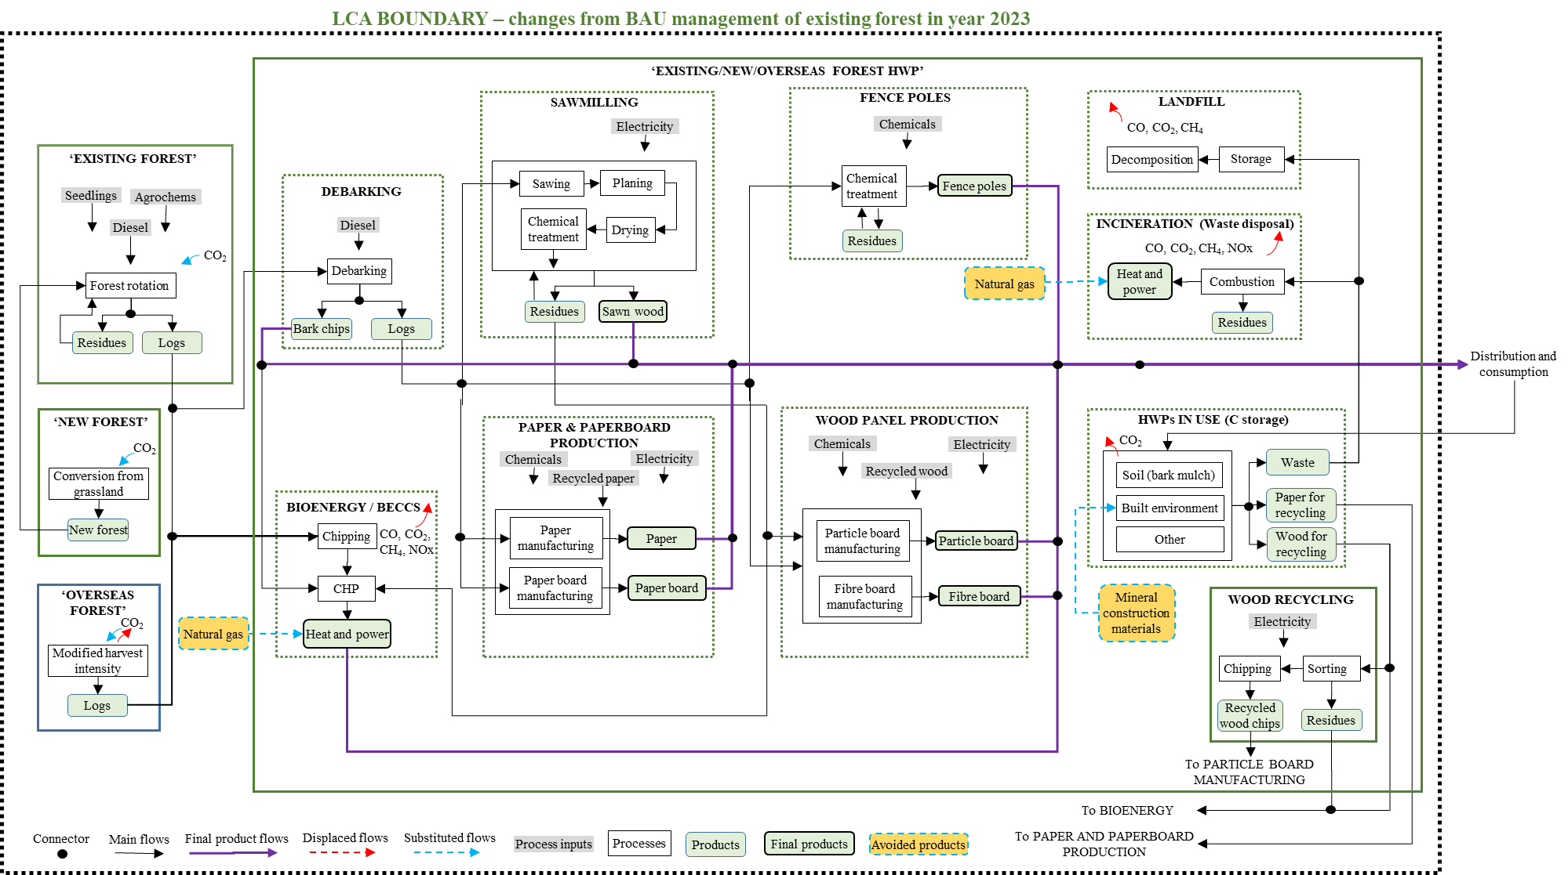

Supplementary References

1. Wernet, G. et al. The ecoinvent database version 3 (part I): overview and methodology. Int. J. Life Cycle Assess. 21, 1218–1230 (2016).
2. Gresham House. Forest production data. (2018).
3. Kull, S. J., Northern Forestry Centre (Canada) & Canada. Natural Resources Canada. Operational-scale carbon budget model of the Canadian forest sector (CBM-CFS3) : version 1.2, user’s guide. (2016).
4. James Jones & Sons. Sawmill production data provided from personal correspondence. (2019).
5. Matthews, R. W., Jenkins, T. A. R., Mackie, E. D. & Dick, E. C. Forest Yield: A handbook on forest growth and yield tables for British forestry. (2016).
6. BRE. IMPACT database v5 (accessed via etool LCA software). (2018).
7. Forster, E.J., Healey, J.R., Dymond, C., Styles, D. Commercial afforestation can deliver effective climate change mitigation under multiple decarbonisation pathways. Nature Communications 12, 3831 (2021). https://doi.org/10.1038/s41467-021-24084-x

