Supplementary Material
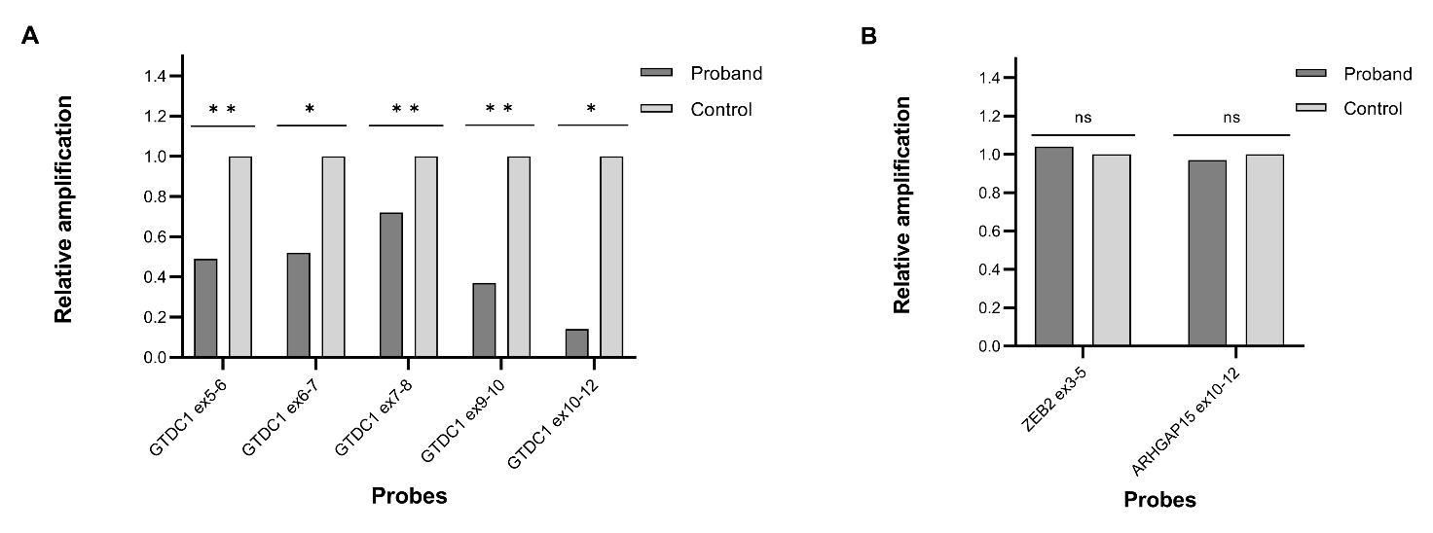

Figure S1. Expression of GTDC1, ZEB2 and ARHGAP15 in the proband’s LCL. RT-qPCR results for GTDC1 (A), ZEB2 and ARHGAP15 (B) in the proband and control LCLs, showing reduced expression of GTDC1, as evaluated by using five primers pairs spanning from exon 5 to exon 12 of the transcript, and normal expression levels of ZEB2 and ARHGAP15. Data of one representative experiment (from three independent replicates), analyzed using the 2^{−ΔΔCt} method (housekeeping gene: GAPDH), are shown. Statistically significant p-values were expressed as *p<0.05 and **p<0.01, respectively. ns: not statistically significant.

Table S1. Primers used for the breakpoint cloning analysis (qPCR) and expression analysis (RT-qPCR)
qPCR (gDNA analysis)
Target gene | Probe | Relative amplification | Chromosomal coordinates (hg38) | Primer sequence
GTDC1 | Proximal control | 1.00 | 144118916-144119017 | F: TGGATCGTGAAAATTCCTGGGT  R: TGTGAAACCTTTATTTGGGCCA
GTDC1 | Proximal 1 | 1.18 | 144119164-144119296 | F: GCAGGATTAATTCCCAGAGT  R: GGTTTGTGCACATGGTTAGT
GTDC1 | Proximal 2 | 0.43 | 144119500-144119576 | F: TACCTCATACAGATTGTGCACA  R: CCTTCACATTTCACCAGTCTT
GTDC1 | Proximal 3 | 0.53 | 144120033-144120151 | F: GAAGGGTTGGAAAGAAGTCA  R: GGGAAATTGGAATTGCATTC
GTDC1 | Proximal 4 | 0.57 | 144120238-144120352 | F: TTCTGACCCACCTCACTTGC  R: TACAGATATTGGGGCAGTTG
GTDC1 | Deletion control | 0.52 | 144150073-144150199 | F: TTCAGTAGGCCCCTCTCCTC  R: CCTCCTGAAGCCATGCAAGA
GTDC1 | Distal 1 | 0.55 | 144193047-144193199 | F: CAGTCTCATTCCACCACAGGT  R: GGAAAGTGGTTGAATTGCTCTC
GTDC1 | Distal 2 | 0.49 | 144193994-144194075 | F: ACATTATGGTTTCGGGCCAA  R: TGTGAGTAGGAGAGATGACATAGA
GTDC1 | Distal 3 | 1.22 | 144194676-144194821 | F: CGGAAGGCATTCTTGGTTAG  R: GCCATCTGAATCAGTATTTCCA
GTDC1 | Distal 4 | 1.24 | 144195234-144195334 | F: GTTTCTGGAACAGGAGAAGG  R: GGTGAGTACCAGCCTCTTAGAA
GTDC1 | Distal control | 1.06 | 144195495-144195654 | F: CACTACCATCTGCCAGCATT  R: GGAAAATGCACATACGTACACA
RT-qPCR (cDNA analysis)
Target gene | Probe | Relative amplification | Transcript coordinates | Primer sequence
GTDC1 | ex 5-6 | 0.49 | NM_001376312.2: c.456_579 | F: CCTGACCTTGGGAAACTGAAA  R: CCACCAGGCATGAAAGAATTTG
GTDC1 | ex 6-7 | 0.52 | NM_001376312.2: c.713_811 | F: TTACTTTCCCATCAGGTTTCC  R: GCACCGCCATTTCCTTTA
GTDC1 | ex 7-8 | 0.68 | NM_001376312.2: c.981_1124 | F: GATAATTCAAGCTCTCATCATGG  R: GCTTTCTGGATCTTTATCATGC
GTDC1 | ex 9-10 | 0.37 | NM_001376312.2: c.1262_1375 | F: CTACTTACCCAGCAAAGATGACTAT  R: CCACAGTACACGCTTCCAA
GTDC1 | ex 10-12 | 0.14 | NM_001376312.2: c.1376_1531 | F: GTGTTACCCACTTTGTCCTAA  R: GGAGCGATTTCACCCTTATAG
ZEB2 | ex 3-5 | 1.04 | NM_014795.4: c.571_670 | F: AGATGGTCCAGAAGAAATGAAG  R: GCAATTTGCATTCTTCACTGTA
ARHGAP15 | ex 10-12 | 0.98 | NM_018460.4: c.983_1059 | F: AAGAGGTCTAGATGTTGATGGAAT  R: CCAAATTCAGCTTCTCTTCTTG

Table S2. List of up-regulated genes in the proband’s LCL (n=74)
Up-regulated genes
ANO5, ASRGL1, BIRC3, CCL17, CCL22, CCL3L1, CCL4L1, CCR8, CD83, CDCP1, CNKSR3, CNN3, DMKN, DSG2, FABP3, FHL1, GLYATL2, GTF2H2, GTSF1, HERC5, HIC1, HIST1H1C, HIST1H1D, HIST1H2AE, HIST1H2AH, HIST1H2AI, HIST1H2AJ, HIST1H2BG, HIST1H3C, HIST1H3D, HIST1H3G, HIST1H4A, HIST1H4B, HIST1H4D, HIST1H4E, HIST1H4H, HLA-DRB4, HLA-DRB5, HOMER1, IFIT3, INSIG1, ISG15, LAPTM4B, LGALS3BP, LOC102724219, LOC102724843, LOC102724951, ME1, MMP7, MOCOS, MSX1, MYO1B, NFKBIA, NID1, NOMO3, OXTR, PAG1, PEG10, PLA2G16, PNMA8A, RAB31, RPSAP58, SERPINB10, SLC45A3, SLFN11, SOX9, SSTR2, SYNGR1, TBC1D3,TC2N, TNFRSF21, TUBB2A, TUBB2B, UBD, USP18
Genes belonging to the “chemokine-mediated signaling” and “phosphorylation of CD3 and TCR zeta (ζ) chains” pathways are respectively colored in blue and purple.

Table S3. List of down-regulated genes in the proband’s LCL (n=132)
Down-regulated genes
ACY3, AIF1, ALDH2, ALDH7A1, APELA, ARHGEF11, BASP1, BEX4, BHLHE40, BLK, C10orf99, C11orf74, C16orf74, CCL3L3, CCL4L2, CD99, CDIP1, CDK2AP2, CDKN1A, CHI3L2, CKLF, CORO1B, CTNND1, CTSW, CXCR3, CXXC1, CYTH4, DERL3, DOK1, DSTN, DUSP23, ECHDC2, EGR1, ESAM, FAM129B, FAM24B, FCER1G, FES, FLOT2, FUT7, FXYD2, FYN, GAMT, GDPD5, GGT1, GIMAP6, GLDC, GPAT2, GPC4, GPR18, GPR55, GSN, GSTM2, GSTM4, GTDC1, HEBP2, HLA-DRB3, ID3, IFITM3, IGLL5, IL10, IRAK3, ITGB5, ITGB7, ITM2C, KRT18, LARGE1, LARP6, LAT, LGALS1, LGALS3, LOC102723360, LPAR6, LPIN1, MACROD2, MGST2, MOXD1, MYO1F, NLRP2, NRGN, NT5E, P2RX1, PALD1, PCGF2, PCSK6, PIGR, PKIG, POLR2J3, PRKCH, PTGR1, PTMS, PTPRJ, PVRIG, PXN, RAMP1, RASA4, RGS2, RIMKLB, RNASE6, RUBCNL, S100A4, SCIMP, SGK1, SLC12A7, SLC12A8, SLFN13, SMAD1, SMCO4, SOCS3, SORBS3, SPINT2, STEAP1, SULT1A1, TBC1D3L, TBC1D4, TBX15, TBX21, TBXAS1, TCL1A, TIMP1, TMEM173, TOX, TOX2, TPM2, TRAM2, U2AF1L5, UPK3BL1, WFDC2, WWC3, ZFP36, ZNF205, ZNF300
Genes belonging to the “glycine, serine and threonine metabolism” and glycerolipid metabolism” pathways are respectively colored in blue and purple. The double color used for ALDH7A1 indicates its involvement in both pathways.

