Supplementary figure 1. Definition of Genotype Concordance, Specificity and Sensitivity
0 represents reference allele while 1 represents Non-Reference (NR) allele, dot means allele missing called. For each metrics, the value equals to the corresponding red rectangles divided by all rectangles with blue border.
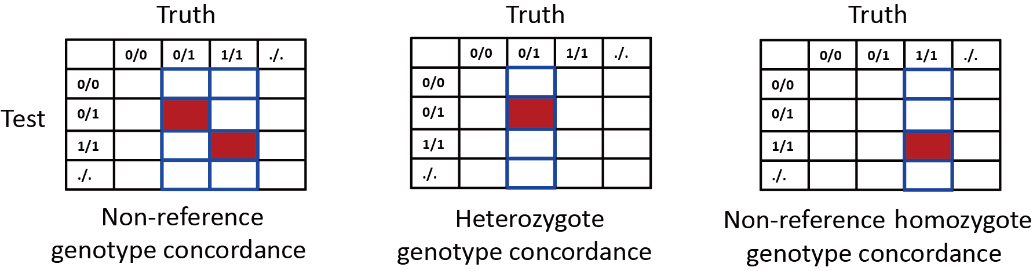

Supplementary figure 2. The mean NR-allele concordance rate in Africa, America, Europe, Middle East and Oceania populations of HGDP. For all populations of HGDP, we used Axiom array sites to make preudo array. We also used the Asia screening array loci to make pseudo array in East Asian and Central and South Asian populations.
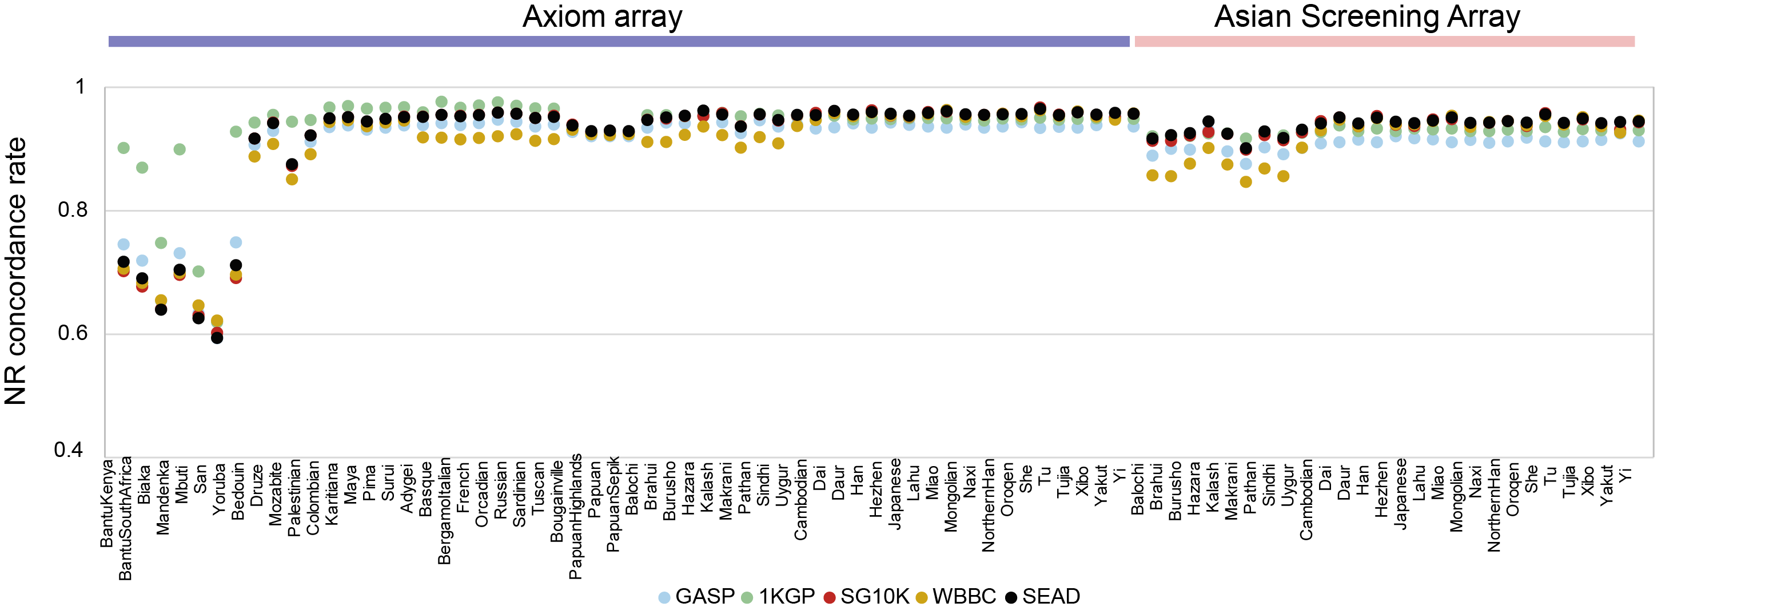

Supplementary figure 3. A. The fold change of mean NR-allele concordance rate in Africa, America, Europe, Middle East and Oceania populations of HGDP. For all populations of HGDP, we used Axiom array sites to make preudo array. We also used the Asia screening array loci to make pseudo array in East Asian and Central and South Asian populations. A. foldchange=SEAD/GAsP; B. foldchange=SEAD/SG10K; C. foldchange=SEAD/WBBC.
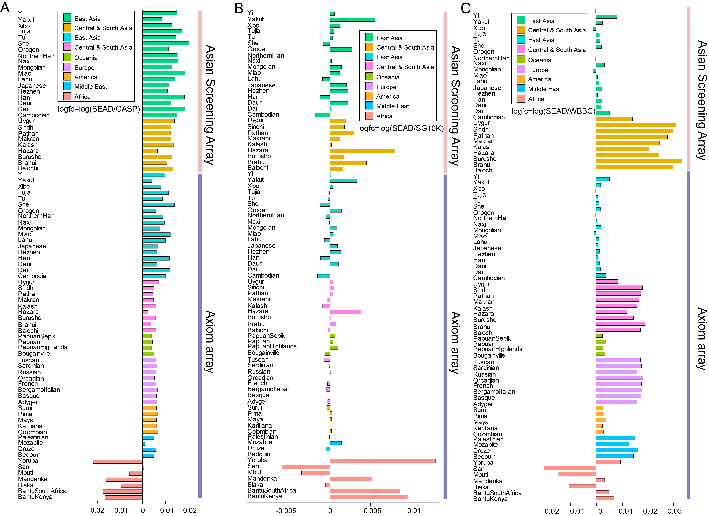

Supplementary figure 4. Non-reference allele (NR-allele) concordance rate distribution (imputed variants vs. WGS variants) in East Asia populations (A) and Central and South Asia populations. Each dot represents an individual. The plots on the top and right are the corresponding density distributions.
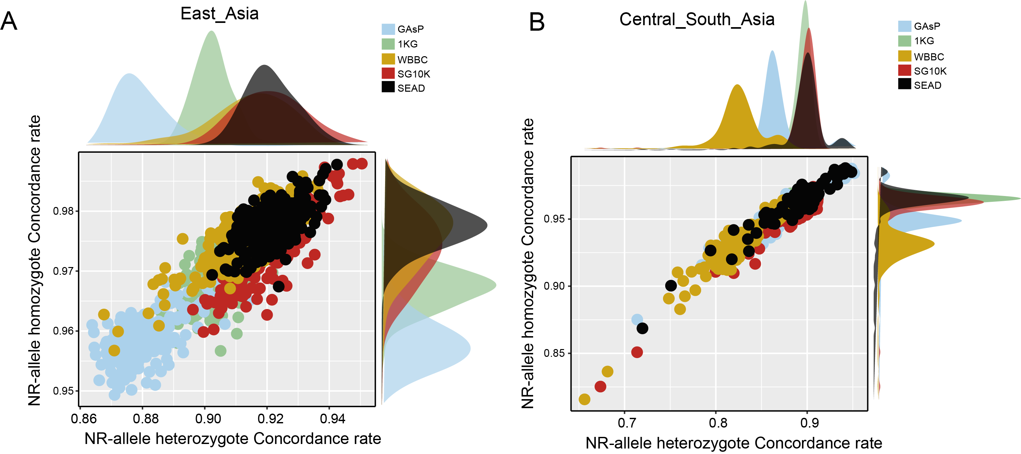

Supplementary figure 5. Manhattan and QQ plot with common and rare variants (MAF > 0.001) of Hip (A and B) and FN BMD (C and D) using GWAS individual analysis.
