Supplementary material
Title: Population genetic structure of wild boar and dispersal performance based on kinship analysis in the northern region of South Korea
Journal: Conservation Genetics
Authors: Seung Woo Han¹, Han Chan Park², Jee Hyun Kim¹, Jae Hwa Suh³, Hang Lee¹ and Mi Sook Min¹
¹ College of Veterinary Medicine, Seoul National University, Seoul 08826, Republic of Korea
² Department of Life Science, College of Natural Science, Yeongnam University, Gyeongbuk 38541, Republic of Korea
³ Animal Resources Division, National Institute of Biological Resources, Incheon 22689, Republic of Korea
Corresponding Author: Mi Sook Min (minbio@yahoo@co.kr)

Table S1. Detailed location of 24 groups used for Isolation by Distance (IBD) analysis.
Group No. | Location | Number of samples
1 | Jongro-gu, Dobong-gu, Uijeongbu, Goyang, part of Yangju | 27
2 | Dongducheon, part of Yangju | 23
3 | Part of Gapyeong | 18
4 | Namyangju | 17
5 | Pocheon | 20
6 | Hanam, Yangpyeong, part of Gapyeong, part of Hongcheon | 19
7 | Yeoncheon | 17
8 | Pyeongtaek, Ansung | 23
9 | Gwangju | 15
10 | Icheon | 17
11 | Yeoju | 15
12 | Yongin, Hwasung | 18
13 | Chuncheon | 17
14 | Hoengsung | 15
15 | Hwacheon | 20
16 | Part of Inje, part of Hongcheon | 21
17 | Pyeongchang | 18
18 | Yanggu, part of Inje | 20
19 | Yeongweol | 18
20 | Gangneung, Donghae | 24
21 | Gosung | 20
22 | Samcheok | 19
23 | Sokcho, Yangyang | 33
24 | Taebaek | 20
Group numbers are used in Fig. S1

Table S2. Genetic statistics of 13 microsatellite loci of 6 sample groups
Locus | NGG  (N = 128) | SGG  (N = 100) | NWGW  (N = 79) | SWGW  (N = 51) | NEGW  (N = 60) | SEGW  (N = 56)
S0026
NA | 8 | 6 | 8 | 8 | 7 | 7
HO | 0.789 | 0.650 | 0.785 | 0.863 | 0.783 | 0.893
HE | 0.793 | 0.790 | 0.829 | 0.826 | 0.794 | 0.827
HWE P-value | 0.5234 | 0.005* | 0.0212* | 0.7647 | 0.3062 | 0.2034
S0068
NA | 6 | 8 | 10 | 9 | 7 | 7
HO | 0.633 | 0.860 | 0.772 | 0.824 | 0.633 | 0.696
HE | 0.693 | 0.789 | 0.779 | 0.767 | 0.764 | 0.721
HWE P-value | 0.0148* | 0.9287 | 0.9007 | 0.004* | 0.4567 | 0.3496
S0155
NA | 6 | 5 | 7 | 5 | 5 | 5
HO | 0.711 | 0.710 | 0.722 | 0.725 | 0.650 | 0.696
HE | 0.704 | 0.674 | 0.701 | 0.705 | 0.682 | 0.633
HWE P-value | 0.8127 | 0.7791 | 0.5546 | 0.7551 | 0.4052 | 0.3494
IGF1
NA | 4 | 5 | 5 | 5 | 5 | 5
HO | 0.563 | 0.500 | 0.595 | 0.451 | 0.500 | 0.643
HE | 0.582 | 0.546 | 0.554 | 0.429 | 0.616 | 0.573
HWE P-value | 0.8406 | 0.5884 | 0.1182 | 0.0048* | 1 | 0.1764
SW240
NA | 6 | 7 | 7 | 6 | 7 | 6
HO | 0.813 | 0.740 | 0.759 | 0.765 | 0.733 | 0.625
HE | 0.804 | 0.781 | 0.791 | 0.765 | 0.780 | 0.792
HWE P-value | 0.3786 | 0.4007 | 0.4055 | 0.1548 | 0.5414 | 0.0008*
SW857
NA | 4 | 5 | 5 | 4 | 5 | 4
HO | 0.547 | 0.600 | 0.646 | 0.588 | 0.600 | 0.661
HE | 0.691 | 0.681 | 0.699 | 0.597 | 0.614 | 0.606
HWE P-value | 0.0056* | 0.3945 | 0.3314 | 0.5365 | 0.9511 | 0.2412
SW24
NA | 8 | 8 | 7 | 8 | 9 | 8
HO | 0.750 | 0.770 | 0.684 | 0.784 | 0.767 | 0.750
HE | 0.793 | 0.763 | 0.794 | 0.805 | 0.819 | 0.736
HWE P-value | 0.174 | 0.1293 | 0.0368* | 0.7472 | 0.9245 | 0.6812
SW632
NA | 7 | 7 | 6 | 5 | 5 | 6
HO | 0.586 | 0.730 | 0.595 | 0.706 | 0.667 | 0.714
HE | 0.674 | 0.727 | 0.593 | 0.659 | 0.595 | 0.707
HWE P-value | 0.115 | 0.7009 | 0.6222 | 0.989 | 0.3221 | 0.8272
SWR1941
NA | 5 | 6 | 6 | 5 | 5 | 5
HO | 0.445 | 0.590 | 0.696 | 0.647 | 0.683 | 0.679
HE | 0.520 | 0.570 | 0.689 | 0.670 | 0.663 | 0.692
HWE P-value | 0.0327* | 0.7989 | 0.6519 | 0.8845 | 0.3193 | 0.4132
S0143
NA | 7 | 7 | 7 | 7 | 7 | 6
HO | 0.664 | 0.700 | 0.696 | 0.667 | 0.750 | 0.750
HE | 0.695 | 0.746 | 0.778 | 0.753 | 0.767 | 0.786
HWE P-value | 0.0251* | 0.1454 | 0.1589 | 0.2388 | 0.0006* | 0.6308
S0226
NA | 7 | 10 | 7 | 6 | 6 | 6
HO | 0.664 | 0.680 | 0.722 | 0.667 | 0.683 | 0.696
HE | 0.691 | 0.654 | 0.745 | 0.703 | 0.740 | 0.673
HWE P-value | 0.2859 | 0.8248 | 0.2806 | 0.7474 | 0.8401 | 0.5882
SW72
NA | 5 | 5 | 5 | 5 | 5 | 5
HO | 0.602 | 0.650 | 0.620 | 0.608 | 0.700 | 0.732
HE | 0.687 | 0.705 | 0.706 | 0.661 | 0.658 | 0.673
HWE P-value | 0.3642 | 0.3805 | 0.1237 | 0.6031 | 0.2606 | 0.4662
S0090
NA | 6 | 6 | 6 | 6 | 6 | 5
HO | 0.688 | 0.740 | 0.810 | 0.706 | 0.767 | 0.732
HE | 0.695 | 0.775 | 0.712 | 0.760 | 0.749 | 0.783
HWE P-value | 0.6282 | 0.0175* | 0.5803 | 0.075 | 0.7941 | 0.4525
N: Number of samples, NA: number of alleles, NE: number of effective alleles, HO: observed heterozygosity, HE: expected heterozygosity, HWE P-value: the probability of Hardy-Weinberg equilibrium, *Significant departure from Hardy-Weinberg equilibrium(P<0.05)
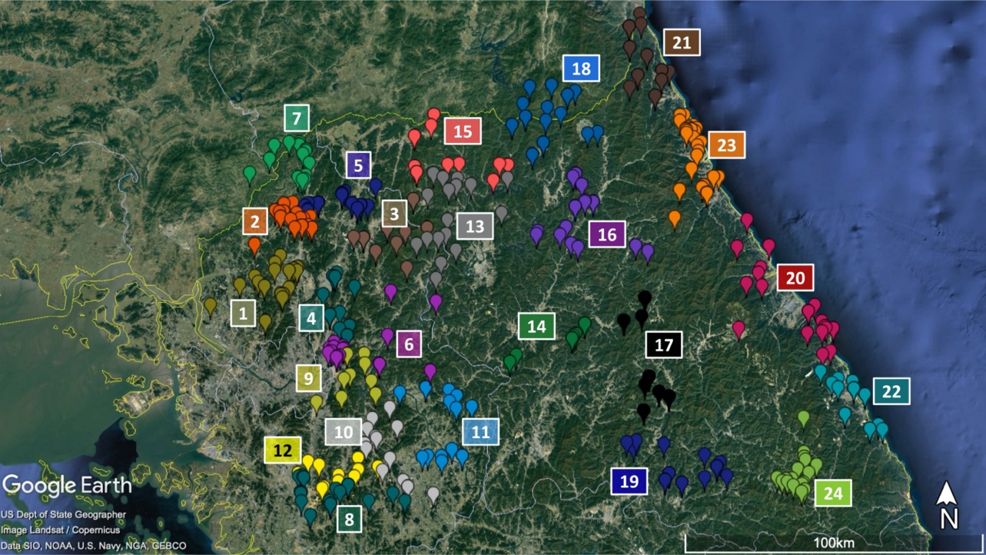
Fig. S1. Group of samples used for Isolation by Distance (IBD) analysis. Check for the location number in Table S1
b)
a)
Fig. S2. Plot of Bayesian posterior probability using STRUCTURE HARVESTER (Earl 2012). a) L(K), b) DeltaK. Estimation of optimal K value (K=2) based on Evanno method (Evanno et al. 2005)

