Supporting information

Title: Flood-induced sediment deposition drives rapid invertebrate colonization of hyporheic zone

Junjiro N. Negishi

Faculty of Environmental Earth Science, Hokkaido University, N10 W5 Sapporo, Hokkaido 060-0810, Japan
negishi@ees.hokudai.ac.jp

Supporting information 1

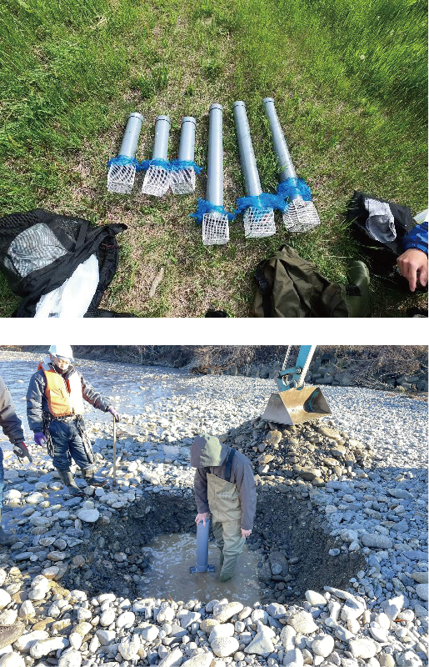
The upper panel shows PVC wells used for hyporheic community sampling. The lower panel shows installation of a well.

Supporting information 2

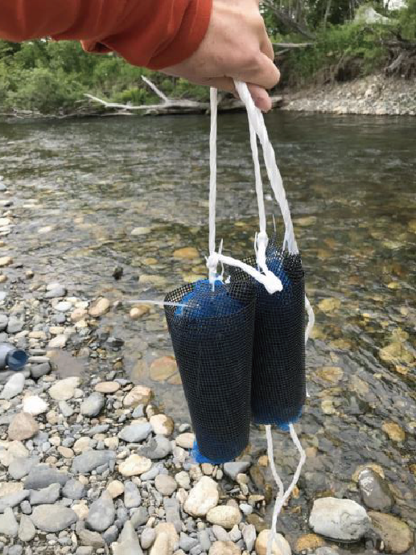
Hyporheic traps are held immediately before installation.

