Adsorption characteristics of Cr⁶⁺ on microalgae immobilized by different carriers
Ran Chen^{a1}, Junjun Wang^{b1}, Ling Fanª, Linlin Cuiª, Yejuan Zhangª, Xueling Wuª, Jiaokun Liª, Weimin Zengª, Li Shenª∗
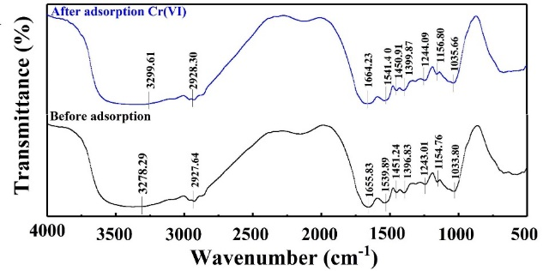
Figure. S1 FTIR spectra of the microalgae before and after adsorption of Cr⁶⁺

Table S1 The orthogonal experiment of three factors and three levels on the ratio of chitosan to acetic acid, microalgae concentration, and immobilization time
No. | A  Chitosan : acetic acid (W/V) | B  Microalgae concentration (cells/mL) | C  Immobilization time (h) | Diameter (mm) | Form ball | Adsorption  efficiency
1 | 1.5:40 | 10⁶ | 6 | 2.9 | difficult to form ball and easy to adhere | 67.5%
2 | 1.5:40 | 10⁷ | 12 | 2.8 | difficult to form ball and easy to adhere | 72.1%
3 | 1.5:40 | 10⁸ | 18 | 3.0 | difficult to form ball and easy to adhere | 80.3%
4 | 2.0:40 | 10⁶ | 12 | 2.9 | easy to form a ball without tailing | 94.7%
5 | 2.0:40 | 10⁷ | 18 | 2.8 | easy to form a ball without tailing | 97.6%
6 | 2.0:40 | 10⁸ | 6 | 2.9 | easy to form a ball without tailing | 95.4%
7 | 2.5:40 | 10⁶ | 18 | 3.3 | difficult to form ball and easy to drag | 84.1%
8 | 2.5:40 | 10⁷ | 6 | 3.1 | difficult to form ball and easy to drag | 75.1%
9 | 2.5:40 | 10⁸ | 12 | 3.1 | difficult to form ball and easy to drag | 82.1%
K₁ | 2.199 | 2.436 | 2.38
K₂ | 2.877 | 2.448 | 2.489
K₃ | 2.413 | 2.583 | 2.62
k₁ | 0.733 | 0.812 | 0.793
k₂ | 0.959 | 0.816 | 0.829
k₃ | 0.804 | 0.861 | 0.873
Range | 0.226 | 0.049 | 0.08
Primary and secondary order | A>C>B
Excellent level | A₂ | B₃ | C₃
Optimal combination | A₂B₃C₃

ª School of Minerals Processing and Bioengineering, Central South University, Changsha, Hunan 410083, China. E-mail: lishen@csu.edu.cn; Fax: +86-731-88879815; Tel: +86-731-88877472 ^{b} School of Metallurgy and Environment, Central South University, Changsha, Hunan 410083, China ¹ These authors contributed equally to this work and should be considered co-first authors.

