Extended data figures and tables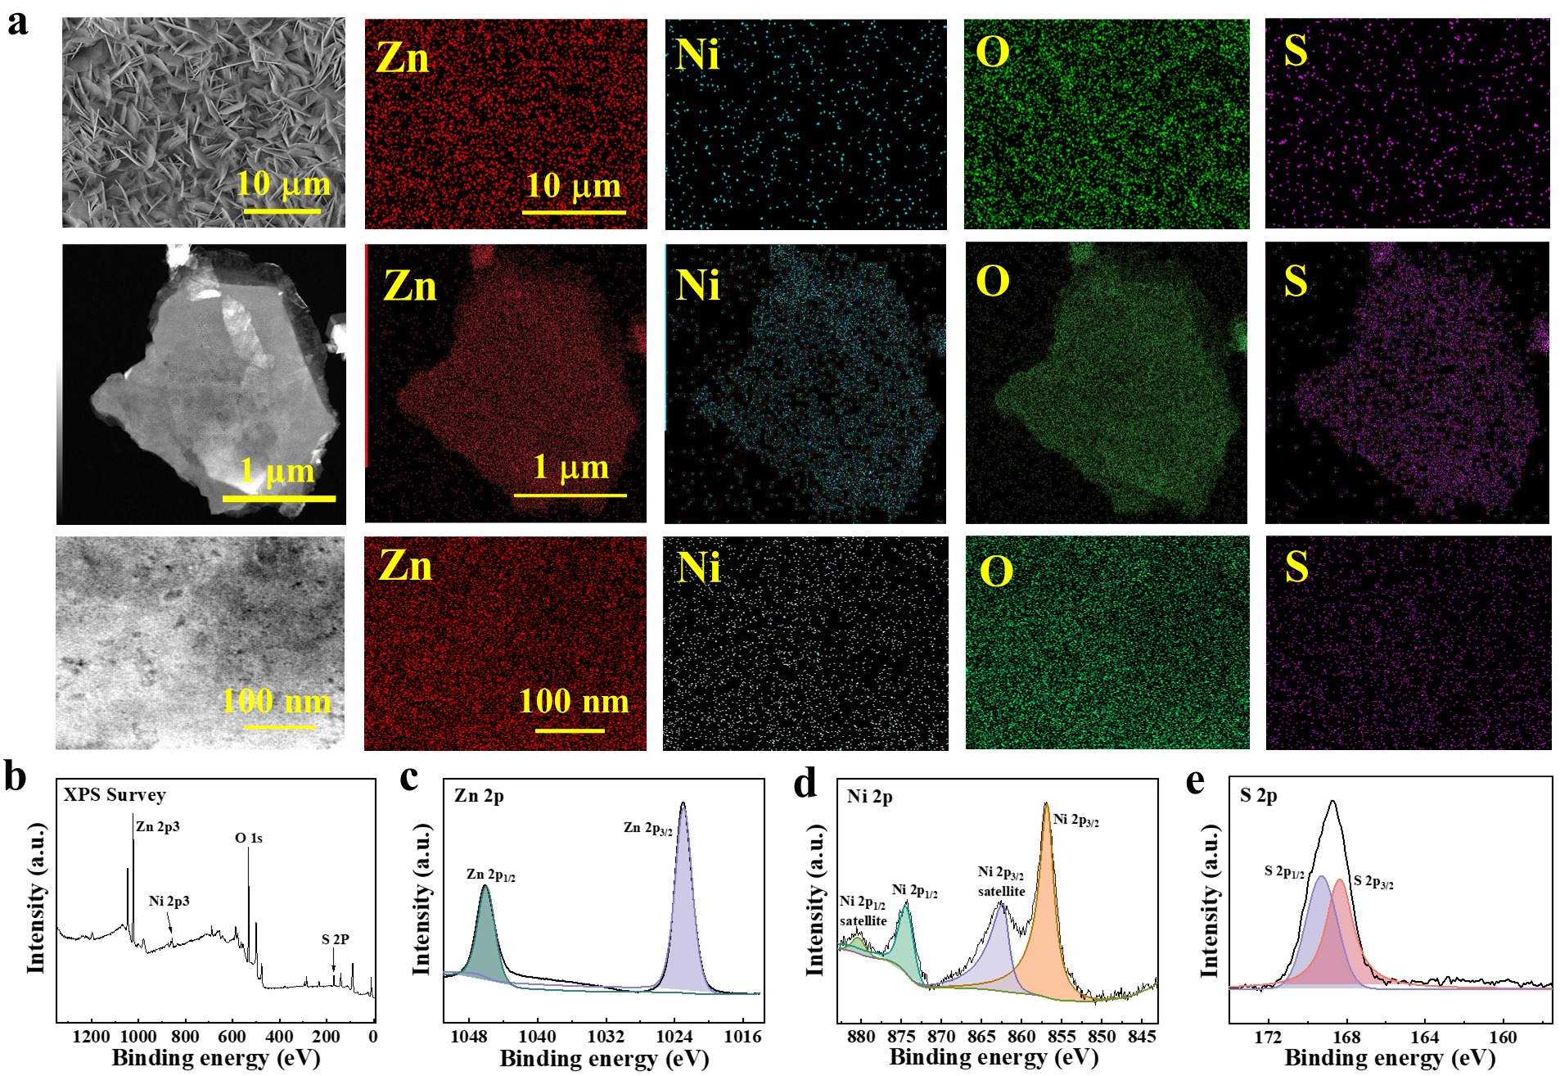
Extended Data Fig. 1| Characterization of Zn-LDH electrode at anode. a, EDS mapping. b-e, XPS survey spectrum (b) and the spectra for Zn 2p (c), Ni 2p (d) and S 2p (e).
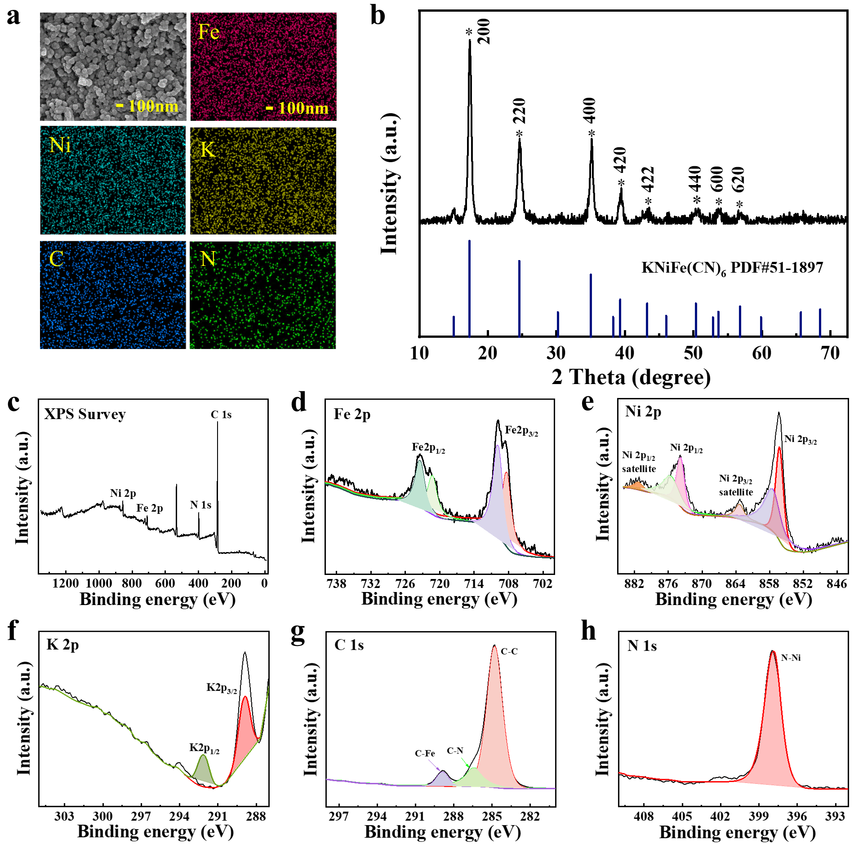
Extended Data Fig. 2 | Characterization of the NiHCF electrode at cathode. a,b, EDS mapping (a) and XRD patterns (b). c-h, XPS survey spectrum (c) and the spectrum for Fe 2p (d), Ni 2p (e), K 2p (f), C 1s (g) and N 1s (h). The diffraction peak of prepared material is in good agreement with the standard card PDF#51-1897.
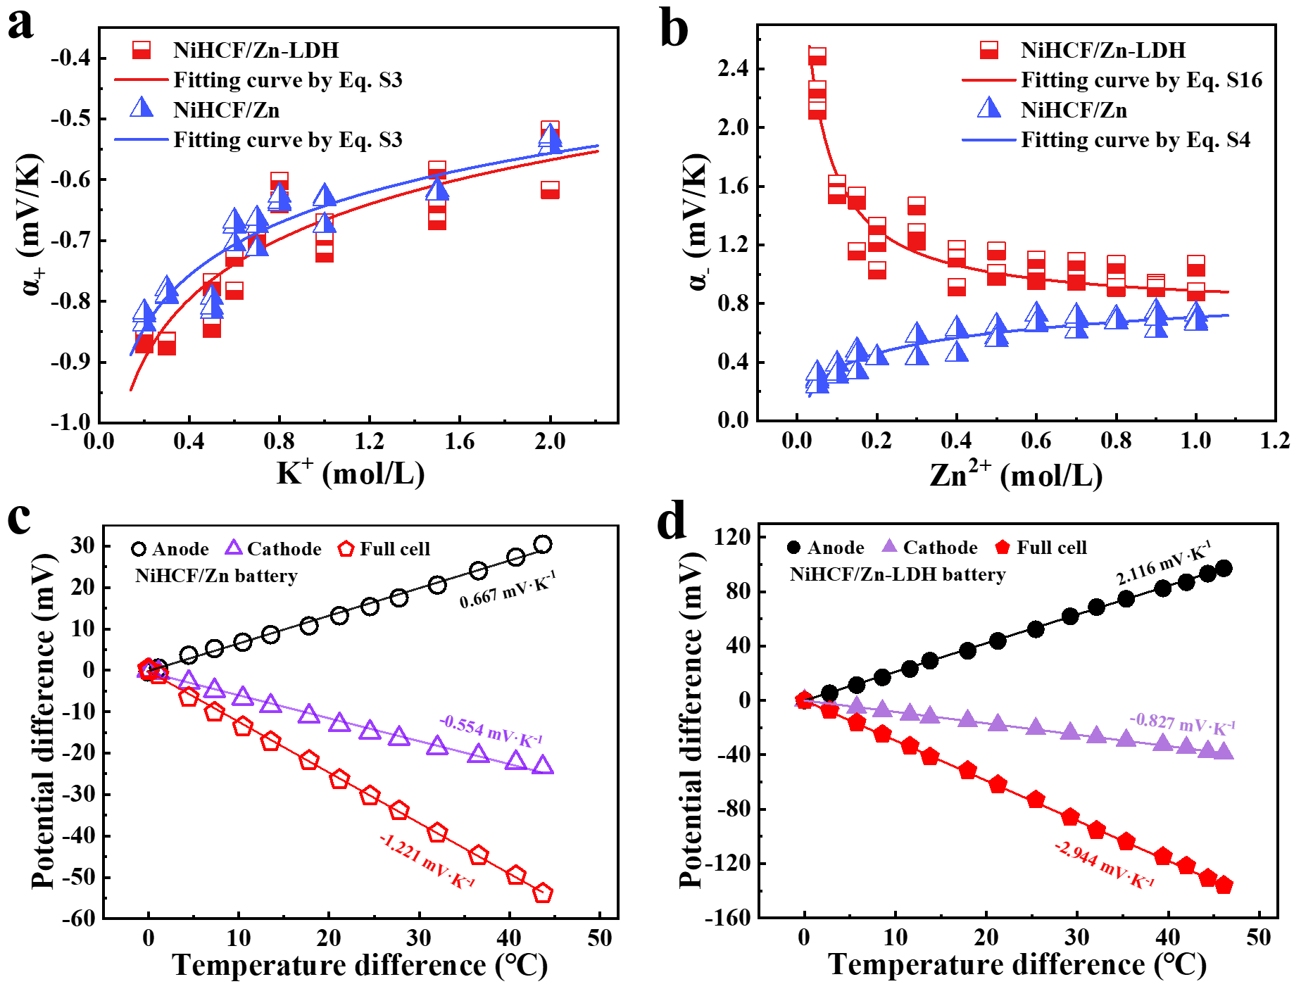
Extended Data Fig. 3 | Temperature coefficients in NiHCF/Zn and NiHCF/Zn-LDH batteries. a,b, α₊ vs K⁺ concentration (a) and α₋ vs Zn²⁺ concentration (b) in NiHCF/Zn and NiHCF/Zn-LDH batteries. c,d, Potential difference vs temperature difference in NiHCF/Zn batteries (c) and NiHCF/Zn-LDH batteries (d).

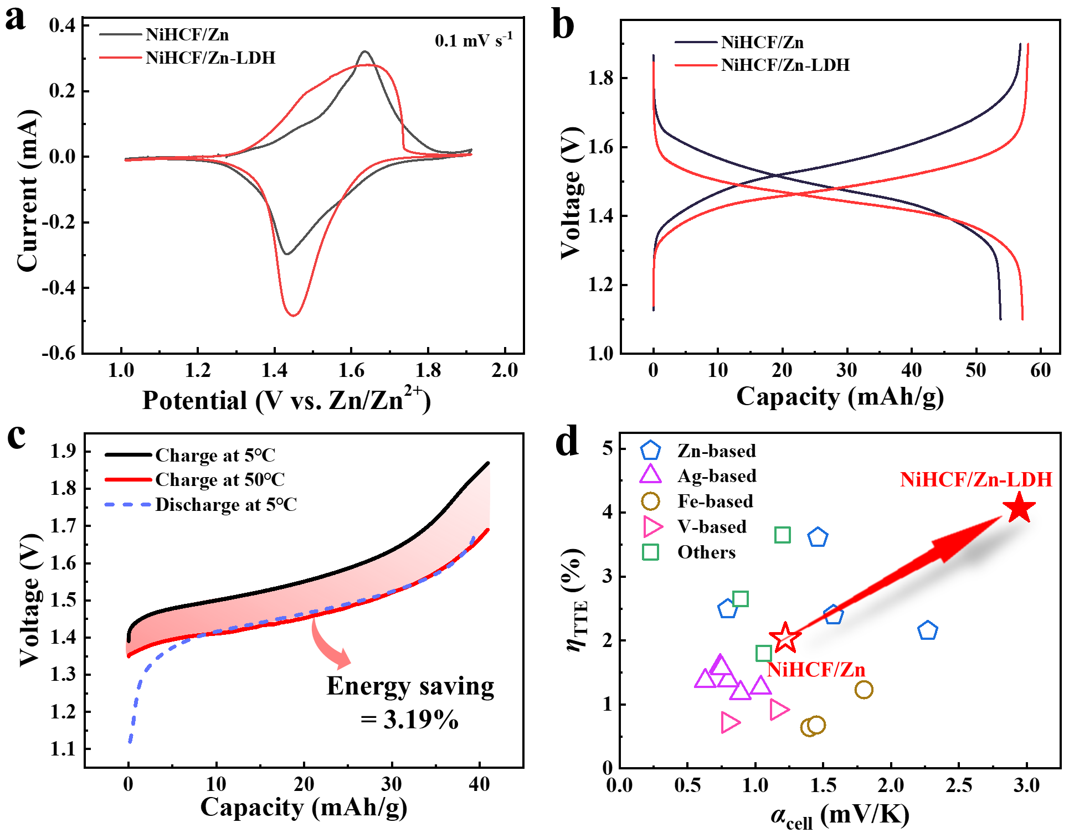
Extended Data Fig. 4 | Electrochemical performance in NiHCF/Zn and NiHCF/Zn-LDH batteries. a,b, CV curves (a) and GCD curves with a current of 0.2C (b) in NiHCF/Zn and NiHCF/Zn-LDH batteries. c, Performance of NiHCF/Zn battery when it is discharged at 5 ℃ but charged at 5 ℃ and 50 ℃. The energy saving is 3.19%. d, η_{TTE} vs α_{cell}. The hollow star and the solid star represent the data in NiHCF/Zn and NiHCF/Zn-LDH batteries, respectively. The others are taken from Refs. 15-25.

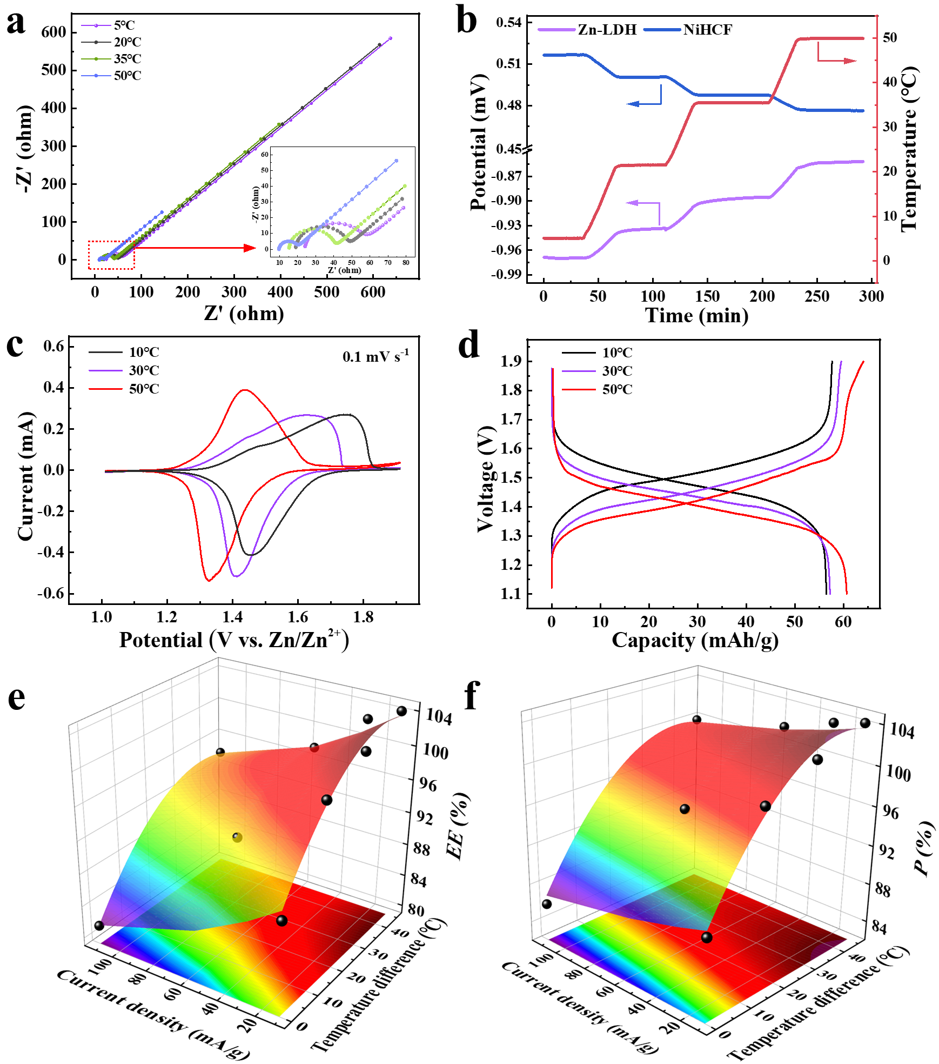
Extended Data Fig. 5 | Electrochemical performance of NiHCF/Zn-LDH batteries worked when charging at high temperature and discharging at low tempeatures. a, Nyquist spectra at different temperatures (inset shows the magnified region between 5 Ohm and 80 Ohm). A noticeable decrease in internal resistance and an increase in ionic mobility are observed when increasing temperature. b, Variation of potential and temperature vs time for NiHCF cathode and Zn-LDH anode. c,d, The CV (c) and GCD curves (d) at various temperatures. The redox potentials of charging and discharging decrease synchronously when increasing temperature. e,f, EE (e) and P (f) values under different current densities and temperature differences; the color surface is fitted by the second-order expansion of Taylor’s formula.

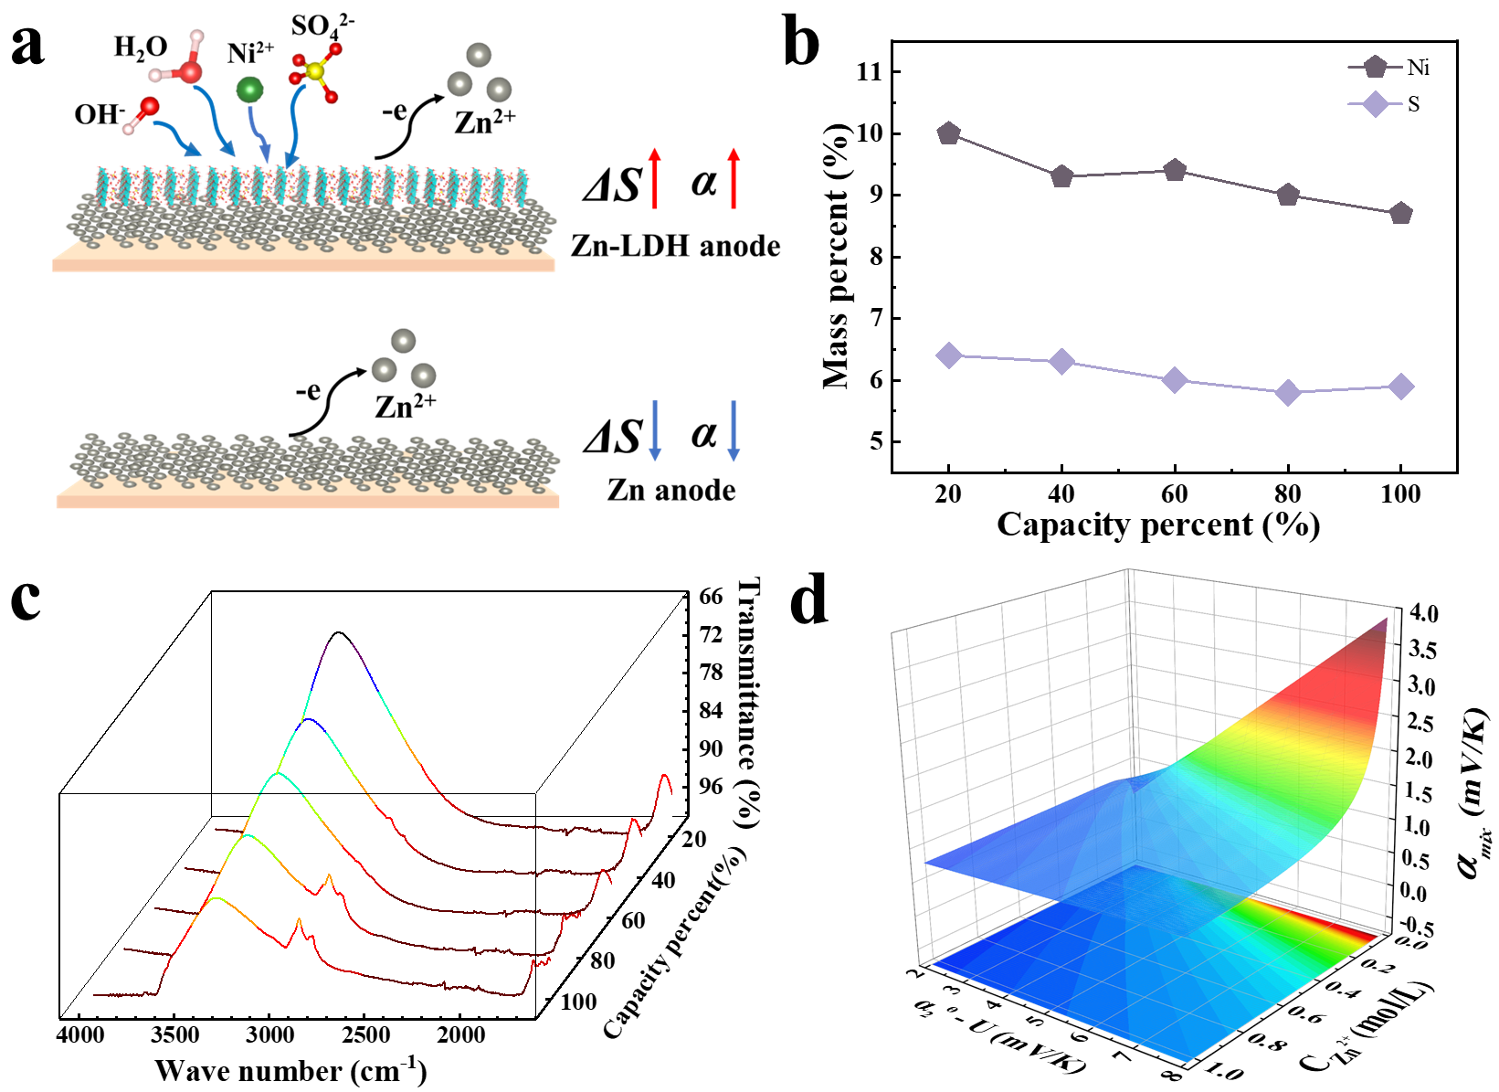
Extended Data Fig. 6 | Influence of LDH material on the performance of NiHCF/Zn-LDH battery. a, Schematic diagram of the chemical reactions at Zn anode and Zn-LDH anode. Introducing LDH materials leads to more ions participating in the anode reaction for large ΔS and α. b, Mass percent of Ni and S contents at different battery’s capacities. c, Variation of characteristic peaks for the Zn-LDH material by FTIR spectra. d, Temperature coefficient α_{mix} as a function of C_{Zn}²⁺ and α₂^{ɵ}-U (see the details in Eqs. (S7-S16)).
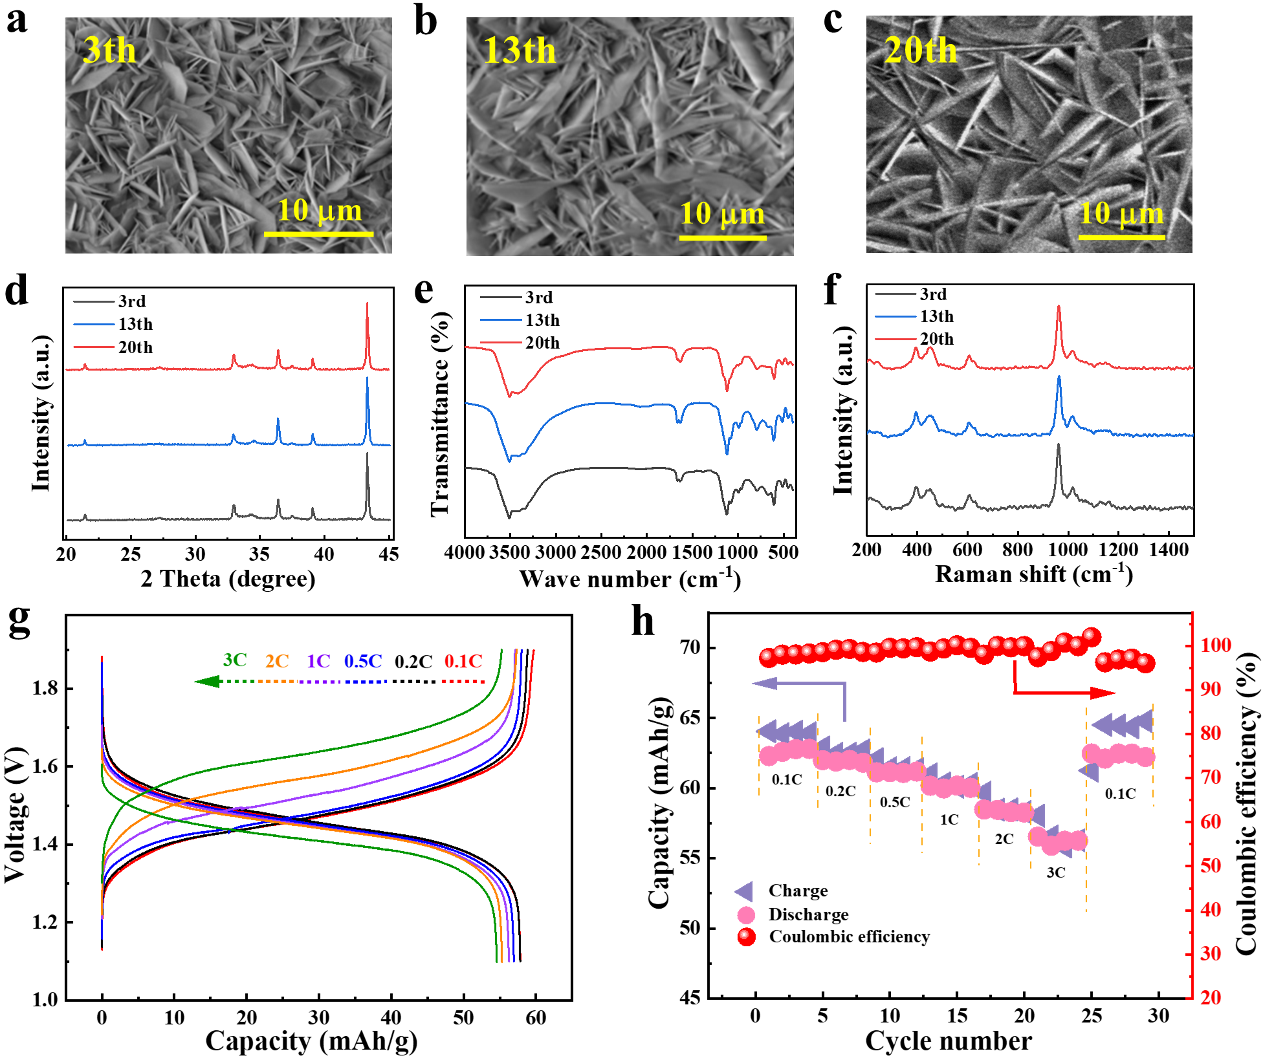
Extended Data Fig. 7 | Stability of NiHCF/Zn-LDH battery. a-f, The SEM images (a-c), XRD pattern (d), FTIR spectra (e) and Raman spectra (f) of Zn-LDH electrode after 3, 13 and 20 cycles. g, The GCD curves with various current densities. h, Rate performance and capacity reversible performance of the NiHCF/Zn-LDH battery.

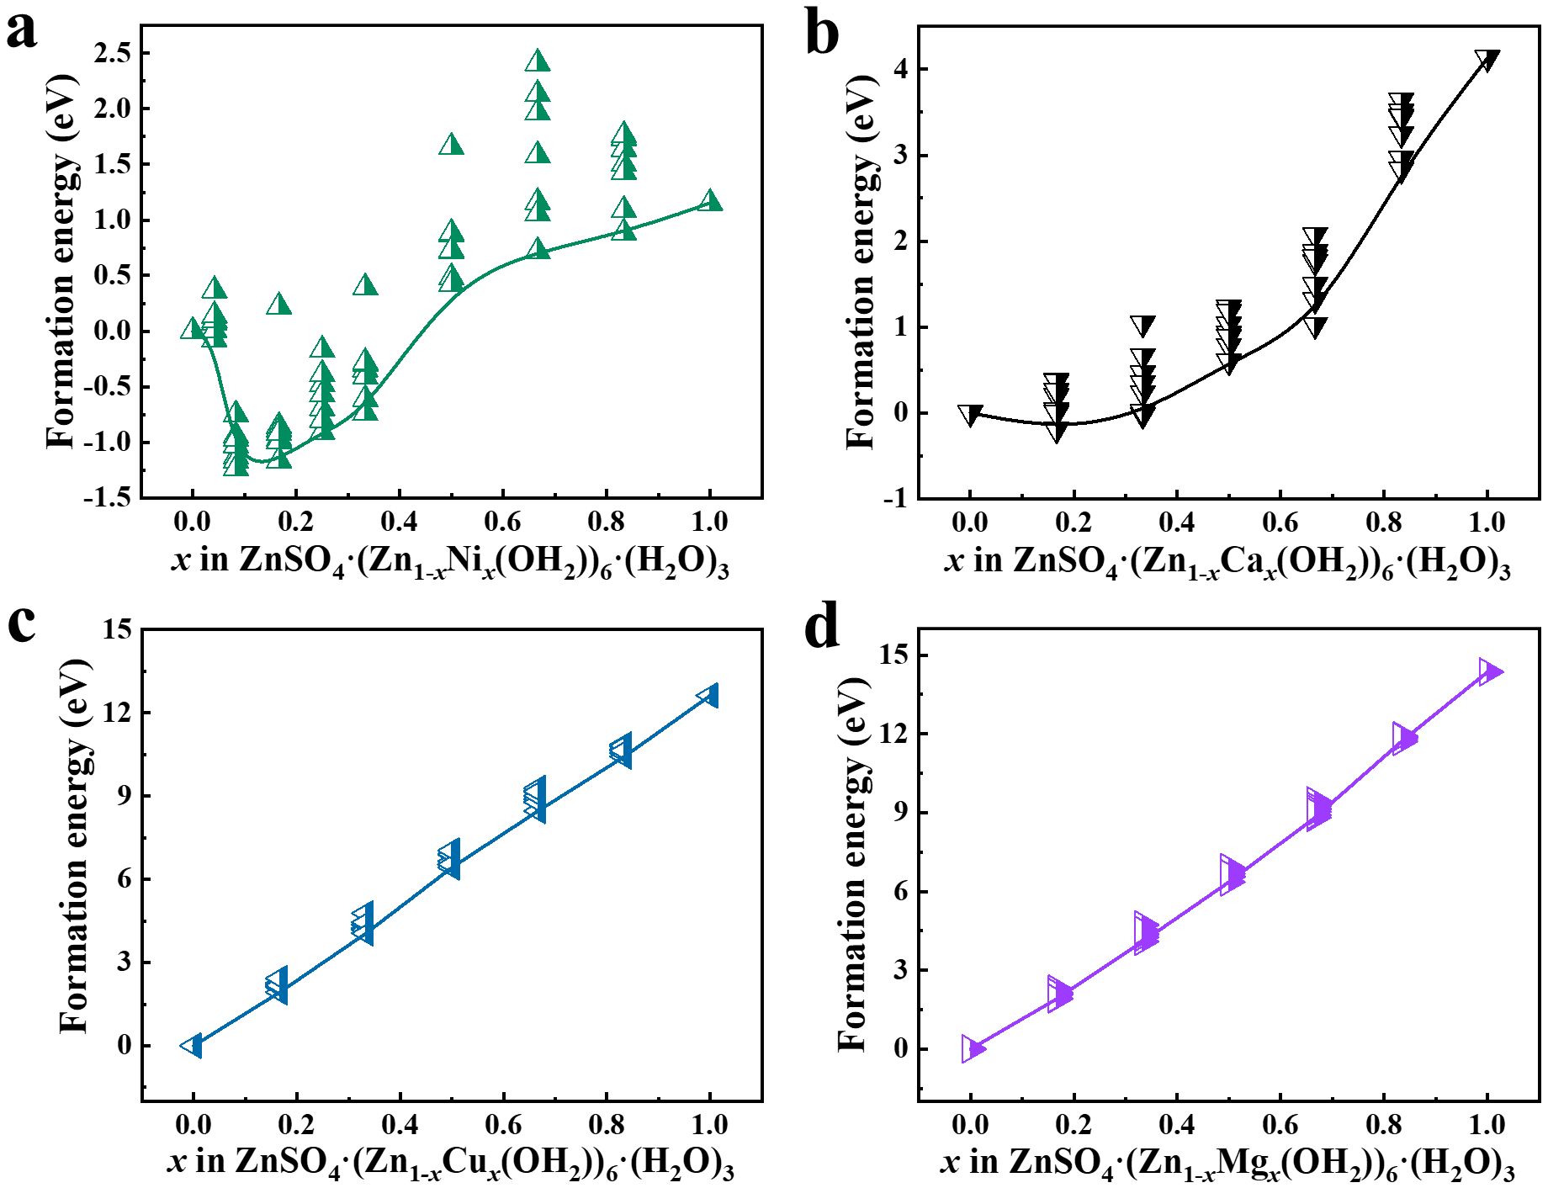
Extended Data Fig. 8 | Formation energy for various element-doped LDH materials. a-d, Formation energy as a function of doping concentrations x in (a) Ni-doped LDH, (b) Ca-doped LDH, (c) Cu-doped LDH, and (d) Mg-doped LDH. The formation energy increases when increasing x in Cu- and Mg-doped LDH, indicating that Cu and Mg ions hinder the formation of LDH. However, the formation energy firstly decreases and then increases when increasing x in Ni- and Ca-doped LDH, indicating that Ca and Ni ions can promote the formation of LDH when x is small. Especially, the ZnSO₄·(Zn_{0.84}Ni_{0.16}(OH)₂)₆·(H₂O)₃ material is the most stable compound with the smallest formation energy of -1.24 eV, which is similar to the LDH compound with the PDF# of 00-063-0705.

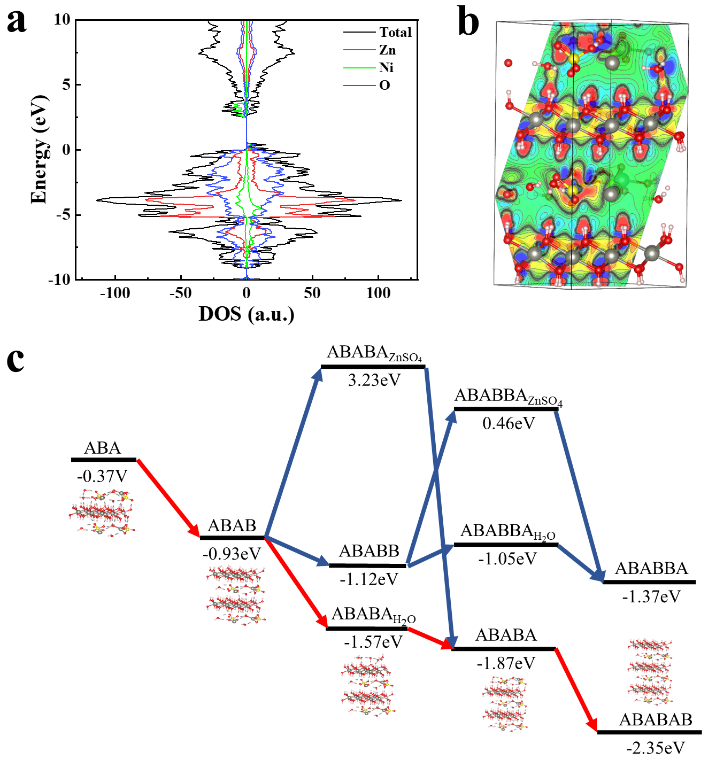
Extended Data Fig. 9 | DFT calculations of LDH material. a,b, The density of states (a) and Deformation charge density diagram (b) of LDH material. c, The energy of the various intermediate states and possible reaction paths for the formation of LDH material. A, A_{ZnSO4}, A_{H2O}, and B refer to the layers of ZnSO₄·(H₂O)₃, ZnSO₄, H₂O, Zn_{0.84}Ni_{0.16}(OH)₂)₆, respectively. The red line is the most possible reaction path.

Extended Data Table 1 | Electrochemical performance of NiHCF/Zn-LDH battery at different current densities and temperature differences.
I  [mA·g⁻¹] | Heat charging temperature  [℃] | Q_{c}  [mAh·g⁻¹] | Coulombic efficiency  [%] | P  [%] | EE  [%] | W  [mWh·g⁻¹]
11.2 | 50 | 40.56 | 99.98 | 104.13 | 104.11 | 7.97
11.2 | 35 | 40.02 | 99.89 | 102.37 | 102.26 | 6.89
11.2 | 20 | 40.09 | 99.93 | 100.00 | 99.93 | 5.18
11.2 | 5 | 40.58 | 99.96 | 90.34 | 90.31 | 0
56 | 20 | 42.38 | 95.57 | 97.04 | 92.74 | -
112 | 5 | 42.42 | 96.53 | 84.25 | 81.32 | 0
28 | 50 | 43.31 | 99.02 | 103.35 | 102.34 | -
56 | 50 | 40.92 | 95.88 | 101.61 | 97.43 | -
112 | 50 | 42.15 | 93.97 | 99.67 | 93.66 | -

Supplementary Information

1 Electrochemical testing
The chemical reaction at cathode in NiHCF/Zn battery is
KNi^{II}Fe^{III}(CN)₆ + K⁺ + e⁻ → K₂Ni^{II}Fe^{II}(CN)₆ (S1)
and the chemical reaction at anode is
Zn²⁺ + 2e⁻ → Zn (S2)
The α₊ and α₋ can be given by the Nernst equation,
$α_{+}={α_{+}}^{ɵ}+\frac{J_{1}R}{nF}\ln{({[K}^{+}])}$ (S3)
$α_{-}={α_{-}}^{ɵ}+\frac{J_{2}R}{nF}\ln{({[Zn}^{2+}])}$ (S4)
where J₁ and J₂ are the correction factors of K⁺ and Zn²⁺ ion concentrations, respectively, R is the ideal gas constant, n is the number of electrons transferred in the reaction, and F is the Faraday constant (96485 C·mol⁻¹).

2 Calculation of thermal-to-electrical energy conversion efficiency
In the electrochemical Stirling-Like cycle, the efficiency (η_{TTE}) from thermal energy to electricity is expressed by
$η_{TTE}=\frac{W}{Q_{H}+Q_{HB}}=\frac{E_{normal-}E_{heat}}{{αT}_{H}Q_{c}+C_{P}△T}$ (S5)
where W is the energy saving through heat charging, Q_{H} is the amount of heat absorbed during the charging at high temperature T_{H} (step 2 in Fig. 2a), Q_{HB} is the extra heat absorbed during the heating from low temperature (T_{L}) to high temperature (step 1 in Fig. 2a). Specifically, W is the energy difference between normal charging (E_{normal}) and heat charging (E_{heat}), Q_{H} is estimated by αT_{H}Q_{c}, and Q_{HB} is calculated by C_{p}ΔT, where Q_{c} is the battery’s charge capacity, C_{p} is the heat capacity of the whole battery, and ΔT is the temperature difference (T_{H}-T_{L}).
In thermoelectrics, η_{TTE} is related to the dimensionless figure-of-merit (ZT), which is calculated by
$η_{TTE}=\frac{∆T}{T_{H}}∙\frac{\sqrt{1+{(ZT)}_{ave}}-1}{\sqrt{1+{(ZT)}_{ave}}+\frac{T_{L}}{T_{H}}}$ (S6)
where (ZT)_{ave} is the average value of ZT between high temperature T_{H} and low temperature T_{L}.

3 Modified Nernst equation for coupled electrochemical reactions at zinc anodes
When the extra electrochemical reaction is introduced into the anode at zinc battery, such as
Zn-2e+a₁A₁+a₂A₂+···+ a_{n}A_{n} ↔ b₁B₁+b₂B₂+···+b_{n}B_{n} (S7)
For Reaction 1, the A₁, A₂, A₃, A₄ and B₁ in Reaction S7 represent Ni²⁺, SO₄²⁻, OH⁻, H₂O and ZnNi_{x}(SO₄)_{y}(OH)_{z}·wH₂O, respectively. The temperature coefficients for Reaction S2 and S7 are denoted as α₁ and α₂, respectively. According to the Nernst equation,
$α_{1}={α_{1}}^{ɵ}+\frac{J_{1}R}{nF}\ln{(C_{{Zn}^{2+}})}$ (S8)
$α_{2}={α_{2}}^{ɵ}-\frac{J_{2}R}{nF}\ln{(\prod_{i=1}^{n}{{x_{i}}^{a_{i}}}\prod_{i=1}^{n}{{y_{i}}^{{-b}_{i}}})}$ (S9)
where J is the correction factor for ion concentration, α₁^{ɵ} and α₂^{ɵ} represent the standard temperature coefficient of Reaction S2 and S7, respectively. C_{Zn}²⁺, x_{i}, and y_{i} are the concentration of Zn²⁺, A_{i}, and B_{i}, respectively.
If the proportions of Reaction S2 and S7 are l and (1-l), respectively, the total temperature coefficient of these two reactions ($α_{mix}$) can be described as
$α_{mix}=α_{1}×l+α_{2}×\left(1-l\right)$ (S10)
For the equilibrium state, the ion concentration can be given by
$C_{{Zn}^{2+}}\prod_{i=1}^{n}{{x_{i}}^{a_{i}}}\prod_{i=1}^{n}{{y_{i}}^{{-b}_{i}}}=K_{eq}$ (S11)
where K_{eq} is the equilibrium constant. When the variation of Zn ion concentration (Δx) is small, Eq. (S11) is changed to
$(C_{{Zn}^{2+}}+∆x-m)\prod_{i=1}^{n}{{{(x}_{i}-{ma}_{i})}^{a_{i}}}\prod_{i=1}^{n}{{{(y}_{i}-{mb}_{i})}^{{-b}_{i}}}=K_{eq}$ (S12)
where m=Δx(1-l), which refers to the consumption of the zinc through Reaction S7.
Dividing Eq. (S11) by Eq. (S12) and taking first-order approximation of (x_{i}-ma_{i})^{ai} and (y_{i}-mb_{i})^{-bi} through the Taylor expansion,
$\prod_{i=1}^{n}{(1-\frac{m-∆x}{C_{{Zn}^{2+}}})(1-\frac{m{a_{i}}^{2}}{x_{i}})}\prod_{i=1}^{n}{(1+\frac{m{b_{i}}^{2}}{y_{i}})}=1$ (S13)
Because $\frac{m-∆x}{C_{{Zn}^{2+}}}$, $\frac{m{a_{i}}^{2}}{x_{i}}$ and $\frac{m{b_{i}}^{2}}{y_{i}}$ are relatively small, taking the first-order approximation of these terms gives
$m\left(\frac{1}{C_{{Zn}^{2+}}}+\sum_{i=1}^{n}{\frac{{a_{i}}^{2}}{x_{i}}}-\sum_{i=1}^{n}{\frac{{b_{i}}^{2}}{y_{i}}}\right)=\frac{∆x}{C_{{Zn}^{2+}}}$ (S14)
Using the experiment data can give l values by Eq. (S14).
According to Eq. (S10) and Eq. (S14)
$α_{mix}={α_{1}}^{ɵ}+\frac{{α_{2}}^{ɵ}-{α_{1}}^{ɵ}-U+(M+NHC_{{Zn}^{2+}})lnC_{{Zn}^{2+}}}{1+HC_{{Zn}^{2+}}}$ (S15)
where, $H=\sum_{i=1}^{n}{\frac{{a_{i}}^{2}}{x_{i}}}-\sum_{i=1}^{n}{\frac{{b_{i}}^{2}}{y_{i}}}$, $N=\frac{J_{1}R}{nF}$, $M=\frac{J_{2}R}{nF}$ and $U=\frac{J_{2}R\ln{K_{eq}}}{nF}$. Considering that NHC_{Zn}²⁺lnC_{Zn}²⁺ is very small, α_{mix} is approximated to
$α_{mix}≈{α_{1}}^{ɵ}+\frac{{α_{2}}^{ɵ}-{α_{1}}^{ɵ}-U+MlnC_{{Zn}^{2+}}}{1+HC_{{Zn}^{2+}}}$ (S16)

