Supplementary information

Keto-anthraquinone covalent organic framework for H₂O₂ photosynthesis with oxygen and alkaline water
Xiangcheng Zhang¹, Silian Cheng¹, Chao Chen², Xue Wen¹, Jie Miao¹, Baoxue Zhou¹, Mingce Long^{1*}, Lizhi Zhang^{1*}

¹ School of Environmental Science and Engineering, Key Laboratory of Thin Film and Microfabrication Technology (Ministry of Education), Shanghai Jiao Tong University, Shanghai 200240, China
² School of Ecological and Environmental Science, Key Laboratory for Urban Ecological Processes and Eco-Restoration, East China Normal University, Shanghai 200241, China
* Corresponding Author
E-mail for Mingce Long: long_mc@sjtu.edu.cn
E-mail for Lizhi Zhang: zhanglizhi@sjtu.edu.cn

Supplementary Sections

Chemical materials
2,6-diaminoanthraquinone (AQ), 2,4,6-triformylphloroglucinol (Tp), pyromellitic aldehyde (LZU), 2,6-diaminoanthracene (DA) and acetonitrile were purchased from Shanghai Aladdin Bio-Chem Technology Co., Ltd. N, N-dimethylacetamide and 1,4-dioxane were obtained from Sigma-Aldrich (Shanghai, China). N, N-dimethylformamide and acetone were purchased from Sinopharm Chemical Reagent Co., Ltd. (Beijing, China). Anhydrous MnO₂, Na₂SO₄, CH₃COONa and NaOH were obtained from Acros (Shanghai, China). All the chemicals were of analytical grade and used as received without any further purification. Deionization water was used in all experiments.
Synthesis of TpDA
TpDA was synthesized via a solvothermal method. Typically, a 10 mL Schlenk tube was charged with 2,4,6-triformylphloroglucinol (Tp, 40 mg, 0.15 mmol) and 2,6-diaminoanthracene (DA, 62.4 mg, 0.15 mmol) in 1,4-dioxane (2 mL) with a catalytic amount of ice acetic acid (0.4 mL). The mixture was then sonicated for 10 min and degassed by freeze-pump-thaw three times. After the mixture was allowed to warm to room temperature, it was heated at 120 ºC and left undisturbed for 72 h. The red precipitate was obtained by filtration and washed with N, N-dimethylformamide and acetone. Finally, the precursor COF was dried at 120 ºC for 12 h in a vacuum oven. The obtained reference catalyst was denoted as TpDA.
Synthesis of LZUAQ
A 10 mL Schlenk tube was charged with pyromellitic aldehyde (LZU, 64 mg, 0.6 mmol) and 2,6-diaminoanthraquinone (AQ, 42.1 mg 0.30 mmol) in 1,4-dioxane (2 mL) with a catalytic amount of ice acetic acid (0.3 mL). The synthesis procedure was the same as that for TpDA. The obtained yellowish powder was denoted as LZUAQ.
Characterizations
Wide angle X-ray diffraction patterns (XRD) were conducted by a Rigaku D/max-2200/PC diffractometer with a Cu-Kα radiation (λ=0.154 nm). Solid-state nuclear magnetic resonances (NMR) spectra of C¹³ were carried out on a Bruker BioSpin Avance III HD 400 high performance digital NMR spectrometer. X-ray photoelectron spectra (XPS) and Ultraviolet photoelectron spectroscopy (UPS) were implemented on an Axis Ultra DLD system (Shimadzu/Kratos) that was calibrated by C 1s at 284.6 eV. Raman spectra were recorded on a Bruker Senterra R200-L dispersive Raman microscope at 532 nm. Fourier transform infrared (FTIR) spectra were obtained from a Nicolet 6700 spectrometer (Thermo Electron). Transmission electron microscopy (TEM) images were obtained from a TECNA1 G2F20 microscope at an accelerating voltage of 200 kV. Scanning electron microscope (SEM) images were obtained on a Hitachi S-4800 microscope. The UV–vis diffuse reflectance spectrophotometer (DRS, Lambda 950, PerkinElmer, USA) was used to investigate the optical properties of catalysts. The steady-state and transient-state photoluminescence (PL) spectra were obtained on an Edinburgh-250 instrument with an excitation wavelength at 250 nm. Nitrogen adsorption–desorption isotherms were analyzed on a Micromeritics ASAP 2020 analyzer.
Kinetics analysis of H₂O₂
Kinetic analysis was carried out to assess the formation and decomposition rate constants of H₂O₂ during photocatalysis. The kinetic constants were calculated by fitting the H₂O₂ production curves via the following Box-Lucas model.
[𝑯_{𝟐}𝑶_{𝟐}] = (𝒌_{𝒇}/𝒌_{𝒅})[𝟏 − 𝒆^{(−𝒌𝒅𝒕)}] (S1)
y=A[1-e^{(-Bx)}] (𝒌_{𝒅} = 𝑩; 𝒌_{𝒇} = 𝑨 $×$ 𝑩) (S2)
Here, k_{f} is the zero-order H₂O₂ formation rate constant; k_{d} is the first-order H₂O₂ decomposition rate constant; t is the reaction time.
Apparent quantum yield (AQY)
The apparent quantum yield (AQY) was calculated by measuring H₂O₂ photosynthesis of Kf-AQ under different monochromatic light irradiation. The light intensities of 400, 450, 550, 600 and 650 nm were measured by an optical power meter (FZ-A, China). The AQY (%) was calculated by the following equation:¹
(S3)
$AQY \left(\%\right)=\frac{\left[H_{2}O_{2} generated \left(mol\right)\right]×2}{\left[photon number entered into the reactor \left(mol\right)\right]}×100\%$
The amount of H₂O₂ is presented in Table S3. The total photon number entering into the reactor can be calculated by the product of S, t, P, and λ, wherein, S is the irradiation area (m²); t is the reaction time (3600 s); P is the incident monochromatic light intensity (W m⁻²); λ is the wavelength of the incident monochromatic light (m), respectively.
Solar-to-chemical conversion (SCC) efficiency
For the investigation of SCC efficiency, 5 mg Kf-AQ was dispersed into 30 mL ultrapure water with different pH. After 1.0 h visible light (λ > 400 nm) illumination, the total incident power and amount of generated H₂O₂ were well calculated (Table S4). The SCC efficiency of Kf-AQ in different pH were determined by the following equation:²
S$CC(\%)=\frac{{△G}_{H2O2}×n_{H2O2}}{t_{ir}×S_{ir}×I_{cut420}}×$100% S4
△G (117 kJ mol⁻¹) is represent the free energy of H₂O₂ generation; $t_{ir}$ (3600 s) is represent the irradiation time; $S_{ir}$ (3.74$×$10⁻³ m²) is represent the irradiation area; $I_{cut400}$ (984 W m⁻²) is represent the incident light intensity, respectively.
Electron transfer number (n)
The electron transfer number for oxygen reduction reaction (ORR) was measured on a rotating disk electrode (RDE) in an O₂-saturated Na₂SO₄ (0.1 mol L⁻¹) system with different rotating speeds. The average numbers of electrons (n) were calculated by the Koutecky-Levich equation:³
$\frac{1}{i}=\frac{1}{i_{k}}+[\frac{1}{0.620nFAD^{2/3}v^{-1/6}C}]ω^{-1/2}$ S5
Here, i and i_{k} are the current density (μA cm⁻²) and kinetic current density (μA cm⁻²), respectively; n is the number of electron transfer; F is the Faraday constant (96485 C mol⁻¹); A is the working electrode area (0.196 cm²); D is the oxygen diffusion coefficient (1.93×10⁻⁵ cm² s⁻¹); v is the kinematic viscosity of the electrolyte (0.0109 cm² s⁻¹); C is the saturated oxygen concentration in water (1.26×10⁻³ M); ω is the rotating speed.

Supplementary Figures

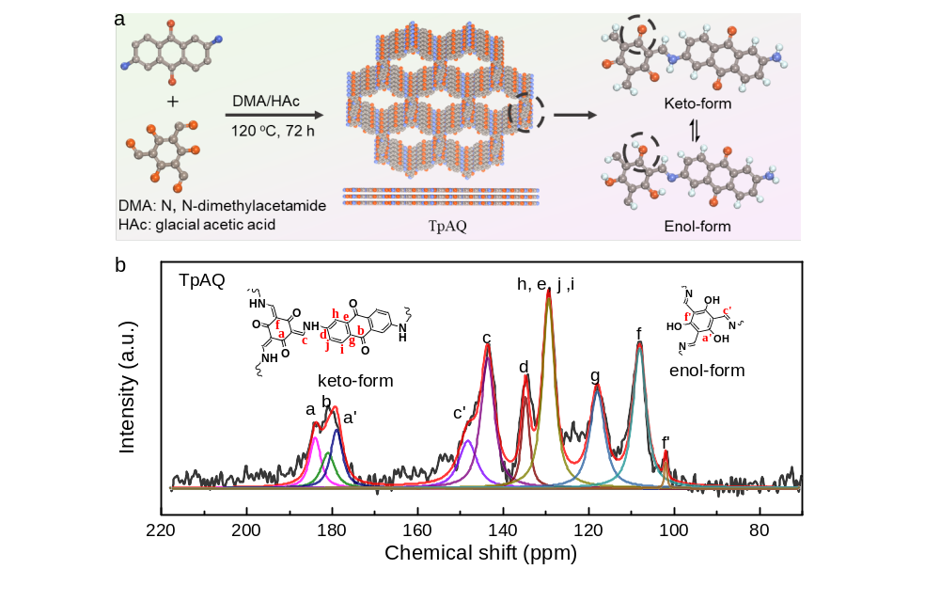
Figure S1. (a) Scheme of TpAQ synthesis via solvothermal process; (b) solid-state ¹³C NMR spectra of TpAQ.

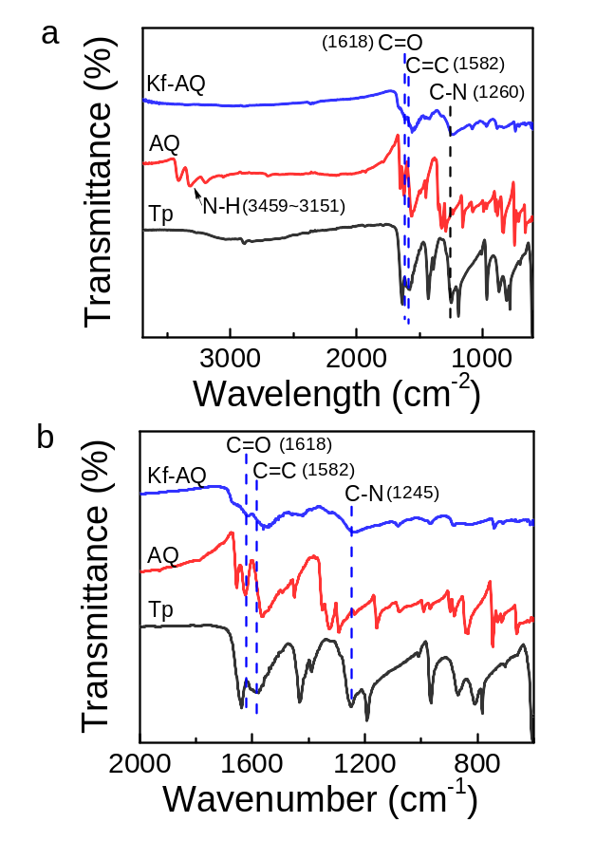
Figure S2. (a) FTIR spectra of Tp, AQ and Kf-AQ, (b) the amplified regions of 600 cm⁻¹~2000 cm⁻¹.
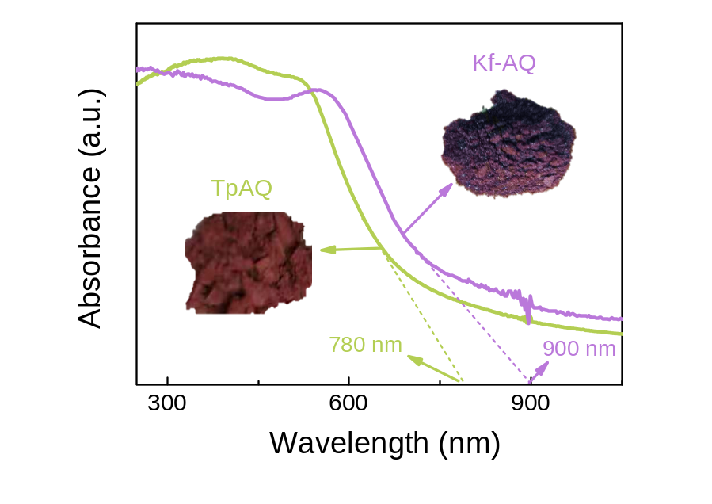
Figure S3. The UV-visible diffuse reflectance spectrum (DRS) of Kf-AQ and TpAQ.

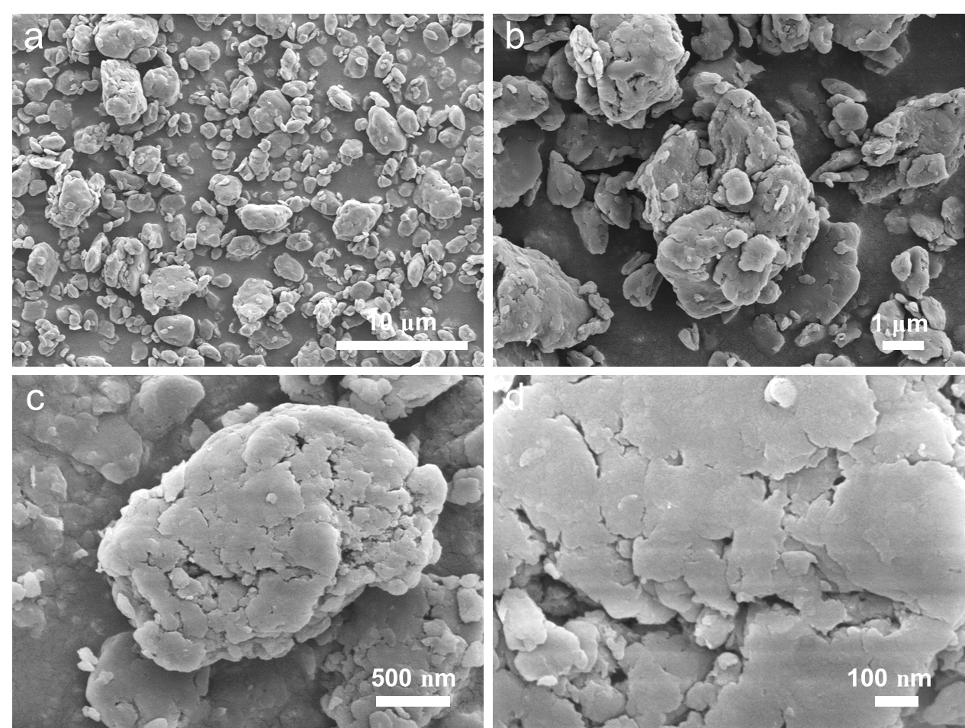
Figure S4. SEM images of Kf-AQ.

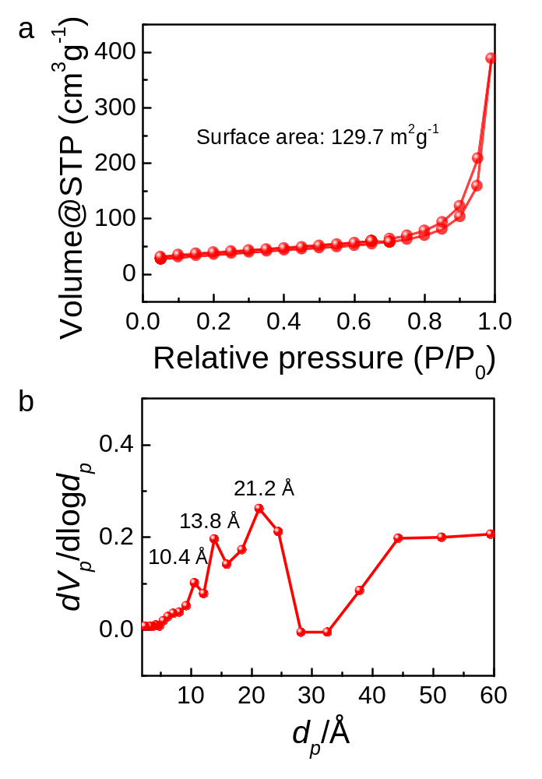
Figure S5. (a) N₂ adsorption isotherm and (b) pore size distribution of Kf-AQ. The specific surface area of Kf-AQ is calculated to be 129.7 m² g⁻¹, and the pore sizes are centered at 1.04 nm, 1.38 nm and 2.12 nm. The mesoporous distribution indicates the stacking structure of Kf-AQ.

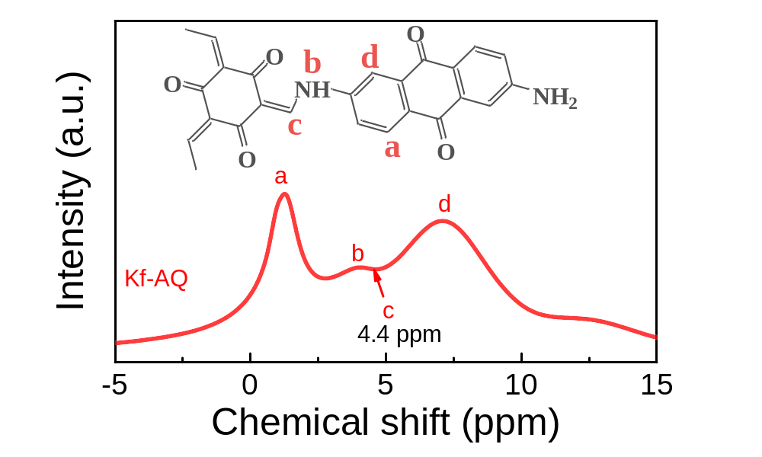
Figure S6. Solid-state ¹H NMR spectra of Kf-AQ.

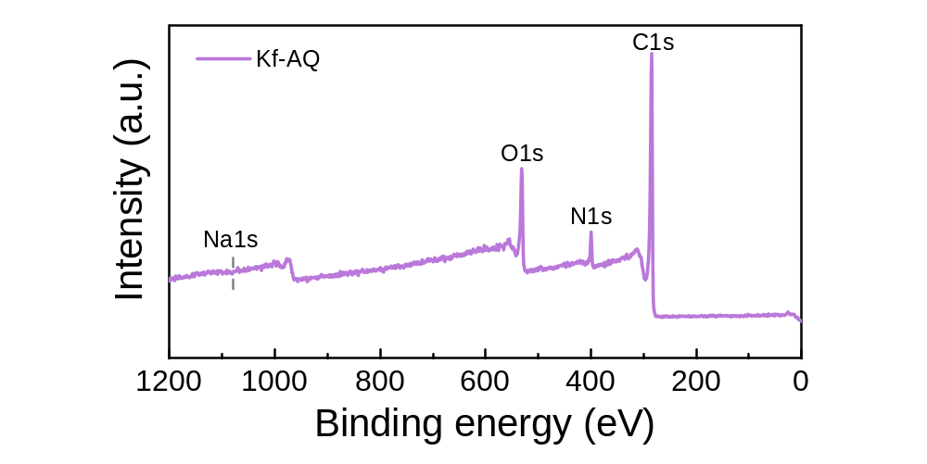
Figure S7. XPS survey spectrum of Kf-AQ.

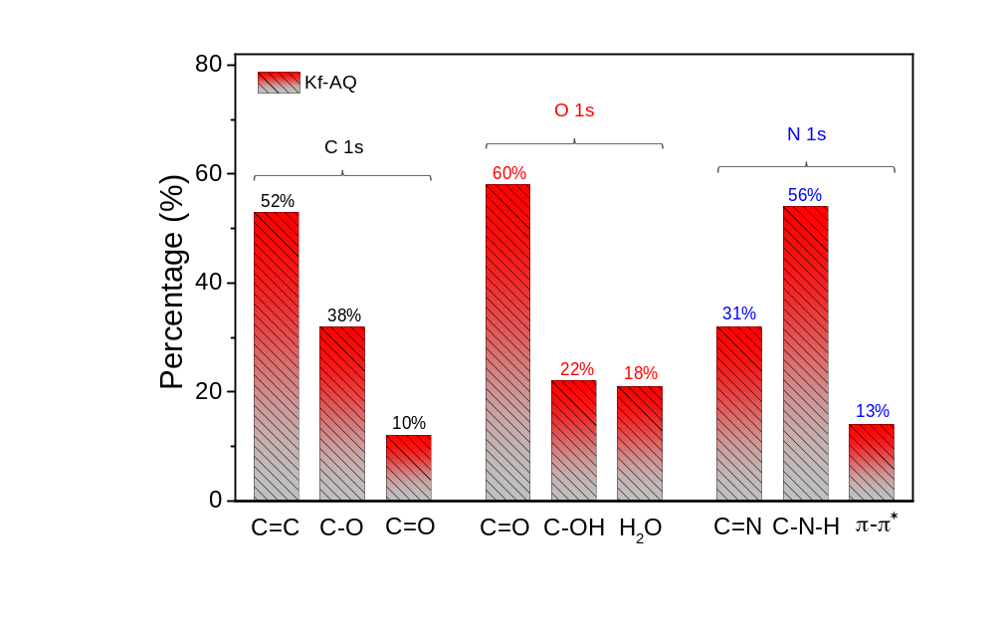
Figure S8. The percentage of peak areas for different chemical bonds that were calculated from the deconvoluted C 1s, O 1s and N 1s XPS bands.

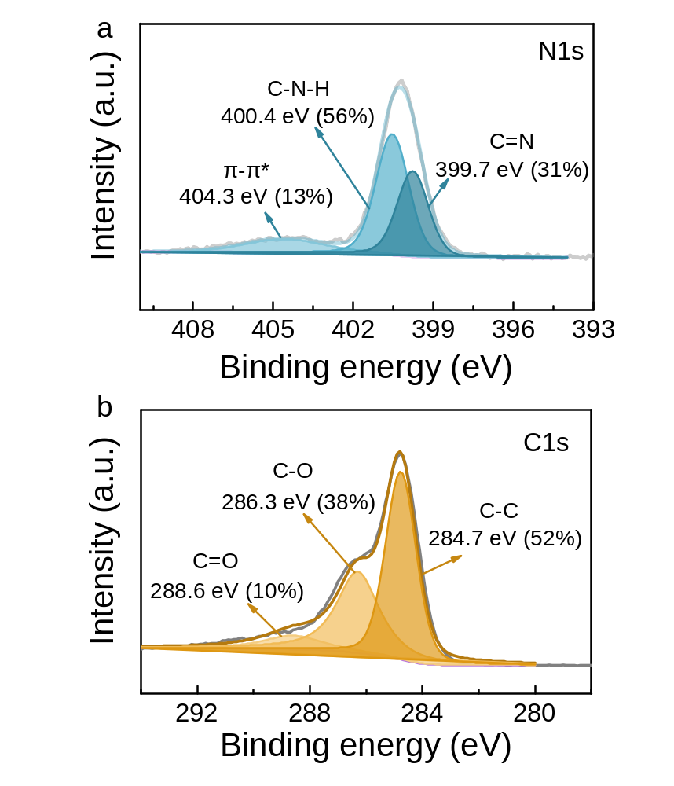
Figure S9. High-resolution N 1s (a) and C 1s (b) XPS spectra of Kf-AQ.

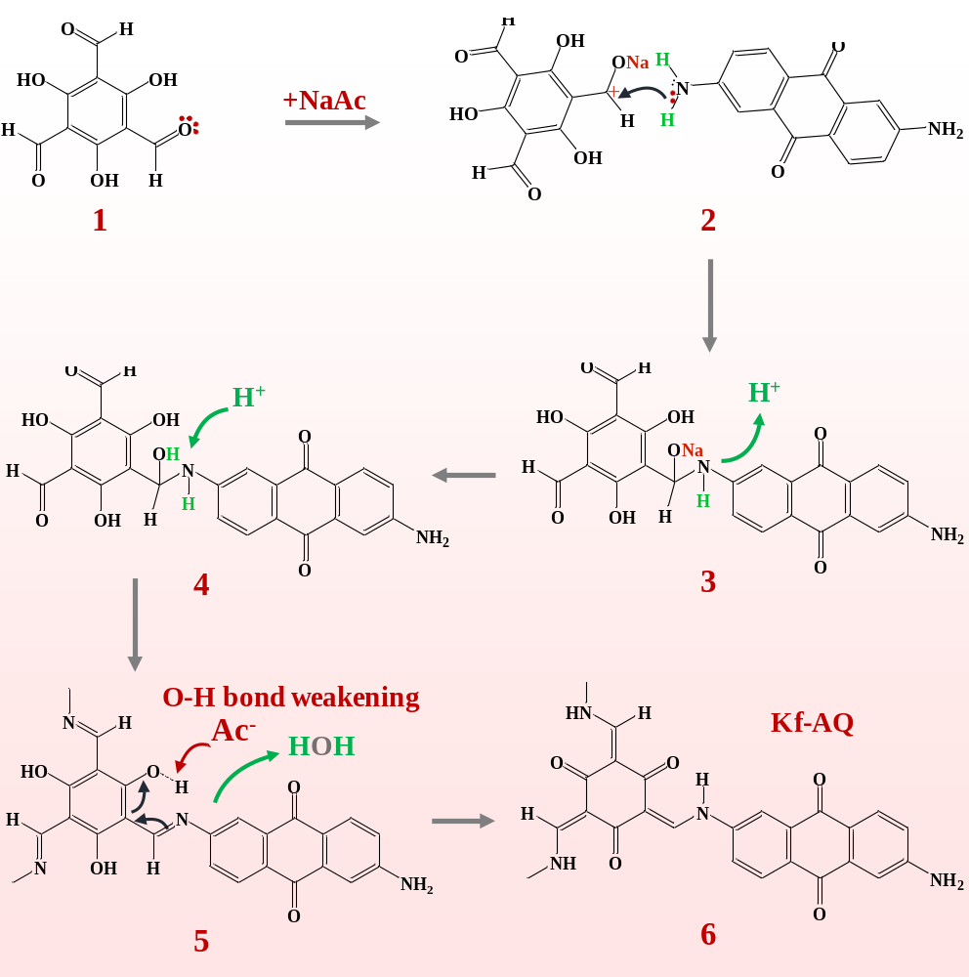
Figure S10. Probable synthetic mechanism of Kf-AQ.

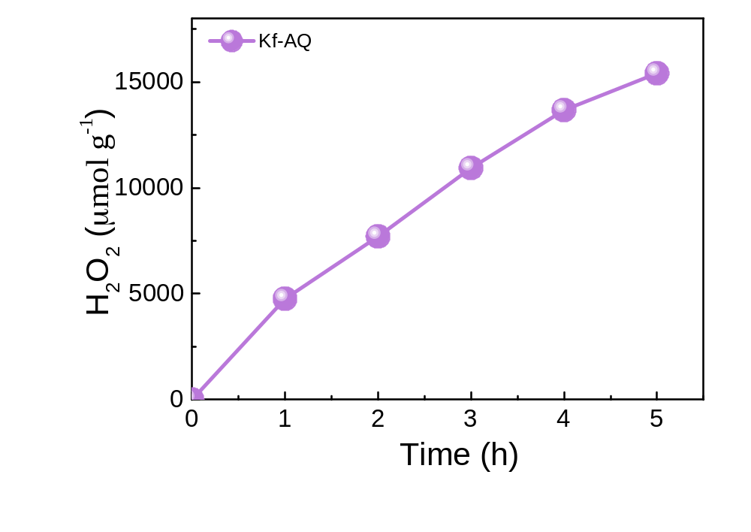
Figure S11. H₂O₂ photosynthesis of Kf-AQ in a prolonged test.

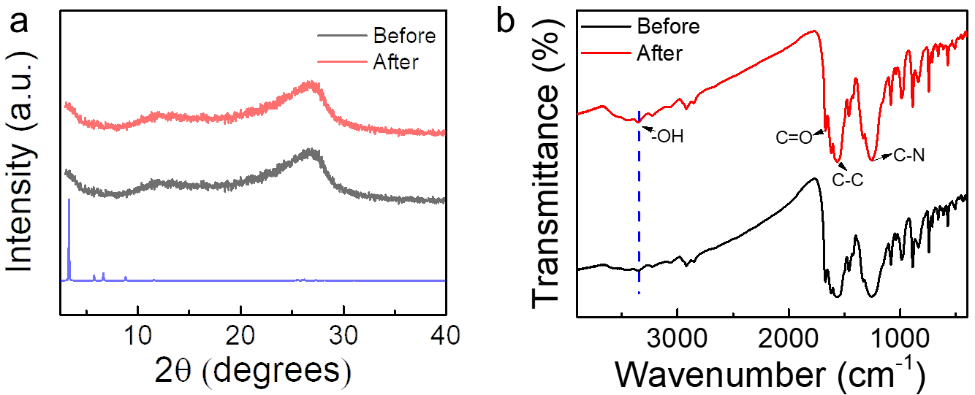
Figure S12. The PXRD patterns (a) and FTIR spectra (b) of Kf-AQ before and after photoreaction.

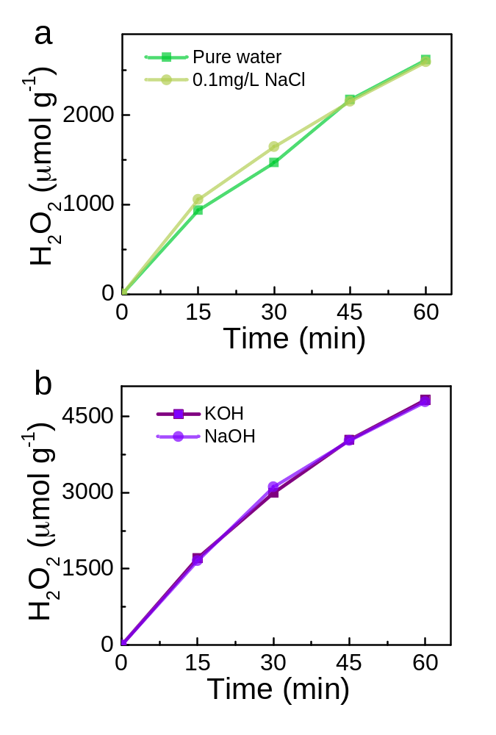
Figure S13. H₂O₂ photosynthesis in various solution: (a) pure water and 0.1 mg L⁻¹ NaCl; (b) KOH (pH=13) and NaOH (pH=13).

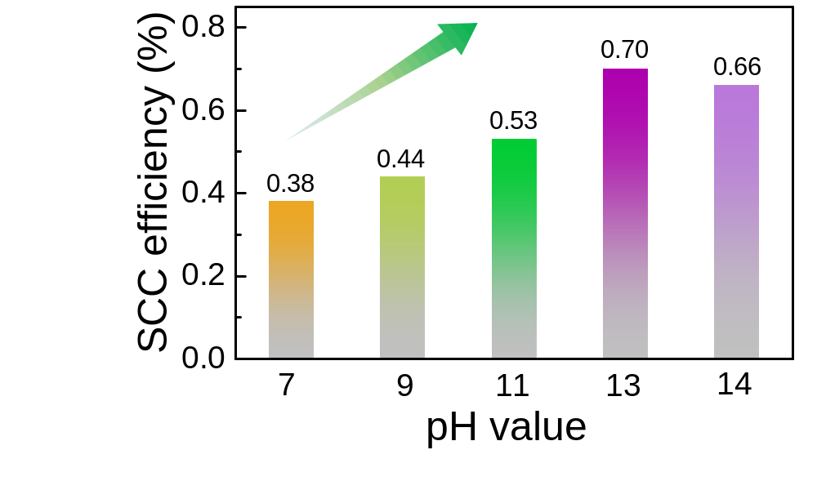
Figure S14. Solar-to-chemical conversion (SCC) efficiencies of Kf-AQ under visible light (λ≥400 nm) illumination.

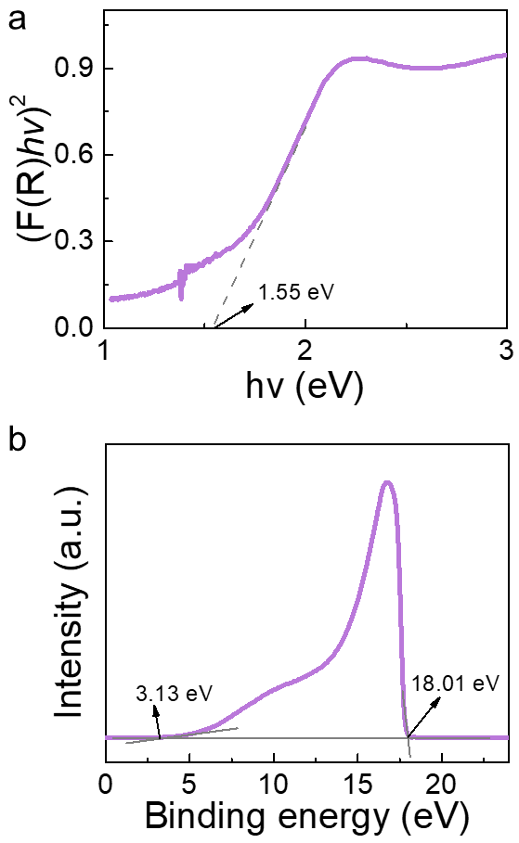
Figure S15. (a) Tauc plots, (b) Ultraviolet photoelectron spectra of Kf-AQ.

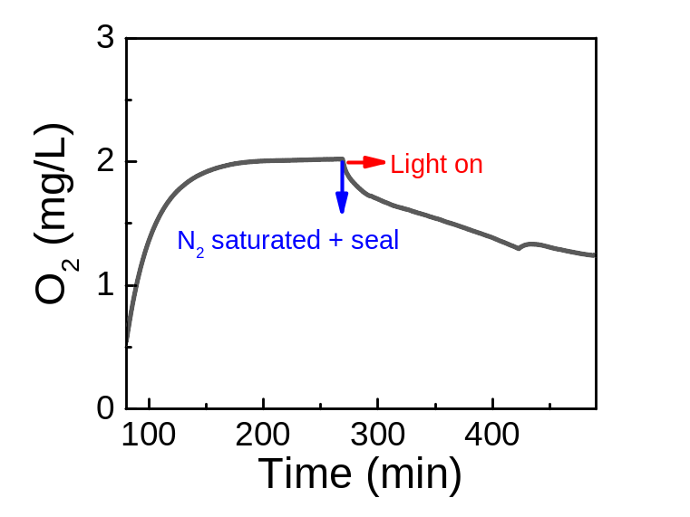
Figure S16. Oxygen concentration in a Kf-AQ suspension at pH=13.

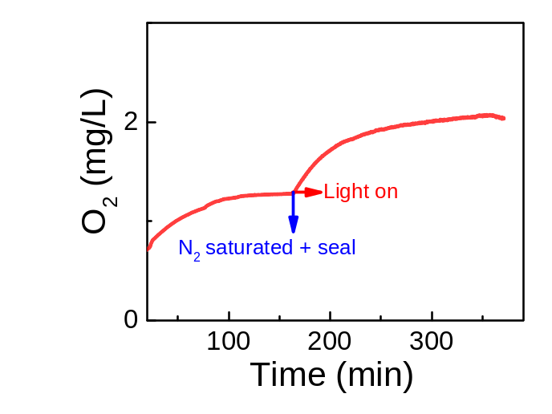
Figure S17. Photocatalytic O₂ evolution in Kf-AQ suspension in the presence of AgNO₃ (0.16 g L⁻¹).

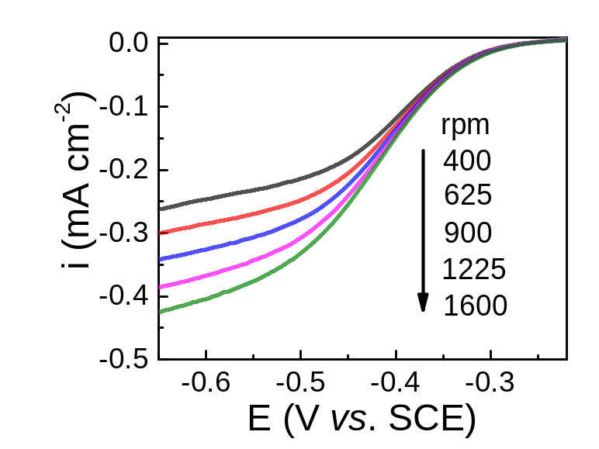
Figure S18. LSV curves of Kf-AQ in an air saturated NaClO₄ (0.1 M) solution.

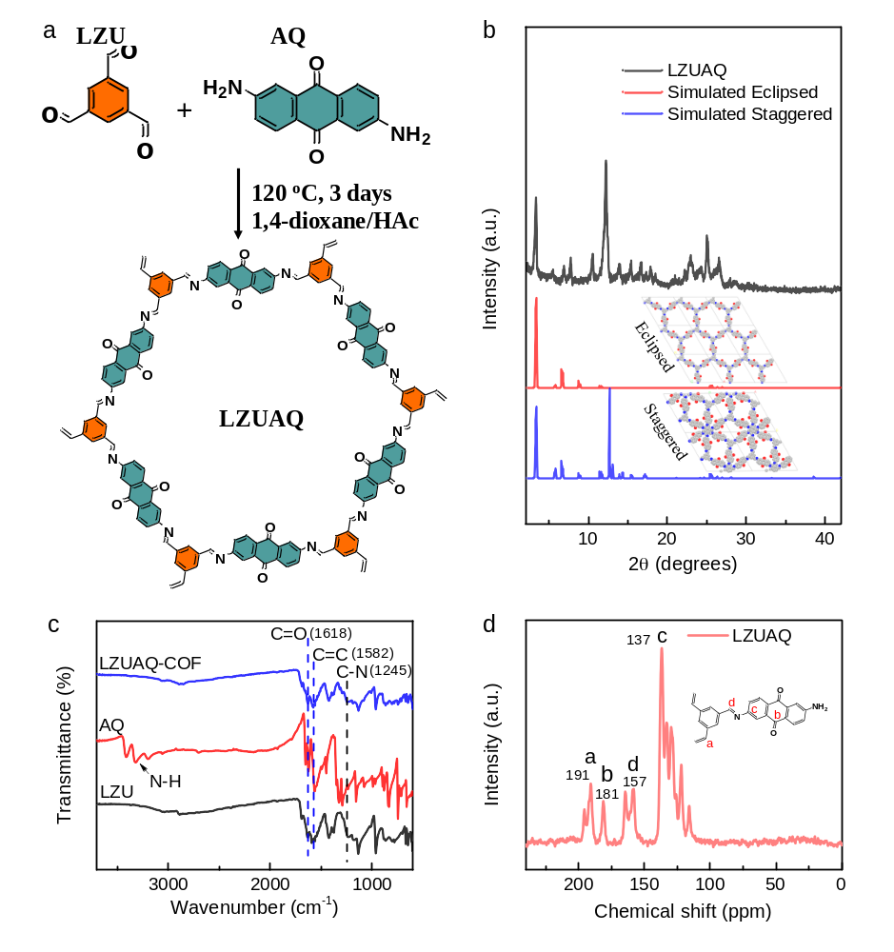
Figure S19. (a) Scheme of the LZUAQ condensation process. (b) PXRD patterns, experimentally observed (dark), simulated using eclipsed AA-stacking (red) and staggered AB stacking (blue) models. (c) FIRT spectra of LZU, AQ and LZUAQ, respectively. After condensation, the stretch peak of N-H in AQ disappeared, and the C=O at 1618 cm⁻¹ in LZUAQ emerged, indicating the formation of conjugated structures. (d) ¹³C NMR spectrum of LZUAQ. The chemical shift at 157 ppm was ascribed to C=N in the conjugated structure.

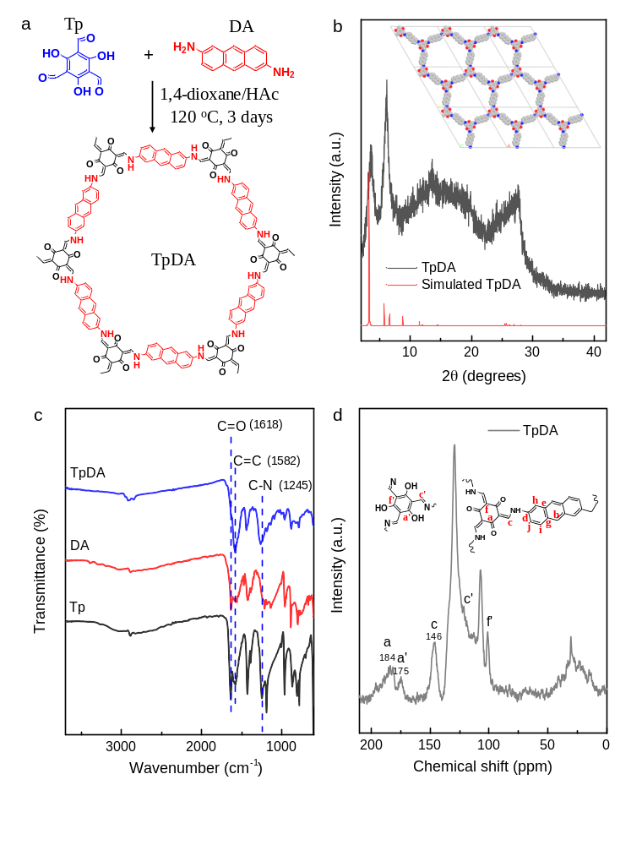
Figure S20. (a) Synthesis of the TpDA. (b) PXRD patterns, experimentally observed (dark), simulated using eclipsed AA-stacking (red) model. (c) FIRT spectra of Tp, DA and TpDA. FTIR spectra revealed the formation of a new C-N stretching band at 1245 cm⁻¹, ascribing to the Tp and DA conjugation. (d) ¹³C NMR spectra of TpDA. The chemical shift at 184 ppm, 175 ppm and 146 ppm are ascribing to C=O, C-OH and C-NH-, respectively. The keto-form structure is dominated in the TpDA.

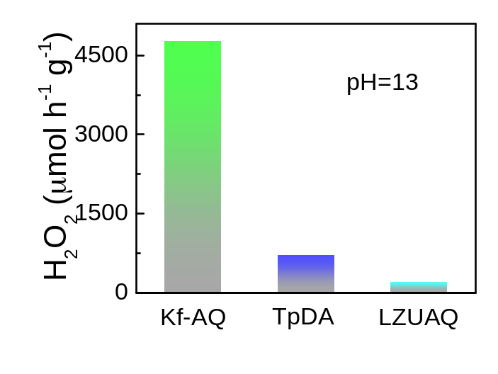
Figure S21. H₂O₂ photosynthesis of Kf-AQ, TpDA and LZUAQ.

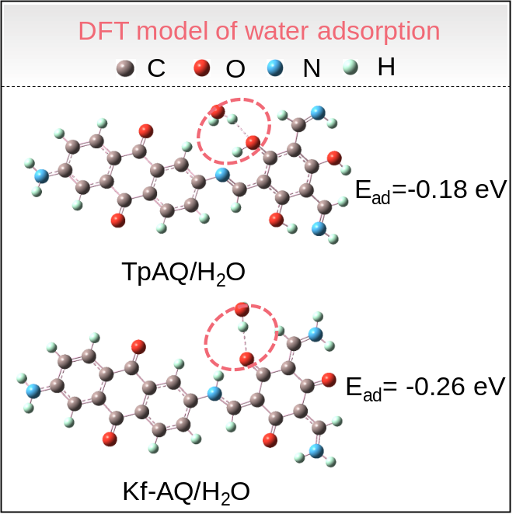
Figure S22. The adsorption energy of H₂O over TpAQ and Kf-AQ.

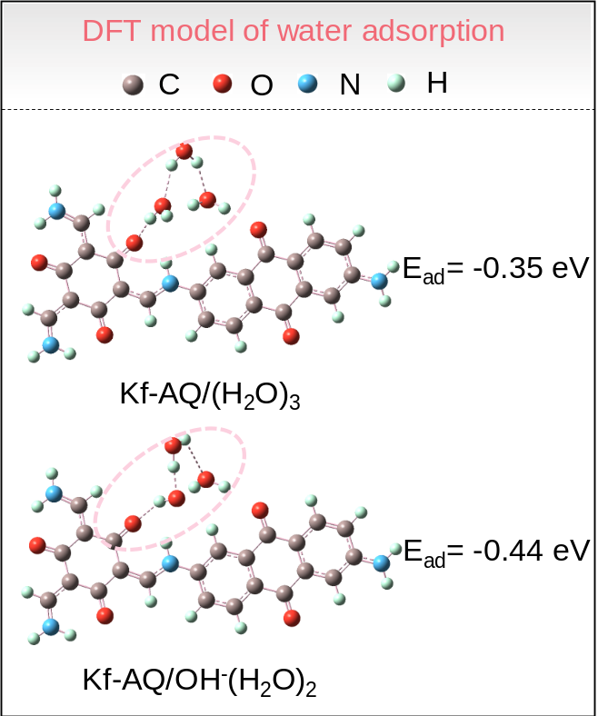
Figure S23. The adsorption energy of different water clusters over Kf-AQ.

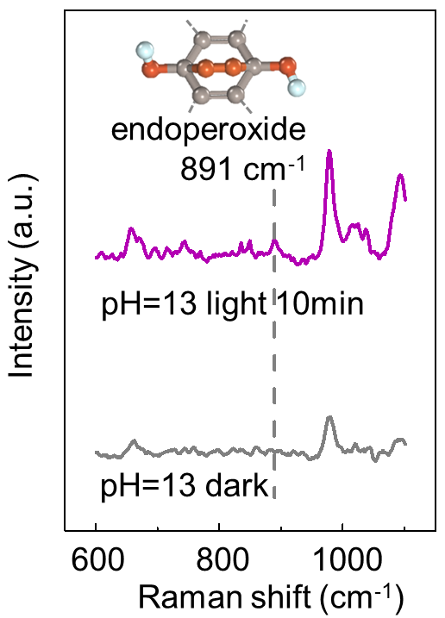
Figure S24. Raman spectra of a Kf-AQ suspension under dark and intermittent visible light irradiation.

Supplementary Tables

Table S1. H₂O₂ photosynthesis of Kf-AQ and other reported photocatalysts without sacrificial agents.
Catalyst | Reaction conditions | H₂O₂ yield (μmol h⁻¹g⁻¹) | AQY (%) | Ref
Kf-AQ | dosage: 0.33 g/L (pH=13), λ > 400 nm | 4784 | 15.8 (400) | This work
Kf-AQ | dosage: 0.33 g/L (pH=7), λ > 400 nm | 2582 | 9.8 (400) | This work
RF-DHAQ-2 | prue water, dosage: 0.2 g/L, λ > 420 nm | 1820 | 11.6 (420) | ⁴
PM-CDs-30 | sea water, dosage: 0.2 g/L, λ > 420 nm | 1776 | 1.3 (420) | ¹
SA-TCPP | prue water, dosage: 1.5 g/L, λ > 420 nm | 2500 | 14.9 (420) | ⁵
CoO_{x}/Mo:BiVO₄/Pd | PBS pH=7, dosage: 0.17 g/L, AM1.5 G | 1400 | 5.8 (420) | ⁶
HJ-C₃N₄ | pure water, dosage: 0.2 g/L, λ > 400 nm | 575 | - | ⁷
CAD300 | pure water, dosage: 0.25 g/L, λ > 420 nm | 557.2 | 2.45 (420) | ⁸
Sb-SAPC15 | pure water, dosage: 2.0 g/L, λ > 420 nm | 344.4 | 17.6 (420) | ⁹
COF-TfpBpy | pure water, dosage: 1.5 g/L, λ > 420 nm | 312 | 8.1 (420) | ¹⁰
RF-NH₃-523 | pure water, dosage: 5 g/L, λ > 420 nm | 215 | 7.6 (420) | ²
Co–CN@G | pure water, dosage: 1.0 g/L, λ > 420 nm | 577 | 9.1 (420) | ¹¹
Pt@β-CD/ C₃N₄-M | pure water, dosage: 1.0 g/L, λ > 400 nm | 147.1 | - | ¹²
OCN-500 | pure water, dosage: 1.0 g/L, λ > 420 nm | 106 | 10.2 (420) | ¹³
CTF-BDDBN | pure water, dosage: 0.6 g/L, λ > 420 nm | 96.7 | - | ¹⁴
g-C₃N₄/PDI/rGO | pure water, dosage: 5 g/L, λ > 420 nm | 76 | 6.1 (420) | ¹⁵
Co₁/AQ/C₃N₄ | pure water, dosage: 0.5 g/L, AM1.5 G | 62 | - | ¹⁶
PI_{5.0}-NCN | pure water, dosage: 1.0 g/L, λ > 420 nm | 60 | 3.2 (420) | ¹⁷
COF-F2 | pure water, dosage: 0.6 g/L, AM1.5 G | 14 | 4.8% (420) | ¹⁸
g-C₃N₄-CoWO | pure water, dosage: 1.0 g/L, λ > 420 nm | 9.7 | 15.1 (420) | ¹⁹
g-C₃N₄/PDIx | pure water, dosage: 1.7 g/L, λ > 420 nm | 6 | 2.5 (420) | ²⁰
melam/WO₃ | pure water, dosage: 1.0 g/L, 435 nm LED | 3.2 | 2.2 (435) | ²¹

Table S2. The kinetic constants of k_{f} and k_{d} at different pH conditions.
pH value | k_{f} | k_{d}
7 | 13.12 ± 1.21 | 0.017 ± 0.001
9 | 12.12 ± 1.01 | 0.012 ± 0.005
11 | 20.91 ± 1.54 | 0.029 ± 0.002
13 | 31.39 ± 1.35 | 0.031 ± 0.002
14 | 26.34 ± 1.32 | 0.036 ± 0.005

Table S3. Details of the AQY calculation for Kf-AQ under various monochromatic light illumination (pH=13).
Wavelength  (nm) | Light intensity (W/m²) | H₂O₂ yield (mol) | Irradiation area (m²) | Irradiation time (s) | AQY (%)
400 | 24 | 10.23×10⁻⁶ | 3.74×10⁻³ | 3600 | 15.8
450 | 30 | 9.27×10⁻⁶ | 3.74×10⁻³ | 3600 | 10.2
550 | 75 | 8.56×10⁻⁶ | 3.74×10⁻³ | 3600 | 2.50
600 | 95 | 6.96×10⁻⁶ | 3.74×10⁻³ | 3600 | 2.03
650 | 74 | 4.88×10⁻⁶ | 3.74×10⁻³ | 3600 | 1.51

Table S4. Details of the SCC calculation for Kf-AQ.
pH value | 7 | 9 | 11 | 13 | 14
$n_{H2O2}$ (mol) | 4.3×10⁻⁴ | 5.0×10⁻⁴ | 6.1×10⁻⁴ | 7.9×10⁻⁴ | 7.5×10⁻⁴
SCC (%) | 0.38 | 0.44 | 0.53 | 0.70 | 0.66

Supplementary References.
1 Wu, Q. et al. A metal-free photocatalyst for highly efficient hydrogen peroxide photoproduction in real seawater. Nat. Commun. 12, 483 (2021).
2 Shiraishi, Y. et al. Resorcinol-formaldehyde resins as metal-free semiconductor photocatalysts for solar-to-hydrogen peroxide energy conversion. Nat. Mater. 18, 985-993 (2019).
3 Yang, C., Wan, S., Zhu, B., Yu, J. & Cao, S. Calcination-regulated microstructures of donor-acceptor polymers towards enhanced and stable photocatalytic H₂O₂ production in pure water. Angew. Chem. Int. Ed. 61, e202208438 (2022).
4 Zhao, C. et al. Molecular level modulation of anthraquinone-containing resorcinol-formaldehyde resin photocatalysts for H₂O₂ production with exceeding 1.2% efficiency. Angew. Chem. Int. Ed. 62, e202218318 (2023).
5 Zhang, Y. et al. H₂O₂ generation from O₂ and H₂O on a near-infrared absorbing porphyrin supramolecular photocatalyst. Nat. Energy 8, 361-371 (2023).
6 Liu, T. et al. Overall photosynthesis of H₂O₂ by an inorganic semiconductor. Nat. Commun. 13, 1034 (2022).
7 Ma, P. et al. Band alignment of homojunction by anchoring CN quantum dots on g-C₃N₄ (0D/2D) enhance photocatalytic hydrogen peroxide evolution. Appl. Catal. B: Environ. 300, 120736 (2022).
8 Chu, C. et al. Photocatalytic H₂O₂ production driven by cyclodextrin-pyrimidine polymer in a wide pH range without electron donor or oxygen aeration. Appl. Catal. B: Environ. 314, 121485, (2022).
9 Teng, Z. et al. Atomically dispersed antimony on carbon nitride for the artificial photosynthesis of hydrogen peroxide. Nat. Catal. 4, 374-384 (2021).
10 Kou, M. et al. Molecularly engineered covalent organic frameworks for hydrogen peroxide photosynthesis. Angew. Chem. Int. Ed. 61, 202200413 (2022).
11 Wang, W. et al. Photothermal-enabled single-atom catalysts for high-efficiency hydrogen peroxide photosynthesis from natural seawater. Nat. Commun. 14, 2493 (2023).
12 Zhu, H. et al. Decorating Pt@cyclodextrin nanoclusters on C₃N₄/MXene for boosting the photocatalytic H₂O₂ production. J. Mater. Chem. A 9, 6872-6880 (2021).
13 Wei, Z. et al. Efficient visible-light-driven selective oxygen reduction to hydrogen peroxide by oxygen-enriched graphitic carbon nitride polymers. Energy Environ. Sci. 11, 2581-2589 (2018).
14 Chen, L. et al. Acetylene and diacetylene functionalized covalent triazine frameworks as metal-free photocatalysts for hydrogen peroxide production: a new two-electron water oxidation pathway. Adv. Mater. 32, e1904433 (2020).
15 Kofuji, Y. et al. Carbon nitride-aromatic diimide-graphene nanohybrids: metal-free photocatalysts for solar-to-hydrogen peroxide energy conversion with 0.2% efficiency. J. Am. Chem. Soc. 138, 10019-10025 (2016).
16 Chu, C. et al. Spatially separating redox centers on 2D carbon nitride with cobalt single atom for photocatalytic H₂O₂ production. Proc. Natl. Acad. Sci. U S A 117, 6376-6382 (2020).
17 Yang, L. et al. Two-channel photocatalytic production of H₂O₂ over g-C₃N₄ nanosheets modified with perylene imides. J. Catal. 352, 274-281, (2017).
18 Zhao, W. et al. Accelerated synthesis and discovery of covalent organic framework photocatalysts for hydrogen peroxide production. J. Am. Chem. Soc. 144, 9902-9909 (2022).
19 Zhao, S. & Zhao, X. Insights into the role of singlet oxygen in the photocatalytic hydrogen peroxide production over polyoxometalates-derived metal oxides incorporated into graphitic carbon nitride framework. Appl. Catal. B: Environ. 250, 408-418 (2019).
20 Shiraishi, Y. et al. Sunlight-driven hydrogen peroxide production from water and molecular oxygen by metal-free photocatalysts. Angew. Chem. Int. Ed. 53, 13454-13459 (2014).
21 Jin, Z. et al. Constructing hydrogen bond based melam/WO₃ heterojunction with enhanced visible-light photocatalytic activity. Appl. Catal. B: Environ. 205, 569-575 (2017).

