Supplement to: Diverse Decarbonization Pathways Under Near Cost-Optimal Futures

Aditya Sinha^{1,*}, Aranya Venkatesh^{2,4}, Katherine Jordan², Cameron Wade⁵, Hadi Eshraghi¹, Anderson R. de Queiroz^{1,3}, Paulina Jaramillo^{2,6}, Jeremiah X. Johnson^{1,6}
¹Department of Civil and Environmental Engineering, North Carolina State University, Raleigh, NC
²Department of Engineering and Public Policy, Carnegie Mellon University, Pittsburgh, PA
³Department of Decision Sciences, North Carolina Central University, Durham, NC
⁴Electric Power Research Institute, Palo Alto, CA
⁵Sutubra Research Inc., Nova Scotia, Canada
⁶Senior author
*Corresponding author and lead contact: asinha2@ncsu.edu

Section S1: Model Structure and Description of Deterministic Scenarios.
Description of the main constraints: Our optimization model is constructed as a linear program in Temoa.¹ Four main equations govern the flow of energy through the model network. The Demand_Constrant (Equation 1) ensures that the supply meets demand in all time intervals. For each process, the Capacity_Constraint (Equation 2) ensures sufficient capacity to meet the commodity flows in all time intervals. Between processes, the CommodityBalance_Constraint (Equation 3) ensures that global commodity production across the energy system is sufficient to meet the endogenous demands for that commodity. Finally, the objective function (Equation 4) drives the model to minimize the system-wide cost of energy supply by optimizing the deployment and utilization of energy technologies across the system.
Demand_Constrant:
$\sum_{I,T-T^{a},V}{FO_{r,p,s,d,i,t}}+SEG_{s,d}⋅\sum_{I,T^{a},V}{FOA_{r,p,i,t}}=DEM_{r,p,dem}⋅DSD_{r,s,d,dem}$
Equation 1
Where $FO_{r,p,s,d,i,t}$ is the commodity flow by time slice out of a technology based on a given input, $SEG_{s,d}$ is the fraction of year represented by each (season (s), day (d)) tuple, $FOA_{r,p,i,t}$ is the annual commodity flow out of a technology based on a given input, $DEM_{r,p,dem}$ is the end-use demands, by period (p) and $DSD_{r,s,d,dem}$ is the demand-specific distribution. The subscripts $r,p,s,d,i,t, o$ belong to sets defined on the regions in the model ($r$), the time periods in the model ($p$), the season ($s$), time of day ($d$), input commodity ($i$), technology ($t$) and output commodity ($o$).

Capacity_Constraint:
$$\left({\text{CFP}}_{r,t,v}⋅{\text{C2A}}_{r,t}⋅{\text{SEG}}_{s,d}⋅{\text{PLF}}_{r,p,t,v}\right)⋅CAP_{r,t,v}=\sum_{I,O}{FO_{r,p,s,d,i,t,v,o}}+\sum_{I,O}{CUR_{r,p,s,d,i,t,v,o}}$$
Equation 2
Where ${\text{CFP}}_{r,t,v}$ is the process-specific capacity factor, ${\text{C2A}}_{r,t}$ converts from capacity to activity units, $SEG_{s,d}$ like in Equation 1 is the fraction of year represented by each (season (s), day (d)) tuple, ${\text{PLF}}_{r,p,t,v}$ is the process life fraction active in a time period, $FO_{r,p,s,d,i,t,v,o}$ is defined in Equation 1 and $CUR_{r,p,s,d,i,t,v,o}$ is the commodity flow out of a technology that is curtailed.
CommodityBalance_Constraint:

$$\left({\text{CFP}}_{r,t,v}⋅{\text{C2A}}_{r,t}⋅{\text{SEG}}_{s,d}⋅{\text{PLF}}_{r,p,t,v}\right)⋅CAP_{r,t,v}=\sum_{I,O}{FO_{r,p,s,d,i,t,v,o}}+\sum_{I,O}{CUR_{r,p,s,d,i,t,v,o}}$$
Equation 3
Where ${\text{CFP}}_{r,t,v}$, ${\text{C2A}}_{r,t}$, ${\text{SEG}}_{s,d}$, ${\text{PLF}}_{r,p,t,v}$, $FO_{r,p,s,d,i,t,v,o}$ and $\sum_{I,O}{CUR_{r,p,s,d,i,t,v,o}}$ have been defined above in Equation 1 and Equation 2. $CAP_{r,t,v}$ refers to the required tech capacity to support associated activity.
Objective Function:
$${Min C}_{tot}={Min (C}_{loans}+C_{fixed}+C_{variable})$$
Equation 4
Where $C_{tot}$ refers to the total system cost, which is made up of the investment costs converted into loans ($C_{loans}$), the fixed costs ($C_{fixed}$), and the variable costs ($C_{variable}$).
$$C_{fixed}=\sum_{r,p,t,v}{\left(\left[CF_{r,p,t,v}⋅\frac{{\left(1+GDR\right)}^{P_{0}-p+1}⋅\left(1-{\left(1+GDR\right)}^{-MPL_{r,t,v}}\right)}{GDR}\right]⋅CAP_{r,t,v}\right)}$$

$$C_{loans}=\sum_{r,t,v}{\left(\left[CI_{r,t,v}⋅LA_{r,t,v}⋅\frac{{\left(1+GDR\right)}^{P_{0}-v+1}⋅\left(1-{\left(1+GDR\right)}^{-LLP_{r,t,v}}\right)}{GDR}\right.\right.}\left.\left.⋅\frac{1-{\left(1+GDR\right)}^{-LPA_{r,t,v}}}{1-{\left(1+GDR\right)}^{-LTP_{r,t,v}}}\right]⋅CAP_{r,t,v}\right)$$
$$C_{variable}=\sum_{r,p,t,v}{\left(CV_{r,p,t,v}⋅\frac{{\left(1+GDR\right)}^{P_{0}-p+1}⋅\left(1-{\left(1+GDR\right)}^{-MPL_{r,p,t,v}}\right)}{GDR}⋅\sum_{S,D,I,O}{FO_{r,p,s,d,i,t,v,o}}\right)}+\sum_{r,p,t,v}{\left(CV_{r,p,t,v}⋅\frac{{\left(1+GDR\right)}^{P_{0}-p+1}⋅\left(1-{\left(1+GDR\right)}^{-MPL_{r,p,t,v}}\right)}{GDR}⋅\sum_{I,O}{FOA_{r,p,i,t∈T^{a},v,o}}\right)}$$
Equation 5
Where $CF_{r,p,t,v}$ represents the fixed operations & maintenance cost, $GDR$ is the global discount rate used to calculate present cost, $P_{0}$ is the start of the time horizon, $MPL_{r,t,v}$ is the smaller of the remaining model horizon or process technology life, $CAP_{r,t,v}$ has been defined in Equation 3, $CI_{r,t,v}$ represents the technology-specific investment cost, $LA_{r,t,v}$ is the loan amortization by technology and vintage based on the discount rate of the technology, and $CV_{r,p,t,v}$ refers to the variable operations & maintenance cost.
Along with these constraints, other constraints are also imposed in the model structure. These are network-related constraints (for example, ensuring commodity balances throughout the model), physical and operational constraints (for example, storage, firm generation, ramping, and reserve margins in the power sector).
Scenario Descriptions: The deterministic least-cost pathway provides solutions minimizing the total system cost of the linear program. The analysis spans 2020 to 2050 in 5-year increments. All years within a given 5-year time period are assumed to be identical; thus, the optimal results represent an indicative year within the five years. The United States is represented according to the regions shown in Figure S 1. These regions were chosen as they represent aggregations of United States electric balancing authorities and follow U.S. state boundaries.

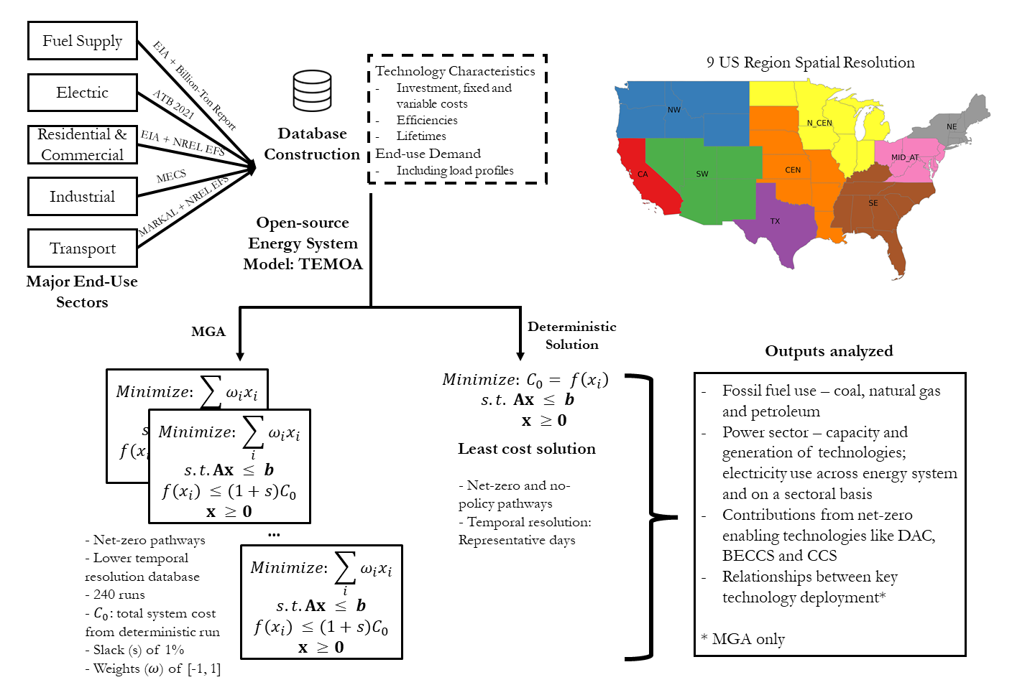
Figure S1: A flow diagram showing the inputs from the major end-use sectors, some characteristics of the database used, application of the Temoa model, and type of runs conducted (deterministic and modeling to generate alternatives (MGA)). The major outputs analyzed in the current work are also included. A nine-region description is used to represent the U.S., with the regions corresponding to combinations of several states in most cases. Northwest (NW): Washington, Oregon, Idaho, Montana, and Wyoming; North Central (N_CEN): Iowa, Wisconsin, Michigan, Illinois, Minnesota, Indiana, North Dakota; Northeast (NE): New York, Massachusetts, Vermont, Connecticut, Maine, New Hampshire, Rhode Island; Southwest (SW): Net Mexico, Nevada, Utah, Colorado and Arizona, Central (CEN): Nebraska, Arkansas, Missouri, Louisiana, Kansas, South Dakota and Oklahoma; Southeast (SE): Alabama, Kentucky, Georgia, Tennessee, Florida, North Carolina, South Carolina, Mississippi; Mid-Atlantic (MID_AT): Maryland, Delaware, Ohio, Pennsylvania, Virginia, New Jersey, District of Columbia, West Virginia; California (CA) and Texas (TX). Data sources in figure: Energy Information Administration (EIA)²; Billion Ton Report³; Annual Technology Baseline (ATB)⁴; National Renewable Labs Electrification Futures Study (NREL EFS)⁵; Manufacturing Energy Consumption Survey (MECS)⁶; MARKAL database.^{7,8}
Current-Policy scenario: This scenario assumes that all existing policies as of the end of 2022 remain in their current form and no new federal or state policies are implemented. These results indicate how projected fuel prices and technology costs will shape the energy system in the absence of additional climate policies. The policies included in this scenario are state-level Renewable Portfolio Standards (RPS), the Cross-State Air Pollution Rule (CSAPR), the California Cap and Trade program, the federal Investment Tax Credit (ITC), and the provisions of the Inflation Reduction Act (also detailed in Section S 5). Note that these policies are also included in the Net-Zero deterministic run as well as the modeling to generate alternatives (MGA) runs. Unlike in the net-zero pathways, there are no additional policies to constrain CO₂ emissions or support mitigation efforts after the provisions in the policies listed above expire. In this Current-Policy scenario, exogenous fuel prices are based on the Energy Information Administration (EIA) Annual Energy Outlook (AEO) 2022 ‘Reference’ case.
Net-Zero scenario: This scenario assumes that the U.S. energy system will reach net-zero CO₂ emissions by 2050. A constraint in the optimization caps CO₂ emissions across the energy system to achieve this objective. The CO₂ cap is defined as a linear reduction in annual CO₂ emission beginning in the 2020 model period and reaching net-zero by 2050. In this scenario, exogenous fuel prices are based on the EIA AEO 2022 ‘Low Oil Price’ case.
Section S2: Application of k-means clustering to select illustrative pathways.
To highlight the diverse ways in which net-zero CO₂ emissions can be achieved across the U.S. energy system, Figure 5 of the main manuscript highlights a set of illustrative pathways. We first create a feature matrix for the 2050 model year, incorporating all relevant parameters (such as hydrogen, electricity, or natural gas use) for the 2050 model year. Subsequently, we normalized the feature matrix to consider parameters spanning multiple orders of magnitude, ensuring equal weight for each parameter. We then applied k-means clustering and tested for clusters between 2 and 10, ranking our findings based on a silhouette score and a Calinski-Harabasz score. We found that three clustering parameters best represented the set of 240 decarbonization pathways. Out of the set of parameters initially introduced, the combination of hydrogen, synthetic liquids, and petroleum use was associated with the most favorable scores. Next, we divided the 240 decarbonization runs into low/high hydrogen, low/high direct air capture, and low/high electricity use. Low and high were defined as the lowest 25th percentile or higher than the 75th percentile of the 240 decarbonization runs. The features we identified above were then used to find the cluster centers in each of these low/high groups. We identified the nearest decarbonization pathways to the cluster center based on the Euclidean distance and presented these as the illustrative pathways in Figure 5 in the main manuscript.
Section S3: Temporal-resolution representation sensitivity
Research has highlighted the importance of adequate representations of operation detail in capacity expansion models for the power system, particularly at higher renewable penetration levels.^{9,10} The incorporation of this operational detail comes with an additional computational burden. Depending on the computational resource available at an energy system modeler’s disposal, it may be possible to run optimization models (in a greenfield setting) of up to 96 regions with 2-hourly time steps for a year for hundreds of scenarios in “reasonable” amounts of time.¹¹ However, even highly detailed models produce outputs with uncertainty.¹² Furthermore, researchers are required to balance between model resolution, uncertainty, and computational burden. ¹³
Due to computational limits, the power system representation used in the MGA simulations in the current study relies on an aggregate representation of twelve time slices. Our aim with this analysis is to answer the question of uncertainty in capacity expansion across multiple decades for hundreds of net-zero futures. We are interested in capturing insights from multi-decadal pathway optimization for near cost-optimal futures instead of evaluating a highly detailed 1-year snapshot. Due to the need to create many future scenarios, we face a tradeoff between temporal resolution and computational burdens. While high-resolution models are necessary to assess finer points of implementation in energy transitions, they cannot provide the range of scenarios we explore in this analysis. The distribution of pathways enabled by hundreds of model runs with lower temporal resolution can and should be considered in tandem with high resolution analyses that offer few modeling runs. The feasibility space discussed in the main manuscript should also include an evaluation of power system reliability for each near-cost-optimal pathway.
Section S4: Sectoral details:
The energy system representation includes the electric, buildings (residential and commercial), industrial, and transportation sectors.
Section S4.1 Electric sector:
The electric sector includes representations of existing and new generation technologies indexed by the region in which they are located. Thermal power plants include coal-fired steam with and without CCS, natural gas steam plants, open-cycle, and combined-cycle natural gas turbines with and without CCS, and light-water nuclear reactors. Renewable sources include conventional hydro, centralized solar photovoltaics (PV), centralized solar thermal, distributed solar, onshore and offshore wind, biomass, and geothermal technologies. Data for the electric sector are compiled using PowerGenome, an open-source tool that allows users to create input datasets for power system capacity expansion models.¹⁴ PowerGenome primarily uses data from the National Renewable Energy Laboratory (NREL), the U.S. Energy Information Administration (EIA), and the US Environmental Protection Agency (EPA). The Catalyst Cooperative’s Public Utility Data Liberation Project compiled much of these underlying data into a single SQLite database that PowerGenome uses. Using PowerGenome, we aggregated balancing authorities (as defined by EPA’s Integrated Planning Model¹⁵ regions) into nine OEO regions to develop the spatial representation for the electric sector shown in Figure S1.
Existing generators: Due to computational limitations, the electricity sector operations in the modeled regions cannot be represented by individual generator operations. To develop a reduced-order representation of these generators that is computationally tractable, PowerGenome uses k-means clustering techniques to aggregate existing generators into groups or clusters. The generators are clustered using four generator characteristics: nameplate capacity, heat rate, installation year, and fixed O&M costs. In each region, existing conventional coal-fired steam and natural gas combined cycle plants are represented by 4 clusters each; natural gas combustion turbine, natural gas steam turbine, nuclear, and conventional hydroelectric plants are represented by 2 clusters each, while all other technology types – biomass, geothermal, centralized solar photovoltaic, onshore wind – are represented by a single cluster each.
New thermal generators: New thermal generators are represented by a single cluster for every modeled year and include natural gas combined cycle (NGCC), natural gas combustion turbine, NGCC with 90% efficient carbon capture and storage (CCS), NGCC with 100% efficient CCS, geothermal (hydro binary and hydro flash technologies), coal integrated gasification combined cycle (IGCC), ultra-supercritical pulverized coal with 90% efficient CCS, biomass combined-cycle, and hydrogen combined-cycle. Data for these technologies are derived from the NREL Annual Technology Baseline (ATB) via PowerGenome, except for items listed below:
- Hydrogen combined-cycle turbines: Hydrogen at 100 bar pressure can be burned new in combined-cycle turbines to produce electricity, which is assumed to have the same techno-economic characteristics as NGCC generators but without any combustion emissions.
- Bio-energy with carbon capture and storage: This technology representation comes from the U.S. EPA MARKAL database^{7,8}.
- Hydrogen storage: This technology representation comes from the literature.¹⁶
New renewable generator clusters: In all model regions, new utility solar photovoltaics (PV) and onshore wind capacities are represented by three clusters each, while offshore wind is represented by a single cluster in each of three regions with offshore potential (CA, NW, NE regions in Figure S1). Within a region, techno-economic data for all renewable clusters of a single technology type are identical except for capacity factor and maximum available capacity. These techno-economic characteristics are derived from the NREL ATB via PowerGenome. Further, PowerGenome uses k-means clustering to develop these groups, which differ by capacity factor and maximum available capacity in each region. Although PowerGenome does not explicitly develop technology clusters for new residential-scale PV, we use the tool to develop cost estimates (investment and O&M costs) for a single representative cluster with underlying data from the NREL ATB. As an approximation, we also use the capacity factors developed for the three utility PV clusters in each region to represent residential PV generation. Each cluster has the same cost estimates as developed through PowerGenome. Residential PV annual generation is specified exogenously, with data from the NREL dGen¹⁷ model’s Mid (PV cost) scenario – data available at the state level is aggregated to each of the nine OEO regions. This technology is assumed to have no other resource constraints. We also developed a single cluster of concentrating solar thermal technologies in the California and Southwestern US regions. In the NREL ATB, the representative technology is assumed to be a 100 MW molten salt power tower with 10 hours of thermal energy storage driven by Class 5 (excellent) resources.
Section S4.2 Buildings sector:
The buildings sector is divided into the residential and commercial sectors. The main components used to represent these sectors are 1) end-use service demands, 2) the techno-economic characteristics of the technologies used to meet those demands, and 3) the existing capacity of technologies currently in service.
The service demands are derived from the NREL Electrification Futures Study⁵ and consist of two components: 1) the region-specific annual demands projected to 2050 and 2) the apportionment of these annual demands at the hourly level. The demand technologies are characterized by their capital costs, fixed and variable operation and maintenance costs, efficiencies, capacity factors, existing capacity, and fuel inputs.
Service Demands: The service demands represented in the residential sector include space cooling, space heating, refrigeration, freezing, lighting, water heating, cooking, clothes drying, and dishwashing. In the commercial sector, we model space cooling, space heating, water heating, refrigeration, cooking, lighting, and ventilation. The NREL Electrification Futures Study (EFS) provides annual projections for these end-use demands in the United States through 2050. These annual projections are available at the state level for each end-use demand in Table S1.
We use the estimates of buildings-related service demands for the end-use demands listed above. In certain cases, external data was required to spatially allocate the demands reported from the EFS. For example, residential space heating service demands were downscaled using the product of each state’s share of heating-degree-days and residential square footage. Next, we perform an additional aggregation to represent the state-level demands from this exercise into the nine regions represented in Figure S1. In the case of commercial ventilation, the annual service demands were estimated from the AEO as the product of the commercial square footage of a region multiplied by ventilation efficiency and ventilation energy consumption.

Table S1. Annual service demand categories and units are drawn from the NREL Electrification Futures Study.
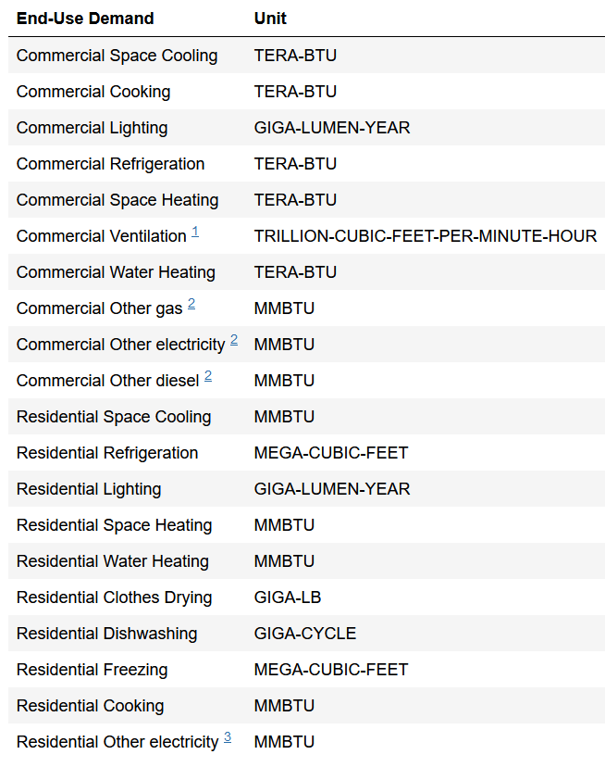
¹Service demand estimated from AEO as commercial regional square footage × ventilation efficiency × ventilation energy consumption.² The commercial other category in our databases aggregates the service demands reported by EFS for the categories: 'Commercial Other,’ 'District Services,' 'Office Equipment (NON-P.C.),' and 'Office Equipment (P.C.).'³ The residential other category in the OEO databases aggregates the service demands reported by EFS for the categories: 'Televisions and related,' 'Computers and related,' 'residential other uses,' and 'residential furnace fans.'
The EFS study provides state-level projections of hourly electricity demands for a subset of the subsectors listed above. These load profiles were developed by NREL using the outputs of other models such as ResStock/ComStock and other data (e.g., from metering studies) for a range of future scenarios. The resulting load profile from the 'High-Electrification and Rapid End-use Technology Advancement' scenario is selected as the load profile for electric end-uses in our database as it incorporates the largest share of total service demands. In cases where the hourly profile of an end-use demand is not available, we assume the service demands to be constant throughout the year.
The load profiles for space heating and cooling are combined into a single profile in the EFS data. However, we are interested in separating these two profiles to represent these demands distinctly and allow for technological choice in the model. We use population-weighted heating and cooling degree hour (hdh/cdh) data to separate the heating and cooling profiles.¹⁸ This data is available at the hourly timescale for the year 2010. We first calculate an average hourly hdh (and cdh) fraction for each hour of 2010 within a given model region. Next, the combined heating (/cooling) load taken from EFS is multiplied by these fractions to estimate each hour's heating (/cooling) load.
Demand Technology Specification: The characteristics of the demand technologies in the residential and commercial sectors in the OEO database are based on the Residential Demand Module (RDM) and Commercial Demand Module (CDM) of the National Energy Modeling System (NEMS) - Updated Buildings Sector Appliance and Equipment Costs and Efficiency. In our database, we incorporate 1) technology-specific efficiencies, 2) fixed and variable operations and maintenance costs, 3) investment costs, 4) lifetimes, and 5) typical capacities based on contract reports prepared by Navigant Consulting, Inc. for the U.S. Energy Information Administration. We represent a diverse set of equipment classes/types capable of servicing different parts of the building sector. For example, the technologies capable of meeting residential cooling demand include room air conditioners, central air conditioners, and heat pumps. Three types of heat pumps are represented for residential cooling: air-source, ground-source, and natural gas heat pumps. We use this dataset to adjust the heat pump coefficient of performance (COP) to reflect more regionally appropriate values. Other work has estimated a linear relationship between COP and outside temperature for various heat pumps.¹⁹ Our work assumes that the indoor temperatures stay constant at 70ºF, and we use the slope of this linear relationship to adjust heat pump COPs at the regional level using state-level population-weighted temperatures.
Along with diversity in technology representations, we also incorporate the changes in the techno-economic parameters for residential and commercial equipment from 2020 to 2050 in 5-year increments based on projections incorporated in NEMS. In most cases, two versions of a given technology are included in our database: 1) a standard version and 2) a high-efficiency version. For example, the heating seasonal performance factor (HSPF) for a typical air-source heat pump of a 2020 vintage is 8.6, whereas a high-efficiency version has an HSPF of 9.0. The costs and lifetimes may also vary across these different technology options. The techno-economic parameters of a given technology are assumed to be region agnostic, except heat pump COPs as described above.
Existing Capacity: We rely on two data sources to estimate existing capacity at the technology level in the buildings database: 1) NREL EFS service demands scaled using a derived utilization factor, which gives us the existing capacities of most of the existing electric technologies and 2) the MARKAL database, which gives us the existing capacities for technologies not included in 1). The estimation method from the two data sources is briefly described below:
1) NREL EFS: First, an end-use service demand-specific 'utilization factor' is calculated using the hourly load profile data published in the EFS. This is done by calculating the average demand across the 8,760 hours divided by the 95th percentile demand for each end-use service demand in each model region for which hourly load profiles are available. The existing capacity of the buildings sector technologies is then estimated as the service demand in 2017 from EFS scaled using the calculated utilization factors.
2) MARKAL database: We rely on existing capacity estimations from the U.S. EPA MARKAL database.²⁰ MARKAL reports the existing capacities for most technologies listed in the EIA dataset for the nine census divisions. However, since our regional representation differs from the census divisions, we scale the reported existing capacities using U.S. Census state population data to obtain estimates of existing capacity in each U.S. state. Finally, we aggregate up to the regions shown in Figure S1 and estimate the existing capacities of the technologies represented. MARKAL estimates the existing capacity by multiplying the demand met (taken from AEO) in an end-use service sub-sector by the estimated market share of a technology contributing to the end-use service category. This value is then divided by a utilization factor to estimate the existing capacity of a certain technology in a given region.
Section S4.3 Transportation sector:
The transportation sector models the following transport modes: light-duty vehicles, trucks, buses, rail passenger, rail freight, subways, aviation, marine, and off-highway. The demands, efficiencies, and costs for these transport modes are drawn from various data sources, including the MARKAL database, Princeton's Net-Zero America study, the National Renewable Energy Laboratory, and Argonne National Laboratory.
The transportation sector in our database can be split into three categories: light-duty, medium-duty, and heavy-duty vehicles. We represent seven light-duty vehicle-size classes. We exogenously constrain the percent of end-use demand met by each size class. As Temoa optimizes for the least-cost solution, the model would deploy only cheap, fuel-efficient minicars and compact cars without this constraint. We base size-class demand distributions using the MARKAL database. Medium-duty vehicles consist only of medium-duty trucks, corresponding to class 6 and 7 trucks. Heavy-duty vehicles include heavy trucks, buses, passenger and freight rail, aviation, marine vessels, and off-highway vehicles. Each transportation technology meets a separate, exogenously specified end-use demand. Depending on the technology, the demand may be in ton miles, passenger miles, or vehicle miles traveled. Temoa does not currently allow for modal switching. For example, a long-haul truck cannot meet the same freight demand as a train; the two have distinct exogenously defined demand profiles. Existing work shows that modal switching is one effective means of reducing transportation energy consumption, and future work will incorporate modal switching into the Temoa framework.²¹
We define technology-specific discount rates, or hurdle rates, for some technologies. Hurdle rates allow the modeler to account for consumer preferences otherwise ignored in a least-cost optimization model.²² In the light-duty vehicle sector, we assume that conventional and hybrid gasoline-fueled vehicles (excluding plug-in hybrid vehicles) have a 5% hurdle rate, equal to the model's global discount rate, and all other powertrains have a 6% hurdle rate. For heavy-duty vehicles, conventional technologies have a 5% hurdle rate, and alternative-fueled vehicles have a 10% hurdle rate.

Section S4.4 Industrial Sector:
The industrial sector in the OEO database is subdivided into the manufacturing and non-manufacturing sectors. Their representation in the OEO database consists of two key components: 1) end-use service demands and 2) the demand technologies/processes used to meet those demands.
Service Demands: End-use demands in the industrial sector of the database are aggregated based on the North American Industry Classification System (NAICS). Table S2 shows the end-use demands represented, mapped to their NAICS codes. The sectors represented here account for approximately 99% of industrial energy consumption per the EIA. The demands for these industrial sub-sectors are represented in estimates of annual billion dollars of production shipment value, except cement manufacturing, where demands are instead represented in a million metric tons of cement production. These demands are derived from the Manufacturing Energy Consumption Survey (MECS) for the base year 2014 on a U.S. state-by-state basis. The state-based demands are then aggregated into the regions shown in Figure S1. Subsector-specific growth rates are applied to the end-use demands in the industrial sector. For example, growth in demand in the petroleum refining and the iron and steel mills and ferroalloys sub-sectors are assumed to be flat based on the refinery utilization and iron and steel manufacturing projections and in the AEO reference case. Based on other work, the demand for plastic and rubber products is assumed to increase by 3% annually from 2020 to 2050.²³ The growth in demand for cement manufacturing is also taken from the AEO reference case. Finally, the growth rates of all other manufacturing and non-manufacturing sub-sectors are assumed to increase at an annual rate of 1%.

Table S2: Annual service demand categories making up the Industrial Sector.
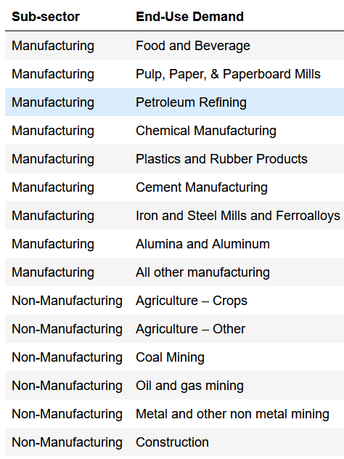
Demand Technology Specification: Due to the heterogeneous nature of the industrial sector, explicit end-use technology options with costs and efficiencies are not depicted for most subsectors. Instead, we consider the major energy consumed by common industrial processes to account for the heterogeneity across the industrial sector. These industrial processes include 1) process heating, 2) conventional boiler use, 3) combined heat and power or co-generation systems, 4) machine drives, 5) facility heating ventilation and air conditioning systems, 6) process cooling and refrigeration and 7) a catch-all 'other' energy use category. However, we incorporate technological choice in the case of new boiler use and process heat. We specify cost premiums for new conventional electric boilers (368 $2016/kW), electric process heating equipment (368 $2016/kW), hydrogen boilers (227 $2016/kW), and hydrogen process heating equipment (227 $2016/kW) across the industrial manufacturing sectors. We also set the fixed cost premiums at 0.6 $2018/kW for the entire lifetime of these boilers and process heating equipment (20 years). In our modeling approach, heavy industries, including cement, chemicals, iron and steel mills, ferro-alloys, petroleum refining, and plastics, are precluded from using hydrogen or electricity for process heat. However, we assume that all sectors can electrify conventional boilers.
Section S5: Inflation Reduction Act Representation
We include the major provisions from the 2022 Inflation Reduction Act. The provisions we model include the investment and production tax credits for renewable electricity generators, carbon capture, and use/sequestration, the production tax credit for existing nuclear capacity, the clean hydrogen production tax credit, and tax credits for passenger and commercial vehicles. We provide details on each modeled provision below.
Production Tax Credit (sections 45, 45Y): The production tax credit (PTC) provides $27.50/MWh over ten years of operation for qualified facilities (assuming labor requirements are met). Bonuses are available for domestic content and projects located in energy communities. Following modeling assumptions from the National Renewable Energy Laboratory, we assume the bonus credits start at an average rate of 5% in 2023, increase to 10% by 2028, and stay at 10% until the credit expires in 2033. We also adjusted the tax credit to align with Temoa’s 5-year time periods. The IRA PTC begins in 2023, so it is available only in the last two years of Temoa’s first time period (2020-2024). We prorate the tax credit as necessary, given our 5-year model increment, ensuring that projects receive the equivalent of 10 years of tax credits. We represent the IRA’s extension of the existing PTC (section 45) and the newly introduced technology-neutral PTC (section 45Y) that allows any zero-emission generation to qualify. Under section 45, qualifying technologies are solar, onshore and offshore wind, geothermal, biomass, and hydropower. Section 45 is replaced with 45Y in 2025.
Investment Tax Credit (sections 48, 45E): The investment tax credit (ITC) offers 30% of a project’s installed capital costs, plus bonuses for domestic content and energy community locations. Pre-IRA, an ITC of 26% was available. We model the ITC as a reduction in capital cost for qualifying technologies, which include solar, on and offshore wind, geothermal, and energy storage. In Temoa’s first time period, we assume new qualifying technologies could receive a 26% reduction in 2020 and 2021 and a 30% reduction for 2022-2024, for an average credit of 28.4%. Projects constructed in the model’s second time period are eligible for full credit. The ITC drops to 22.5% in 2034, after which it sunsets.
Again, following the NREL convention, we assume a 5% bonus starting in 2023 that increases to 10% by 2028, where it stays until the credit sunsets after 2034. We represent the IRA’s extension of the existing ITC (section 48) and the newly introduced technology-neutral ITC (section 48E) that allows any zero-emission generation to qualify.
Carbon Capture (section 45Q): Credits for carbon capture vary depending on the source of the carbon dioxide and whether the captured carbon is sequestered or used. For post-combustion carbon capture, facilities earn $85/tonne for sequestered CO₂ and $60/tonne for facilities that capture and use the CO₂. For direct air capture facilities, the credits increase to $180/tonne for sequestration and $130/tonne for use. While we do not represent enhanced oil recovery, we credit facilities using CO₂ to produce synthetic fuels. We assume all wage and apprenticeship requirements are met. The credit is available for new facilities for 12 years, and facilities must be in place by 2033. Like the PTC and ITC, we model the credit in the first and third time periods as a weighted average to effectively prorate Temoa’s five-year time periods and the credit’s time horizon. The credit is modeled as a negative variable cost.
Existing Nuclear (section 45U): Existing nuclear technologies receive $30/MWh starting in 2024 and sunsetting in 2032. We model this credit as a negative variable cost, with the first and third time periods receiving a weighted average credit of 1/5 and 3/5, respectively.
Clean Hydrogen (section 45V): The clean hydrogen tax credit is tiered based on the carbon intensity of the production mechanism (see Table S3). With the current average grid mix, electrolytic hydrogen is not eligible for even the lowest tier. We allow hydrogen produced by biomass with CCS or an electrolyzer fed with new zero-emission electric capacity to receive the full $3/kg H₂ credit. The International Energy Association assumes an emission factor of 1.0 kg CO₂/kg H₂ for natural gas reforming with carbon capture, qualifying for the second tier of the tax credit ($1/kg H₂). All credits are modeled as a negative variable cost.
Table S3: Hydrogen credits in the Inflation Reduction Act ²⁴
Carbon intensity  [kg CO₂-eq / kg H₂] | IRA credit  [$ / kg H₂]
> 4.0 | 0
2.5 – 4.0 | 0.06
1.5 – 2.5 | 0.075
0.45 – 1.5 | 1.00
< 0.45 | 3.00

Passenger Vehicles (section 30D): Individuals purchasing a qualified plug-in electric vehicle (EV) or fuel cell vehicle (FCV) between 2023 and 2032 may be eligible for credit up to $7,500 (segmented into two $3,750 credits). The credits are subject to several requirements, including limits on the vehicle’s manufacturer-suggested retail price (MSRP), the individual’s adjusted gross income, requirements for domestic battery assembly, critical mineral sourcing, and avoidance of entities of concern. The number of vehicles and individuals qualifying for the credit remains uncertain. Still, a recent report from the International Council on Clean Transportation (ICCT) and Energy Innovation Policy & Technology estimates the fraction of vehicle sales eligible for each. We use the report’s “moderate” scenario in our modeling. The study assumes that 100% of new EVs are eligible for the full $3,750 domestic battery assembly credit. In 2023, the study assumes 100% of new EVs meet the critical material requirements, dropping to 79% in 2025 and 72% in 2030 as the requirements increase in stringency. In 2032, the study assumes 78% of vehicles qualify. The report assumes that 87% of new EVs meet MSRP eligibility and 50% meet the entities of concern provision. Finally, the study assumes that 68% of individuals meet the adjusted gross income (AGI) requirements in 2023, rising to 77% in 2030. We model the provision as an average credit, implemented as a reduction in capital cost applied to all qualifying vehicles (all EVs and FCVs). Using the fractions outlined above, we calculate the average credit in a given year as follows:
$$C_{T}= {F_{MSRP}F_{AGI}F_{EC}[(C}_{DBA}F_{DBA})+(C_{CMS}F_{CMS})]$$
Equation 5
Where $C_{T}$ is the total credit available, $C_{DBA}$ is the domestic battery assembly credit, $C_{CMS}$ is the critical mineral sourcing credit, and $F_{x}$ are the fractions of vehicles meeting the MSRP, AGI, entities of concern, domestic battery assembly, and critical minerals sourcing requirements. Table S4 outlines the calculated credit values in each year and each Temoa time period.
Table S4: IRA vehicle credits
Year | $$F_{CMS}$$ | $$F_{MSRP}$$ | $$F_{AGI}$$ | $$F_{EC}$$ | $$C_{DBA}$$ | $$C_{CMS}$$ | $$C_{T}$$ | Credit by time period, 2022 USD | Credit by time period, 2015 USD
2020 | 0 | 0 | 0 | 0 | 0 | 0 | $0.00 | $3,000.00 | $2,430.00
2021 | 0 | 0 | 0 | 0 | 0 | 0 | $0.00
2022 | 0 | 0 | 0 | 0 | 0 | 0 | $0.00
2023 | 1 | 1 | 1 | 1 | $3,750 | $3,750 | $7,500.00
2024 | 1 | 1 | 1 | 1 | $3,750 | $3,750 | $7,500.00
2025 | 0.79 | 0.87 | 0.68 | 0.5 | $3,750 | $3,750 | $3,971.12 | $4,059.41 | $3,288.12
2026 | 0.698 | 0.87 | 0.698 | 0.5 | $3,750 | $3,750 | $3,866.73
2027 | 0.716 | 0.87 | 0.716 | 0.5 | $3,750 | $3,750 | $4,008.49
2028 | 0.734 | 0.87 | 0.734 | 0.5 | $3,750 | $3,750 | $4,152.37
2029 | 0.752 | 0.87 | 0.752 | 0.5 | $3,750 | $3,750 | $4,298.36
2030 | 0.72 | 0.87 | 0.77 | 0.5 | $3,750 | $3,750 | $4,320.86 | $2,637.73 | $2,136.56
2031 | 0.75 | 0.87 | 0.77 | 0.5 | $3,750 | $3,750 | $4,396.22
2032 | 0.78 | 0.87 | 0.77 | 0.5 | $3,750 | $3,750 | $4,471.58
2033 | 0 | 0 | 0 | 0 | 0 | 0 | $0.00
2034 | 0 | 0 | 0 | 0 | 0 | 0 | $0.00
2035 | 0 | 0 | 0 | 0 | 0 | 0 | $0.00

Commercial Vehicles (section 45W): Commercial vehicles are not subject to the same restrictions as passenger vehicles. The IRA provides a tax credit equal to 30% of the vehicle's purchase price for qualifying light-, medium-, and heavy-duty vehicles. Light-duty commercial vehicles tax credits cannot exceed $7,500, and medium- and heavy-duty vehicles may not receive credits over $40,000. To implement this provision, we reduce the capital cost by 30%. If 30% of the capital cost exceeds $7,500/$40,000, we reduce the capital cost by that value.
Stacked credits: Temoa’s technology-explicit representation enables us to represent distinct pathways in cases where a technology can qualify for one of multiple provisions. Renewable energy project owners may receive either the PTC or ITC, but not both. Similarly, projects cannot qualify for both 45V and 45Q. We implement tax credits such that the model may choose one or the other, allowing it to optimize credit efficacy.

Supplemental Figures:
Section 2.2 in the main text discusses electricity generation in the power sector. In Figure S2, we show the capacities in the power sector used to achieve those generation levels across the near cost-optimal net-zero pathways. In Figure S3, we show the fraction of generation coming from renewable and nuclear + renewable sources across the near cost-optimal net-zero pathways. In Figure S4, we show the electricity use by sector across the near cost-optimal net-zero pathways.

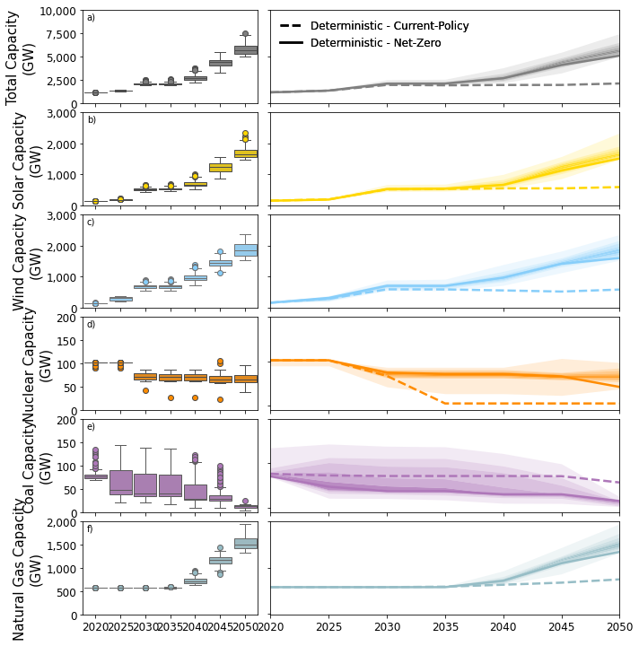

Figure S2: Near cost-optimal pathways showing capacity in the power sector for a) total capacity, b) solar, c) wind, d) nuclear, e) coal, and f) natural gas in net-zero CO2 pathways. The boxplots on the left show the distribution of the capacities in the power sector across all 240 net-zero pathways. The pathway plots on the right show the range of capacities, with the shading representing each decile of results across the 240 model runs (darkest shades around the median, lightest shades around the 10th and 90th percentiles). The solid line shows the deterministic least-cost net-zero pathway, while the dashed lines depict the least-cost current-policy pathway.
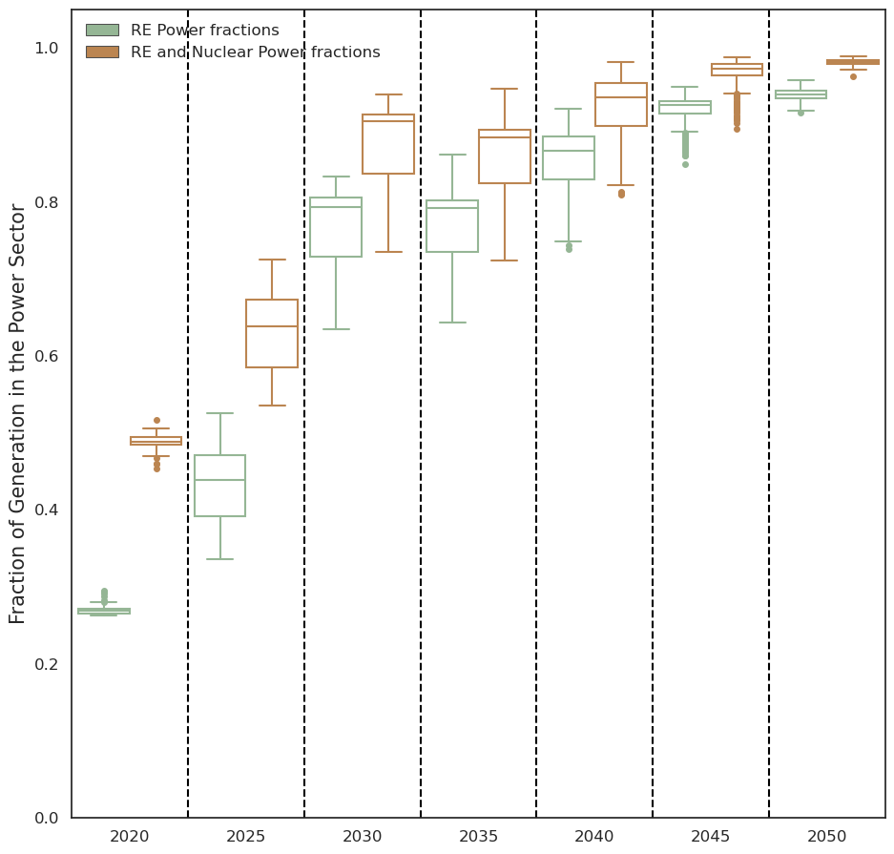
Figure S3: Fraction of electricity generation in each time period from only renewables (green) and renewables + nuclear (brown) in the near cost-optimal decarbonization pathways.

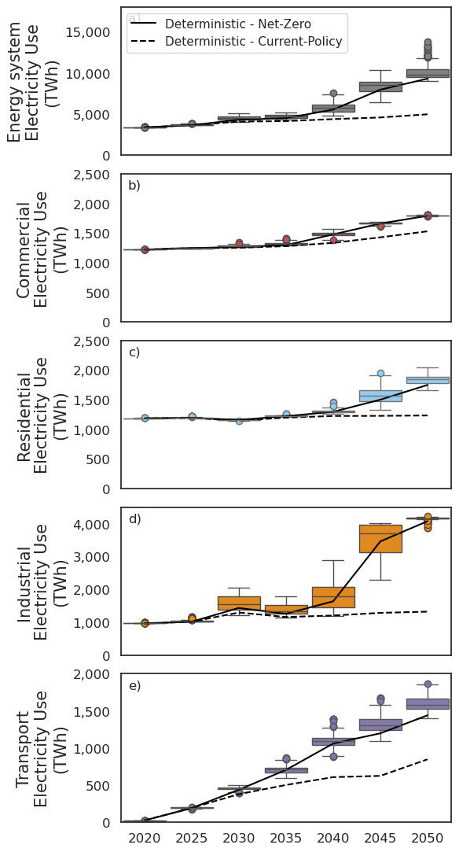
Figure S4: Electricity use for the a) total energy system, b) commercial, c) residential, d) industrial, and e) transport sectors in terawatt-hours across the near cost-optimal net-zero pathways. The solid line shows the deterministic (least-cost) net-zero scenario, while the dashed lines distinguish the current-policy deterministic run.
References
1. Hunter, K., Sreepathi, S., and DeCarolis, J.F. (2013). Modeling for insight using Tools for Energy Model Optimization and Analysis (Temoa). Energy Econ. 40, 339–349. 10.1016/j.eneco.2013.07.014.
2. Annual Energy Outlook 2020 with Projections to 2050 (2020).
3. Langholtz, M.H., Stokes, B.J., and Eaton, L.M. (2016). 2016 Billion-Ton Report: Advancing Domestic Resources for a Thriving Bioeconomy 10.2172/1271651.
4. Vimmerstedt, L.J., Akar, S., Augustine, C.R., Beiter, P.C., Cole, W.J., Feldman, D.J., Kurup, P., Lantz, E.J., Margolis, R.M., Stehly, T.J., et al. (2019). 2019 Annual Technology Baseline (National Renewable Energy Labs) 10.2172/1566062.
5. Mai, T.T., Jadun, P., Logan, J.S., McMillan, C.A., Muratori, M., Steinberg, D.C., Vimmerstedt, L.J., Haley, B., Jones, R., and Nelson, B. (2018). Electrification Futures Study: Scenarios of Electric Technology Adoption and Power Consumption for the United States (National Renewable Energy Labs) 10.2172/1459351.
6. Manufacturing energy consumption (MECS) (2018). (U.S. Energy Inf. Adm. (EIA)).
7. Loulou, R. (2008). ETSAP-TIAM: the TIMES integrated assessment model. part II: mathematical formulation. Comput. Manag. Sci. 5, 41–66. 10.1007/s10287-007-0045-0.
8. Loulou, R., and Labriet, M. (2008). ETSAP-TIAM: the TIMES integrated assessment model Part I: Model structure. Comput. Manag. Sci. 5, 7–40. 10.1007/s10287-007-0046-z.
9. Poncelet, K., Delarue, E., Six, D., Duerinck, J., and D’haeseleer, W. (2016). Impact of the level of temporal and operational detail in energy-system planning models. Appl. Energy 162, 631–643. 10.1016/j.apenergy.2015.10.100.
10. Mallapragada, D.S., Papageorgiou, D.J., Venkatesh, A., Lara, C.L., and Grossmann, I.E. (2018). Impact of model resolution on scenario outcomes for electricity sector system expansion. Energy 163, 1231–1244. 10.1016/j.energy.2018.08.015.
11. Pickering, B., Lombardi, F., and Pfenninger, S. (2022). Diversity of options to eliminate fossil fuels and reach carbon neutrality across the entire European energy system. Joule 6, 1253–1276. 10.1016/j.joule.2022.05.009.
12. DeCarolis, J., Daly, H., Dodds, P., Keppo, I., Li, F., McDowall, W., Pye, S., Strachan, N., Trutnevyte, E., Usher, W., et al. (2017). Formalizing best practice for energy system optimization modelling. Appl. Energy 194, 184–198. 10.1016/j.apenergy.2017.03.001.
13. Yliruka, M., Moret, S., and Shah, N. (2023). Detail or uncertainty? Applying global sensitivity analysis to strike a balance in energy system models. Comput. Chem. Eng. 177, 108287. 10.1016/j.compchemeng.2023.108287.
14. Schivley, G. (2022). Github - Powergenome. https://github.com/PowerGenome/PowerGenome.
15. Supply, C., and Horizon, M.T. (2010). Updates to EPA Base Case v3. 02 EISA Using the Integrated Planning Model.
16. Dowling, J.A., Rinaldi, K.Z., Ruggles, T.H., Davis, S.J., Yuan, M., Tong, F., Lewis, N.S., and Caldeira, K. (2020). Role of Long-Duration Energy Storage in Variable Renewable Electricity Systems. Joule 4, 1907–1928. 10.1016/j.joule.2020.07.007.
17. Sigrin, B., Gleason, M., Preus, R., Baring-Gould, I., and Margolis, R. (2016). Distributed generation market demand model (dGen): Documentation (National Renewable Energy Lab.(NREL), Golden, CO (United States)).
18. Roberts, M.J., Zhang, S., Yuan, E., Jones, J., and Fripp, M. (2022). Using temperature sensitivity to estimate shiftable electricity demand. Iscience 25.
19. Vaishnav, P., and Fatimah, A.M. (2020). The environmental consequences of electrifying space heating. Environ. Sci. Technol. 54, 9814–9823.
20. Victor, N., Nichols, C., and Zelek, C. (2018). The US power sector decarbonization: Investigating technology options with MARKAL nine-region model. Energy Econ. 73, 410–425.
21. Kaack, L.H., Vaishnav, P., Morgan, M.G., Azevedo, I.L., and Rai, S. (2018). Decarbonizing intraregional freight systems with a focus on modal shift. Environ. Res. Lett. 13, 083001.
22. McCollum, D.L., Wilson, C., Pettifor, H., Ramea, K., Krey, V., Riahi, K., Bertram, C., Lin, Z., Edelenbosch, O.Y., and Fujisawa, S. (2017). Improving the behavioral realism of global integrated assessment models: An application to consumers’ vehicle choices. Transp. Res. Part Transp. Environ. 55, 322–342.
23. Meys, R., Kätelhön, A., Bachmann, M., Winter, B., Zibunas, C., Suh, S., and Bardow, A. (2021). Achieving net-zero greenhouse gas emission plastics by a circular carbon economy. Science 374, 71–76.
24. White House (2022). Clean Energy Tax Provisions in the Inflation Reduction Act. White House. https://www.whitehouse.gov/cleanenergy/clean-energy-tax-provisions/.

