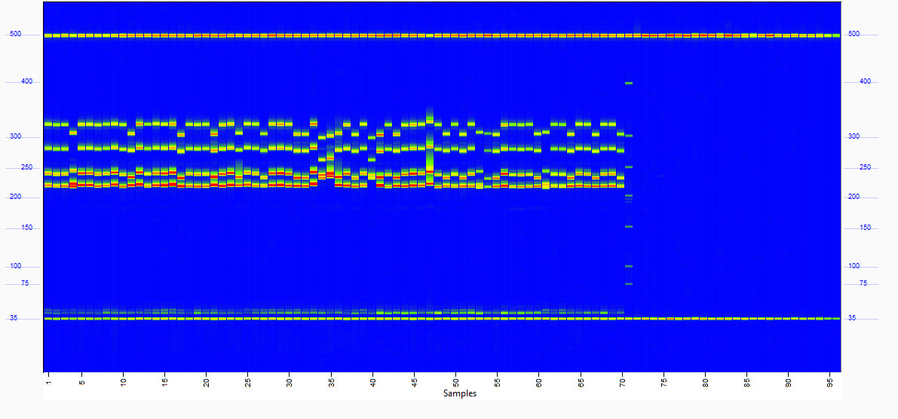
Fig.S1 Electrophoretic map of SM19 in Xinluzao cotton series. The abscissa is the name of the material, the specific material corresponding to the number is shown in Table S8, and the ordinate is the length of amplified polymorphic bands.

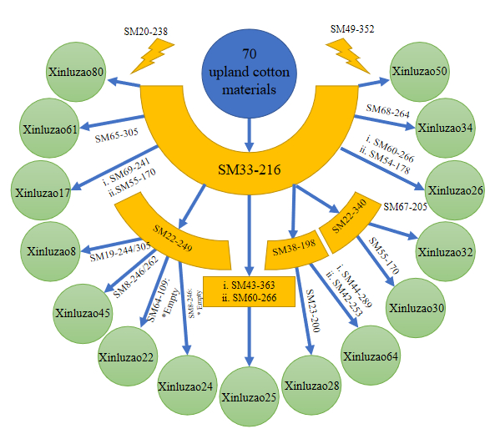
Fig.S2 A flow chart for identifying individual materials from 70 upand cotton materials of Xinluzao using combined primers.

