Table 2 Augmentable Rating of Mangalagiri Weaving
Image Target | Rating | Status
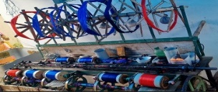  Image_Target_1 |  | Active
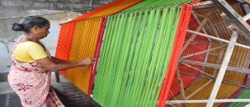  Image_Target_ 2 |  | Active
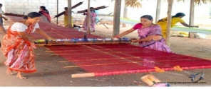  Image_Target_3 |  | Active
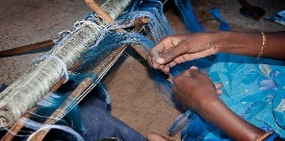  Image_Target_4 |  | Active
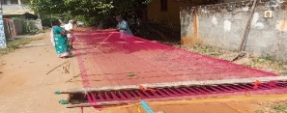  Image_Target_5 |  | Active
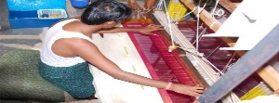  Image_Target_6 |  | Active
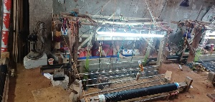  Image_Target_7 |  | Active
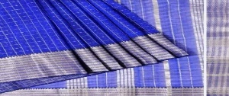  Image_Target_8 |  | Active

