Table 1. Baseline characteristics of COPD participants according to serum 25(OH)D concentrations in NHANES data from 2007 to 2018, weighted.
*The percentage of the categorical variables does not sum to 100% because some participants chose to ‘not answer’. COPD, chronic obstructive pulmonary disease; 25(OH)D, 25-hydroxyvitamin D; HDL, high-density lipoprotein cholesterol; TC, cholesterol; WBC, white blood cell; eGFR: estimated glomerular filtration rate.
Table 2. The relationship between serum 25(OH)D concentrations and risk of COPD among participants from the NHANES (2007-2018).
Crude model: Non-adjusted
Model 1: adjusted for age, gender, race/ethnicity, education, marriage
Model 2: adjusted for model 1 plus smoking status, body mass index, DM, hypertension, CVD, TC, HDL, WBC, eGFR

Table 3. All-cause mortality according to serum 25(OH)D concentrations among participants with COPD from the NHANES (2007-2018).
Crude model: Non-adjusted
Model 1 adjusted for age, gender, race/ethnicity, education, marriage
Model 2: adjusted for model 1 plus smoking status, body mass index, DM, hypertension, CVD, TC, HDL, WBC, eGFR
Table 4. CVD mortality according to serum 25(OH)D concentrations among participants with COPD from the NHANES (2007-2018).
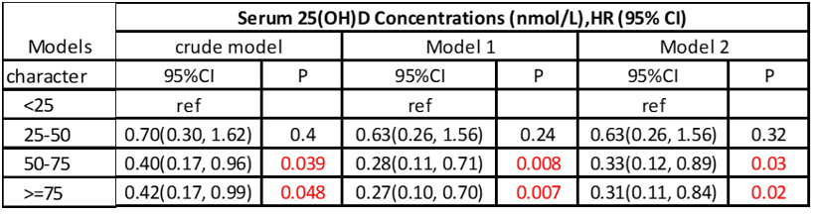
Crude model: Non-adjusted
Model 1: adjusted for age, gender, race/ethnicity, education, marriage
Model 2: adjusted for model 1 plus smoking status, body mass index, DM, hypertension, CVD, TC, HDL, WBC, eGFR
Table 5. Subgroup analyses of the associations between serum 25(OH)D concentrations and all-cause mortality among participants with COPD from the NHANES (2007-2018). The Cox proportional hazard model was used to estimate the HR of all-cause mortality according to DII.
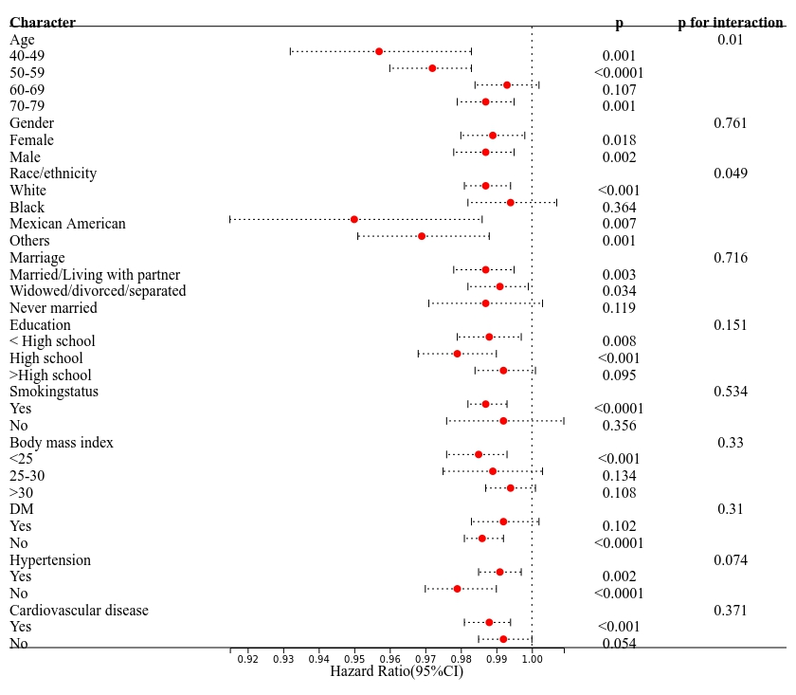
Adjusted for age, gender, race/ethnicity, education, marriage, smoking status, body mass index, DM, hypertension, CVD

