Supplementary Material
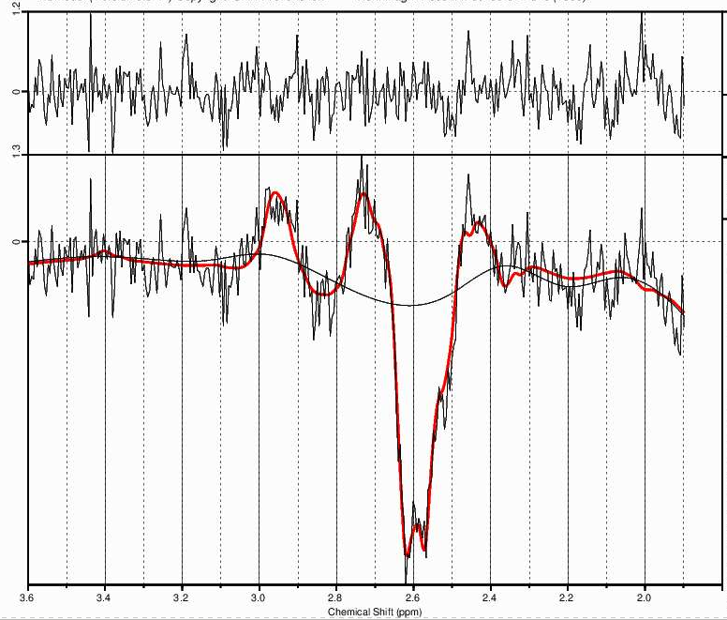
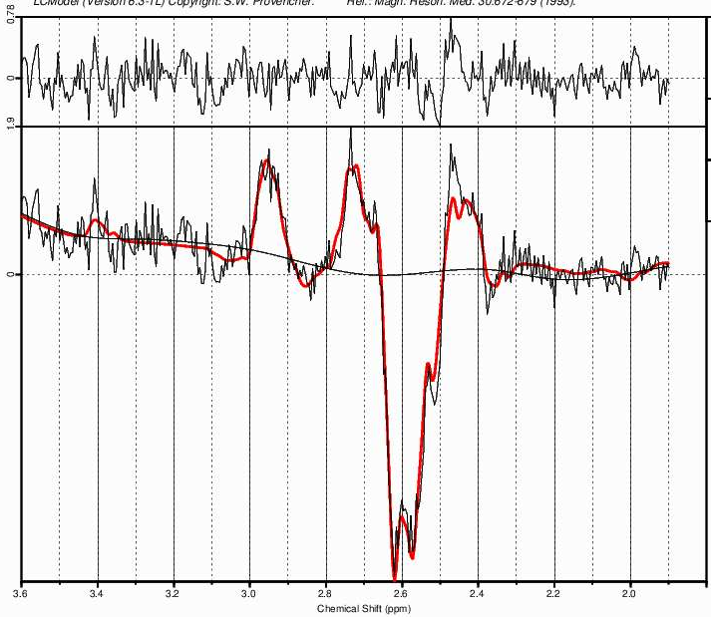
mOCC
DMPFC
B
A

GSH

GSH

Figure 1S. Example of a glutathione (GSH) difference spectrum from the A) dorsomedial prefrontal cortex (DMPFC) and B) from the medical occipital cortex (mOCC).

Table S1. ¹H-MRS quality measures and GSH levels in institutional units for each voxel and group.

 |  |  | non-ASD |  | ASD |  | Statistics
Region |  |  | mean ± SD 95% CI | Range | mean ± SD 95% CI | Range
 | N (m/f) |  | 36 (19/17) | -- | 26 (20/6) | --
 | GSH |  | 0.93 ± 0.3 [0.83-1.03] | 0.49 - 1.7 | 1.0 2± 0.3 [0.90-1.14] | 0.48 - 1.89 | U = 377.0 |  | p = 0.097ª
DMPFC | SNR |  | 6.3 ± 1 [6 -7] | 4 - 8 | 5.5 ± 1 [5 -6] | 4 - 8 | U = 289.5 |  | p = 0.008
 | FWHM |  | 0.05 ± 0.02 [0.04 – 0.05] | 0.010 - 0.105 | 0.05 ± 0.02 [0.04 – 0.05] | 0.02 – 0.09 | U = 437.5 |  | p = 0.662
 | % CRLB GSH |  | 10 ± 2 [10 – 11] | 8 - 16 | 11 ± 2 [10 – 12] | 7 - 18 | U = 450.0 |  | p = 0.794
 | N (m/f) |  | 38 (20/18) | -- | 29 (22/7) | --
 | GSH |  | 0.72 ± 0.2 [0.66 – 0.79] | 0.42 – 1.14 | 0.72 ± 0.19 [0.65 – 0.79] | 0-49 – 1.21 | U = 544.0 |  | p = 0.929
mOCC | SNR |  | 5.9 ± 1 [5 – 6] | 4 - 7 | 6.0 ± 1 [5 – 6] | 4 - 7 | U = 530.0 |  | p = 0.769
 | FWHM |  | 0.05 ± 0.02 [0.04 - 0.06] | 0.02 – 0.09 | 0.05 ± 0.02 [0.04 – 0.06] | 0.02 – 0.09 | U = 501.5 |  | p = 0.529
 | % CRLB GSH |  | 12 ± 3 [11 - 13] | 2 - 22 | 12 ± 2 [12 – 13] | 9 - 17 | U = 464.5 |  | p = 0.296

Abbreviations: DMPFC, dorsomedial prefrontal cortex; mOCC, medial occipital cortex; non-ASD, non-autistic control group; ASD, Autism Spectrum Disorder group; SD, standard deviation; 95% CI, 95% confidence interval; N, number of participants; m, male; f, female; GSH, glutathione; SNR, signal-to-noise ratio; FWHM, full-width-half-maximum; CRLB, Cramer-Rao lower bounds; U, Mann-Whitney test value; p, significance level. ª one-sided t test. Significant differences are in bold (p < 0.05).

Table S2. Voxel tissue proportions for each region and group.

 |  |  | non-ASD |  |  | ASD |  | Statistics
Region |  |  | mean ± SD 95% CI | Range |  | mean ± SD 95% CI | Range
 | N (m/f) |  | 36 (19/17) | -- |  | 26 (20/6) | --
 | GM |  | 0.55 ± 0.03 [0.54 – 0.56] | 0.50 – 0.61 |  | 0.54 ± 0.05 [0.52 – 0.56] | 0.45 – 0.62 | U = 425.0 |  | p = 0.540
DMPFC | WM |  | 0.22 ± 0.04 [0.21 – 0.24] | 0.16 – 0.31 |  | 0.21 ± 0.04 [0.19 – 0.23] | 0.10 – 0.26 | U = 442.0 |  | p = 0.711
 | CSF |  | 0.22 ± 0.05 [0.21 – 0.24] | 0.13 – 0.31 |  | 0.25 ± 0.06 [0.22 – 0.27] | 0.16 – 0.41 | t₍₆₀₎ = -1.634 |  | p = 0.108
 | N (m/f) |  | 38 (20/18) | -- |  | 29 (22/7) | --
 | GM |  | 0.66 ± 0.04 [0.65 – 0.67] | 0.57 – 0.73 |  | 0.65 ± 0.04 [0.23 -0.25] | 0.57 – 0.71 | t₍₆₅₎ = 0.987 |  | p = 0.327
mOCC | WM |  | 0.24 ± 0.03 [0.23 – 0.25] | 0.19 – 0.32 |  | 0.25 ± 0.03 [0.23 – 0.26] | 0.19 – 0.35 | U = 534.0 |  | p = 0.830
 | CSF |  | 0.10 ± 0.03 [0.09 – 0.11] | 0.05 – 0.18 |  | 0.10 ± 0.03 [0.09 – 0.12] | 0.04 – 00.16 | U = 486.0 |  | p = 0.411

Abbreviations: DMPFC, dorsomedial prefrontal cortex; mOCC, medial occipital cortex; non-ASD, neurotypical control group; ASD, Autism Spectrum Disorder group; SD, standard deviation; 95% CI, 95% confidence interval; N, number of participants; m, male; f, female; GM, grey matter; WM, white matter; CSF, cerebrospinal fluid; t, independent samples t test value; U, Mann-Whitney test value; p, significance level.

