Supporting Information
Enhanced 3D framework composite solid electrolyte with alumina-modified Li_{1.4}Al_{0.4}Ti_{1.6}(PO₄)₃ for solid-state lithium battery
Long Chen^{1,2}, Feng Zhu², Dongjuan Ma^{1,3}, Yan Liu¹, Fang Yan¹, , Jingyi Qiu¹, Gaoping Cao¹ and Hao Zhang^{1*}
1. Research Institute of Chemical Defense, Beijing, 100191, China
2., China National new energy vehicle technology innovation center, Beijing, 100176, China
3. Tianjin EV Energies Co., Ltd., Tianjin, 300380, China
*Corresponding author: Email: dr.h.zhang@hotmail.com.
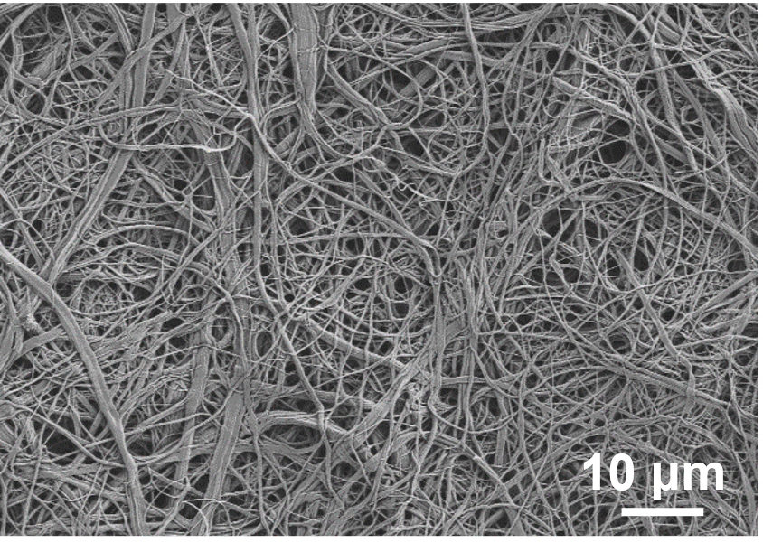
Fig. S1. SEM image of cellulose acetate membrane.
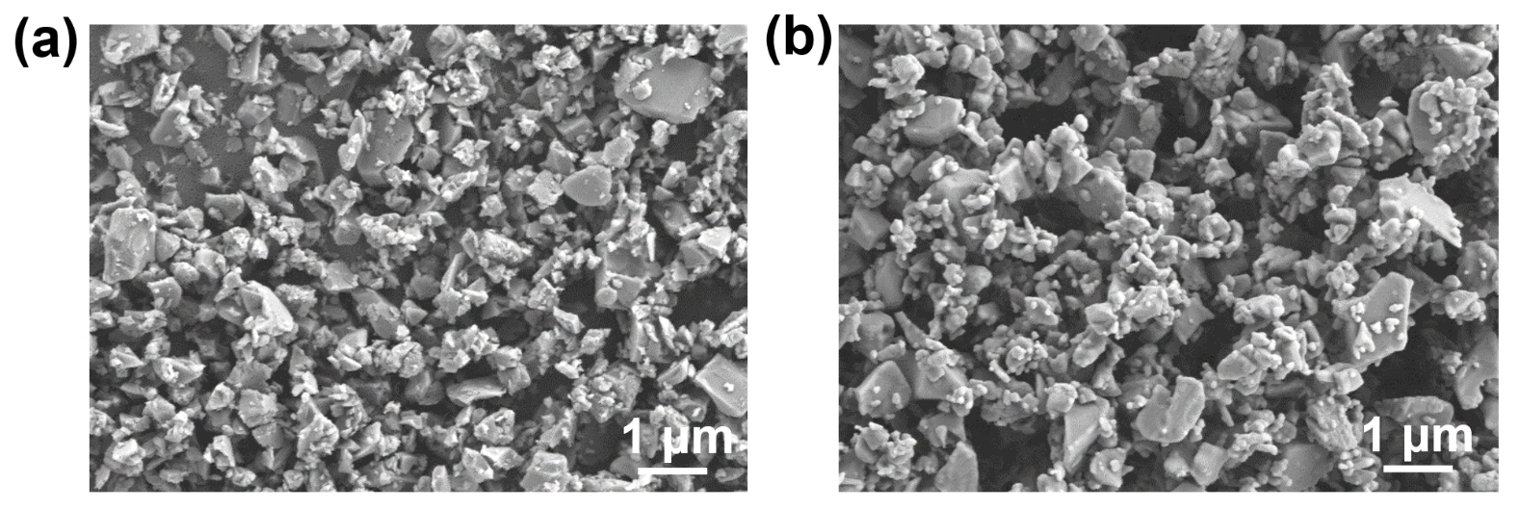
Fig. S2. SEM image of (a) LATP and (b) Al₂O₃@LATP powders.
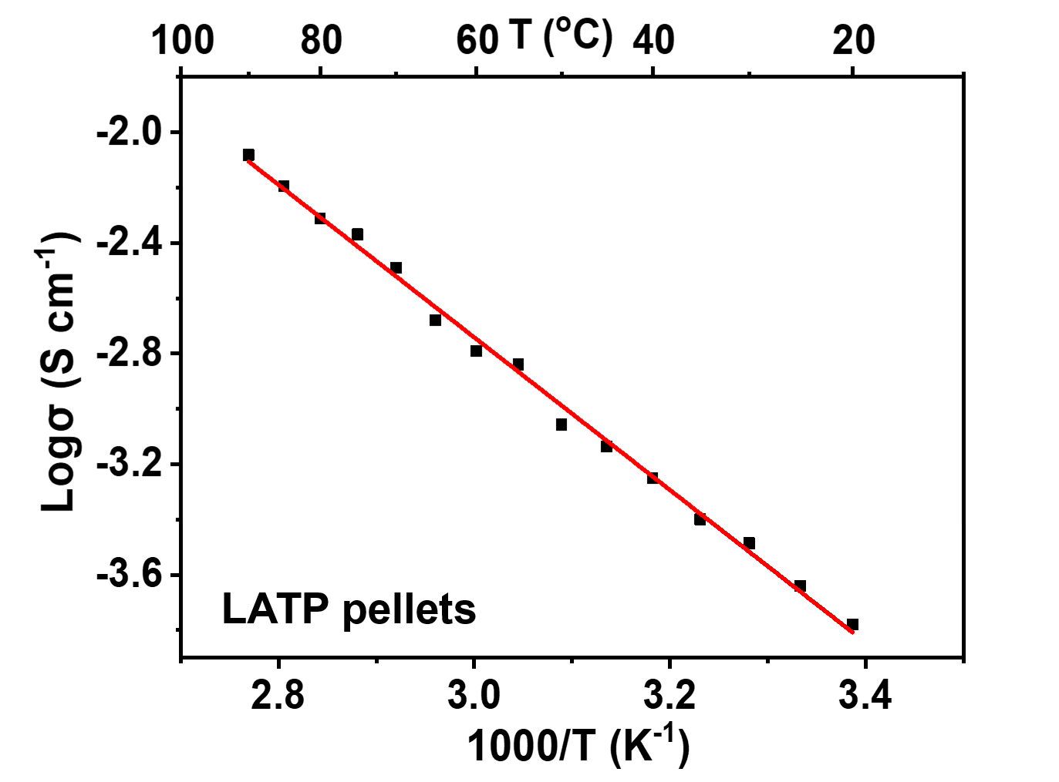
Fig. S3. Temperature dependence of ionic conductivities for LATP pellets.

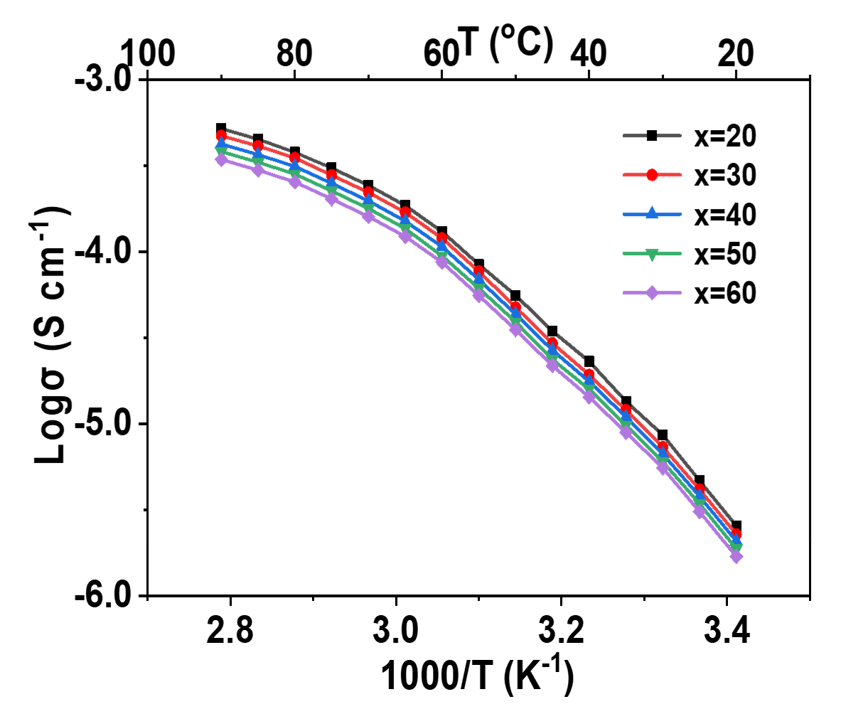
Fig. S4. Temperature dependence of ionic conductivities for PEO₈-LiTFSI-x%Al₂O₃@LATP + CA electrolytes, x=20, 30, 40, 50, 60.
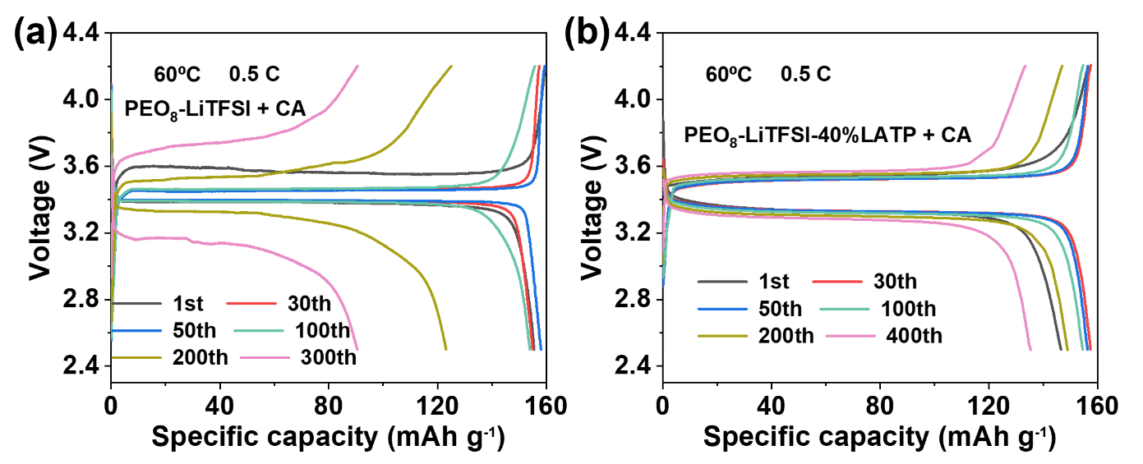
Fig. S5. Typical charge-discharge voltage profiles of LiFePO₄|Li cell with (a) PEO₈-LiTFSI + CA and (b) PEO₈-LiTFSI-40%LATP + CA at 0.5C rate and 60ºC.
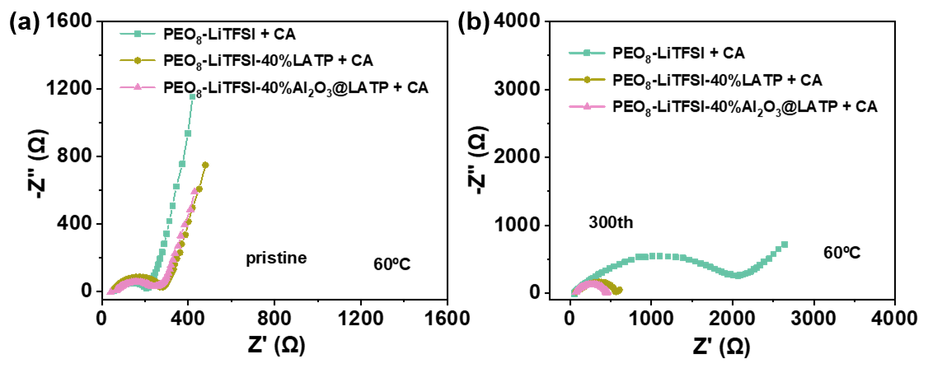
Fig. S6. AC impedances of LiFePO₄|PEO₈-LiTFSI + CA|Li, LiFePO₄|PEO₈-LiTFSI-40%LATP + CA|Li and LiFePO₄|PEO₈-LiTFSI-40%Al₂O₃@LATP + CA|Li cells, pristine and after 300 cycles at 60ºC.
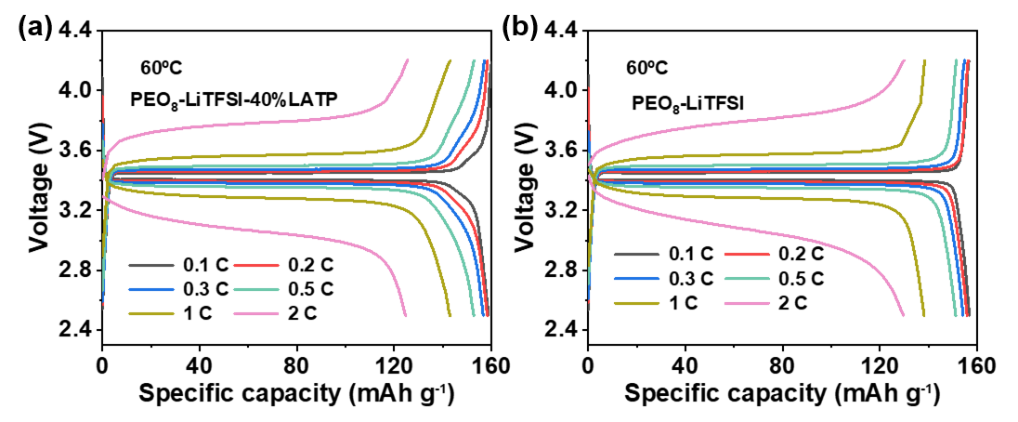
Fig. S7. Initial charge and discharge curves of (a) LiFePO₄|PEO₈-LiTFSI-40%LATP + CA|Li and (b) LiFePO₄|PEO₈-LiTFSI + CA|Li cells at different rates and 60ºC.

