Supplemental Data
Sex disparities of the effect of the COVID-19 pandemic on mortality among patients living with tuberculosis in the United States

Running Headline: TB-related Mortality during Pandemic

Huan Deng^{1＃}, Yishan Liu^{2,＃}, Fan Lv³, Xiaofeng Li^{2,4}, Mingyan Qi⁵, Yajing Bo², Sikai Qiu⁵, Xinyuan He², Fanpu Ji^{1,2,6,7,8,*}, Qing-Lei Zeng^{9,*}, Ning Gao^{2,*}

¹National & Local Joint Engineering Research Center of Biodiagnosis and Biotherapy, the Second Affiliated Hospital of Xi’an Jiaotong University, Xi’an, PRC.
²Department of Infectious Diseases, the Second Affiliated Hospital of Xi’an Jiaotong University, Xi’an, PRC.
³School of Mathematics and Statistics, Xi’an Jiaotong University, Xi’an, PRC.
³Division of General Internal Medicine, Cedars-Sinai Medical Center, Los Angeles, CA, USA.
²Department of Infectious Diseases, the Second Affiliated Hospital of Xi’an Jiaotong University, Xi’an, PRC.
⁴Center for Infectious Diseases, The Second Affiliated Hospital of Air Force Medical University, Xi'an, China
⁵The Second Affiliated Hospital of Xi’an Jiaotong University, Xi’an, PRC.
⁶Shaanxi Provincial Clinical Medical Research Center of Infectious Diseases, Xi'an, PRC.
⁷Global Health Institute, School of Public Health, Xi'an Jiaotong University Health Science Center, Xi'an, PRC.
⁸Key Laboratory of Surgical Critical Care and
Life Support (Xi'an Jiaotong University), Ministry of Education, China
⁹Department of Infectious Diseases, The First Affiliated Hospital of Zhengzhou University, Zhengzhou, Henan, China;

#These two authors contributed equally to the work
*These authors contributed equally to the supervision.

*Corresponding authors:
Dr. Fanpu Ji, MD, PhD
Department of Infectious Diseases,
The Second Affiliated Hospital of Xian Jiaotong University
No.157 Xi Wu Road, Xi'an 710004, Shaanxi Province, PRC.
Email: jifanpu1979@163.com or infection@xjtu.edu.cn

Dr. Qing‐Lei Zeng, MD, PhD
Professor of Medicine, Department of Infectious Diseases,
The First Affiliated Hospital of Zhengzhou University,
No. 1, Eastern Jianshe Road, Zhengzhou 450052, Henan, China.
Email: zengqinglei2009@163.com

Dr. Ning Gao, MD, PhD
Department of Infectious Diseases,
The Second Affiliated Hospital of Xian Jiaotong University
No.157 Xi Wu Road, Xi'an 710004, Shaanxi Province, PRC.
Email: gaohuining1@163.com
ORCID ID ：0000-0003-1018-3990

Table of Contents

Table S1. Model parameters in mortality among U.S. adults living with TB, 2006-2021.
Table S2. Annual percentage change (APC) of TB-related mortality in U.S. adults, 2006-2021.
Table S3. Annual percentage changes (APC) of TB-related mortality in U.S. adults, by age and further stratified by sex, 2006-2021.
Table S4. Age-standardized mortality rate and annual percentage change (APC) in TB-related mortality among U.S. adults by race/ethnicity, 2006-2020.

Figure S1. Temporal trends of mortality in general population and excess mortality during the COVID-19 pandemic, by sex, further stratified by Age.
Figure S2. Observed and predicted age-standardized mortality rates for TB-related deaths before and during the COVID-19 pandemic among different sex and age subgroups.
Figure S3. Observed and predicted age-standardized mortality rates for TB-related deaths before and during the COVID-19 pandemic by race/ethnicity.

Supplemental Table 1. Model parameters in TB-related mortality among adults in the U.S., 2006-2021.
 | [95%CI] | [95% CI] | [95%CI] | *
Overall
Total∭ | 0.75  [0.71,0.79] | -0.05  [-0.06,-0.04] | 0.002  [0.001,0.003] | 0.96
Age
25-44 years∭ | 0.12  [0.09,0.15] | -0.01  [-0.02,-0.002] | 0.001  [0,0.001] | 0.50
45-64 years∭ | 0.50  [0.46,0.55] | -0.02  [-0.04,-0.01] | 0.001  [0,0.002] | 0.87
≥65 years∭ | 2.53  [2.40,2.67] | -0.17  [-0.22,-0.13] | 0.01  [0.004,0.01] | 0.96
Sex
Female∭ | 0.49  [0.45,0.53] | -0.03  [-0.04,-0.02] | 0.0001  [0.0002,0.002] | 0.92
Male∭ | 1.09  [1.03,1.16] | -0.07  [-0.09,-0.05] | 0.003  [0.002,0.004] | 0.95
Race and ethnicity
Non-Hispanic Whites∭ | 0.44  [0.42,0.46] | -0.03  [-0.03,-0.02] | 0.001  [0.0005,0.001] | 0.97
Non-Hispanic Blacks∭ | 1.82  [1.64,2.00] | -0.17  [-0.23,-0.12] | 0.007  [0.003,0.01] | 0.94
Hispanics∭ | 1.53  [1.35,1.72] | -0.12  [-0.17,-0.06] | 0.004  [0.001,0.01] | 0.88
Non-Hispanic AI/AN∭ | 3.49  [2.44,4.54] | -0.08  [-0.41,0.24] | -0.01  [-0.03,0.02] | 0.68
Non-Hispanic Asians∭ | 3.22  [2.83,3.60] | -0.22  [-0.34,-0.11] | 0.01  [0.001,0.02] | 0.84
Female by age
25-44 years∬ | 0.06  [0.05,0.08] | -0.001  [-0.003,0.001] | -- | 0.10
45-64 years∭ | 0.21  [0.18,0.25] | 0.002  [-0.01,0.01] | -0.0004  [-0.001,0.0003] | 0.62
≥65 years∭ | 1.90  [1.76,2.04] | -0.15  [-0.19,-0.10] | 0.006  [0.003,0.009] | 0.95
Male by age
25-44 years∭ | 0.18  [0.14,0.21] | -0.02  [-0.03,-0.008] | 0.001  [0.0003,0.002] | 0.60
45-64 years∭ | 0.81  [0.74,0.88] | -0.05  [-0.07,-0.03] | 0.002  [0.001,0.003] | 0.89
≥65 years∭ | 3.53  [3.30,3.75] | -0.23  [-0.30,-0.16] | 0.01  [0.005,0.01] | 0.94

*: the goodness of fit, which is used to describe the fitting degree of the regression equation to the observed value. The value range of is [0,1]. The closer is to 1, the better the fitting degree is.
∬ ; ∭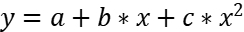
Supplemental Table 2. Annual percentage change (APC) of TB-related mortality among U.S. adults, overall, by age and sex, between 2006 and 2021.
 | Year | Trend Segment  APC [95% CI]
Overall
 | 2006-2015  2015-2021 | -4.6*[-6.0 to -3.7]  2.2 [-0.1 to 4.5]
Age Group
25-44 years | 2006-2021 | -0.4[-3.1 to 2.4]
45-64 years | 2006-2019  2019-2021 | -2.8* [-3.7 to -1.9]  16.8[-2.2 to 39.5]
≥65 years | 2006-2014  2014-2021 | -5.7* [-6.8 to -4.5]  0.5[-1.0 to 1.9]
Sex
Female | 2006-2015  2015-2021 | -5.6* [-7.3 to -3.8]  2.9 [-0.5 to 6.5]
Male | 2006-2011  2011-2019  2019-2021 | -6.5*[-9.3 to -3.7]  -1.5[-3.2 to 0.3]  6.7[-6.5 to 21.7]

*P-value ≤ 0.05
Supplemental Table 3. Annual percentage changes (APC) of TB-related mortality among U.S. adults, by age and further stratified by sex, 2006-2021.
 | Year | Trend Segment  APC [95% CI]
Females
25-44 years | 2006-2021 | 0.1 [-2.8to3.2]
45-64 years | 2006-2019  2019-2021 | -2.2* [-3.6 to -0.8]  22.8 [-1.7 to 68.7]
≥65 years | 2006-2014  2014-2021 | -7.2* [-8.6 to -5.8]  0.9* [-1.0 to 2.7]
Males
25-44 years | 2006-2012  2012-2021 | -12.1* [-19.0 to -4.5]  6.5* [1.9 to 11.3]
45-64 years | 2006-2014  2014-2021 | -4.7* [-6.9 to -2.4]  1.1 [-1.7 to 4.1]
≥65 years | 2006-2011  2011-2021 | -6.9* [-9.7 to -3.9]  -1.1 [-2.2 to 0]

*P-value ≤0.05

Supplemental Table 4. Age-standardized mortality rate and annual percentage change (APC) in TB-related mortality among U.S. adults by race/ethnicity, 2006-2020.
Age-Standardized Mortality Rate Per 100,000 Persons |  |  |  |  |  |  | Temporal Trend Differences
 | Pre-Pandemic  Epoch, 2006 | Pre-Pandemic  Epoch, 2019 | Pandemic Epoch 1  2020 |  |  |  | Trend Segments | APC [95% CI]
Race/Ethnicity | Observed | Observed | Observed | Predicted  [95% CI] |  | % Difference†
Non-Hispanic Whites | 0.42 | 0.28 | 0.30 | 0.27  [0.25-0.29] | 10.29 |  | 2006-2016  2016-2020 | -4.3[-5.1 to -3.5]  2.4[-0.9 to 5.8]
Non-Hispanic Blacks | 1.68 | 0.60 | 0.82 | 0.78  [0.60-0.96] | 6.06 |  | 2006-2015  2015-2020 | -8.4*[-11.1 to -5.6]  1.1[-6.0 to 8.7]
Hispanics | 1.52 | 0.63 | 0.87 | 0.77  [0.59-0.96] | 12.18 |  | 2006-2020 | -4.3*[-5.7 to -5.7]
Non-Hispanic AI/AN | 3.44 | 1.40 | 1.87 | 1.0  [0.01-2.11] | 76.25 |  | 2006-2020 | -6.0[-8.4 to -3.5]
Non-Hispanic Asians | 3.10 | 1.96 | 1.91 | 1.87  [1.49-2.26] | 1.93 |  | 2006-2020 | -3.4[-4.7 to -2.2]

†Denotes % difference between predicted and observed values.
*P-value ≤0.05
Non-Hispanic AI/AN, Non-Hispanic American Indian/Alaska Native
Supplemental Figure 1. Temporal trends of all-cause mortality in general population and excess mortality during the COVID-19 pandemic, by sex, further stratified by age. (A) Overall population, (B) Female, (C) Male, (D) Aged at 25-44 years old in overall population, (E) Aged at 25-44 years old in female, (F) Aged at 25-44 years old in male, (G) Aged at 45-64 years old in overall population, (H) Aged at 45-64 years old in female, (I) Aged at 45-64 years old in male, (J) Aged 65 years and above in overall population, (K) Aged 65 years and above in female, (L) Aged 65 years and above in male. The mortality rates (per 100,000 persons) in general population increased across all subgroups during the pandemic. The observed mortality rates were above the predicted mortality rates (dashed horizontal line). Depicted by purple bars, the excess mortality associated with COVID-19 was more pronounced in people aged 45 years, especially for people older than 65 years during the pandemic.
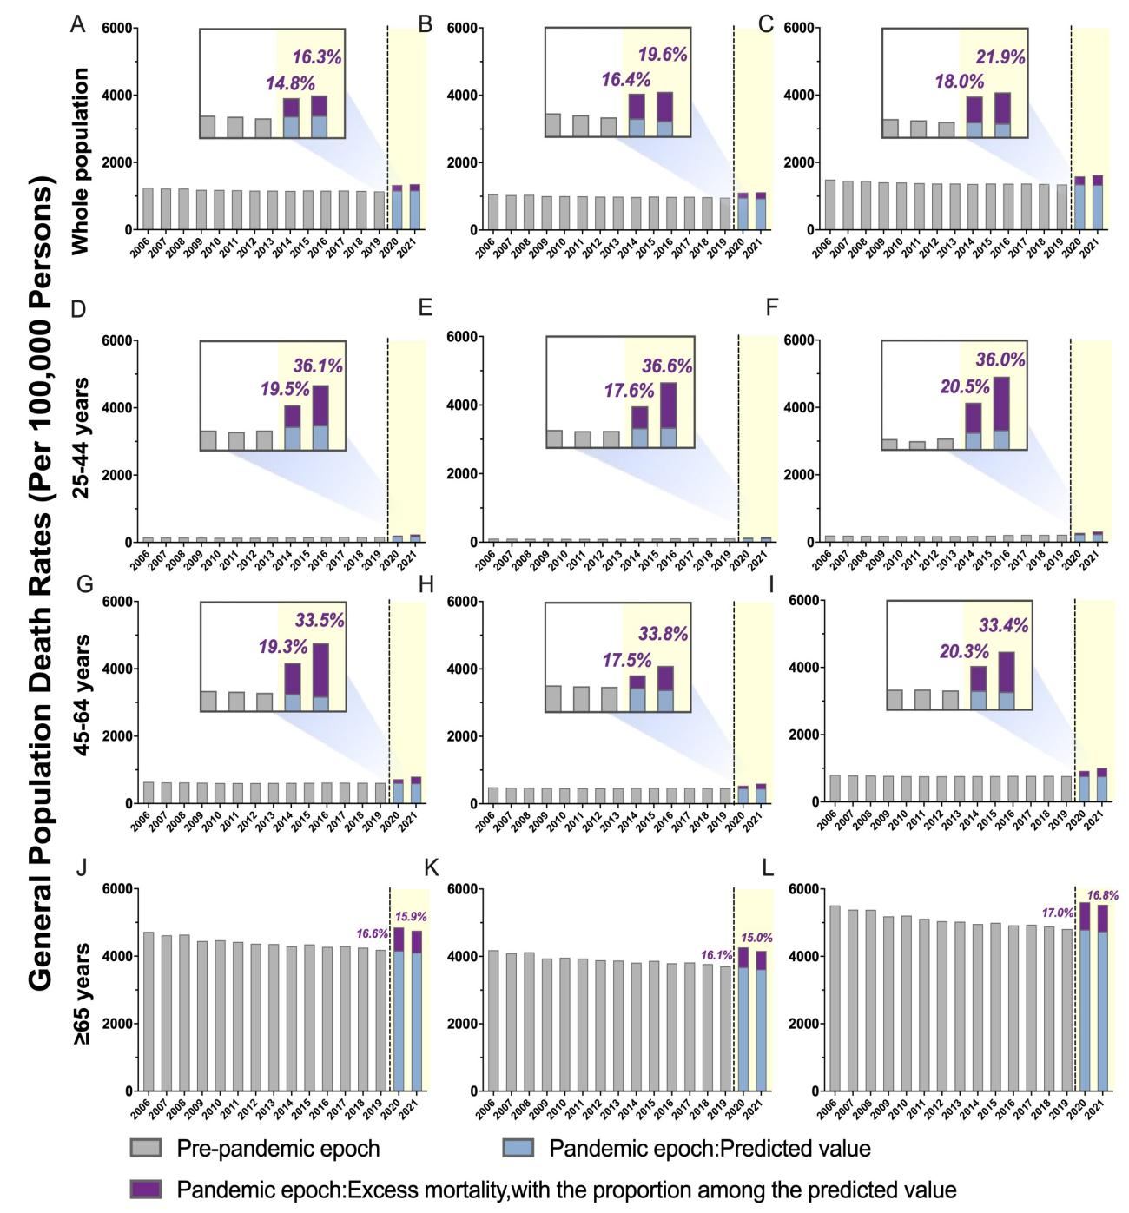

Supplemental Figure 2. Observed and predicted age-standardized mortality rates for TB-related deaths before and during the COVID-19 pandemic among different sex and age subgroups.
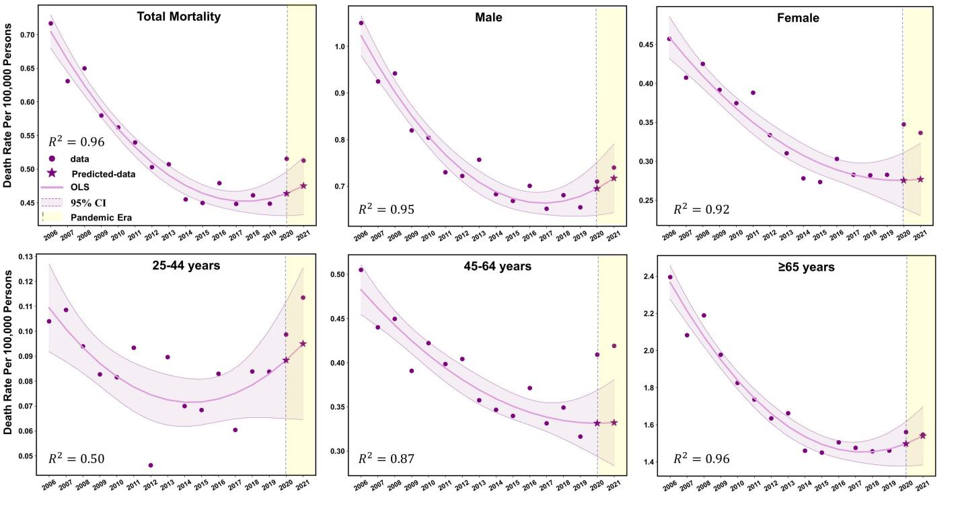

Supplemental Figure 3. Observed and predicted age-standardized mortality rates for TB-related deaths before and during the COVID-19 pandemic by race/ethnicity.
