Supplementary Information
Mitigating Candidiasis with Acarbose by targeting Candida albicans α-Glucosidase: In-silico, In-vitro and Transcriptomic Approaches
Helma David¹, Sahana Vasudevan^{1,2*}, Adline Princy Solomon^{1*}
¹Quorum Sensing Laboratory, Centre for Research in Infectious Diseases (CRID), School of Chemical and Biotechnology, SASTRA Deemed to be University, Thanjavur, 613401, India.
²Institute for Stem Cell Science and Regenerative Medicine (inStem), Bangalore 560065, India
Email IDs: adlineprinzy@sastra.ac.in , savvysahana@gmail.com

Figure S1: Illustrates the docked image of Human α-glucosidase Acarbose complex interacting with active site residues (A) Three-dimensional docked pose; The protein structure is shown in wheat color surface representation (left): cartoon representation (right) and acarbose is shown as a rainbow stick representation. (B) Two-dimensional interaction. Hydrogen bond (purple arrow) with ASP443 and ASP542; Electrostatic Interaction (orange color) with GLU446.
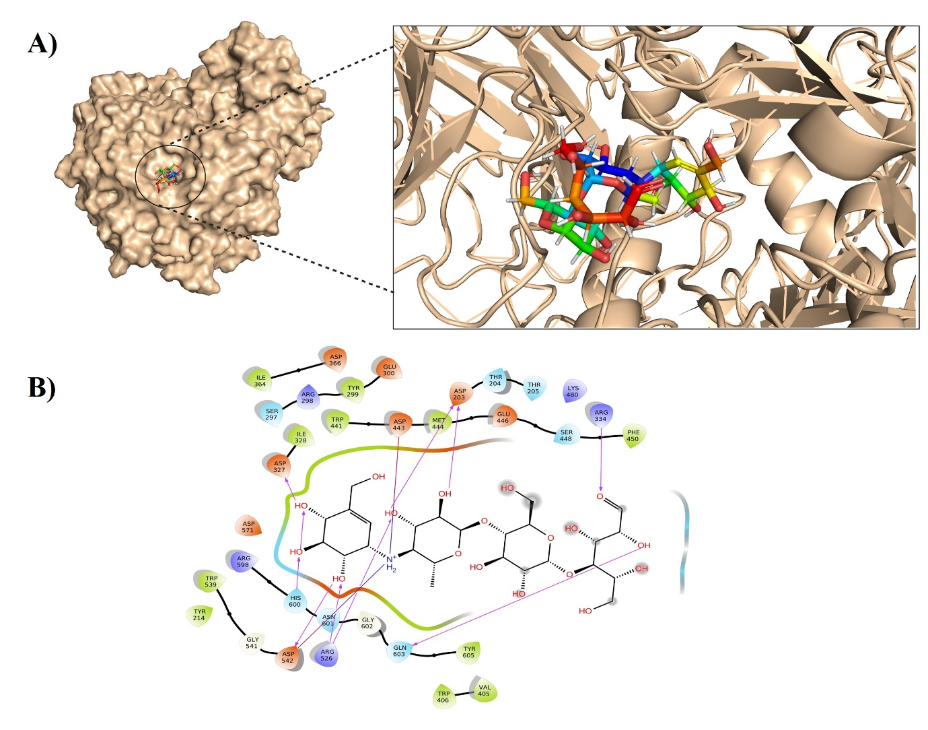

Figure S2: Illustrates the Germ tube inhibition kinetics of A) ATCC90028 and B) Clinical isolate BF1 90 nM of Acarbose. Phase contrast images were taken every 2 h till 6 h at 60 X magnification to visualize the time-dependent inhibition of hyphal morphogenesis compared to the control. Until 6 h, the Acarbose treated cells were in yeast form. The scale bar indicates 50 µm.
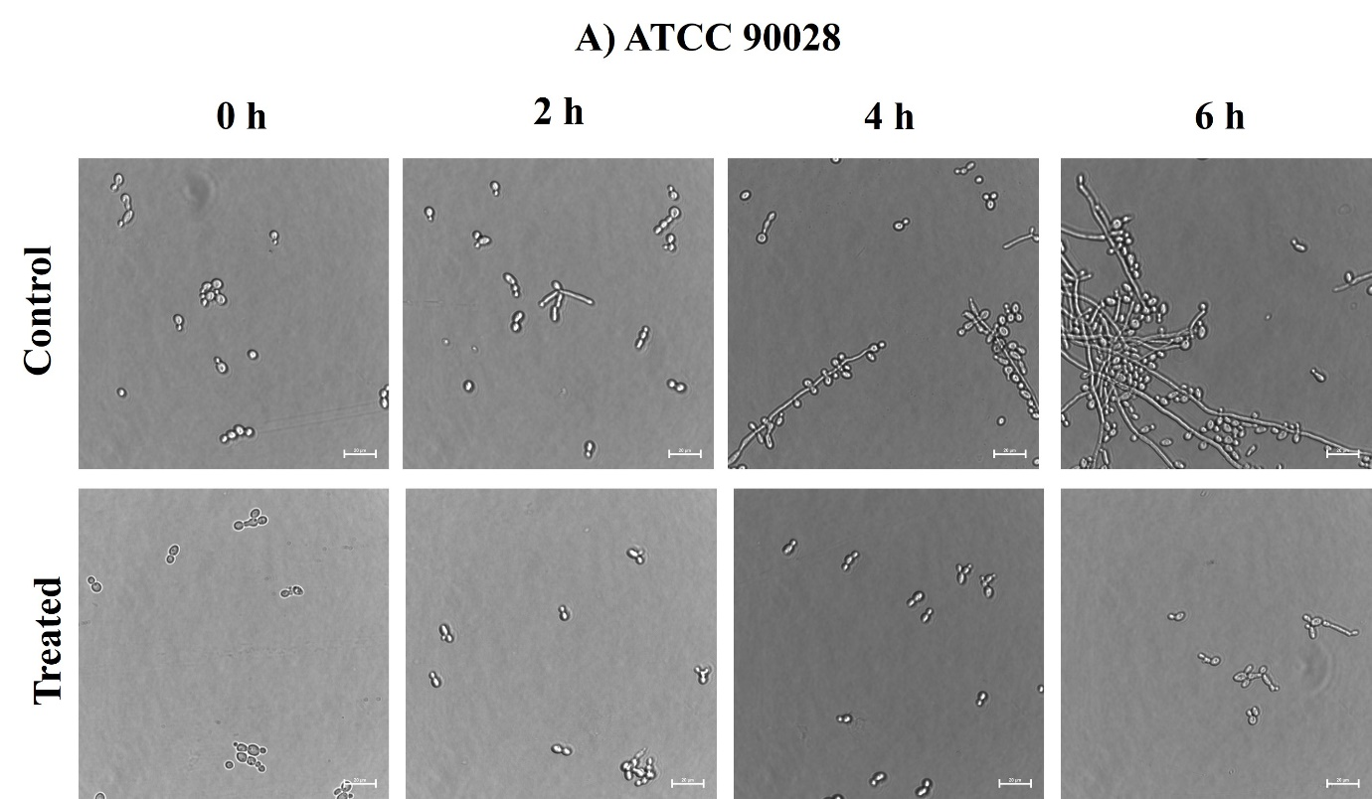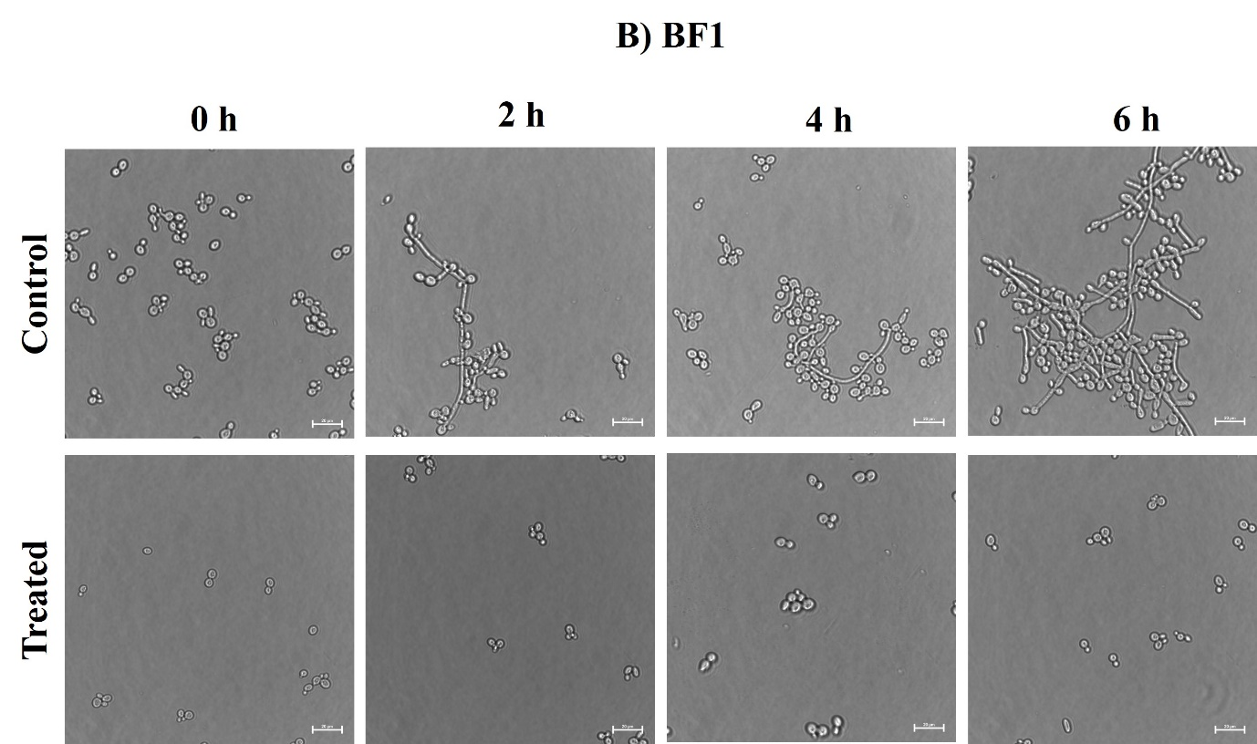

Table S1: AlphaFold2 generated Models of Candidal α-glucosidase.
Sl. No: | Model | Structure | Quality Factor | Ramachandran Plot
 |  |  |  | Residues in the most favorable region (%) | Residues in Disallowed Region (%)
1 | QSL-M1 | 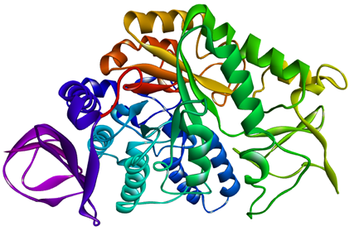 | 93.9 | 95.9 | 0.2
2 | QSL-M2 | 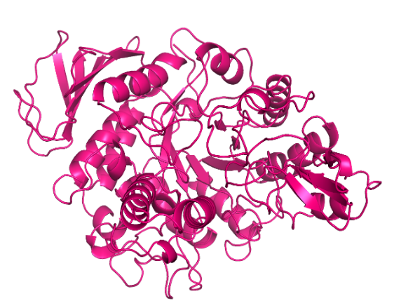 | 92.7 | 95.5 | 0.2
3 | QSL-M3 | 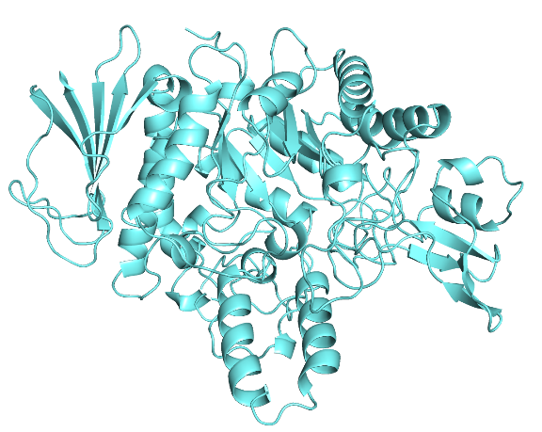 | 92.7 | 95.1 | 0.2
4 | QSL-M4 | 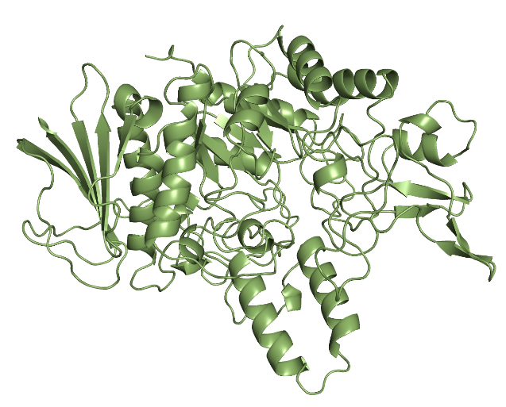 | 91.89 | 95.7 | 0.2
5 | QSL-M5 | 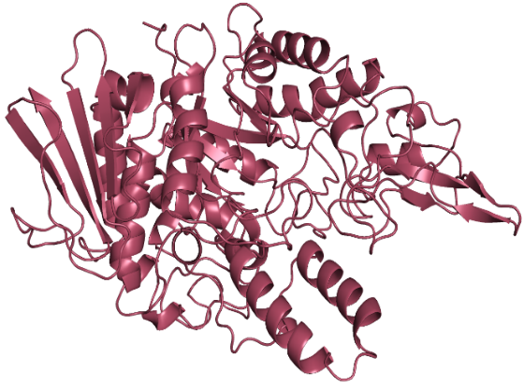 | 91.68 | 95.1 | 0.2

Table S2: Top 50 FDA-Approved glycomimetic drugs showing lowest Glide Score in XP docking using Schrodinger Glide.
Sl. No. | Drug | Glide score
1 | Acarbose | -11.4717
2 | Ribostamycin | -10.8977
3 | Inulin | -9.93883
4 | Calcium glubionate | -9.53847
5 | Lincomycin | -9.11977
6 | Idarubicin | -8.86281
7 | Lactulose | -8.82533
8 | Lactose | -8.80864
9 | Lactitol | -8.73616
10 | Hydroxyethyl Starch | -8.63156
11 | Polydatin | -8.59837
12 | Sorbitol | -8.45395
13 | Chondroitin sulfate | -8.35498
14 | Gaxilose | -8.02547
15 | Decitabine | -7.73085
16 | Arbutin | -7.57581
17 | Dapagliflozin | -7.21004
18 | Migalastat | -7.11438
19 | Esculin | -7.05611
20 | 5-O-phosphono-alpha-D-ribofuranosyl diphosphate | -7.02831
21 | Glucosamine | -7.0279
22 | Calcium glucoheptonate | -6.98094
23 | Ticagrelor | -6.87254
24 | Adenosine | -6.75357
25 | N-Acetylglucosamine | -6.69087
26 | Gadobenic acid | -6.66576
27 | Galactose | -6.55569
28 | Manganese gluconate | -6.29639
29 | Gluconic Acid | -6.28932
30 | Zinc gluconate | -6.19946
31 | Vidarabine | -6.18147
32 | Calcium D-saccharate | -6.13861
33 | Gluconolactone | -6.10851
34 | Xylose | -6.09635
35 | Copper gluconate | -6.01235
36 | Zanamivir | -6.00435
37 | Calcium gluconate | -5.87312
38 | Spectinomycin | -5.74324
39 | Inositol | -5.71329
40 | Miglustat | -5.59723
41 | Miglitol | -5.59577
42 | Trimetrexate | -5.59374
43 | Calcium glycerophosphate | -5.54396
44 | Gemcitabine | -5.46608
45 | Vitamin C | -5.22469
46 | Novobiocin | -5.21894
47 | Streptozocin | -5.17313
48 | Calcium glycerophosphate | -5.02665
49 | Sodium tartrate | -4.98996
50 | Sodium glycerophosphate | -4.9584

Table S3: List of primers used for qRTPCR.
S.No. | List of Genes | Forward Primer | Reverse Primer | Reference
 | PHR1 | GGTTTGGTTCTGGTTGATGG | AGCAGCAGTTCCTGGACATT | ⁴⁹
 | PHR2 | CTCCTCCATTTCCAGAACCA | CGTCTGAATCAACCTTGTCG | ⁴⁹
 | SOD1 | TTGAACAAGAATCCGAATCC | AGCCAATGACACCACAAGCAG | ⁴⁹
 | ERG11 | GAAAGAGAACCATTACCAGG | AGGAATCGACGGATCAC | ³⁴
 | CDR | TGGTGCCATGACTCCTGCTA | CCATCGAGACCAACCCAACA | ³⁴
 | MDR | CCACTGGTGGTGCAAGTGTT | GAACCACAAACAGCACCCAA | ³⁴
 | UME6 | AGCACCAAATTCGCCTTATG | AGGTTGAGCTTGCTGCAGTT | ³⁴
 | EFG | CCAGGGTGGTGCTGCTAATG | GGGTGAAGGGTGAACTGAACC | ³⁴
 | RBT1 | CTGCCATTCAACCATCTAACTCCTCATAC | GCAGCAAGACCAATAATAGCAGCACCATAAGT | ³⁴
 | RAS1 | GGCCATGAGAGAACAATATA | GTCTTTCCATTTCTAAATCAC | ³⁴

