Supplementary Material: De novo inverse materials design by combining optimization algorithm, universal potential and universal property model

Guanjian Cheng^{1,2}, Xin-Gao Gong^{3,2}, Wan-Jian Yin^{1,2,4,*}

¹College of Energy, Soochow Institute for Energy and Materials InnovationS (SIEMIS), and Jiangsu Provincial Key Laboratory for Advanced Carbon Materials and Wearable Energy Technologies, Soochow University, Suzhou 215006, China
²Shanghai Qi Zhi Institute, Shanghai, 200232, China
³Key Laboratory for Computational Physical Sciences (MOE), Institute of Computational Physical Sciences, Fudan University, Shanghai, 200438, China
⁴Light Industry Institute of Electrochemical Power Sources, Soochow University, Suzhou 215006, China
*wjyin@suda.edu.cn

Supplementary Fig. 1. UPot-predicted and DFT-calculated (a) total energies, (b) atomic forces, and (c) stress for 2,944 testing materials.

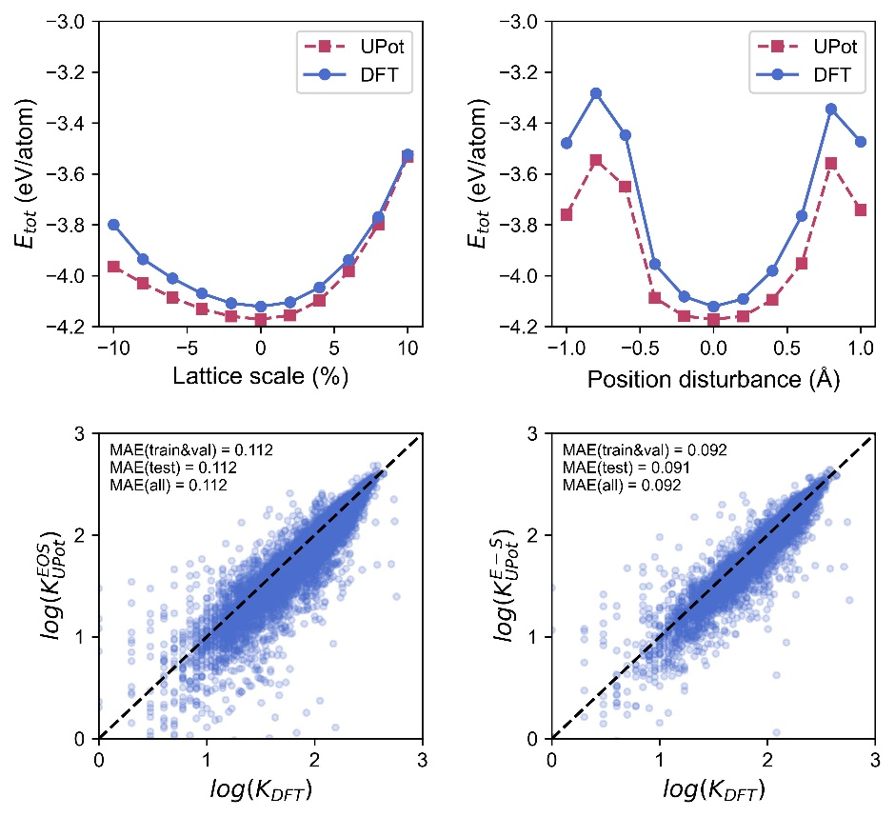
(a)
(b)
(c)
(d)

Supplementary Fig. 2. a, b, The curve of the total energy of A follows lattice (a) and atomic coordinate (b) disturbances. c, d, The parity plots for the UBmod by EOS (c) and E-S (d), the dash lines (y=x) are guides for the eye.

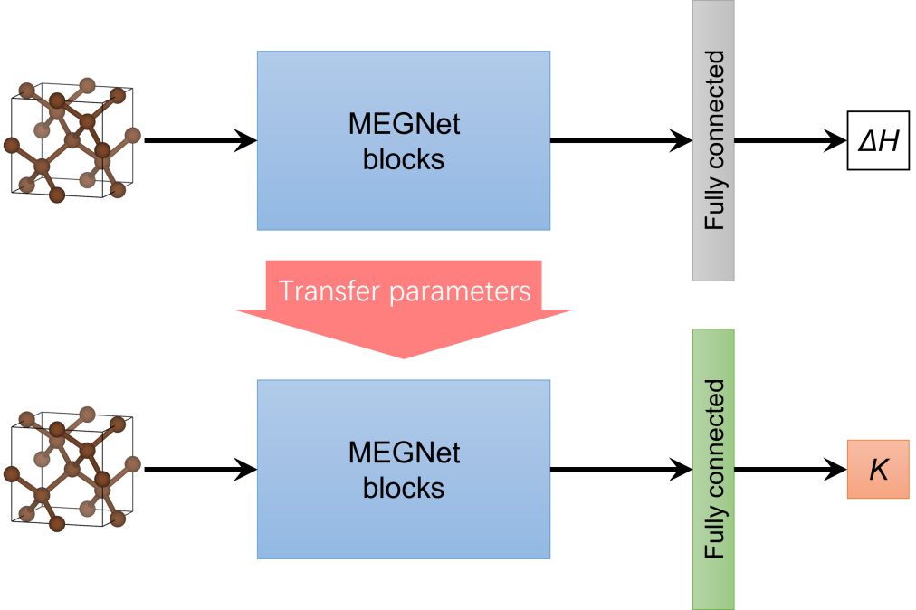

Supplementary Fig. 3. Transfer learning flow chart.

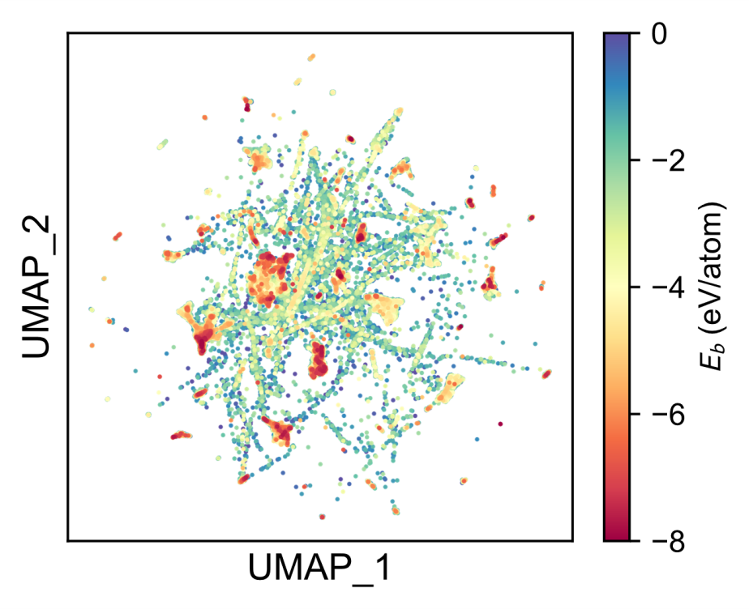

Supplementary Fig. 4. 2D UMAP formed by extensive random sampling in full space. The heat map represents the relative cohesive energy.

Supplementary Table 1. Selection 50 typical compounds with the high atomic cohesion identified by the UPot-BO.

# | a | c | s | $$E_{b}^{pred}$$ | $$∆H^{pred}$$ | $$E_{b}^{DFT}$$ | $$∆H^{DFT}$$ | Matched in MP
1 | Zr-C | 1-1 | Zr5C5 | -7.961 | -0.766 | -8.034 | -0.840 | mp-2795, mp-1009894
2 |  |  | Zr4C4 | -7.462 | -0.268 | -7.939 | -0.745
3 |  |  | Zr5C5 | -7.693 | -0.499 | -7.319 | -0.124
4 |  | 4-5 | Zr4C5 | -7.615 | -0.342 | -7.785 | -0.511
5 |  |  | Zr4C5 | -7.619 | -0.346 | -7.716 | -0.443
6 |  |  | Zr4C5 | -7.642 | -0.368 | -7.595 | -0.322
7 |  |  | Zr4C5 | -7.573 | -0.299 | -7.546 | -0.273
8 |  |  | Zr4C5 | -7.545 | -0.272 | -7.528 | -0.255
9 |  |  | Zr4C5 | -7.564 | -0.291 | -7.405 | -0.132
10 |  |  | Zr4C5 | -7.461 | -0.188 | -7.307 | -0.034
11 |  |  | Zr4C5 | -7.443 | -0.170 | -7.254 | 0.019
12 |  |  | Zr4C5 | -7.383 | -0.110 | -7.209 | 0.064
13 |  | 5-4 | Zr5C4 | -7.618 | -0.503 | -7.639 | -0.524
14 |  |  | Zr5C4 | -7.555 | -0.440 | -7.566 | -0.451
15 |  |  | Zr5C4 | -7.586 | -0.471 | -7.548 | -0.433
16 |  |  | Zr5C4 | -7.462 | -0.347 | -7.433 | -0.318
17 |  |  | Zr5C4 | -7.199 | -0.084 | -7.057 | 0.058
18 |  | 3-4 | Zr3C4 | -7.438 | -0.142 | -7.627 | -0.331
19 |  | 3-5 | Zr3C5 | -7.534 | -0.162 | -7.612 | -0.239
20 |  |  | Zr3C5 | -7.233 | 0.139 | -7.450 | -0.077
21 |  | 2-5 | Zr2C5 | -7.545 | -0.045 | -7.371 | 0.129
22 |  | 1-5 | Zr1C5 | -7.498 | 0.171 | -7.153 | 0.517
23 | Zr-N | 1-1 | Zr5N5 | -7.431 | -1.580 | -7.597 | -1.746 | mp-1352, mp-1009885
24 |  | 5-4 | Zr5N4 | -7.197 | -1.277 | -7.500 | -1.580
25 |  |  | Zr5N4 | -7.250 | -1.330 | -7.183 | -1.262
26 |  |  | Zr5N4 | -7.206 | -1.285 | -7.080 | -1.159
27 |  | 2-1 | Zr4N2 | -7.292 | -1.232 | -7.233 | -1.172
28 |  |  | Zr4N2 | -7.292 | -1.232 | -7.230 | -1.170
29 |  | 4-5 | Zr4N5 | -7.212 | -1.432 | -7.216 | -1.435
30 |  | 5-3 | Zr5N3 | -7.168 | -1.160 | -7.159 | -1.151
31 | Zr-O | 5-4 | Zr5O4 | -7.190 | -2.101 | -7.326 | -2.237
32 |  | 4-5 | Zr4O5 | -7.291 | -2.550 | -7.322 | -2.581
33 |  | 1-1 | Zr5O5 | -7.148 | -2.233 | -7.208 | -2.293 | mp-33088, mp-10197
34 |  | 5-3 | Zr5O3 | -7.082 | -1.776 | -7.183 | -1.876
35 |  | 2-1 | Zr4O2 | -7.111 | -1.674 | -7.031 | -1.593
36 | Zr-B | 4-5 | Zr4B5 | -7.169 | -0.771 | -7.147 | -0.750
37 |  | 5-4 | Zr5B4 | -7.082 | -0.668 | -7.050 | -0.636
38 |  | 2-5 | Zr2B5 | -7.083 | -0.709 | -6.841 | -0.467
39 |  | 1-1 | Zr5B5 | -6.778 | -0.372 | -6.796 | -0.390 | mp-451
40 | Ti-N | 5-3 | Ti5N3 | -6.712 | -1.216 | -7.103 | -1.207
41 | Y-O | 4-5 | Y4O5 | -7.011 | -3.196 | -7.033 | -3.217
42 |  | 3-5 | Y3O5 | -6.843 | -3.100 | -6.944 | -3.201
43 |  | 1-1 | Y5O5 | -6.764 | -2.890 | -6.675 | -2.800
44 | Ti-O | 1-1 | Ti5O5 | -6.912 | -2.406 | -7.012 | -2.186
45 |  | 2-1 | Ti4O2 | -6.712 | -1.822 | -7.004 | -1.686
46 | Sc-C | 1-2 | Sc2C4 | -6.735 | -0.008 | -6.699 | 0.031
47 | Sc-N | 1-1 | Sc5N5 | -6.713 | -1.914 | -6.667 | -1.869 | mp-2857, mp-1009750
48 |  | 5-4 | Sc5N4 | -6.246 | -1.496 | -6.431 | -1.679
49 | B-C | 5-4 | B5C4 | -6.852 | 0.180 | -6.594 | 0.438
50 |  | 1-1 | B5C5 | -7.049 | 0.070 | -6.538 | 0.582

Supplementary Table 2. Selection 50 typical compounds with the high atomic cohesion identified by the UPot-CHEERS.

# | a | c | s | $$E_{b}^{pred}$$ | $$∆H^{pred}$$ | $$E_{b}^{DFT}$$ | $$∆H^{DFT}$$ | Matched in MP
1 | Zr-C | 1-1 | Zr4C4 | -7.961 | -0.767 | -8.039 | -0.844 | mp-2795, mp-1009894
2 |  |  | Zr4C4 | -7.871 | -0.677 | -7.871 | -0.677 | mp-1014307
3 |  |  | Zr4C4 | -7.666 | -0.472 | -7.650 | -0.455
4 |  |  | Zr4C4 | -7.839 | -0.645 | -7.643 | -0.448 | mp-1009894
5 |  |  | Zr4C4 | -7.620 | -0.425 | -7.616 | -0.422
6 |  |  | Zr4C4 | -7.535 | -0.340 | -7.523 | -0.328
7 |  |  | Zr4C4 | -7.618 | -0.424 | -7.501 | -0.307
8 |  | 5-4 | Zr5C4 | -7.541 | -0.426 | -7.885 | -0.771
9 |  |  | Zr5C4 | -7.560 | -0.445 | -7.535 | -0.420
10 |  | 4-3 | Zr4C3 | -7.900 | -0.808 | -7.882 | -0.790
11 |  |  | Zr4C3 | -7.539 | -0.447 | -7.509 | -0.416
12 |  | 4-5 | Zr4C5 | -7.749 | -0.479 | -7.818 | -0.544
13 |  |  | Zr4C5 | -7.631 | -0.358 | -7.636 | -0.363
14 |  | 3-2 | Zr3C2 | -7.738 | -0.687 | -7.771 | -0.720
15 |  |  | Zr3C2 | -7.641 | -0.589 | -7.397 | -0.345
16 |  | 5-3 | Zr5C3 | -7.573 | -0.557 | -7.691 | -0.676
17 |  | 2-3 | Zr2C3 | -7.614 | -0.277 | -7.676 | -0.340
18 |  |  | Zr2C3 | -7.639 | -0.302 | -7.619 | -0.282
19 |  |  | Zr2C3 | -7.566 | -0.229 | -7.555 | -0.218
20 |  |  | Zr2C3 | -7.562 | -0.225 | -7.377 | -0.041
21 |  | 3-4 | Zr3C4 | -7.636 | -0.340 | -7.667 | -0.371
22 |  |  | Zr3C4 | -7.585 | -0.289 | -7.580 | -0.284
23 |  |  | Zr3C4 | -7.547 | -0.251 | -7.483 | -0.187
24 |  | 2-1 | Zr4C2 | -7.668 | -0.712 | -7.578 | -0.622
25 |  | 1-2 | Zr2C4 | -7.538 | -0.106 | -7.457 | -0.025
26 |  | 3-5 | Zr3C5 | -7.533 | -0.160 | -7.414 | -0.042
27 | C | 1 | C4 | -7.895 | 0.013 | -7.915 | -0.007 | mp-48, mp-569304, mp-632329, mp-937760, mp-568363, mp-568286
28 |  |  | C4 | -7.895 | 0.012 | -7.914 | -0.006 | mp-169
29 |  |  | C4 | -7.894 | 0.013 | -7.907 | 0.001 | mp-48, mp-632329, mp-568363, mp-568806
30 |  |  | C4 | -7.843 | 0.064 | -7.894 | 0.014 | mp-48, mp-937760, mp-568363, mp-568286
31 | Ti-C | 1-1 | Ti1C1 | -7.599 | -0.815 | -7.869 | -0.764 | mp-631
32 |  | 3-2 | Ti3C2 | -7.289 | -0.730 | -7.621 | -0.676
33 |  | 2-3 | Ti2C3 | -7.326 | -0.317 | -7.440 | -0.175
34 | Zr-O | 1-2 | Zr1O2 | -7.681 | -3.288 | -7.777 | -3.383 | mp-775909, mp-754741, mp-556605, mp-1190186, mp-755759, mp-755089, mp-1565, mp-2574
35 |  |  | Zr1O2 | -7.601 | -3.208 | -7.641 | -3.247
36 |  |  | Zr1O2 | -7.600 | -3.207 | -7.625 | -3.231
37 |  | 2-3 | Zr2O3 | -7.478 | -2.876 | -7.548 | -2.946
38 |  | 3-4 | Zr3O4 | -7.233 | -2.546 | -7.330 | -2.638
39 |  | 1-1 | Zr1O1 | -7.137 | -2.221 | -7.205 | -2.289
40 | Zr-N | 1-1 | Zr2N2 | -7.431 | -1.580 | -7.593 | -1.742 | mp-1352, mp-1009885
41 | Ti-O | 2-3 | Ti2O3 | -7.140 | -2.866 | -7.395 | -2.864
42 |  | 3-5 | Ti3O5 | -7.043 | -2.827 | -7.330 | -2.872
43 | Ti-B | 1-2 | Ti2B4 | -7.169 | -1.061 | -7.364 | -1.042 | mp-1145
44 |  | 2-5 | Ti2B5 | -6.923 | -0.796 | -7.014 | -0.691
45 |  | 2-3 | Ti2B3 | -6.848 | -0.786 | -6.864 | -0.545
46 | C-O | 5-1 | C5O1 | -7.140 | 0.007 | -7.171 | -0.023
47 |  | 5-2 | C5O2 | -6.767 | -0.160 | -6.675 | -0.069
48 | B-C | 1-3 | B1C3 | -7.434 | 0.079 | -7.124 | 0.389
49 | Si-C | 1-5 | Si1C5 | -6.923 | 0.424 | -6.938 | 0.408
50 |  | 1-3 | Si1C3 | -6.595 | 0.471 | -6.596 | 0.470

Supplementary Table 3. Selection 50 typical compounds with the high bulk modulus identified by the UPot- UBmod-BO.

# | a | c | s | $$K_{}^{pred}$$ | $$∆H^{pred}$$ | $$K_{}^{DFT}$$ | $$∆H^{DFT}$$ | Matched in MP
1 | C | 1 | C6 | 433.157 | 0.140 | 434.443 | 0.133 | mp-569567, mp-66, mp-1080826, mp-24, mp-998866
2 |  |  | C6 | 392.998 | 0.871 | 390.724 | 1.067
3 |  |  | C6 | 326.852 | 0.653 | 341.414 | 0.878 | mp-1181996
4 |  |  | C7 | 285.489 | 0.844 | 339.092 | 0.855
5 |  |  | C7 | 358.389 | 0.761 | 337.543 | 0.765
6 |  |  | C4 | 361.873 | 0.766 | 333.434 | 0.932 | mp-632329, mp-568806
7 |  |  | C7 | 368.803 | 0.758 | 327.530 | 0.838
8 |  |  | C5 | 347.155 | 0.546 | 324.859 | 0.794
9 |  |  | C7 | 365.891 | 0.846 | 321.441 | 0.705
10 |  |  | C7 | 251.594 | 0.708 | 246.772 | 0.801
11 |  |  | C7 | 307.261 | 0.974 | 233.142 | 1.058 | mp-1182029
12 | B-C | 1-2 | B2C4 | 360.895 | 0.677 | 421.612 | 0.636
13 |  |  | B2C4 | 332.057 | 0.449 | 308.765 | 0.794
14 |  | 1-4 | B1C4 | 316.833 | 0.733 | 283.379 | 0.490
15 |  |  | B1C4 | 258.827 | 0.400 | 268.474 | 0.535
16 |  |  | B1C4 | 252.085 | 0.435 | 228.262 | 0.684
17 |  | 3-1 | B3C1 | 324.637 | 0.442 | 298.955 | 0.776
18 |  |  | B3C1 | 281.330 | 0.248 | 217.226 | 0.418
19 |  | 2-1 | B2C1 | 294.686 | 0.249 | 279.020 | 0.593
20 |  | 2-5 | B2C5 | 283.709 | 0.368 | 256.795 | 0.427
21 |  |  | B2C5 | 248.306 | 0.527 | 251.717 | 0.843
22 |  |  | B2C5 | 253.750 | 0.575 | 248.380 | 0.760
23 |  | 2-3 | B2C3 | 271.909 | 0.401 | 252.967 | 0.482
24 |  | 1-1 | B4C4 | 268.278 | 0.100 | 238.476 | 0.305
25 |  | 3-2 | B3C2 | 262.500 | 0.471 | 225.700 | 0.498
26 |  | 4-1 | B4C1 | 252.990 | 0.211 | 221.607 | 0.444
27 |  | 5-2 | B5C2 | 250.794 | 0.362 | 215.962 | 0.610
28 | C-N | 1-2 | C2N4 | 307.230 | 0.942 | 406.570 | 0.969 | mp-1009818
29 |  | 2-1 | C4N2 | 303.924 | 0.592 | 392.586 | 0.723
30 |  | 5-2 | C5N2 | 267.781 | 0.895 | 271.667 | 0.816
31 | B-N | 1-2 | B2N4 | 289.073 | 0.599 | 353.525 | 0.862
32 |  |  | B2N4 | 307.221 | 0.433 | 321.055 | 0.628
33 |  |  | B2N4 | 274.691 | -0.196 | 294.223 | -0.101
34 |  |  | B1N2 | 307.189 | 0.433 | 284.439 | 0.635
35 |  | 3-1 | B3N1 | 299.604 | -0.291 | 276.051 | -0.342
36 |  |  | B3N1 | 299.584 | -0.291 | 270.741 | -0.339
37 |  | 2-1 | B2N1 | 268.144 | -0.353 | 257.465 | 0.036
38 | Cu-C | 1-2 | Cu1C2 | 301.999 | 0.504 | 274.079 | 0.612
39 |  |  | Cu1C2 | 294.691 | 0.424 | 259.509 | 0.555
40 | Be-C | 1-3 | Be1C3 | 310.340 | 0.184 | 265.439 | 0.593
41 |  | 1-2 | Be2C4 | 319.757 | 0.407 | 255.115 | 0.430
42 |  |  | Be2C4 | 279.881 | 0.345 | 214.517 | 0.512
43 | Si-C | 1-2 | Si2C4 | 275.529 | 0.583 | 241.525 | 0.554
44 |  | 1-3 | Si1C3 | 277.035 | 0.918 | 238.698 | 0.925
45 | B | 1 | B7 | 248.541 | 0.271 | 224.757 | 0.432
46 | Be-N | 1-2 | Be2N4 | 277.249 | 0.317 | 231.711 | 0.484
47 |  | 3-2 | Be3N2 | 207.541 | -0.853 | 204.680 | -0.770
48 | Ti-C | 1-2 | Ti1C2 | 266.017 | 0.143 | 212.506 | 0.155
49 | Al-C | 1-2 | Al1C2 | 257.448 | 0.607 | 207.995 | 0.522
50 | Zr-N | 1-2 | Zr2N4 | 260.348 | -0.816 | 200.471 | -0.722 | mp-1178600

Supplementary Table 4. Selection 50 typical compounds with the high bulk modulus identified by the UPot- UBmod-CHEERS.

# | a | c | s | $$K_{}^{pred}$$ | $$∆H^{pred}$$ | $$K_{}^{DFT}$$ | $$∆H^{DFT}$$ | Matched in MP
1 | C | 1 | C8 | 433.166 | 0.140 | 434.480 | 0.134 | mp-569567, mp-66, mp-1080826, mp-24, mp-998866
2 |  |  | C8 | 425.168 | 0.164 | 430.949 | 0.154 | mp-47
3 |  |  | C7 | 412.372 | 0.465 | 408.277 | 0.552
4 |  |  | C8 | 405.881 | 0.319 | 400.033 | 0.326 | mp-1008395
5 |  |  | C8 | 405.347 | 0.359 | 398.909 | 0.335
6 |  |  | C3 | 393.001 | 0.871 | 390.982 | 1.067
7 |  |  | C6 | 390.886 | 0.349 | 388.651 | 0.239
8 |  |  | C8 | 395.041 | 0.474 | 370.068 | 0.454 | mp-1182029, mp-624889
9 |  |  | C7 | 344.445 | 0.522 | 351.796 | 0.629
10 |  |  | C8 | 352.804 | 0.412 | 350.546 | 0.432 | mp-1008374, mp-1182029, mp-1078845
11 |  |  | C7 | 359.095 | 0.845 | 345.622 | 0.912
12 |  |  | C6 | 341.759 | 0.656 | 344.558 | 0.606 | mp-1182029, mp-1056957, mp-1181996
13 |  |  | C3 | 322.751 | 0.695 | 344.146 | 0.877 | mp-1181996
14 |  |  | C9 | 373.631 | 0.749 | 343.846 | 0.937
15 |  |  | C6 | 333.230 | 0.576 | 334.618 | 0.586 | mp-1182029
16 |  |  | C8 | 342.450 | 0.554 | 334.092 | 0.539
17 |  |  | C8 | 361.015 | 0.765 | 333.258 | 0.932 | mp-632329, mp-568806
18 |  |  | C9 | 358.502 | 0.728 | 331.316 | 0.769
19 |  |  | C9 | 331.022 | 0.595 | 323.496 | 0.846
20 |  |  | C9 | 337.985 | 0.858 | 321.497 | 0.849
21 |  |  | C9 | 326.819 | 0.629 | 318.270 | 0.666
22 |  |  | C8 | 324.727 | 0.677 | 316.674 | 0.691
23 |  |  | C5 | 321.025 | 0.957 | 308.879 | 0.777
24 |  |  | C8 | 332.931 | 0.775 | 297.784 | 0.800 | mp-632329, mp-1056957, mp-568806
25 |  |  | C7 | 322.482 | 0.829 | 287.418 | 0.952
26 |  |  | C4 | 335.806 | 0.909 | 280.508 | 1.126 | mp-66, mp-1080826
27 | B-C | 1-5 | B1C5 | 342.559 | 0.408 | 425.180 | 0.244 | mp-1018649
28 |  |  | B1C5 | 339.289 | 0.802 | 376.300 | 0.270 | mp-1077125
29 |  |  | B1C5 | 385.036 | 0.430 | 351.317 | 0.544
30 |  |  | B1C5 | 362.147 | 0.564 | 335.811 | 0.531
31 |  |  | B1C5 | 317.506 | 0.776 | 306.776 | 0.711
32 |  |  | B1C5 | 315.617 | 0.574 | 302.909 | 0.772
33 |  | 1-4 | B1C4 | 393.781 | 0.893 | 359.365 | 0.460
34 |  |  | B1C4 | 341.717 | 0.590 | 323.580 | 0.475
35 |  | 1-3 | B1C3 | 379.358 | 0.297 | 347.889 | 0.309
36 |  | 1-2 | B1C2 | 332.762 | 0.449 | 308.271 | 0.796
37 | B-N | 1-1 | B4N4 | 341.498 | -1.198 | 371.513 | -1.218 | mp-1639
38 |  |  | B4N4 | 321.996 | -0.468 | 355.332 | -0.015
39 |  | 5-3 | B5N3 | 322.271 | 0.862 | 308.986 | 0.928
40 |  | 2-1 | B2N1 | 310.070 | -0.063 | 277.425 | -0.184
41 |  | 3-1 | B3N1 | 299.750 | -0.290 | 275.998 | -0.342
42 |  | 3-4 | B3N4 | 301.518 | -0.081 | 257.332 | 0.152
43 | Ti-N | 1-1 | Ti2N2 | 245.768 | -0.831 | 259.156 | -0.781 | mp-998903
44 |  | 1-3 | Ti1N3 | 264.739 | 0.782 | 233.593 | 0.903
45 | B-O | 4-3 | B4O3 | 245.851 | -0.460 | 250.276 | 0.234
46 |  | 5-1 | B5O1 | 217.202 | -0.528 | 227.137 | -0.128
47 |  | 2-1 | B4O2 | 212.428 | 0.400 | 200.270 | 0.551
48 | B | 1 | B4 | 308.398 | 0.675 | 233.155 | 1.070
49 | Ti-O | 1-1 | Ti2O2 | 251.185 | -2.187 | 223.011 | -1.925
50 | P-C | 1-1 | P4C4 | 249.851 | 0.666 | 216.954 | 0.856

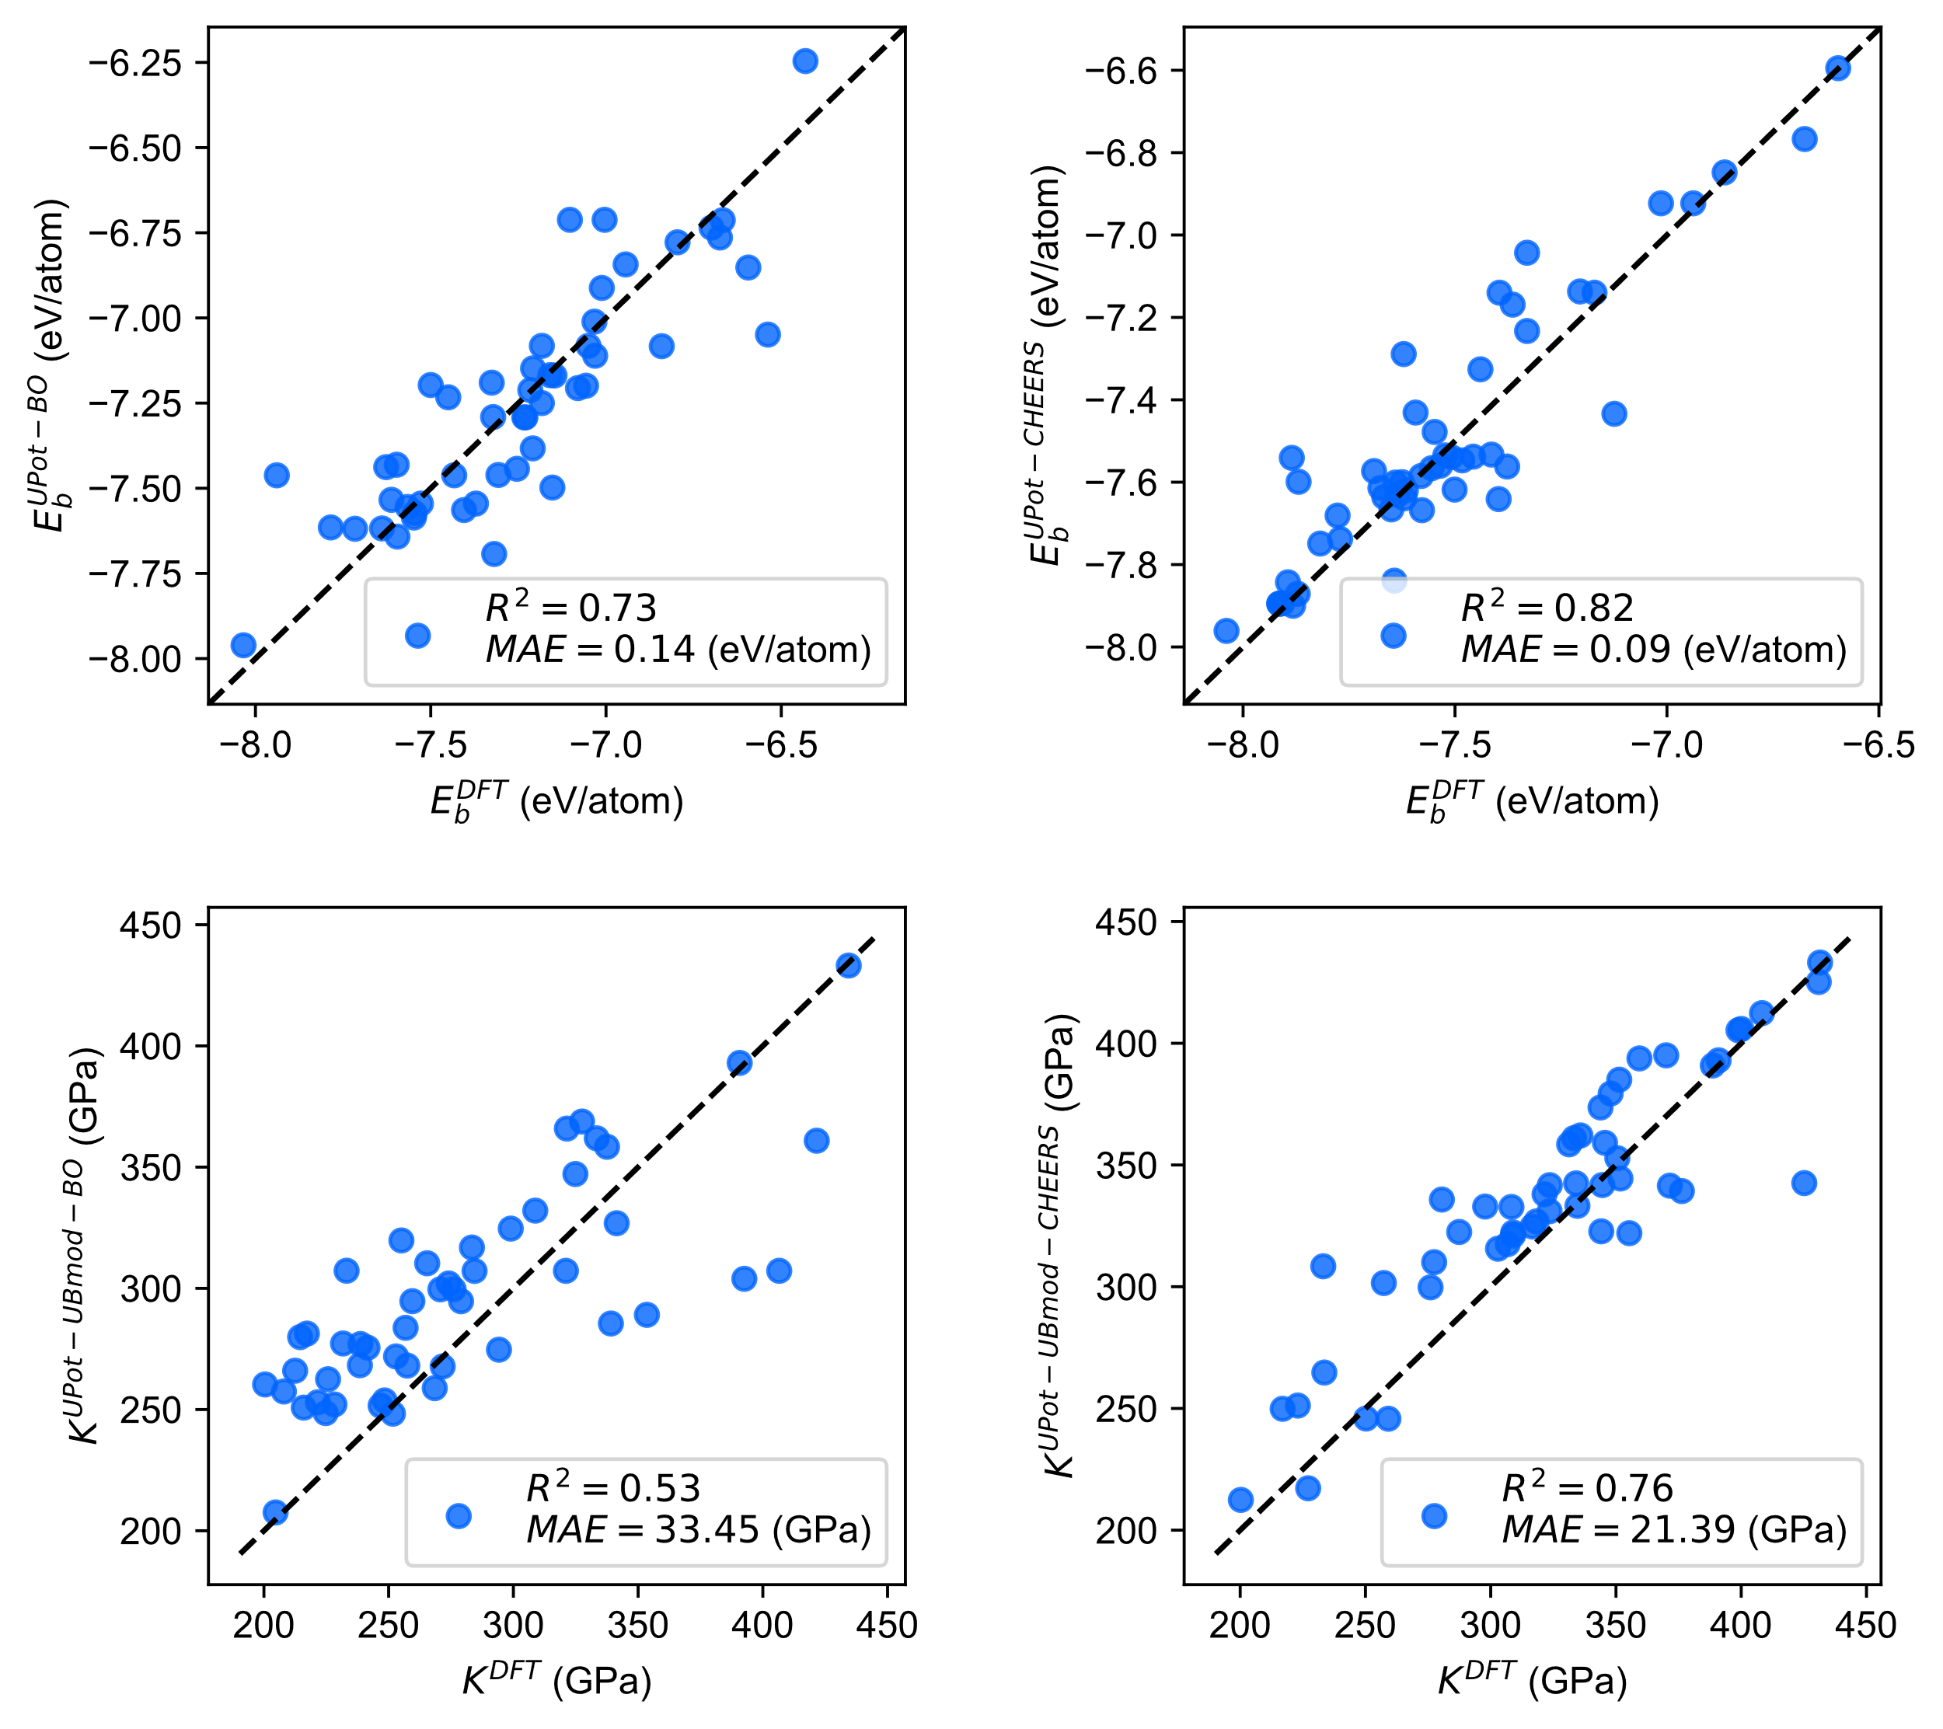
(a)
(b)
(c)
(d)

Supplementary Fig. 5. The parity plots for the results of DNID. a, b, The 50 typical compounds with the high atomic cohesion identified by the UPot-BO (a) and UPot-CHEERS (b) approaches. c, d, The 50 typical compounds with the high atomic cohesion identified by the UPot-BO (c) and UPot-CHEERS (d) approaches.

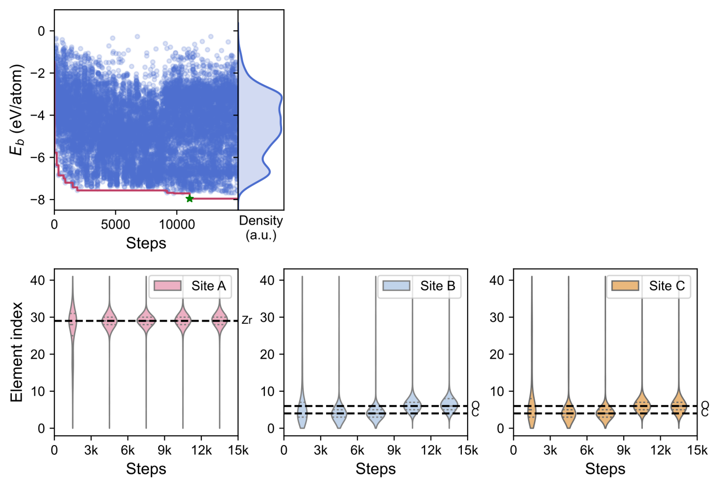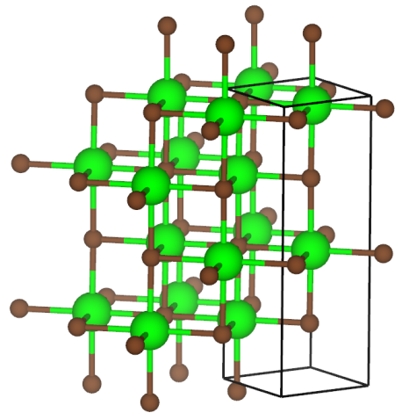
(a)
(c)
(d)
(e)
(b)

Supplementary Fig. 6. The optimization process of atomic cohesion energy E_{b} for ternary compound A_{l}B_{m}C_{n} (a), with the corresponding atomic compositions shown in (c)-(e). (b) The ZrC structure of the best material in (a).

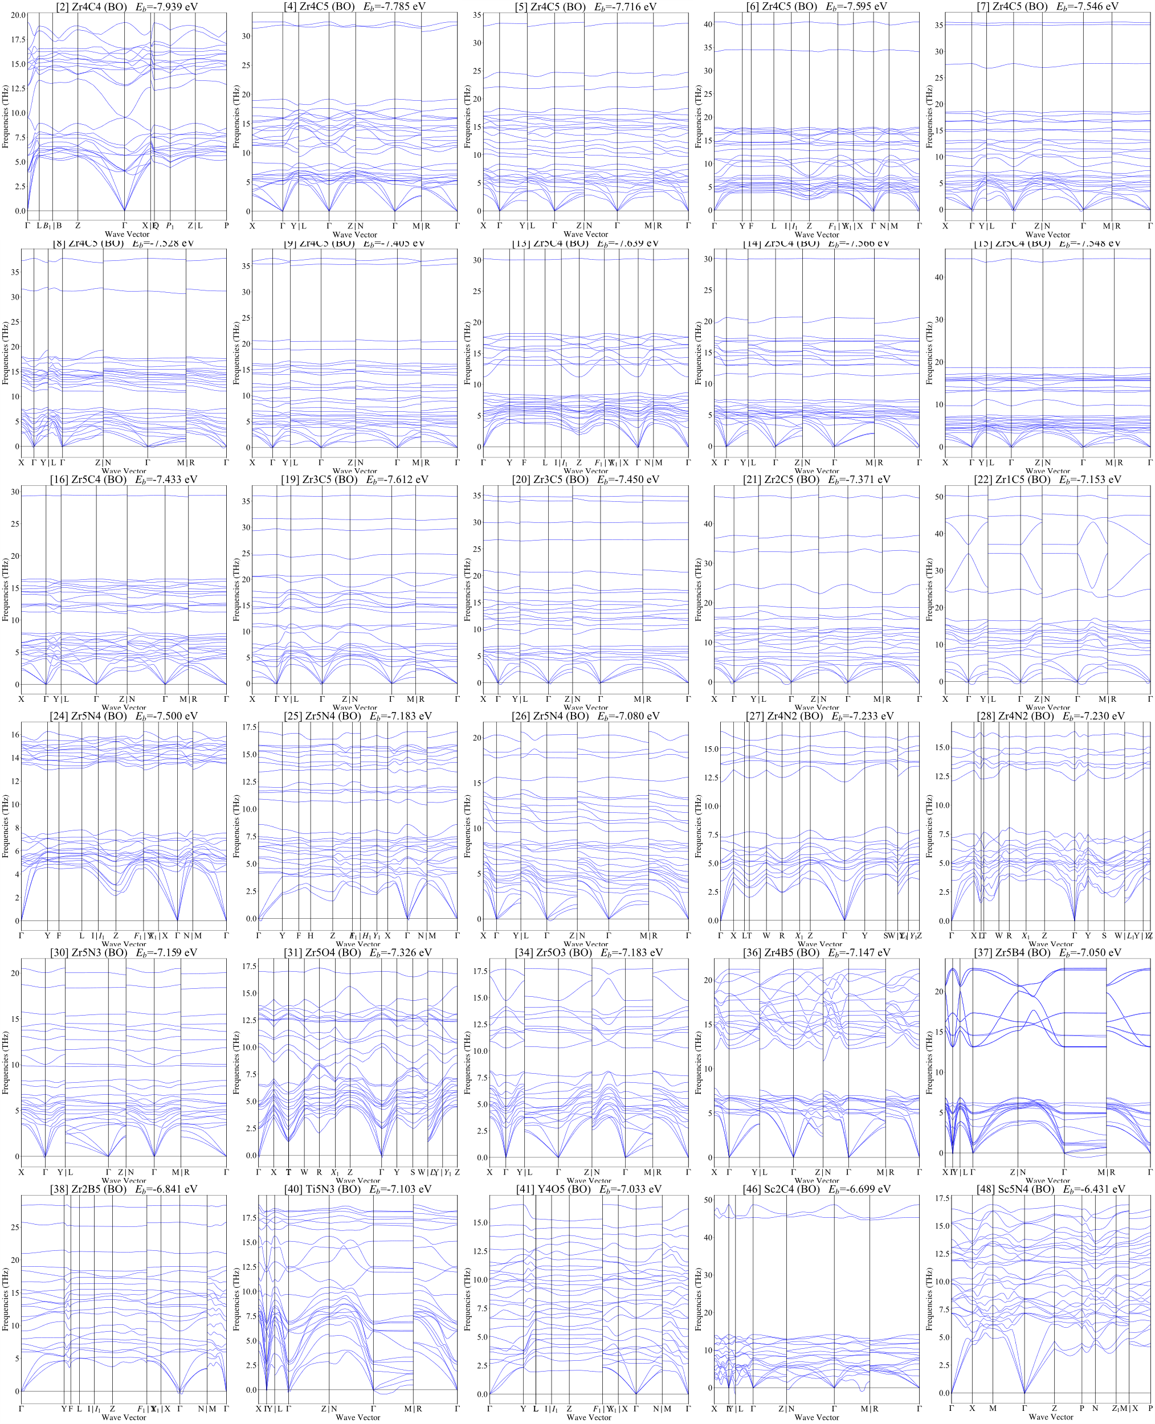

Supplementary Fig. 7. The phonon spectra for selection 30 compounds in Table S1.

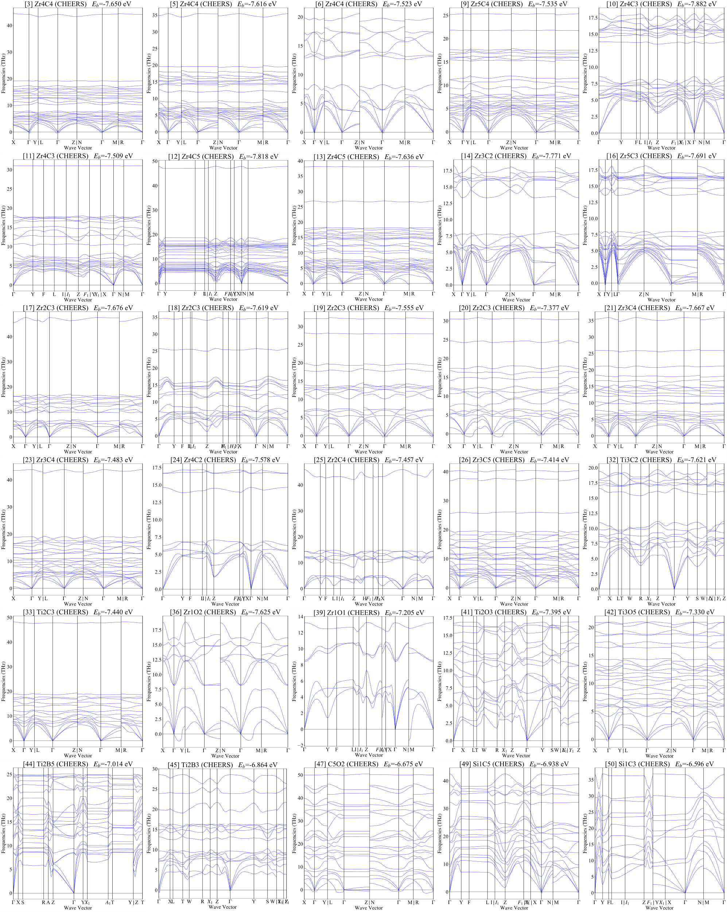

Supplementary Fig. 8. The phonon spectra for selection 30 compounds in Table S2.

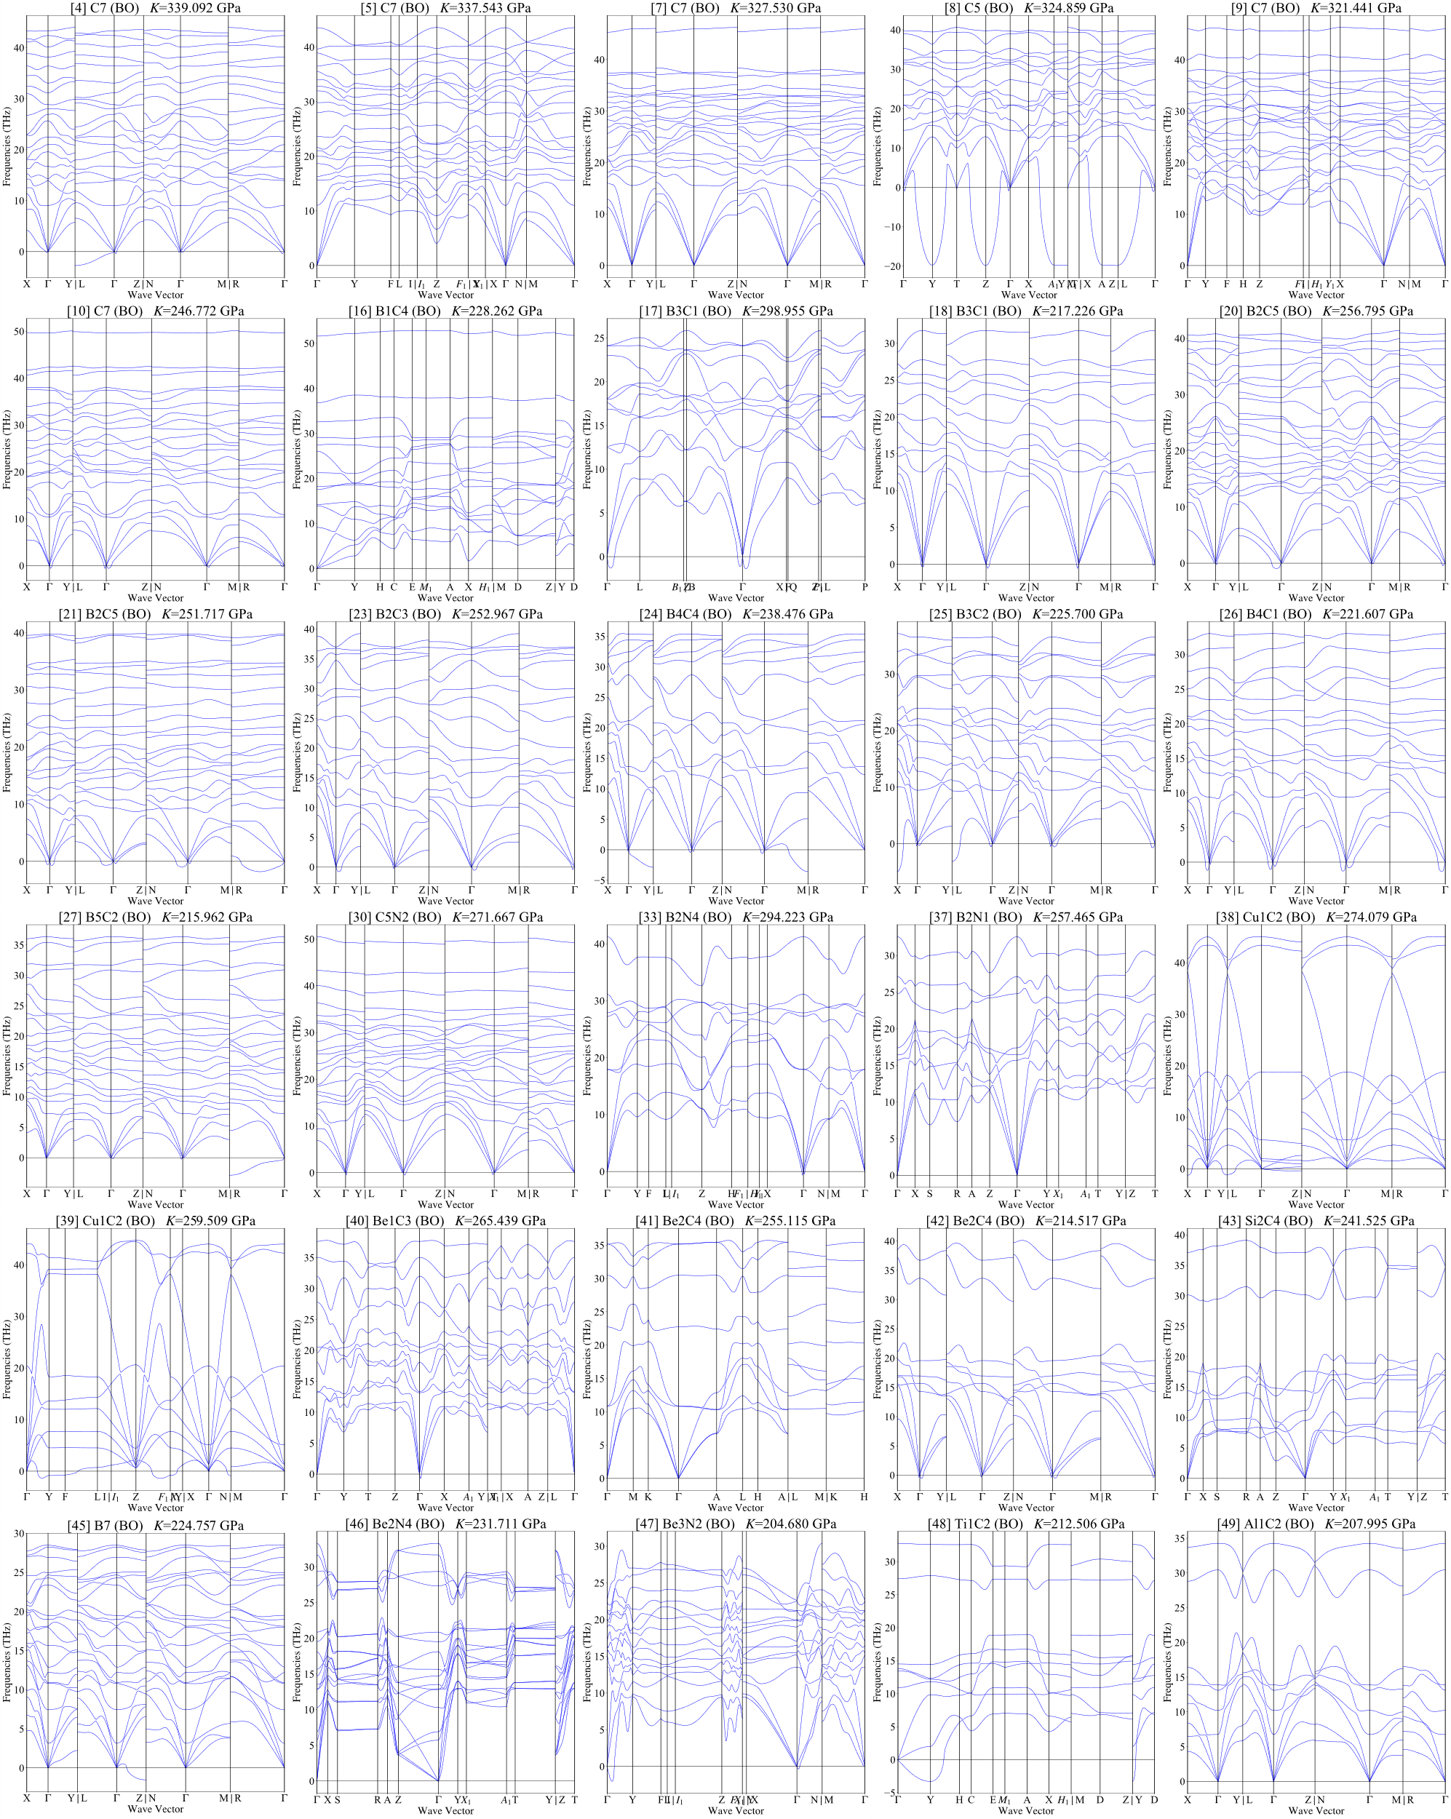

Supplementary Fig. 9. The phonon spectra for selection 30 compounds in Table S3.

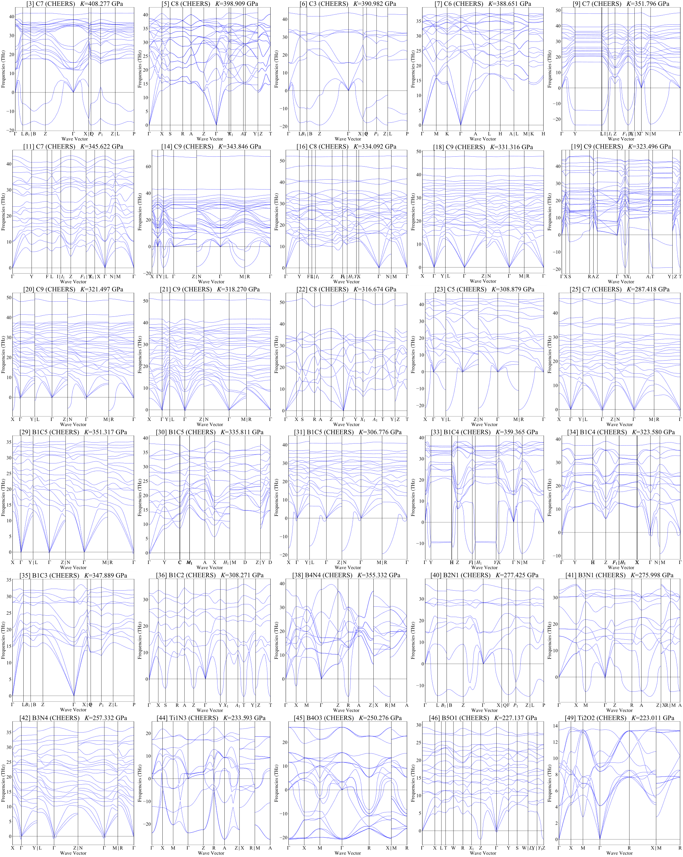

Supplementary Fig. 10. The phonon spectra for selection 30 compounds in Table S4.

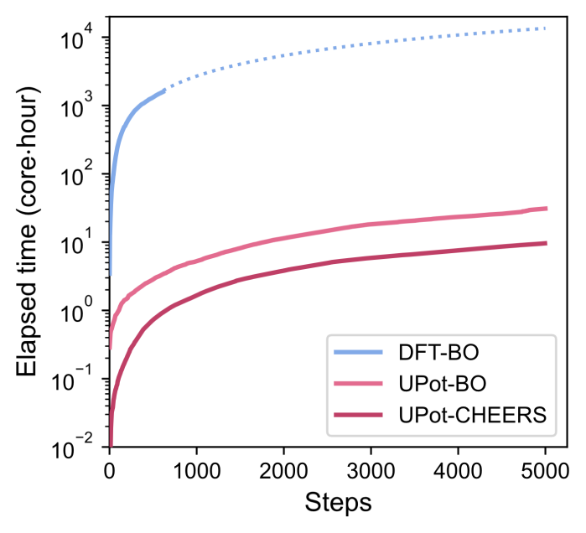
Supplementary Fig. 11. The elapsed time of searching for large cohesive energy materials by DFT-BO, UPot-BO and UPot-CHEERS. The dashed curve extrapolates the estimated time.

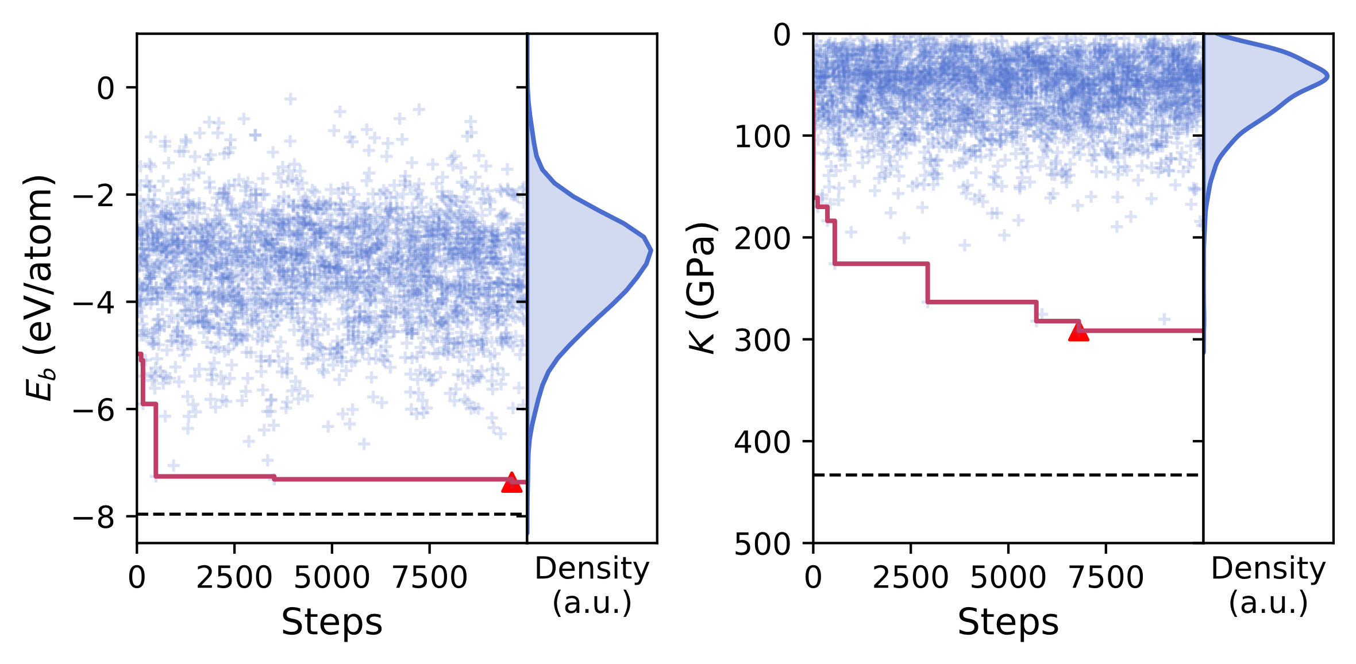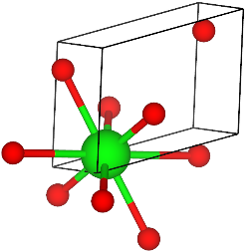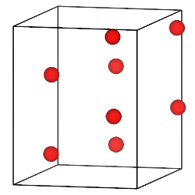
(a)
(b)
(c)
(d)
(c)
(d)
Zr1O2
O8
Supplementary Fig. 12. a,b, The process of CDVAE to search the materials with large cohesive energy (a) and high bulk modulus (b). The dashed lines are the target values searched by DNID. c,d, The best candidate materials searched by CDVAE.

