Supplementary material of Toxicity of External Beam Accelerated Partial-Breast Irradiation (APBI) in Adjuvant Therapy of Early-stage Breast Cancer: Randomized Prospective Study
Supplementary Table 1: Dose constraints and plan optimization [1–4]

Dose constraints
APBI arm |  |  |  | WBI arm
Organ | Volume | Limit | Prescribe | Organ | Volume | Limit | Prescribe
Ipsilateral breast | 50%  35% | 15 Gy  30 Gy | V₁₅ < 50%  V₃₀ < 35% | Ipsilateral breast | NA | NA | NA
Contralateral breast | D_{max} | 1 Gy | D_{max} < 1 Gy | Contralateral breast | 10% | 5 Gy | V₅ < 10%
Ipsilateral lung | 20 % | 10 Gy | V₁₀ < 20% | Ipsilateral lung | 25%  10% | 20 Gy  30 Gy | V₂₀ ≤ 25%  V₃₀ ≤ 10%
Contralateral lung | 10 % | 5 Gy | V₅ < 10% | Heart | D_{mean} | 2.5 Gy | D_{mean} < 2.5 Gy
Heart  (right site) | 5 %  10 % | 1.5 Gy  3 Gy | V_{1.5} < 5%  V₃ < 10% | Left ventricle | D_{mean}  17%  5 % | 3 Gy  5 Gy  23 Gy | D_{mean} < 3 Gy  V₅ < 17%  V₂₃ < 5%
Heart  (left site) | 40 %  10 % | 1.5 Gy  3 Gy | V_{1.5} < 40%  V₃ < 10 % | Left anterior descending artery | D_{mean}  2%  1% | 10 Gy  30 Gy  40 Gy | D_{mean} < 10 Gy  V₃₀ < 2%  V₄₀ < 1%
Chest wall | D_{max} | 36 Gy | D_{max} < 36 Gy
Skin | D_{max} | 36 Gy | D_{max} < 36 Gy
Plan optimization
100% of prescribed dose covers ≥ 95% of PTV
D_{near-max} to PTV < 105% (D_{2%} < 31.5 Gy)
D_{near-min} to PTV > 28 Gy (D_{98%} > 28 Gy)

Abbreviations: APBI = accelerated partial breast irradiation, WBI = whole breast irradiation, Gy = Gray, NA = not applicable, PTV = planning target volume, V_{x} = volume of appropriate dose, D_{mean} = mean dose of the volume, D_{max} = maximum dose of the volume, D_{near-min} = near-minimum dose of the volume, D_{near-max} = near maximum dose of the volume. D_{near-min} and D_{near-max} referred according to ICRU report 83 [5].

Supplementary Figure 1: Dose distribution and beam arrangement for APBI arm
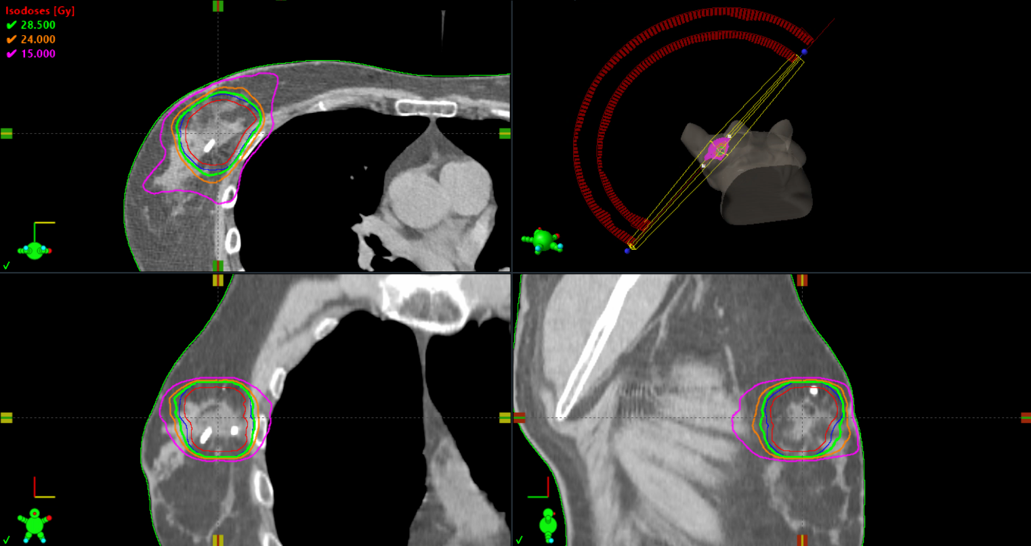

CTV (red line) = 41.7 cc, PTV (blue line) = 64.5 cc, D_{min} in CTV = 29.5 Gy, D_{near-min} in CTV = 30.1 Gy, Dmin in PTV = 28.2 Gy, D_{near-min} in PTV = 29.7 Gy, D_{mean} in PTV = 30.4 Gy, D_{near-max} = 31.2 Gy, D_{max} = 31.9 Gy, appropriate isodose lines (95% of prescribed dose = green, 80% of prescribed dose = orange and 50% of prescribed dose = violet line).

References:
[1] Livi L, Meattini I, Marrazzo L, Simontacchi G, Pallotta S, Saieva C, et al. Accelerated partial breast irradiation using intensity-modulated radiotherapy versus whole breast irradiation: 5-year survival analysis of a phase 3 randomised controlled trial. Eur J Cancer 2015;51:451–63. https://doi.org/10.1016/J.EJCA.2014.12.013.
[2] Obayomi-Davies O, Kole TP, Oppong B, Rudra S, Makariou E V., Campbell LD, et al. Stereotactic Accelerated Partial Breast Irradiation for Early-Stage Breast Cancer: Rationale, Feasibility, and Early Experience Using the CyberKnife Radiosurgery Delivery Platform. Front Oncol 2016;6:23. https://doi.org/10.3389/FONC.2016.00129.
[3] Piroth MD, Baumann R, Budach W, Dunst J, Feyer P, Fietkau R, et al. Heart toxicity from breast cancer radiotherapy : Current findings, assessment, and prevention. Strahlenther Onkol 2019;195. https://doi.org/10.1007/S00066-018-1378-Z.
[4] Lee BM, Chang AS, Kim SY, et al. Risk of radiation pneumonitis following individualized modern radiotherapy with IMRT, a breath-holding technique, and prone positioning for breast cancer. Abstract selected for 2018 Best of ASTRO (November 30-December 1, 2018) from ASTRO’s 60th Annual Meeting (October 21-24, 2018). n.d.
[5] Gregoire V, Mackie TR. State of the art on dose prescription, reporting and recording in Intensity-Modulated Radiation Therapy (ICRU report No. 83). Cancer/Radiothérapie (2011) 15:555–9. doi: 10.1016/j.canrad.2011.04.003

