Supplementary information

Title: Antimicrobial efficacy of direct air gas soft jet plasma for oral bacterial biofilm eradication and treatment
Authors: Valentina Puca¹, Beatrice Marinacci^{1,2}, Morena Pinti³, Federica Di Cintio^{3,6}, Bruna Sinjari², Maria Carmela Di Marcantonio², Gabriella Mincione², Tirtha Raj Acharya⁴, Nagendra Kumar Kaushik⁴, Eun Ha Choi⁴, Michele Sallese^{2,6}, Simone Guarnieri^{5,6}, Rossella Grande^{1,6}* and Vittoria Perrotti³*

This PDF file includes:
- Supplementary Figure S1
- Supplementary Figure S2
- Supplementary Figure S3

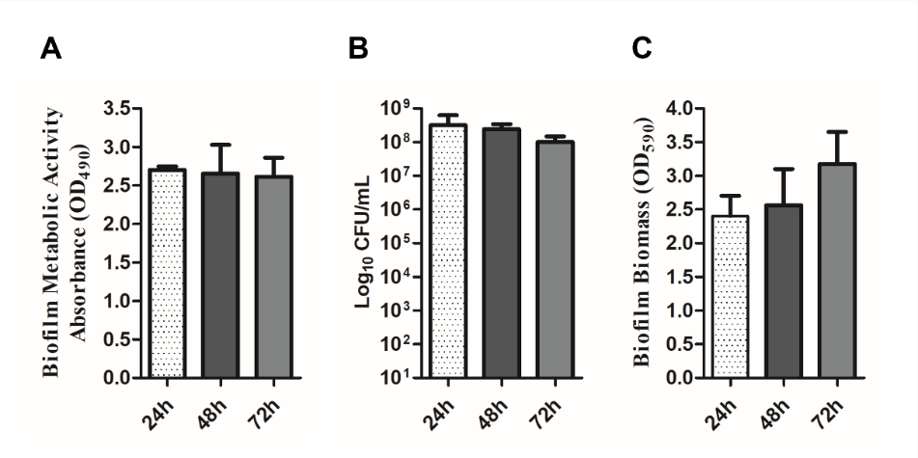
Supplementary Figure S1. Evaluation of the biofilm formed by the microorganisms isolated from a saliva sample after 24, 48 and 72h of incubation. (A) biofilm metabolic activity absorbance (XTT assay); (B) CFU count; (C) biofilm biomass measured via CV staining. The results represent the mean±SD of three independent experiments.

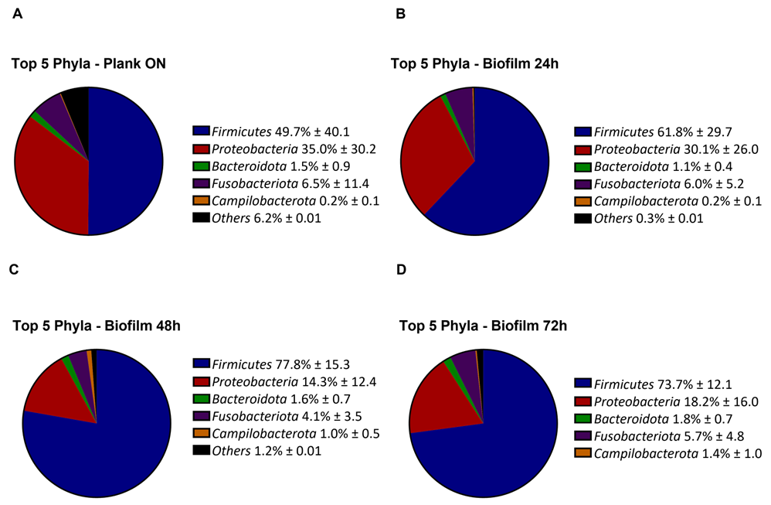
Supplementary Figure S2. Characterization of microbial fraction of planktonic and biofilm cells by phyla.
Comparison of phyla composition of planktonic ON (A) and biofilm after 24h (B), 48h (C), and 72h (D) of incubation. The top 5 phyla in terms of maximum relative abundance are shown. All other phyla with low presence (≤ 0.7) were grouped as “Other”. All Data are expressed as means ± SD (n=3).

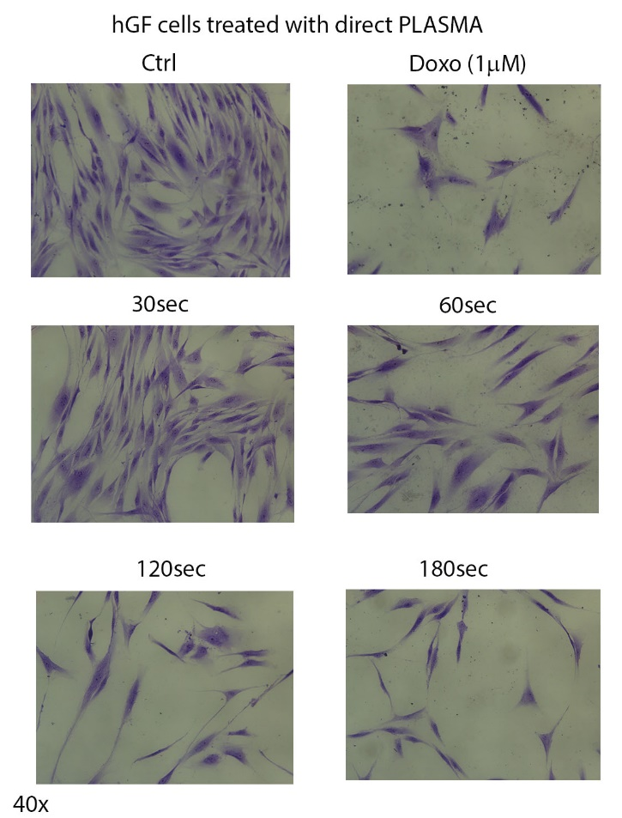

Supplementary Figure S3. Effects of direct CAP treatment on hGF cells morphology. CTRL: control, untreated cells; Doxo (1μM); CAP treatment for 30 sec, 30 seconds; 60sec, 60 seconds; 120sec, 120s seconds; 180sec, 180 seconds. Inverted optical microscopy images were acquired at a total magnification: 400x.

