Supplementary material

Table S1 – Results of zpg-7280/N’Gousso and vas2-5958/N’Gousso hybrid backcrosses to G3, with information about the progeny pools and haplotypes. TLH = target locus heterology. Closest SNP position indicates the nucleotide position relative to the gene drive cut site of the closest SNP between the parent chromosomes, and therefore the limit of detection of small GCTs in each larval pool.

Pool | Gene drive inheritance (%) | # in pool | TLH in parent (%) | # of haplotypes | Larvae per haplotype | Closest SNP position
 |  |  |  |  |  | Left | Right
zpg-7280/N’Gousso x G3
A | 86.7 | 39 | 3.31 | 12 | 3.25 | 11 | 11
B | 100.0 | 49 | 3.17 | 12 | 4.08 | 53 | 11
C | 100.0 | 68 | 3.10 | 15 | 4.53 | 53 | 11
D | 87.2 | 41 | 3.05 | 14 | 2.93 | 11 | 11
E | 89.1 | 41 | 5.39 | 13 | 3.15 | 68 | 38
F | 100.0 | 55 | 3.45 | 12 | 4.58 | 53 | 71
vas2-5958/N’Gousso x G3
G | 93.5 | 29 | 1.82 | 16 | 1.81 | 27 | 76
H | 98.0 | 50 | 2.62 | 24 | 2.08 | 48 | 62
I | 93.2 | 34 | 2.62 | 18 | 1.89 | 48 | 62
J | 100.0 | 28 | 2.96 | 15 | 1.87 | 72 | 62

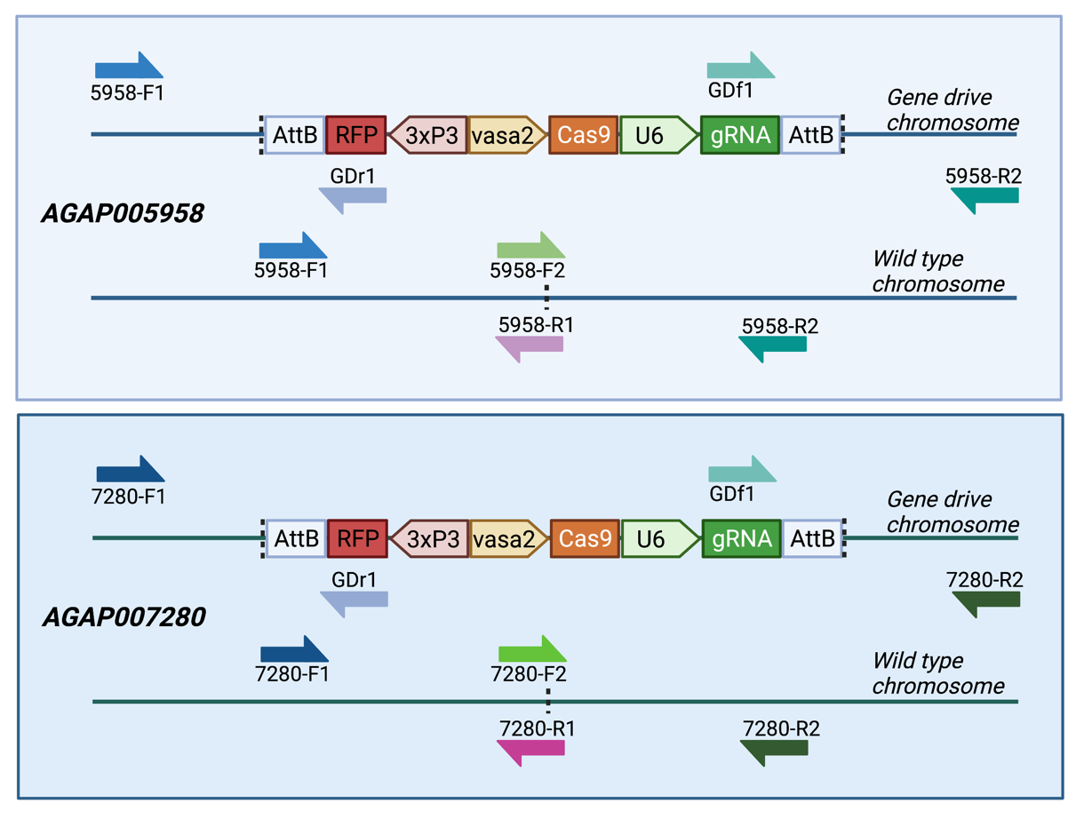
Figure S1 – Sequencing primer locations on both vas2-5958 and zpg-7280 gene drive and wild type target chromosomes.

Table S2 - Primer sequences, with Illumina adapters in brackets.

Name | Sequence (5’-3’)
5958-F1 | (ACA CTC TTT CCC TAC ACG ACG CTC TTC CGA TCT) GCG CAC ATT AAG CCG TAC C
5958-R1 | (GAC TGG AGT TCA GAC GTG TGC TCT TCC GAT CT) AGT GAC GAG ATA CTG GAG CC
5958-F2 | (ACA CTC TTT CCC TAC ACG ACG CTC TTC CGA TCT) TCC TGG AGC AAC CGA TCA AG
5958-R2 | (GAC TGG AGT TCA GAC GTG TGC TCT TCC GAT CT) TCG AGT AAA CCT TCT GGC CG
7280-F1 | (ACA CTC TTT CCC TAC ACG ACG CTC TTC CGA TCT) GAC CGT TTG TGT GTC AGA GCA
7280-R1 | (GAC TGG AGT TCA GAC GTG TGC TCT TCC GAT CT) GAA GCT CTC TGT GTG GCA CTA
7280-F2 | (ACA CTC TTT CCC TAC ACG ACG CTC TTC CGA TCT) TGT GGG ATG GAT CAG ATG CT
7280-R2 | (GAC TGG AGT TCA GAC GTG TGC TCT TCC GAT CT) CTC TGT ACT GAG GTC TGT TGT G
GDf1 | (ACA CTC TTT CCC TAC ACG ACG CTC TTC CGA TCT) CAA CTT GAA AAA GTG GCA CCG
GDr1 | (GAC TGG AGT TCA GAC GTG TGC TCT TCC GAT CT) CAA TGT ATC TTT CCG GAG CG

Table S3 – Annealing temperatures for all sequenced PCR products.

Amplicon | Primers | Annealing temp (°C)
vas2-5958 wild type (left) | 5958-F1 + 5958-R1 | 63
vas2-5958 wild type (right) | 5958-F2 + 5958-R2 | 64
vas2-5958 gene drive (left) | 5958-F1 + GDr1 | 63
vas2-5958 gene drive (right) | GDf1 + 5958-R2 | 61
zpg-7280 wild type (left) | 7280-F1 + 7280-R1 | 64
zpg-7280 wild type (right) | 7280-F2 + 7280-R2 | 63
zpg-7280 gene drive (left) | 7280-F1 + GDr1 | 63
zpg-7280 gene drive (right) | GDf1 + 7280-R2 | 61

Table S4 – Larval number, gene drive inheritance rate and the number of haplotypes found in each pool.

Amplicon pool | Gene drive locus | Number in pool | Gene drive inheritance rate | Number of haplotypes
A_left | AGAP007280 | 39 | 86.7 | 7
A_right | AGAP007280 | 39 | 86.7 | 5
B_left | AGAP007280 | 49 | 100.0 | 7
B_right | AGAP007280 | 49 | 100.0 | 5
C_left | AGAP007280 | 68 | 100.0 | 7
C_right | AGAP007280 | 68 | 100.0 | 8
D_left | AGAP007280 | 41 | 87.2 | 9
D_right | AGAP007280 | 41 | 87.2 | 5
E_left | AGAP007280 | 41 | 89.1 | 9
E_right | AGAP007280 | 41 | 89.1 | 4
F_left | AGAP007280 | 55 | 100.0 | 4
F_right | AGAP007280 | 55 | 100.0 | 8
G_left | AGAP005958 | 29 | 93.5 | 10
G_right | AGAP005958 | 29 | 93.5 | 6
H_left | AGAP005958 | 50 | 98.0 | 15
H_right | AGAP005958 | 50 | 98.0 | 9
I_left | AGAP005958 | 82 | 93.2 | 12
I_right | AGAP005958 | 82 | 93.2 | 6
J_left | AGAP005958 | 63 | 100.0 | 10
J_right | AGAP005958 | 63 | 100.0 | 5

Table S5 – All haplotype sequences that passed filtering, and their relative percentage of all reads per sample. (submitted separately as an Excel spreadsheet)

