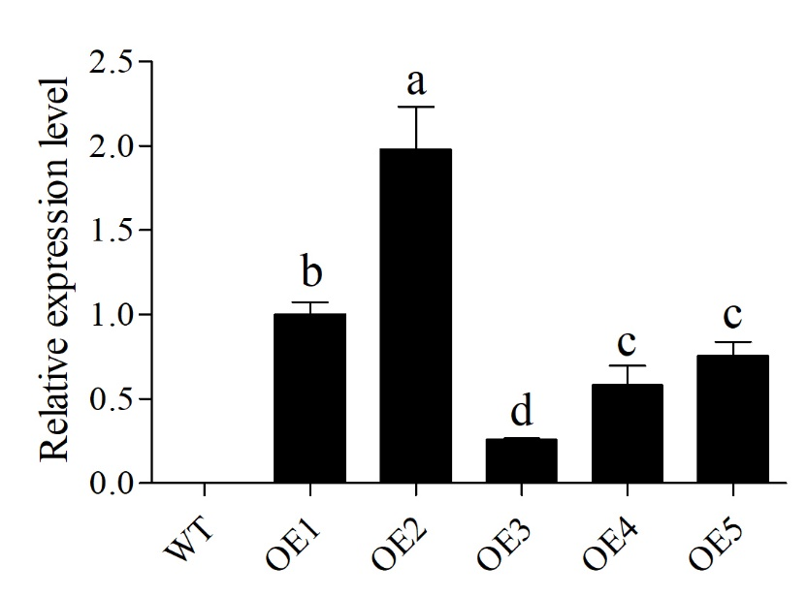
Fig.S1 qRT-PCR identification of GhWRKY31 transgenic Arabidopsis lines. The two-week-old
seedlings were used to perform the molecular identification of GhWRKY31 transgenic Arabidopsis plant and lines. WT: wild type; OE1, 2, 3, 4, and 5: GhWRKY31 transgenic Arabidopsis lines of T₃ generation. The lower letter above the bar indicates the significant difference (P < 0.05).
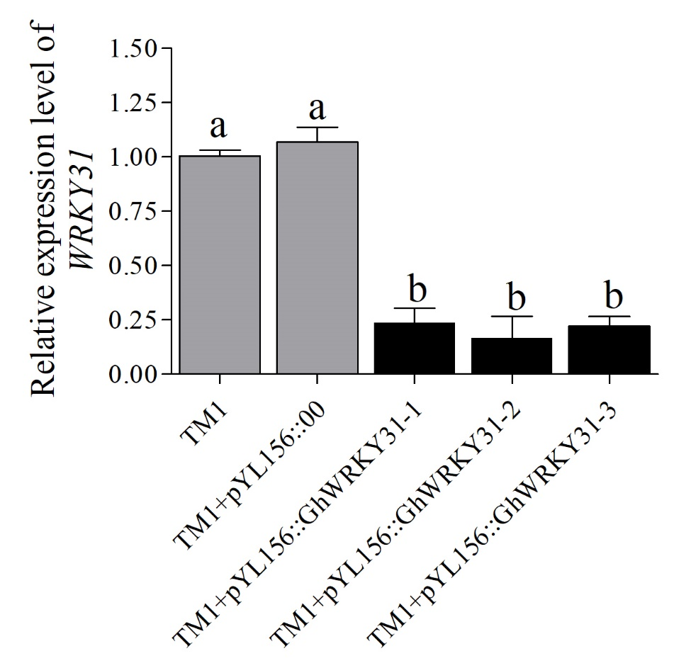
Fig.S2 qRT-PCR identification of silencing efficiency in cotton seedings. The data represent the means ± SE from three independent experiments. Independent t-tests indicated that there was significant difference among the ‘TM1’, ‘TM1 + pYL156:00’ and ‘TM1+pYL156:GhWRKY31’. The lower letter above the bar indicates the significant difference (P < 0.05).

