Controllable Chiral Lattices for 2D ROA Mapping and
a Long-term Stable Broadband CPL Detector

Junyoung Kwon¹, Jae Bum Jeon¹, Won Jin Choi², Uichang Jeong¹, Wookjin Jung¹, Kyung Min Kim¹, Jihyeon Yeom¹*
¹Department of Materials Science and Engineering, Korea Advanced Institute of Science and Technology (KAIST), Daejeon 34141, Republic of Korea
²Physical and Life Sciences, Lawrence Livermore National Laboratory, Livermore, California 94550, United States

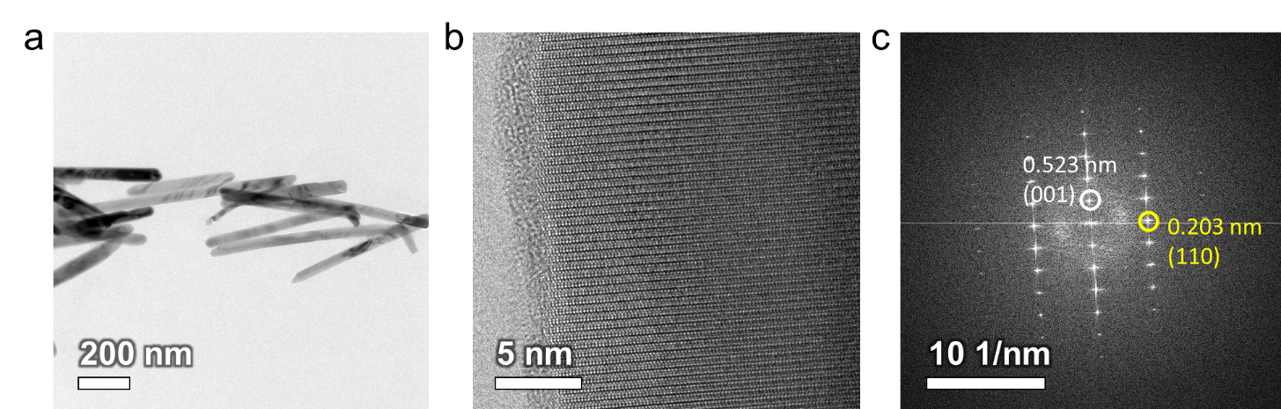
Supplementary Figure 1. TEM images of L-Cys-Se NRs. (a) TEM image, (b) HR-TEM lattice fringe image, (c) FFT image calculated from (b) showing 0.523 nm and 0.203 nm spacings with trigonal Se projected along [1 -1 0].

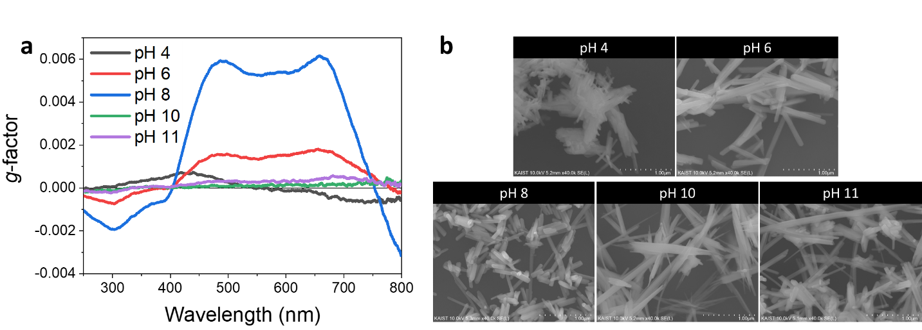
Supplementary Figure 2. pH effect on g-factor and morphology of Se nanorods (NRs). (a) g-factor spectra and (b) SEM images of Se NRs at different reaction pH.

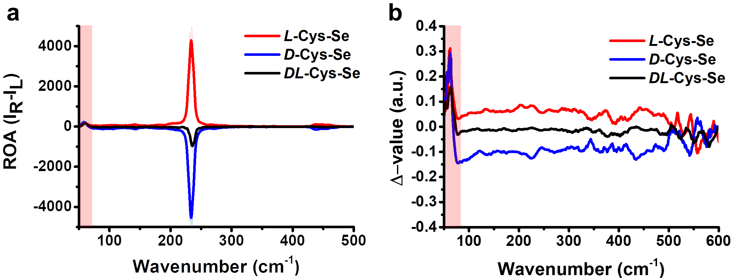
Supplementary Figure 3. ICP-ROA spectra, ∆-value spectra showing consistent ICP-ROA signs from quartz substrate. (a) ICP-ROA spectra, (b) ∆-value spectra of L-, D-, DL-Cys-Se NRs film.

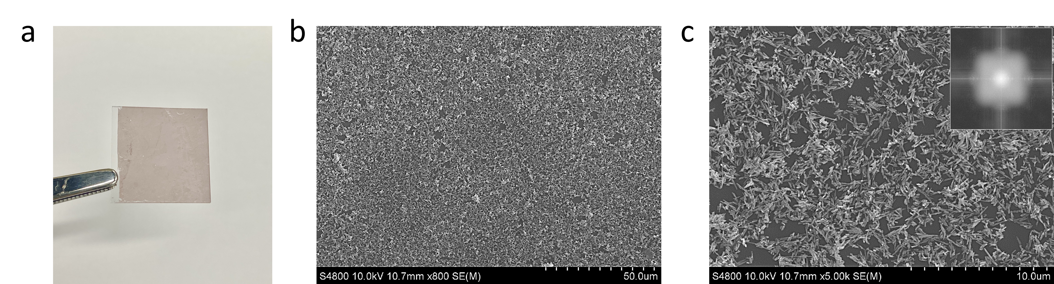
Supplementary Figure 4. L-Cys-Se NRs monolayer. (a) Digital photo and (b-c) SEM images of L-Cys-Se NRs monolayer on quartz substrate (20 × 20 mm). (inset) Fast Fourier Transform (FFT) image

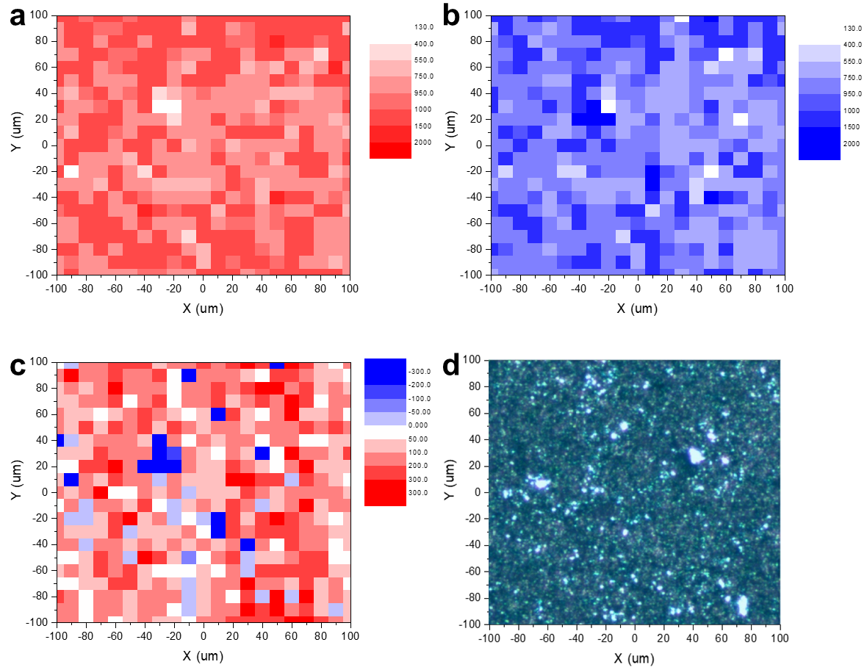
Supplementary Figure 5. 2D ROA mapping of a fully covered L-Cys-Se NRs monolayer. (a) 2D Raman mapping under RCP incident light, (b) 2D Raman mapping under LCP incident light, (c) 2D ROA mapping, (d) microscopic image of L-Cys-Se NRs monolayer.

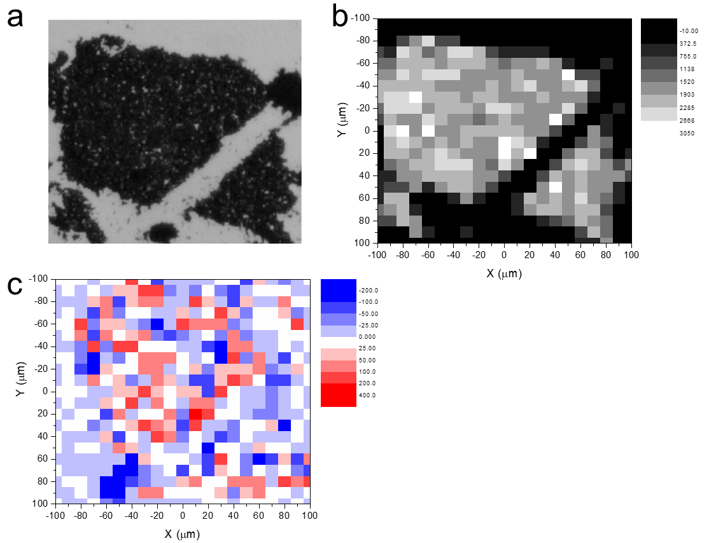
Supplementary Figure 6. 2D ROA mapping of DL-Cys-Se NRs monolayer.

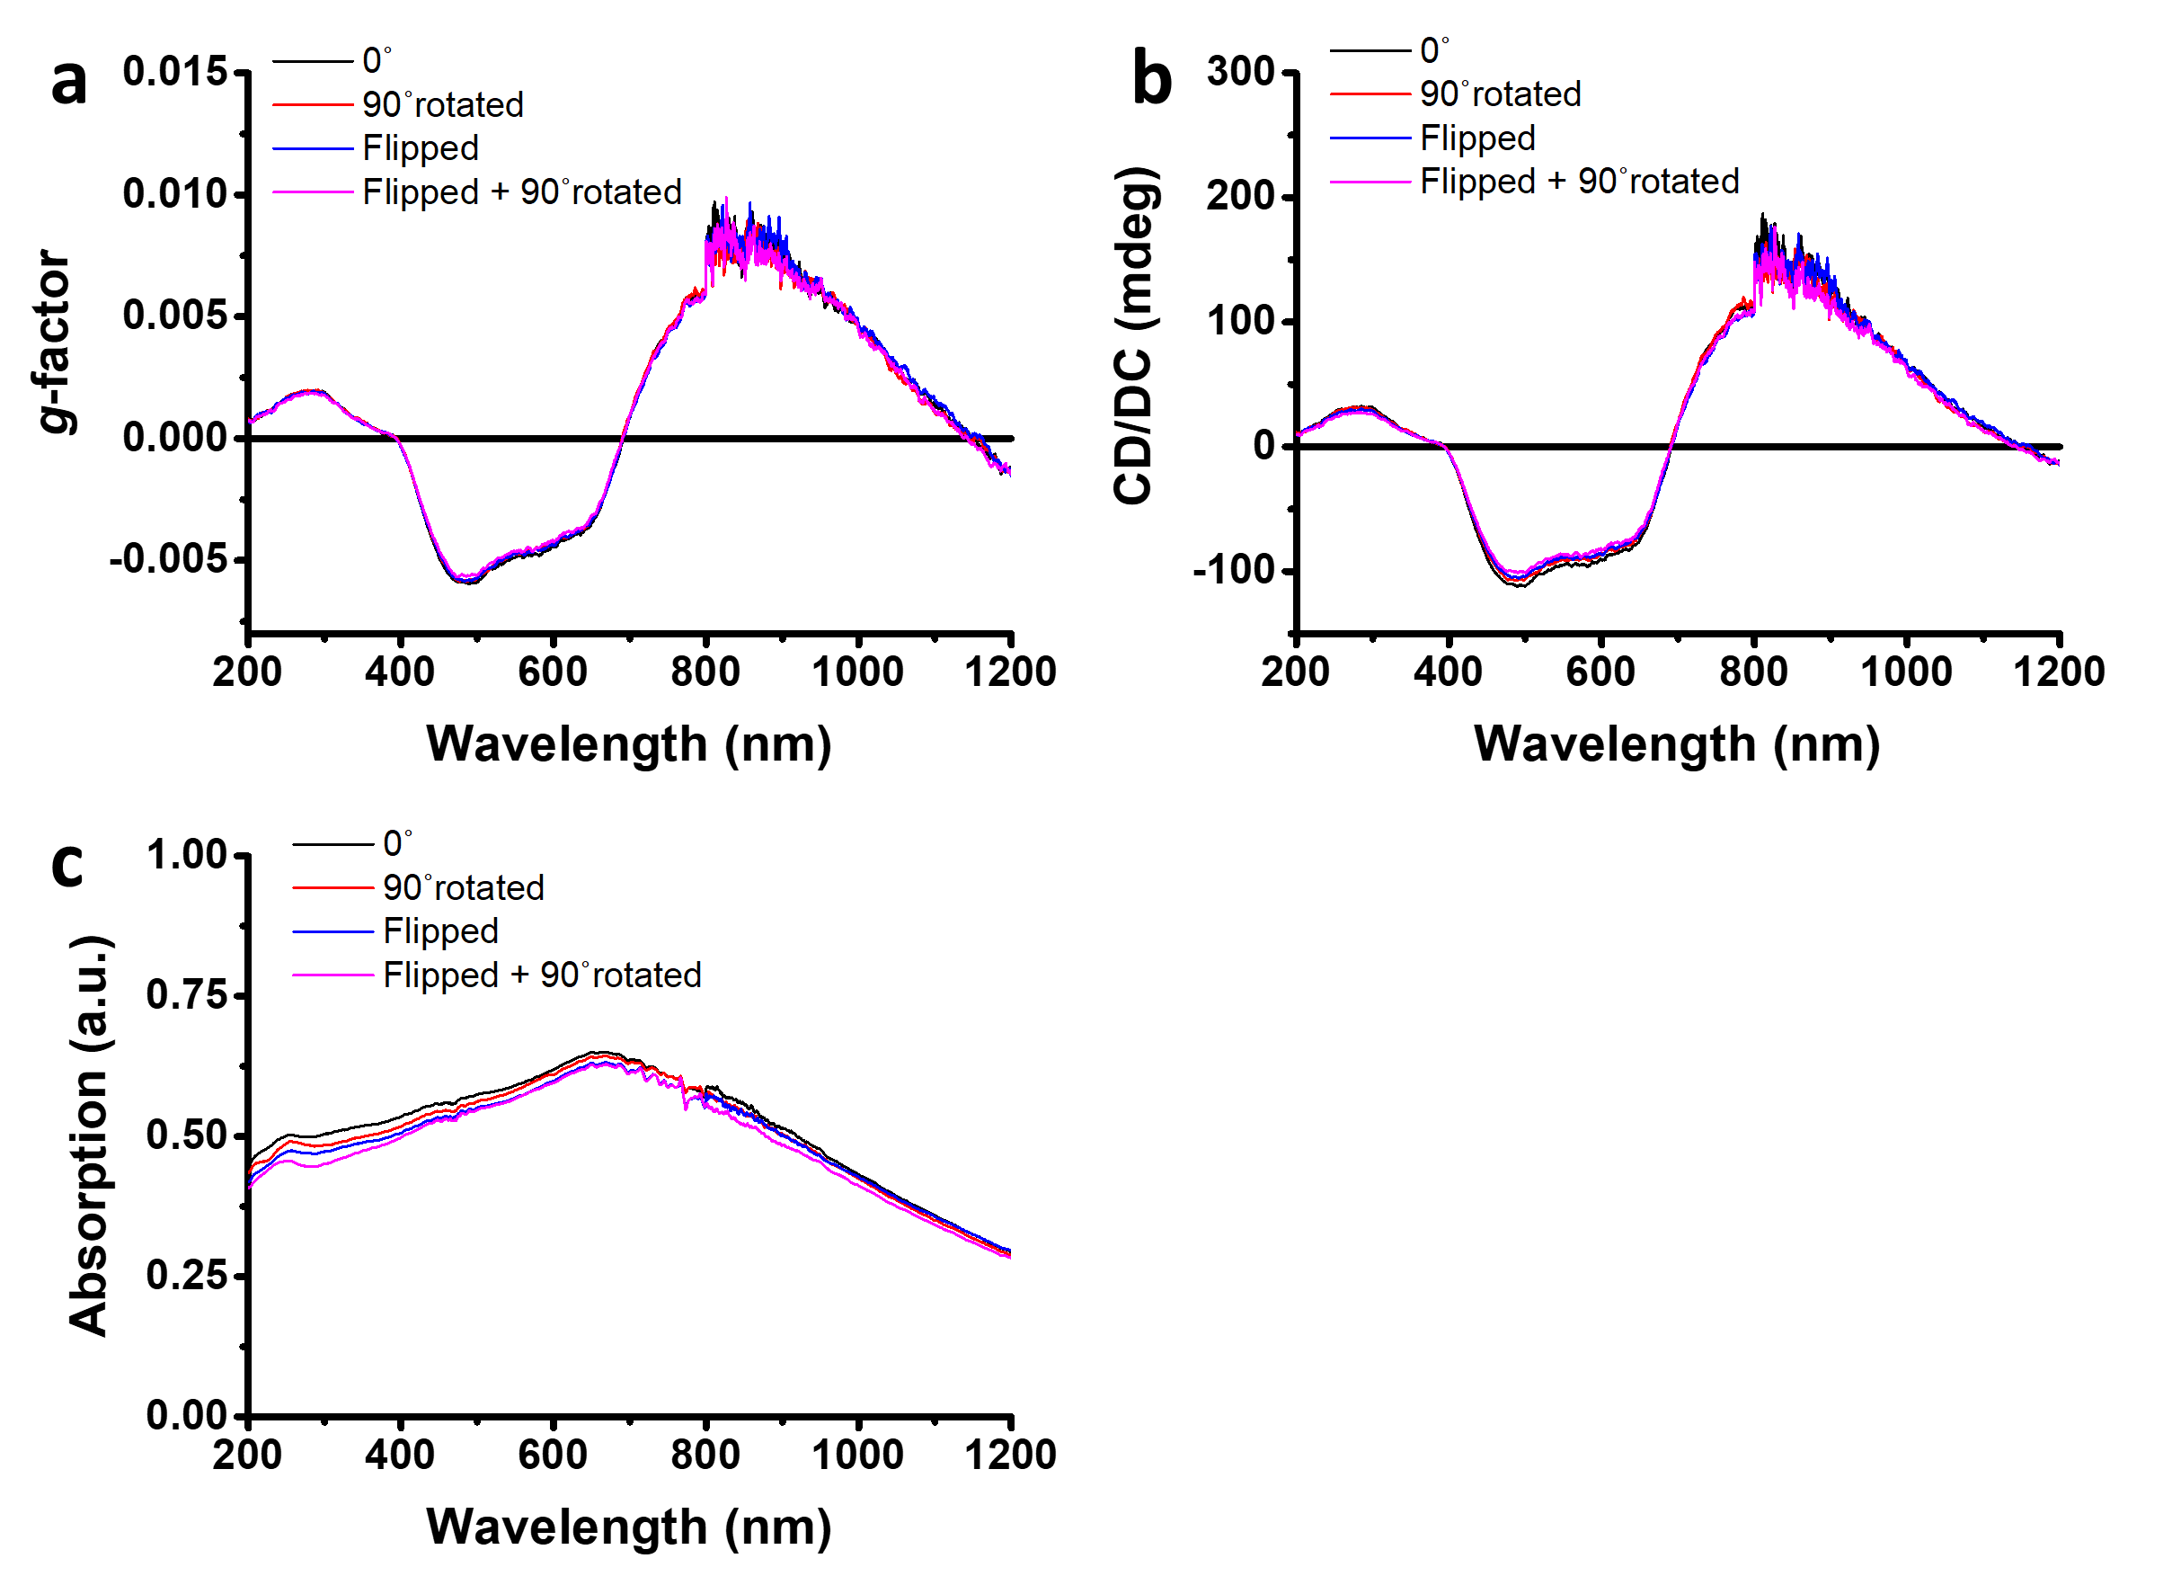
Supplementary Figure 7. CD spectra of L-Cys-Se NR film with sample of 0°, 90° rotated, incident light in opposite side (flipped) and 90° rotated (flipped + 90° rotated). These spectra were taken after 1 year placement in ambient condition in the form of monolayered film.

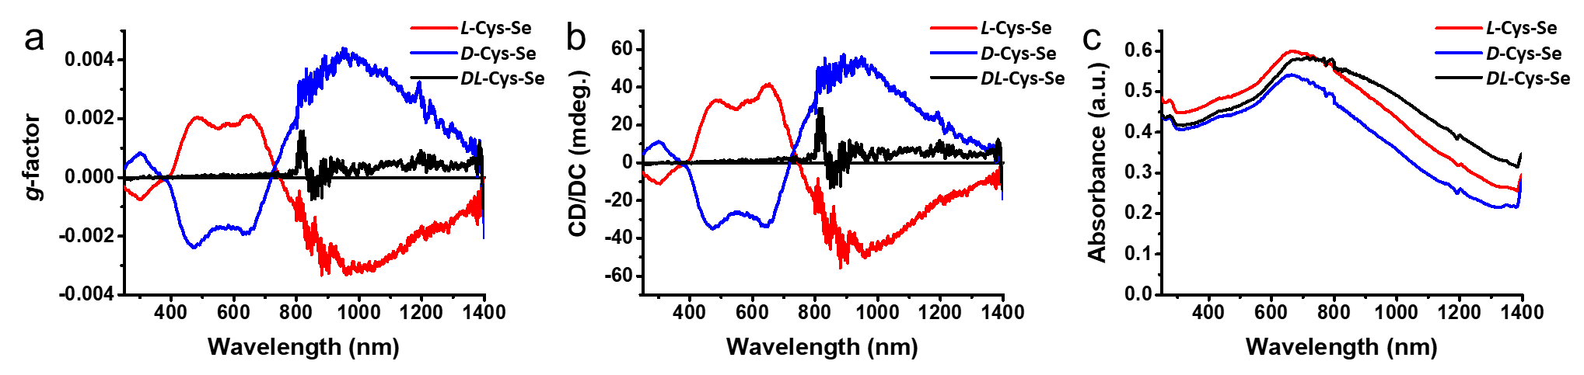
Supplementary Figure 8. (a) g-factor spectra, (b) CD spectra, and (c) absorbance spectra of L-, D-, DL-Cys-Se NRs dispersed in ethanol.

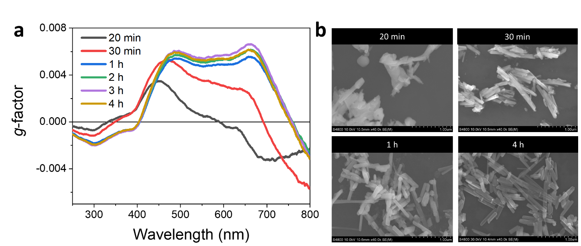
Supplementary Figure 9. Reaction time-dependent g-factor and morphology of Se NRs. (a) g-factor spectra and (b) SEM images of Se NRs at different reaction time.

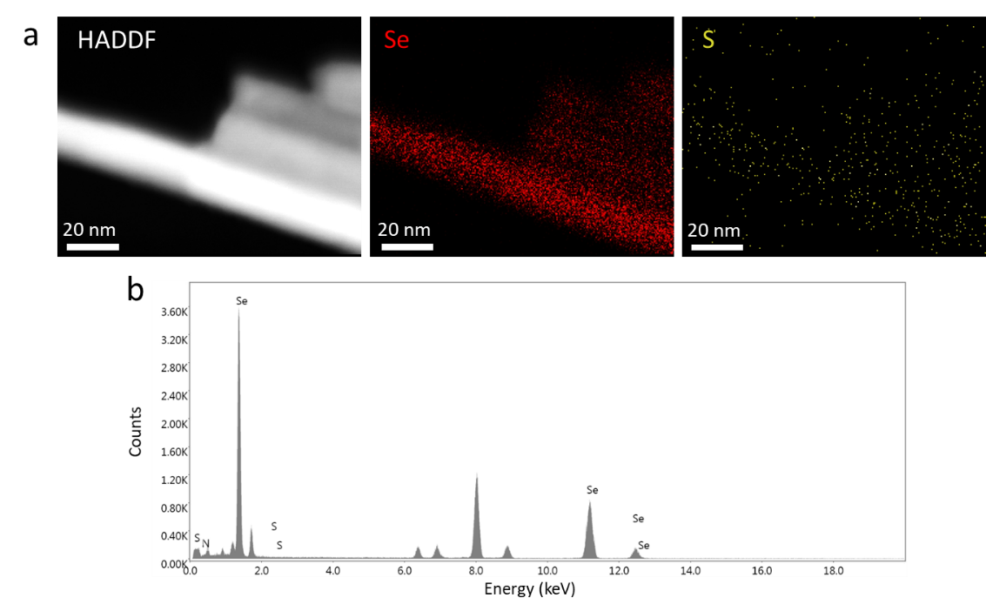 Supplementary Figure 10. Element analysis of L-Cys-Se using TEM. (a) HADDF-STEM and EDS elemental mapping images (Se and S), (b) area EDS spectrum Cys-Se NRs.

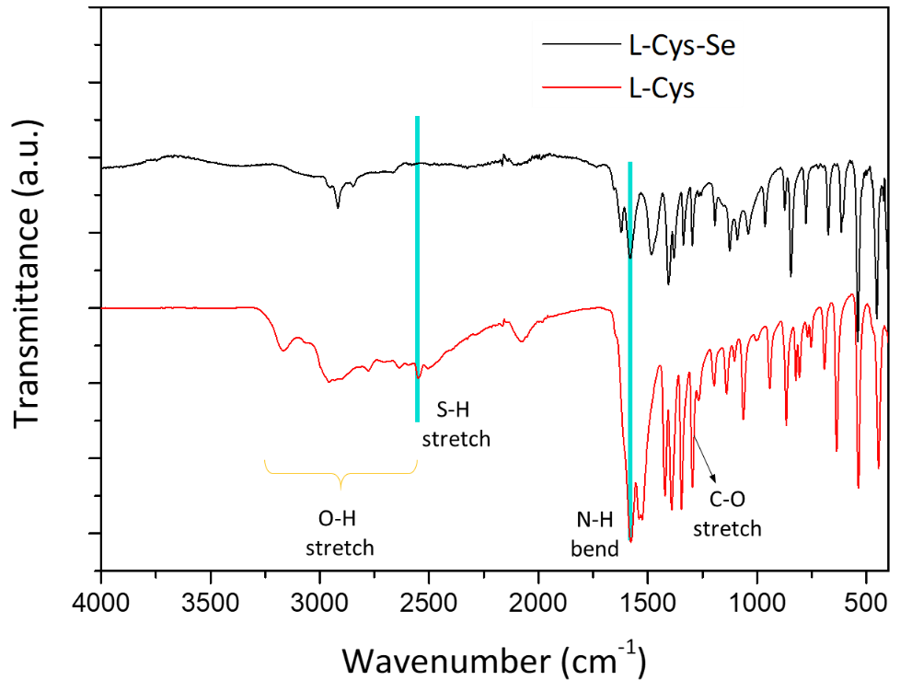
Supplementary Figure 11. FT-IR spectra of L-Cys and L-Cys-Se NRs.

