Appendix 1: search strategy narrative review
("Bone-Anchored Prosthesis"[Mesh] OR "Artificial Limbs"[Mesh] OR “artificial limb*”[tiab] OR "Joint Prosthesis"[Mesh] OR "Elbow Prosthesis"[Mesh] OR "Shoulder Prosthesis"[Mesh] OR ampute*[tiab] OR ((bone-anchored[tiab] OR joint*[tiab] OR elbow*[tiab] OR shoulder*[tiab] OR "upper limb" [tiab] OR myoelectric[tiab]) AND (prosthe*[tiab])))
AND
("Virtual Reality"[Mesh] OR "User-Computer interface*"[Mesh] OR ((virtual[tiab] OR augmented[tiab] OR immersive[tiab]) AND (realit*[tiab] OR environment*[tiab] OR technolog*[tiab] OR training*[tiab])) OR VR[tiab] OR VRs[tiab] OR AR[tiab] OR ARs[tiab] OR (user-computer[tiab] AND interface*[tiab]) OR “virtual system*”[tiab] OR “Video Game*”[Mesh] OR “video game*”[tiab] OR “computer game*”[tiab] OR “serious game*”[tiab])
Appendix 2
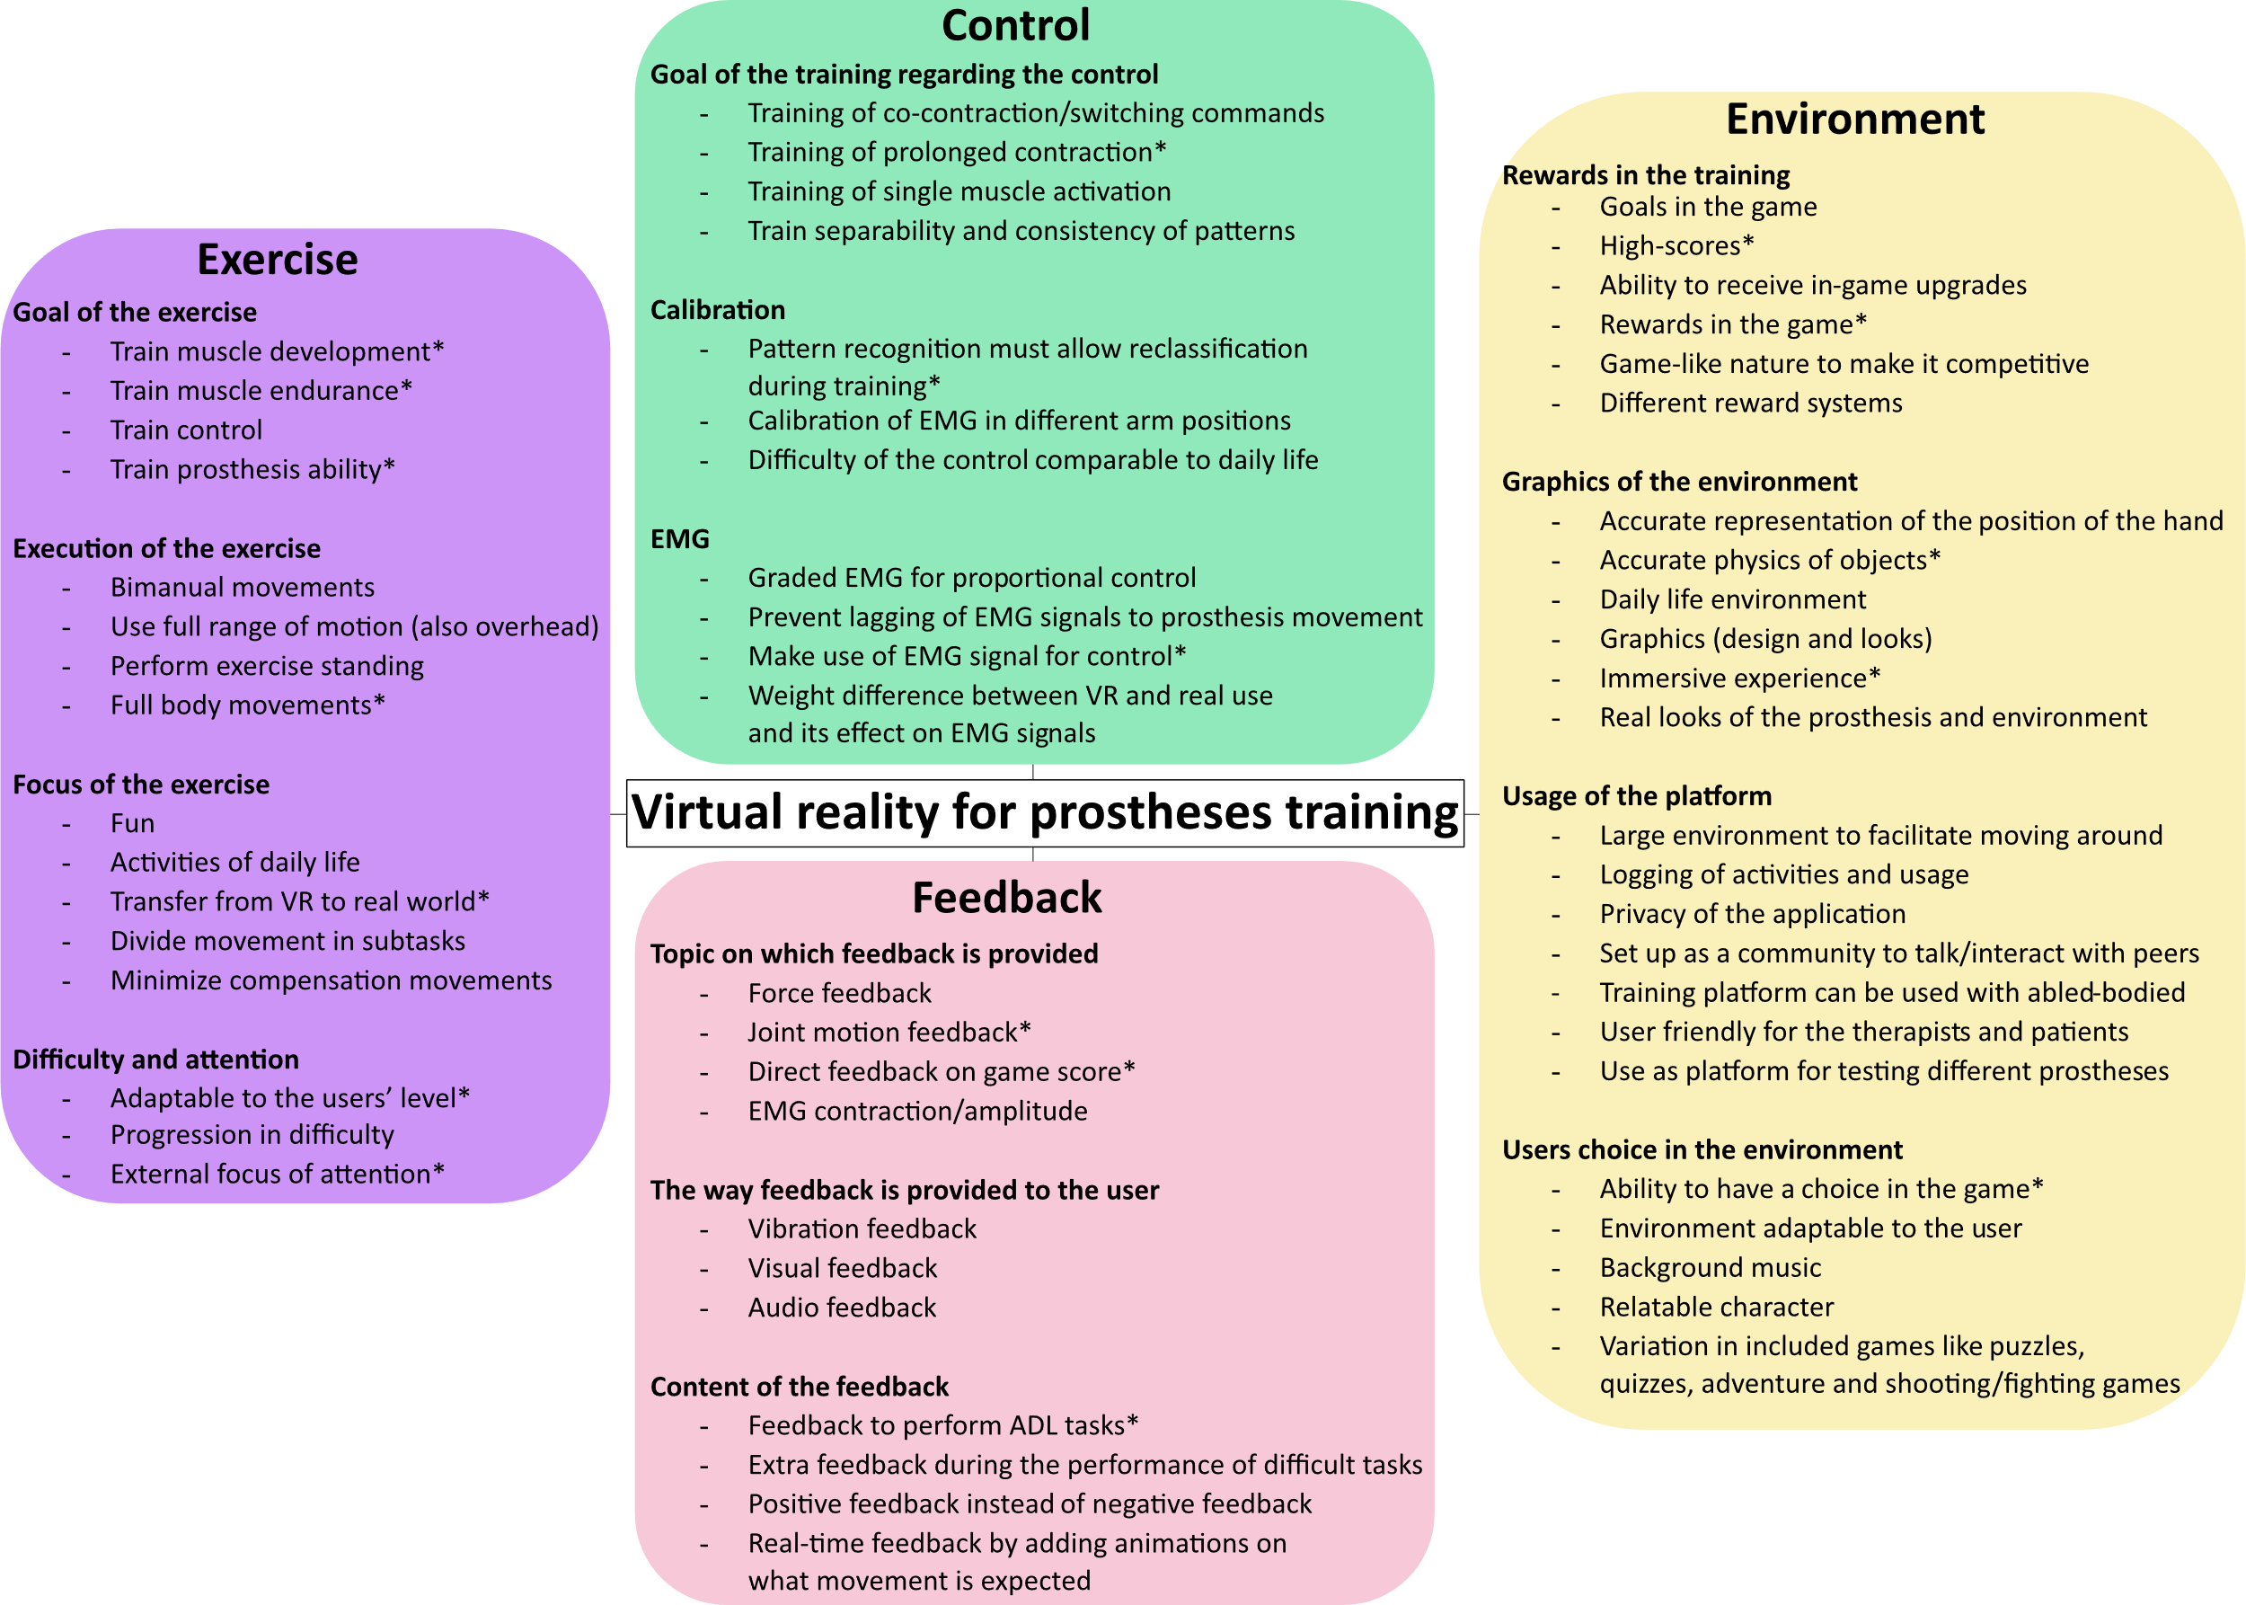
Fig. 5 Preliminary framework of the main domains Feedback, Exercise, Control and Environment that may play a role in designing a VR environment to train myoelectric prosthesis control, based on the literature review. Each main domain is divided in subdomains which contain the factors that were extracted from the narrative review. Factors with an asterisk were omitted in the final framework.

