Supp. Figure 1. Flow diagram detailing the search strategy and results.

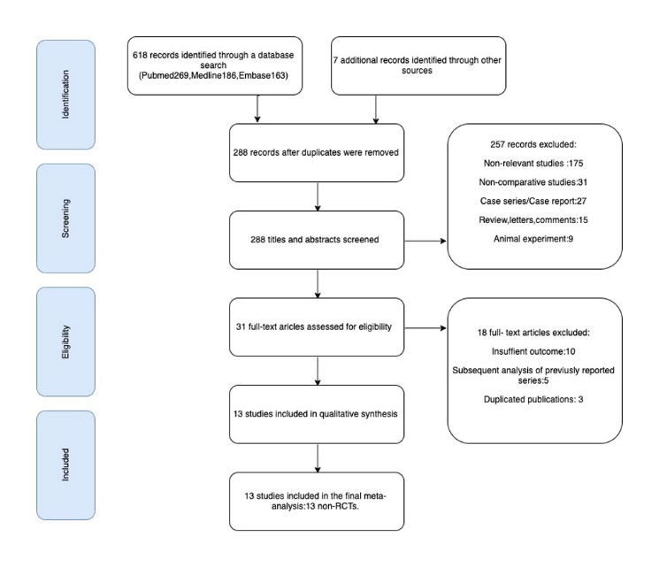
Supp. Figure 2. Forest plot for comparison of the rates of spinal cord injury (SCI) between the hybrid aortic repair (HAR) group and the open total aortic replacement (OTAR) group. A) Total pooled results. B) Sensitivity analysis for available propensity-matched data.
