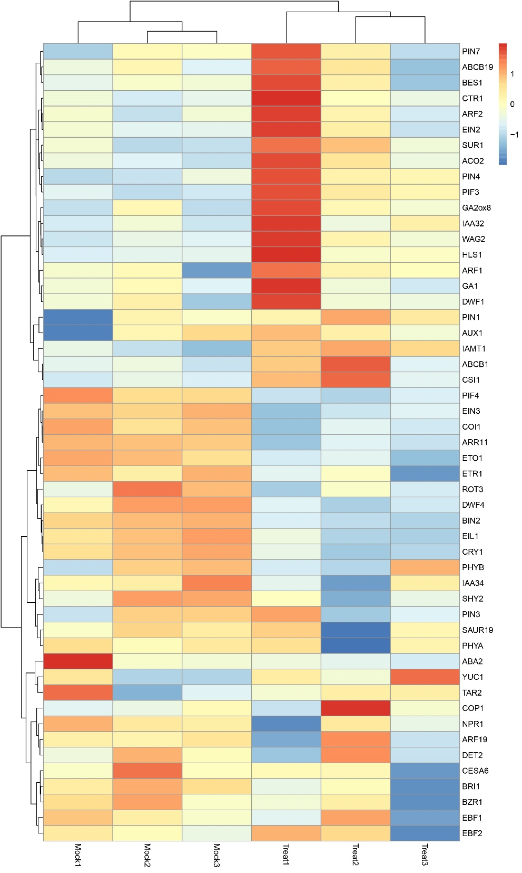
Figure S1. Expression of genes involved in the development of the apical hook under sugar-containing or sugar-free conditions.

