Supporting Information for
A physical demonstration of the increase
in global surface energy due to increasing $P_{{CO}_{2}}$
Hugo F. Franzen, Professor Emeritus. Iowa State University
Stefan Franzen. Professor of Physical Chemistry. North Carolina State University
Sections
1. Theoretical intensities of CO₂ transitions
3. Methods for spectral calculations, flux, and effect of linewidth
3. Fortran programs for calculating the geometrically averaged line shapes
4. Atmospheric temperature increase as result of CO₂ increase (differential flux method)
5. Earth_Temperature Spreadsheet, Earth_Temperature_Spreadsheet.pdf and Python scripts that demonstrate the columns of the spreadsheet graphically and follow each step of the derivation from HITRAN CO₂ absorption bands to CO₂ transmittance and finally surface temperature of the Earth.

- Theoretical intensities of CO₂ transitions

Although we use HITRAN data for CO2 spectra in this demonstration it is important to observe that CO2 spectra are well studied and the theory explains essentially all the tens of thousands of transitions. In fact, some of the data in HITRAN are computed because the spectral lines are too weak to be observed. Because of the linear $D_{∞h}$ symmetry of carbon dioxide and the fact that the oxygen nuclei are indistinguishable bosons, the allowed rotational states of the bending modes at 667 cm⁻¹ have even quantum numbers, $J=0, 2, 4, …$ in the vibrational ground state. Dipole allowed transitions are possible because the odd $J$ quantum numbers are allowed in the odd-numbered vibrational excited states. Thus, the $∆J=±1$ selection rule is valid for rotational transitions. Because of the angular momentum coupling of the internal rotation due to bending itself there are two quantum numbers needed to describe the rovibrational spectra, $J$ and $L$. $L$ represents an angular momentum contribution from the bending vibration itself, which depends on the symmetry of the vibrational state. The vibrational states has symmetries $Σ_{g+}$,$Π_{u-}$, and degenerate$Δ_{g}$ and $Σ_{g+}$for the $L=0, 1,$ and $2$ quantum numbers. Since CO₂ lacks a permanent dipole moment, both the vibrational and rotational transitions of the spectrum are allowed by the fact that the bending vibration breaks the symmetry. Just as in the case of symmetric top molecule, there are parallel and perpendicular rotational constants, A and B with two different moments of inertia with appropriate selection rules.
Parallel
If $L$ ≠ 0, then ΔJ = 0, ±1 and Δ$L$ = 0
If $L$ = 0, then ΔJ = ±1 and Δ$L$ = 0
Perpendicular
ΔJ = 0, ±1 and Δ$L$ = ±1

The transition energies for the Q branch include any allowed changes in $L$ for $ΔJ=0$.¹
$$Q(J)={ \tilde{ν}}_{0}+\left(B^{'}-B^{''}\right)J\left(J+1\right)$$
The P and R branch transitions are observed $ΔJ=-1$ and $ΔJ=+1$, respectively, ²
$$P(J)={ \tilde{ν}}_{0}+B^{'}J\left(J+1\right) and R(J)={ \tilde{ν}}_{0}+B^{''}J\left(J+1\right)$$
where single and double prime represent the lower and upper states rotational constants and it is understood that the $J$ quantum numbers have values of -2, -4, -6… and 2, 4, 6,… for the P and R transitions, respectively. The intensities of these bands can be calculated in the same manner as the angular momentum coupling used for symmetric top molecules. The formula for intensities are given by Kaplan¹ and Martin and Barker.² These can be derived from the Clebsch-Gordon coefficients for coupling of the $J$ and $L$ angular momentum. ³ For convenience, we provide these results in the Supporting Information. ^{1,2}
The intensities of bending mode transitions rotational-vibrational transitions require coupling of the two angular momenta, rotation, J and vibrational, L. The Clebsch-Gordon coefficients can be reduced to the following form, providing a model for the intensities of P, Q and R branch transitions. Each intensity is multiplied by the intensity from the Fermi Golden Rule for a transition from $n→m$, which is proportional to the square of the transition dipole moment, $M_{nm}^{2}$, the ground state degeneracy, $g_{n}$, and the frequency of the transition $ν_{nm}$.
$$W={g_{n}ν_{nm}M}_{nm}^{2}e^{-E_{n}/kT}\left(1-e^{-hν/kT}\right)$$
Where the perpendicular and parallel moments of inertia and asymmetry parameter are
$$B=\frac{h}{8π^{2}cI_{⊥}} and A=\frac{h}{8π^{2}c I ∥ \{\backslash displaystyle I_\{\backslash parallel \}\} I_{∥}} and β=1-\frac{A}{B}$$
R branch: $\left(J=2, 4, 6, ….\right)$
$$I\left(J,L+1→J+1,L\right)=W\left[\frac{(J-L)(J-L+1)}{2(J+1)}\right]exp\left\{-\frac{Bhc\left[2J\left(J+1\right)-{βL}^{2}\right]}{kT}\right\}$$
and
$$I\left(J,L→J+1,L+1\right)=W\left[\frac{(J+L+2)(J+L+1)}{2(J+1)}\right]exp\left\{-\frac{Bhc\left[2J\left(J+1\right)-βL^{2}\right]}{kT}\right\}$$
Q branch $\left(J=2, 4, 6, ….\right)$:
$$I\left(J,L+1→J,L\right)=W\left[\frac{(2J+1)(J-L)(J+L+1)}{2J(J+1)}\right]exp\left\{-\frac{Bhc\left[2J\left(J+1\right)-βL^{2}\right]}{kT}\right\}$$
and
$$I\left(J,L→J,L+1\right)=W\left[\frac{(2J+1)(J-L)(J+L+1)}{2J(J+1)}\right]exp\left\{-\frac{Bhc\left[2J\left(J+1\right)-βL^{2}\right]}{kT}\right\}$$
P branch $\left(J=0, 2, 4, 6, ….\right)$
$$I\left(J+1,L+1→J,L\right)=W\left[\frac{(J+L+2)(J+L+1)}{2(J+1)}\right]exp\left\{-\frac{Bhc\left[2J\left(J+1\right)-βL^{2}\right]}{kT}\right\}$$
and
$$I\left(J+1,L→J,L+1\right)=W\left[\frac{(J-L)(J-L+1)}{2(J+1)}\right]exp\left\{-\frac{Bhc\left[2J\left(J+1\right)-βL^{2}\right]}{kT}\right\}$$
The two bending modes of CO₂ have additional infrared absorptions owing to Fermi resonance, which are also indicated in Figure 2. A Fermi resonance is a quantum mechanical result of the interaction of a two-quantum transition in the bending mode with the symmetric stretching mode. The symmetry of the two-quantum transition is totally symmetric because the symmetry of the square of any spectroscopic term is totally symmetric. The interaction gives rise to a splitting resulting from the sum and difference of an interaction energy between these two transitions. first observed in the splitting of the Raman spectrum of the symmetric stretching band of CO₂ in 1930 by Enrico Fermi.⁴ Because the coupling is a mutual effect, the splitting is observed in the infrared transition in the excited state of the bending mode as well as the Raman spectrum of the symmetric stretching mode. The Fermi resonance splitting energy is ~100 cm⁻¹ so that the consequence of Fermi resonance in the infrared spectrum is a new set of absorptions with the entire set of rovibrational transitions located at 618 cm⁻¹ and 720 cm⁻¹ on either side of the main Q-band at 667 cm⁻¹ (see Figure 2A).
2. Methods for spectral calculations, flux, and effect of linewidth
This report covers the start to finish calculation of transmittance that affects the flux from the earth to space.
Calculation of the transmittance of terrestrial radiation from the surface to the TOA
Our approach to the calculation of absorbance by the bending mode of atmospheric CO₂ begins with a vertical section of the atmosphere above a 1 m² area of the earth’s surface. To obtain the flux of radiant energy from the earth, one can neglect the curvature of the earth while maintaining 99% accuracy. The effect of the curvature is to increase the area through which the radiant energy passes by a factor proportional to the square of the radius of the earth and thus reduce the flux by that factor. Given that earth’s radius is about 6.4 million meters while the height of 99.9% of the atmosphere less than 70,000 meters from the surface, the geometric factor when flux is emitted at the top of the atmosphere using rectilinear coordinates above a small region is:
$${\left(\frac{r_{e}}{r_{e}+z_{TOA}}\right)}^{2}≅{\left(\frac{6.4 x {10}^{6}}{6.4 x {10}^{6}+7.0 x {10}^{4}}\right)}^{2}≅0.99$$
Thus, using rectilinear coordinates introduces an error of only 1%.
The line strengths obtained from the HITRAN database,⁶ are defined by:
$$S_{if}=\frac{A_{if}}{8πhc^{2}{\tilde{ν}}_{if}^{3}}\frac{g'exp\left\{-\frac{c_{2}{\tilde{E}}_{i}}{T}\right\}\left(1-exp\left\{-\frac{c_{2}{\tilde{ν}}_{if}}{T}\right\}\right)}{Q(T)} (S1a)$$
g’ is the upper state statistical weight (i.e. degeneracy)
$E_{i}$ is the lower state energy
$c_{2}$ is the second radiation constant $c_{2}=\frac{hc}{k_{B}}$
$Q(T)$ is the partition function
$$Q\left(T\right)=\sum_{k}{g_{k}exp\left\{-\frac{c_{2}{\tilde{E}}_{k}}{T}\right\}} (S1b)$$
where i labels a set of quantum numbers, i.e. the molecular states, $N_{A}$is Avagadro’s number, $M_{n.m}$ is the transition dipole moment, $\left({\tilde{ν}}_{m}-{\tilde{ν}}_{n}\right)hc$ is the energy of the line and the last term is the Boltzmann factor accounting for the temperature dependence of the ground state population. This expression for a transition from $n→m$ in the HITRAN database.
To calculate the absorption intensity, the absorption coefficients are the products of line strengths,$S_{i}$, and a Lorentzian line shape,
$$L\left({\tilde{ν}}_{i}\right)=\frac{1}{π}\frac{\tilde{α}}{\left[{\left(\tilde{ν}-{\tilde{ν}}_{i}\right)}^{2}+{\tilde{α}}^{2}\right]} (S2)$$
where $α$ is the width at half maximum.⁵ An alternative Gaussian function that represents Doppler broadening is
$$G\left({\tilde{ν}}_{if}\right)=\sqrt{\frac{ln⁡(2)}{π{\tilde{α}}_{D}^{2}}}exp\left\{-\frac{{(\tilde{ν}-{\tilde{ν}}_{if})}^{2} ln⁡(2)}{{\tilde{α}}_{D}^{2}}\right\} (S3)$$
Although Lorentizan broadening provides the fundamental homogeneous linewidth, Doppler broadening is referred to in the HITRAN documentation, but collisional broadening dominates at room temperature. Either of these physical phenomena make the Gaussian lineshape the most appropriate for the calculation. Both $G\left({\tilde{ν}}_{if}\right)$ and $L\left({\tilde{ν}}_{if}\right)$ carry units of 1/ cm⁻¹ such that the monochromatic absorption coefficient $k_{if}$_{j}($\tilde{ν}$,T,p) in units of 1/(molecule cm⁻²) at wave number $\tilde{ν}$ in cm⁻¹ is calculated by summation over all lines with these functions. This is equivalent to drawing a vertical line at a chosen wave number that intersects waveforms yielding partial wave number absorption coefficients, which sum to form the wave number coefficients:
$$k_{\tilde{ν}}=\sum_{i}{S_{i}\left(\tilde{ν}\right)G_{i}\left(\tilde{ν}\right)} (S4)$$
Only when we have multiplied by the broadening function (which has units of cm) will we obtain the monochromatic absorption coefficient. The optical pathlength has units of moles/m². Thus, we need to multiply the absorption coefficient Avagadro’s number, N_{A} and to convert from cm² to m². The molar monochromatic absorption coefficient is given by:
$${k'}_{if}=\frac{N_{A}k_{if}}{10,000 {cm}^{2}m^{-2} mole} (S5)$$
Once we have this coefficient there is a convenient way to parameterize the monochromatic flux calculation.
By treating the entire atmosphere as a single function up to the top of the atmosphere, we can obtain analytical formulae for $k_{\tilde{ν}}$ using a Lorentzian, Gaussian or an analytical approximation for the Voigt profile.⁷⁻⁹ The Fortran code used for the calculation of the spectral intensities is a loop over a series of peaks provided by the HITRAN database combined with an interior loop to calculate the Gaussian peak for each HITRAN entry is given below. We need to multiply each of the HITRAN intensities by Avagadro’s number, N_{A}, and divide by 10,000 to obtain the absorption coefficients, $k_{\tilde{ν}},$ in units of m²/mole. The absorbance at each wave number is $A\left(\tilde{ν}\right)=k_{\tilde{ν}}u_{{CO}_{2}}$. For linear absorption the fractional transmittance is given by ${10}^{-A\left(\tilde{ν}\right)}$.
The transmittance is calculated by generalizing the Beer-Lambert law to the case of a gas of variable concentration in the atmosphere and from a single absorbing frequency to a broadband range of frequencies. Consider a ray of length $l$ of Planck radiation emitted at an angle $θ$ with respect to the normal to the earth’s surface. The change in intensity, $dI$, of a ray of the Earth’s Planck radiation with an increase in path length, $dl,$ is given by the Beer-Lambert law
$$dI_{\tilde{ν}}=-k_{\tilde{ν}}I_{\tilde{ν}}\left(l\right)c\left(l\right)dl (S6a)$$
where $k_{\tilde{ν}}$ is the absorption coefficient and $c\left(l\right)$ and $I_{\tilde{ν}}\left(l\right)$ are the concentration of the absorbing species and the intensity at length $l$ along the ray. According to the HITRAN documentation,
$$k_{\tilde{ν}}=-\frac{ln\left(τ_{\tilde{ν}}\right)}{c\left(l\right)l} (S6b)$$
The absorption coefficient, $k_{\tilde{ν}}$, has units of molecule⁻¹ m². Integrating Eqn. (S6b) we obtain
$$ln\left(\frac{I_{\tilde{ν}}(l)}{I_{\tilde{ν}}(0)}\right)=-k_{\tilde{ν}}\int_{0}^{h}{c\left(l\right)dl} (S7)$$The quantity
$$u_{h}=\int_{0}^{h}{c\left(l\right)dl} (S8)$$
The quantity $u_{h}$ is the optical path length of the atmosphere up to a height, $h$, for a given cross-sectional area. Thus, we have
$$I_{\tilde{ν}}\left(h,\tilde{ν}\right)=I_{\tilde{ν}}\left(0,\tilde{ν}\right)e^{-k_{\tilde{ν}}u_{h}} (S9)$$
A more convenient distance measure is the height above the earth’s surface which, given the neglect of the earth’s curvature, is
$$z=\frac{l}{μ}=\frac{l}{\cos{θ}} (S10a)$$
where $μ$ is the cosine of the polar angle. By integrating over the polar and azimuthal angles,$θ$ and $ϕ$, one can account for all optical paths from the earth’s surface to the top of the atmosphere. In the case of atmospheric radiation it is helpful to convert from intensity to spectral radiance and then finally to vertical flux, F(T), which is a function of temperature because of the Stefan-Boltzmann law. First, we define the integrated projection of the intensity onto the vertical axis at a particular wave number to give the spectral flux, $Φ_{0}\left(T,\tilde{ν}\right)$, which we will also call $Φ_{ground}\left(T,\tilde{ν}\right)$. In the presence of an energy-absorbing atmosphere this quantity is $Φ_{TOA}\left(T,\tilde{ν}\right)$. Thus,
$$Φ_{TOA}\left(T,\tilde{ν}\right)=I_{0}\left(T,\tilde{ν}\right)\int_{0}^{1}{\int_{0}^{2π}{e^{-k_{\tilde{ν}}u_{h}/μ}μdμdϕ}} (S10b)$$
where $ϕ$ is the polar angle. After integration over $ϕ$,
$$Φ_{TOA}\left(T,\tilde{ν}\right)=2πI_{0}\left(T,\tilde{ν}\right)\int_{0}^{1}{e^{-k_{\tilde{ν}}u_{h}/μ}μdμ} (S10c)$$
The spectral flux at the earth’s surface requires $u_{h}\left(0\right)=0$. Thus,
$$Φ_{0}(T,\tilde{ν})=2πI_{0}\left(T,\tilde{ν}\right)\int_{0}^{1}{zdz} (S10d)$$
which integrates to $Φ_{0}(T,\tilde{ν})=πI_{0}\left(T,\tilde{ν}\right).$ In some publications, $Φ_{0}(T,\tilde{ν})$ is known as the flux and $F_{0}(T)$ the integrated flux, where $F_{0}(T)=\int{Φ_{0}(T,\tilde{ν})d\tilde{ν} }$. In order to calculate radiation balance of the sun and earth, including an atmosphere, we require integrated fluxes. The spectral flux transmittance is
$$τ_{\tilde{ν}}=\frac{Φ_{atm}(T,\tilde{ν})}{Φ_{0}(T,\tilde{ν})} (S11)$$
Second, we convert these quantities to the integrated flux of the earth and earth plus atmosphere by integrating over the spectral radiance functions for the Planck distribution of the bare earth and the earth with an absorbing-gas atmosphere. The calculation of the earth’s emission begins with the Planck spectral radiance
$$I_{0}\left(T,\tilde{ν}\right)=2hc^{2}{\tilde{ν}}^{3}\frac{1}{e^{hc\tilde{ν}/kT}-1} (S12)$$
which has units of power emitted per unit projected area of the emitting surface, per unit solid angle, per spectral unit (wave numbers in this case). To derive the Stefan-Boltzmann law we must integrate $dΩ=\sin{θ}dθ dϕ$ over a half sphere to obtain the spectral flux and then integrate $\tilde{ν}$ from 0 to $∞$.
$$F_{o}\left(T\right)=\int_{0}^{∞}{I_{o}\left(T,\tilde{ν}\right)d\tilde{ν}}\int_{0}^{2π}{dϕ}\int_{0}^{π}{\cos{θ}\sin{θ}dθ} (S13)$$
To carry out the integral over the spectral radiance. Let $z=\frac{hc\tilde{ν}}{kT}$ and d$z=\frac{hc}{kT}d\tilde{ν}$
$$F_{o}\left(T\right)=πhc^{2}\int_{0}^{∞}{\frac{{\tilde{ν}}^{3}}{e^{\frac{hc\tilde{ν}}{kT}}-1}d\tilde{ν}}=\frac{2πh}{c^{2}}{\left(\frac{kT}{h}\right)}^{4}\int_{0}^{∞}{\frac{z^{3}}{e^{z}-1}dz} (S14)$$
The integral is a standard integral known as the Riemann zeta function $ζ$(4) and has a value of $π^{4}/15$. Therefore,
$$F_{o}\left(T\right)=\frac{2π^{5}k^{4}}{{15c}^{2}h^{3}}T^{4}=σT^{4} (S15)$$
This well-known result is the Stefan-Boltzmann law and collection of constants is called $σ$. It tells us what the emitted flux from the earth (or any object at thermal equilibrium) would be in the absence of absorption. The magnitude of the flux, $F_{o}(T)$, can be compared to the flux of thermal radiation in the presence of the angle dependence of CO₂ absorption,
$$F_{TOA, {CO}_{2}}\left(T\right)=2πhc^{2}\int_{0}^{1}{\int_{0}^{∞}{\frac{{\tilde{ν}}^{3}e^{-k_{{CO}_{2}}(\tilde{ν})u_{{CO}_{2}/μ}}}{e^{hc\tilde{ν}/kT}-1}d\tilde{ν}}μdμ (S16)}$$
Combining the above results, the calculated flux transmittance at $τ_{TOA}$ is
$$τ_{TOA}=\frac{F_{TOA}(T)}{F_{atm}(T)} (S17)$$
It is important to keep in mind that the transmittance is a function of the ${CO}_{2}$ ppm because $u_{{CO}_{2}}$depends on the concentration of ${CO}_{2}$.
We can obtain the molar absorptivity of the ${CO}_{2}$ transitions from global measurements at a wide range of latitudes and altitudes, which have been tabulated in the HITRAN database.⁶ Similar calculations are possible for other energy-absorbing gases such as $H_{2}O$ and ${CH}_{4}$. Methane is an increasing concern because of the large amount of this gas trapped in permafrost that will be released as warming continues creating a greater forcing. However, methane plays a relatively minor role today, compared to ${CO}_{2}$. We will include $H_{2}O$ as a constant because it plays a major role in feedback processes and is important to any approximate model of atmospheric transmittance.
2.2 Numerical approach to calculation of the flux integral
The spectral flux was defined in Eqn. S8c as
$$Φ_{TOA}\left(\tilde{ν}\right)=2πI_{0}\left(\tilde{ν}\right)\int_{0}^{1}{e^{-k_{\tilde{ν}}u_{h}/μ}μdμ} (S18)$$
We can compare the simple transmittance
$$T\left(\tilde{ν}\right)∝e^{-k_{\tilde{ν}}u_{h}} (S19a)$$
to the transmittance integral over polar angles of a point source at the surface.
$$T^{'}\left(\tilde{ν}\right)∝\int_{0}^{1}{e^{-\frac{k_{\tilde{ν}}u_{h}}{μ}}μdμ} (S19b)$$
to create a function that converts from T to T’. Then once have obtained the product of the optical cross section and optical pathlength, $k_{\tilde{ν}}u_{h}$ we can calculate the value of $T\left(\tilde{ν}\right)$ at each wavenumber. Figure S1 shows the function $e^{-k_{\tilde{ν}}u_{h}/μ}μ$ vs. $μ$ for a variety of different products of optical parameters $A_{rel}=k_{\tilde{ν}}u_{h}$
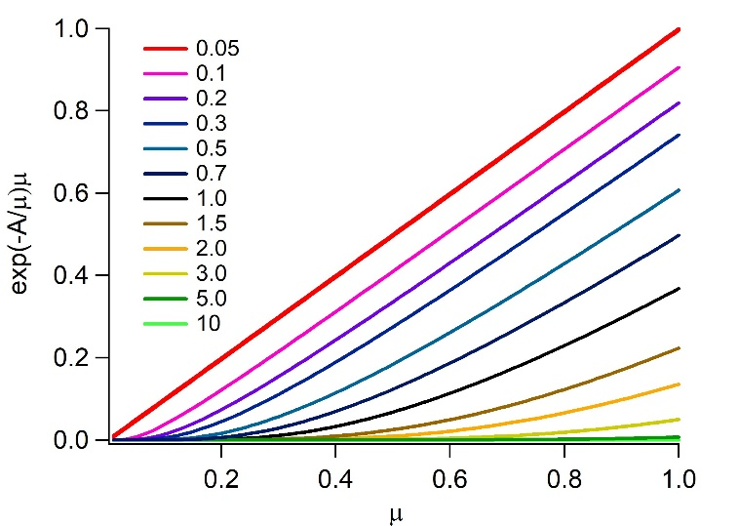
Figure S1. Plot of the integrand of the transmittance function for a point source versus the cosine of the polar angle.
Figure 2B shows the integrated value, using numerical integration of the curves in Figure S1, $T'\left(\tilde{ν}\right)$, in blue and $T\left(\tilde{ν}\right)$ in red.
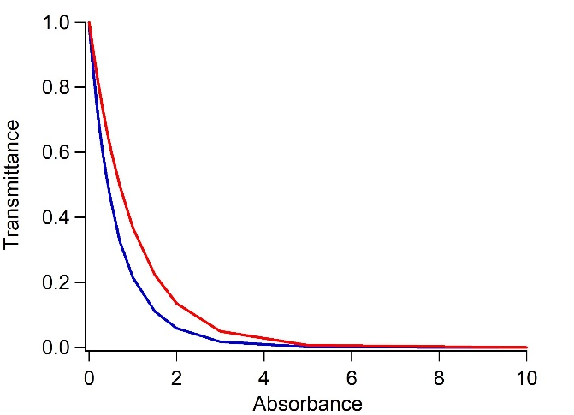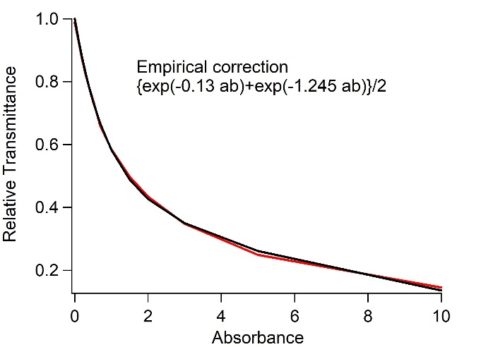
Figure S2. Empirical result of the correction function that accounts for integration over polar angles of a point source at the surface of the earth. This method was applied to spreadsheet calculation in column H.
To convert from one to the other parametrically we plot the ratio $T'\left(\tilde{ν}\right)/T\left(\tilde{ν}\right)$. It is convenient that the function is fit well by a biexponential. This empirical method permits us to convert from isotropic single point radiation in a hemisphere to vertical flux without having to repeatedly carry out the numerical integration for each new condition.
2.3 Test calculations to validate linewidth effects
Among the necessary considerations is the role of the line shape function. First, we applied a test of the model system using three bands with an intensity of 1.0. These were dressed with Lorentizans, $\tilde{α}$ = 0.1 cm⁻¹ and $\tilde{α}$ = 0.5 cm⁻¹, shown in Figure S3. The narrow red bands have the smaller $\tilde{α}$ = 0.1 cm⁻¹ and the broader blue bands have $\tilde{α}$ = 0.5 cm⁻¹. The integrated curves in both cases show that the height is basically the same. Each peak integrates to 1.0. This test gives confidence that the program used to calculate absorption spectra gives accurate results.
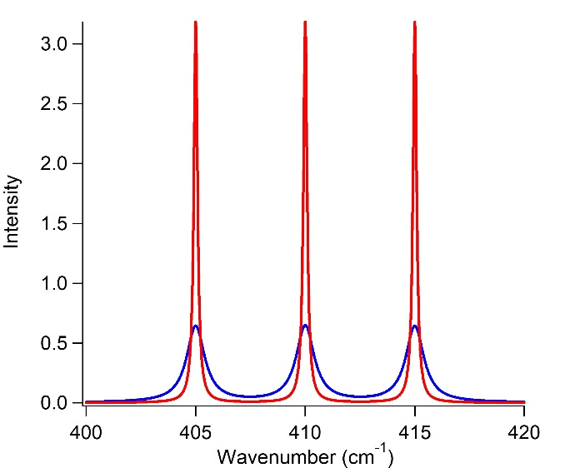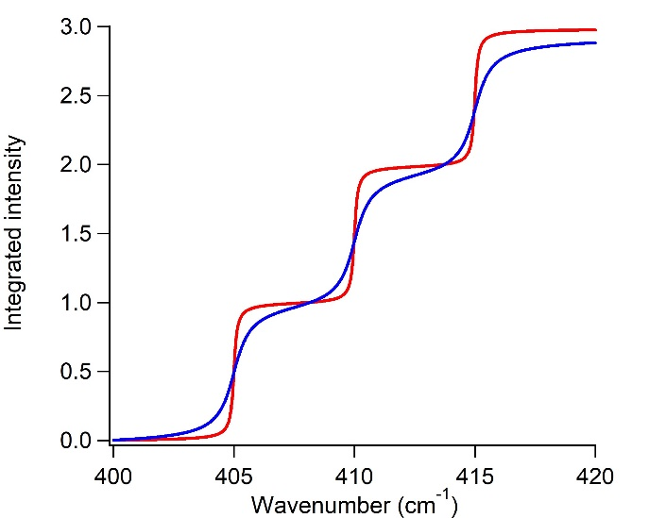
Figure S3. Test of the numerical integration procedure for different theoretical linewidths of the atmospheric absorption lines.
Before proceeding, we wish to define the relative absorbance, which is the $k_{\tilde{ν}}u_{h}$ product from Eqn. 6 in the paper. The true absorbance is $A=k_{\tilde{ν}}u_{h}$/2.303, which is the appropriate factor to permit conversion of the exponential to base 10. We are not using the absorbance directly in any of our calculations, thus we will let the exponential function remain in base e.
A next step is to consider the calculation of transmission. For simplicity we will simply use the
$$T=e^{-A_{rel}}$$
For each model the spectral transmittance and average transmittance are shown in Figure S4.
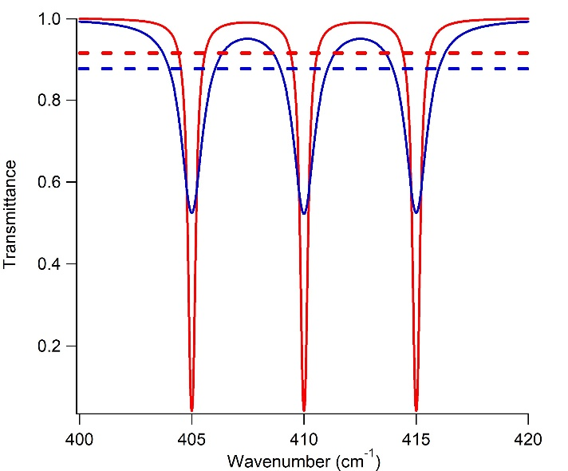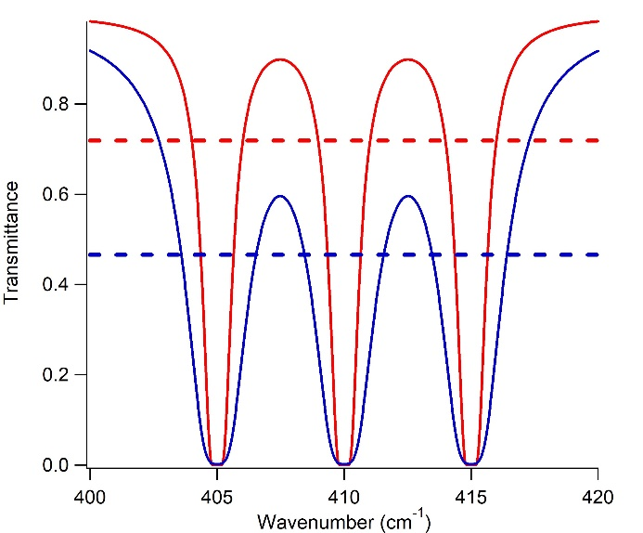
Figure S4. The difference in integrated transmittance is small in the case of peaks that have a line intensity of 1 (left panel). For ten times larger absorbances shown in the right panel, the difference in average transmittance is significantly larger. In the example of the right panel the average transmittance across the spectral range falls from 0.72 to 0.47 for $\tilde{α}$ = 0.1 cm⁻¹ and $\tilde{α}$ = 0.5 cm⁻¹, respectively.
2.4 Effect of Transmittance on Integrated Planck flux
We can test the effect of ${CO}_{2}$ and $H_{2}O$ linewidths on the transmittance. Here, we choose a Lorentzian function as the example because of its relatively slow fall off in the wings of the function. Since the function is normalized, one might expect that the transmittance does not change with linewidth. However, the conversion from relative absorbance to transmittance is exponential and furthermore there are regions of the spectrum that are saturated. For a very intense absorption band or region, such as the Q-band, a change in linewidth by changing the parameter $\tilde{α}$ in the above equation, only affects the transmittance by changing the width. The smaller contribution of this intense band decreases proportional to the linewidth. We can first examine the effect of ${CO}_{2}$ and $H_{2}O$ transmittance on the Planck curve in Figure S5. Then we can compare the effect of linewidth on the transmittance of ${CO}_{2}$ and $H_{2}O$ shown in Figure S6.

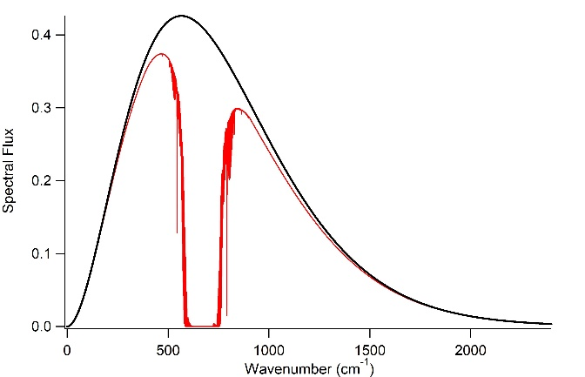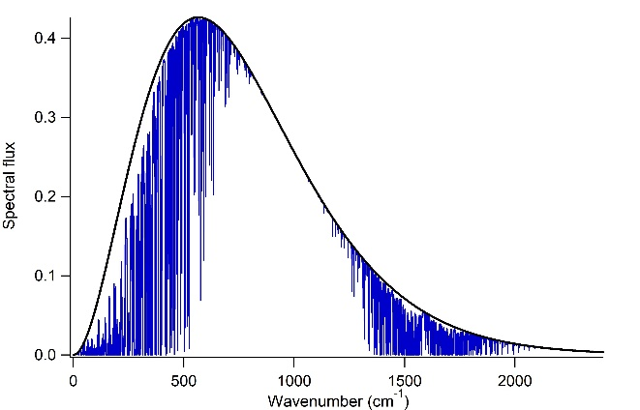
Figure S5. Comparison of thermal emission in the presence of CO₂ (left) and H₂O (right) absorption lines.

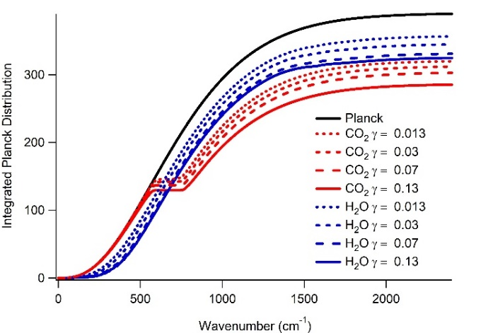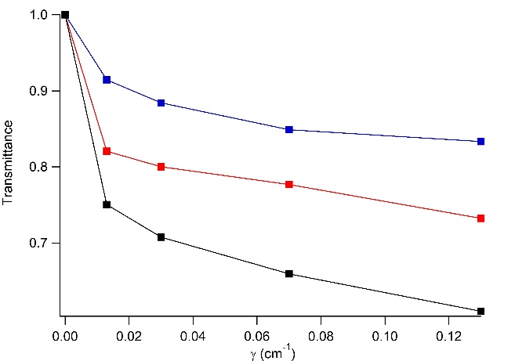
Figure S6. Comparison of the effect of linewidth on the final integral over thermal radiation with CO₂ absorption transitions from HITRAN included.
The value of the combined ${CO}_{2}$ and $H_{2}O$ transmittance that corresponds to the current surface temperature of the earth is approximately 0.62. Using the value of $\tilde{α}$= 0.01 cm⁻¹, have calculated the change in transmittance that will occur as the partial pressure of ${CO}_{2}$ increases above its current value of 420 ppm using the HITRAN data converted to a relative absorbance. The line-by-line model is technically not possible to implement since the lines are not evenly spaced, which makes integrating inaccurate, but mainly because the lines are not defined without the lineshape function. Finally, the line approach is equivalent to a very narrow Lorentzian. Using the line model the transmittance of ${CO}_{2}$ was 0.97. In the above calculation is approximately 0.75. This may be an overestimate, but a consistent an sensible result is obtained if $\tilde{α}$= 0.01 cm⁻¹. Using this value we can calculate the transmittance as a function of the partial pressure of ${CO}_{2}$. This is shown in Figure S7.
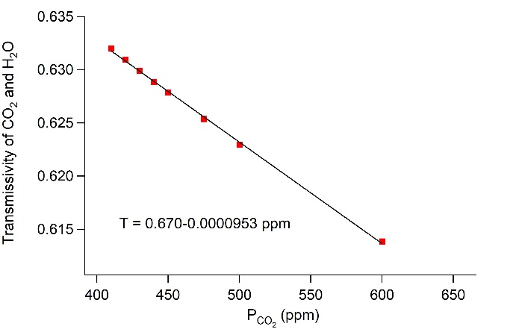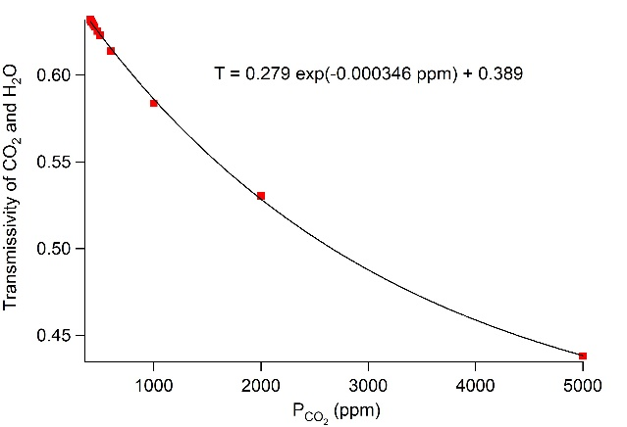
Figure S7. Combined transmittance of CO₂ and H₂O as explained in the text.
2.5 The overlap issue
Lorentzians are known for having very long tails. As a consequence, there may be interference between molecules in the gas phase. Absorption by one molecule reduces the probability of absorption of a neighbor. To understand how large this effect is I created a series of Lorentzians spaced systematically by distances ranging from 0.02 cm⁻¹ to 0.8 cm⁻¹.
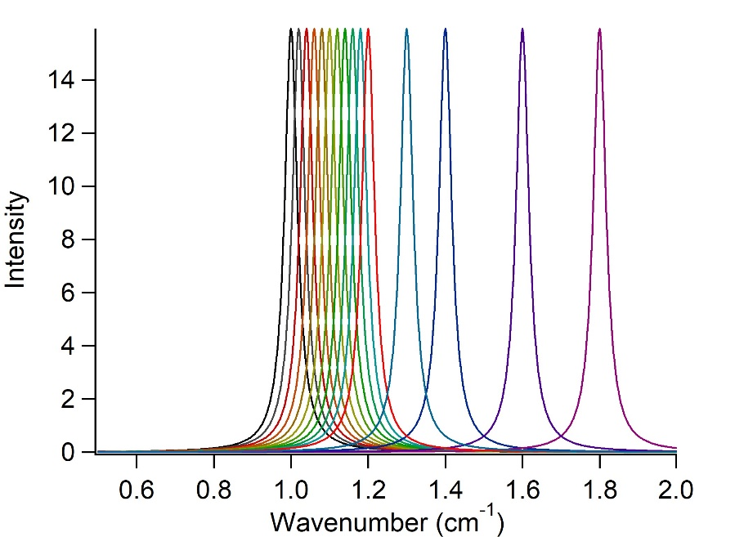
Figure S8. Depiction of Lorentzian function of fixed width plotted at various spectral distances to numerically determine the overlap.
The overlap region for each was determined and that plot is shown in Figure S9.
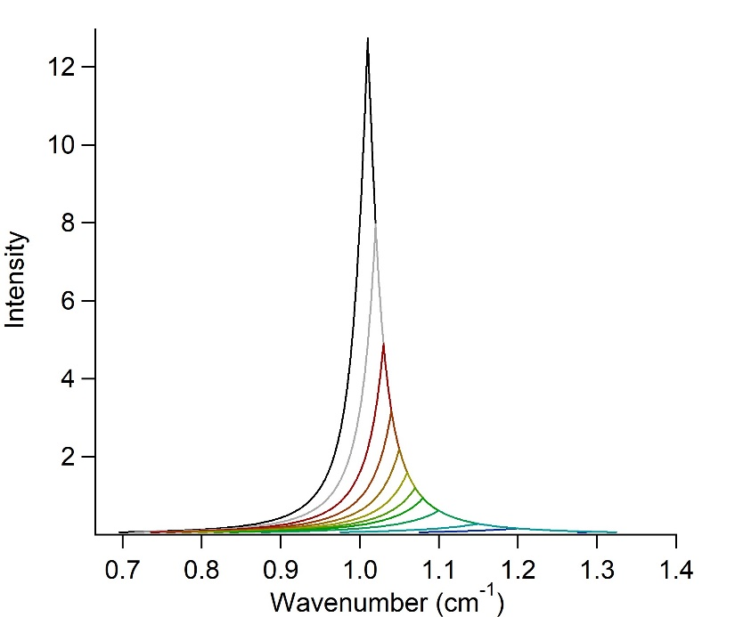

Figure S9. Overlap calculation as a function of linewidth.
The integrated areas of these overlap areas are compared to the integrated area of the normalized Lorentzian, which is 1.0. The relative integrated areas are plotted as a function of the distance.
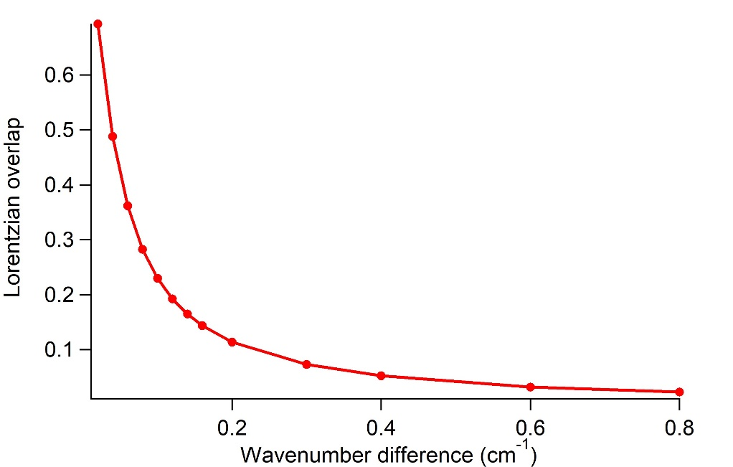
Figure S10. Integrated overlap over Lorentzians separated by the distances shown. The fixed width of the Lorenztians. The width of the Lorentzian used for this model was α = 0.02 cm⁻¹.
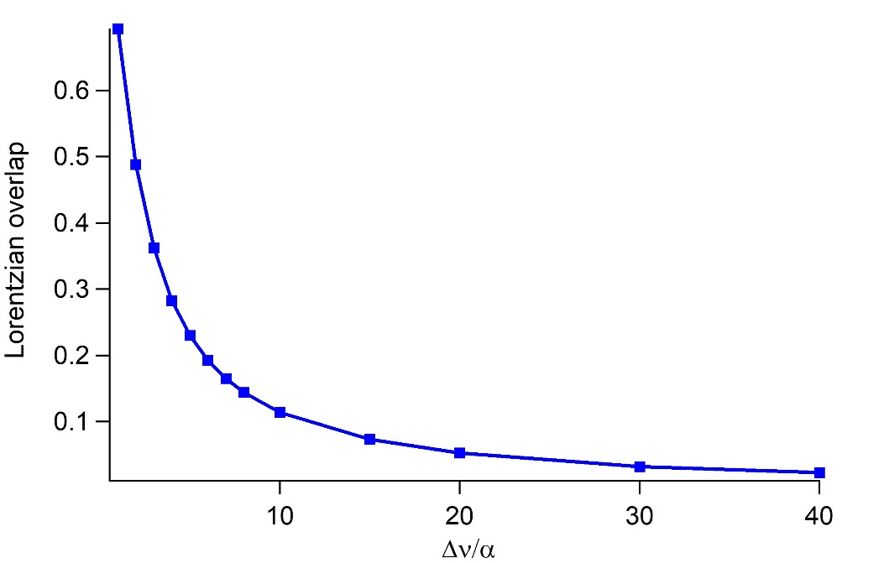
Figure S11. Integrated overlap over Lorentzians separated by the distances shown. The fixed width of the Lorenztians. The angle-dependent integration factor has been applied as a correction file determined by the empirical method above.
It is difficult to estimate the effect of this overlap given the large number of bands in the area of interest. Using the HITRAN database and limiting the transitions to natural abundance CO₂, there circa 76,000 transitions over the 2,400 cm⁻¹ that captures more than 97% of the earth’s radiation. Many of these transitions are extremely weak. On the other hand, other regions, such as the Q-band have many closely overlapped, relatively intense transitions. However, the Q-band and nearby regions that have strong overlap of intense absorption bands are already saturated and thus, the effects described here are of no consequence in those regions. Nonetheless, when considered across the range of interest, there is an over-calculation of the absorption in a significant part of the spectrum. Goody and Yung have suggested that an average value for such overlaps is 0.15. ¹⁰ The calculation done here certainly indicates that this value is reasonable. The spacing of the most intense bands is 0.4 cm⁻¹ (i.e. the rotational spacing of CO₂). Thus, the lower limit is 0.05 (from Figure 3). Since there many more bands that have significantly larger overlap, the proposed value of 0.15 seems reasonable. This suggests that absorption is overestimated by the data and should be decreased by a factor of 0.85.
3. Fortran programs for calculating the geometrically averaged lineshapes
The Gaussian linewidth parameter is called $γ$. It has also identified as $α$ in the HITRAN documentation. The fortran code can be used to apply Gaussian width to the HITRAN bands where $γ$ is the r.m.s deviation and the full width at half maximum is 1.122 $γ$.
****************************************************************
program hitran_gauss_convert
****************************************************************
c
c This program calculates a set of gaussian peaks from
c an input file

c To compile non-graphics programs use :
c gfortran ir_spec.f -o ir_spec
c
parameter (n = 240000)
parameter (m = 100000)
real*8 w(n), g(n),t(n)
real*8 w0(m), r(m)
real*8 sigma, Pi
character*40 fname
character*40 gname
integer i,j,npts
integer icolumn,iostatus
integer cnunit
parameter ( cnunit = 10 )
c
Pi = 3.1415926
c
print *,'Input filename:'
read(5,*) fname
c
open(unit=cnunit,file=fname,status='old',form='formatted')

print *, 'Enter number of HITRAN data points: '
read(5, *) npts

do i=1,npts
read(cnunit,*,err=3000) w0(i), r(i)
r(i) = r(i)*6.022e19
c print *, w0(i), r(i)
end do
c

print *, 'Enter Gaussian Variance: '
read(5, *) sigma
c: sigma = 0.13
c
print *,'Enter Output Filename: '
read(5,*) gname
c
open(unit=7,file=gname,form='formatted',
$ status='new',err=990)
c
do j=1,240000
w(j)=j*0.01
t(j)=0.0
end do
do i = 1, npts
do j = max(1,int(w0(i)*100)-130),min(240000,int(w0(i)*100)+130)
g(j) = (w(j) - w0(i)) * (w(j) - w0(i)) / (2 * sigma * sigma)
t(j) = t(j) + r(i) * exp(-g(j)) / sqrt(2 * Pi) / sigma
end do
end do
do j=1,240000
write(7,210) w(j),t(j)
end do
210 format(f8.3,' , ',f16.12)
goto 999
3000 continue
print *,'Error in input file'
goto 999
990 continue
print *,'Error in output file'
999 continue
c
end

4. Differential estimates of radiative forcing as a result of CO₂ increase
4.1 The differential flux model for application to radiative forcing
The differential flux model based on the Stefan-Boltzmann law begins with the equation
$$δF=σT^{3}δT (20a)$$
or
$$∆F=σT^{3}∆T (20b)$$
We can connect this model to the calculation of the absorption by CO₂ using
$$∆F=∆\left(1-τ_{atm}\right)F_{surface} (20c)$$
Finally, we can solve for the change in temperature due to a change in flux.
$$∆T=\frac{∆F}{σT^{3}} (20d)$$
Because it is a differential model, it will only be valid for small changes in flux. Thus, it may be valid for the annual change in the radiation flux that we calculate due to the annual decrease in $τ_{atm}$ that arises from increasing CO₂ ppm. In the Supporting Information we show that even this simple equation predicts the annual temperature increase of 0.015 ºC associated with an increase of 2.1 ppm of CO₂.
4.2 Long-term effects of changes in CO₂ partial pressure
If we assume that the atmosphere itself is a thermal (blackbody) emitter then we can assume that the differential flux is
$$∆F_{atm}=\frac{∆\left(1-τ_{atm}\right)F_{surface}}{2} (S21)$$
We have included the fact that the radiation of the atmosphere includes an upward and downward component, which reduces the radiated flux by a factor of 2. The change in the transmittance as a function of CO₂ ppm can be obtained from the regression line in Figure 5. Using the data from the Keeling curve showing that CO₂ in the atmosphere increases at an annual rate of 2.1 ppm, we select two values with a one-year delay between them to calculate the differential flux. Evaluation of Eqn. 8 at 410 ppm and 412 ppm gives values of $τ_{atm}=0.6364$ and $τ_{atm}=0.6357$. According to this model, the flux from the atmosphere increases by
$$∆F_{atm}=\left(2 x {10}^{-4}\right)\left(390\frac{W}{m^{2}}\right)\left(\frac{1}{2}\right)=0.0390 \frac{W}{m^{2}} (S22)$$
on an annual basis due to the increased absorption of energy by CO₂. The corresponding temperature increase is
$$∆T_{atm}=\frac{∆F_{atm}}{σT^{3}}=\frac{0.0390 \frac{W}{m^{2}}}{(5.678 x {10}^{-8}){288}^{3}}=0.0287 {}_{}^{o}C (S23)$$
on an annual basis. This is the simplest model and it is relatively accurate. The fact that it does not calculate the overall energy-absorbing gas effect correctly is concerning, but it is a differential model, which means it is only valid in the limit of small changes. It is consistent with the radiation balance model.
4.3 A differential model for the energy imbalance due to emission of energy-absorbing gas
The model can also be employed to demonstrate how an energy absorbing gas can act as a forcing. Starting at a steady-state condition we can calculate the radiation flux imbalance at the top of the atmosphere as an energy absorbing gas is emitted at constant temperature. In differential form the flux imbalance is
$$δF_{TOA}=F_{atm}δτ_{atm} (S24)$$
where we assumed $δF_{atm}=0$. From Eqn. 11 in the text we have
$$δτ_{atm}=-0.000072 ppm (S25)$$
in which the slope has units of ${ppm}^{-1}.$ We can include time-dependent changes in the system by considering the time derivative of the transmittance caused by changes in energy absorbing gas.
$$\frac{δτ_{atm}}{δt}=-0.000061 \frac{δppm}{δt} (S26)$$
We can write the time dependence of the of effect of this change on the radiation leaving the TOA as
$$\frac{δF_{TOA}}{δt}=F_{ground}\frac{δτ_{atm}}{δt} (S27)$$
Thus, using the current value of $F_{ground}=390 W/m^{2},$ the model indicates
$$\frac{δF_{TOA}}{δyear}=\left(-0.0213\frac{W}{m^{2}ppm}\right) \frac{δppm}{δyear} (S28)$$
Assuming $δppm$/$δyear$ = 2.1, the annual change in outward flux at the TOA is $∆F_{TOA}=-0.0447 W/m^{2} year$ due to emission of CO₂. Given that the imbalance is estimated to be on the order of $1 W/m^{2}$, we can estimate that it took 22.3 years to achieve this imbalance. We can also ask how long it would much the earth’s surface temperature would increase if we stopped emitting CO₂ immediately. The transient form is:
$$\frac{δT_{atm}}{δt}=-\frac{T_{bare earth}}{4{τ_{atm}}^{\frac{5}{4}}}\frac{δτ_{atm}}{δt} (S29)$$
Which can be written more simply as
$$\frac{δT_{atm}}{δt}=\frac{T_{atm}}{4τ_{atm}}\frac{δτ_{atm}}{δt} (S30)$$
This estimate of the rate of temperature change of the surface is clearly on the high side since it does not consider lags in energy transfer to the earth’s surface from convection and conduction. However, we can still use it to estimate the temperature increase on an annual basis
$$\frac{δT_{atm}}{year}=0.014\frac{{}_{}^{o}C}{year} (S31)$$
Thus, after 22.3 years the surface temperature would increase by ~0.3 ${}_{}^{o}C$. Using a much more detailed model Hansen estimated that the change in temperature due the inertia in the system would be 0.6 ${}_{}^{o}C$.⁴⁰ Any lag in the system would potentially increase the time rate of heating as well as the duration of heating due to the imbalance. The pure Planck radiation model does not account for lags due to convection, conduction or scattering by aerosols. Yet, this very simple model predicts the energy-absorbing gas effect in reasonable agreement with sophisticated computer simulations of the changes in the earth’s energy balance that arise from CO₂ forcing.
5.3 Spreadsheets and Scripts to Illustrate Effect of CO₂ Absorbance
The spreadsheet entitled “Earth_Temperature.xlsx” contains wavenumbers and intensities in columns A and B. The 240,000 calculated values are based on 67,000 lines of natural abundance CO₂ obtained from the HITRAN database with Gausian functions calculated by the fortran program hgc.f in Section 3 above. Column B can be substituted with CO₂ data calculated with different line widths, $γ$. Accepted values of $γ$ have ranged from 0.02 cm⁻¹ to 0.2 cm⁻¹. We use the value of $γ=0.13 {cm}^{-1}$ for the spectral broadening. The columns in the spreadsheets are given in: Excel_spreadsheet.pdf
Column A: $\tilde{ν}$ (cm⁻¹)
Column B: CO₂ Intensity $k_{{CO}_{2}},\tilde{ν}$ (m²/mole)
Column C: Number density $u_{{CO}_{2}}$ (mole/m²) per CO₂ ppm [$u_{{CO}_{2}}$ is the product of C and D]
Column D: CO₂ ppm [this value can be changed to calculate a new surface temperature]
Column E: $u_{{CO}_{2}}$ optical pathlength [product of C and D]
Column F: $A_{rel,\tilde{ν}}=k_{{CO}_{2},\tilde{ν}}u_{{CO}_{2}}$
Column G: Spherical transmittance, $T_{\tilde{ν}}=exp\left\{-2.303A_{rel,\tilde{ν}}\right\}$
Column H: flux transmittance correction, $C_{\tilde{ν}}=[exp\left\{-2.867A_{rel,\tilde{ν}}\right\}+exp\left\{-0.299A_{rel,\tilde{ν}}\right\}]/2$
Column I: Spectral flux transmittance, $τ_{\tilde{ν}}=T_{\tilde{ν}}C_{\tilde{ν}}$
Column J: Absolute temperature estimate at surface of the earth, $T_{earth}$
Column K: Planck distribution at temperature $T_{earth}$
Column L: Planck distribution at temperature $T_{earth}$ multiplied by $τ_{\tilde{ν}}$
Column M: Results
M4 Planck flux (no atmosphere), $F_{atm}$
M6 Planck flux (CO₂ absorption), $F_{TOA}$
M8 Total transmittance $τ_{TOA}=M6/M4$ ($τ_{atm}=F_{atm}/F_{0}$)
M10 Temperature obtained from Planck ratio using Eqn. 8.
Although it is possible to graph the relevant columns of the Excel spreadsheet using a scatter plot, the quality of the plot is much better when IgorPro or a python script is used. The IgorPro equivalent of the spreadsheet is also provided with this document in the Supporting Information. Moreover, having independent scripts that calculate the various entries is convenient for visualizing the process. A complete set of Python scripts is included.
References
1. Kaplan, L.D. The Absorption Spectrum of Carbon Dioxide From 14 to 16 Microns. J. Chem. Phys. 15, 809-815 (1947).
2. Martin, P.E. & Barker, E.F. The infrared absorption spectrum of carbon dioxide. Physical Review 41, 291-303 (1932).
3. Zare, R.N. Angular Momentum. John Wiley and Sons Printed in the United States of America(1988).
4. Fermi, E. The Raman effect of carbon dioxide. Zeitschrift Fur Physik 71, 250-259 (1931).
5. Wyatt, P.J., Stull, V.R. & Plass, G.N. Infrared Transmittance of Water Vapor. Applied Optics 3, 229-& (1964).
6. Gordon, I.E., et al. The HITRAN2016 molecular spectroscopic database. Journal of Quantitative Spectroscopy & Radiative Transfer 203, 3-69 (2017).
7. Liu, Y.Y., Lin, J.L., Huang, G.M., Guo, Y.Q. & Duan, C.X. Simple empirical analytical approximation to the Voigt profile. Journal of the Optical Society of America B-Optical Physics 18, 666-672 (2001).
8. Di Rocco, H.O. & Cruzado, A. The Voigt Profile as a Sum of a Gaussian and a Lorentzian Functions, when the Weight Coefficient Depends Only on the Widths Ratio. Acta Physica Polonica A 122, 666-669 (2012).
9. Temme, N.M. Voigt function. NIST Handbook of Mathematical Functions, Cambridge University Press Olver, Frank W. J.; Lozier, Daniel M.; Boisvert, Ronald F.; Clark, Charles W. (eds.)(2010).
10. Goody, R.M. & Y, L.Y. Atmospheric Radiation. Oxford University Press, Oxford, U.K. (1989).
11. Zhou, Y.P., Kratz, D.P., Wilber, A.C., Gupta, S.K. & Cess, R.D. An improved algorithm for retrieving surface downwelling longwave radiation from satellite measurements. Journal of Geophysical Research-Atmospheres 112(2007).
12. Gui, S., Liang, S.L. & Li, L. Evaluation of satellite-estimated surface longwave radiation using ground-based observations. Journal of Geophysical Research-Atmospheres 115(2010).

