Supplementary
Environmentally Friendly nanomembrane from PEF–PHBv composites: Preparation and investigation of morphologies, thermal, and mechanical properties
Somprasong Thongkham¹*, Tanatorn Thiamsing¹, Chothika Onsuwan¹, Orawan Termkunanon¹, and Woraporn Kiwjaroun¹
¹ National Nanotechnology Center, 114 Thailand Science Park, Paholyothin Rd., Klong 1, Klong Luang, Pathumthani 12120, Thailand
E-mail: somprasong.tho@nanotec.or.th

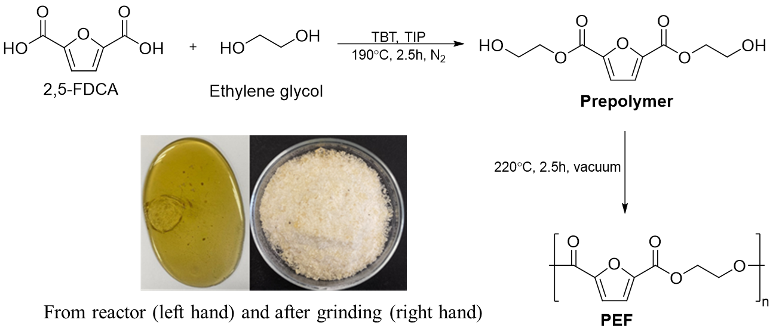
Scheme S1. Synthesis of (Polyethylene 2,5-furandicarboxylate, PEF)

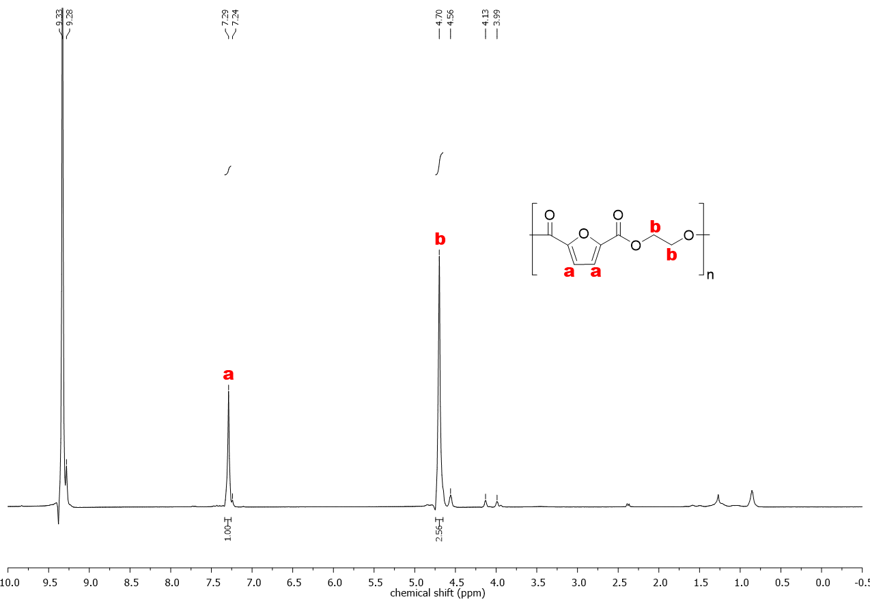
Figure S1. ¹H NMR spectrum (500 MHz, CDCl3, 25 °C) of poly(ethylene furanoate)

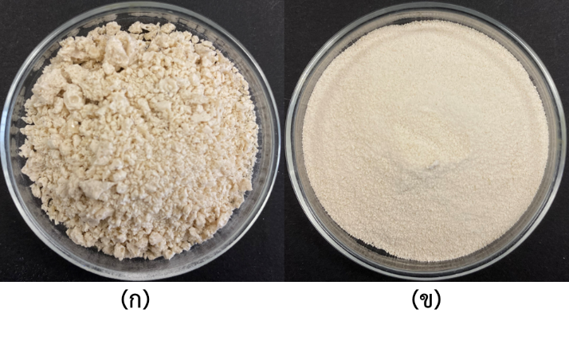
Figure S2. PEF after SSP: white solid from reactor (left) and Power after grinding (right).

Table S1. T_{g}, T_{CC}, T_{m}, and H_{CC} /H_{m} of PEF และ SSP-PEF
Sample | T_{g} (ºC) | T_{cc} (ºC) | T_{m} (ºC) | H_{cc} (J/g) | H_{m} (J/g) | X_{c} (%)
PEF(2h) | 58.00 | 125.50 | 203.60 | 46.41 | 60.04 | 9.74
PEF(3h) | 72.90 | 150.70 | 204.90 | 49.23 | 25.21 | 17.16
PEF(4h) | 63.80 | 151.70 | 206.90 | 45.65 | 45.75 | 0.07
SSP(1)_PEF(3h) | 68.70 | - | 205.90 | - | 63.11 | 45.08
SSP(2)_PEF(3h) | 69.80 | - | 213.40 | - | 64.06 | 45.76
SSP(3)_PEF(3h) | 67.50 | - | 221.50 | - | 63.21 | 45.15
 | $\text{\% Crystallinity}$ (X_{c}) | = | $$\frac{{\text{∆H}}_{\text{m}}-{\text{∆H}}_{\text{CC}}}{{\text{∆H}}_{\text{m}}^{\text{0}}}\text{× }\text{100}$$
โดย ${\text{∆H}}_{\text{m}}$ = heat of melting (J/g)
${\text{∆H}}_{\text{m}}^{\text{0}}$ = heat of melting for 100% crystalline PEF sample (${\text{∆H}}_{\text{m}}^{\text{0}}$ = 137 J/g)
${\text{∆H}}_{\text{CC}}$ = heat of cold crystallization (J/g)
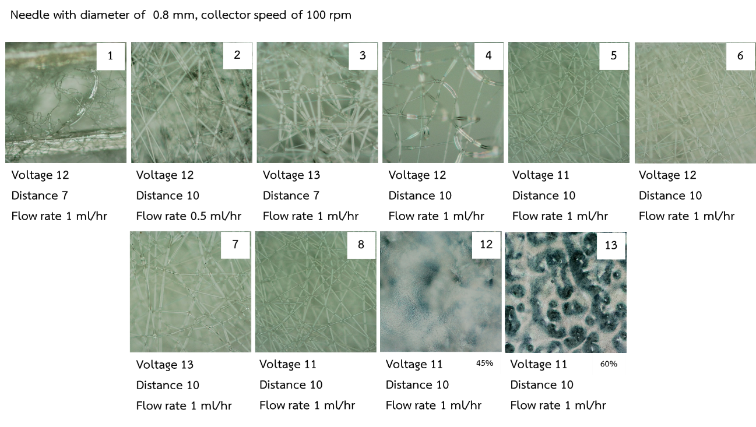
Figure S3. Optimization parameters of electrospining using 30%wt of PEF.
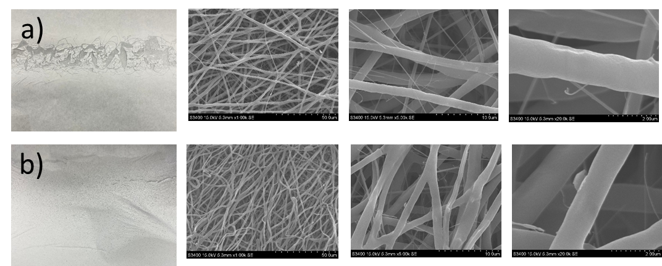
Figure S4. Nanofibers of PHBv 5%(a) and 10% (b). The membranes are too brittle
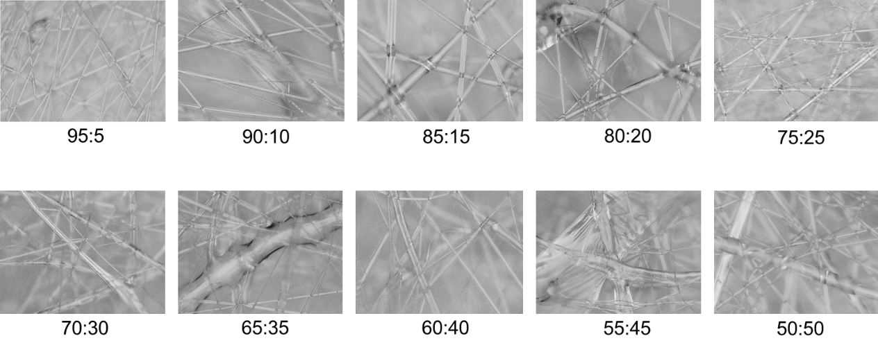
Figure S5. Fibers of different ratio of PEF:PHBv observed by optical microscope.
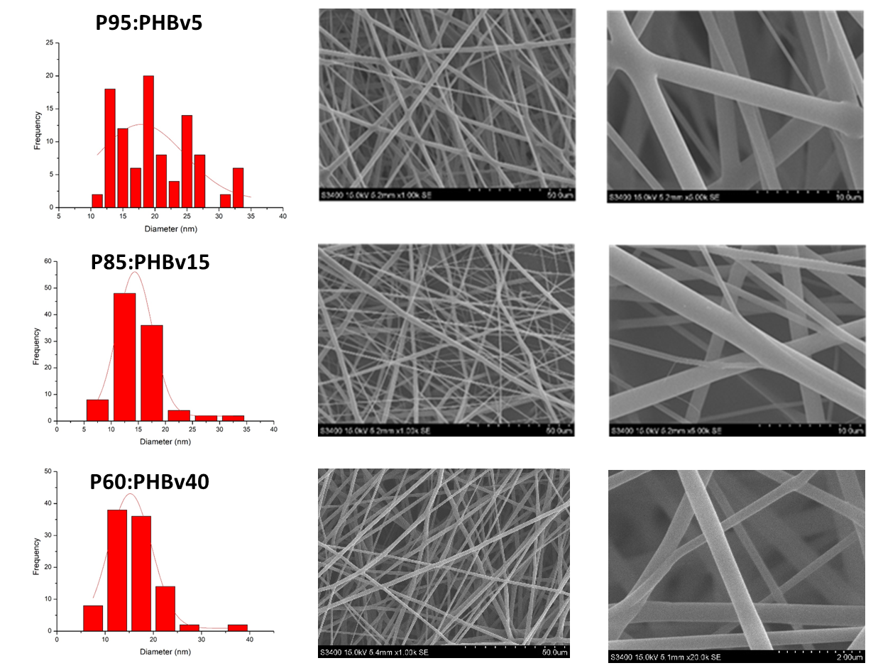
Figure S6. Nanofibers of different ratio of PEF:PHBv observed by SEM.
Table S2. T_{g}, T_{m}, T_{d}, and X_{c} of PEF และ SSP-PEF
Sample | T_{g} (ºC) | T_{m} (ºC) | T_{d} _{onset} (ºC) | T_{d} _{peak} (ºC) | X_{c} (%)
PEF | 85.5 | 210.9 | 249.17 | 405.42 | 13.53%
P95 | - | 195.8 | 319.33 | 400.10 | 27.17%
P85 | - | 194.2 | 325.27 | 405.21 | 20.20%
P60 | - | 183.5 | 325.30 | 399.21 | 12.33%

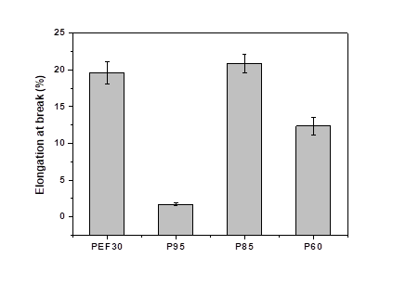
Figure S7. Elongation at break of PEF nanofibers and PEF-PHBv composite nanofibers.

Table S3. Avage contact angle of PEF (30%) nanofibers and PEF/PHBv composite nanofibers.
Sample | Contact angle (°)  At 180 s
PEF30 | 129.51±1.62
P95:PHBv5 | 111.66±1.48
P85:PHBV15 | 117.78±2.44
P60:PHBv40 | 117.55±1.82

