Supplementary Information of

Ocean Tides on Planets Orbiting Low-mass Stars
Jiaru Shi,¹ Jun Yang,^{1,2}* Dorian S. Abbot,³* Yonggang Liu,1,2 Wanying Kang,⁴ Yufeng Lin,⁵, and Yongyun Hu^{1,2}
- Laboratory for Climate and Ocean-Atmosphere Studies, Department of Atmospheric and Oceanic Sciences, School of Physics, Peking University, Beijing 100871, China
- Institute of Ocean Research, Peking University, Beijing 100871, China
- Department of the Geophysical Sciences, University of Chicago, Chicago, IL 60637, USA
- Department of Earth, Atmosphere and Planetary Science, MIT, Cambridge, MA 02139, USA
- Department of Earth and Space Sciences, Southern University of Science and Technology, Shenzhen 518055, China
*Corresponding authors: Jun Yang: junyang@pku.edu.cn and Dorian S. Abbot: abbot@uchicago.edu

Figure S1. Orbital-mean amplitude of tidal potential (V_{tid}) on Earth (a) and on Proxima b (b), and instantaneous V_{tid} on Proxima b at perihelion (c) and at aphelion (d). Note that panel (a) has a different colorbar.

Figure S2. Snapshots of simulated tidal elevation and tidal current on GJ 3323b. Upper panels are for the experiment with modern Earth’s continents, and lower panels are for the experiment with no continent (i.e., aqua-planet). This figure is the same as Fig. 1 in the main text but for GJ 3323b. Tidal elevation and tidal current on GJ 3323b are 2-3 orders stronger than those on Earth.

Figure S3. Snapshots of simulated tidal elevation and tidal currents on TRAPPIST-1e. This figure is the same as Fig. S2 but for TRAPPIST-1e. In these simulations, orbital eccentricity is set to be 0.005. Tidal elevation and tidal currents on TRAPPIST-1e are weaker than those on Proxima b and GJ 3323b, but still larger than those on Earth.

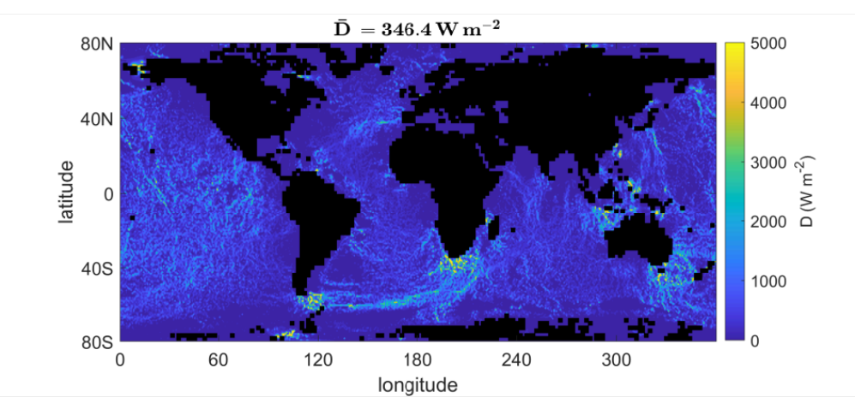
Figure S4. Long-term mean of simulated tidal dissipation on Proxima b. This figure is same as that shown in Fig. 2b of the main text, but a simple, linear drag (Eq. (19) in the Methods) is used to calculate the tidal dissipation. The global-mean value is 346.4 W m⁻².

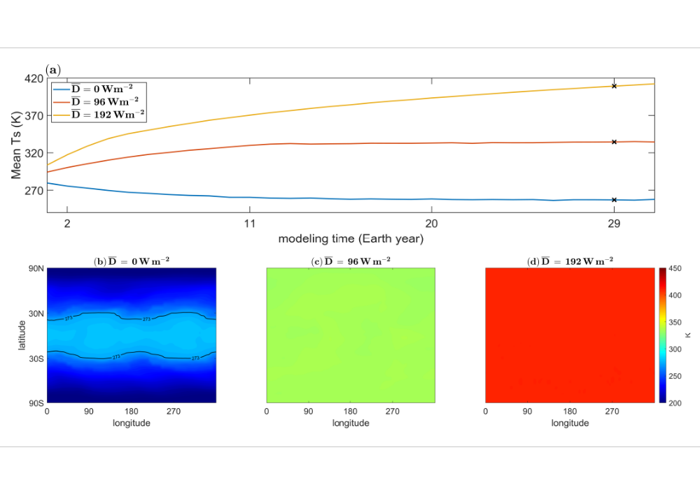
Figure S5. Same as Figure 4 in the main text, but for an aqua-planet configuration. Tidal dissipation warms the surface, melts the sea ice, and may push the system into a runaway greenhouse state.

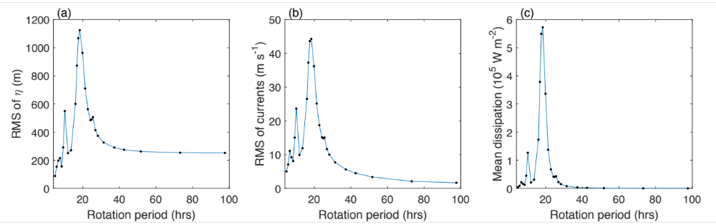
Figure S6. The root mean square (RMS) of tidal elevation (a), RMS of tidal current velocity (b), and global-mean tidal dissipation (c) as a function of planetary rotation period. Planetary parameters of TRAPPIST-1e are employed except that the rotation period is varied. Resonance occurs at a rotation period of ~19 hrs, and a second peak exists at around ~9.5 hrs.

Figure S7. High-level cloud fraction (0-1) as a function of orbital phase, viewed by a distant observer. For the 1st-3rd rows, the experiments use modern Earth’s land-sea configuration without tidal heating, with a tidal heating of 96 W m⁻², and with a tidal heating of 192 W m⁻², respectively. For the 4th-6th rows, the experiments use aqua-planet configuration without tidal heating, with a tidal heating of 96 W m⁻², and with a tidal heating of 192 W m⁻², respectively. For spatial distribution of tidal heating, please see Fig. 2b in the main text. $P_{orb}$ is the planetary orbital period. The planet is at perihelion when the $x$ axis is 0.5$P_{orb}$ or 1.5$P_{orb}$ and at aphelion when the $x$ axis is 0.0$P_{orb}$, 1.0$P_{orb}$, or 2.0$P_{orb}$. In this figure, we assume that the inclination angle is 90º and the observer views the planet’s dayside during perihelion and sees the planet’s nightside during aphelion.

Table S1. Parameters of Earth and the three potentially habitable exoplanets
Planets | Earth | Proxima b | GJ 3323b | TRAPPIST-1e
Star mass ($M_{⊙}$) | 1 | 0.12 | 0.17 | 0.08
Planet mass ($M_{⊕}$) | 1 | 1.27* | 2.02* | 0.62*
Planet radius ($a$, km) | 6371 | 8282* | 7645 | 5861
Planet gravity ($g$, m s⁻²) | 9.81 | 7.37* | 13.76* | 7.20*
Mean density ($\overline{ρ}$, kg m⁻³) | 5507 | 3183* | 6437 | 4413
Orbital period (Earth days) | 365 | 11.19 | 5.36 | 6.10
Rotation period (Earth days) | 1 | 7.46† | 3.57† | 6.10†
Semi-major axis ($r$, AU) | 1 | 0.0485 | 0.0328 | 0.0282
Global-mean stellar flux (W m⁻²) | 340 | 225 | 877 | 205
Observed eccentricity (0-1) | 0.0167 | $≤$0.35 | 0.23$±$0.11 | 0.0051$±$0.00058
Employed eccentricity (0-1) | 0.0167 | 0.3* | 0.23* | 0.005*
Tidal potential (0.80 m² s⁻²) | 1.0 | 1778 | 6947 | 3024
Tidal acceleration (2.5$×$10⁻⁷ m s⁻²) | 1.0 | 2861 | 11164 | 4886
*These parameters are not well known from observations.
†The rotation period is chosen following a 3:2 spin-orbit resonance state (like Mercury) for Proxima b and GJ 3323b, but 1:1 for TRAPPIST-1e due to its very small eccentricity.

Table S2. Scale analysis of the horizontal momentum equation for the control experiment of Proxima b under an aqua-planet configuration.
Terms* | Expression | Form of scale | Magnitude
Tidal acceleration | $$∇_{h}V_{tid}$$ | $$\frac{GMa}{D^{3}}$$ | $${10}^{-4} m s^{-2}$$
Pressure gradient | $$g∇_{h}η$$ | $$\frac{gη^{*}}{a}$$ | $${10}^{-4} m s^{-2}$$
Coriolis force | $$2\left(Ω_{h}×u\right)$$ | $$ΩU^{*}$$ | $${10}^{-5} m s^{-2}$$
Tidal bottom drag | $$\frac{C_{tid}⋅u}{H}$$ | $$\frac{C_{tid}}{H}U^{*}$$ | $${10}^{-5} m s^{-2}$$
Quadratic drag | $$\frac{C_{D}}{H}\left|u\right|u$$ | $$\frac{C_{D}}{H}{U^{*}}^{2}$$ | $${10}^{-7} m s^{-2}$$
Advection term | $$\left(u⋅∇\right)u$$ | $$\frac{{U^{*}}^{2}}{a}$$ | $${10}^{-7} m s^{-2}$$
Viscosity term | $$A_{h}∇_{h}^{2}u$$ | $$\frac{A_{h}U^{*}}{a^{2}}$$ | $${10}^{-9} m s^{-2}$$
*In scaling the different terms, $V_{tid}$ is the tidal potential and it is on the order of 10³ m² s⁻² for the three exoplanets we examined, $M$ is the star’s mass, $D$ is the star—planet distance, $U^{*}$ is the typical value of the tidal currents ($u$, on the order of 1.0 m s⁻¹), $η^{*}$ is the typical value of tidal elevation ($η$, on the order of 100 m), $g$ is the planet’s gravity (on the order of 10 m s⁻²), $Ω$ is the planetary rotation rate (on the order of 10⁻⁵ s⁻¹), $H$ is the ocean depth (on the order of 10,000 m for the open ocean), $a$ is the planet’s radius (also being equal to the typical horizontal length scale, on the order of 10⁷ m), $C_{tid}$ is the tidal conversion coefficient (on the order of 0.1 m s⁻¹), $C_{D}$ is the bottom drag coefficient in shallow oceans (on the order of 0.001), and $A_{h}$ is the horizontal eddy viscosity (on the order of 10⁵ m² s⁻¹).

