Supplementary information

The MYB-related Transcription Factor MYPOP acts as a Selective Regulator of Cancer Cell Growth

Johannes Strunk¹, Alena Hüppner², Mahwish Sial¹, Matthias Plath¹, Sascha Wagner¹, Kirsten Freitag¹, Snježana Mikuličić¹, Tatjana Döring¹, Tobias Bopp^{3,4,5,9}, Matthias Klein^{3,9}, Krishnaraj Rajalingam⁶, Gregory Harms^{3,6,9,10}, Federico Marini^{7,9}, Annekathrin Ludt⁷, Thomas Hankeln⁸, Carina Osterhof⁸, Alina Henrich², Andrea Nubbemeyer², Martin Suchan², Barbara Schrörs², Sebastian Kreiter², Anne Kölsch², Mustafa Diken², Luise Florin^{1,4,9,}*

Supplementary Table 1: HeLa RNA-Seq 24h post pDNA transfection. All DEGs with an adjusted p-value ≤ 0.05 of the HeLa RNA-Seq experiment 24h p.t. using expression plasmids for the transfection are listed according to the fold change. Shown are gene symbols, stable identifiers (ENSEMBL ID) as well as log₂-fold change values, p-values and adjusted p-values for each DEG, respectively.

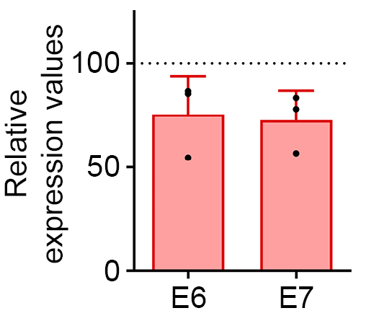
Supplementary Fig. 1: HPV18 E6 and E7 transcripts are reduced after transfection with GFP-MYPOP. Relative expression values of HPV18 E6 and E7 genes from RNA-Seq experiments with HeLa cells and overexpressed GFP-MYPOP 24h p.t. Normalized counts (DESeq2, median of ratios) from control treated samples were set to 100% indicated by a dotted line.
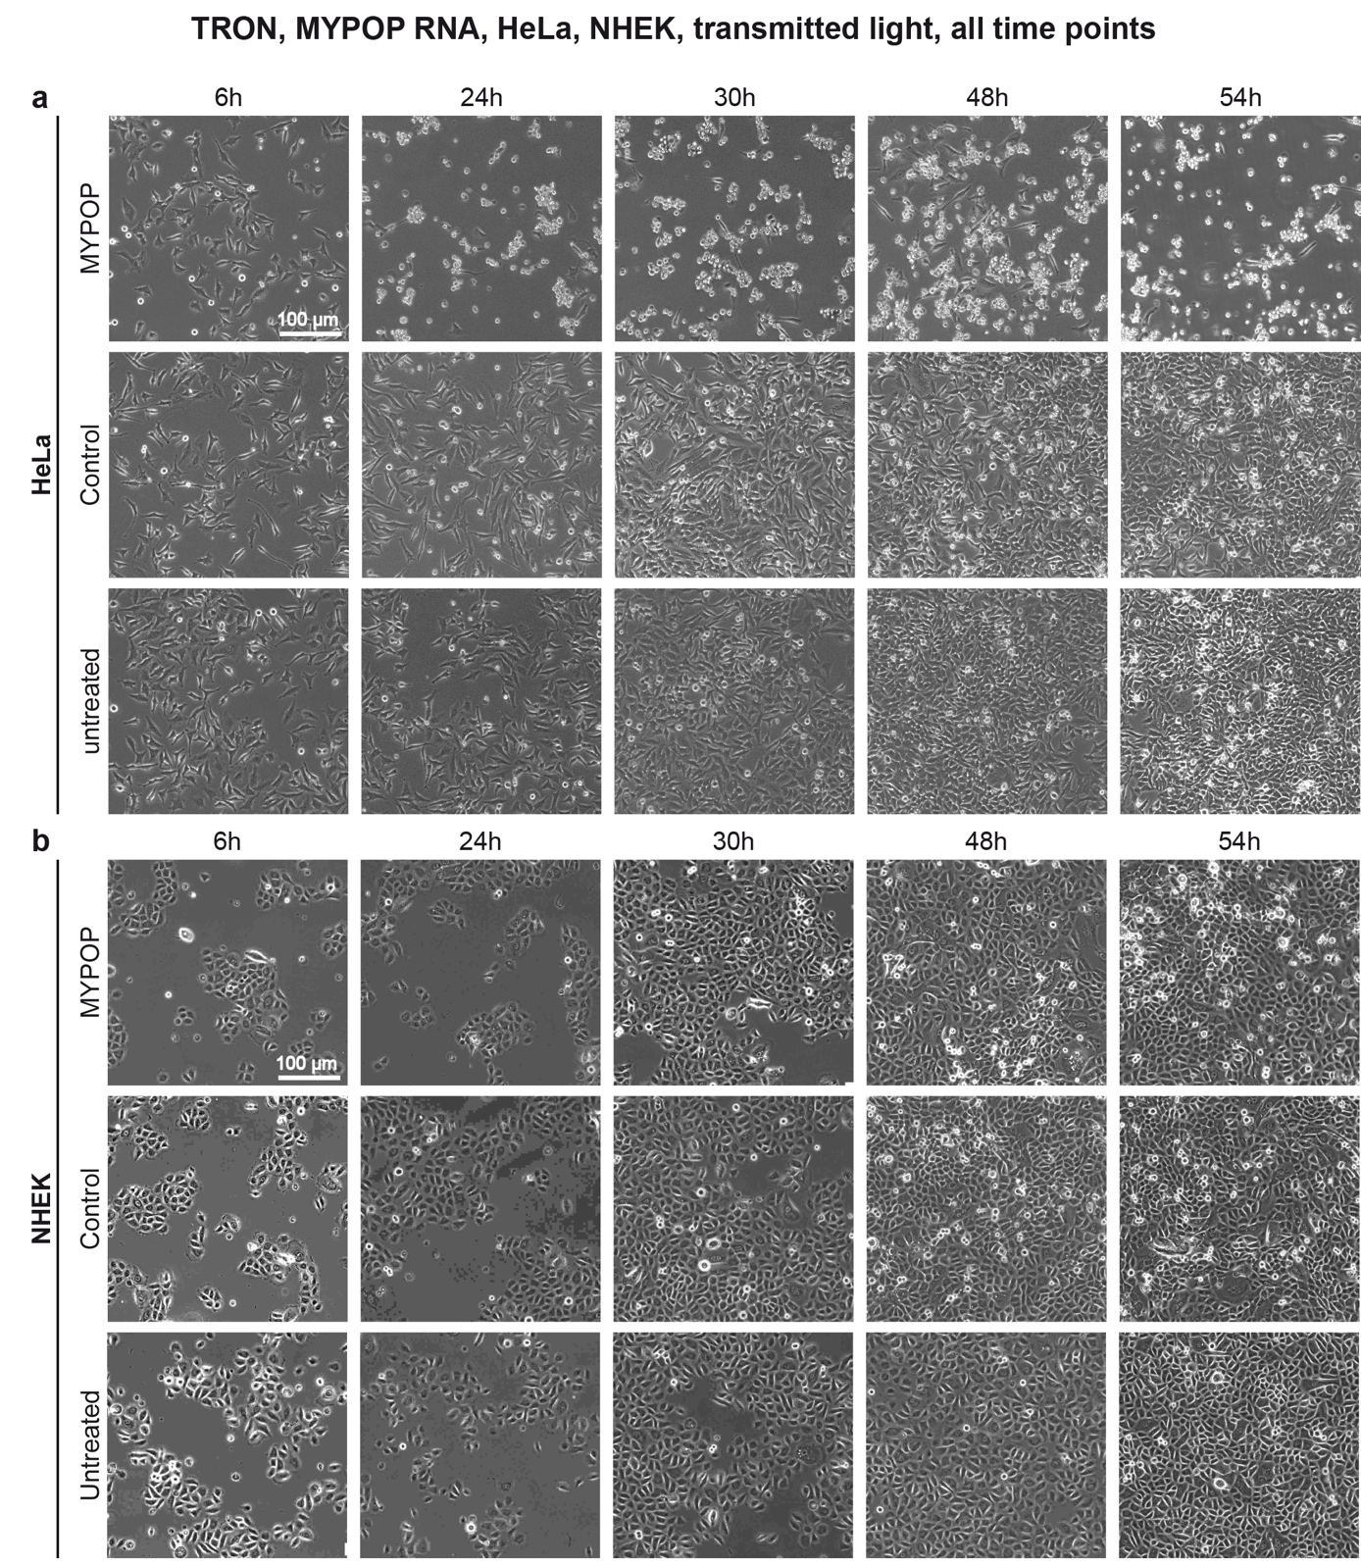
Supplementary Fig. 2: The effect of MYPOP mRNA transfection on morphology and cell growth of HeLa and NHEK cells. Optical microscope overview images of untreated, control transfected and MYPOP transfected HeLa cells (a) and NHEK cells (b) at time points between 6 and 54 hours post mRNA transfection.
Supplementary Table 2: HeLa RNA-Seq 6h post mRNA transfection. All DEGs with an adjusted p-value ≤ 0.05 of the HeLa RNA-Seq experiment 6h p.t. using mRNA constructs for the transfection are listed according to the fold change. Shown are gene symbols, stable identifiers (ENSEMBL ID) as well as log₂-fold change values, p-values and adjusted p-values for each DEG, respectively.

Supplementary Table 3: HeLa RNA-Seq 24h post mRNA transfection. All DEGs with an adjusted p-value ≤ 0.05 of the HeLa RNA-Seq experiment 24h p.t. using mRNA constructs for the transfection are listed according to the fold change. Shown are gene symbols, stable identifiers (ENSEMBL ID) as well as log₂-fold change values, p-values and adjusted p-values for each DEG, respectively.

Supplementary Table 4: NHEK RNA-Seq 6h post mRNA transfection. All DEGs with an adjusted p-value ≤ 0.05 of the NHEK RNA-Seq experiment 6h p.t. using mRNA constructs for the transfection are listed according to the fold change. Shown are gene symbols, stable identifiers (ENSEMBL ID) as well as log₂-fold change values, p-values and adjusted p-values for each DEG, respectively.

Supplementary Table 5: NHEK RNA-Seq 24h post mRNA transfection. All DEGs with an adjusted p-value ≤ 0.05 of the NHEK RNA-Seq experiment 24h p.t. using mRNA constructs for the transfection are listed according to the fold change. Shown are gene symbols, stable identifiers (ENSEMBL ID) as well as log₂-fold change values, p-values and adjusted p-values for each DEG, respectively.

Supplementary Fig. 3: mRNA transfection efficiency, protein localization, and MYPOP effect on HeLa cells. Representative confocal laser scanning microscopy images of HeLa cells show transfection efficiency, protein localization and the shrinkage of cells and cell nuclei as well as the effect of MYPOP on the α-tubulin network at 6, 24 and 48 hours post transfection. Staining was performed as in legend to Fig.4 with α-tubulin shown in magenta, MYPOP shown in green and chromatin in blue (Hoechst 33342). A white box in the α-tubulin images indicates the area that was used for the enlarged images.

Supplementary Table 6: Primer list
Gene | Sequence 5‘ to 3‘ | Reference /Accession No.
GAPDH | F: GTGAAGGTCGGAGTCAACGG  R: TGACAAGCTTCCCGTTCTCA | NM_002046.7
HPV18 E6 | F: GTGCCAGAAACCGTTGAATCC  R: CGAATGGCACTGGCCTCTAT | NC_001357.1
HPV18 E7 | F: ACATTTACCAGCCCGACGAG  R: GGTCGTCTGCTGAGCTTTCT | NC_001357.1
IL11 | F: GACCACAACCTGGATTCCCT  R: AGGTAGGACAGTAGGTCCGC | NM_000641.4; NM_001267718.2
IL1A | F: CGCCAATGACTCAGAGGAAGA  R: AGGGCGTCATTCAGGATGAA | Nasser et al. 2012⁹²
IL20 | F: CATTGTGGGGAGGAAGCAATG  R: TAGTTCCCCCAAAGCCTTCAC | NM_018724.4
IL24 | F: GCTTCTCTGGAGCCAGGTATCA  R: ACATCTCATTTTCTTGCGAGACG | NM_001185157.1
MYC | F: CAGCGACTCTGAGGAGGAAC  R: CCCTCTTGGCAGCAGGATAG | NM_002467.6
MYPOP | F: ACAGAAGGGCCGATACAAGC  R: CTTTAGGTCTAGGGCAGCCG | -

