Supplementary Information

1 Precipitation data comparison.
The scatter plot of the values for the daily precipitation for Alappuzha in 2018 is shown in Figure 2.
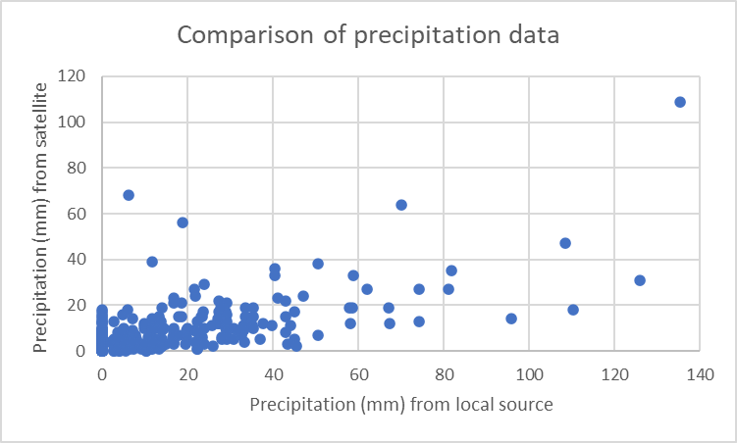
Figure 1 Precipitation from local and global sources

2 River discharge estimation
The summary of the missing values and the total values estimated for 2018 river discharges are provided in Table 1.

Table 1 Summary of the estimation of missing values
Dates for which estimation was done | Number of inputted values | Dates for which estimation was done | Number of inputted values
Q_Erappuzha |  | Q_Kurudamannil
16th August – 20th August | 5 | 25th February | 1
12th September – 18th September | 7 | 15th August – 19th August | 5
26th September – 28th September | 3
Total missing values estimated | 15 | Total missing values estimated | 6
Total number of records with missing values | 193 | Total number of records with missing values | 6
Total number of daily records | 365 | Total number of daily records | 365

3 Script for Regression Analysis
library(spdep)
library(maptools)
library(raster)
library(rgdal)
library(sp)
library(varycoef)
library(sf)
library(tmap)
library(gstat)

#Set working directory and import the shapefile with values for flood extent and postflood incdence
setwd("C:/MSc_Thesis/Data")
factors_HARV <- readOGR("Index", "Indicators_p2", stringsAsFactors = T)
extent(factors_HARV)

#Print the headers to confirm the file and know how to call each column
names(factors_HARV@data)

#Covert mean centre coordinates to kilometres to reduce computation time
locs <- as.matrix(factors_HARV@coords[, 1:2])/1000

fit_svc_post2 <- SVC_mle(postfl2018 ~ Flood_18, locs = locs, data = factors_HARV@data)
summary(fit_svc_post2)

fit_svc_post3 <- SVC_mle(postfl2019 ~ Flood_19, locs = locs, data = factors_HARV@data)
summary(fit_svc_post3)

4 Clusters and outliers for the years
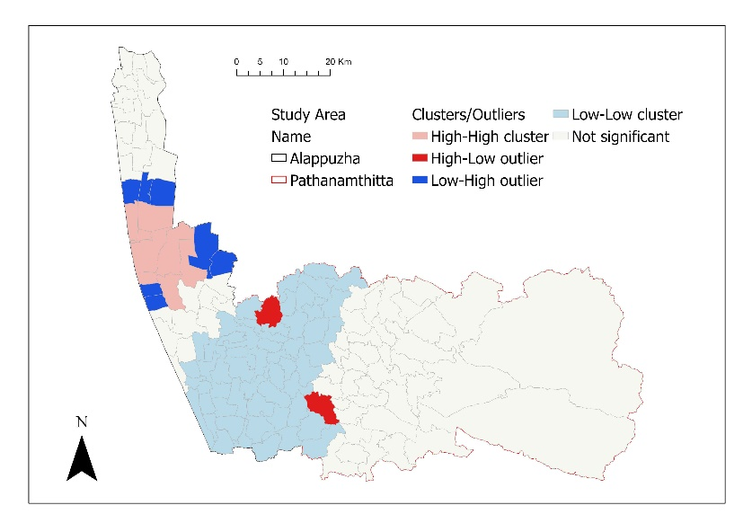
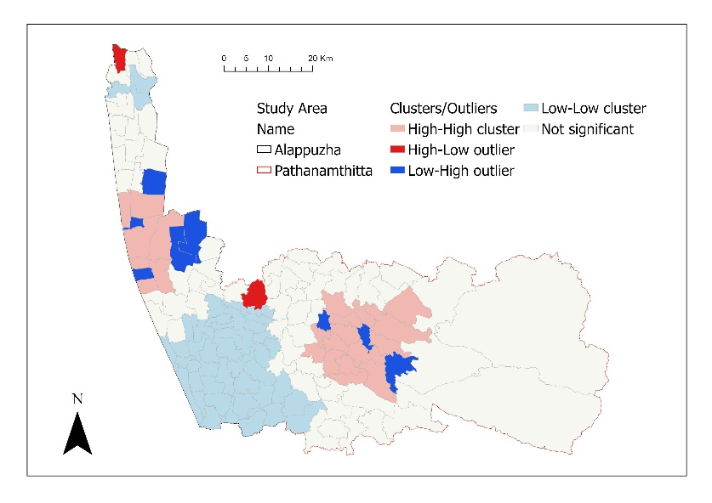
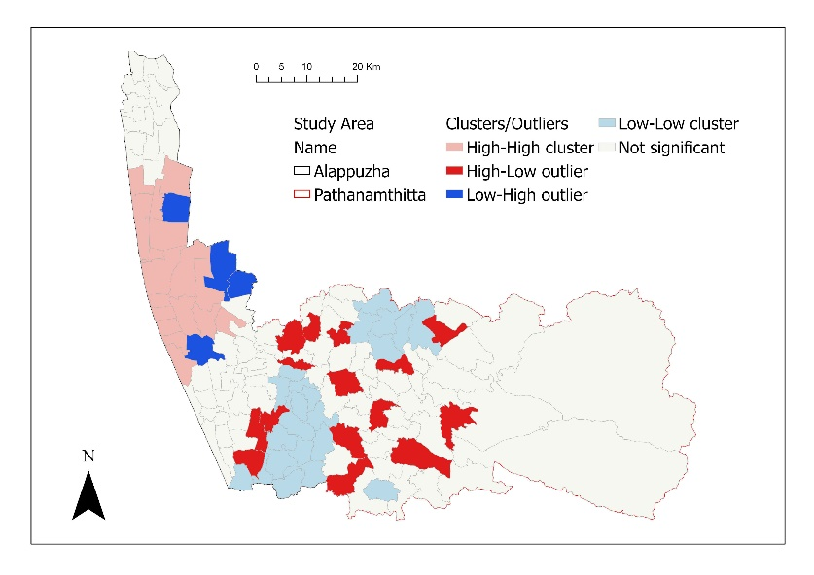
The clusters and outliers of the cases of leptospirosis in 2017, 2018 and 2019 can be found in Figure 4. The clusters and outliers of the cases of leptospirosis in 2018 and 2019 can be found in Figures 5 and 6.
a
b
c

Figure 2. Cluster and outliers of cases across considered years (a) 2017 (b) 2018 (c) 2019

5 Clusters and outliers for the flood phases of flooded years
The clusters and outliers of the cases of leptospirosis in 2018 and 2019 during the three flood phases can be found in Figures 5 and 6.

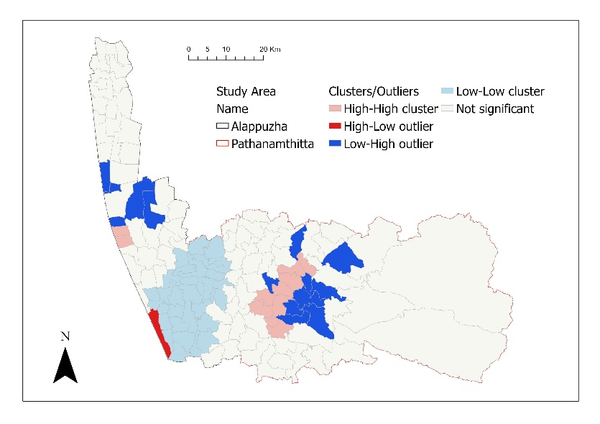
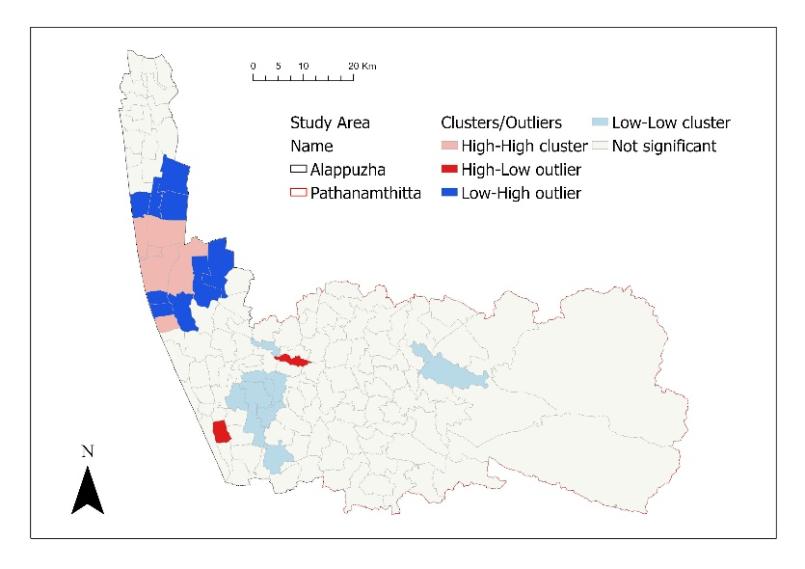
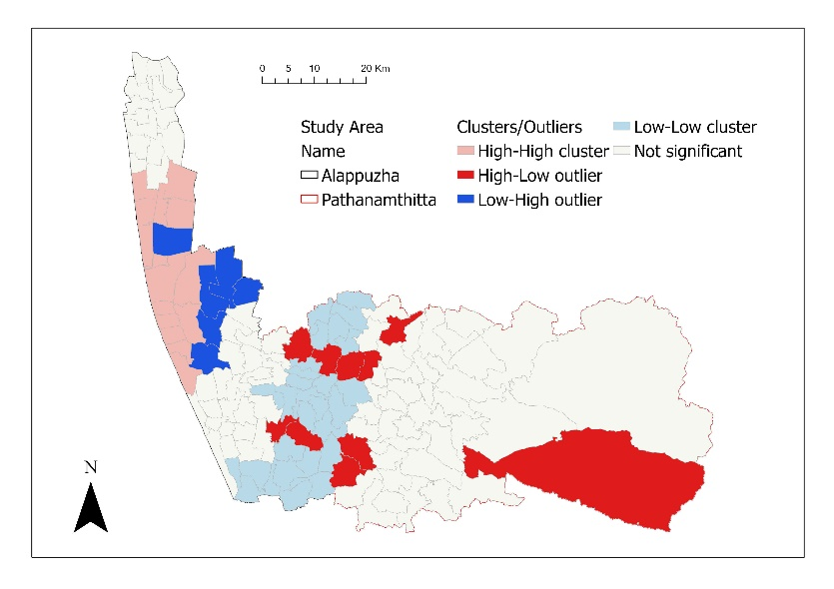
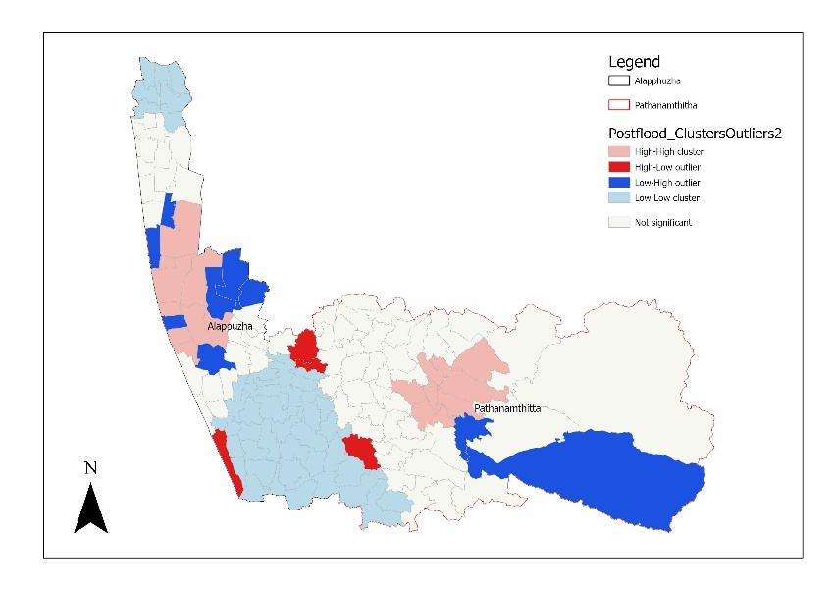
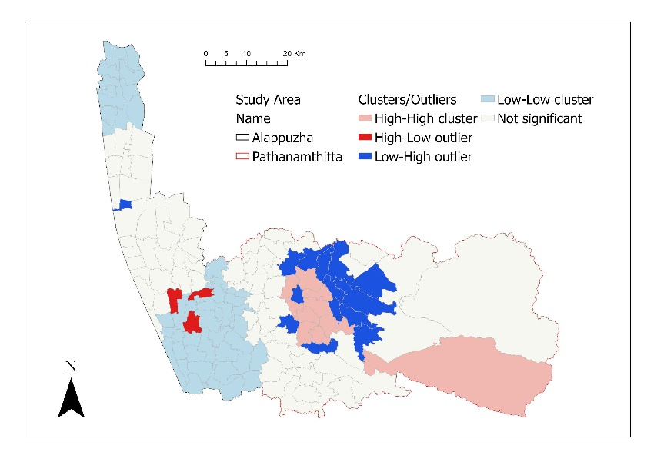
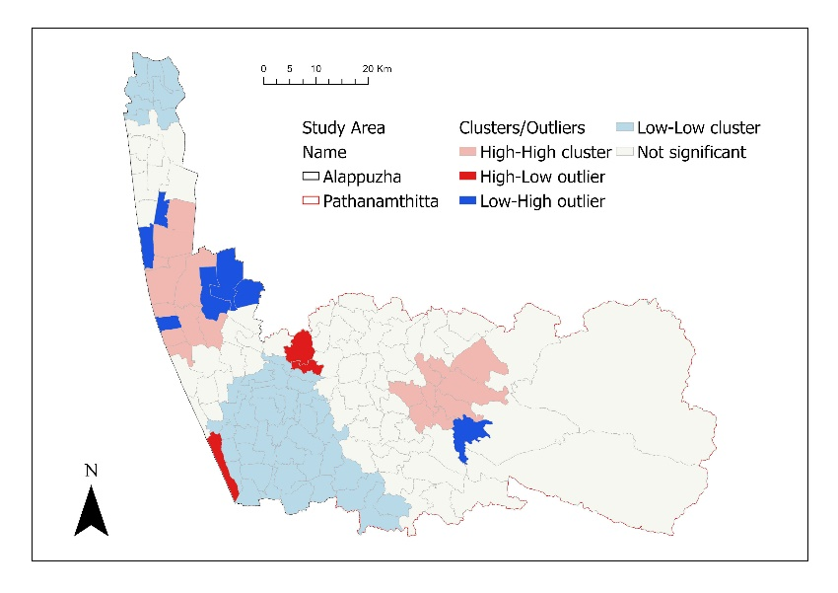
Figure 3. Cluster and outliers of cases across flood phases (a) 2018 preflood (b) 2018 during flood (c) 2018 postflood (d) 2019 preflood (e) 2019 during flood (f) 2019 postflood
d
e
f
a
b
c

