Supporting information
Journal of Applied Electrochemistry

Shape influence of β-MnO₂ on catalytic activity in the oxygen reduction reaction in alkaline media
I. Cruz-Reyes¹, B. Trujillo-Navarrete^{1*}, R.M. Félix Navarro¹, F. Paraguay-Delgado²
¹ Tecnológico Nacional de México/ IT Tijuana. Blvd. Alberto Limón Padilla s/n Col. Otay Tecnológico, Tijuana, B.C. México.
² Centro de Investigación en Materiales Avanzados, S.C. (CIMAV), Av. Miguel de Cervantes #120, Complejo Industrial Chihuahua, Chihuahua, Chih. México. C.P. 31136.
*e-mail: balter.trujillo@tectijuana.edu.mx

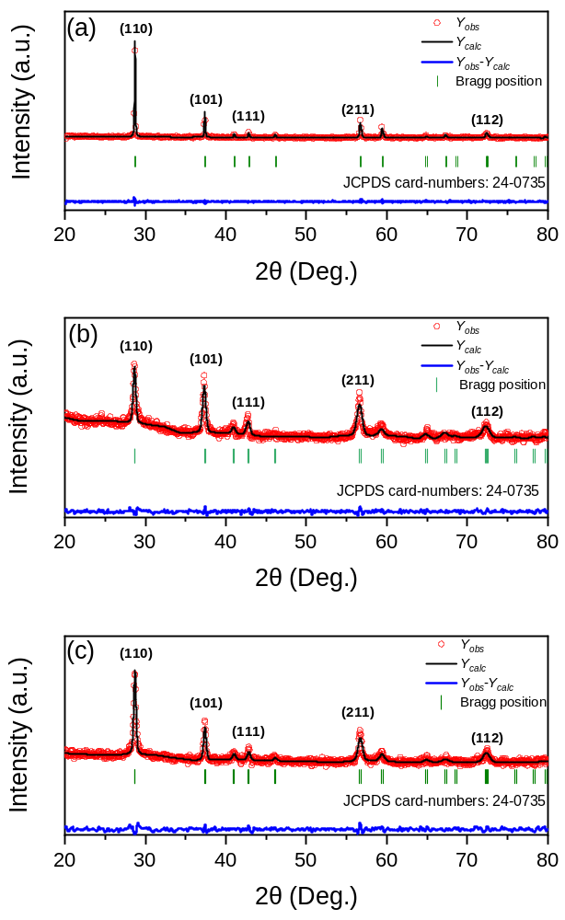
Figure SI-1 Rietveld refinement plots of β-MnO₂ powders: (a) Commercial β-MnO₂, rods, and (b) dandelions; Vertical bars (|) indicate the positions of the Bragg reflections of β-MnO₂.

Table SI-1. R-factors of Rietveld refinement for shapes of β-MnO₂.
MnO₂ | Dandelions | Nanorods | Commercial MnO₂
Rp(%) | 4.61 | 4.43 | 4.74
Rwp(%) | 5.94 | 5.76 | 3.74
χ² | 1.46 | 1.42 | 1.24

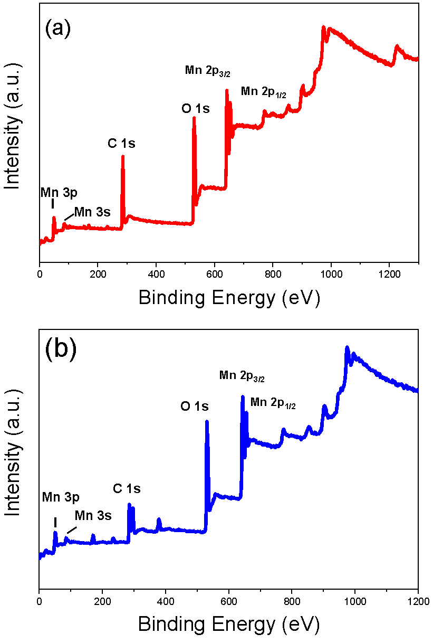
Figure SI-2 XPS survey of β-MnO₂: Mn 2p peaks were identified, showing a distance between peaks Δ ≈ 11.9 eV.

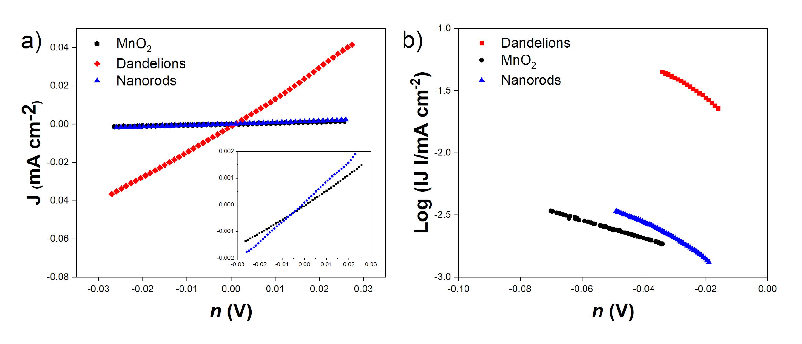

Figure SI-3 (a) ORR/OER micro-polarization region. (b) Tafel plots of β-MnO₂ shapes recorded in O₂-saturated 0.1 M NaOH.

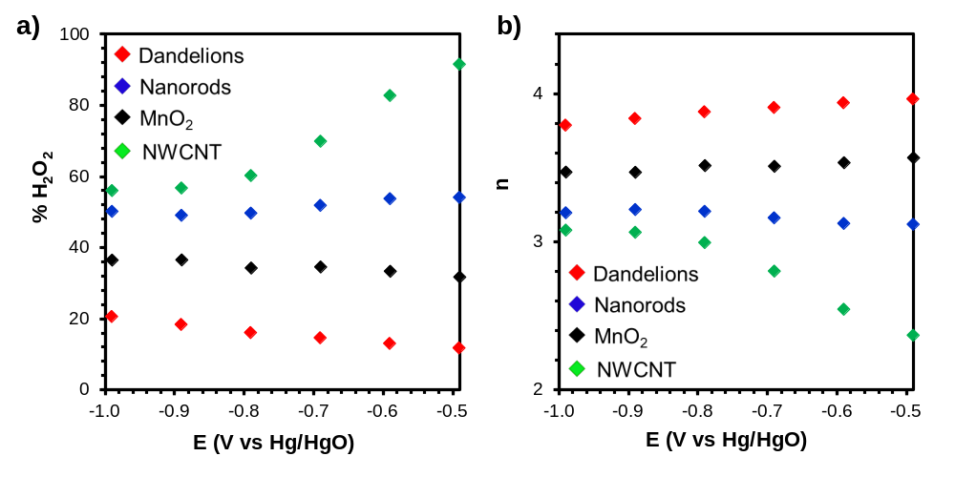

Figure SI-4. (a) Percentage of H₂O₂ and (b) the number of electrons transferred (n) during ORR for β-MnO₂ shapes and commercial MnO₂ and MWCNT.

