Tables and Figures:
Table 1. Characteristics from Pre-Training Surveys
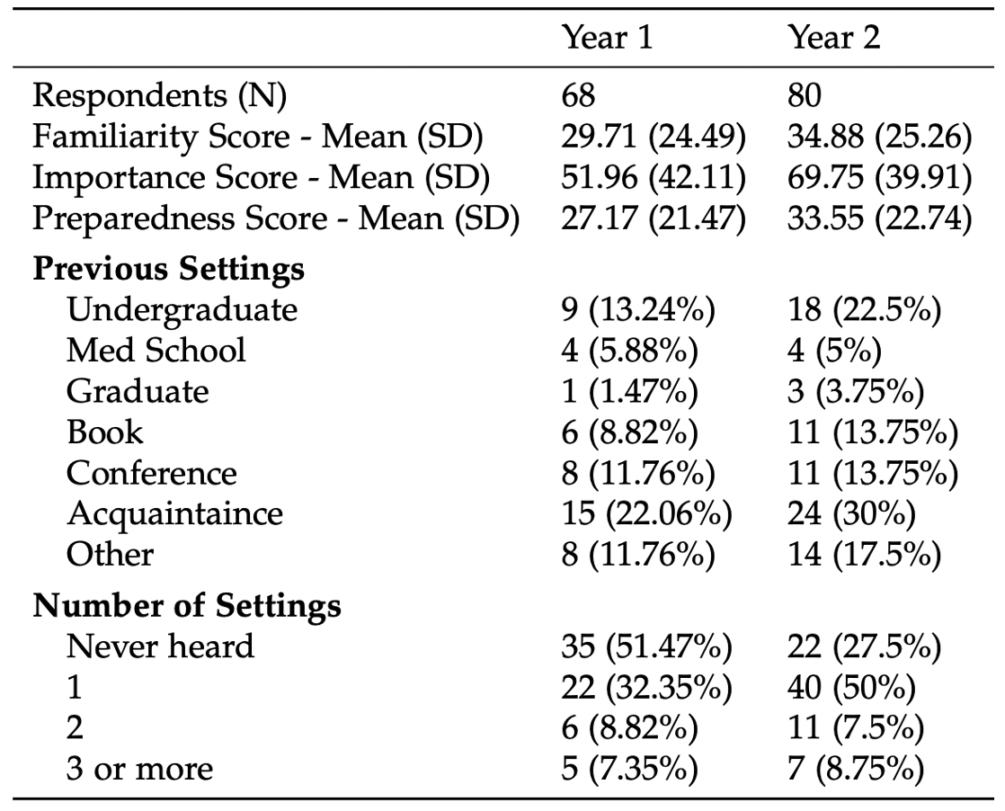

Table 2. Characteristics from Post-Training Surveys
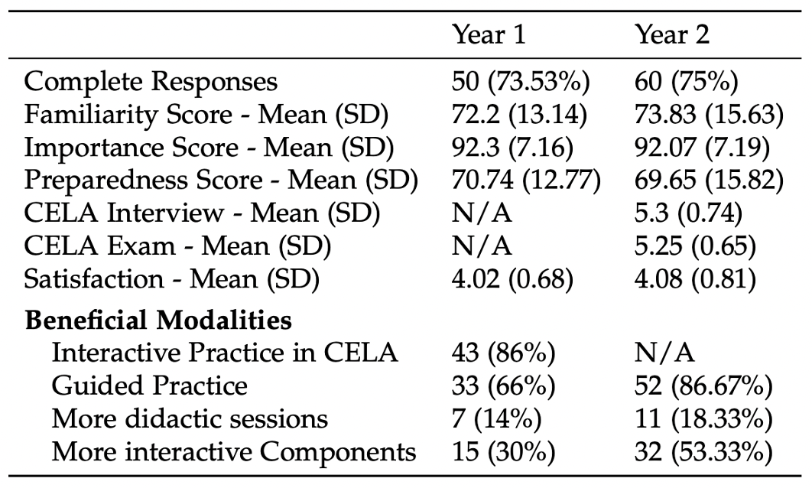

Table 3. Results of Paired t-tests Comparing Pre-Training Scores to Post-Training Scores
