Supplemental Figure 1: Patients’ disposition

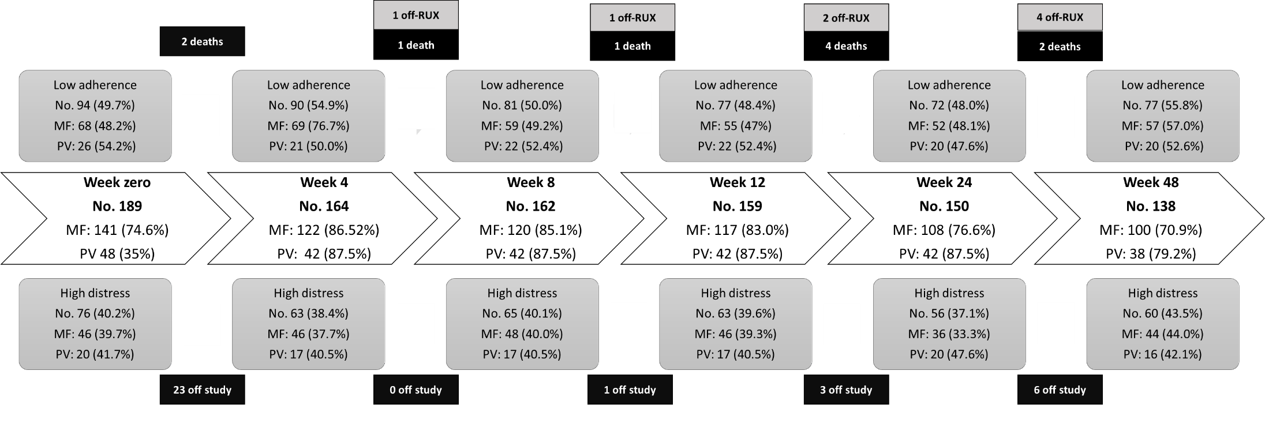
Characteristics at week 0 | No. of pts = 189
Presence of caregiver, n (%) | 85 (45.0%)
Education, n (%)  None  Primary  Middle school  High school  University | 2 (1.0%)  31 (16.4%)  55 (29.1%)  74 (39.2%)  27 (14.3%)
Employment, n (%)  Retired  Employed  Domestic work  Unemployed | 105 (55.5%)  50 (26.6%)  30 (15.8%)  4 (2.1%)
Visit frequency in the last 12 months  One or more visit every 3 months  One visit every 3-6 months  One visit > 6 months | 52 (27.6%)  132 (69.8%)  5 (2.6%)
Other therapies for other diseases, n (%)  Total number of daily tablets except ruxolitinib, median (range)  Patients taking > 6 tablets a day except ruxolitinib, no (%) | 152 (80.4%)  6 (0-20)  94 (49.7%)
Patients who are followed by a stable team of hematologists, no. (%) | 189 (100%)
Patients who are satisfied by the relationship with the hematologists, no. (%) | 188 (99.5%)
Patients who feel they are taking an excessive number of tablets/daily, no. (%) | 19 (10%)
Patients who feel that ruxolitinib intake impairs their work/social activities, no. (%) | 7 (3.7%)
Patients who feel that correct ruxolitinib intake is important for their health, no (%) | 186 (98.4%)

Supplemental Table 1: Basic patients’ information
Supplemental Table 2: Problem list at week-0, according to degree of distress and disease type 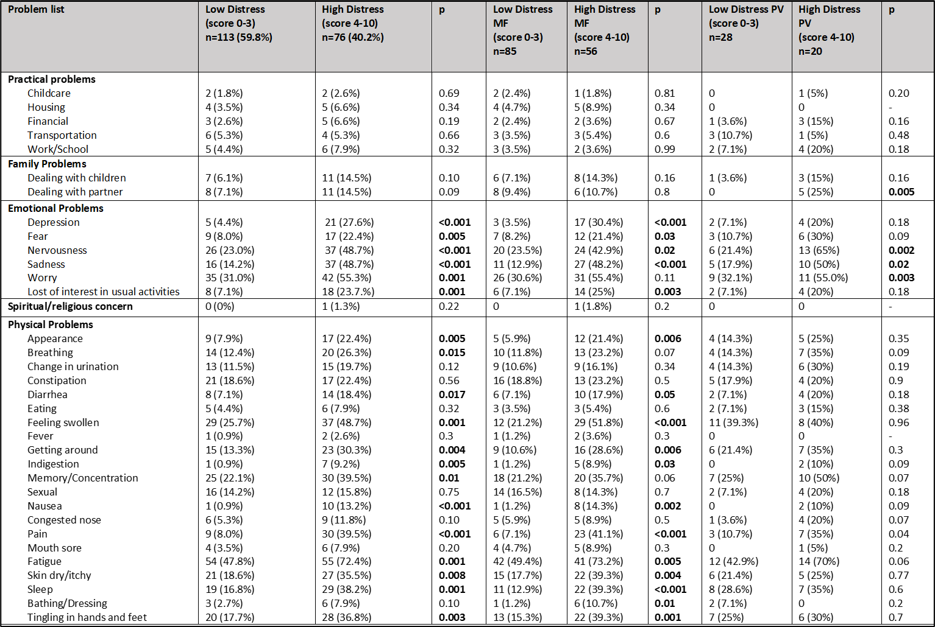

Supplemental Figure 2: Main problems with differential expression in patients with high and low distress

Supplemental Figure 3: Reasons for Low adherence

Supplemental Table 3: mean ARMS total scores and mean distress thermometer total scores
ARMS
Timepoint | Mean ± SD [range]
Week 0 | 14.35 ± 2.02 [12-21]
Week 24 | 14.12 ± 1.95 [12-22]
Week 48 | 14.39 ± 1.88 [12-21]
Distress Thermometer
Timepoint | Mean ± SD [range]
Week 0 | 3.18 ± 2.87 [0-10]
Week 24 | 2.74 ± 2.52 [0-10]
Week 48 | 3.18 ± 2.72 [0-10]

