Supplementary figures
Figure S1
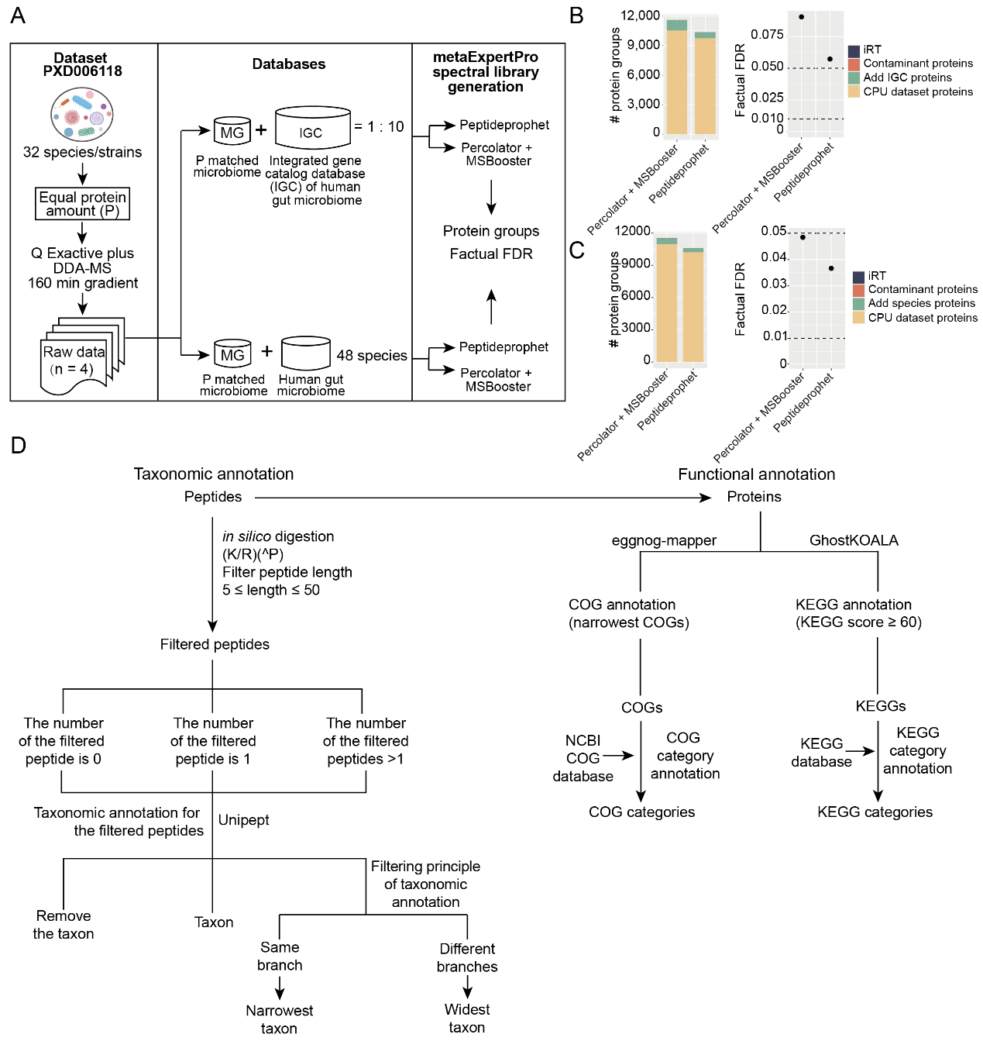
Figure S1 Protein inference and annotation of taxa and functions.
(A) The experimental design for the benchmark tests on protein group identification based on the Peptideprophet and MSBooster-Percolator PSM validation method of FragPipe. The DDA-MS data from CPU dataset (PXD006118) were searched against the matched metagenomic (MG) database, supplemented with either the 10 × IGC database or the 48-species human gut microbiome database, respectively. (B–C) The results of protein groups and factual FDR in the MG-10 × IGC and MG-48-species benchmark tests are showed in (B) and (C). (D) The procedures for taxonomic and functional annotation as well as filtering principles. For taxonomic annotation, in silico digested peptides were filtered based on their length (5 ≤ length ≤ 50). The filtered peptides were further annotated using Unipept to acquire their corresponding taxa. For functional annotation, COG annotation was performed using eggnog-mapper, and KEGG annotation was conducted using GhostKOALA.
Figure S2
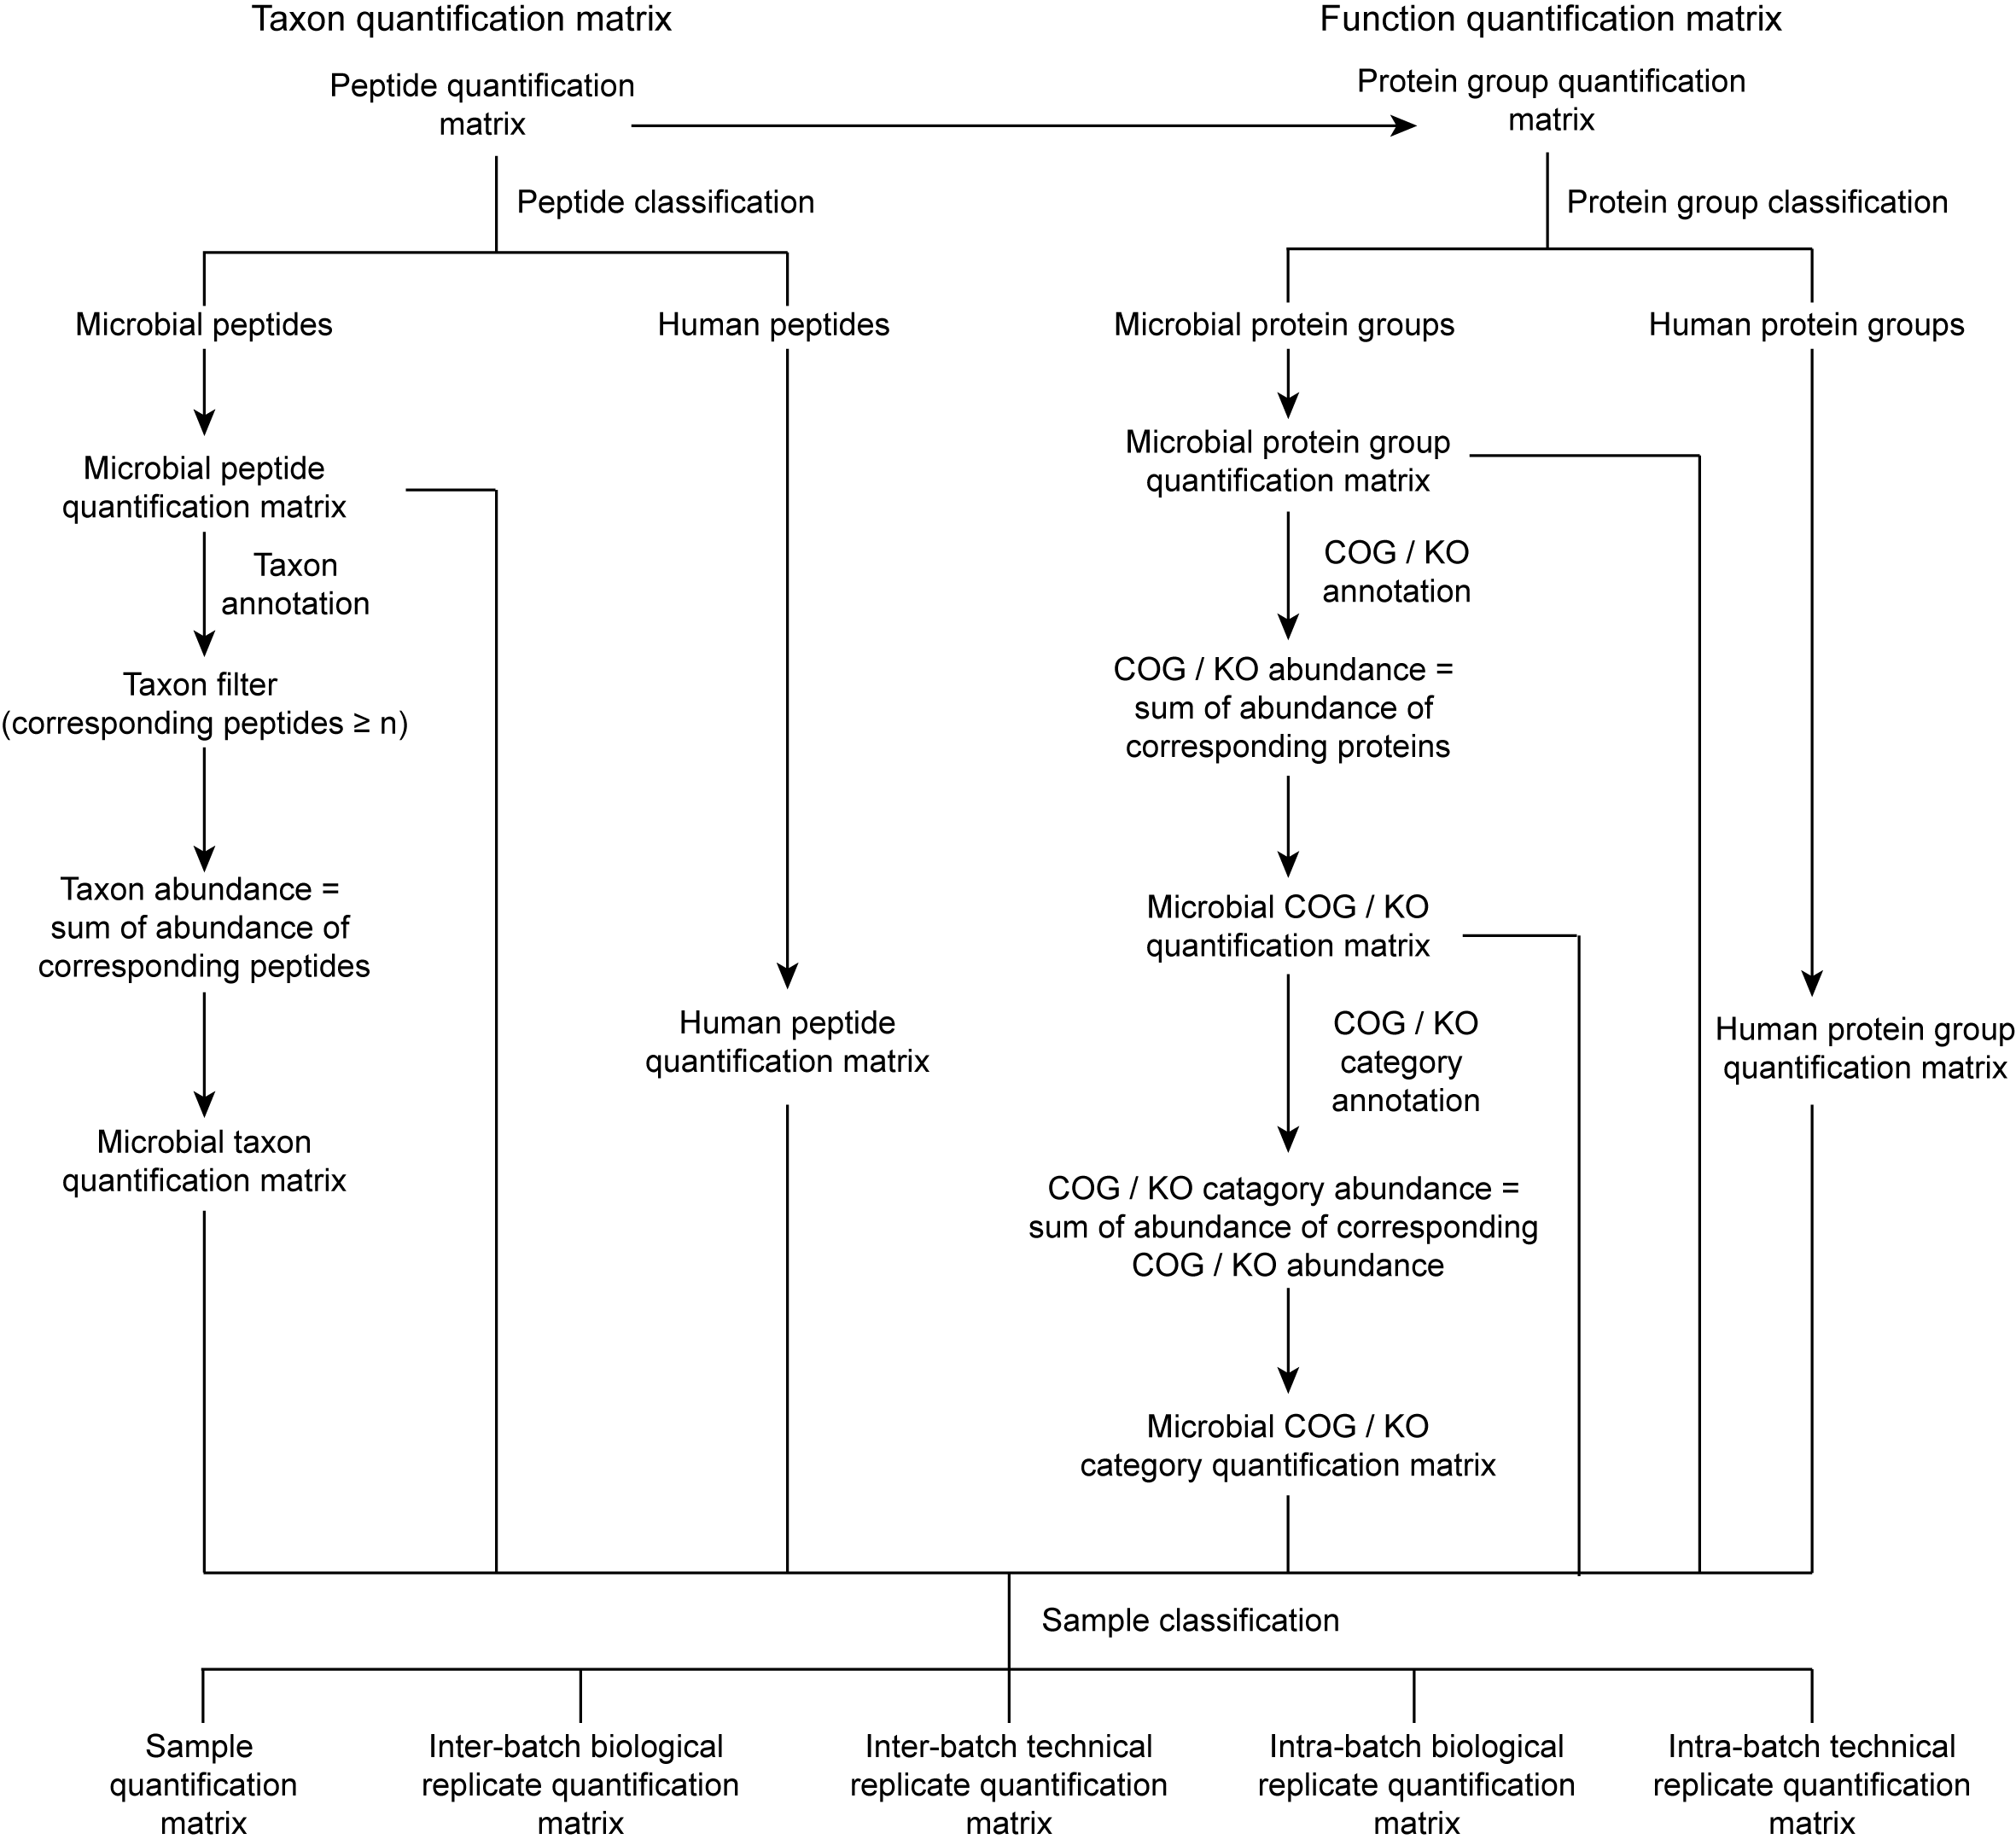
Figure S2 The workflow of the quantitative matrix generation.
The procedures for peptides and proteins classification and abundance calculation at each level are illustrated.
Figure S3
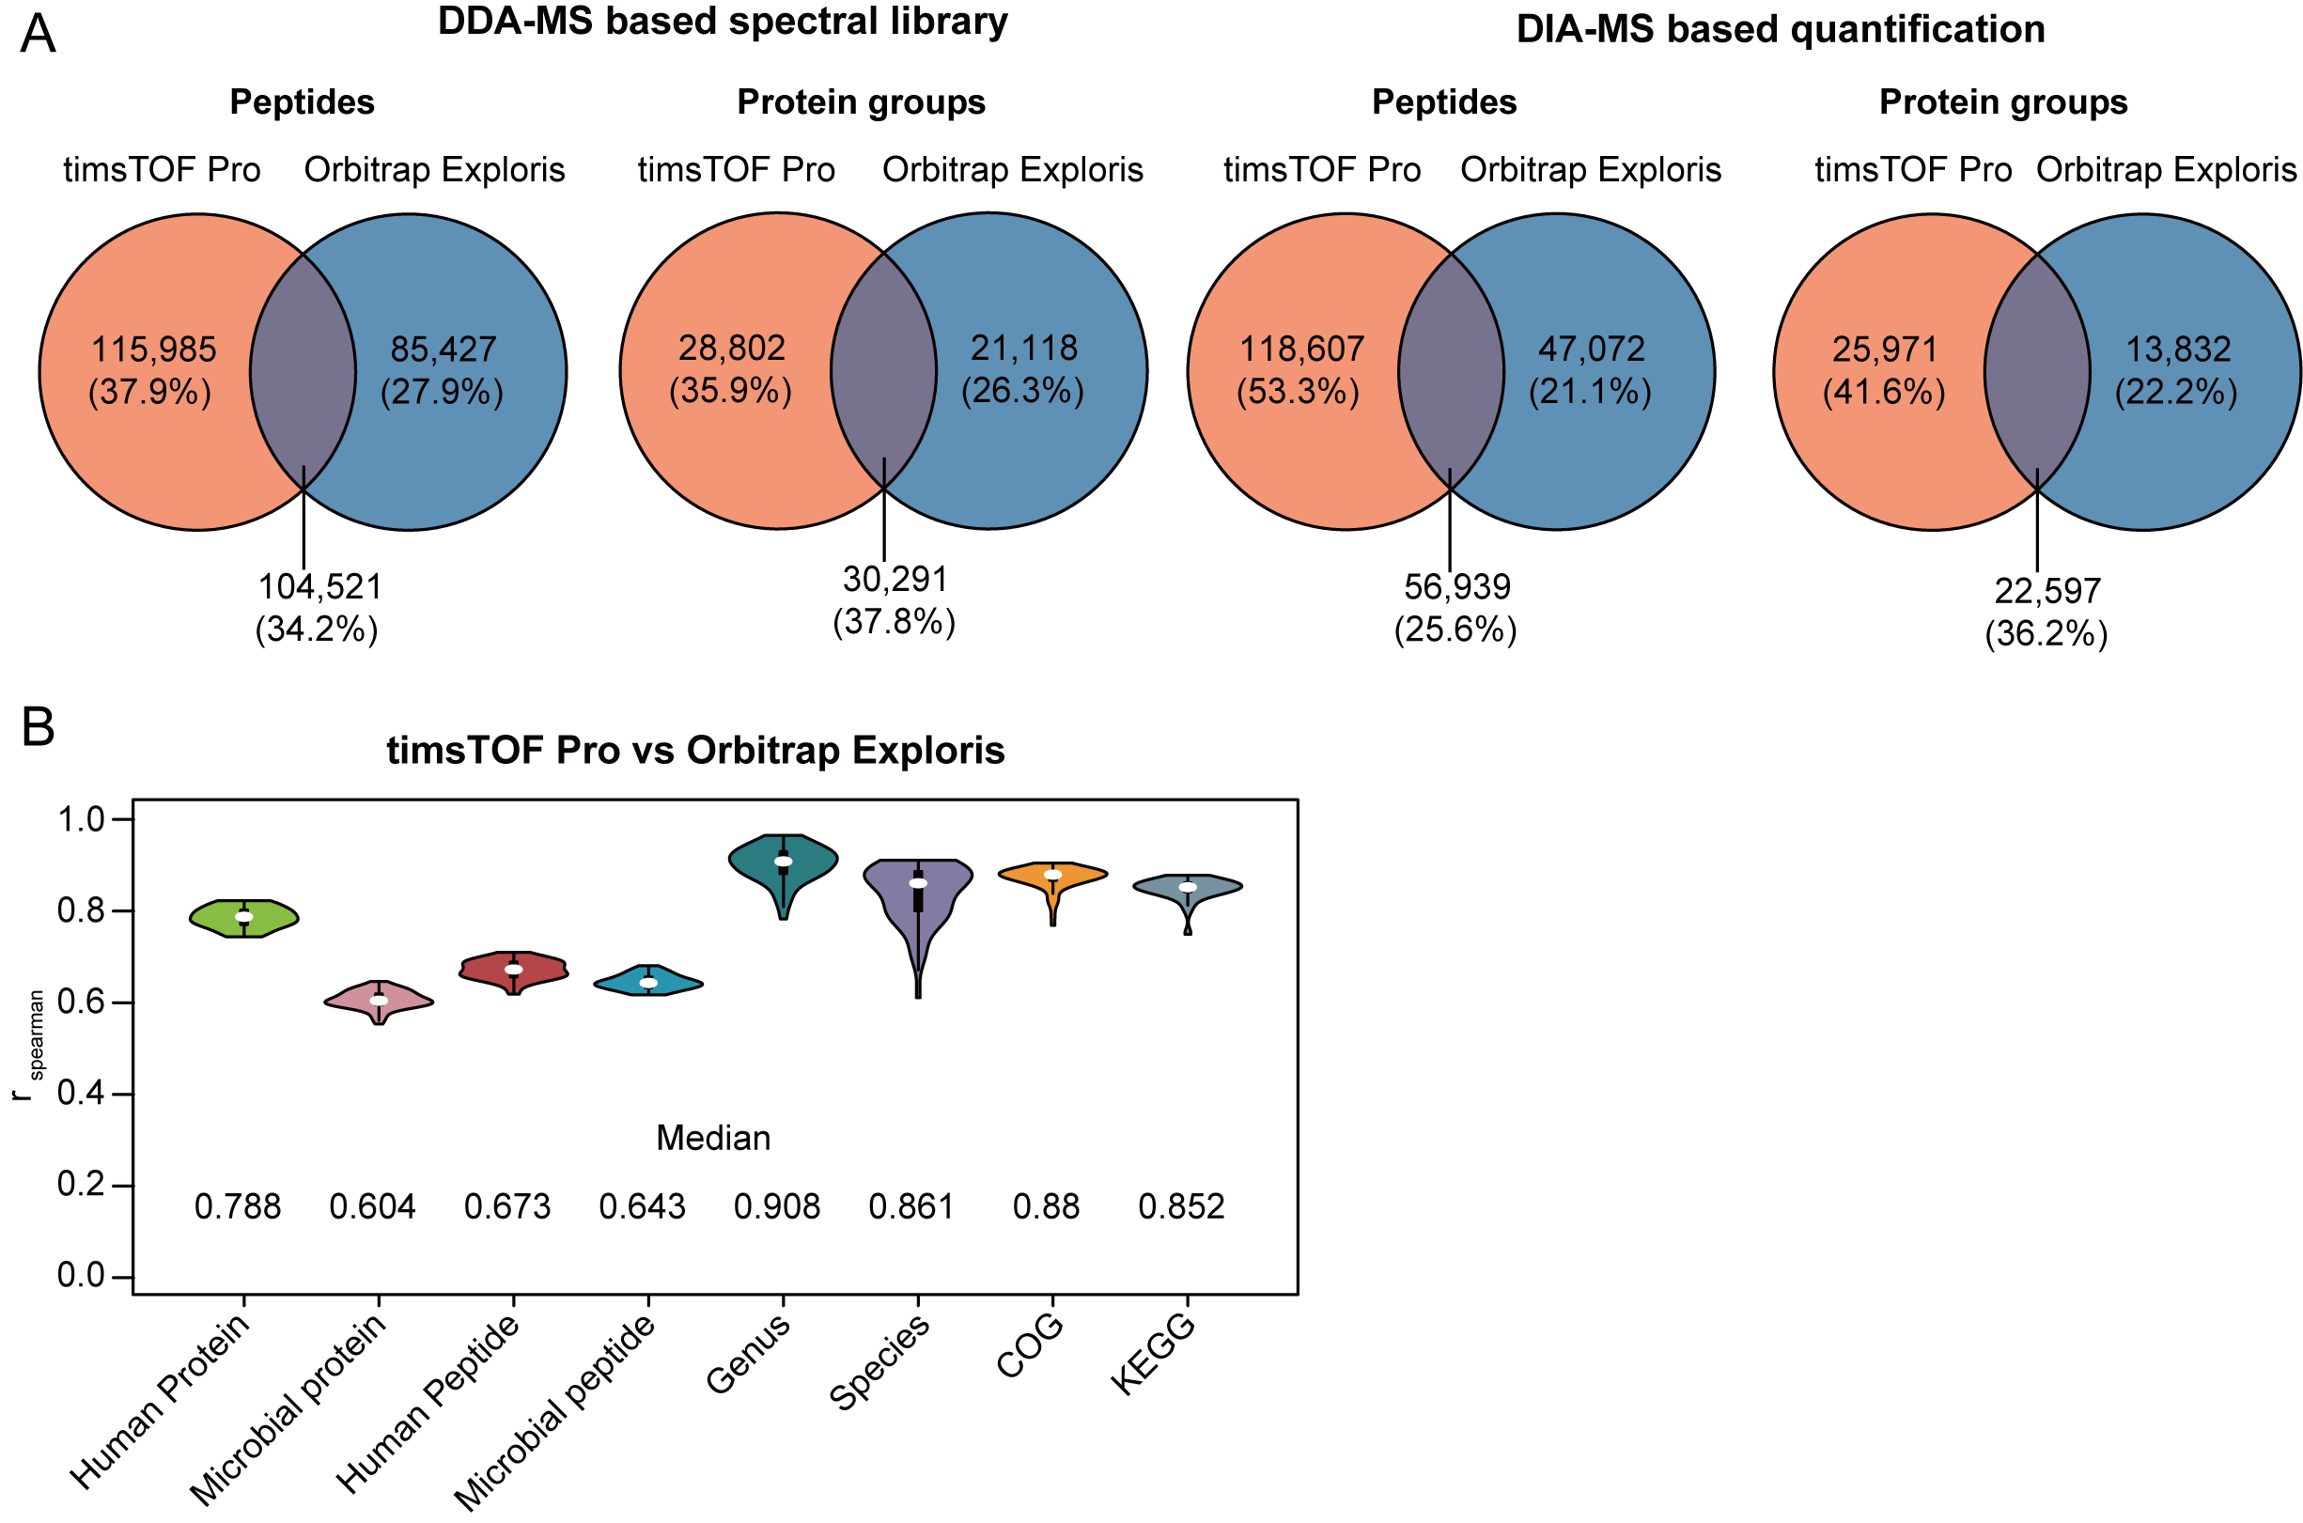
Figure S3 Reproducibility estimation between timsTOF Pro and Orbitrap Exploris MS instruments.
The analyses were based on 30 DDA-MS runs (60 min gradient) and 60 DIA-MS runs (60 min gradient) from 60 human fecal samples on timsTOF Pro or Orbitrap Exploris, respectively. (A) Overlapped peptides and protein groups between timsTOF and Orbitrap MS instruments in DDA-MS based spectral library and DIA-MS based quantification, respectively. (B) Abundance correlation of the common protein groups, peptides, genus, species, COGs, and KOs, respectively, quantified by timsTOF and Orbitrap.
Figure S4
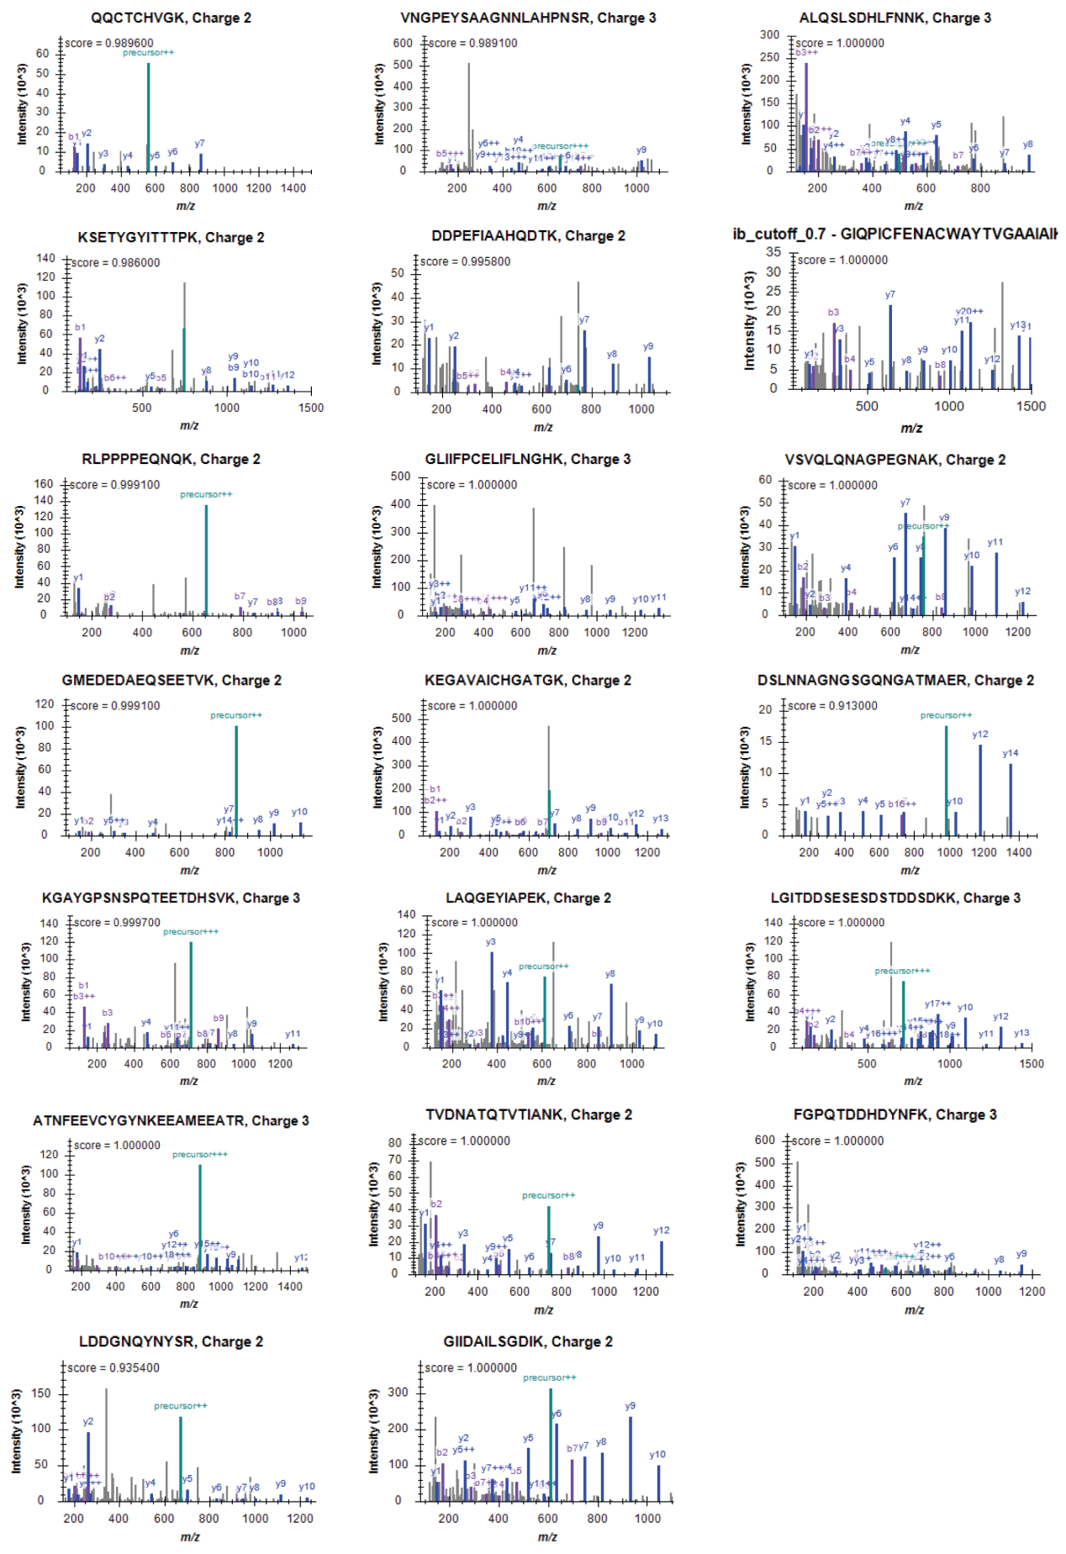
Figure S4 DDA MS/MS spectra of the 20 lowest abundant peptides in the spectral library of metaExpertPro.
The y-axis shows the precursor intensity, while the x-axis stands for the m / z values.
Figure S5
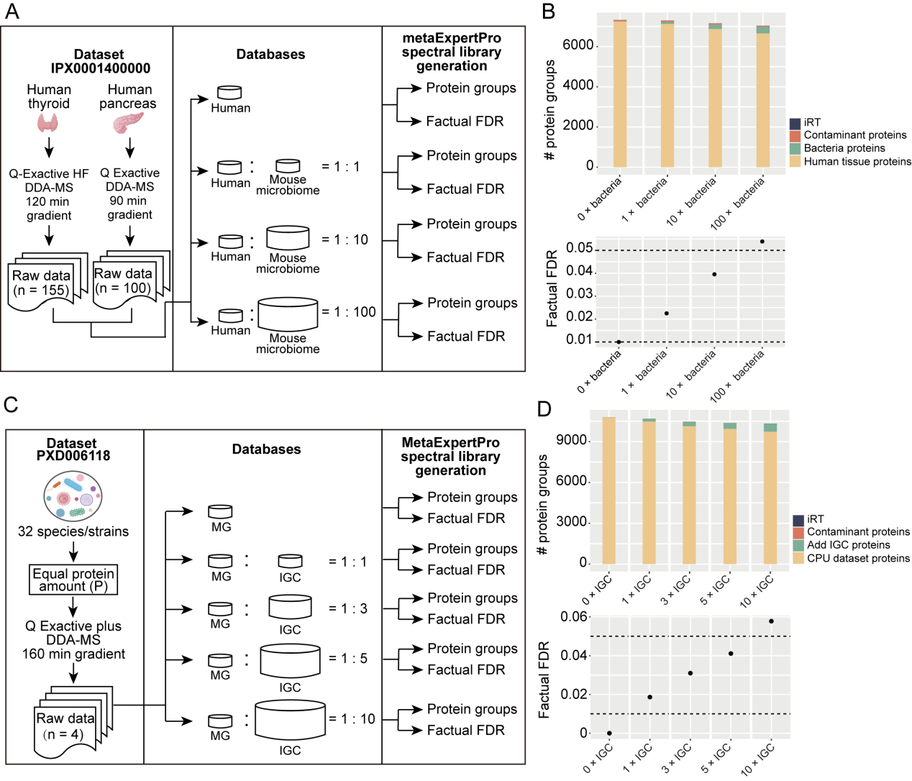
Figure S5 Benchmark test of protein group identifications of metaExpertPro
(A) The experimental design of the benchmark test for protein groups based on 255 human tissues, including 155 human thyroid data and 100 human pancreas data (IPX0001400000). The dataset was searched against human database supplemented with 0×, 1×, 10×, and 100× of mouse gut microbiome database. (B) The number and factual FDR of protein groups in each subset test is presented. (C) The experiment design of the benchmark test for protein groups based on dataset PXD006118. The raw data was searched against the P matched metagenomic database supplemented with 0×, 3×, 5×, and 10× IGC database, respectively. (D) The number and factual FDR of protein groups in each subset test is present. The dashed lines show the factual FDR of 0.05 and 0.01.
Figure S6
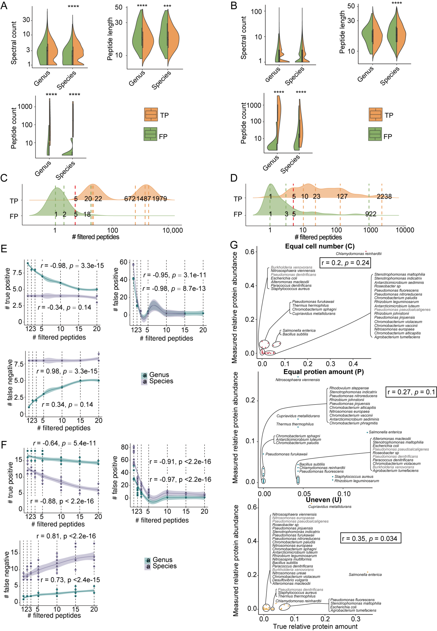
Figure S6 Accuracy estimation of taxa.
(A–B) The comparison of spectra count, peptide length, and the number of peptides corresponding to the taxa between true positive (TP) and false positive (FP) identifications at genus and species levels based on the 12-mix dataset (A) and CPU dataset (B). (C–D) Comparison of the peptide count distribution between TP and FP species based on the 12-mix dataset (C) and CPU dataset (D). (E–F) The number of TP, FP, and false negative (FN) genera and species filtered by different numbers of peptides corresponding to the taxa based on 12-mix MS data (E) or CPU data (F). (G) Spearman correlation between true relative protein abundance of species and relative protein abundance of species measured by metaExpertPro in the CPU dataset. The species with fewer than five distinct peptides are excluded from the analysis. The grey-colored species indicate their absence in the Unipept database.
Figure S7
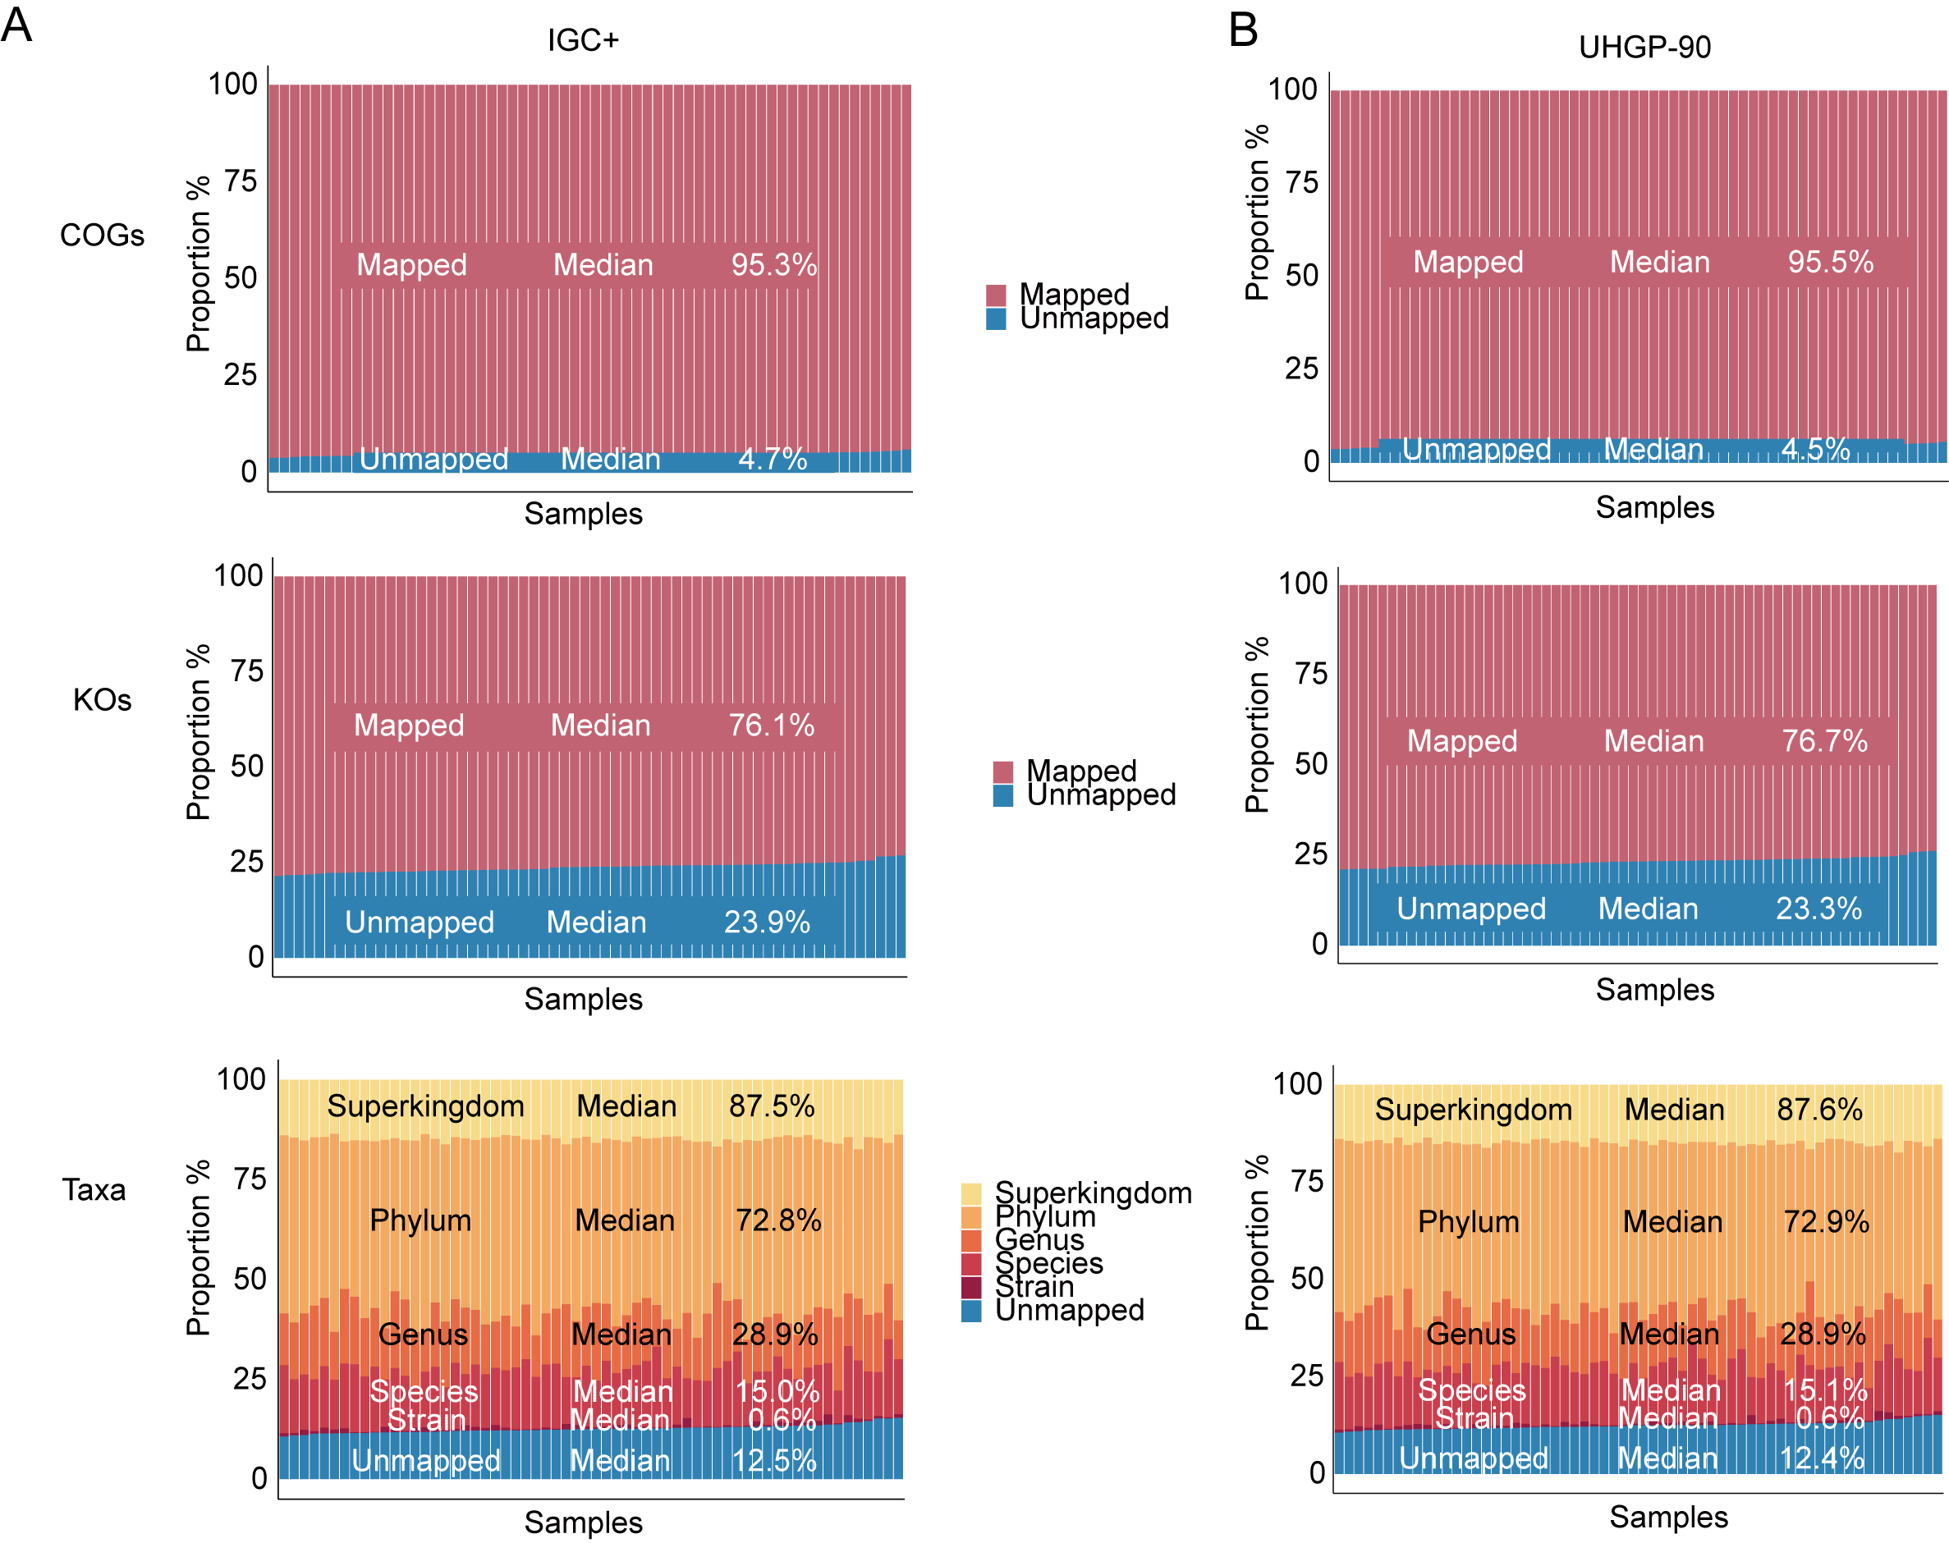
Figure S7 Mapping ratio of functional and taxonomic annotation.
The mapping ratio at COG, KO, and taxonomy levels in each human fecal sample when searching against the IGC+ database (A) or UHGP-90 database (B).
Figure S8
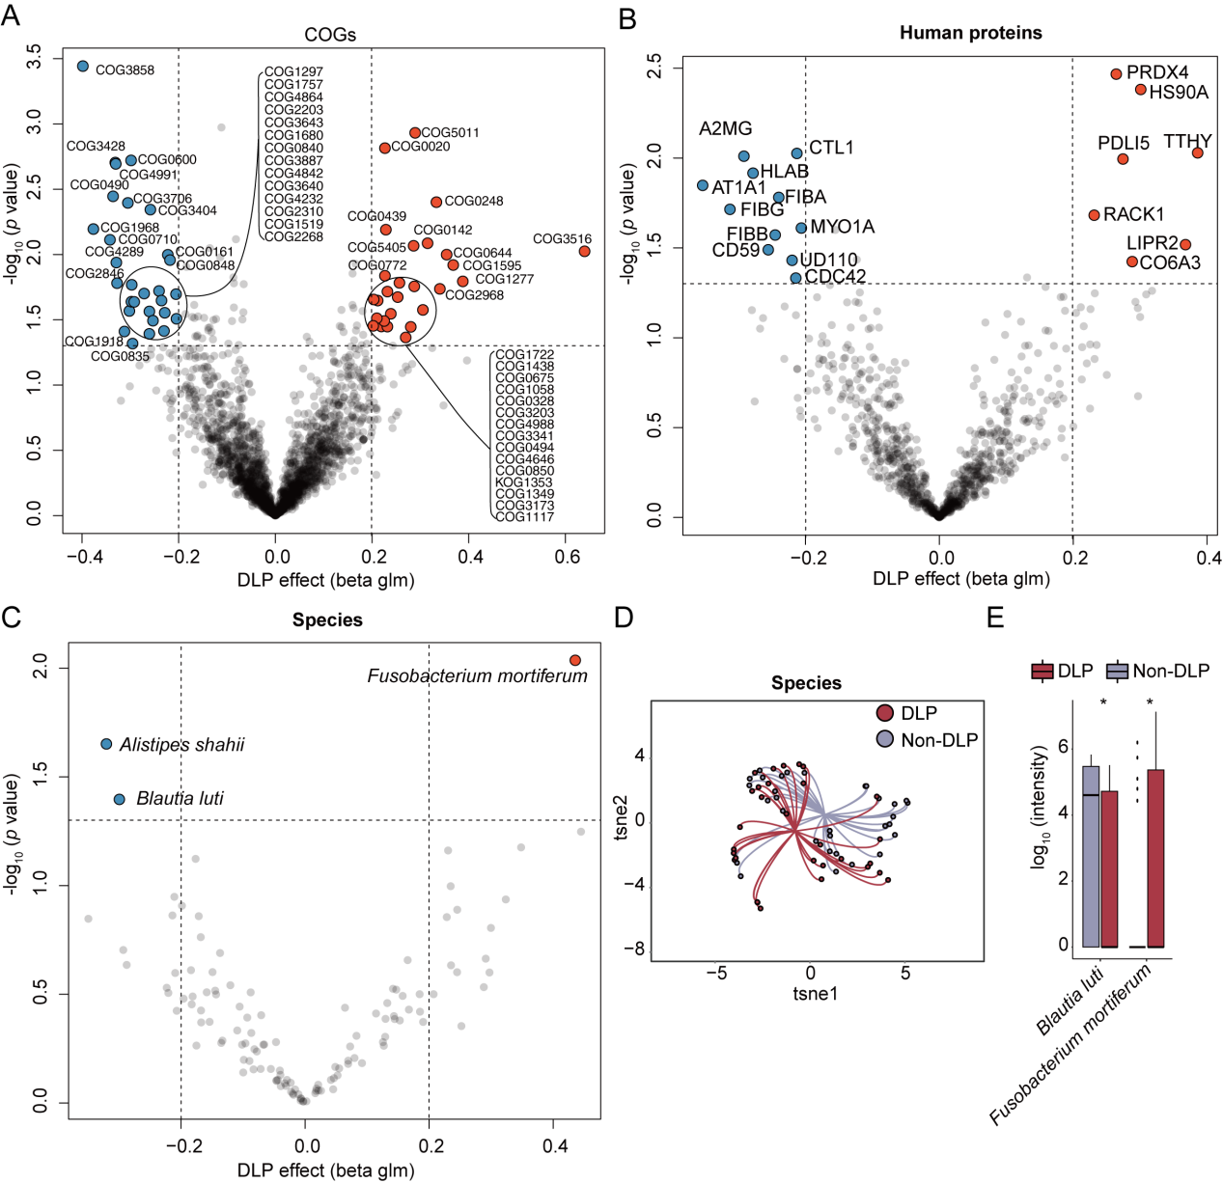
Figure S8 Differentially expressed analysis between DLP and non-DLP groups based on metaExpertPro workflow.
(A–C) The volcano plots show the significantly associated COGs (A), human proteins (B), and species (C) with DLP (General Linear Model (GLM), p-value < 0.05 and | beta coefficient | > 0.2). The y-axis indicates log₁₀ transformed p values. The x-axis indicates the beta coefficient of COGs (A), human proteins (B), and species (C) on DLP. (D) The t-SNE visualization of significantly associated species with DLP. (E) The abundance (log₁₀ transformed) of significantly changed species between DLP and non-DLP groups (Wilcoxon Rank Sum Test, p < 0.05). p value: * p < 0.05; ** p < 0.01; *** p < 0.001, **** p < 0.0001

