Supplementary figure 1 The levels of circulating A) WBC, B) granulocytes, C) lymphocytes, D) monocytes before (normo)-, during hypoglycemia, and 24 hours after hypoglycemia, *: significant difference between Hypo and Normo, #: significant difference between D+1 and normo, *: <0.05, **: <0.01, ***: <0.001,
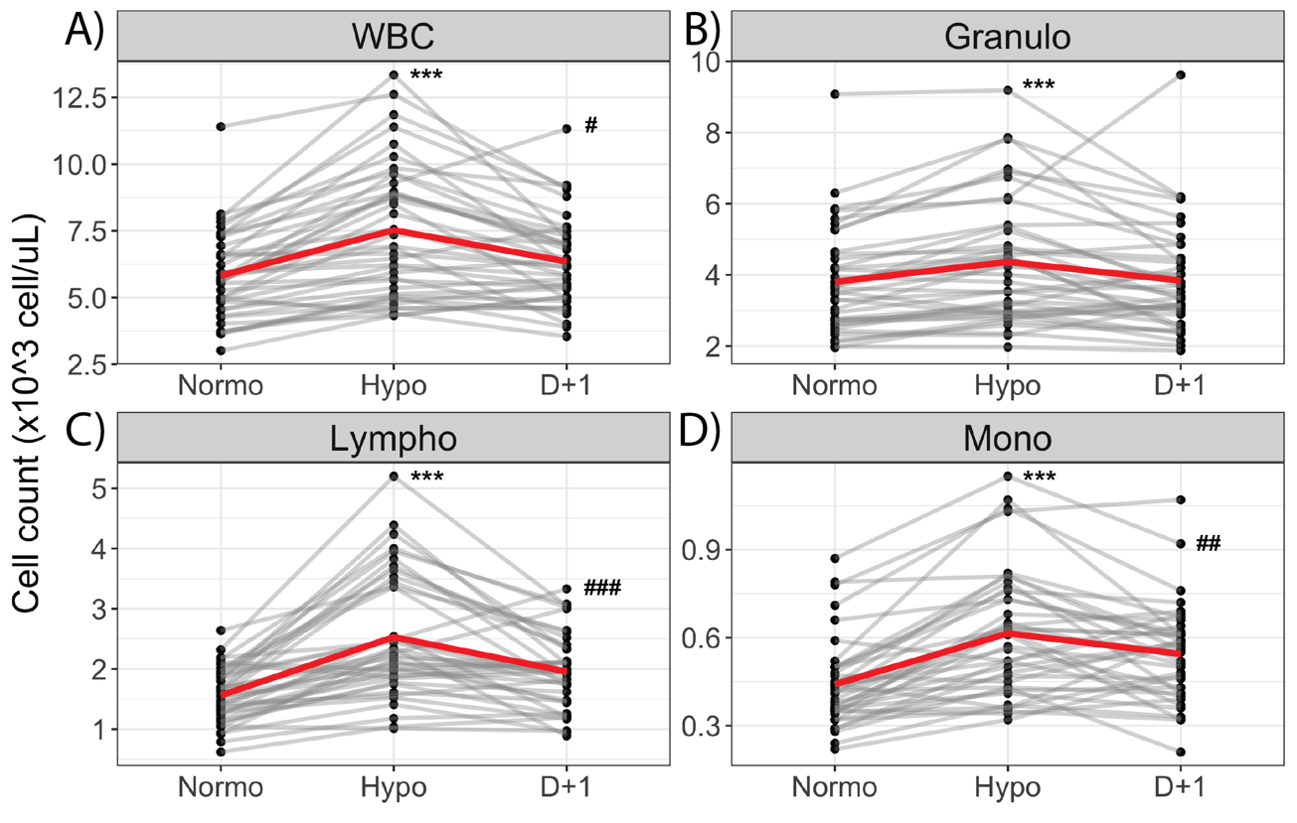

Supplementary figure 2. The relation between adrenaline change and change in immune cell counts during experimental hypoglycemia
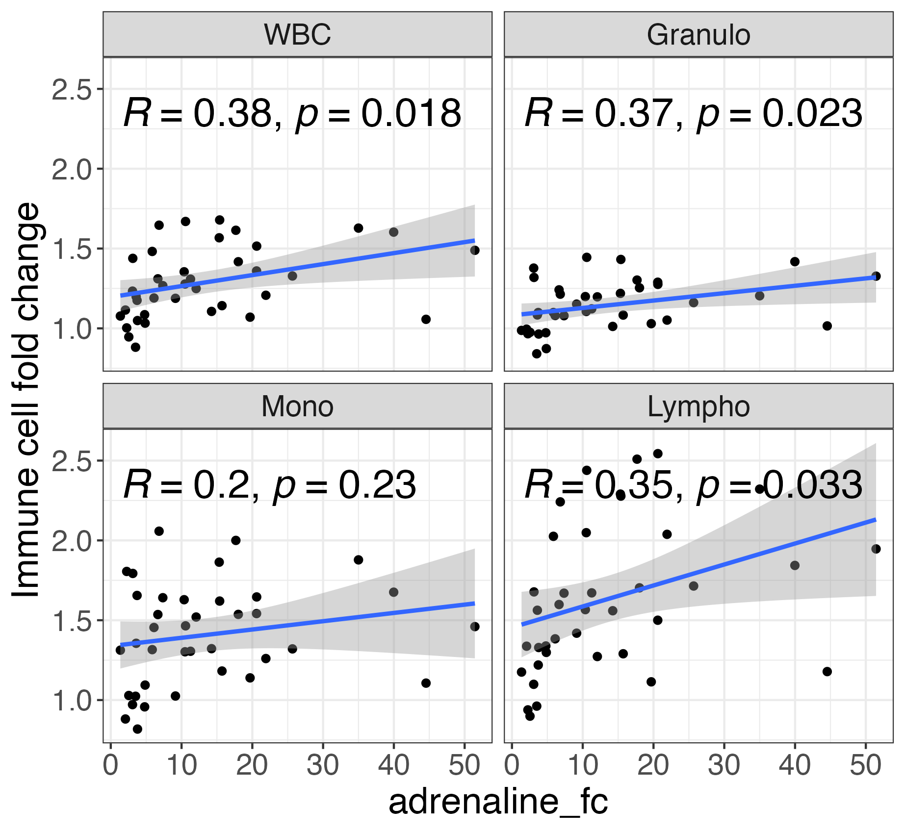

Supplementary figure 3. Changes in ex vivo cytokine production from LPS-stimulated monocytes during experimental hypoglycemia.

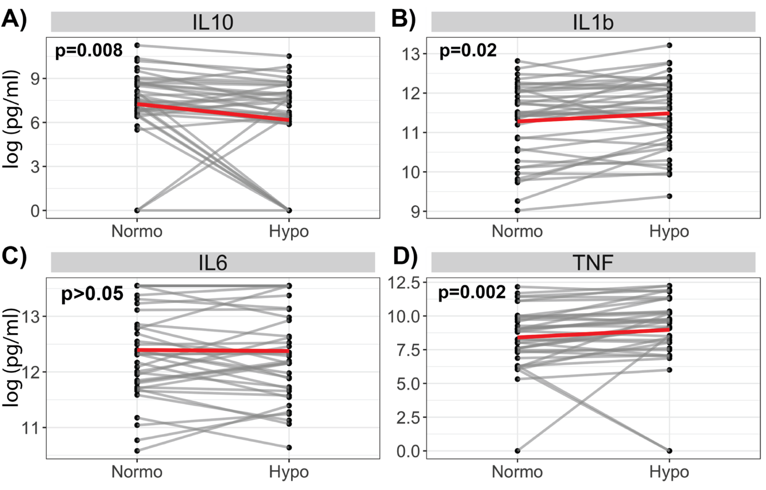

Supplementary table 1. Tissue expression clusters of proteins in different modules

Protein | Module | Tissue specificity | Tissue exp cluster | Brain specificity | Single cell type specificity | Single cell type expression cluster | Tissue cell type classification | Note
uPA | red | Tissue enhanced (kidney, urinary bladder) | Adipose tissue - ECM organization (mainly) | Low human brain regional specificity | Cell type enhanced (Basal respiratory cells, Ionocytes, Exocrine glandular cells, Collecting duct cells) | Pancreatic cells - Mixed function (mainly) | No predicted cell type specificity
FGF-5 | red | Group enriched (brain, gallbladder) | Cerebellum - Gene expression regulation (mainly) | Human brain regional enhanced (cerebellum) | Cell type enhanced (Excitatory neurons, Exocrine glandular cells, Proximal tubular cells, Microglial cells, Melanocytes) | Neurons - Neuronal signaling (mainly) | No predicted cell type specificity
LIF-R | red | Low tissue specificity | Non-specific - Angiogenesis (mainly) | low human brain regional specificity | Cell type enhanced (Astrocytes, Adipocytes, Endothelial cells, Oligodendrocytes) | Endothelial cells - Angiogenesis (mainly) | No predicted cell type specificity
Flt3L | red | Low tissue specificity | Macrophages - Immune response (mainly) | low human brain regional specificity | Cell type enhanced (T-cells, NK-cells) | T-cells - T-cell receptor (mainly) | Cell type enriched (Stomach - Fibroblasts)
DNER | red | Tissue enhanced (adrenal gland, brain, choroid plexus) | Brain - Neuropeptide signaling (mainly) | low human brain regional specificity | Cell type enhanced (Oligodendrocyte precursor cells, Inhibitory neurons, Oligodendrocytes, Serous glandular cells, Horizontal cells, Bipolar cells) | Neurons - Synaptic function (mainly) | Cell type enriched (Lung - Respiratory ciliated cells, Skin - Eccrine sweat gland cells, Thyroid - Parafollicular cells)
TWEAK | red | Low tissue specificity | Non-specific - Unknown function (mainly) | Low human brain regional specificity | Cell type enhanced (Adipocytes, granulocytes) | Macrophages - Innate immune response (mainly) | Cell type enriched (Kidney - Fibroblasts, Thyroid - Fibroblasts)
IL8 | brown | Tissue enriched (bone marrow) | Neutrophils - Humoral immune response (mainly) | Human brain regional enriched (cerebral cortex) | Cell type enhanced (Langerhans cells, Basal respiratory cells, Ionocytes, Macrophages) | Myeloid cells - Innate immune response (mainly) | Cell type enriched (Pancreas - Ductal cells) | chemokine/chemokine ligand
CXCL11 | brown | Tissue enhanced (lymphoid tissue) | T-cells - Adaptive immune response (mainly) | Low human brain regional specificity | Cell type enhanced (Exocrine glandular cells, Macrophages, Basal respiratory cells, Kupffer cells, Hofbauer cells, monocytes) | Macrophages - Degranulation (mainly) | Cell type enriched (Adipose visceral - T-cells) | chemokine/chemokine ligand
MCP-4 | brown | Tissue enhanced (intestine, urinary bladder) | Smooth muscle tissue - Mixed function (mainly) | Not detected in human brain | Cell type enhanced (Macrophages, Hofbauer cells, Langerhans cells, Melanocytes) | Macrophages - Innate immune response (mainly) | No predicted cell type specificity | chemokine/chemokine ligand
CCL11 | brown | Tissue enhanced (intestine, lymphoid tissue, stomach, urinary bladder) | Intestine - Unknown function (mainly) | Not detected in human brain | Cell type enriched (Fibroblasts) | Non-specific - Transcription (mainly) | No predicted cell type specificity | chemokine/chemokine ligand
CCL19 | brown | Tissue enriched (lymphoid tissue) | T-cells - Adaptive immune response (mainly) | Low human brain regional specificity | Cell type enhanced (Smooth muscle cells, Langerhans cells, Fibroblasts, Basal respiratory cells, granulocytes) | Smooth muscle cells - ECM organization (mainly) | No predicted cell type specificity | chemokine/chemokine ligand
CXCL5 | brown | Group enriched (lymphoid tissue, salivary gland) | Salivary gland - Salivary secretion (mainly) | Low human brain regional specificity | Cell type enhanced (Macrophages, Mucus glandular cells, Basal respiratory cells, Ductal cells, Langerhans cells, Pancreatic endocrine cells) | Macrophages - Innate immune response (mainly) | Cell type enriched (Testis - Spermatogonia) | chemokine/chemokine ligand
MMP-10 | brown | Tissue enriched (endometrium) | Fibroblasts - ECM organization (mainly) | Human brain regional enhanced (thalamus) | Cell type enriched (Basal respiratory cells) | Bronchus - Unknown function (mainly) | No predicted cell type specificity
CCL28 | brown | Tissue enriched (salivary gland) | Salivary gland - Salivary secretion (mainly) | Low human brain regional specificity | Cell type enhanced (Mucus glandular cells, Serous glandular cells, Salivary duct cells, Breast glandular cells, Breast myoepithelial cells) | Serous glandular cells - Salivary secretion (mainly) | No predicted cell type specificity | chemokine/chemokine ligand
CCL25 | brown | Group enriched (intestine, lymphoid tissue) | Intestine - Unknown function (mainly) | Not detected in human brain | Group enriched (Proximal enterocytes, Undifferentiated cells) | Proximal enterocytes - Transmembrane transport (mainly) | No predicted cell type specificity | chemokine/chemokine ligand

Supplementary table 2. Linear models on the relation between circulating immune cell counts and hypoglycemia-related parameters. Models were corrected for age, sex, BMI, and DM duration
WBC.subtype | term | estimate | std.error | statistic | p.value | p.adjust
Granulo | Hypo_ep_lv1 | -0.0987939 | 0.04166076 | -2.3713908 | 0.02390714 | 0.03187619
Lympho | Hypo_ep_lv1 | -0.3129852 | 0.12632447 | -2.477629 | 0.0186933 | 0.03187619
Mono | Hypo_ep_lv1 | -0.1088555 | 0.08358842 | -1.3022795 | 0.20211653 | 0.20211653
WBC | Hypo_ep_lv1 | -0.1548605 | 0.06008323 | -2.5774331 | 0.01476581 | 0.03187619
Granulo | Hypo_ep_lv2 | -0.0468139 | 0.07804765 | -0.5998122 | 0.55285537 | 0.55285537
Lympho | Hypo_ep_lv2 | -0.4858919 | 0.22368291 | -2.1722352 | 0.03735648 | 0.1494259
Mono | Hypo_ep_lv2 | -0.1875126 | 0.14529396 | -1.2905737 | 0.20609882 | 0.27479843
WBC | Hypo_ep_lv2 | -0.1910896 | 0.10962864 | -1.7430631 | 0.09092566 | 0.18185131
Granulo | hypo_duration_lv1 | -0.0008986 | 0.00054355 | -1.6531502 | 0.10807951 | 0.43231803
Lympho | hypo_duration_lv1 | -0.0012982 | 0.00171351 | -0.7576527 | 0.45420244 | 0.45420244
Mono | hypo_duration_lv1 | -0.0009629 | 0.0010617 | -0.9069502 | 0.3712124 | 0.45420244
WBC | hypo_duration_lv1 | -0.0009568 | 0.00081023 | -1.1808716 | 0.2463566 | 0.45420244
Granulo | hypo_duration_lv2 | -0.0005493 | 0.000429 | -1.280432 | 0.20959704 | 0.55480076
Lympho | hypo_duration_lv2 | -0.0003629 | 0.00134129 | -0.2705274 | 0.78849179 | 0.78849179
Mono | hypo_duration_lv2 | -0.0006809 | 0.00082647 | -0.8238902 | 0.41610057 | 0.55480076
WBC | hypo_duration_lv2 | -0.0005505 | 0.00063548 | -0.8661964 | 0.39283081 | 0.55480076
Granulo | TBR_lv2 | -0.0210354 | 0.0136208 | -1.5443607 | 0.13233403 | 0.13233403
Lympho | TBR_lv2 | -0.0768449 | 0.04090831 | -1.8784667 | 0.06945433 | 0.13233403
Mono | TBR_lv2 | -0.0426464 | 0.02572781 | -1.6576012 | 0.1071712 | 0.13233403
WBC | TBR_lv2 | -0.0383453 | 0.01949191 | -1.9672405 | 0.05787572 | 0.13233403
Granulo | TBR_lv1 | -0.0143734 | 0.00567156 | -2.5342866 | 0.01635977 | 0.03206277
Lympho | TBR_lv1 | -0.0414558 | 0.01750045 | -2.368842 | 0.02404708 | 0.03206277
Mono | TBR_lv1 | -0.0199118 | 0.01126325 | -1.7678507 | 0.08662075 | 0.08662075
WBC | TBR_lv1 | -0.0218608 | 0.00822046 | -2.6593124 | 0.0121283 | 0.03206277

Supplementary table 3. Linear models on the relation between ex vivo-stimulated monocytes and hypoglycemia-related parameters. Models were corrected for age, sex, BMI, and DM duration
circulating_marker | term | estimate | std.error | statistic | p.value | p.adjust
FC.LPS_IL10 | Hypo_ep_lv1 | -0.4462442 | 0.63861095 | -0.6987732 | 0.48958954 | 0.78334326
FC.LPS_IL1b | Hypo_ep_lv1 | -0.100229 | 0.09504804 | -1.0545087 | 0.29930988 | 0.78334326
FC.LPS_IL6 | Hypo_ep_lv1 | 0.06331125 | 0.08702658 | 0.72749324 | 0.47205407 | 0.78334326
FC.LPS_TNF | Hypo_ep_lv1 | 0.27848042 | 0.45046626 | 0.61820483 | 0.54068394 | 0.78644937
FC.LPS_IL10 | Hypo_ep_lv2 | 0.00462902 | 1.12837589 | 0.00410237 | 0.99675149 | 0.99675149
FC.LPS_IL1b | Hypo_ep_lv2 | -0.1401865 | 0.16773334 | -0.8357701 | 0.40929508 | 0.7276357
FC.LPS_IL6 | Hypo_ep_lv2 | 0.2070474 | 0.14958226 | 1.38417081 | 0.17559626 | 0.6162689
FC.LPS_TNF | Hypo_ep_lv2 | -0.0354321 | 0.79465316 | -0.0445881 | 0.96470435 | 0.99675149
FC.LPS_IL10 | hypo_duration_lv1 | -0.0113631 | 0.00734046 | -1.5480021 | 0.13115966 | 0.6995182
FC.LPS_IL1b | hypo_duration_lv1 | 0.00188929 | 0.0010936 | 1.727587 | 0.09341192 | 0.6995182
FC.LPS_IL6 | hypo_duration_lv1 | 0.00057423 | 0.00103181 | 0.55653361 | 0.58160088 | 0.9305614
FC.LPS_TNF | hypo_duration_lv1 | 0.0080605 | 0.00516691 | 1.56002259 | 0.12829455 | 0.6995182
FC.LPS_IL10 | hypo_duration_lv2 | -0.0025542 | 0.00591363 | -0.43191 | 0.66861588 | 0.98920214
FC.LPS_IL1b | hypo_duration_lv2 | 0.00088204 | 0.00087749 | 1.00518414 | 0.32212225 | 0.98920214
FC.LPS_IL6 | hypo_duration_lv2 | 0.00066329 | 0.00080036 | 0.82874261 | 0.4132043 | 0.98920214
FC.LPS_TNF | hypo_duration_lv2 | 0.00252229 | 0.00415338 | 0.60728711 | 0.54781666 | 0.98920214

