Supplementary material

Supplementary table 1: Tongariro National Park field sites, with the approximate C. vulgaris density and the latitude, longitude coordinates.

TNP site  number | Average C. vulgaris cover (%) | C. vulgaris cover categories | Latitude | Longitude
1 | 34 | Medium | -39.293661 | 175.726798
2 | 0 | Low | -39.293453 | 175.726325
3 | 66 | High | -39.292099 | 175.728896
4 | 60 | High | -39.277717 | 175.738553
5 | 44 | Medium | -39.277927 | 175.736899
6 | 0 | Low | -39.277003 | 175.738768
7 | 0 | Low | -39.188068 | 175.755345
8 | 60 | High | -39.188326 | 175.757781
9 | 35 | Medium | -39.188561 | 175.758454
10 | 76 | High | -39.227605 | 175.731479
11 | 0 | Low | -39.233941 | 175.731624
12 | 56 | Medium | -39.233697 | 175.730637
13 | 31 | Medium | -39.242515 | 175.72525
14 | 64 | High | -39.2422652 | 175.7253725
15 | 0 | Low | -39.288231 | 175.704315

Supplementary table 2: Percent cover of C. vulgaris in all study plots
Plot | Geographic location | Area | Site | Heather cover category | Replicate | C. vulgaris density (%)
1 | South | A | 1 | Medium | 1 | 30
2 | South | A | 1 | Medium | 2 | 10
3 | South | A | 1 | Medium | 3 | 40
4 | South | A | 1 | Medium | 4 | 60
5 | South | A | 1 | Medium | 5 | 30
6 | South | A | 2 | Low | 1 | 0
7 | South | A | 2 | Low | 2 | 0
8 | South | A | 2 | Low | 3 | 0
9 | South | A | 2 | Low | 4 | 0
10 | South | A | 2 | Low | 5 | 0
11 | South | A | 3 | High | 1 | 60
12 | South | A | 3 | High | 2 | 50
13 | South | A | 3 | High | 3 | 80
14 | South | A | 3 | High | 4 | 70
15 | South | A | 3 | High | 5 | 70
16 | South | B | 4 | High | 1 | 60
17 | South | B | 4 | High | 2 | 60
18 | South | B | 4 | High | 3 | 70
19 | South | B | 4 | High | 4 | 60
20 | South | B | 4 | High | 5 | 50
21 | South | B | 5 | Medium | 1 | 20
22 | South | B | 5 | Medium | 2 | 50
23 | South | B | 5 | Medium | 3 | 60
24 | South | B | 5 | Medium | 4 | 40
25 | South | B | 5 | Medium | 5 | 50
26 | South | B | 6 | Low | 1 | 0
27 | South | B | 6 | Low | 2 | 0
28 | South | B | 6 | Low | 3 | 0
29 | South | B | 6 | Low | 4 | 0
30 | South | B | 6 | Low | 5 | 0
31 | North | E | 7 | Low | 1 | 0
32 | North | E | 7 | Low | 2 | 0
33 | North | E | 7 | Low | 3 | 0
34 | North | E | 7 | Low | 4 | 0
35 | North | E | 7 | Low | 5 | 0
36 | North | E | 8 | High | 1 | 60
37 | North | E | 8 | High | 2 | 70
38 | North | E | 8 | High | 3 | 60
39 | North | E | 8 | High | 4 | 60
40 | North | E | 8 | High | 5 | 50
41 | North | E | 9 | Medium | 1 | 30
42 | North | E | 9 | Medium | 2 | 25
43 | North | E | 9 | Medium | 3 | 20
44 | North | E | 9 | Medium | 4 | 40
45 | North | E | 9 | Medium | 5 | 60
46 | Centre | C | 10 | High | 1 | 70
47 | Centre | C | 10 | High | 2 | 60
48 | Centre | C | 10 | High | 3 | 70
49 | Centre | C | 10 | High | 4 | 90
50 | Centre | C | 10 | High | 5 | 90
51 | Centre | C | 11 | Low | 1 | 0
52 | Centre | C | 11 | Low | 2 | 0
53 | Centre | C | 11 | Low | 3 | 0
54 | Centre | C | 11 | Low | 4 | 0
55 | Centre | C | 11 | Low | 5 | 0
56 | Centre | C | 12 | Medium | 1 | 50
57 | Centre | C | 12 | Medium | 2 | 40
58 | Centre | C | 12 | Medium | 3 | 50
59 | Centre | C | 12 | Medium | 4 | 80
60 | Centre | C | 12 | Medium | 5 | 60
61 | Centre | D | 13 | Medium | 1 | 40
62 | Centre | D | 13 | Medium | 2 | 30
63 | Centre | D | 13 | Medium | 3 | 15
64 | Centre | D | 13 | Medium | 4 | 20
65 | Centre | D | 13 | Medium | 5 | 50
66 | Centre | D | 14 | High | 1 | 60
67 | Centre | D | 14 | High | 2 | 80
68 | Centre | D | 14 | High | 3 | 70
69 | Centre | D | 14 | High | 4 | 40
70 | Centre | D | 14 | High | 5 | 70
71 | South | D | 15 | Low | 1 | 0
72 | South | D | 15 | Low | 2 | 0
73 | South | D | 15 | Low | 3 | 0
74 | South | D | 15 | Low | 4 | 0
75 | South | D | 15 | Low | 5 | 0

Supplementary table 3: Plant species found in this study in Tongariro National Park, along with their 6-letter codes, structural class, status, and mycorrhizal type AM= arbuscular mycorrhizal, ErM = ericoid mycorrhizal, EcM = ectomycorrhizal, NM = non-mycorrhizal.
Code | Species | Structural  class | Mycorrhizal  type | Status
AGRCAP | Agrostis capillaris | Pastoral | AM | Non-native
ANDEMP | Androstoma empetrifolia | Native shrub | ErM | Native
AUSTOE | Austroderia toetoe | Native grass | AM | Native
CALVUL | Calluna vulgaris | Non-native shrub | ErM | Non-native
CARNAN | Carmichaelia nana | Native shrub | AM | Native
CELGRA | Celmisia gracilenta | Native forb | AM | Native
CELSPE | Celmisia spectabilis | Native forb | AM | Native
CHIRUB | Chionochloa rubra | Native grass | AM | Native
COPCHE | Coprosma cheesemanii | Native shrub | AM | Native
COPPER | Coprosma perpusilla | Native shrub | AM | Native
COPRUG | Coprosma rugosa | Native shrub | AM | Native
CORPTE | Coriaria pteridoides | Native forb | NM | Native
DRAREC | Dracophyllum recurvum | Native shrub | ErM | Native
DRASUB | Dracophyllum subulatum | Native shrub | ErM | Native
EMPMIN | Empodisma minus | Native sedges and rushes | NM | Native
EPAALP | Epacris alpina | Native shrub | ErM | Native
GAUCOL | Gaultheria colensoi | Native shrub | ErM | Native
GAUDEP | Gaultheria depressa | Native shrub | ErM | Native
GLEDIC | Gleichenia dicarpa | Native fern | NM | Native
HYPRAD | Hypochaeris radicata | Pastoral | AM | Non-native
LEPSCO | Leptospermum scoparium | Native shrub | Ecto/AM | Native
LEUFRA | Leucopogon fraseri | Native shrub | ErM | Native
LOLPER | Lolium perenne | Pastoral | AM | Non-native
LOTPED | Lotus pedunculatus | Pastoral | AM | Non-native
MUEAXI | Muehlenbeckia axillaris | Native shrub | NM | Native
OLENUM | Olearia nummulariifolia | Native shrub | AM | Native
ORESTR | Oreobolus strictus | Native sedges and rushes | NM | Native
OZOLEP | Ozothamnus leptophyllus | Native shrub | AM | Native
PENPUM | Pentachondra pumila | Native shrub | ErM | Native
POACOL | Poa colensoi | Native grass | AM | Native
PODNIV | Podocarpus nivalis | Native shrub | AM | Native
RYTSET | Rytidosperma setifolium | Native grass | AM | Native
VERTET | Veronica tetragona | Native shrub | AM | Native
VERVEN | Veronica venustula | Native shrub | AM | Native
WAHPYG | Wahlenbergia pygmaea | Native shrub | AM | Native

Species | Geographic location | Indicator value | Mean | S.D | p-value
AGRCAP | Centre | 12.7 | 7.9 | 3.85 | 0.1256
ANDEMP | Centre | 8 | 4.7 | 2.42 | 0.1374
AUSTOE | South | 10.8 | 7.2 | 3.57 | 0.1408
CALVUL | Centre | 33.9 | 28.5 | 3.91 | 0.0952
CARNAN | South | 11.4 | 7.3 | 3.5 | 0.2028
CELGRA | South | 3.4 | 5.5 | 3.03 | 0.8058
CELSPE | Centre | 16.7 | 11.5 | 4.4 | 0.1154
CHIRUB | Centre | 34.3 | 38 | 2.7 | 0.9624
COPCHE | North | 49 | 21.7 | 5.22 | 0.0006 ***
COPPER | South | 5.7 | 4.7 | 2.56 | 0.3575
COPRUG | North | 6.7 | 4 | 1.42 | 0.1978
CORPTE | South | 2.9 | 4 | 1.45 | 1
DRAREC | South | 10 | 9.1 | 4.03 | 0.3115
DRASUB | North | 51.6 | 29.6 | 5.44 | 0.0034 **
EMPMIN | South | 17.1 | 7.9 | 3.92 | 0.0304 *
EPAALP | Centre | 40.2 | 15.5 | 5.47 | 0.0016 **
GAUCOL | Centre | 4.7 | 6.1 | 3.26 | 0.6831
GAUDEP | Centre | 18.9 | 15.2 | 5.08 | 0.1934
GLEDIC | South | 14 | 7.7 | 3.78 | 0.0834
HYPRAD | North | 37.1 | 24 | 6.09 | 0.0406 *
LEPSCO | Centre | 66.2 | 22.1 | 5.52 | 0.0002 ***
LEUFRA | South | 12.9 | 9.7 | 4.31 | 0.1722
LOLPER | North | 40 | 8.1 | 4.04 | 0.0002 ***
LOTPED | North | 17.2 | 6.4 | 3.36 | 0.013 **
MUEAXI | North | 13.3 | 5 | 2.58 | 0.0404 *
OLENUM | Centre | 11.9 | 7.3 | 3.62 | 0.0982
ORESTR | South | 2.9 | 4 | 1.42 | 1
OZOLEP | North | 26.3 | 21.9 | 6.06 | 0.2006
PENPUM | North | 24.5 | 18.5 | 5.37 | 0.13
POACOL | North | 10.3 | 14.3 | 4.98 | 0.7796
PODNIV | South | 2.2 | 4.9 | 2.57 | 0.9098
RYTSET | South | 28.6 | 10.4 | 4.24 | 0.0026 **
VERTET | South | 11.4 | 6.3 | 3.28 | 0.092
VERVEN | South | 53.1 | 18.1 | 6.01 | 0.0004 ***
WAHPYG | Centre | 4.9 | 5.6 | 3.05 | 0.4289
Supplementary table 4: Indicator species analysis of plant species by geographic location (Southern, Central, Northern) of plot. Species which significantly indicate one of the three locations types are marked (* P< 0.05; **P < 0.01; *** P < 0.001).

Supplementary Table 5: Indicator species analysis of plant species by C. vulgaris cover category. Species which significantly indicate one of the three category types are marked (* P< 0.05; **P < 0.01; *** P < 0.001).

Species | C. vulgaris density | Indicator value | Mean | S.D | p-value
AGRCAP | Medium | 7.2 | 7.5 | 3.48 | 0.4907
ANDEMP | Low | 8 | 4.2 | 2.68 | 0.3275
AUSTOE | High | 15.4 | 6.8 | 3.29 | 0.034 *
CALVUL | High | 61.3 | 28.2 | 3.6 | 0.0002 ***
CARNAN | Low | 16 | 7.2 | 3.14 | 0.0256 *
CELGRA | Low | 5.3 | 5.1 | 2.85 | 0.7746
CELSPE | Medium | 15.1 | 11 | 3.91 | 0.1378
CHIRUB | Low | 37.7 | 37.7 | 2.56 | 0.4413
COPCHE | High | 19.8 | 21.3 | 4.92 | 0.5319
COPPER | High | 8 | 4.5 | 2.53 | 0.3395
COPRUG | Low | 4 | 4 | 0.06 | 1
CORPTE | Medium | 4 | 4 | 0.06 | 1
DRAREC | Medium | 19.1 | 8.7 | 3.66 | 0.0192 *
DRASUB | Low | 63.8 | 29.1 | 5.06 | 0.0002 ***
EMPMIN | Low | 11.9 | 7.6 | 3.66 | 0.1372
EPAALP | Low | 13.3 | 15.1 | 5.09 | 0.5745
GAUCOL | Low | 9 | 5.8 | 2.93 | 0.3103
GAUDEP | Low | 21.8 | 14.8 | 4.62 | 0.084
GLEDIC | Low | 24 | 7.3 | 3.32 | 0.0026 **
HYPRAD | Low | 37.3 | 23.5 | 5.62 | 0.0256 **
LEPSCO | High | 30.4 | 21.6 | 5.12 | 0.0688
LEUFRA | High | 7.1 | 9.6 | 4.04 | 0.7325
LOLPER | Medium | 19.3 | 7.7 | 3.56 | 0.0208 **
LOTPED | High | 9.5 | 6 | 3.1 | 0.166
MUEAXI | Medium | 8 | 4.9 | 2.15 | 0.3303
OLENUM | Low | 20 | 7.1 | 3.56 | 0.0102 **
ORESTR | High | 4 | 4 | 0.06 | 1
OZOLEP | Low | 28.6 | 21.5 | 5.78 | 0.1166
PENPUM | Medium | 20.8 | 18.2 | 5.01 | 0.247
POACOL | Low | 12.7 | 13.8 | 4.57 | 0.5177
PODNIV | Low | 8 | 4.9 | 2.19 | 0.3279
RYTSET | Low | 13.5 | 9.9 | 3.82 | 0.1694
VERTET | Low | 16 | 6 | 3.11 | 0.0318 *
VERVEN | Low | 46 | 17.7 | 5.59 | 0.0004 ***
WAHPYG | High | 3.6 | 5.3 | 2.83 | 0.769

Supplementary Table 6: Indicator species analysis of plant species by study area (A-E). Species which significantly indicate one of the locations are marked (* P< 0.05; **P < 0.01; *** P < 0.001).

Species | Study area | Indicator value | Mean | S.D | p-value
CELGRA | A | 8.9 | 5.9 | 4.15 | 0.5051
COPPER | A | 13.3 | 6.1 | 3.5 | 0.1916
CORPTE | A | 6.7 | 6.7 | 0.09 | 1
DRAREC | A | 26.4 | 8.9 | 4.32 | 0.0044**
PENPUN | A | 20 | 6.5 | 3.93 | 0.0364*
VERTET | A | 13.8 | 7.1 | 4.1 | 0.0908
AUSTOE | B | 25.6 | 7.7 | 4.23 | 0.0062**
EMPMIN | B | 40 | 8.4 | 4.5 | 0.0006***
GLEDIC | B | 33 | 8 | 4.07 | 0.0012**
LEUFRA | B | 11.8 | 11.8 | 5.46 | 0.5035
ORESTR | B | 6.7 | 6.7 | 0.09 | 1
VERVEN | B | 24.2 | 16.6 | 6.37 | 0.1256
COPCHE | C | 38 | 17.2 | 4.78 | 0.0016**
COPRUG | C | 6.7 | 6.7 | 0.09 | 1
DRASUB | C | 35.6 | 21.9 | 4.71 | 0.0122*
LOLPER | C | 40 | 8.4 | 4.54 | 0.0002***
LOTPED | C | 15.8 | 7.1 | 4.22 | 0.0612
MUEAXI | C | 13.3 | 7.2 | 3.02 | 0.1946
OZOLEP | C | 20.1 | 17.9 | 5.65 | 0.2889
ANDEMP | D | 13.3 | 5.6 | 3.72 | 0.1876
CALVUL | D | 16.5 | 20 | 3.06 | 0.8974
CELSPE | D | 24.8 | 10.4 | 4.36 | 0.0136*
GAUCOL | D | 6.7 | 6.7 | 3.94 | 0.7908
LEPSCO | D | 42.2 | 17.6 | 5.03 | 0.001**
OLENUM | D | 19.7 | 8.3 | 4.68 | 0.0402*
PENPUM | D | 24 | 15.4 | 4.98 | 0.064
WAHPYG | D | 9.6 | 6.7 | 3.97 | 0.3449
AGRCAP | E | 12 | 8.3 | 4.34 | 0.1888
CARNAN | E | 26.7 | 9.4 | 4.47 | 0.0074**
CHIRUB | E | 27.6 | 24.9 | 2.14 | 0.1066
EPAALP | E | 52.9 | 14 | 5.69 | 0.0002***
GAUDEP | E | 19.8 | 13.2 | 4.85 | 0.0982
HYPRAD | E | 26.4 | 19.3 | 5.74 | 0.1142
POACOL | E | 23.8 | 12.7 | 5.05 | 0.0414*
PODNIV | E | 5.6 | 7 | 3.02 | 1
RYTSET | E | 15.3 | 10.1 | 4.65 | 0.1332

Note: Indicator species analysis of plant species by site (1-15), indicated no significant association of any plant species with any site.

Supplementary Table 7: Results of a linear mixed-effects model for the percent root length of C. rubra colonised by AMF as a function of C. vulgaris (heather) density (%). The best model of AMF colonisation in C. rubra was lmer(log(Fungal_Colonisation) ~ Heather_Density + (1 | Area)).
Fixed Effects | Estimate | Std Error | df | F value | P value
Heather density | -0.0099 | 0.0011 | 70.1 | 78.71 | P< 0.0001
Random Effects | Variance | Std Deviation
Area | 11.58 | 3.4

Supplementary Table 8: Results of a linear mixed-effects model for total soil microbial biomass (as indicated by the sum of 8 FAMEs) as a function of C. vulgaris (heather) density (%).
Fixed Effects | Estimate | Std Error | df | F value | P value
Heather density | 0.275 | 0.249 | 69.6 | 1.22 | 0.27
Random Effects | Variance | Std Deviation
Region | 87.38 | 9.35

Supplementary Table 9: Results of a linear model the proportional abundance of fungi in soil samples (18:2ω6 / ∑ 8 PLFAs) as a function of C. vulgaris (heather) density (%).
Fixed Effects | Estimate | Std Error | df | F value | P value
Heather density | 0.0533 | 0.0258 | 1 | 4.28 | 0.042
*Note: linear model - lm(Fungi ~ Heather_Density ) was used as singular fits indicated no variance explained by random effects of Area and Region

Supplementary Table 10: Results of a generalized linear model of the probability of detection of the arbuscular mycorrhizal fungi biomarker (NLFA 16:1ω5) in response to increasing density of C. vulgaris. Final model glm(AMF_Presence ~ Heather_Density , family = "binominal")
Fixed Effects | Estimate | Std Error | df | Z value | P value
Heather density | -0.437 | 0.374 | 1 | -1.51 | 0.131

Supplementary Table 11: Results of linear models for soil nutrients as a function of geographic region of the study site (Southern, Central, Northern).
Soil Nutrient | Model | Fixed Effects | Sum of squares | Mean Sq | df | F value | P value
Olsen P | lm(Olsen_P ~ Region) | Region | 11.067 | 5.553 | 2 | 6.225 | 0.014
 |  | Residuals | 10.667 | 0.889 | 12
Soil C | lm(Carbon ~ Region) | Region | 13.161 | 5.553 | 2 | 1.262 | 0.318
 |  | Residuals | 62.555 | 5.213 | 12
Soil N | lm(Nitrogen ~ Region) | Region | 0.0461 | 0.023 | 2 | 9.566 | 0.0033
 |  | Residuals | 0.0289 | 0.002 | 12
C:N | lm(CN ~ Region) | Region | 109.86 | 54.93 | 2 | 0.8404 | 0.455
 |  | Residuals | 784.31 | 65.36 | 12

Supplementary Figures

Supplementary figure 1: Satellite image (earth.google.com/web) of Tongariro National Park with locations of the 5 study areas indicated by yellow ellipses. Within each study area, 3 sites were selected, one each with high, medium or low density of C. vulgaris. Locations of sites are indicated with yellow pins. Within each site, 5 plots centred on randomly selected C. rubra plants. Areas A and B were considered to be the Southern part of the study region, areas C and D were considered to be the Central part of the study region, and area E was considered to be the Northern part of the study region. See supplementary Table 1 for geographic coordinates of study sites.
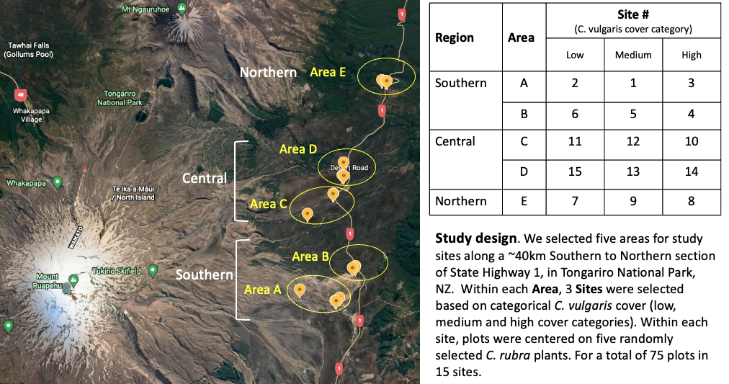

Supplementary figure 2: C. rubra plant diameter (cm) in response to C. vulgaris density (%) in Tongariro National Park, fitted with a linear trend line and 95% confidence interval.
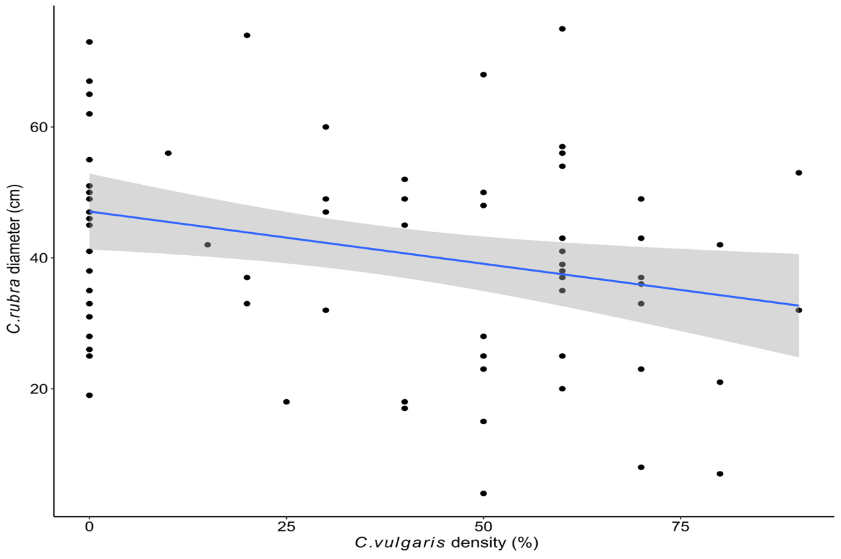
R² = 0.078
p = 0.014

Supplementary figure 3: Generalized linear model of the probability of detection of the arbuscular mycorrhizal fungi biomarker in response to increasing density of C. vulgaris.

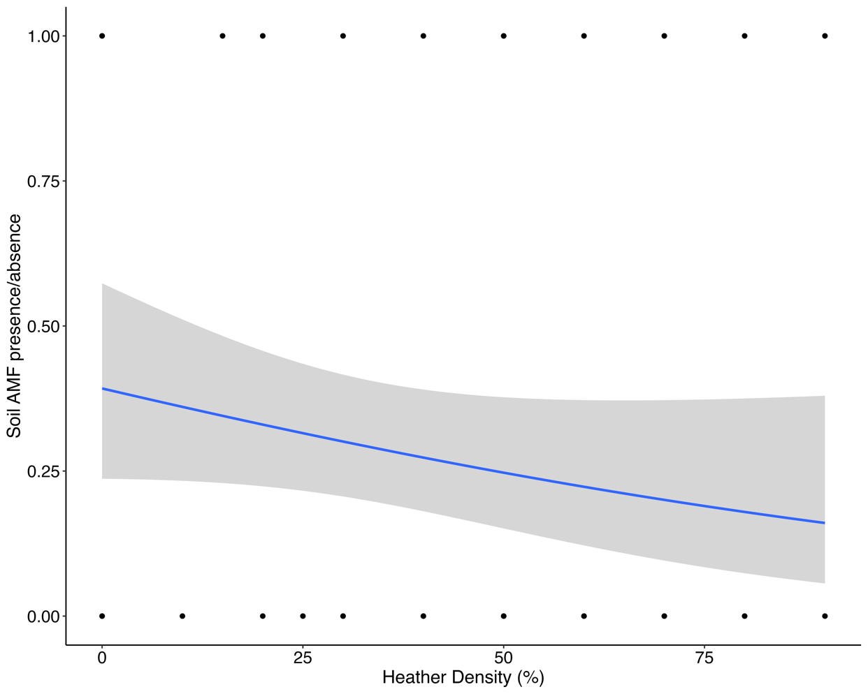
Nagelkerke R² = 0.04
p = 0.13

