Supplementary material

Table S1 The mobile phase conditions for antibiotic analysis
Mobile phase conditions for CAPs  (mobile A: 0.05% ammonia solution; B: ACN ) |  | Mobile phase conditions for QNs and TCs  (mobile A: 0.1% FA solution; B: MeOH )
Time (min) | Mobile B (ACN) | Time (min) | Mobile B (MeOH)
0~0.5 | 10% | 0~1.0 | 10%
0.5~2.0 | 90% | 1.0~4.5 | 30%
2.0~3.0 | 90% | 4.5~7.0 | 99%
3.0~3.5 | 10% | 7.0~9.0 | 99%
3.5~5.0 | 10% | 9.0~9.1 | 10%
3.5~5.0 | 10% | 9.1~10.0 | 10%
The colomn is Waters BEH C₁₈（1.7μm，2.1mm×100mm）

Table S2 The parameters of mass spectrometry for targeted analytes
Antibiotic |  | Molecular formula | Ion source | Precursor Ion (m/z) | Product Ion (m/z) | Collision Energy  (eV) | Cone voltage  (V)
QNs | Ciprofloxacin | C₁₇H₁₈FN₃O₃ | ESI+ | 332.2 | 314.3/288.3 | 19/17 | 36
QNs | Enrofloxacin | C₁₉H₂₂FN₃O₃ | ESI+ | 360.3 | 316.4/342.3 | 19/23 | 38
QNs | Lomefloxacin | C₁₇H₁₉F2N₃O₃ | ESI+ | 352.3 | 265.2/308.3 | 23/17 | 36
QNs | Norfloxacin | C₁₆H₁₈FN₃O₃ | ESI+ | 320.3 | 302.3/276.3 | 19/17 | 50
QNs | Norfloxacin-d₅ | C₁₆H₁₃D₅FN₃O₃ | ESI+ | 325.1 | 281.1 | 12 | 50
QNs | Ofloxacin | C₁₈H₂₀FN₃O₄ | ESI+ | 362.2 | 318.3/261.2 | 18/27 | 38
QNs | Pefloxacin | C₁₇H₂₀FN₃O₃ | ESI+ | 334.3 | 290.3/233.2 | 17/25 | 38
TCs | Chlortetracycline | C₂₂H₂₃ClN₂O₈ | ESI+ | 479.2 | 426/444 | 18/10 | 40
TCs | Doxycycline | C₂₂H₂₄N₂O₈ | ESI+ | 445 | 428/153.9 | 14/20 | 30
TCs | Oxytetracycline | C₂₂H₂₄N₂O₉ | ESI+ | 461 | 426/443 | 18/10 | 40
TCs | Tetracycline | C₂₂H₂₄N₂O₈ | ESI+ | 445 | 410/427 | 25/15 | 35
CAPs | Chloramphenicol | C₁₁H₁₂C_{l2}N₂O₅ | ESI- | 321 | 152/257 | 18/16 | 22
CAPs | Chloramphenicol-d₅ | C₁₁H₇D₅Cl₂N₂O₅ | ESI- | 326 | 157 | 15 | 25
CAPs | Thiamphenicol | C₁₂H₁₅Cl₂NO₅S | ESI- | 354 | 185/290 | 18/10 | 14
CAPs | Florfenicol | C₁₂H₁₄Cl₂FNO₄S | ESI- | 356 | 336/185 | 10/10 | 25
CAPs | Florfenicol Amine | C₁₀H₁₄FNO₃S | ESI+ | 248 | 230/130 | 10/10 | 25

Table S4 The formula and structure of analyzed antibiotics
Antibiotic |  | Chemical formula | Log K_{ow} | Structural formula
QNs | Ciprofloxacin | C₁₇H₁₈FN₃O₃ | 0.28 | 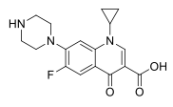
QNs | Enrofloxacin | C₁₉H₂₂FN₃O₃ | 1.1, 2.31 | 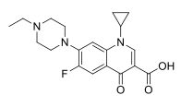
QNs | Lomefloxacin | C₁₇H₁₉F2N₃O₃ | 0.31 | 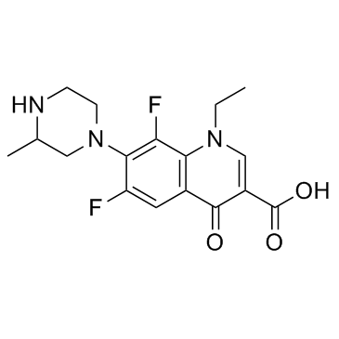
QNs | Norfloxacin | C₁₆H₁₈FN₃O₃ | -1.03 | 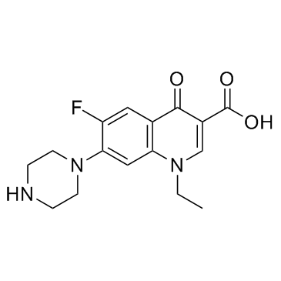
QNs | Ofloxacin | C₁₈H₂₀FN₃O₄ | -2.0 | 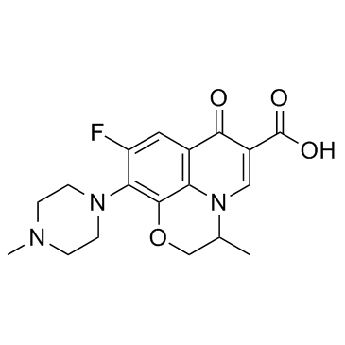
QNs | Pefloxacin | C₁₇H₂₀FN₃O₃ | -0.27 | 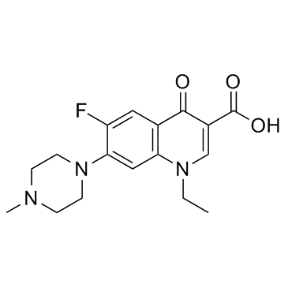
TCs | Chlortetracycline | C₂₂H₂₃ClN₂O₈ | -0.62 | 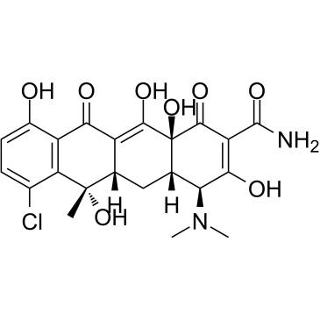
TCs | Doxycycline | C₂₂H₂₄N₂O₈ | -1.36, -0.02 | 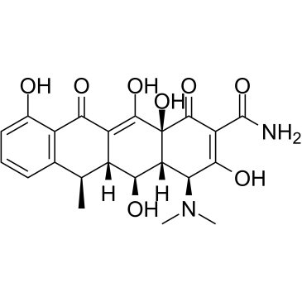
TCs | Oxytetracycline | C₂₂H₂₄N₂O₉ | -2.87, -0.9 | 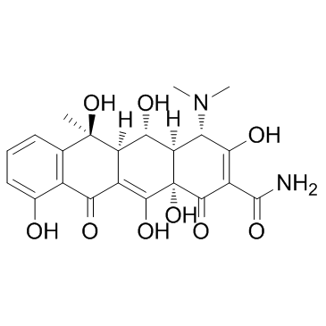
TCs | Tetracycline | C₂₂H₂₄N₂O₈ | -1.33 | 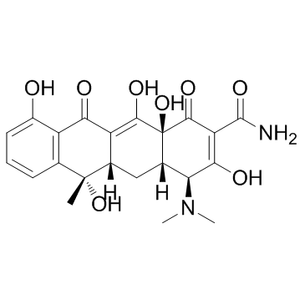
CAPs | Chloramphenicol | C₁₁H₁₂C_{l2}N₂O₅ | 0.94, 1.14 | 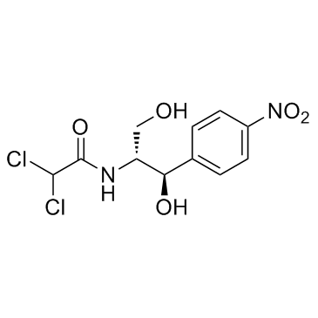
CAPs | Thiamphenicol | C₁₂H₁₅Cl₂NO₅S | -0.33, -0.27 | 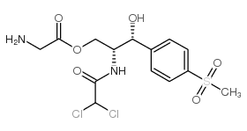
CAPs | Florfenicol | C₁₂H₁₄Cl₂FNO₄S | -0.04 | 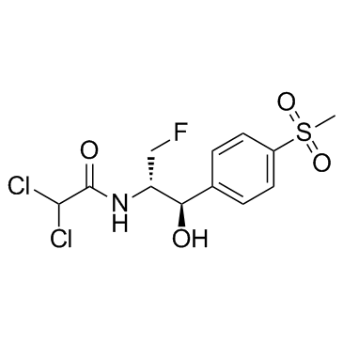
CAPs | Florfenicol amine | C₁₀H₁₄FNO₃S | -1.27 | 