Table 2.1. QoL, BSI and mMRC as a predicting factor of mortality. (appendix)
Age and gender adjusted
 | Sig. | Exp(B) | 95% CI for Exp(B)
 | Sig. | Exp(B) | Lower | Upper
QoL-B | 0.02 | 0.99 | 0.98 | 0.99
BSI score | 0.13 | 1.16 | 0.96 | 1.39
mMRC | 0.03 | 5.54 | 1.8 | 16.99

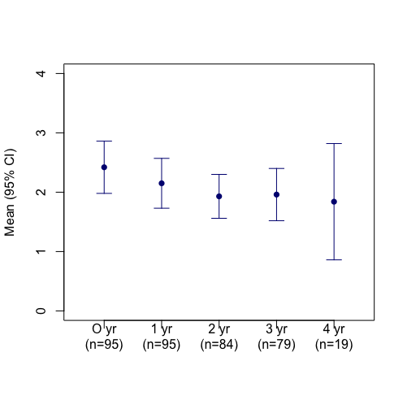
Figure 2. Annual exacerbations (n) in 4 years of follow-up. (appendix)

