SUPPLEMENTARY INFORMATION
Co-benefits of Nature-based solutions exceed the costs of implementation
Authors: González-García, A., Palomo, I., Codemo, A., Rodeghiero, M., Dubo, T., Vallet, A., Lavorel, S.

Contents:
- Distribution and characteristics of NbS projects
  - Examples of satellite images used in photointerpretation
- Detailed results of ecosystem services modelling and biodiversity
  - Land use land cover changes
  - Average increase per ecosystem service
  - Urban cooling model
  - Flood risk mitigation model
  - Carbon storage and sequestration model
  - Landslide protection model
  - Biodiversity
  - Results of statistical analysis
- Detailed results for beneficiaries
- Detailed results of economic assessment
  - Detailed results on costs of actions
  - Detailed results on cost-effectiveness analysis
- Discussion on ecosystem services economic valuation
- Limitations of the study
  - Models and data limitations
  - Beneficiaries and ecosystem services flow limitations
  - Economic valuation limitations
  - Future needs and potential enhancements
- Supplementary methods
  - Urban cooling model
  - Flood risk mitigation model
  - Carbon storage and sequestration model
  - Landslide protection model
  - Biodiversity assessment
  - Buffers to analyze beneficiaries
  - Analysis of the distribution of NbS in relation to GDP
  - Economic value of ecosystem services
  - Multifunctionality analysis of NbS
- Supplementary references

- Distribution and characteristics of NbS projects
Figure S1 depicts the spatial distribution of the 85 Nature-Based Solutions (NbS) actions within the perimeter of the Alpine Space. The NbS database used in this study is presented in Dubo et al. (2023), based on an extensive search of existing adaptation initiatives databases such as ClimateADAPT, Oppla, N4Cities, PANORAMA, Reconnect, WeADAPT and PHUSICOS among others. Additionally, websites of environmental public agencies focusing on forestry, agriculture, freshwater provision, biodiversity conservation, and protected areas were explored. For the purpose of this study, we specifically focused on on-the-ground NbS, which comprise ecological restoration, reforestation, green infrastructure, and similar actions.
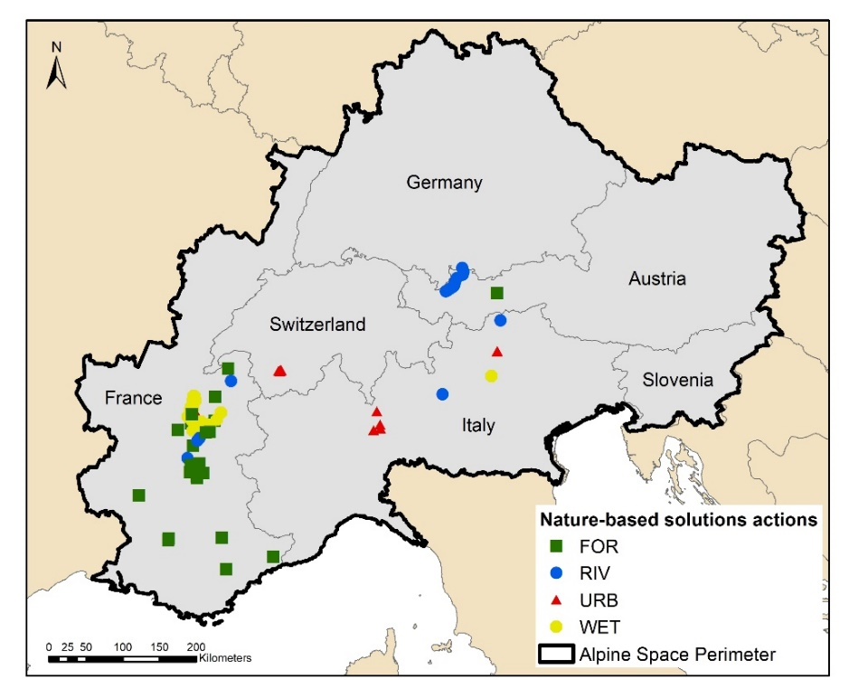
Figure S 1. Distribution of Nature-based Solutions (NbS) actions by type of ecosystem in the Alpine Space Perimeter. FOR: Forest; RIV: River; URB: Urban; WET: Wetland.
The total surface covered by analysed NbS actions is 1,594 hectares, with an average size of 18 ± 40 hectares. These actions comprise: 26 forest actions, 17 river actions, 15 urban actions, and 26 wetland actions. Among these, forest actions tend to have the largest average size (39.7 ± 57 ha), followed by wetland and river actions, as depicted in Figure S2. Conversely, urban actions generally have smaller sizes, with in some instances even very small areas (less than 10 m²). It is important to highlight the significant variability in the sizes of actions across all types, including both small-scale and large-scale initiatives for each of them.
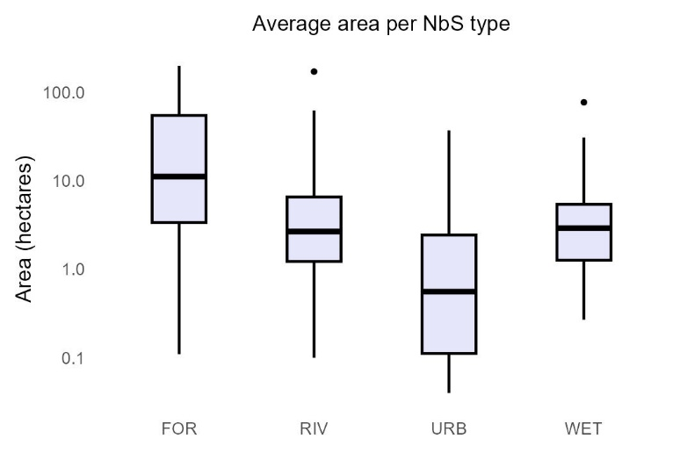
Figure S 2, Average size of actions per type of ecosystem. FOR: Forest; RIV: River; URB: Urban; WET: Wetland.
  - Examples of satellite images used in photointerpretation
The photointerpretation process commenced by identifying the year when each NbS action was initiated. Subsequently, we examined the Land Use/Land Cover (LULC) changes prior to and after the specified dates provided in the project details. It should be noted that each action had a different starting date. Some actions exhibited evident changes before and after implementation, as illustrated in Figure S3 and Figure S4. Conversely, certain actions displayed limited development, as depicted in Figure S5. In cases where the actions were not clearly discernible in the images, we consulted project data and communicated with project developers to gather information on potential changes. For instance, in Figure S5, the vacant space within the polygon had already been planted with several trees of different species.
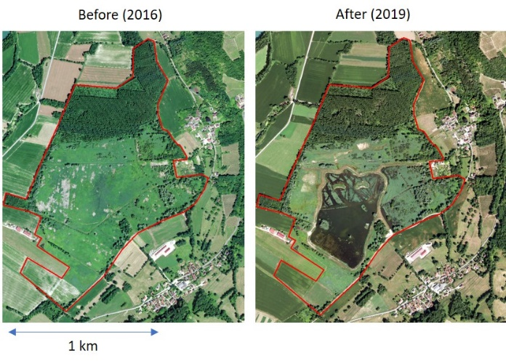
Figure S 3. Example of wetland restoration. The code in the tables for this initiative is InRe123.
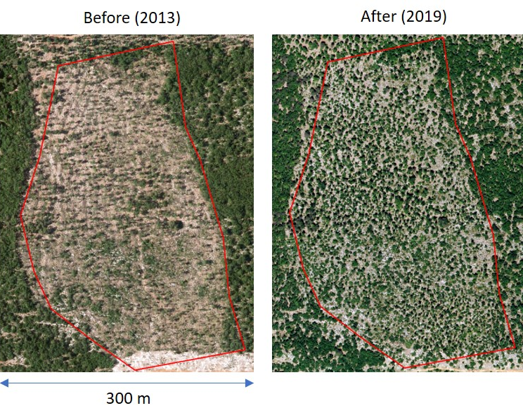
Figure S 4. Example of reforestation. The code in the tables for this initiative is ReCan1.
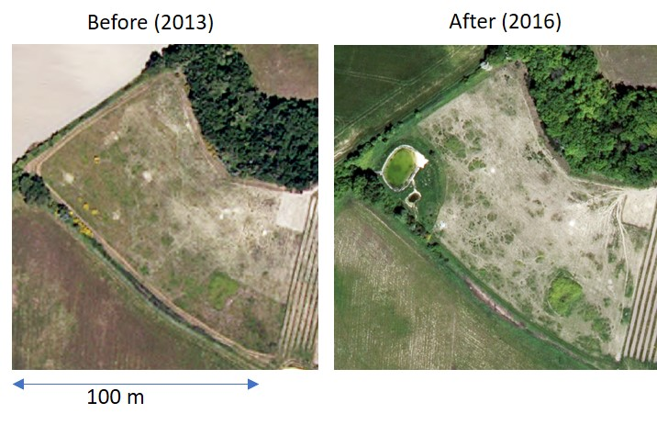
Figure S 5. Example of forest action, with additional actions such as amphibian ecosystem restoration. The code in the tables for this initiative is ReLa1.
- Detailed results of ecosystem services modelling and biodiversity
  - Land use land cover changes
Figure S6 illustrates the outcomes of the LULC analysis derived from the photointerpretation process. For photointerpretation, we utilized level 3 classifications following the system of CORINE land cover, which incorporates greater detail (i.e., distinct types of forest such as conifers and broad-leaved). However, for the sake of clarity and readability, the graph displays the results for level 1 categories, which encompass more generalized classifications. We employed the same codes and names as found in the CORINE land cover dataset. Notably, the most substantial increase was forests, expanding from 673 ha to 1,131 ha. The surface of urban fabric reduced notably from 4.64 ha to 1.16 ha following the implementation of various NbS projects. This reduction is primarily attributed to the establishment of urban green infrastructure, such as urban parks, gardening and green roofs; it does not entail the destruction of the existing urban fabric (i.e., a green roof does not imply the destruction of the building, and integrating green elements in a street does not imply destroying the street). Heterogeneous agricultural areas experienced an increase from 23.9 ha to 26.9 ha, while arable land slightly expanded from 43 ha to 43.5 ha. Artificial, non-agricultural vegetated areas, including urban zones, exhibited a remarkable surge from 0.7 ha to 18.4 ha. Inland wetlands expanded from 81 ha to 105 ha, and inland water bodies, encompassing rivers and lakes, grew from 33 ha to 49 ha. Conversely, open spaces with little or no vegetation showed the most pronounced decrease, contracting from 627 ha to 145 ha. Scrublands underwent a reduction in surface area from 85 ha to 54 ha. Industrial and commercial areas remained unchanged, while mine, dumps, and construction sites saw a reduction in their total area from 13 ha to 9.4 ha.

Figure S 6. Total Land Use Land Cover (LULC) changes before and after the implementation of Nature-based Solutions (NbS). This plot displays the total LULC area that was photo-interpreted within the NbS action boundaries both before and after project implementation. It is important to note that not all of the detected changes are directly related to LULC alterations; they also encompass increases in forest cover and changes in soil properties, which are not represented in this graph.
  - Average increase per ecosystem service
The average increase in ecosystem services supply shows in general a high standard deviation (Figure S7). Heatwave mitigation (Figure S7A) increases substantially in forest (137% ± 203) and urban areas (107% ± 144), while wetlands show a more modest increase (10% ± 14). NbS actions in rivers do not significantly improve heatwave mitigation (46% ± 132). Flood regulation (Figure S7B) increases most in rivers (419% ± 865) followed by urban areas (157% ± 179), and forests (89% ± 84). However, wetlands experience a decrease (-25% ± 12). Climate regulation (Figure S7C) increases most in urban ecosystems (21,807% ± 34,725), followed by wetlands (7,751% ± 39,679), forests (730% ± 995), and rivers (252% ± 570). Landslide protection (Figure S7D) is only provided by forest ecosystems with more than 15% slope, resulting in a significant decrease in landslide probability (-19% ± 13).
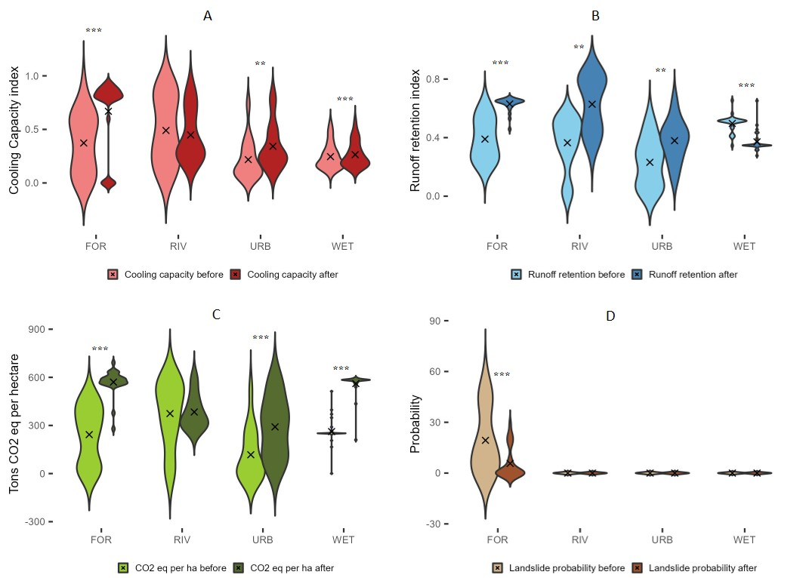
Figure S 7. Ecosystem services supply before (light colours) and after (dark colours) the implementation of Nature-based Solutions (NbS) projects by ecosystem type (FOR: Forest; RIV: River, URB: Urban, WET: Wetland). (A) Heatwave mitigation. (B) Flood regulation. (C) Climate regulation. (D) Landslide protection. Asterisks show the significance of the results of the Wilcox test for paired samples. The 'X' inside the plots represents the mean value, which is calculated across all the NbS in each category of ecosystem. The value of each indicator within each NbS is the average of all the pixels inside the NbS before and after NbS implementation.
  - Urban cooling model
The supplementary material includes two additional results from the Urban Cooling Model of InVEST, presented in Figures S8 and 9. Figure S8 illustrates the Heat Mitigation Index, which accounts for the cooling effect of green areas larger than 2 hectares. Forest, river, and wetland actions show high values for this index, attributed to their larger size compared to urban initiatives, which had limited impact on increasing cooling capacity due to their smaller area.
Figure S8 displays the Wet Bulb Globe Temperature (WBGT), an index that calculates the impacts of heat on work productivity (in ºC), considering humidity. The dotted lines represent thresholds at which work productivity would be reduced by 25%, 50%, and 75% for different levels of work intensity. Notably, there is a significant reduction in this index for most NbS types, with the exception of wetlands. However, only a few forest and a river NbS project demonstrate a substantial reduction in this temperature. The limited reduction could be linked to the spatial isolation of NbS, emphasizing the importance of considering landscape-scale approaches for effective heat mitigation (Peng et al., 2022).
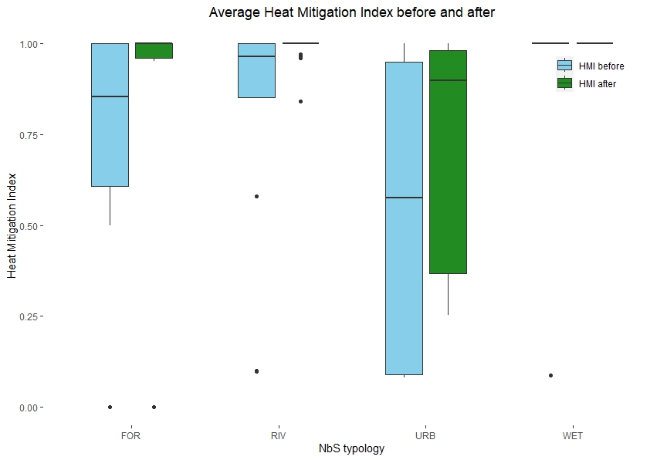
Figure S 8. Average values of the Heat Mitigation Index for different types of Nature-based Solutions (NbS), calculated using the Urban Cooling Model from InVEST. The index quantifies the cooling effect of each NbS type and provides insights into their potential contributions to heat mitigation. FOR: Forest; RIV: River; URB: Urban; WET: Wetland.
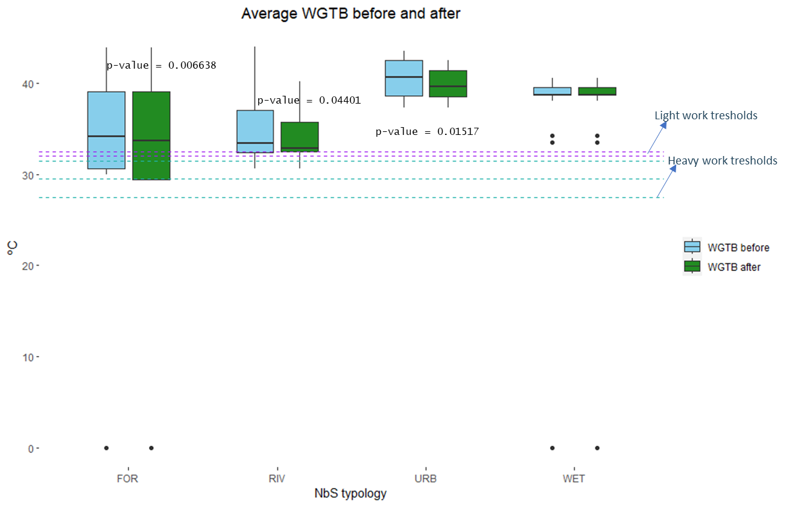
Figure S 9. Average values of the Wet Bulb Globe Temperature (WBGT) index for different types of Nature-based Solutions (NbS), derived from the Urban Cooling Model of InVEST. FOR: Forest; RIV: River; URB: Urban; WET: Wetland.
  - Flood risk mitigation model
The Figure S10 displays the average runoff retention in m³ per type of NbS. Forest actions resulted in a substantial capacity to retain water, primarily due to their larger size. In contrast, river, wetland, and urban initiatives show relatively lower values for this index. Notably, certain large river initiatives have the potential to retain significant water volumes, as evident from the presence of outliers in the data. The results highlight the importance of considering both the size and type of NbS in assessing their capacity for runoff retention.
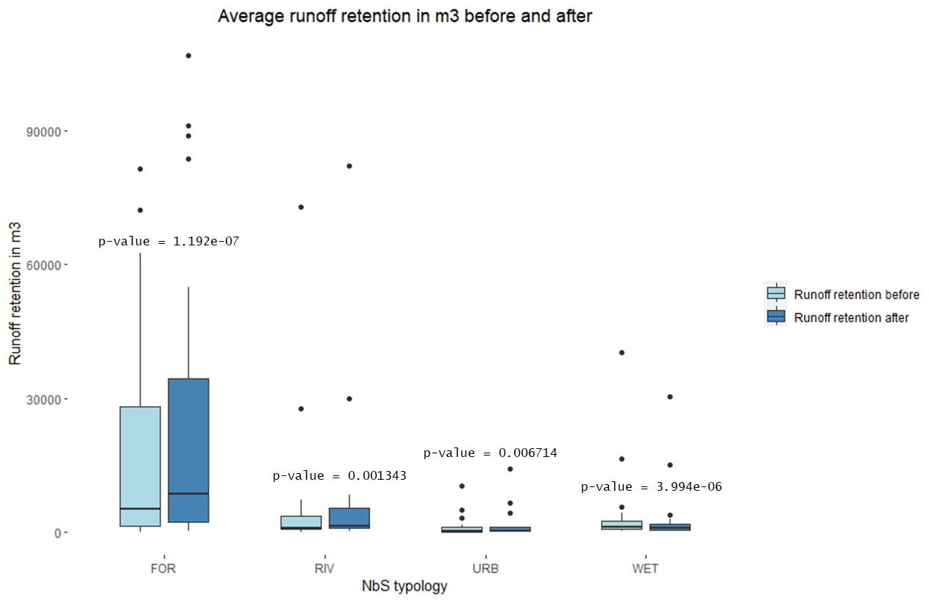
Figure S 10. Average runoff retention in m³ per Nature-based Solutions (NbS) type. FOR: Forest; RIV: River; URB: Urban; WET: Wetland.
  - Carbon storage and sequestration model
Figure S11 displays the average carbon storage per type of NbS for each action. Forest NbS, with their large restoration areas and high values for soil and aerial carbon, store a significant amount of carbon. In contrast, the other initiatives exhibit lower values due to their smaller size compared to forest NbS.
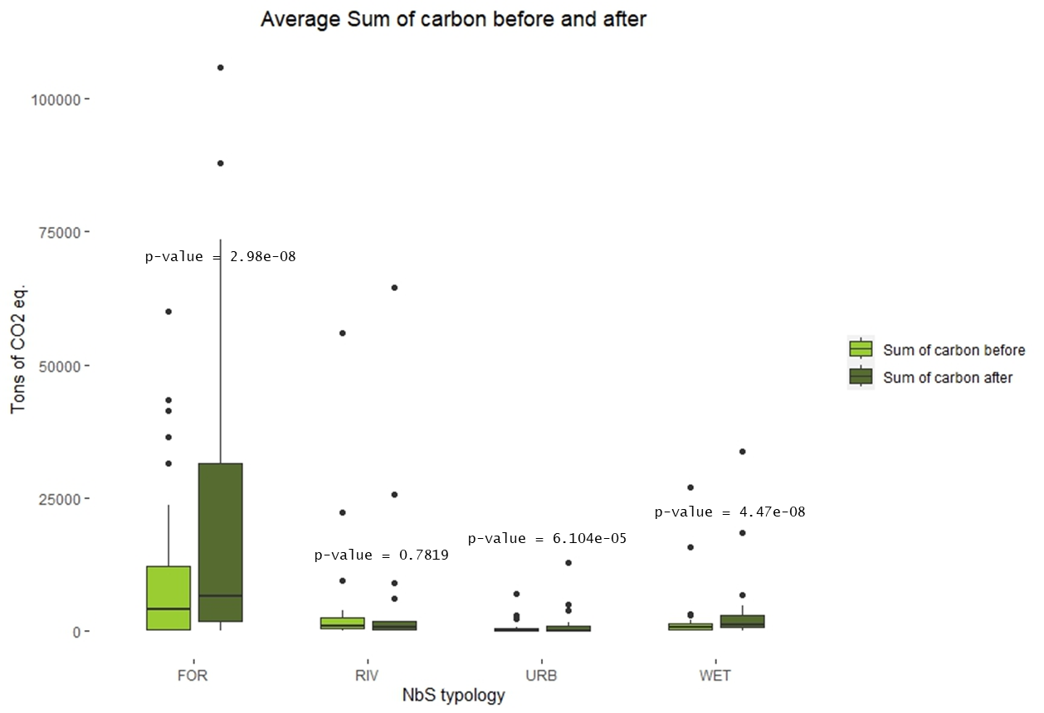
Figure S 11. Average total CO₂ eq. stored in each action per Nature-based Solutions (NbS) ecosystem. FOR: Forest; RIV: River; URB: Urban; WET: Wetland.
  - Landslide protection model
Figure S12 illustrates the degree of protection before and after NbS implementation. This variable is negatively correlated with landslide probability, meaning that a higher degree of protection corresponds to lower landslide probability. In general, forest initiatives demonstrate high effectiveness in protecting against shallow landslides in almost all cases.
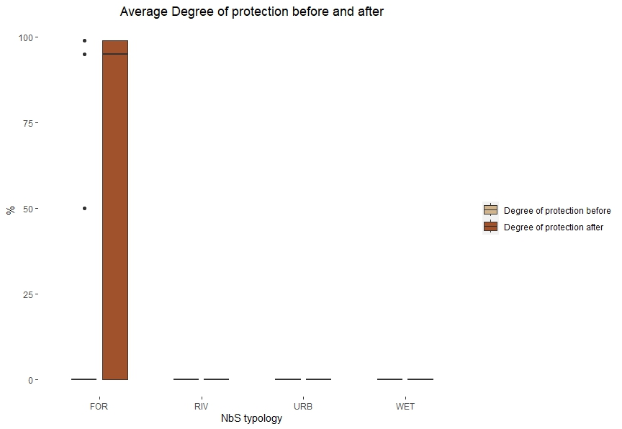
Figure S 12. Degree of protection before and after Nature-based Solutions (NbS) implementation per type of ecosystem. Note that this ecosystem service has been measured only for forest initiatives with at least 15% of slope. FOR: Forest; RIV: River; URB: Urban; WET: Wetland.
The Slidefornet model results provide different graphics presented in Figures S13, S14, and S15, representing specific results on the probability of landslides and landslide release areas. The names in the graphics correspond to the codes of NbS projects. We presented the graphics before and after in cases where the actions were related to forest condition improvements, such as forest NbS where there were changes in forest cover or species. In these cases, it is notable that the graphics representing values after NbS implementation show a reduction in landslides. On the other hand, the rest of the initiatives were areas where the predominant LULC was open spaces with little or no vegetation. These actions involved forest plantations, and the graphics show the differences between forest and non-forest cover.
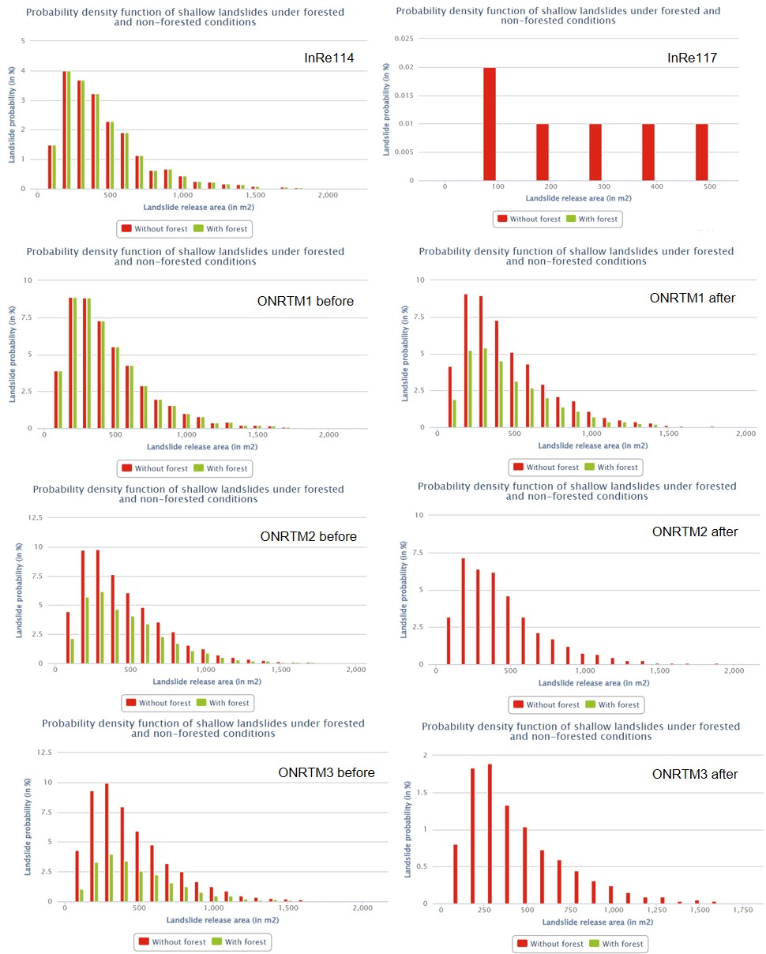
Figure S 13. Results of Slidefornet model for landslide protection assessment (part 1).
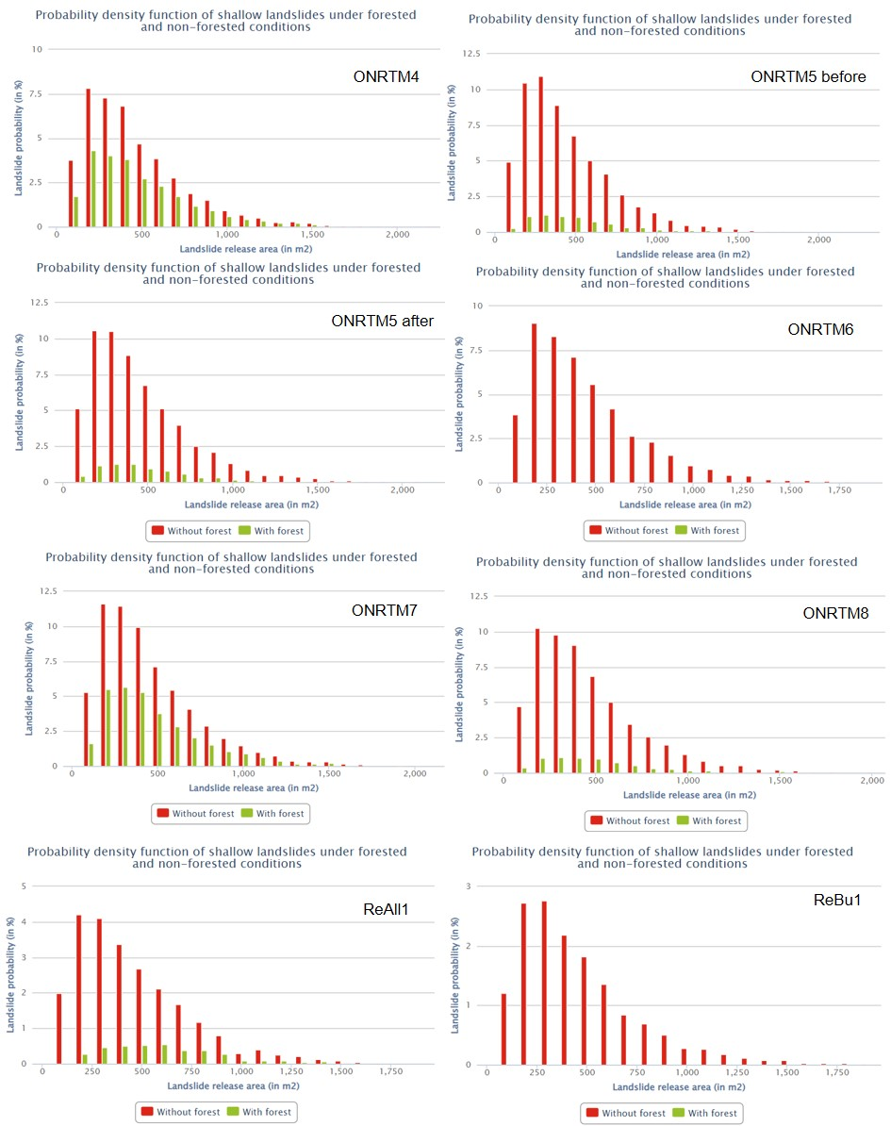
Figure S 14. Results of Slidefornet model for landslide protection assessment (part 2).

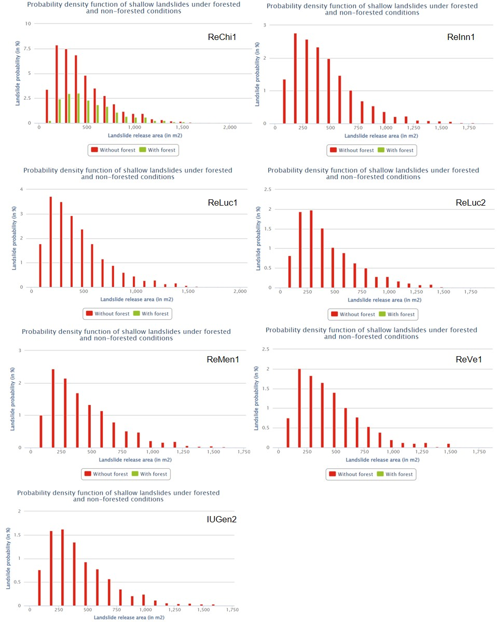
Figure S 15. Results of Slidefornet model for landslide protection assessment (part 3).
  - Biodiversity
The results for the biodiversity analysis are presented in Figure S16. This figure shows the average mentions of priority habitats for biodiversity included in the EU habitats directive (Council Directive 92/43/EEC). Forest initiatives generally have low values for biodiversity since most of them prioritize other aspects such as integrating conifers for landslide protection and carbon sequestration, rather than focusing on priority ecosystems. Similarly, urban initiatives do not include relevant habitats in their restoration efforts, as they mainly consist of green roofs, green infrastructure, urban parks, and urban forests. In contrast, river and wetland initiatives showed the highest values for relevant habitats included in the EU directive. The list of habitats detected in the projects includes:
- 3140: Hard oligo-mesotrophic waters with benthic vegetation of Chara spp.
- 3150: Natural eutrophic lakes with Magnopotamion or Hydrocharition
- 3220: Alpine rivers and the herbaceous vegetation along their banks
- 3230: Alpine rivers and their ligneous vegetation with Myricaria germanica
- 3240: Alpine rivers and their ligneous vegetation with Salix elaeagnos
- 3260: Water courses of plain to montane levels with the Ranunculion fluitantis and Callitricho-Batrachion vegetation
- 5110: Stable xerothermophilous formations with Buxus sempervirens on rock slopes (Berberidion p.p.)
- 5130: Juniperus communis formations on heaths or calcareous grasslands
- 6210: Semi-natural dry grasslands and scrubland facies on calcareous substrates (Festuco-Brometalia) (* important orchid sites)
- 6410: Molinia meadows on calcareous, peaty or clayey-silt-laden soils (Molinion caeruleae)
- 6510: Lowland hay meadows (Alopecurus pratensis, Sanguisorba officinalis)
- 7210: Calcareous fens with Cladium mariscus and species of the Caricion davallianae
- 7220: Petrifying springs with tufa formation (Cratoneurion)
- 7230: Alkaline fens
- 9110: Luzulo-Fagetum beech forests
- 9140: Medio-European subalpine beech woods with Acer and Rumex arifolius
- 9160: Sub-Atlantic and medio-European oak or oak-hornbeam forests of the Carpinion betuli
- 9170: Galio-Carpinetum oak-hornbeam forests
- 9180: Tilio-Acerion forests of slopes, screes and ravines
- 91E0: Alluvial forests with Alnus glutinosa and Fraxinus excelsior (Alno-Padion, Alnion incanae, Salicion albae)
- 91F0: Riparian mixed forests of Quercus robur, Ulmus laevis and Ulmus minor, Fraxinus excelsior or Fraxinus angustifolia, along the great rivers (Ulmenion minoris)
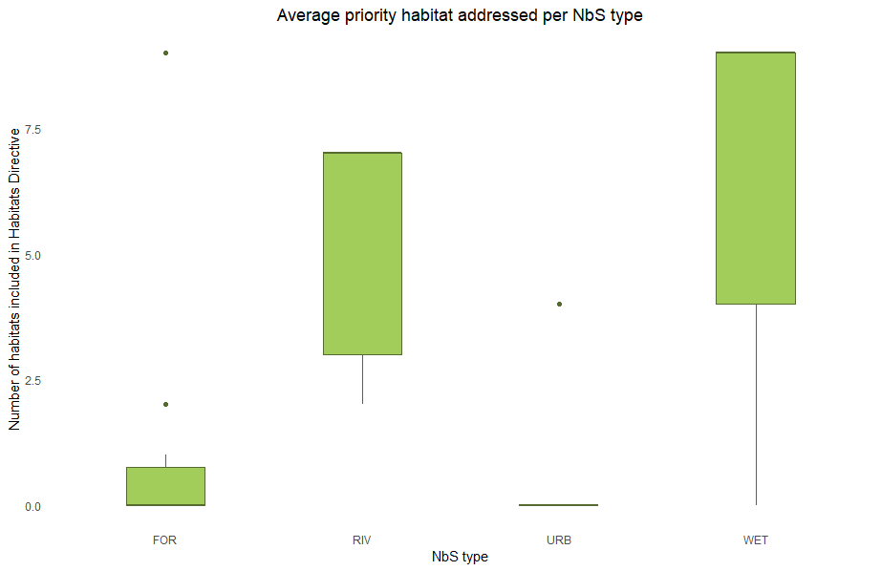
Figure S 16. Average mentions to habitats included in the EU habitat directive by type of ecosystem. FOR: Forest; RIV: River; URB: Urban; WET: Wetland.
  - Results of statistical analysis
Table S1 presents the results of the analysis for paired samples, showing the changes before and after NbS projects. These results correspond to those shown in Figure 1 of the main text.
Table S 1. Detailed results of the statistical analysis of supply of ecosystem services before and after Natue-based Solutions (NbS) actions. FOR: Forest; RIV: River; URB: Urban; WET: Wetland.
Ecosystem service | Types | Test | Test results
Heatwave mitigation | FOR (n = 26) | Wilcox (paired samples) | V = 0, p-value = 9,569e-05 | ***
Heatwave mitigation | RIV (n = 17) | Wilcox (paired samples) | V = 80, p-value = 0,8871
Heatwave mitigation | URB (n = 15) | Wilcox (paired samples) | V = 7, p-value = 0,002866 | **
Heatwave mitigation | WET (n = 27) | Wilcox (paired samples) | V = 24, p-value = 0,0002016 | ***
Flood regulation | FOR (n = 26) | Wilcox (paired samples) | V = 1, p-value = 9,896e-06 | ***
Flood regulation | RIV (n = 17) | Wilcox (paired samples) | V = 10, p-value = 0,001777 | **
Flood regulation | URB (n = 15) | Wilcox (paired samples) | V = 11, p-value = 0,005876 | **
Flood regulation | WET (n = 27) | Wilcox (paired samples) | V = 374, p-value = 7,887e-06 | ***
Climate regulation | FOR (n = 26) | Wilcox (paired samples) | V = 0, p-value = 8,804e-06 | ***
Climate regulation | RIV (n = 17) | Wilcox (paired samples) | V = 68, p-value = 0,7049
Climate regulation | URB (n = 15) | Wilcox (paired samples) | V = 0, p-value = 0,0007265 | ***
Climate regulation | WET (n = 27) | Wilcox (paired samples) | V = 1, p-value = 6,647e-06 | ***
Landslide protection | FOR (n = 26) | Wilcox (paired samples) | V = 168, p-value = 0,0003537 | ***

- Detailed results for beneficiaries
This section presents detailed results of the beneficiaries' analysis and the distribution of NbS in terms of GDP in the area. The methods for selecting the buffers are explained in section VII of this document. Table S2 shows the results for heatwave mitigation, Table S3 for flood regulation, Table S4 for landslide protection, and Table S5 shows the results for the analysis of how NbS are distributed in terms of GDP and the statistical analysis.
Table S 2. Beneficiaries for heatwave mitigation: "Total population" indicates the number of inhabitants per buffer and Nature-based Solution (NbS) type, while "Average population" represents the average inhabitants per buffer. ± denotes the standard deviation. FOR: Forest; RIV: River; URB: Urban; WET: Wetland.
 | Total population |  |  | Average population per NbS
 | 30m | 240m | 450m | 30m | 240m | 450m
FOR | 11 | 536 | 1675 | 0 ± 1 | 21 ± 48 | 64 ± 142
RIV | 109 | 2640 | 7051 | 6 ± 21 | 155 ± 463 | 415 ± 1134
URB | 1773 | 21436 | 53510 | 118 ± 175 | 1429 ± 1605 | 3567 ± 3479
WET | 9 | 1323 | 4007 | 0 ± 1 | 49 ± 77 | 148 ± 178
Total | 1901 | 25936 | 66244

Table S 3. Beneficiaries for floods regulation: "Total population" indicates the number of inhabitants per buffer and Nature-based Solutions (NbS) type, while "Average population" represents the average inhabitants per buffer. ± denotes the standard deviation. FOR: Forest; RIV: River; URB: Urban; WET: Wetland.
 | Total population |  |  |  | Average population per NbS
 | 50m | 100m | 150m | 200m | 50m | 100m | 150m | 200m
FOR | 20 | 76 | 170 | 285 | 1 ± 2 | 7 ± 6 | 3 ± 15 | 11 ± 27
RIV | 221 | 662 | 1390 | 2245 | 13 ± 46 | 82 ± 126 | 39 ± 246 | 132 ± 387
URB | 3469 | 8970 | 13954 | 20553 | 231 ± 326 | 930 ± 888 | 598 ± 1239 | 1370 ± 1782
WET | 47 | 204 | 527 | 1005 | 2 ± 5 | 20 ± 19 | 8 ± 39 | 37 ± 68
Total | 3757 | 9912 | 16041 | 24088

Table S 4. Beneficiaries for landslide protection: "Total population" indicates the number of inhabitants per buffer and Nature-based Solutions (NbS) type, while "Average population" represents the average inhabitants per buffer. ± denotes the standard deviation. FOR: Forest; RIV: River; URB: Urban; WET: Wetland.
 | Total population |  |  | Average population per NbS
 | 20m | 65m | 200m | 20m | 65m | 200m
FOR | 8 | 71 | 1010 | 0 ± 1 | 3 ± 7 | 39 ± 117
RIV | 0 | 0 | 0 | 0 | 0 | 0
URB | 0 | 0 | 0 | 0 | 0 | 0
WET | 0 | 0 | 0 | 0 | 0 | 0
Total | 8 | 71 | 1010
In terms of GDP per km², urban NbS are situated in areas with an average GDP per km² of 44 ± 52 million Eur, while forest NbS areas have an average of 11 ± 43 million Eur per km². River NbS areas show an average GDP per km² of 7.7 ± 18 million Eur, whereas wetland NbS areas have an average GDP per km² of 0.83 ± 1.9 million Eur. Table S5 shows the detailed values and the results of statistical analysis.
Table S 5. Distribution of NbS actions in terms of GDP and statistical analysis on differences between pairs. The results of the statistical analysis are from a Kruskall-Wallis test and the postdoc analysis. FOR: Forest; RIV: River; URB: Urban; WET: Wetland.
Etiquetas de fila | Average GDP 2021 (€) | Pairs comparisons | Test results (p-value)
FOR | 11,173,779 ± 43,969,515 | FOR-RIV | 0,273
RIV | 7,763,792 ± 18,135,541 | FOR-URB | 0,026 (*)
URB | 44,345,947 ± 52,202,114 | FOR-WET | 0,642
WET | 837,197 ± 1,970,703 | RIV-URB | 0,319
 |  | RIV-WET | 1
 |  | URB-WET | 0,015 (*)

- Detailed results of economic assessment
The results of the economic value for each action and ecosystem service assessed are presented in Table S6. Values for flood regulation, heatwave mitigation and landslide protection may show several zero values because in some cases, the areas where these actions are located do not overlap with economic assets that could benefit from protection.
Table S 6. Results of the value of each ecosystem service per action, HM : Heatwave Mitigation, FR : Floods Regulation, CR : Climate Regulation, and LP : Landslides Protection. The "Action" column includes the codes used for each Nature-based Solution (NbS). FOR: Forest; RIV: River; URB: Urban; WET: Wetland.
Action | TYPE | HM (€) | FR (€) | CR (€) | LP 20m(€) | LP 65m(€) | LP 200m(€)
Ateco1 | FOR | -419,069 |  | 16,747
BIDyn1 | RIV |  |  | -34,127
BIDyn10 | RIV |  |  | 431
BIDyn11 | RIV |  |  | -172,670
BIDyn12 | RIV |  |  | 14,009
BIDyn2 | RIV | 474,945 |  | -21,945
BIDyn3 | RIV | -1,257,207 |  | -34,824
BIDyn4 | RIV | 1,564,524 | -428,150 | 10,469
BIDyn5 | RIV | 12,683,823 |  | 26,776
BIDyn6 | RIV |  | 25 | -52,011
BIDyn7 | RIV |  |  | -32,493
BIDyn9 | RIV |  |  | 3,936
BozHos1 | URB | 2,011,531 |  | 14,772
Can1 | URB |  |  | 26,576
Cem1 | WET |  |  | 14,206
CeRes1 | WET |  | 81,093 | 143,969
CiRes1 | WET |  |  | 117,103
CiRes2 | WET |  | -112,729 | 226,995
CiRes3 | WET |  |  | 52,297
CiRes4 | WET |  |  | -17,070
CiRes5 | WET |  |  | 221,457
CiRes6 | WET |  |  | 188,590
CiRes7 | URB |  |  | 68,950
Table S 6. Continuation 1.
Action | TYPE | HM (€) | FR (€) | CR (€) | LR 20m(€) | LR 65m(€) | LR 200m(€)
Fir1 | URB | 1,508,649 | 2,045,720 | 25,649
InRe11 | WET |  |  | 25,875
InRe110 | WET |  |  | 59,035
InRe111 | FOR |  |  | 124,356
InRe112 | WET |  |  | 27,845
InRe114 | FOR |  |  | 209,526 |  | 25 | 9,279
InRe115 | WET |  | -170,215 | 344,933
InRe117 | FOR |  |  | 63,689 |  | 253,837 | 5,134,270
InRe118 | WET |  |  | 24,340
InRe119 | WET |  |  | 85,457
InRe12 | WET |  |  | 154,461
InRe122 | WET |  |  | 34,404
InRe123 | WET |  | -60 | 593,213
InRe124 | WET |  | -63,480 | 135,480
InRe125 | WET |  |  | 145,482
InRe127 | WET |  |  | 65,428
InRe128 | WET |  |  | 62,971
InRe13 | WET |  |  | 58,569
InRe14 | WET |  |  | 95,859
InRe15 | WET |  |  | 18,803
InRe17 | WET |  |  | 47,830
InRe19 | WET |  |  | 28,724
InRe20 | WET |  |  | 40,376
IUGEN1 | RIV | 10,728,168 | 10 | 6,905
IUGEN2 | FOR |  |  | 137,649 | 2,220,402 | 8,817,596 | 25,002,716
IUROM1 | RIV |  |  | 100,543
IUSE1 | RIV |  | 1 | 753,632
IUSE2 | RIV |  |  | 299,179
Mar1 | RIV | -447,007 | 393,062 | -36,596
NCION1 | URB | 2,793,794 |  | 9,116
NCION2 | URB | 3,101,111 |  | 24
NCION3 | URB | 2,849,670 |  | 164
NCION4 | URB | -2,486,476 |  | 358
NCION5 | URB | 1,564,524 |  | 8,040
NCION6 | URB | 3,687,808 |  | 1,923
NCION7 | URB | 2,849,670 |  | 2,432
NCION8 | URB | 8,660,760 |  | 504
ONRTM1 | FOR |  |  | 943,043
ONRTM10 | FOR |  |  | 95,428
ONRTM2 | FOR |  |  | 102,666
ONRTM3 | FOR |  |  | 356,190 | 70,814 | 89,560 | 270,953
ONRTM4 | FOR | 474,945 |  | 5,663,194 |  |  | 22,782
ONRTM5 | FOR |  |  | 616,556 | 699 | 7,821 | 28,913
ONRTM6 | FOR |  |  | 1,567,115
Table S 6. Continuation 2.
Action | TYPE | HM (€) | FR (€) | CR (€) | LR 20m(€) | LR 65m(€) | LR 200m(€)
ONRTM7 | FOR |  |  | 1,174,730
ONRTM8 | FOR |  |  | 1,062,855
PaDug1 | URB | 447,007 | 11 | 526,338
ParNorMi1 | URB |  | 4 | 183,826
PerMi1 | URB |  | 75,158,389 | 137,890
ReAll1 | FOR |  |  | 145,416 |  |  | 917
ReBu1 | FOR |  |  | 6,351 | 34,645 | 714,502 | 1,555,188
ReCan1 | FOR |  |  | 420,593
ReChi1 | FOR |  |  | 89,840
ReInn1 | FOR |  |  | 7,344,641 | 19,803 | 2,076,085 | 77,937,632
ReLa1 | FOR |  |  | 51,489
Reluc1 | FOR |  |  | 235,895
Reluc2 | FOR | 474,945 |  | 123,328 | 3,179,661 | 11,002,750 | 38,136,418
ReMen1 | FOR | 1,564,524 | 815 | 296,952 | 5,997 | 156,683 | 34,235,097
ReSa11 | FOR |  | 262 | 424,966
ReSa2 | FOR |  |  | 194,923
ReVe1 | FOR |  | 3 | 930,547 | 708,719 | 4,172,884 | 11,941,657
ValCam1 | RIV |  | 513,397,452 | 321,219

  - Detailed results on costs of actions
Details on cost per action are provided in Table S7. The average cost of all the actions is 209,732 Eur/ha ± 1 million Eur. The highest costs are for river NbS (809,135 Eur/ha ± 2.2 million Eur), followed by urban (143,396 Eur/ha ± 187,795), wetland (59,950 Eur/ha ± 157,711), and forest NbS (11,630 Eur/ha ± 25,421). Regarding the cost of actions, the highest values are for river (9.9 million Eur ± 25 million Eur), followed by urban (1.66 million Eur ± 5.9 million Eur), forests (727,241 Eur ± 3 million Eur) and wetland NbS (150,042 Eur ± 340,830 Eur).
Table S 7. Costs associated to each Nature-based Solution action. The "Action" column includes the codes used for each Nature-based Solution (NbS). FOR: Forest; RIV: River; URB: Urban; WET: Wetland.
Action | TYPE | Area (ha) | Cost (€/ha) | Total cost (€)
Ateco1 | FOR | 3.97 | 5,960 | 23,659
BIDyn1 | RIV | 1.61 | 265,847 | 428,014
BIDyn10 | RIV | 0.1 | 265,847 | 26,585
BIDyn11 | RIV | 6.58 | 265,847 | 1,749,275
BIDyn12 | RIV | 3.02 | 265,847 | 802,859
BIDyn2 | RIV | 1.01 | 265,847 | 268,506
BIDyn3 | RIV | 2.68 | 265,847 | 712,471
BIDyn4 | RIV | 2.23 | 265,847 | 592,839
BIDyn5 | RIV | 1.09 | 265,847 | 289,774
BIDyn6 | RIV | 3.21 | 265,847 | 853,370
BIDyn7 | RIV | 1.23 | 265,847 | 326,992
BIDyn9 | RIV | 0.16 | 265,847 | 42,536
BozHos1 | URB | 1.5 | 582,667 | 874,000
Can1 | URB | 0.56 | 65,000 | 36,400
Cem1 | WET | 0.27 | 462,963 | 125,000
Table S 7. Continuation 1.
Action | TYPE | Area (ha) | Cost (€/ha) | Total cost (€)
CeRes1 | WET | 4.9 | 69,653 | 341,300
CiRes1 | WET | 8.34 | 855 | 7,129
CiRes2 | WET | 8.25 | 855 | 7,052
CiRes3 | WET | 2.12 | 855 | 1,812
CiRes4 | WET | 5.58 | 855 | 4,770
CiRes5 | WET | 30.99 | 855 | 26,489
CiRes6 | WET | 7.14 | 855 | 6,103
CiRes7 | URB | 2.72 | 855 | 2,325
Fir1 | URB | 2.2 | 89,753 | 197,456
InRe11 | WET | 0.87 | 20,094 | 17,482
InRe110 | WET | 2 | 20,094 | 40,189
InRe111 | FOR | 2.69 | 20,094 | 54,054
InRe112 | WET | 0.97 | 20,094 | 19,492
InRe114 | FOR | 4.21 | 20,094 | 84,597
InRe115 | WET | 11.78 | 20,094 | 236,712
InRe117 | FOR | 3.02 | 20,094 | 60,685
InRe118 | WET | 0.83 | 20,094 | 16,678
InRe119 | WET | 2.92 | 20,094 | 58,676
InRe12 | WET | 5.3 | 20,094 | 106,500
InRe122 | WET | 1.17 | 20,094 | 23,510
InRe123 | WET | 77.38 | 20,094 | 1,554,905
InRe124 | WET | 4.63 | 20,094 | 93,037
InRe125 | WET | 4.98 | 20,094 | 100,070
InRe127 | WET | 2.22 | 20,094 | 44,610
InRe128 | WET | 3.32 | 20,094 | 66,713
InRe13 | WET | 2 | 20,094 | 40,189
InRe14 | WET | 3.3 | 20,094 | 66,312
InRe15 | WET | 0.63 | 20,094 | 12,659
InRe17 | WET | 1.63 | 20,094 | 32,754
InRe19 | WET | 0.78 | 20,094 | 15,674
InRe20 | WET | 1.37 | 719,218 | 985,329
IUGEN1 | RIV | 1.43 | 76,061 | 108,767
IUGEN2 | FOR | 15.08 | 76,061 | 1,146,999
IUROM1 | RIV | 2.7 | 9,444,444 | 25,500,000
IUSE1 | RIV | 172.13 | 575,448 | 99,051,790
IUSE2 | RIV | 62.47 | 575,448 | 35,948,210
Mar1 | RIV | 19.7 | 142,132 | 2,800,000
NCION1 | URB | 1.11 | 89,753 | 99,625
NCION2 | URB | 0.07 | 89,753 | 6,283
NCION3 | URB | 0.04 | 89,753 | 3,590
NCION4 | URB | 0.07 | 89,753 | 6,283
NCION5 | URB | 0.28 | 89,753 | 25,131
NCION6 | URB | 0.06 | 89,753 | 5,385
NCION7 | URB | 0.18 | 89,753 | 16,155
NCION8 | URB | 0.18 | 89,753 | 16,155
Table S 7. Continuation 2.
Action | TYPE | Area (ha) | Cost (€/ha) | Total cost (€)
ONRTM1 | FOR | 24.41 | 3,232 | 78,902
ONRTM10 | FOR | 1.92 | 3,232 | 6,206
ONRTM2 | FOR | 3.2 | 3,232 | 10,344
ONRTM3 | FOR | 16.67 | 3,232 | 53,883
ONRTM4 | FOR | 167.05 | 3,232 | 539,964
ONRTM5 | FOR | 55.28 | 3,232 | 178,684
ONRTM6 | FOR | 54.34 | 3,232 | 175,646
ONRTM7 | FOR | 129.4 | 3,232 | 418,266
ONRTM8 | FOR | 199.54 | 3,232 | 644,983
PaDug1 | URB | 37.31 | 616,457 | 23,000,000
ParNorMi1 | URB | 17.73 | 1,184 | 21,000
PerMi1 | URB | 8.83 | 77,010 | 680,000
ReAll1 | FOR | 6.55 | 469 | 3,071
ReBu1 | FOR | 0.11 | 14,486 | 1,593
ReCan1 | FOR | 8.97 | 801 | 7,183
ReChi1 | FOR | 1.78 | 1,253 | 2,230
ReInn1 | FOR | 138.8 | 111,042 | 15,412,579
ReLa1 | FOR | 1.09 | 1,755 | 1,913
Reluc1 | FOR | 13.96 | 90 | 1,262
Reluc2 | FOR | 8.25 | 90 | 746
ReMen1 | FOR | 5.97 | 517 | 3,088
ReSa11 | FOR | 64.73 | 232 | 15,037
ReSa2 | FOR | 16.23 | 208 | 3,376
ReVe1 | FOR | 85.19 | 35 | 2,945
ValCam1 | RIV | 11.77 | 17,443 | 205,300

  - Detailed results on cost-effectiveness analysis
The details of our cost-effectiveness analysis are depicted in Figure S17. For the average cost per hectare (as shown in Fig. S17A), river actions incur the highest cost at 809,135 Eur/ha ± 2.22 million Eur, followed by urban actions at 143,396 Eur/ha ± 187,795 Eur, wetland actions at 59,950 Eur/ha ± 157,711 Eur, and forest actions at 11,630 Eur/ha ± 25,421 Eur. Turning to the average value per hectare (Fig. S17B), urban actions display the most significant value, reaching 15 million Eur/ha ± 28.5 million Eur/ha. This is followed by river actions at 3.7 million Eur/ha ± 10.7 million Eur/ha, forest actions at 70,286 Eur/ha ± 122,811 Eur/ha, and wetland actions at 25,416 Eur/ha ± 11,574 Eur/ha. When considering both the total value and the total cost per hectare, the resulting average cost-effectiveness ratio for each ecosystem (as indicated in Fig. S17C and Fig. S17D) stands at 260 ± 992 for forest NbS, 170 ± 316 for urban NbS, 155 ± 605 for river NbS, and 4 ± 8.5 for wetland NbS.
The cost-effectiveness ratio exhibits significant heterogeneity due to the distinct nature of each intervention. For instance, we identified a forest NbS with a ratio that exceeded 5,000 times the cost of each hectare, which amounted to just 90€. This disparity arose because this initiative demonstrated an economic value of ES of 457,931 Eur/ha, while its associated costs were quite minimal. This low cost is particularly tied to an enterprise that undertakes compensation actions by planting forests (www.reforestaction.com). Similarly, we detected a river NbS that yielded a return of 2,500 times the investment, showcasing an average cost per hectare of 17,442 Eur and an average value per hectare of 43 million Eur. This specific river action is situated in a valley within the Italian Alps, where the exposure level of infrastructure is exceptionally high. This location results in a significant value for flood regulation ecosystem service (amounting to 513 million Eur in total) and a notable value attributed to carbon sequestration (321,219 Eur).
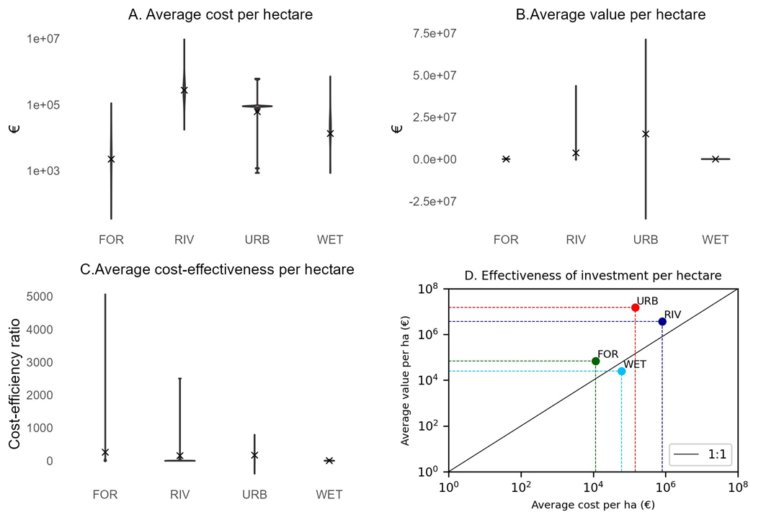
Figure S 17. Detailed analysis of the cost-effectiveness of Nature-based Solutions (NbS). (A) Depicts the average cost per hectare for each ecosystem type. (B) Illustrates the average value per hectare, calculated by dividing the summed values of the four ecosystem services analysed by the area of each NbS action. (C) Presents the average cost-effectiveness ratio, derived from the average value per hectare and the average cost per hectare. (D) Indicates the position of the average cost-effectiveness ratio in relation to a 1:1 value. FOR: Forest, RIV: River, URB: Urban, WET: Wetland.
- Discussion on ecosystem services economic valuation
Ecosystem service valuation involves various approaches that require description for comparison with other studies. Most economic valuations pertain to the value of specific ecosystem services over a specific time frame. For instance, Costanza et al. (1997) and Costanza et al. (2014) assessed 17 ecosystem services and analysed value changes between 1997 and 2011. They reported an average value for river biomes, for example, at $12,512/ha/year, while urban biomes had a value of $6,661/ha/year. In our study, river NbS had a value of €1.8 million per hectare, and urban NbS had €1.4 million per hectare. However, the notable difference lies in the nature of each evaluation and the selected ecosystem services. While this study selected ecosystem services such as landslide protection and flood regulation, which are related to specific events, the 17 ecosystem services in their study primarily relate to annual provisioning, such as food, water supply, pollination, biological control, or nutrient cycling between others. Further, Costanza et al. (2014) considered the general value of ecosystem services, including services in areas with no specific beneficiaries, such as building protection or roads. When quantifying the economic value provided by specific NbS, which is typically related to addressing a specific challenge, higher values are expected. For example, a hectare of forest in the middle of a tropical forest may not provide local heatwave mitigation since nobody uses this service. Similarly, even if that forest protects a slope from landslides, there is nothing potentially damaged by the landslide. Therefore, it is normal for NbS to show much higher values compared to regular assessments of ecosystem service economic value.
In addition, de Groot et al. (2012) provided a maximum value of $350,000/ha/year for coral reefs, considered one of the highest economic values in the literature of ecosystem service economic value. This value, compared with the one we provide for rivers, is five times lower. However, our value represents a static value, linked to a single event or specific events that can occur during a specific time period. Thus, even though the magnitude differs significantly, the values provided in most studies are annual, while we provide a static value. For example, Sharma et al. (2015) assessed the economic value of wetlands in Nepal, obtaining a value of $916/ha/year, while we provide a value of €244/ha. In their study, they assessed provisioning, regulating, and cultural ecosystem services, with only provisioning ecosystem services accounting for $781/ha/year, including agriculture, livestock fodder, fishery, and other wetland products. In our study, we did not include provisioning or cultural ecosystem services, leading to an underestimation of the value in wetland ecosystems. However, this depends largely on the nature of each wetland and the wetland typologies. For example, we included only inland wetlands in mountain regions, while Sharma et al. (2015) included mostly wetlands linked to river floodplains.
Assessing the economic value of ecosystem services provided by NbS is a challenging task. The value can sometimes be linked to specific events, but if these events occur repeatedly and the NbS consistently protects against them (e.g., mangroves protecting against floods), the value could increase substantially. Moreover, our approach aims to capture the direct economic value of ecosystem services, but it may not account for indirect costs. For instance, in the case of a landslide, the costs involve not only the damage to infrastructure that requires replacement but also expenses related to area recovery, potential delays caused by road blockages, and direct harm to humans when the event occurs.
In this study, we employed an approach that integrated multiple ring buffers. The inclusion of one or more of these buffers can significantly alter the total value. For example, in the context of landslide protection, we only considered the value within the 20 m range, as most shallow landslides impact this buffer, at least in the Alps (Rickli and Graf, 2009). However, landslides can extend up to 200 m, depending on factors like slope or landslide size (Lombardo et al., 2021). In our study, using the 20 m range resulted in a value of 6.2 million Euros. However, if we consider the 200 m range, the value increases to as much as 192 million Euros. This highlights how accounting for the extent of the effect of NbS on certain ecosystem services can yield different values.
- Limitations of the study
The methodology and assumptions of this research had four types of constraints and limitations: (1) constraints related to models and data, (2) limitations associated with beneficiaries and the flow of ecosystem services (3) constraints linked to economic value of ecosystem services, and (4) future needs and potential enhancements.
  - Models and data limitations
In this study, we applied four ecosystem service models using spatial data from various sources. The spatial extent of some NbS projects and the limited availability of high-resolution data posed challenges, potentially resulting in overestimation or underestimation of certain variables. For instance, precipitation and evapotranspiration were at a resolution of 1 km, while soil hydrologic groups were analysed at 250m. To address this limitation, an intensive photointerpretation process using high-resolution images of different years was conducted to enhance the accuracy of LULC data. This allowed for robust assessment of landscape variations related to NbS initiatives, as done in previous studies (González-García et al., 2020). Additionally, the photointerpretation process was strengthened by identifying the actions and changes implemented in NbS projects where aerial images were insufficient. Although two models (urban cooling and urban flood risk mitigation) were originally designed for urban areas, specific indexes from the models such as cooling capacity and water retention index were utilized to analyse the contributions of NbS projects before and after implementation, offering insights compatible with non-urban ecosystems. Finally, while recognizing the importance of a landscape perspective in assessing NbS projects (Cohen-Shacham et al., 2019) and their effects on LULC, this study focused on isolating the benefits and costs of NbS projects, thus, a landscape approach could provide more insights in relation to the global improvement of ecosystem services supply.
Certain limitations pertaining to wetland ecosystems should be acknowledged. In our study, we assumed that degraded wetlands, primarily affected by invasive species, possessed greater water absorption capacity compared to restored wetlands. This assumption was based on the idea that restored wetlands, already saturated with water, might not retain additional water, potentially leading to increased flooding. However, the intricate hydrological dynamics of wetlands warrant further investigation for a more comprehensive understanding of this process. Nevertheless, restored wetlands offer substantial climate regulation through a significant increase in carbon storage. Similarly, the enhancement of priority habitats through restoration is well-supported by the ecological recovery of wetlands, facilitating the restoration of ecological relationships and functions. Consequently, additional studies should be conducted to better grasp the trade-offs in ecosystem services provided by wetlands, particularly in the context of wetland restoration activities.
In relation to the NbS database, it is important to recognize certain limitations. In some cases, projects do not provide accurate spatial information or detailed economic costs of specific actions. For instance, projects focused on increasing species for protective forests on particular slopes often lack specific details on tree planting locations, making it challenging to ascertain this information from aerial images. Nonetheless, we addressed this limitation by utilizing project information and conducting a thorough analysis of the images. Similarly, certain projects involve multiple actions, such as European projects or other research initiatives, which may not be disaggregated sufficiently to understand the true costs of the individual initiatives. However, to the best of our knowledge, no studies have previously captured the relationships between the benefits, beneficiaries, and costs of NbS, despite NbS being a mainstream concept (Adams et al., 2023). Hence, we believe that this initial approach will be of great interest to practitioners, researchers, and enterprises alike.
  - Beneficiaries and ecosystem services flow limitations
Regarding benefits and beneficiaries, it is important to acknowledge certain limitations. Firstly, different approaches were applied for each type of ecosystem services due to variations in the flow between service supply and beneficiaries. Studies addressing ecosystem services flows primarily focus on water-related ecosystem services, natural hazards, and recreation (Wang et al., 2022). However, it remains challenging to determine the actual flow of several ecosystem services simultaneously from supply to beneficiaries. Distances were determined based on available literature; nevertheless, the direction of floods or landslides may vary depending on landscape processes (Metzger et al., 2021). Secondly, the number of beneficiaries was considered as individuals residing within a specific radius. This approach may underestimate the actual number of beneficiaries, as human mobility within the territory is not accounted for. Nonetheless, this approach aimed to capture at least those individuals residing in close proximity to the initiatives who would directly benefit. Lastly, beneficiaries were considered as potential beneficiaries, as the initiatives may not always provide sufficient ecosystem services to ensure beneficiary benefit. For instance, a green roof, considered an NbS, can offer heatwave mitigation benefits within a range of 0 to 450 meters from the action. However, people may not necessarily utilize the service if they prefer to stay home and use artificial cooling systems (Wieland et al., 2016). Nevertheless, we believe that individuals residing in close proximity to NbS actions have the potential to benefit from the ecosystem service at some point, hence their inclusion as potential beneficiaries.
  - Economic valuation limitations
Quantifying the economic value of natural capital and ecosystem services, especially regulating services, presents significant challenges. Therefore, we must acknowledge certain limitations in this study. For example, we considered the value of landslide protection and flood regulation as a singular value, which corresponds to a single catastrophic event. However, the recurrence of such events could be highly relevant, potentially leading to an underestimation of the ecosystem services value. Similarly, when assessing heatwave mitigation, we determined the value based on the number of days with heatwaves, considering historical data from the period 2003-2018 (García-León et al., 2021). Moreover, it's important to note that the projected value for the future could be even more significant. Recent studies showed that we may encounter numerous days with extremely high temperatures, especially in the context of climate change, which could potentially prolong the duration of heatwaves in lake ecosystems (Woolway et al., 2021).
Additionally, estimating the economic value of heatwave mitigation can be complex since inhabitants may not directly utilize the ES, opting for artificial cooling systems for buildings instead. Moreover, we did not consider potential trade-offs in heatwave economic value, such as irrigation systems. Studies have demonstrated that irrigation significantly impacts local temperature reductions, potentially affecting the value of the ecosystem service, as we would need to include the cost of water (González-García et al., 2023). Furthermore, our assessment of heatwave mitigation involved multiplying the daily value by the average duration of the most significant heatwaves during the warmest years in the last two decades, as outlined in García-León et al. (2021). This approach blends values that are consistently provided, such as heatwave mitigation, with values linked to specific events like landslides. Consequently, the economic value of certain ecosystem services delivered by NbS can be notably high, particularly when these services are continually available when needed. For instance, if we were to consider the removal of pollutants from the atmosphere, this ecosystem service is provided daily, posing challenges in comprehensively assessing the overall economic value of all ecosystem services delivered by a single NbS. Future studies might opt to separate ES provided regularly and those provided for a single event, offering a more accurate perspective on when an investment in an NbS becomes cost-effective. For example, combining ecosystem services like flood regulation and landslide protection may not be cost-effective, but after 10 years of providing services such as pollutants removal, carbon sequestration, and heatwave mitigation, in addition to flood regulation and landslide protection economic value, the NbS could become cost-effective.
Moreover, we must highlight that a few initiatives deliver the majority of the economic value in the entire database (Table S6). This is attributed to NbS situated in areas with limited urban or road presence, resulting in lower economic value concerning the protection they offer to these infrastructures. Nevertheless, this interdisciplinary analysis uncovers trade-offs wherein certain ecosystems may not provide immediate benefits, underscoring the necessity to examine large sets of ecosystem services. Despite these limitations, we believe that, in general terms, there is an underestimation of the economic value, as we did not analyse all possible values of all ecosystem services provided by the initiatives, including cultural ES. However, this limitation is not likely to significantly impact the overall conclusions of this study regarding the cost-effectiveness of NbS in the context of climate change. Lastly, we did not incorporate non-economic values into our analysis, which could have a substantial influence on the results of NbS value and cost-effectiveness. Considering cultural aspects or the intrinsic values of nature could potentially highlight even greater cost-effectiveness in NbS (Pascual et al., 2023).
  - Future needs and potential enhancements
In terms of future needs and enhancements, transparency is of utmost importance in understanding the capacity of what we refer to as NbS projects, which serve as a core multifunctional strategy to address global change challenges. As the concept of NbS projects encompasses a wide range of sectors, including private entities, NGOs, public research institutions, and individual efforts, sharing information across these projects becomes crucial for assessing and quantifying their outcomes. This allows for the measurement of the efforts required to tackle specific challenges in the Anthropocene era (Crowther et al., 2022).
Furthermore, within the context of climate change adaptation and mitigation, this study quantified four relevant ES. However, expanding the quantification to include additional ES would demonstrate that NbS initiatives are even more cost-effective than what has been presented in this study. Incorporating considerations such as aesthetic value, recreation, air pollutants removal, noise reduction, and other ES would influence the economic value portrayed in this study.
Nevertheless, we identified 24 actions within the database that did not yield returns exceeding the initial investment. Some of these cases were associated with a river NbS project involving the restoration of the river plain, which necessitated the clearing of a significant expanse of riparian forest. Others were linked to wetland initiatives, where the value of floods regulation saw a drastic reduction due to changes in hydrological characteristics. Future models should consider these factors from a different perspective rather than focusing solely on LULC. For example, the restoration of a river's floodplain could generate multiple positive effects. In our study, we adjusted soil hydrological conditions in these instances, but employing hydrological models may offer more precise assessments of such dynamics in wetland and river ecosystems.
Finally, several values of nature could arise in relation to NbS projects, which need to be addressed with complementary methodologies rather than models (Pascual et al., 2023). For instance, the intrinsic values of nature, or how an NbS could be linked to spiritual aspects, are essential dimensions to consider in future studies. Integrating this dimension of values from NbS would be key in further enhancing our understanding of their broader impacts.
- Supplementary methods
We employed four different models, each executed for all 85 actions present in the database. The models were fed with the LULC data obtained through photointerpretation, which also allowed us to estimate the three covers (before and after the NbS implementation) in a distinct field of the vector layer. The LULC codes used are consistent with those from CORINE land cover. Consequently, the results' variability in the models is influenced by changes in LULC and other ecosystem variations that impact the biophysical table variables, such as wetland restoration or soil hydrological properties. In the photointerpretation process, we carefully mapped agricultural areas, urban areas, and roads within a radius of 450 m from the NbS actions (the maximum radius considered for beneficiaries) to ensure the accuracy of the LULC data.
  - Urban cooling model
The urban cooling model of InVEST (https://naturalcapitalproject.stanford.edu/software/invest) calculates the cooling capacity index at the pixel scale, considering shade, evapotranspiration, and albedo. The model utilizes a biophysical table that includes albedo and evapotranspiration values for each LULC category (Table S8). In this study, we included the shade ratio for each LULC to account for variability between land cover types (e.g., a pine forest with 60% cover differs from one with 90% cover).
Several geographical variables are integrated into the model:
- Evapotranspiration: Derived from the Chelsa database (Karger et al., 2021), providing average potential evapotranspiration data at 1 km pixel resolution over the last decade.
- Precipitation: Obtained from the Chelsa database, representing precipitation values with the same time period and resolution as evapotranspiration.
- Maximum cooling distance: Set at 450 meters, representing the distance within which areas larger than 2 hectares can mitigate the heat island effect.
- Reference air temperature: Calculated as the average maximum temperature of summer months in Europe over the last decade from Chelsa. A 1 km buffer around the mapped urban areas was used to determine the average reference temperature unaffected by urbanization.
- Urban heat island effect: Calculated by comparing average maximum temperatures inside urban areas with the reference air temperature. Several initiatives located in rural areas may exhibit little variation between both temperatures.
- Air blending distance: Set at 500 meters, following InVEST's user recommendations based on Schatz et al. (2014) and Lonsdorf et al. (2021).
- Average relative humidity: Computed using raster layers in Chelsa to determine the average relative humidity in each action. This variable is employed in the Work Productivity Valuation to assess the Wet Bulb Globe Temperature, which impacts worker productivity.
For the model, we selected the cooling capacity method of "factors" and excluded building typology due to unavailable data. The model was run for LULC before and after NbS implementation to incorporate the effect of NbS projects. Additionally, for wetlands (code 411), we modified the evapotranspiration and albedo based on Eichelmann et al. (2018), increasing albedo by 27% when restoring a vegetated wetland with invasive species to a fully restored wetland with water and ecological functions.

Table S 8. Albedo and Evapotranspiration values linked to the biophysical table. Kc is the evapotranspiration coefficient for each Land Use Land Cover (LULC). (*) Is the value used for the restored wetlands.
LULC | Albedo | Kc | References
111 | 0.143 | 0.325 | Trlica et al., (2017)
112 | 0.147 | 0.25 | Trlica et al., (2017)
121 | 0.132 | 0.35 | Trlica et al., (2017)
122 | 0.139 | 0.3 | Trlica et al., (2017)
133 | 0.132 | 0.31 | Trlica et al., (2017)
141 | 0.13675 | 0.27 | average (142, 244, 311, 312, 313, 321, 322, 324)
142 | 0.176 | 0.25 | Blumthaler and Ambach, (1988)
211 | 0.13 | 1.3 | Sieber et al., (2022)
212 | 0.16 | 1.4 | Sieber et al., (2022)
242 | 0.15 | 1.3 | Sieber et al., (2022)
243 | 0.173 | 1.075 | Trlica et al., (2017)
244 | 0.115 | 1.075 | Schwaab et al., (2015)
311 | 0.126 | 1.55 | Schwaab et al., (2015)
312 | 0.104 | 1 | Schwaab et al., (2015)
313 | 0.115 | 1.4 | Schwaab et al., (2015)
321 | 0.194 | 1.125 | Tian et al., (2014); Blumthaler and Ambach, (1988)
322 | 0.132 | 0.975 | Aartsma et al., (2020)
324 | 0.132 | 0.975 | Aartsma et al., (2020)
331 | 0.23 | 0.275 | Blumthaler and Ambach, (1988)
332 | 0.3 | 0.125 | Al Fahdawi, 2021
333 | 0.13 | 0.55 | Sieber et al., (2022)
334 | 0.13 | 0.1 | Sieber et al., (2022)
411 | 0.159 | 0.625 | Trlica et al., (2017)
511 | 0.091 | 0.95 | Blumthaler and Ambach, (1988)
512 | 0.091 | 0.95 | Blumthaler and Ambach, (1988)
411* | 0.091 | 0.793 | Trlica et al., (2017); Eichelmann et al., (2018)

  - Flood risk mitigation model
The urban flood risk mitigation model employs the curve number method NRCS-USDA (2004) to calculate the runoff of each pixel and estimate runoff retention based on LULC and hydrological conditions. In this study, we determined the condition of each LULC based on tree cover, as outlined in Table S9. The model was run using the LULC data before and after NbS implementation for each action, similarly to the urban cooling model. The model utilizes the following variables to estimate runoff retention and economic value:
- Rainfall depth: A floating number expressed in mm; we used a value of 100m, following Goswami et al. (2006).
- Soil hydrologic group: A raster layer containing the soil hydrologic group for each pixel, based on Ross et al. (2018) global dataset. Values range from 1 to 4, representing groups a, b, c, and d in Table S9. We manually changed values for cases where soil hydrologic conditions were altered by NbS actions using conditional functions in ArcGis (e.g., changing from 3 to 4 for projects including improvements of soil hydrological conditions, as seen in some river actions with floodplain restoration).
- Biophysical table: Linked to the LULC data, this table corresponds to Table S9 and includes curve number values for the four main soil hydrologic groups. For restored wetlands, we modified the hydrological condition following Hey and Philippi (1995); and Acreman and Holden (2013).
- Built infrastructure: The model considers built infrastructure (or LULC prone to flood damage) to calculate the avoided water retention effect on these areas and assess economic value. For this study, we used urban, roads, and agricultural areas mapped during photointerpretation.
- Damage loss table: This table provides the value per square meter of built infrastructure (including roads and agriculture in our study). We utilized values from Huizinga et al. (2017) as outlined in Table S10. For urban areas, where we did not differentiate between commerce, residential, industry, or transport, we used the average value for Europe.
Table S 9. Biophysical table associated with Land Use/Land Cover LULC. Cover indicates the percentage of forest cover used to define soil conditions in the equivalences. The Equivalences column displays the original names of the variables as provided in the sources of information.
LULC | Cover | cn_a | cn_b | cn_c | cn_d | References | Equivalent
111 | 0 | 98 | 98 | 98 | 98 | Cronshey (1986) | Impervious areas
112 | 0 | 61 | 75 | 83 | 87 | Cronshey (1986) | 1⁄4 acre (38% imp.)
121 | 0 | 89 | 92 | 94 | 95 | Cronshey (1986) | Commercial and bussines
122 | 0 | 98 | 98 | 98 | 98 | Cronshey (1986) | Paved; curbs and storm sewers (excluding right-of-way)
133 | 0 | 72 | 82 | 87 | 89 | Cronshey (1986) | Dirt
141 | 100 | 39 | 61 | 74 | 80 | Cronshey (1986) | Open space (Good condition)
142 | 0 | 39 | 61 | 74 | 80 | Cronshey (1986) | Open space (Good condition)
211 | 0 | 72 | 81 | 88 | 91 | Cronshey (1986) | Row crops
212 | 0 | na | 67 | 82 | 91 | Im et al. (2007)
242 | 0 | na | 74 | 85 | 91 | Im et al. (2007) | Average 211, 212
243 | 0 | 43 | 65 | 76 | 82 | Cronshey (1986) | Woods—grass combination (orchard or tree farm).D (Fair)
244 | 0 | 43 | 65 | 76 | 82 | Cronshey (1986) | Woods—grass combination (orchard or tree farm).D (Fair)
311 | 100 | 30 | 55 | 70 | 77 | Jaafar et al. (2019); Tedela et al. (2012) | Good condition
311 | 90 | 30 | 55 | 70 | 77 | Jaafar et al. (2019); Tedela et al. (2012) | Good condition
311 | 80 | 30 | 55 | 70 | 77 | Jaafar et al. (2019); Tedela et al. (2012) | Good condition
311 | 70 | 30 | 55 | 70 | 77 | Jaafar et al. (2019); Tedela et al. (2012) | Good condition
311 | 60 | 36 | 60 | 73 | 79 | Jaafar et al. (2019); Tedela et al. (2012) | Fair condition
311 | 50 | 45 | 60 | 73 | 79 | Jaafar et al. (2019); Tedela et al. (2012) | Fair condition
311 | 40 | 45 | 66 | 77 | 82 | Jaafar et al. (2019); Tedela et al. (2012) | Poor condition
311 | 30 | 45 | 66 | 77 | 82 | Jaafar et al. (2019); Tedela et al. (2012) | Poor condition
311 | 20 | 45 | 66 | 77 | 82 | Jaafar et al. (2019); Tedela et al. (2012) | Poor condition
311 | 10 | 45 | 66 | 77 | 82 | Jaafar et al. (2019); Tedela et al. (2012) | Poor condition
312 | 100 | 33 | 58 | 72 | 78 | Jaafar et al. (2019); Tedela et al. (2012) | Good condition
312 | 90 | 33 | 58 | 72 | 78 | Jaafar et al. (2019); Tedela et al. (2012) | Good condition

Table S 9. Continuation
Lucode | Cover | cn_a | cn_b | cn_c | cn_d | References | Equivalent
312 | 80 | 33 | 58 | 72 | 78 | Jaafar et al. (2019); Tedela et al. (2012) | Good condition
312 | 70 | 33 | 58 | 72 | 78 | Jaafar et al. (2019); Tedela et al. (2012) | Good condition
312 | 60 | 40 | 63 | 75 | 80 | Jaafar et al. (2019); Tedela et al. (2012) | Fair condition
312 | 50 | 40 | 63 | 75 | 80 | Jaafar et al. (2019); Tedela et al. (2012) | Fair condition
312 | 40 | 50 | 70 | 79 | 83 | Jaafar et al. (2019); Tedela et al. (2012) | Poor condition
312 | 30 | 50 | 70 | 79 | 83 | Jaafar et al. (2019); Tedela et al. (2012) | Poor condition
312 | 20 | 50 | 70 | 79 | 83 | Jaafar et al. (2019); Tedela et al. (2012) | Poor condition
312 | 10 | 50 | 70 | 79 | 83 | Jaafar et al. (2019); Tedela et al. (2012) | Poor condition
313 | 100 | 43 | 65 | 76 | 82 | Jaafar et al. (2019); Tedela et al. (2012) | Good condition
313 | 90 | 99 | 99 | 99 | 99 | Jaafar et al. (2019); Tedela et al. (2012) | Good condition
313 | 80 | 66 | 78 | 85 | 88 | Jaafar et al. (2019); Tedela et al. (2012) | Good condition
313 | 70 | 32 | 57 | 71 | 78 | Jaafar et al. (2019); Tedela et al. (2012) | Good condition
313 | 60 | 38 | 62 | 74 | 79 | Jaafar et al. (2019); Tedela et al. (2012) | Fair condition
313 | 50 | 38 | 62 | 74 | 79 | Jaafar et al. (2019); Tedela et al. (2012) | Fair condition
313 | 40 | 47 | 68 | 78 | 83 | Jaafar et al. (2019); Tedela et al. (2012) | Poor condition
313 | 30 | 47 | 68 | 78 | 83 | Jaafar et al. (2019); Tedela et al. (2012) | Poor condition
313 | 20 | 47 | 68 | 78 | 83 | Jaafar et al. (2019); Tedela et al. (2012) | Poor condition
313 | 10 | 47 | 68 | 78 | 83 | Jaafar et al. (2019); Tedela et al. (2012) | Poor condition
321 | 0 | 39 | 61 | 74 | 80 | Jaafar et al. (2019); Tedela et al. (2012) | Poor condition
322 | 0 | 35 | 56 | 70 | 77 | Cronshey (1986) | Brush—brush-weed-grass mixture with brush the major element.B (Fair)
324 | 0 | 43 | 65 | 76 | 82 | Cronshey (1986) | Woods—grass combination (orchard or tree farm).D (Fair)
331 | 0 | 99 | 99 | 99 | 99 | Cronshey (1986) | LULC is saturated of water
332 | 0 | 98 | 98 | 98 | 98 | Cronshey (1986) | Water
333 | 0 | 77 | 86 | 91 | 94 | Cronshey (1986) | Bare soil
334 | 0 | 77 | 86 | 91 | 94 | Cronshey (1986) | Bare soil
411 | 0 | 49 | 69 | 79 | 84 | Chen et al. (2014) | Wet tussock grassland with herbs, sedges or rushes, herblands or ferns (degraded wetland)
511 | 0 | 99 | 99 | 99 | 99 | Cronshey (1986) | Water
512 | 0 | 99 | 99 | 99 | 99 | Cronshey (1986) | Water
411* |  | 67 | 83 | 87 | 90 | Hey & Philippi, (1995); Acreman & Holden, (2013) | Restored wetland

Table S 10. Damage loss table in € per m² obtained from Huizinga et al. (2017) (see table 3-21 of the cited document).
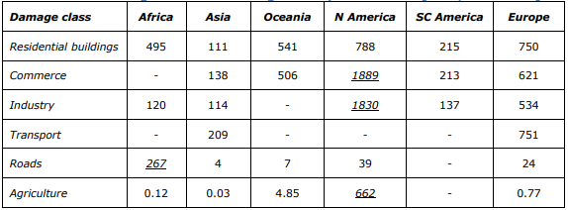
  - Carbon storage and sequestration model
The carbon storage and sequestration model of InVEST calculates the total amount of carbon in each landscape pixel based on provided values (Nelson et al., 2009). The values are specified in tons per hectare of CO₂ equivalent and categorized into four different pools: carbon in soil, carbon in aboveground biomass, carbon in belowground biomass, and carbon in litter (Table S11). In this study, we utilized the cover percentage to adjust the carbon amount in above and belowground biomass, following a linear relation (e.g., a forest with 60% cover will have values equivalent to 100% forest cover multiplied by 0.6).
To ensure model accuracy, we introduced a new code (992) to represent riparian forest, as the carbon storage and sequestration information for this ecosystem type was available. Additionally, to account for the impact on carbon storage and sequestration in restored or degraded wetlands, we followed the approach of Nahlik and Fennessy (2016), estimating a 36% decrease in carbon compared to non-degraded wetlands. This estimate aligns with the value provided in Meli et al. (2014). The values and references used for this model are detailed in Table S11.
Table S 11. Tones of CO₂ eq. per Land Use/Land Cover LULC used for carbon storage and sequestration model and their references. Cover is the percentage of tree cover, C_soil is the carbon in soil, C_Above is the carbon in aboveground biomass, C_Below is the carbon in belowground biomass, C_litter in the carbon in dead matter. (*) Show the carbon for a degraded wetland (411). The code 992 corresponds with riparian forests that are not included in the rest of the models as separated code.
LULC | Cover | C_soil | C_Above | C_Below | C_litter | References
111 | 0 | 0.2 | 0.1 | 0 | 0 | González-García et al. (2020)
112 | 0 | 64.0 | 16.9 | 8.6 | 0 | Dorendorf et al. (2015)
121 | 0 | 12.3 | 14.4 | 0 | 0 | Dorendorf et al. (2015)
122 | 0 | 0.2 | 0.1 | 0 | 0 | González-García et al. (2020)
133 | 0 | 0.2 | 0.1 | 0 | 0 | González-García et al. (2020)
141 | 0 | 258.8 | 135.8 | 50.6 | 0 | Dorendorf et al. (2015)
142 | 0 | 64.0 | 16.9 | 8.6 | 0 | 112 (soil, above) 324 (below)
211 | 0 | 81.7 | 5.1 | 0 | 0 | Dorendorf et al. (2015)
212 | 0 | 81.7 | 5.1 | 0 | 0 | Dorendorf et al. (2015)
242 | 0 | 103.4 | 86.5 | 33.4 | 0.4 | Average 244,212
243 | 0 | 125 | 168 | 66.8 | 0.9 | González-García et al. (2020)
244 | 0 | 125 | 168 | 66.8 | 0.9 | González-García et al. (2020)
311 | 100 | 296.8 | 176.4 | 67.4 | 18.1 | INFC 2005, Tonolli & Salvagni, (2007)
311 | 90 | 296.8 | 158.8 | 60.7 | 16.3 | INFC 2005, Tonolli & Salvagni, (2007)
Table S 11. Continuation
Lucode | Cover | C_soil | C_Above | C_Below | C_litter | References
311 | 80 | 296.8 | 141.1 | 53.9 | 14.5 | INFC 2005, Tonolli & Salvagni, (2007)
311 | 70 | 296.8 | 123.5 | 47.2 | 12.7 | INFC 2005, Tonolli & Salvagni, (2007)
311 | 60 | 296.8 | 105.8 | 40.5 | 10.9 | INFC 2005, Tonolli & Salvagni, (2007)
311 | 50 | 296.8 | 88.2 | 33.7 | 9.1 | INFC 2005, Tonolli & Salvagni, (2007)
311 | 40 | 296.8 | 70.6 | 27 | 7.2 | INFC 2005, Tonolli & Salvagni, (2007)
311 | 30 | 296.8 | 52.9 | 20.2 | 5.4 | INFC 2005, Tonolli & Salvagni, (2007)
311 | 20 | 296.8 | 35.3 | 13.5 | 3.6 | INFC 2005, Tonolli & Salvagni, (2007)
311 | 10 | 296.8 | 17.6 | 6.7 | 1.8 | INFC 2005, Tonolli & Salvagni, (2007)
312 | 100 | 258.9 | 268 | 76.5 | 30.1 | INFC 2005, Tonolli & Salvagni, (2007)
312 | 90 | 258.9 | 241.2 | 68.9 | 27.1 | INFC 2005, Tonolli & Salvagni, (2007)
312 | 80 | 258.9 | 214.4 | 61.2 | 24.1 | INFC 2005, Tonolli & Salvagni, (2007)
312 | 70 | 258.9 | 187.6 | 53.6 | 21.1 | INFC 2005, Tonolli & Salvagni, (2007)
312 | 60 | 258.9 | 160.8 | 45.9 | 18.1 | INFC 2005, Tonolli & Salvagni, (2007)
312 | 50 | 258.9 | 134 | 38.3 | 15 | INFC 2005, Tonolli & Salvagni, (2007)
312 | 40 | 258.9 | 107.2 | 30.6 | 12 | INFC 2005, Tonolli & Salvagni, (2007)
312 | 30 | 258.9 | 80.4 | 23.0 | 9 | INFC 2005, Tonolli & Salvagni, (2007)
312 | 20 | 258.9 | 53.6 | 15.3 | 6 | INFC 2005, Tonolli & Salvagni, (2007)
312 | 10 | 258.9 | 26.8 | 7.7 | 3 | INFC 2005, Tonolli & Salvagni, (2007)
313 | 100 | 277.8 | 222.2 | 72 | 24.1 | Average of 311 and 312
313 | 90 | 277.8 | 200 | 64.8 | 21.7 | Average of 311 and 312
313 | 80 | 277.8 | 177.7 | 57.6 | 19.3 | Average of 311 and 312
313 | 70 | 277.8 | 155.5 | 50.4 | 16.9 | Average of 311 and 312
313 | 60 | 277.8 | 133.3 | 43.2 | 14.5 | Average of 311 and 312
313 | 50 | 277.8 | 111.1 | 36 | 12.1 | Average of 311 and 312
313 | 40 | 277.8 | 88.9 | 28.8 | 9.6 | Average of 311 and 312
313 | 30 | 277.8 | 66.7 | 21.6 | 7.2 | Average of 311 and 312
313 | 20 | 277.8 | 44.4 | 14.4 | 4.8 | Average of 311 and 312
313 | 10 | 277.8 | 22.2 | 7.2 | 2.4 | Average of 311 and 312
321 | 0 | 278 | 7.1 | 13.2 | 0 | Bahn et al. (2008); Guidi et al. 2014 (managed grassland)
322 | 0 | 84.2 | 6.2 | 8.6 | 4.9 | Sørensen et al., (2018)
324 | 0 | 273.1 | 11 | 24 | 4.9 | Guidi et al. (2014) (Abandoned grassland: above are young trees)
331 | 0 | 18.5 | 0 | 0 | 0 | Shields et al. (2017) (calculated at 30cm depth based on delta averages values)
332 | 0 | 0 | 0 | 0 | 0
333 | 0 | 12.3 | 6.2 | 8.6 | 4.9 | 322 and 121 (soil)
334 | 0 | 276.9 | 0.0 | 49.0 | 0 | Average value of 311, 312, 313, 321, 324 less aerial part (burnt) and litter (burnt)
411* | 0 | 344 | 43 | 0 | 0 | IPCC, Nahlik & Fennessy, (2016), Meli et al. (2014)
411 | 0 | 539 | 43 | 0 | 0 | IPCC, Nahlik & Fennessy, (2016), Meli et al. (2014)
511 | 0 | 320.1 | 0.4 | 0.2 | 1.8 | González-García et al. (2020)
512 | 0 | 320.1 | 0.4 | 0.2 | 1.8 | González-García et al. (2020)
992 | 100 | 250.5 | 190 | 72.0 | 29.3 | Sutfin et al. (2016)
992 | 90 | 250.5 | 171 | 64.8 | 26.4 | Sutfin et al. (2016)
992 | 80 | 250.5 | 152 | 57.6 | 23.4 | Sutfin et al. (2016)
992 | 70 | 250.5 | 133 | 50.4 | 20.5 | Sutfin et al. (2016)
992 | 60 | 250.5 | 114 | 43.2 | 17.6 | Sutfin et al. (2016)

  - Landslide protection model
The Slidefornet model (https://www.ecorisq.org/slidefor-net-en), utilized for assessing landslide protection, estimates the probability of shallow landslides based on slope, forest cover, stand density, and other forest parameters affecting root reinforcement (Schwarz et al., 2012). Before running the model, we conducted various trials to identify the parameters that most significantly influence the results. Consequently, we chose to focus on NbS initiatives located in areas with at least a 15% slope, as there were no notable changes observed for NbS with slopes less than 15%. The model incorporates the following parameters, detailed in Table S12:
- Mean gradient slope: Calculated in degrees using the digital elevation model from Copernicus at 25m resolution (https://land.copernicus.eu/imagery-in-situ/eu-dem/eu-dem-v1.1/view), processed with the ArcGIS Slope tool.
- Estimated depth of the slide plane (DSP): Derived from the spatial data provided by the maps of storing and filtering capacity of European soils (Makó et al., 2017), using the parameter MDSP (Maximum Depth of Soil Profile with filter and Storage Properties) intersected with the NbS layer.
- Effective friction angle (FA): Presented in degrees, obtained from the maps of storing and filtering capacity of European soils, selecting the "PARMADO" variable representing soil textures and setting values based on model data.
- Effective soil cohesion (SC): Linked to the effective soil friction angle, determined similarly to effective friction angle by using "PARMADO" and corresponding table values from the model data.
- Safety factor (SF): Set to a constant value of 1, as advised by the model developers.
- Mean diameter at breast height (MDBH): Set to 25 cm based on available literature, considering this size as a reasonable point for NbS actions to ensure the provision of ES.
- Mean stand density: Representing the number of stands per hectare in each NbS, derived from provided project data or estimated using aerial images when data was not available.
- Occurrence of dominant species (BF-CF): Shows the percentage of cover of different tree species. We focused on options such as "other broadleaved species" and "other coniferous species" due to data limitations, and used information from projects and aerial images to estimate these variables.
In the case of NbS actions with pre-existing trees, the model was run twice to analyze improvements in landslide protection. This is why Figures S12, S13, and S14 depict NbS with analyses both before and after implementation.

Table S 12. Parameters used for the Slidefornet model. Action refers to the code assigned to each action, Slope indicates the average slope of the action calculated using the digital elevation model, DSP represents the estimated depth of the slide plane, FA denotes the effective friction angle, SC indicates the effective soil cohesion, SF stands for the safety factor, MDBH represents the mean diameter at breast height, SD_B refers to the stand density before Nature-based Solution (NbS) implementation, SD_A refers to the stand density after implementation, BF(%) represents the percentage of broadleaved forest, and CFR(%) indicates the percentage of conifer forest.
Action | Slope | DSP | FA | SC | SF | MDBH | SD_B | SD_A | BF(%) | CF(%)
InRe114 | 23.82 | 0.5 | 34 | 0 | 1 | 25 | 0 | 1489 | 50 | 50
InRe117 | 15.54 | 0.5 | 34 | 0 | 1 | 25 | 0 | 350 | 100 | 0
IUGen2 | 18.75 | 1 | 32 | 0 | 1 | 25 | 0 | 200 | 30 | 70
ONRTM1 | 31.44 | 1 | 32 | 0 | 1 | 25 | 34 | 292 | 0 | 100
ONRTM10 | 28.03 | 0.5 | 32 | 0 | 1 | 25 | 0 | 1750 | 0 | 100
ONRTM2 | 33.00 | 1 | 32 | 0 | 1 | 25 | 215 | 508 | 0 | 100
ONRTM3 | 18.87 | 0.5 | 32 | 0 | 1 | 25 | 225 | 394 | 0 | 100
ONRTM4 | 29.89 | 1 | 32 | 0 | 1 | 25 | 84 | 243 | 0 | 100
ONRTM5 | 34.79 | 0.5 | 32 | 0 | 1 | 25 | 248 | 364 | 0 | 100
ONRTM6 | 31.07 | 0.5 | 32 | 0 | 1 | 25 | 0 | 1422 | 0 | 100
ONRTM7 | 30.64 | 1 | 32 | 0 | 1 | 25 | 0 | 538 | 0 | 100
ONRTM8 | 34.40 | 0.5 | 32 | 0 | 1 | 25 | 0 | 240 | 0 | 100
ReAll1 | 23.13 | 0.5 | 32 | 0 | 1 | 25 | 0 | 1022 | 30 | 70
ReBu1 | 20.49 | 0.5 | 32 | 0 | 1 | 25 | 0 | 972 | 0 | 100
ReChi1 | 29.53 | 1.5 | 32 | 0 | 1 | 25 | 0 | 1376 | 0 | 100
ReInn1 | 20.86 | 0.5 | 32 | 0 | 1 | 25 | 0 | 245 | 0 | 100
Reluc1 | 22.06 | 0.5 | 32 | 0 | 1 | 25 | 0 | 253 | 30 | 70
Reluc2 | 19.10 | 0.5 | 32 | 0 | 1 | 25 | 0 | 1378 | 30 | 70
ReMen1 | 19.44 | 0.5 | 32 | 0 | 1 | 25 | 0 | 610 | 40 | 60
ReVe1 | 20.71 | 0.5 | 34 | 0 | 1 | 25 | 0 | 231 | 0 | 100

  - Biodiversity assessment
The IUCN Global Standard for NbS was defined, in criterion 3, to require NbS to result in a net gain to biodiversity and ecosystem integrity (Andrade et al., 2020). In this study, we considered biodiversity improvement to include the targeting of specific species linked to relevant habitats, following the EU Habitat Directive or direct mentions of these specific habitats included in this directive. This approach was adopted to avoid accounting for tree plantations or initiatives in urban ecosystems that might have low biodiversity value but could be erroneously perceived as having high value. We then analyzed mentions of species or direct habitats, excluding other relevant aspects that could have made this assessment more rigorous, such as taxonomic coverage or functional diversity. Previous studies have shown that at the global level, 50% of NbS initiatives did not mention taxonomic coverage, and 57% of biodiversity outcomes did not distinguish between native and non-native species (Key et al., 2022).
  - Buffers to analyze beneficiaries
We employed different frameworks to analyze ecosystem services beneficiaries based on the spatial relation between ecosystem services supply and beneficiaries (Figure S18). Various buffer radios were selected to assess the extent of ecosystem services effects. For heatwave mitigation, we assumed the ecosystem service direction to be in all possible directions due to air movement, using buffer radii of 30, 240, and 450 meters (Figure S18A). The first two radios were based on Grilo et al. (2020) to represent cooling effects, while the last radius followed InVEST model recommendations for a 2-hectare cooling effect (Zardo et al., 2017).
For flood regulation, we considered the gravitational effect and employed two approaches. For areas with less than 5% slope, we assumed all directions, as in heatwave mitigation. For areas with more than 5% slope, we utilized the flow accumulation tool in ArcGIS to identify pixels receiving more water. We selected pixels with at least a value of 5 (5 pixels pour into it) and calculated beneficiaries in buffers of 50, 100, 150, and 200 meters (Figure S18B), following Haddad and Teixeira (2015).
For landslides protection, we applied buffers of 20, 65, and 200 meters (Figure S18C) based on Lombardo et al. (2021). Similar to flood regulation, we utilized the flow accumulation tool with a value of 5 to select pixels receiving water.
To calculate the number of people benefited by these three ES, we intersected the urban layer with the population density map (CIESIN, 2018) to determine the population in each urban polygon. The surface of urban areas in each buffer was then calculated, and linear extrapolation was used to estimate the number of people living in the urban areas (e.g., if 100 inhabitants live in 1 hectare of urban area, 0.1 hectares would assume 10 inhabitants). Climate regulation ES was not included in this analysis as the benefits are global.
The analysis of how NbS actions are distributed in terms of GDP was conducted using the raster layer of GDP from Wang and Sun (2022). Subsequently, we calculated the average GDP inside each NbS action and analyzed the average value of each action per NbS type.

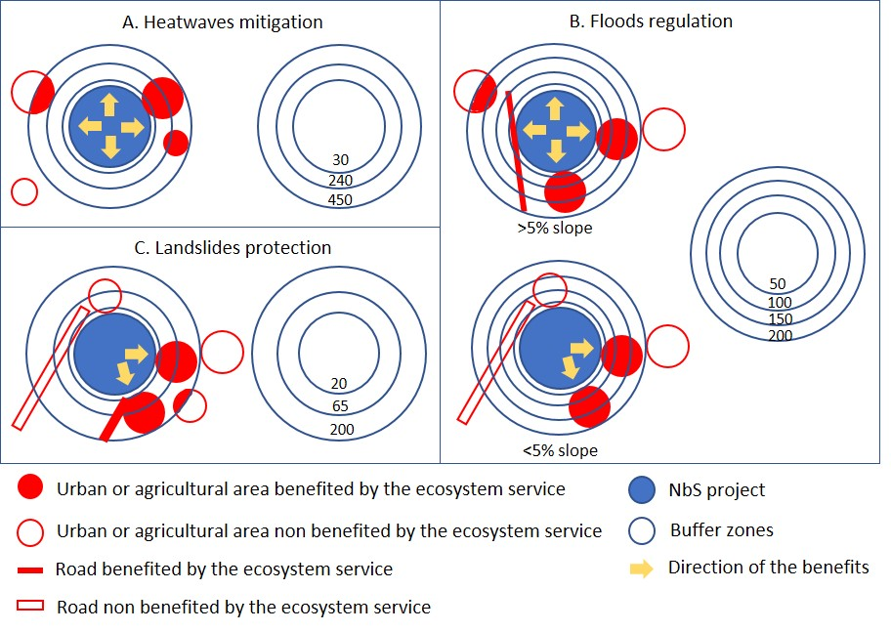
Figure S 18. Frameworks used to analyse the direction of the ecosystem services flow and the beneficiaries in each buffer.
  - Analysis of the distribution of NbS in relation to GDP
We utilized geographical data provided by Wang & Sun (2022), which includes GDP per square kilometer on a global scale for the year 2005. To estimate GDP for the year 2021, we extracted the data for each country and applied a growth factor based on World Bank data (https://genderdata.worldbank.org/indicators/ny-gdp-mktp-kd-zg/), which represents the general increase in GDP.
  - Economic value of ecosystem services
We analyzed the economic value of each ecosystem service based on available literature and direct outputs from the InVEST model.
For heatwave mitigation, we estimated the value using data from Hamel et al. (2021), who provided a value of 71,000 USD/day for a 3ºC reduction in temperature per day. We converted this currency to euros and divided the value by three to obtain the economic value per degree of temperature reduction. We then multiplied this value by the reduction observed in the Wet Bulb Globe Temperature (WGTB) value for heavy work from the InVEST model. Like this we obtained the value per day of extreme temperature event (Table S13). However, since the economic values associated with floods and landslides are linked to specific events that could potentially cause infrastructure damage, we took a different approach for estimating the total economic value of heatwave mitigation. We considered heatwave events during the years with the highest heat levels in the last two decades, as indicated by García-León et al. (2021). This study focused on four particularly warm years (2003, 2010, 2015, and 2018). To carry out this estimation, we utilized the supplementary material provided by García-León et al. (2021) to identify the NUTS (European units for statistical purposes) within the Alpine Space Perimeter. Subsequently, we calculated the average duration of extreme temperature events for each of these NUTS per year and then summed up the average durations for the four years. Finally, we multiplied this sum by our calculated value per day, yielding the total economic value of heatwave mitigation.
Table S 13. Number of heatwave events and cumulative duration based on García-León et al. (2021). The value used for multiplying the daily economic value of heatwave mitigation is 118, presented in total days. It is important to note that we detected these events for the years 2003 and 2015, even though the study encompassed 2010 and 2018 as well.
2003 |  |  | 2015 |  |  | Total days
Region (code NUTS) | Events | Cumulative duration | Region (code NUTS) | Events | Cumulative duration
ITC3 | 3 | 73 | ITH1 | 4 | 50
ITH1 | 6 | 70 | ITC3 | 5 | 50
ITH3 | 4 | 69 | ITH5 | 5 | 48
ITC1 | 5 | 69
FRL0 | 4 | 68
ITH4 | 3 | 67
ITH2 | 7 | 65
Average duration |  | 68.7 |  |  | 49.3 | 118

The economic value associated with floods regulation was directly obtained from the model's output, which includes the amount of water retained based on the ecosystem's water-absorbing capacity. We utilized the "service build" variable from both the model's output before and after NbS implementation to analyze how NbS contribute to the improvement of this value. Additionally, this analysis enabled us to calculate the total economic value resulting from the implementation of NbS for this ecosystem service and also determine the average value per type of NbS.
For climate regulation, we estimated the economic value by multiplying the difference between CO₂ eq. before and after by the average value of the first six months of 2023 (https://tradingeconomics.com/commodity/carbon), which was 88€ per ton of CO₂ eq.
The economic value of landslides protection was calculated for each of the three buffers. We intersected the buffers with urban areas, roads, and agricultural areas in the flow direction. Then, we multiplied the surface area by the respective values provided in Table S10. For the economic analysis, we only considered the 20 m radius following existing analysis in the Alps of shallow landslides (Rickli and Graf, 2009).
Regarding the cost of actions, we obtained the information from project records. In cases where a project included multiple actions, we used detailed cost information when available. If no data was available, we divided the total cost by the number of hectares. In two initiatives where cost data was unavailable, we extrapolated the value from the average cost in the corresponding ecosystem type. The cost-effectiveness analysis was conducted based on the total value of the NbS initiatives in each type divided by the total value of the actions. We also calculated the cost-effectiveness ratio based on the average value of the four analyzed ecosystem services per hectare and the average cost per hectare.
  - Multifunctionality analysis of NbS
The multifunctionality of the NbS was assessed based on their ability to provide multiple benefits to humans simultaneously, following the framework proposed by Manning et al. (2018). To compare all the ecosystem services and biodiversity, which were presented in different units, we employed a normalization method ranging from 1 to 10. This allowed us to plot all these variables and visually evaluate the multifunctionality of each type of NbS in terms of ecosystem services and biodiversity. The value that demonstrates ecosystem services multifunctionality and economic value is based on the difference between before and after NbS implementation to capture the NbS' effects.
For the economic value and the number of people benefited, we did not use normalization since these variables were already in the same units. However, in the economic value analysis, we did not include biodiversity due to the lack of a robust approach to calculate its economic value. Similarly, in the graphical representation of the population, we only included the three ecosystem services for which we were able to analyze the beneficiaries, as mentioned in the previous section.
- Supplementary references
Aartsma, P., Asplund, J., Odland, A., Reinhardt, S., & Renssen, H. (2020). Surface albedo of alpine lichen heaths and shrub vegetation. Arctic, Antarctic, and Alpine Research, 52(1), 312-322.
Acreman, M., & Holden, J. (2013). How wetlands affect floods. Wetlands, 33, 773-786.
Adams, C., Frantzeskaki, N., & Moglia, M. (2023). Mainstreaming nature-based solutions in cities: A systematic literature review and a proposal for facilitating urban transitions. Land Use Policy, 130, 106661.
Andrade, A., Cohen-Shacham, E., Dalton, J., Edwards, S., Hessenberger, D., Maginnis, S., ... & Vasseur, L. (2020). IUCN Global Standard for Nature-Based Solutions: a user-friendly framework for the verification, design and scaling up of NbS. IUCN: Gland, Switzerland.
Bahn, M., Rodeghiero, M., Anderson-Dunn, M., Dore, S., Gimeno, C., Drösler, M., ... & Cernusca, A. (2008). Soil respiration in European grasslands in relation to climate and assimilate supply. Ecosystems, 11(8), 1352-1367.
Blumthaler, M., & Ambach, W. (1988). Solar UVB‐albedo of various surfaces. Photochemistry and Photobiology, 48(1), 85-88.
Chen, Y., Wang, B., Pollino, C. A., Cuddy, S. M., Merrin, L. E., & Huang, C. (2014). Estimate of flood inundation and retention on wetlands using remote sensing and GIS. Ecohydrology, 7(5), 1412-1420.
CIESIN, (2018). Center for International Earth Science Information Network - Columbia University. 2018. Gridded Population of the World, Version 4 (GPWv4): Population Density Adjusted to Match 2015 Revision UN WPP Country Totals, Revision 11. Palisades, New York: NASA Socioeconomic Data and Applications Center (SEDAC). https://doi.org/10.7927/H4F47M65.
Cohen-Shacham, E., Andrade, A., Dalton, J., Dudley, N., Jones, M., Kumar, C., ... & Walters, G. (2019). Core principles for successfully implementing and upscaling Nature-based Solutions. Environmental Science & Policy, 98, 20-29.
Costanza, R., De Groot, R., Sutton, P., Van der Ploeg, S., Anderson, S. J., Kubiszewski, I., ... & Turner, R. K. (2014). Changes in the global value of ecosystem services. Global environmental change, 26, 152-158.
Council Directive 92/43/EEC. https://eur-lex.europa.eu/legal-content/EN/TXT/?uri=CELEX%3A01992L0043-20130701
Cronshey, R, (1986), Urban hydrology for small watersheds (No, 55), US Department of Agriculture, Soil Conservation Service, Engineering Division,
Crowther, T. W., Thomas, S. M., van den Hoogen, J., Robmann, N., Chavarría, A., Cottam, A., ... & Rowe, C. (2022). Restor: Transparency and connectivity for the global environmental movement. One Earth, 5(5), 476-481.
De Groot, R., Brander, L., Van Der Ploeg, S., Costanza, R., Bernard, F., Braat, L., ... & Van Beukering, P. (2012). Global estimates of the value of ecosystems and their services in monetary units. Ecosystem services, 1(1), 50-61.
Dorendorf, J., Eschenbach, A., Schmidt, K., & Jensen, K. (2015). Both tree and soil carbon need to be quantified for carbon assessments of cities. Urban Forestry & Urban Greening, 14(3), 447-455.
Dubo, T,, Palomo, I,, Camacho, L, L,, Locatelli, B,, Cugniet, A,, Racinais, N,, & Lavorel, S, (2023), Nature-based solutions for climate change adaptation are not located where they are most needed across the Alps, Regional Environmental Change, 23(1), 12,
Eichelmann, E., Hemes, K. S., Knox, S. H., Oikawa, P. Y., Chamberlain, S. D., Sturtevant, C., ... & Baldocchi, D. D. (2018). The effect of land cover type and structure on evapotranspiration from agricultural and wetland sites in the Sacramento–San Joaquin River Delta, California. Agricultural and Forest Meteorology, 256, 179-195.
García-León, D., Casanueva, A., Standardi, G., Burgstall, A., Flouris, A. D., & Nybo, L. (2021). Current and projected regional economic impacts of heatwaves in Europe. Nature communications, 12(1), 5807.
González-García, A., Aguado, M., Solascasas, P., Palomo, I., González, J. A., García-Llorente, M., ... & Montes, C. (2023). Co-producing an ecosystem services-based plan for sustainable university campuses. Landscape and Urban Planning, 230, 104630.
González-García, A., Palomo, I., González, J. A., López, C. A., & Montes, C. (2020). Quantifying spatial supply-demand mismatches in ecosystem services provides insights for land-use planning. Land use policy, 94, 104493.
Goswami, B. N., Venugopal, V., Sengupta, D., Madhusoodanan, M. S., & Xavier, P. K. (2006). Increasing trend of extreme rain events over India in a warming environment. Science, 314(5804), 1442-1445.
Grilo, F., Pinho, P., Aleixo, C., Catita, C., Silva, P., Lopes, N., ... & Branquinho, C. (2020). Using green to cool the grey: Modelling the cooling effect of green spaces with a high spatial resolution. Science of the Total Environment, 724, 138182.
Guidi, C., Vesterdal, L., Gianelle, D., & Rodeghiero, M. (2014). Changes in soil organic carbon and nitrogen following forest expansion on grassland in the Southern Alps. Forest ecology and management, 328, 103-116.
Haddad, E. A., & Teixeira, E. (2015). Economic impacts of natural disasters in megacities: The case of floods in São Paulo, Brazil. Habitat International, 45, 106-113.
Hamel, P., Guerry, A. D., Polasky, S., Han, B., Douglass, J. A., Hamann, M., ... & Daily, G. C. (2021). Mapping the benefits of nature in cities with the InVEST software. npj Urban Sustainability, 1(1), 25.
Hey, D. L., & Philippi, N. S. (1995). Flood reduction through wetland restoration: the Upper Mississippi River Basin as a case history. Restoration Ecology, 3(1), 4-17.
Huizinga, J., De Moel, H., & Szewczyk, W. (2017). Global flood depth-damage functions: Methodology and the database with guidelines (No. JRC105688). Joint Research Centre (Seville site).
Im, S., Park, S., & Jang, T. (2007). Application of SCS curve number method for irrigated paddy field. KSCE Journal of Civil Engineering, 11, 51-56.
INFC 2005 – Inventario Nazionale delle Foreste e dei Serbatoi Forestali di Carbonio. Ministero delle Politiche Agricole Alimentari e Forestali, Ispettorato Generale - Corpo Forestale dello Stato. Consiglio per la Ricerca e Sperimentazione in Agricoltura Unità di ricerca per il Monitoraggio e la Pianificazione Forestale (CRA-MPF).
Jaafar, H. H., Ahmad, F. A., & El Beyrouthy, N. (2019). GCN250, new global gridded curve numbers for hydrologic modeling and design. Scientific data, 6(1), 145.
Karger, D.N., Lange, S., Hari, C., Reyer, C. P. O., Zimmermann, N.E. (2021): CHELSA-W5E5 v1.0: W5E5 v1.0 downscaled with CHELSA v2.0. ISIMIP Repository.
Key, I. B., Smith, A. C., Turner, B., Chausson, A., Girardin, C. A., Macgillivray, M., & Seddon, N. (2022). Biodiversity outcomes of nature-based solutions for climate change adaptation: characterising the evidence base. Frontiers in Environmental Science, 10.
Lombardo, L., Tanyas, H., Huser, R., Guzzetti, F., & Castro-Camilo, D. (2021). Landslide size matters: A new data-driven, spatial prototype. Engineering geology, 293, 106288.
Lonsdorf, E.V., Nootenboom, C., Janke, B., & Horgan, B.P. (2021). Assessing urban ecosystem services provided by green infrastructure: Golf courses in the Minneapolis-St. Paul metro area. Landscape and Urban Planning, 208.
Manning, P., Van Der Plas, F., Soliveres, S., Allan, E., Maestre, F. T., Mace, G., ... & Fischer, M. (2018). Redefining ecosystem multifunctionality. Nature ecology & evolution, 2(3), 427-436.
Meli, P., Rey Benayas, J. M., Balvanera, P., & Martínez Ramos, M. (2014). Restoration enhances wetland biodiversity and ecosystem service supply, but results are context-dependent: a meta-analysis. PloS one, 9(4), e93507.
Metzger, J. P., Villarreal-Rosas, J., Suárez-Castro, A. F., López-Cubillos, S., González-Chaves, A., Runting, R. K., ... & Rhodes, J. R. (2021). Considering landscape-level processes in ecosystem service assessments. Science of The Total Environment, 796, 149028.
Nahlik, A. M., & Fennessy, M. S. (2016). Carbon storage in US wetlands. Nature Communications, 7(1), 1-9.
Nelson, E., Mendoza, G., Regetz, J., Polasky, S., Tallis, H., Cameron, D., ... & Shaw, M. (2009). Modeling multiple ecosystem services, biodiversity conservation, commodity production, and tradeoffs at landscape scales. Frontiers in Ecology and the Environment, 7(1), 4-11.
Nistor, M. M., Man, T. C., Benzaghta, M. A., Nedumpallile Vasu, N., DEZSI, Ş., & Kizza, R. (2018). LAND COVER AND TEMPERATURE IMPLICATIONS FOR THE SEASONAL EVAPOTRANSPIRATION IN EUROPE. Geographia Technica, 13(1).
NRCS-USDA. (2004). Chapter 10. Estimation of Direct Runoff from Storm Rainfall. In United States Department of Agriculture (Ed.), Part 630 Hydrology. National Engineering Handbook.
Pascual, U., Balvanera, P., Anderson, C. B., Chaplin-Kramer, R., Christie, M., González-Jiménez, D., ... & Zent, E. (2023). Diverse values of nature for sustainability. Nature, 1-11.
Peng, J., Cheng, X., Hu, Y., & Corcoran, J. (2022). A landscape connectivity approach to mitigating the urban heat island effect. Landscape Ecology, 37(6), 1707-1719.
Rickli, C., & Graf, F. (2009). Effects of forests on shallow landslides–case studies in Switzerland. Forest Snow and Landscape Research, 82(1), 33-44.
Ross, C.W., L. Prihodko, J.Y. Anchang, S.S. Kumar, W. Ji, and N.P. Hanan. 2018. Global Hydrologic Soil Groups (HYSOGs250m) for Curve Number-Based Runoff Modeling. ORNL DAAC, Oak Ridge, Tennessee, USA.
Schröter, M., Koellner, T., Alkemade, R., Arnhold, S., Bagstad, K. J., Erb, K. H., ... & Bonn, A. (2018). Interregional flows of ecosystem services: Concepts, typology and four cases. Ecosystem Services, 31, 231-241.
Schwarz, M., Thormann, J. J., Zürcher, K., & Feller, K. (2012, April). Quantifying root reinforcement in protection forests: Implications for slope stability and forest management. In Proceedings of the Interpraevent.
Sharma, B., Rasul, G., & Chettri, N. (2015). The economic value of wetland ecosystem services: Evidence from the Koshi Tappu Wildlife Reserve, Nepal. Ecosystem Services, 12, 84-93.
Shatz, J. & Kucharik, C.J. (2014). Seasonality of the Urban Heat Island Effect in Madison, Wisconsin. Journal of Applied Meterology and Climatology, 53(10), 2371-2386.
Shields, M. R., Bianchi, T. S., Mohrig, D., Hutchings, J. A., Kenney, W. F., Kolker, A. S., & Curtis, J. H. (2017). Carbon storage in the Mississippi River delta enhanced by environmental engineering. Nature Geoscience, 10(11), 846-851.
Sieber, P., Ericsson, N., Hammar, T., & Hansson, P. A. (2022). Albedo impacts of current agricultural land use: Crop-specific albedo from MODIS data and inclusion in LCA of crop production. Science of The Total Environment, 835, 155455.
Sørensen, M. V., Strimbeck, R., Nystuen, K. O., Kapas, R. E., Enquist, B. J., & Graae, B. J. (2018). Draining the pool? Carbon storage and fluxes in three alpine plant communities. Ecosystems, 21, 316-330.
Sutfin, N. A., Wohl, E. E., & Dwire, K. A. (2016). Banking carbon: a review of organic carbon storage and physical factors influencing retention in floodplains and riparian ecosystems. Earth Surface Processes and Landforms, 41(1), 38-60.
Tedela, N. H., McCutcheon, S. C., Rasmussen, T. C., Hawkins, R. H., Swank, W. T., Campbell, J. L., ... & Tollner, E. W. (2012). Runoff curve numbers for 10 small forested watersheds in the mountains of the eastern United States. Journal of Hydrologic Engineering, 17(11), 1188-1198.
Tian, L., Zhang, Y., & Zhu, J. (2014). Decreased surface albedo driven by denser vegetation on the Tibetan Plateau. Environmental Research Letters, 9(10), 104001.
Tonolli S. & Salvagni F. (a cura di), 2007 - InfoCarb Inventario Forestale del Carbonio della Provincia di Trento, 1-176. Centro di Ecologia Alpina, Trento.
Trlica, A., Hutyra, L. R., Schaaf, C. L., Erb, A., & Wang, J. A. (2017). Albedo, land cover, and daytime surface temperature variation across an urbanized landscape. Earth's Future, 5(11), 1084-1101.
Wang, L., Zheng, H., Chen, Y., Ouyang, Z., & Hu, X. (2022). Systematic review of ecosystem services flow measurement: Main concepts, methods, applications and future directions. Ecosystem Services, 58, 101479.
Wieland, R., Ravensbergen, S., Gregr, E. J., Satterfield, T., & Chan, K. M. (2016). Debunking trickle-down ecosystem services: the fallacy of omnipotent, homogeneous beneficiaries. Ecological Economics, 121, 175-180.
Woolway, R. I., Jennings, E., Shatwell, T., Golub, M., Pierson, D. C., & Maberly, S. C. (2021). Lake heatwaves under climate change. Nature, 589(7842), 402-407.

