Article title: Assessing the growth response to climate of Douglas fir under European temperate oceanic conditions
Journal name: European Journal of Forest Research
Author names and affiliation: Camille Guisset¹ (camille.guisset@uclouvain.be), Quentin Ponette¹, Caroline Vincke¹
¹Earth and Life Institute, Environmental Sciences, UCLouvain, Louvain-la-Neuve, Belgium

Supplementary materials
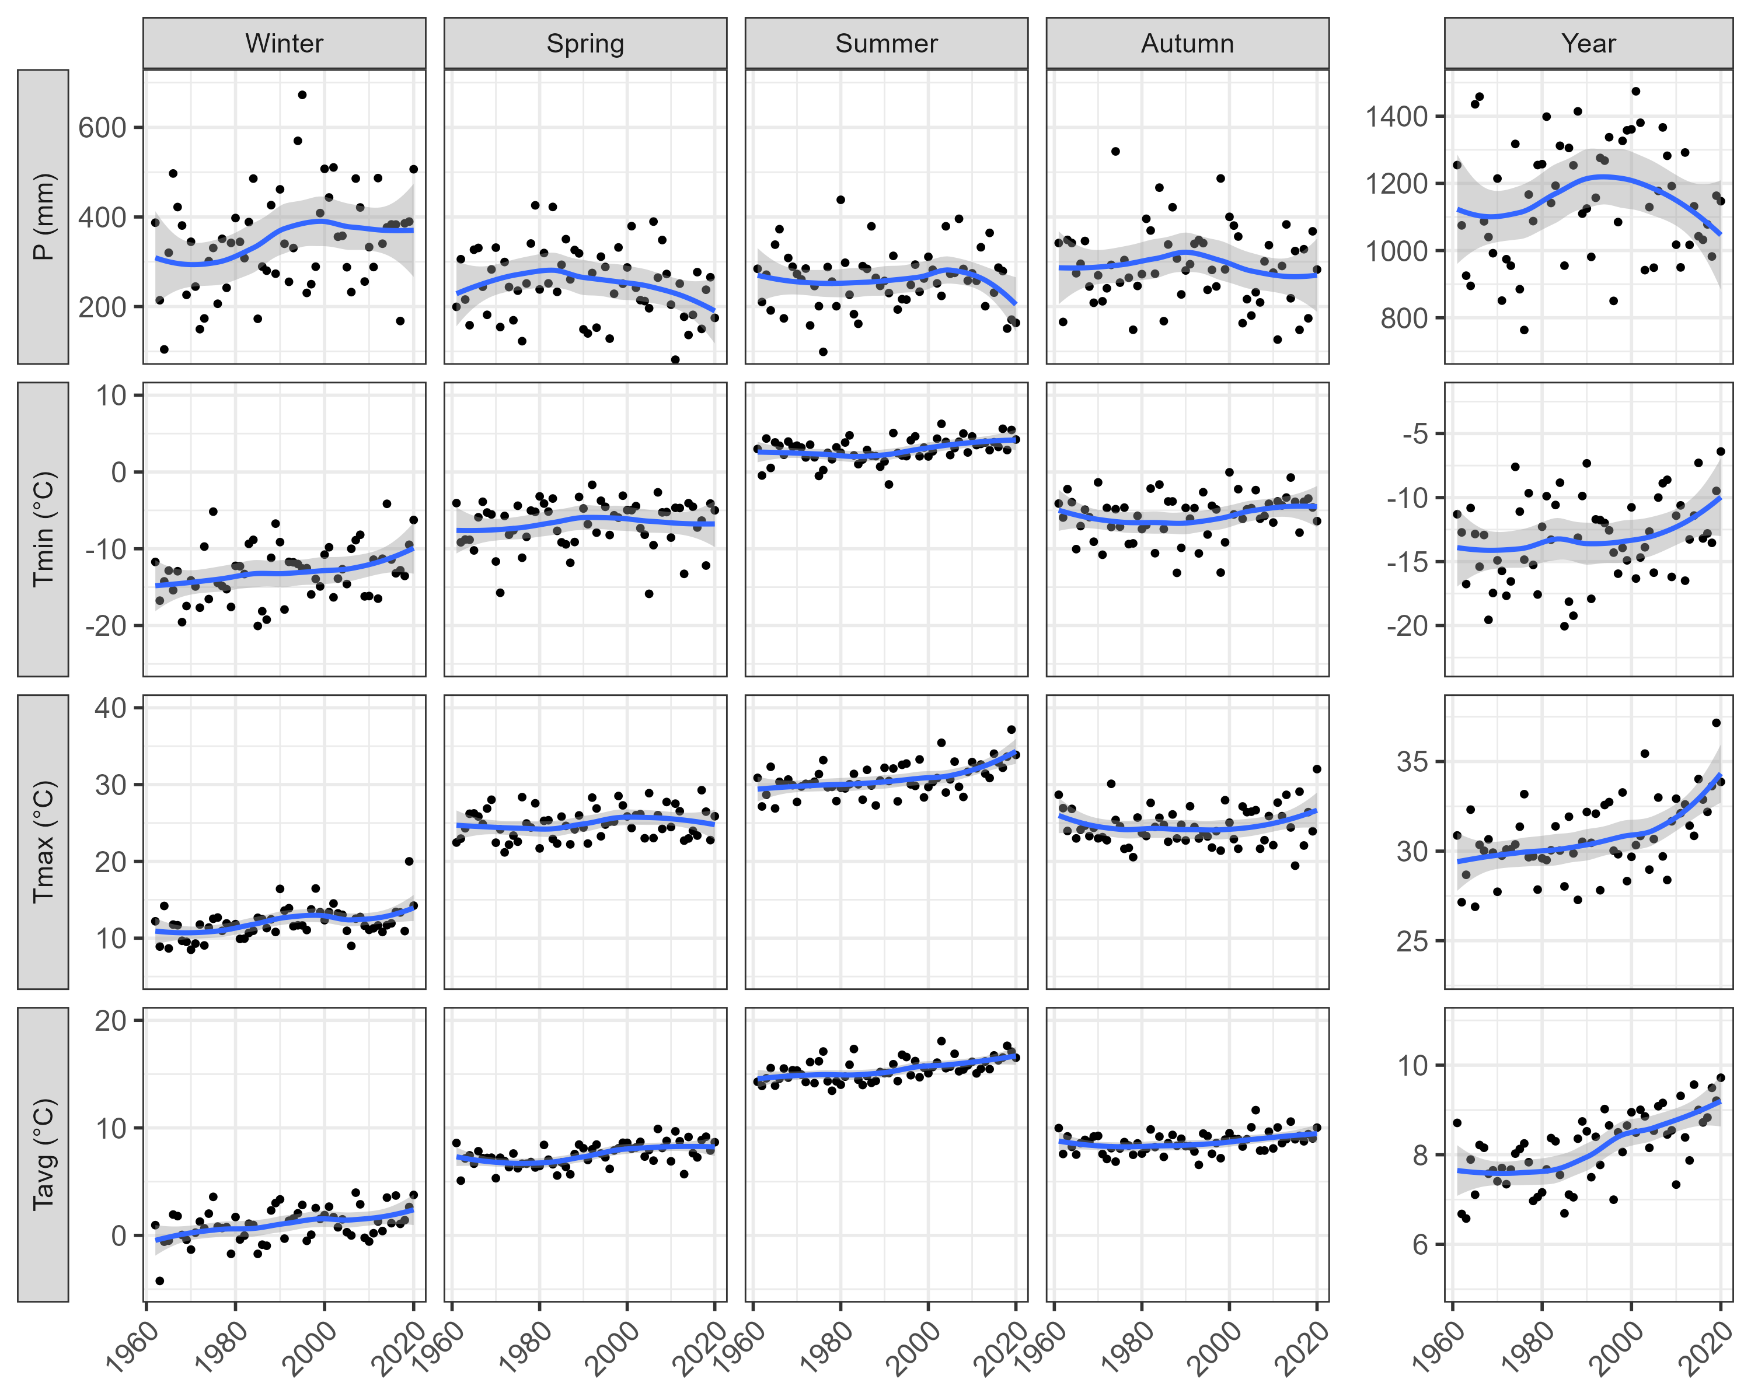
Fig. S1 Seasonal and annual temperature and precipitation trends for the period 1961-2020. P = precipitation sum, Tavg = mean temperature, Tmax and Tmin = maximum and minimum temperatures, calculated from climatic data averaged for all sites
Table S1 Monthly temperature and precipitation trends for the period 1961-2020. P = precipitation sum, Tavg = mean temperature, Tmax and Tmin = maximum and minimum temperatures, calculated from climatic data averaged for all sites. Trends were tested with Mann-Kendall trend test. Changes correspond to the Theil-Sen trend estimates. The significance levels of changes within the periods are indicated by *p < 0.05, ** p < 0.01 and *** p < 0.001
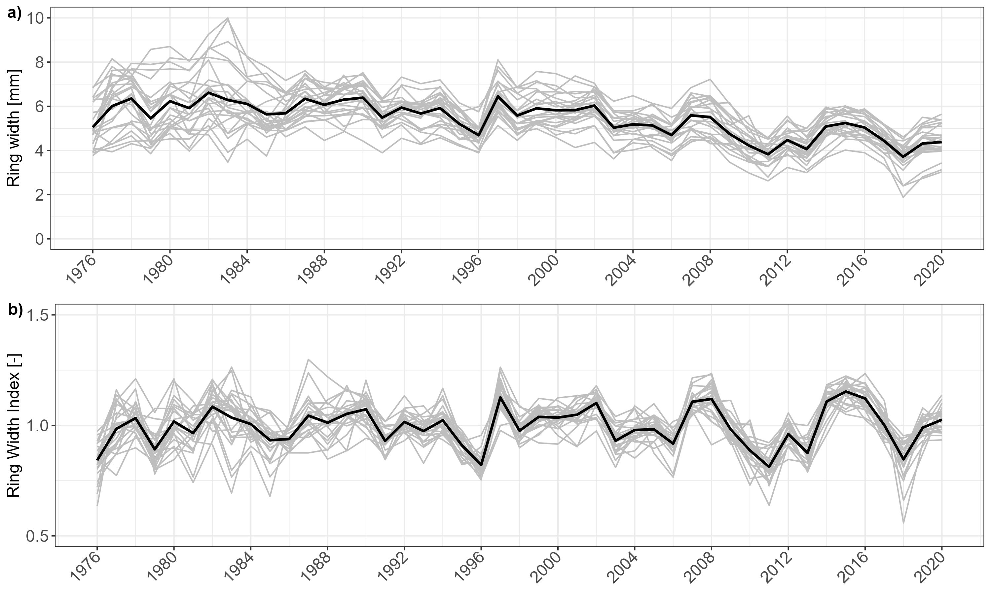
Fig. S2 Average ring width chronologies (a) and standardised average chronologies (b). The grey lines are the average chronologies of the 24 study sites, and the black line is the average chronology for all sites together

