Supplementary Information (SI)
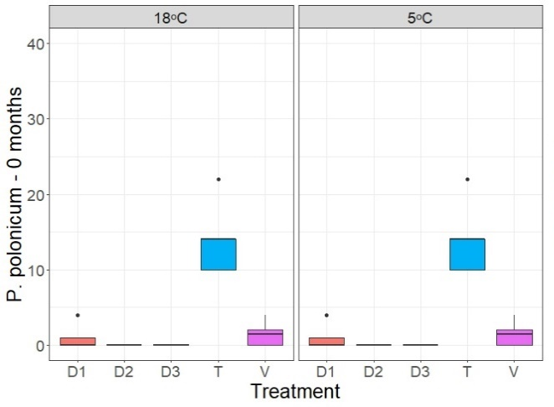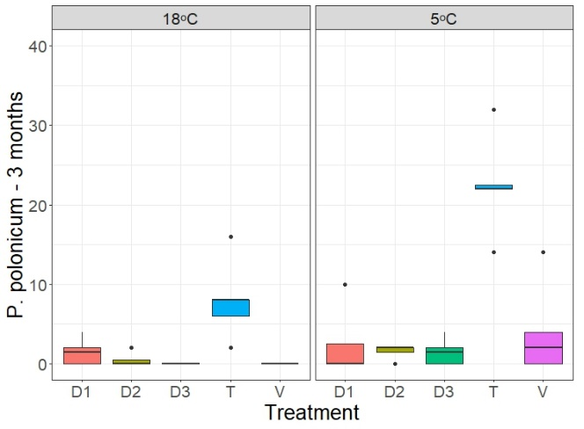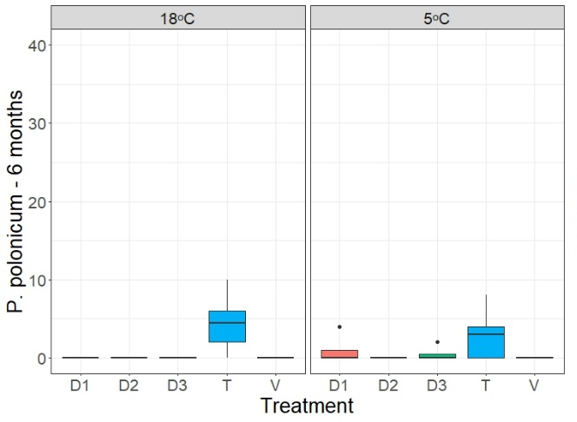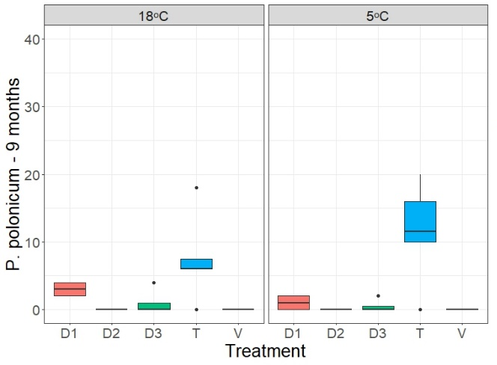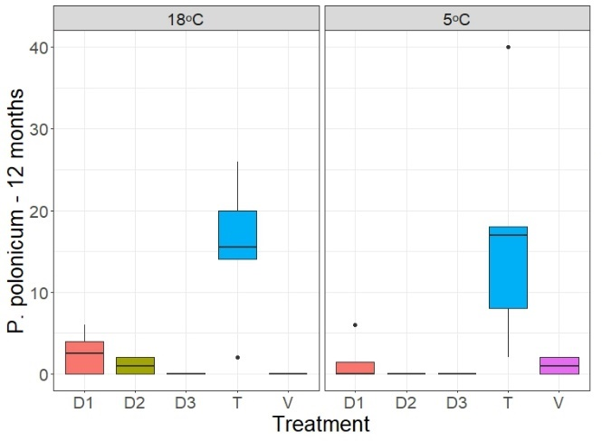
bc
a
c
c
bc
c
ab
c
bc
abc
a
ab
b
b
b
b
b
b
b
b
a
a
a
a
a
a
a
a
a
a
b
b
b
b
b
b
b
b
b
b
b
b
b
b
b
b
b
a
a
a
Figure S1. Penicillium polonicum contamination of treated and untreated sorghum seeds stored at 5°C and 18°C for 0 months, 3 months, 6 months, 9 months, and 12 months as a function of three doses (D1, D2, D3) of T. koningiopsis applied, a chemical control (V) and untreated seeds (T). Same letters indicate no significant difference for the same treatment over time at the same temperature (Tukey p>0.05).
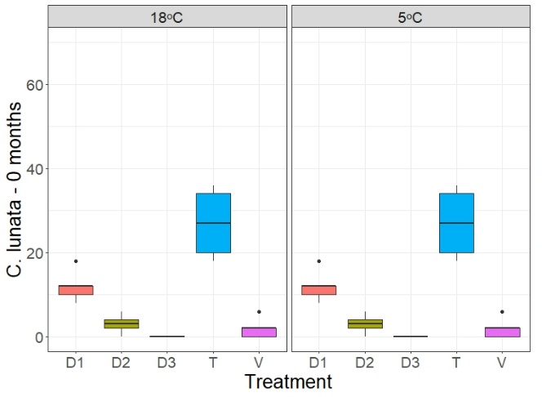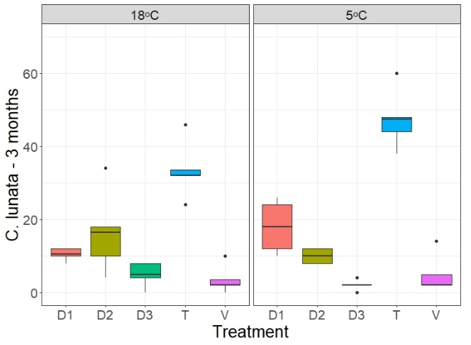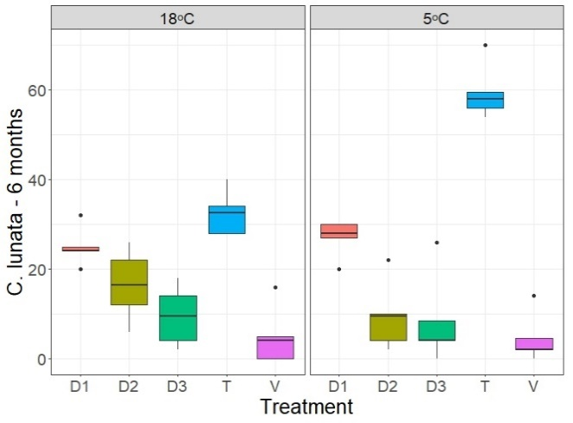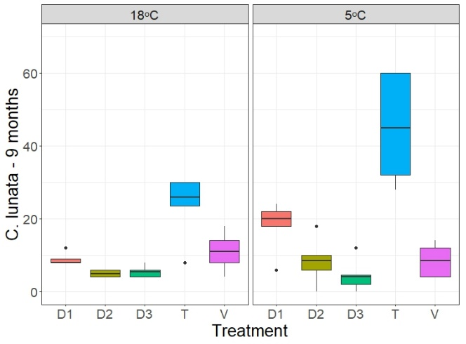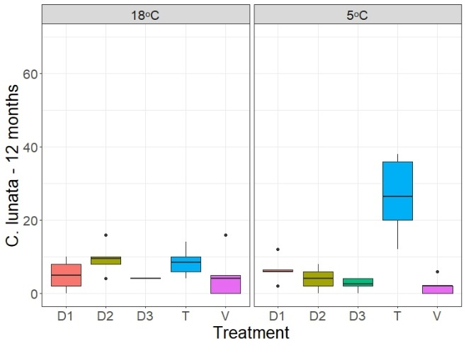
a
a
b
b
b
b
b
b
b
b
b
b
a
b
b
b
b
b
b
b
b
a
d
cd
cd
d
b
cd
bcd
bc
bc
ab
bc
a
c
c
c
c
c
c
c
a
a
bc
bc
c
c
b
b
bc
bc
Figure S2. Curvularia lunata contamination of treated and untreated sorghum seeds stored at 5°C and 18°C for 0 months, 3 months, 6 months, 9 months, and 12 months as a function of three doses (D1, D2, D3) of T. koningiopsis applied, a chemical control (V) and untreated seeds (T). Same letters indicate no significant difference for the same treatment over time at the same temperature (Tukey p>0.05).
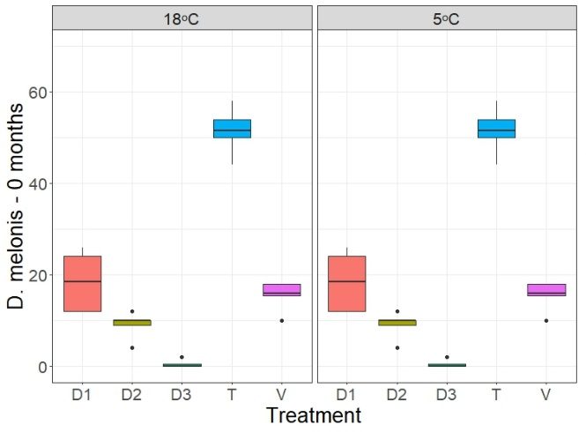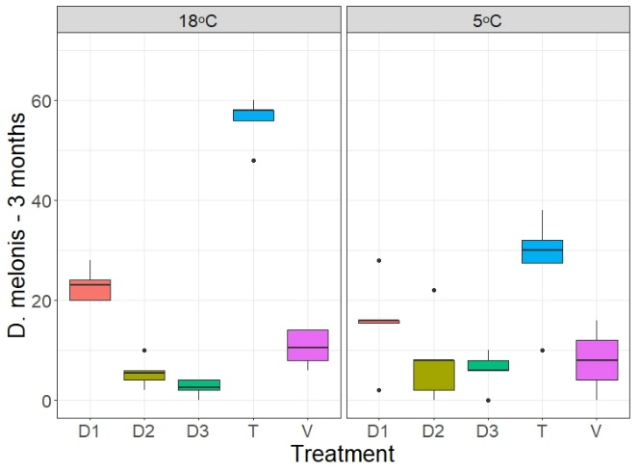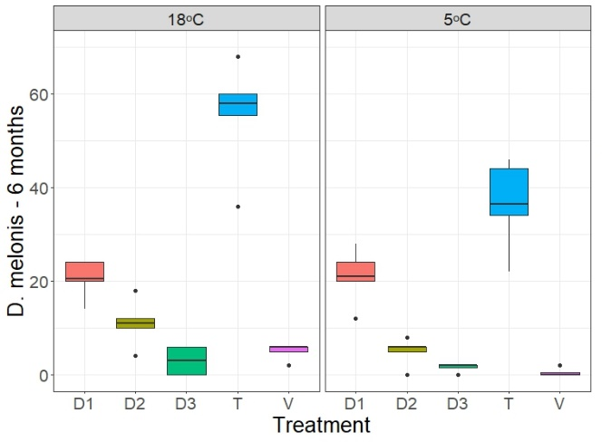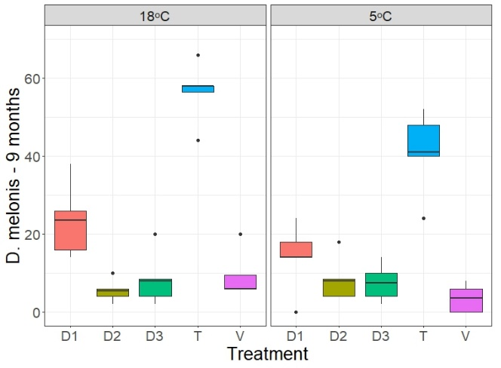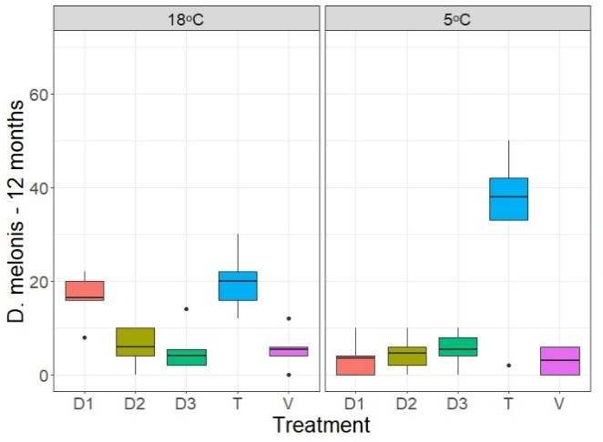
a
b
b
b
b
b
b
b
ab
ab
ab
d
cd
cd
cd
a
cd
cd
cd
bc
b
d
cd
bc
d
a
cd
d
cd
bc
b
d
d
bc
bcd
a
cd
cd
cd
bcd
a
c
bc
b
b
b
a
c
bc
b
Figure S3. Diaporthe melonis contamination of treated and untreated sorghum seeds stored at 5°C and 18°C for 0 months, 3 months, 6 months, 9 months, and 12 months as a function of three doses (D1, D2, D3) of T. koningiopsis applied, a chemical control (V) and untreated seeds (T). Same letters indicate no significant difference for the same treatment over time at the same temperature (Tukey p>0.05).

