Supplement of “Alarming decline in the carbon sink of European forests driven by disturbances”

Enhanced captions:

In the following, we provide enhanced captions for each figure (Fig. 1-4).
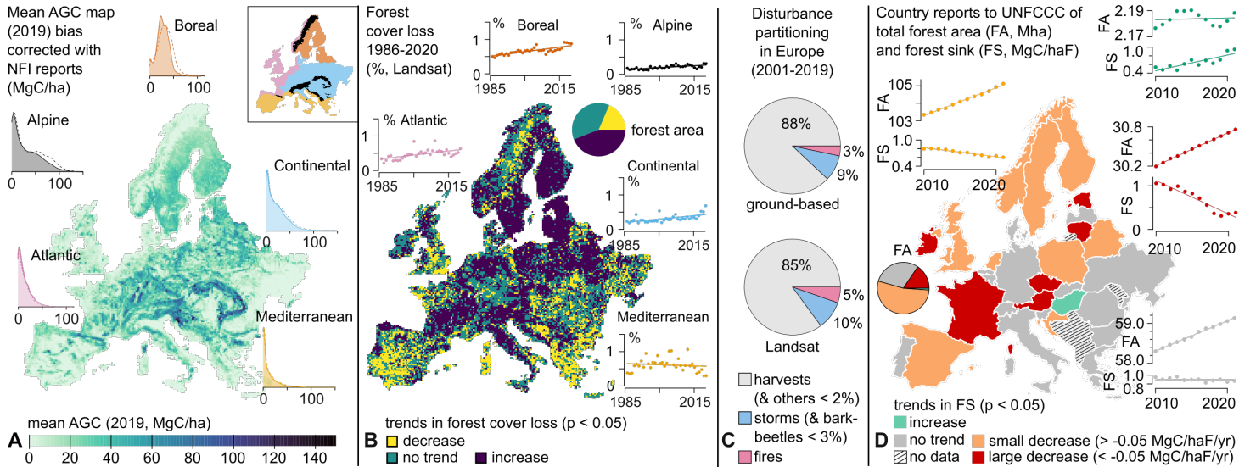
Fig. 1. Forest state in Europe during the historical period. (A) Above-ground biomass for the year 2019, averaged from two products: CCI-ESA (solid lines in the histograms) and PlanetScope (dashed lines), both bias-corrected with NFI data at a sub-national scale (see supplementary Fig. S3). Histograms show the distributions within five biogeographical regions indicated in the miniature. (B) Trends in the mean percentage of forest cover loss at 18 km. The annual forest cover loss has been aggregated from 30 m to 18 km, divided by the forest area at 18 km. Then, a moving average (30-year window) has been computed to produce the mean percentage of forest cover loss (six values from 2000 to 2005). A linear trend has been computed at 18 km based on these six values (no trend corresponds to p > 0.05). Scatterplots display the annual percentage of forest cover loss due to all disturbances (natural and anthropogenic) in each biogeographical region. They were obtained by spatially aggregating the forest cover loss (at 30 m) across each biogeographical region, and then dividing by the total forest cover of the region. See supplementary Fig. S9 for the return interval of the disturbances at 18 km. (C) Disturbance partitioning assessed from ground-based (1) and Landsat-based (2) data. The disturbance agents “bark beetles” and “others” have been merged with “storms” and “harvests” (respectively) due to Landsat’s limited sensitivity. The Landsat partioning has been computed on a sub-sample of Europe described in supplementary Fig. S12 (low-confidence pixels have been discarded). The ground-based partitioning was first established between harvests and natural disturbances (period 2001-2019, natural disturbances accounted for 16% of the mean annual harvest in Europe), then the natural disturbances was further partitioned following numbers given in (1) corresponding to the period 1950-2019 (D) Country reports to UNFCCC giving ground-based estimations from 2010 to 2021 of forest area (FA, Mha) and the forest sink (FS in MgC/haF), which is the sum of the net carbon stock change in the AGC, belowground-biomass, organic and mineral soils, deadwood, litter and harvested wood products. Four groups are separated based on the national forest sink trends: small decrease (in orange), large decrease (in red), and increase (in green, observed in Liechtenstein and Hungary only, which we do not understand; see supplementary Fig. S11) and no trend (in gray). For each group,$FA=\sum_{i}{{FA}_{i}}$ and $FS=(\sum_{i}{{FS}_{i}{FA}_{i}})/\sum_{i}{{FA}_{i}}$ with i a country of the group. The unit haF stands for hectares of forests.

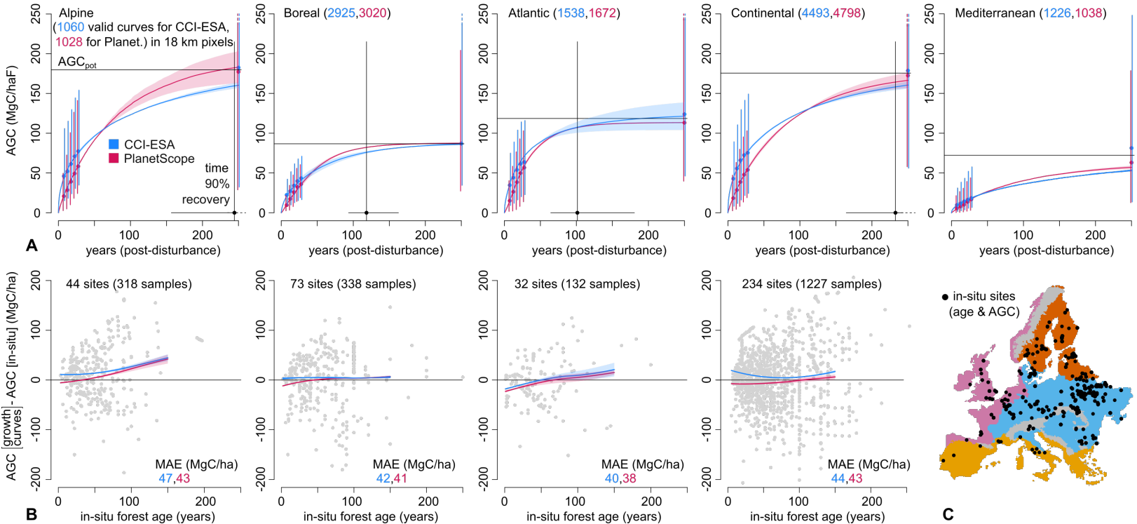
Fig. 2. Forest growth in Europe. (A) AGC recovery curves computed at 18 km based on a Chapman-Richard equation: ${AGC}_{CR}\left(t\right)={AGC}_{pot}{(1-e^{-bt})}^{c}$ using two AGC datasets (CCI-ESA in blue, and PlanetScope in red) harmonized with NFI data on a sub-national scale. See supplementary Fig. S6 for a map of coefficients b, c, and ${AGC}_{pot}$. The representative growth curve (thick line) is obtained with the median of all valid curves associated with a $r^{2}>0.5$ in a specific biogeographical region. Points represent the median of the AGC after a stand-replacing disturbance (limited to 5-30 years based on the Landsat range) or the median of the potential AGC (${AGC}_{pot}$ displayed for the $age=250$ years for visualization purposes only. AGC approaches ${AGC}_{pot}$ asymptotically, never reaching it fully) across all 18 km pixels (whiskers show the 95% variability, from 2.5% to 97.5% percentile). ${AGC}_{pot}$ is scaled from the AGC of forests undisturbed since 1986 with a bootstrap analysis that minimizes the difference between simulated and observed (UNFCCC) changes in AGC from 2010 to 2021 (supplementary Fig. S1 and S2). The 90% AGC recovery interval ($t_{90}$) is retrieved at 18 km with ${AGC}_{CR}\left(t_{90}\right)=0.9{AGC}_{pot}$, and then the median of all 18 km pixels is calculated. The shaded areas and the range of $t_{90}$ (horizontal black line) represent the variability from the bootstrap conducted on the scale of a country or a biogeographical region. (B) In-situ validation with the age and AGC of trees measured from 383 European sites. For each site, $f_{c}{AGC}_{CR}\left(age\right)-{AGC}_{in-situ}\left(age\right)$ has been computed using the nearest growth curve parameters, and $f_{c}$ is the forest fraction estimated at 90 m around the site from our forest mask. The thick curve represents the moving mean (loess) of all available anomalies, with a variability indicated by the mean absolute error for all available samples. The Mediterranean anomalies are discarded due to a small sample size (13 sites, supplementary Fig. S8). See supplementary Fig. S10 for an estimation of the measurement uncertainties. (C) Location of the in-situ sites and the biogeographical regions. The unit haF stands for hectares of forests.

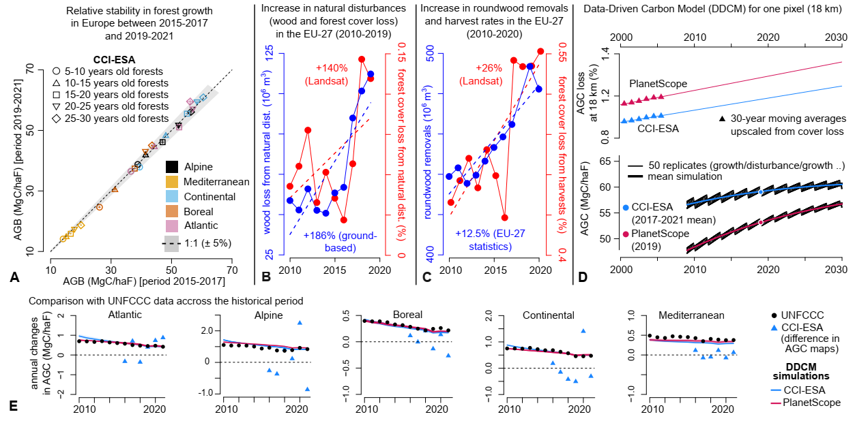
Fig. 3. Changes in forest growth and disturbances, DDCM procedure, and remote sensing inconsistencies in biomass change. (A) Comparison across Europe of the mean AGC (CCI-ESA, bias-corrected with NFI data on a sub-national scale) of forests from 5 to 30 years old (Landsat range) between the periods 2015-2017 and 2019-2021. For each year (2015,2016,2017,2019,2020,2021), the mean AGC of forests (for a given age class) has been aggregated from 30 m to 18 km. One point in panel A corresponds to the mean value of all 18 km pixels across Europe for the given period (2015-2017 for the X axis and 2019-2021 for the Y axis) and a given age class. (B) The volume of wood loss is shown in blue (1) and the percentage of forest cover loss is shown in red (2) due to natural disturbances in the EU-27 from 2010 to 2019. The percentage of forest cover loss has been aggregated from a sub-sample of Europe described in supplementary Fig. S12 (countries in the EU-27 have been selected, and low-confidence pixels have been discarded). (C) Roundwood removals are shown in blue (3) and the percentage of forest cover loss is shown in red (2) due to harvest or salvage logging in the EU-27 from 2010 to 2020. The percentage of forest cover loss has been aggregated from the same sub-sample of Europe described in panel B. (D) Example of AGC simulations from the data-driven carbon model (DDCM) for a forested pixel at 18 km, from two AGC datasets (the year 2019 for PlanetScope and mean of 2017-2021 for CCI-ESA) and one parameterization (bootstrap conducted on each country). See supplementary Fig. S2 for more details. The simulated AGC is the mean of 50 replicates. For each replicate, the period of growth is equal to the return interval, which is the average time between two mean disturbances aggregated at 18 km across 30-year windows (typically between 1 and 5 years). Each replicate has a different starting time of the first disturbance. The mean percentage of AGC loss at 18 km is scaled from the mean percentage of forest cover loss with a bootstrap analysis that minimizes the difference between simulated and observed (UNFCCC) annual changes in AGC from 2010 to 2021. (E) Annual AGC changes from CCI-ESA maps (2015 to 2021), UNFCCC reports, and DDCM simulations from 2010 to 2021 (PlanetScope has only one year of data, and changes cannot be assessed). Annual AGC changes for CCI-ESA (2016-2021) have been aggregated across each biogeographical region, regardless of the quality flag of the CCI-ESA product or possible 0 values emerging from a mismatch with our forest cover mask.

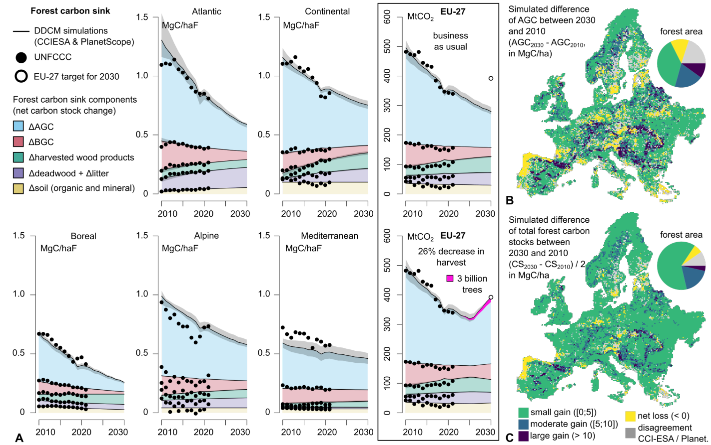

Fig. 4. Spatial and temporal changes in the carbon sink of European forests. (A) Forest sinks for the five biogeographical regions and for the EU-27 are based on two forest management scenarios: business as usual, and a 26% decrease in harvest in addition to the 3 billion trees planted by 2030 (their total forest sink is in pink). The forest sink is the sum of five components: net carbon stock change in the AGC, below-ground biomass (BGC), deadwood and litter, soils and harvested wood products. The EU-27 forest sink target has been estimated at 392 MtCO₂eq, the average for the years 2016-2018 (supplementary Fig. S7). The black-shaded area represents the total variability obtained from using PlanetScope or CCI-ESA maps with the parameterization conducted per country or biogeographical region. (B) Map of the difference between 2030 and 2010 of the AGC simulated by the DDCM. Forests losing AGC from 2010 to 2030 are in yellow. (C) Map of the difference between 2030 and 2010 of the forest carbon stocks composed of AGC, BGC, deadwood and litter, soil and harvested wood products (values have been divided by 2 to match the legend). Forests losing carbon (acting as a source) from 2010 to 2030 are in yellow. For both panels B and C, inconsistencies between CCI-ESA and PlanetScope are in gray (when one product predicts a carbon source and the other a carbon sink).

Method:

We start with a brief, simplified summary of the method, followed by a detailed description of each section. Unless otherwise specified, all variables are defined at 18 km spatial resolution.

Summary

The data-driven carbon model (DDCM version 1.1, supplementary Fig. S1 and Fig. S2) simulates annual AGC stocks from 2010 to 2030 at 18 km resolution. The net carbon stock change in AGC for a year y is computed as $ΔAGC(y)=AGC\left(y\right)-AGC(y-1)$. The net carbon stock changes in belowground biomass ($ΔBGC$), soils ($ΔS)$, harvested wood products ($ΔHWP)$, and deadwood (including litter, $ΔDWL$) are estimated based on$ΔAGC$ with linear relationships derived from UNFCCC data in five different biogeographical regions (supplementary Fig. S4). This gives access to the annual forest sink at 18 km, as defined $FS\left(y\right)=ΔAGC\left(y\right)+ΔBGC\left(y\right)+ΔS\left(y\right)+ΔHWP\left(y\right)+ΔDWL(y)$.

The $AGC\left(y\right)$ is computed from the imbalance between AGC gain due to forest growth and AGC loss due to disturbances. The annual percentage of AGC loss ($s(y)$) is modeled at 18 km resolution based on a linear relationship to capture long-term (30 years) trends in disturbance rates (Fig. 1B). This linear relationship is obtained by applying a scaling factor $α$ (constant over a country or a biogeographical region) to forest cover loss data aggregated spatially and temporally from a Landsat-based disturbance map. AGC gains are modeled using an analytical growth curve at 18 km resolution (Fig. 2A). The growth curve is constrained by an upper limit, referred to as potential AGC (${AGC}_{pot}$), which is obtained by applying a scaling factor $β$ (constant over a country or a biogeographical region) to AGC values of forests undisturbed since 1986. Then the two coefficients of the forest growth curve (b,c) are retrieved at 18 km knowing the age (obtained from the disturbance map, from 5 to 30 years old) and the AGC (obtained from the remote-sensing maps CCI-ESA or PlanetScope) of thousands of 30 m forested pixels inside each 18 km pixel (supplementary Fig. S6). The two upscaling factors $α$ and $β$ are parameterized at the scale of a country (or a biogeographical region) so that DDCM simulations match the UNFCCC observations (2010-2021, see Fig. 3E and supplementary Fig. S5). The reduction in harvest necessary for the EU-27 to meet their target by 2030 has been simulated starting in 2025, knowing the constant ratio at 18 km between harvests and natural disturbances (supplementary Fig. S13 and Fig. S14).

In particular, version 1.1 of the DDCM (i) matches the forest cover and the AGC of European countries based on NFI data for the year 2020 (Supplementary Fig. S3), (ii) does not simulate land-use change (the forest cover is constant), (iii) does not account for changes in the growth curves (for example CO₂ fertilization effects are ignored, Fig. 3A), (iv) captures long-term trends (30-year periods) at 18 km in natural disturbances and harvests (Fig. 1B), and finally (v) ignores the AGC changes according to the maps from CCI-ESA (2015-2021, these are contaminated with artefacts, see Fig. 3E). A single year of AGC data (2019 for PlanetScope and mean of 2017-2021 for CCI-ESA) is used to run the DDCM from 2010 to 2030.

As a proof of concept, supplementary Fig. S16 illustrates the DDCM simulation parameterized using only the UNFCCC data from 2010. Despite no prior information about the decline in the forest sink from 2011 to 2021, the model accurately replicates this trend. This outcome demonstrates that the model avoids overfitting the UNFCCC data and effectively captures the key drivers of the forest carbon sink decline: increasing rates of natural and anthropogenic disturbances, coupled with insufficient compensation from deadwood and harvested wood product sinks, despite their growth.

Sections

Forest mask. This study exclusively focuses on forest lands based on the harmonized NFI dataset on a sub-national scale across Europe for the year 2020 (4). As Ukraine, Moldova and Belarus were missing in this dataset, we extended it using the forest area documented for these countries in the 2020 reports from the Food and Agriculture Organization of the United Nations, Global Forest Resources Assessment (FAO-FRA (5)). We created a gridded forest mask at 30 m in Europe (EPSG:3035) that matches the NFI forest area with the following procedure. We first calculated the mean of two existing forest products at 30 m: the forest mask from the 1986-2020 disturbance map (6) (discrete values of 0 or 1) and the forest canopy cover from the 2019 PlanetScope map (7) (continuous values between 0 and 1). Then, for each departmental unit in Europe (288 units distributed among 40 countries), we calculated a threshold above which the aggregated sum of our forest mask corresponds to the NFI forest area for this unit (supplementary Fig. S3). All 30 m pixels above this threshold were set to 1, otherwise 0. We did not encounter major problems where NFIs reported a forest cover much higher than the mean of the two forest masks. The mean threshold across all units (288) is 0.59 $±$0.26 ($±$ 1 SD).

AGC maps. The annual AGC CCI-ESA maps (8) (2015 to 2021, version 5, at 100 m resolution) and the 2019 PlanetScope-based AGC map (7) (30 m, version 0.1) are downscaled with a bilinear resampling to the 30 m forest mask, and non-forested pixels are discarded. The 2010 CCI-ESA AGC map is discarded because of known biases due to the sensor difference (supplementary Fig. S8B). All AGC maps have been bias-corrected to match the AGC reported at the sub-national scale in the harmonized NFI dataset for the year 2020 (4). As Ukraine, Moldova and Belarus were missing in the harmonized NFI dataset, we extended it using the AGC documented for these countries in the FAO-FRA reports (5) for 2020. The correction for each European departmental unit is a multiplicative factor corresponding to the ratio between the AGC reported by NFIs and the mean raw AGC of 2020 for CCI-ESA or 2019 for PlanetScope (supplementary Fig. S3). The median correction across all units (288) is 1.30 $±$0.27 ($±$ 1 Mean Absolute Deviation) for CCI-ESA, and 1.06 $±$0.24 ($±$ 1 MAD) for PlanetScope.

Biogeographical regions. The biogeographical regions are defined by the European Environment Agency (https://www.eea.europa.eu/en). Some regions (Arctic, Pannonian, Anatolian, Macaronesia, Steppic and Black Sea) are located beyond the study’s boundaries and merged with their closest neighbor (arctic with boreal, the remaining regions with continental). Europe is therefore divided into five biogeographical regions (Fig. 1A) with different characteristics based on topography (the Alpine region includes all major mountains), climate (Atlantic, Continental, Mediterranean) or ecosystem composition.

UNFCCC reports. We used the 2023 common reporting format reports (CRF) of all 33 countries available in Europe (https://unfccc.int/ghg-inventories-annex-i-parties/2023) for the years 2010 to 2021. For each country and each year, we extracted the following components from Table 4a (row “A. total forest land”): “Total area (kha)”, “net carbon stock change in living biomass (ktC)”, “Net carbon stock change in dead wood (ktC)”, “Net carbon stock change in litter (ktC)”, “Net carbon stock change in mineral soils (ktC)” and “Net carbon stock change in organic soils (ktC)”. We extracted the following components from Table 4: “4. Total LULUCF (Land Use, Land-use Change and Forestry) for the Net CO2 emissions/removals (ktCO2)” and “G. Harvested wood products for the Net CO2 emissions/removals (ktCO2)” (ΔHWP). For each year and each country, we converted all components in MgC/haF (Megagrams of Carbon per hectare of forests) by dividing them by the forest area (and multiplying the components in ktCO2 by 12/44 to obtain ktC). Two obvious errors have been found and corrected in the UNFCCC report of two countries (supplementary Fig. S8): (i) France reported a forest area including its overseas territories, but the forest sink has been computed across metropolitan France only (this error has been corrected using an official report from the International Technical Centre on Air Pollution and Climate Change, CITEPA (9)), (ii) The detailed forest sink reported by Portugal in Table 4a does not correspond to the forest sink used in their LULUCF report in Table 4 (We used the forest sink from Table 4a and updated their LULUCF budget). For all countries, we partitioned the “net change in carbon stock change in living biomass” (ΔLB) into two new components: “net change in carbon stock change in above-ground biomass” (ΔAGC) and “net change in carbon stock change in below-ground biomass” (ΔBGC). This partitioning has been performed using $ΔAGC=\frac{1}{1+ε}ΔLB$ and $ΔBGC=\frac{ε}{1+ε}ΔLB$ with $ε=\frac{BGC}{AGC}$. The factor $ε$ has been calculated for each country (supplementary Fig. S4A) based on the national AGC and BGC documented in the FAO-FRA reports (5) for 2020 (The year 2015 has been used instead for Serbia, Albania, Cyprus, Portugal, Greece and Malta as the year 2020 was not available yet). The mean $ε$ across all countries is 0.25 $±$0.06 ($±$ 1 SD). To reduce the large discrepancies between country reports, we summed the “Net carbon stock change in organic soils” with “Net carbon stock change in mineral soils” to create a single component “Net carbon stock change in soils (ΔSoil)”. Similarly, we summed the “Net carbon stock change in deadwood” with “Net carbon stock change in litter” to create a single component “Net carbon stock change in deadwood and litter (ΔDWL)”. For each year $y$ and each country $c$, the forest sink is therefore defined in this study as the sum of five components: ${FS}_{c}(y)={ΔAGC}_{c}(y)+{ΔBGC}_{c}(y)+{ΔSoils}_{c}(y)+{ΔDWL}_{c}(y)+{ΔHWP}_{c}(y)$ expressed in MgC/haF. For each biogeographical region, we reconstructed the five components of the forest sink based on each country's forest area overlapping with the biogeographical region (according to our forest mask, supplementary Fig. S4B). Let b be a biogeographical region, ΔV one of the five components, and $c$ a country with an overlap of forest area ${FA}_{c}$ with b (${FA}_{c}=0$ if the country is outside the biogeographical region), then: ${ΔV}_{b}=(\sum_{c}{{FA}_{c}{ΔV}_{c}})/\sum_{c}{{FA}_{c}}$ (in MgC/haF). For each biogeographical region, linear relationships of ${ΔV}_{b}$ versus ${ΔAGC}_{b}$ were calculated (the mean is computed instead if the trend is non-significant, p > 0.05) based on 12 data points (2010 to 2021). The linear model is justified here because the forest sink ${FS}_{b}$ is strongly linearly related to ${ΔAGC}_{b}$, with a $r^{2}$ varying from 0.87 to 0.99 for the five biogeographical regions. These linear relationships were used in the DDCM model to estimate each forest sink component at 18 km from 2010 to 2030 (supplementary Fig. S4D-G). Hungary and Liechtenstein are the two only countries reporting an increasing trend in their forest sink (Fig. 1D), which we currently do not explain (the growth rate or the disturbance proportions of Hungary do not particularly show large differences compared to its neighbors, supplementary Fig. S11).

Disturbances. Disturbances are defined in this study at 18 km resolution based on spatial and temporal aggregations of the severity in the forest cover loss at 30 m (Landsat-based (6), Fig. 1B). These disturbances aggregated at 18 km are associated with two annual characteristics: (i) $s\left(y\right)$, the annual percentage of AGC loss with y a year, and (ii) $τ\left(y\right)$, the return interval (which is the average time between two mean disturbances at 18 km across 30 years). We explain how we estimated them in the following. For each year (1986 to 2020), the 30 m severity values are summed in 18 km pixels and divided by the forest area to produce a time series of the percentage of forest cover loss in each year (scatter plots in Fig. 1B). For each 18 km pixel, these annual percentages are averaged over six 30-year windows (1986-2015 to 1991-2021) and a linear trend ($f_{loss}(y)$) is calculated through the six mean values to extrapolate the percentage of cover loss from 2010 to 2030 (the mean is computed instead if p > 0.05). The conversion from a percentage of cover loss to a percentage of AGC loss is given by $s\left(y\right)=βf_{loss}(y)$, with $β$ a correction factor calculated on the scale of a country or a biogeographical region (section ”DDCM parameterization”). For each 18 km pixel and six 30-year windows (from 1986-2015 to 1991-2020), the return interval of the mean disturbance is characterized by $τ=\frac{1}{P}$ with $P$ the exceedance probability compared to the mean percentage of forest cover loss in this pixel. $P$ is estimated (10) with the number of years associated with a forest cover loss above the mean loss (across 30 years at 18 km) divided by the time-series length (30 years). A linear trend is calculated based on the six computed values$τ$ per pixel to extrapolate $τ$ from 2010 to 2030 (Fig. 3c). If the trend is not significant (p > 0.05), the median is computed instead because $τ$ takes discrete values. Based on 2005 values, the Atlantic and Continental regions share similar return intervals (~3$.3±0.1$ years), the Alpine and Mediterranean have higher return intervals (~3$.9±0.2$ years), and the Boreal has lower return intervals (2.7 years). The trends are non-significant (p > 0.05) for ~67% of European forests, without obvious spatial patterns for the remaining forests (supplementary Fig. S9). It is important to notice that this return interval does not refer to disturbance events at 30 m (which occur much more rarely) but to disturbances aggregated at 18 km. Finally, we shortly discuss uncertainties related to the Landsat-based disturbance map at 30 m (6). This product relies on the best available pixel composites; therefore, data density affected by changes in technological advances in Landsat has a rather marginal effect. The accuracy has probably not significantly shifted as all data processed to level-2 have the same quality standards, and the spectral differences between different sensors (TM, ETM+ and OLI) have been polished. Finally, the LandTrendr algorithms used to detect a disturbance event (6) remove a lot of noise, resulting in a relatively high omission error. Hence, the overall disturbance rates are likely underestimated.

AGC recovery curves. The AGC of forests recovering after a stand-replacing disturbance (Fig. 2A) is reconstructed at the scale of small regions (18 km grid cells) to account for the spatial variability that exists in their biotic and abiotic drivers (in soil properties, tree species or climates (11)), and also to capture a sufficient number of 30 m stand-replacing disturbances in each 18 km pixel (10% of the forest area of each pixel has been disturbed on average from 1986 to 2020). Similar curves have been used in former studies (12,13), but not at this spatial resolution or spatial extent. The year of the disturbance is first subtracted from the year of the AGC map to obtain post-disturbance years. The AGC maps are then normalized by dividing them with ${AGC}_{pot}$ defined here as ${AGC}_{pot}= α{AGC}_{75\%}$, with ${AGC}_{75\%}$ the 75% percentile of the AGC of all 30 m forests undisturbed since 1986 inside an 18 km pixel, and $α$ a correction factor calculated on the scale of a country or biogeographical region (section ”DDCM parameterization”). For each normalized AGC map (2015-2021 for CCI-ESA and 2019 for PlanetScope) and each 18 km pixel, five mean AGCs are calculated within five-time windows ([5-10 years], [10-15 years],..,[25-30 years]). For each time window, the average of the seven products of CCI-ESA (2015-2021) is computed to reduce uncertainties. A Chapman-Richard growth curve (${AGC}_{CR}\left(t\right)= {(1-e^{-bt})}^{c}$) is fitted through the five values to estimate the $b$ and $c$ coefficients. Growth curves with non-physical inputs are discarded (AGC[5-10 years] > AGC[25-30 years]), and outliers in $b$ and $c$ populations across Europe are removed using the Logbox method (14). Growth curves associated with $r^{2}<0.5$ are finally discarded (supplementary Fig. S6). To visualize the representative AGC recovery curve for a given biogeographical region (Fig. 2A), we first normalized each curve (divided them by their ${AGC}_{pot}$ at 18 km), then stacked them by calculating the median for the age varying from 0 to 250 years. We finally multiplied this representative curve by the median ${AGC}_{pot}$ of all 18 km pixels with valid growth curves. The time $t_{90}$ required to recover 90% of the ${AGC}_{pot}$ after a stand-replacing disturbance corresponds to ${AGC}_{CR}\left(t_{90}\right)=0.9{AGC}_{pot}$ which leads to $t_{90}=-\frac{1}{b}log(1-{0.9}^{\frac{1}{c}})$. The median $t_{90}$ has been calculated from all 18 km pixels with valid growth curves. This procedure has been repeated for each AGC map (AGC maps from CCI-ESA have been averaged from 2017 to 2020) and each model parameterization (see “DDCM parameterization”) to estimate the uncertainty.

DDCM. For each 18 km pixel, the AGC value from the PlanetScope map (2019) or CCI-ESA maps (averaged from 2017 to 2021 to center it around 2019) is the starting point for a backward simulation (from 2019 to 2009) and forward simulation (from 2019 to 2030) of AGC (Fig. 3D). Each simulation is the mean of 50 replicates associated with a different starting date for the first disturbance. One replicate simulates successive periods of growth $τ(y)$ (the return interval of the mean disturbance at 18 km for a year $y$) based on ${AGC}_{CR}\left(t\right)= {{AGC}_{pot}(1-e^{-bt})}^{c}$, followed by a disturbance of severity $τ(y)×s(y)$, with $s(y)$ the annual percentage of AGC loss for the year $y$ (Fig. 3D). Once the simulated AGC maps (in MgC/haF, Megagrams carbon per hectare of forests) are produced from $y=2009$ to $y=2030$, the annual changes in AGC is calculated: $ΔAGC\left(y\right)=AGC\left(y\right)-AGC(y-1)$. Knowing the linear relationships between the forest sink components and observed $ΔAGC$ for the five biogeographical regions (section “UNFCCC”, see supplementary Fig. S4D-G), the forest sink is reconstructed at 18 km across Europe with projections from 2010 to 2030 (Fig. 4). The outputs from the DDCM at 18 km are therefore: forest cover, forest age, linear coefficients of the trend in the percentage of AGC loss ($s\left(y\right)=a_{s}y+b_{s}$ in annual % of AGC loss), linear coefficients of the trend in the disturbance return interval ($τ\left(y\right)=a_{τ}y+b_{τ}$ in years), potential AGC (${AGC}_{pot}$ in MgC/haF), recovery curves coefficients ($b$ and $c$, unitless), simulated AGC from 2009 to 2030 (in MgC/haF), and the forest sink components from 2010 to 2030: $ΔAGC, ΔBGC, ΔHWP, ΔDWL and ΔSoil$(net carbon stock change in MgC/haF). Malta and Cyprus are located outside of our dataset boundary; however, they represent only 0.03% of the European forest sink. Therefore, we simulated their sink component from 2010 to 2030 with a linear extrapolation of their current trends. Any missing values (in the inputs or outputs of the DDCM) at 18 km are spatially interpolated across Europe, with the percentage of missing values given in the supplementary (supplementary Fig. S8).

DDCM parameterization. AGC simulations from the DDCM model are sensitive to two parameters at 18 km: (i) the potential AGC (${AGC}_{pot}$), which is the maximum reachable AGC for a forest left undisturbed during a long period of time, and (ii) the percentage of AGC loss due to disturbances ($s(y)$). These two parameters remain difficult to estimate because (i) old-growth forests are scarce in Europe and undisturbed forests can be traced back to 1986 only (Landsat range), and (ii) the disturbance map built on Landsat images captures the forest cover loss only (and not the AGC loss). To solve this issue, we introduced two corrections $α$ and $β$ (supplementary Fig. S5) such as: ${AGC}_{pot}= α{AGC}_{75\%}$ and $s\left(y\right)=βf_{loss}(y)$. The variable ${AGC}_{75\%}$ is the 75% percentile of the AGC of all 30 m forests undisturbed since 1986 inside an 18 km pixel and $f_{loss}(y)$ is the linear trend at 18 km in the percentage of forest cover loss based on six 30 years moving averages of Landsat data (see section “disturbances” and Fig. 1B). For each AGC dataset (average of AGC maps from 2017-2021 for CCI-ESA, or PlanetScope map of 2019), values of ($α$,$β)$ have been estimated on a country-level or a biogeographical region-level using a bootstrap analysis that minimizes the RMSE between DDCM simulations and observations of $Δ$AGC from UNFCCC reports across the recent historical period (2010-2021, see Fig. 3D). Then these ($α$,$β)$ correction maps have been smoothed at 100 km to reduce the discrepancies at the border between two countries or two biogeographical regions. There are therefore four different versions of the outputs of the DDCM model: CCI-ESA (parameterization conducted on each country), CCI-ESA (parameterization conducted on each biogeographical region), PlanetScope (parameterization conducted on each country) and PlanetScope (parameterization conducted on each biogeographical region). Each version has different AGC recovery curves, disturbance trends and projected forest sinks. Uncertainties reported in brackets and shaded areas in Fig. 2, 3 and 4 show the total range obtained from these versions. Throughout the study, when we mentioned simulated results from “PlanetScope” or “CCI-ESA”, we implicitly considered the average of the two versions of the same dataset and reported the range between them.

In-situ AGC validation data for satellite-based regrowth curves. The in-situ observations for validating the growth curves originate from a diverse forest inventory collection previously used to upscale forest age (15). These data (AGC and age of national forest inventory plots) can be accessed upon request. The forest fraction ($f_{c}$) of these sites has not been reported and has been estimated at 90 m with our forest mask based on a spatial aggregation from 30 m to 90 m. We did this to reduce the mismatch at 30 m between the localization of the in-situ forest plots and our forest mask (all sites with $f_{c}=0$ at 90 m have been discarded). For each remaining site (383 across Europe), ${AGC}_{CR}(t)={AGC}_{pot}{(1-e^{-bt}) }^{c}$ has been computed using the nearest potential AGC (${AGC}_{pot}$) and growth curve parameters ($b$ and $c$) after filling in missing values of $b$, $c$ and ${AGC}_{pot}$ with spatial interpolations at 18 km across Europe. Anomalies shown in Fig. 2B correspond to ${f_{c}AGC}_{CR}\left(age\right)-{AGC}_{in-situ}\left(age\right)$ with the $age$ from ground-based estimations. Uncertainties associated with the in-situ measurements have been estimated between 20 and 30 MgC per site (depending on the age, supplementary Fig. S10).

Forest sink target. The EU-27 defined the LULUCF sink target as 310 MtCO₂eq/year in 2030. The LULUCF sink is the sum of multiple components: forest lands, harvested wood products, croplands, grasslands, wetlands, settlements, and “other” lands. Their target has been partly established on the average greenhouse gas inventory data for the years 2016, 2017 and 2018 (16). We, therefore, recalculated the target for the forest sink only (net carbon stock change in AGC, BGC, deadwood and litter, soil and harvested wood products) of all EU-27 countries from 2016 to 2018 based on the 2023 UNFCCC reports, which led to the value of 392 MtCO₂eq/year, defined as the 2030 forest sink target in our study (supplementary Fig. S7).

Partitioning between natural disturbances and harvests. The partitioning between natural disturbances and harvests has been obtained at 18 km (supplementary Fig. S13) based on the disturbance attribution to three agents using Landsat data at 30 m (2): fire, storms (including bark-beetles that represent less than 3% of the total disturbances according to (1)) and harvests (including “others” that represent less than 2%). For each agent and each year (1986-2020), we spatially summed their associated severity (spectral indice between 0 and 1) from 30 m to 18 km. To flag and discard suspicious pixels at 18 km, we compared the Landsat-based harvests map with a wood production map constrained by NFI data from 2000 to 2010 (17). To do so, we produced two maps at 18 km: (i) the total sum of severities associated with harvests from 2000 to 2010 at 18 km (Landsat-based map), and (ii) the total sum of wood production from 2000 to 2010 at 18 km (NFI-based map). Because these two maps use two different units, we computed a quantile version of each map with discrete values of 0, 0.1, 0.2,…, 1 (Supplementary Fig. S12). A value of 1 means a hotspot of harvest (or wood production) compared to the rest of the continent. We calculated the absolute difference between the two quantile maps. We found 61% of pixels with high agreement (absolute difference below 0.1), 25% of pixels with moderate agreement (absolute difference between 0.2 and 0.3 of difference) and 14% of pixels with low agreement (absolute difference above 0.4). We discarded the pixels of low agreement from the entire study (especially for Fig. 1C described below and for Fig. 3B and Fig. 3C described in the section “recent increase in natural disturbances and harvests”). To produce the map of the ratio between natural disturbances and harvests at 18 km, we first computed the sum of severities associated with natural disturbances (fires and storms) from 1986 to 2020 at 18 km, and then we computed the sum of the severities associated with harvests from 1986 to 2020 at 18 km. We calculated the ratio $R$by dividing both maps at 18 km. We imputed the 14% missing pixels associated with a low agreement with the wood production map. To do so, we first flagged pixels that (i) share similar wood production with the missing pixels (low/medium/high based on the terciles threshold of the percentile map, i.e. 0.33 and 0.66), and (ii) are associated with a high agreement with the wood production map (i.e., their Landsat-based disturbance attributions are trustworthy). We replaced the ratio of the missing pixels with the median ratio from these three groups (low/medium/high wood production, see supplementary Fig. S13). We performed a spatial aggregation of the remaining missing pixels in Europe. Finally, as Ukraine was missing, we gave this country the median ratio value across Europe (17%). In parallel, we also tested for a possible change through time of the ratio between natural disturbances and harvests across Europe (supplementary Fig. S14). We aggregated the total sum of severities (from the Landsat map) associated with natural disturbances for each year. We divided them by the total sum of severities associated with harvests for each year (we discarded the low-confidence pixels from supplementary Fig. S12). We did not detect a significant trend (p = 0.14 > 0.05) in Europe’s ratio between natural disturbances and harvests from 1986 to 2020, which confirms earlier ground-based reports of natural disturbances (1). The mean value is 17%, which is remarkably close to to the ground-based continental value of 16% (1). We finally describe here the design of Fig. 1C. The Landsat-based partitioning in Fig. 1C has been computed using the total sum of severities from 2001 to 2019 associated with the three main agents: fires, storms (including bark-beetles) and harvests (including “others”). Low-confidence pixels at 18 km (described previously) were discarded beforehand. The ground-based partitioning in Fig. 1C was first established between harvests and natural disturbances following numbers given in (1) (period 2001-2019, natural disturbances accounted for 16% of the mean annual harvest in Europe), then the natural disturbances have been further partitioned into fires and storms (including bark-beetles) with their estimates corresponding to the period 1950-2019. The agent “others” (less than 2%) has been merged with harvests to match the convention of the Landsat-based partitioning.

Recent increases in natural disturbances and harvests. To produce Fig. 3B (blue axis on the left), we first extracted the ground-based data from (1) and then computed the total sum of the volume of wood lost due to natural disturbances from all countries in the EU-27 (column “Reported_GapFilled_m3” in their dataset) for each year from 2010 to 2019. The agent “other biotics” in their dataset has been discarded to match the convention of the Landsat-based map with the disturbance agents attributed (see previous section “partitioning between natural disturbances and harvests”). Then, for the Landsat-based estimation of the increase in natural disturbances (red axis on the right in Fig. 3B), we first discarded low-confidence pixels at 18 km (see previous section). Then, we spatially summed for each year (from 2010 to 2019) the severities associated with natural disturbances (storms and fire) in the EU-27. We divided by the forest area of EU-27 (we discarded the forest area of low-confidence pixels). We similarly produced Fig. 3C, except using the severities associated with harvests from 2010 to 2020 for the Landsat-based data (red axis on the right) and the roundwood removals from 2010 to 2020 extracted from Eurostat (3) for the ground-based data (blue axis on the left).

Forest growth change. We estimated forest growth change in Europe with remote-sensing data between 2016 (period 2015-2017) and 2020 (period 2019-2021) for five different age class: [5-10], [10-15], …, [25-30] years old (Fig. 3A). These forests have not been disturbed since (according to the disturbance map). Therefore, the AGC associated with their age represents their net forest growth. For each year (from 2015 to 2021), we first aggregated from 30 m to 18 km the mean AGC (CCI-ESA version 5, bias-corrected with NFI data, see section “AGC maps”) of forests severely disturbed since [5-10], [10-15], …, [25-30] years (therefore five maps per year). Then we calculated for each age class and each year the spatial mean of all 18 km pixels presents in a given biogeographical region. Fig. 3A shows the comparison for each age class between two periods: 2016 (mean of 2015-2017) and 2020 (mean of 2019-2021). We did not detect any significant change in net forest growth between these two periods ($±5\%$). This means for example that a 20 years old forest is associated, on average, with the same AGC whereas it lived in 2016 or in 2020.

Forests acting as carbon sources by 2030. A total of 6% of forests have been estimated to act as carbon sources from 2010 to 2030 (Fig. 4C). The DDCM produces at 18 km for each year the forest sink $FS\left(y\right)=CS\left(y\right)-CS(y-1)$ with CS(y) the total carbon stock of the forest for year y. Therefore $\sum_{y=2011}^{y=2030}{FS\left(y\right)}= CS\left(2030\right)-CS(2010)$. We counted a number of 803 pixels where $CS\left(2030\right)<CS(2010)$ in the simulations from CCI-ESA or PlanetScope (agreement between both datasets in the direction of change for each pixel). According to our forest mask, the total forest area associated with these pixels was 12.21 Mha, which we divided by the forest area of Europe (209.15 Mha) to obtain 6%. However, this estimation is twice as high when considering each dataset individually (i.e., ignoring their disagreements): 10% for CCI-ESA, and 12.5% for PlanetScope. The same procedure is performed for the AGC (Fig. 4B), which leads to 12% of forests losing biomass from 2010 to 2030 (agreement between CCI-ESA and PlanetScope). Considering each dataset individually, this percentage becomes 22% (CCI-ESA) and 23.5% (PlanetScope).

Decrease of 26% in harvest. For the EU-27 to reach their 2030 sink target, a 26 [20,31] % decrease in harvest from 2025 to 2030 has been estimated as necessary as a first-order approximation. We explain this value based on three assumptions: (i) the forest sink target of the EU-27 is 392 MtCO₂eq/year in 2030 (supplementary Fig. S7), (ii) the 3 billion trees pledge is respected (additional 15 MtCO₂eq/year of carbon sink by 2030 (18)), (iii) when the business-as-usual forest management is followed, the ratio $R$ at 18 km between natural disturbances and harvests is constant (Supplementary Fig. S13). For a given 18 km pixel, let $s\left(y\right)=Ay+B$ be the annual percentage of AGC loss (including harvests and natural disturbances) in the business-as-usual scenario ($y$ is the year), and $s_{red}\left(y\right)= A_{red}y+B_{red}$ be the annual percentage of AGC loss (including harvests and natural disturbances) with a reduction in harvest for $y>2025$. We define $w$ as the percentage of reduction in harvest from 2025 to 2030. We have:

$$\left\{\begin{aligned}A_{red}= \frac{1}{1+R}(RA-\frac{w}{500}(2025A+B)) \\ B_{red}=B+\frac{2025}{1+R}(A+\frac{w}{500}(2025A+B))\end{aligned}\right.$$

Because A, B and R are known, $w$ is estimated with a bootstrap so that the forest sink of the EU-27 (including the 3 billion trees) will reach 392 MtCO₂eq/year by 2030. The mean percentage of harvest reduction obtained is $w=26\%$, with a range from $w=20\%$ (PlanetScope, parameterization on each country) to $w=31\%$ (CCI-ESA, parameterization on each country).

Before the mathematical demonstration, two simple verifications that these equations are consistent:
- If $R= ∞$(no harvest in this pixel), then $A_{red}=A$, $B_{red}=B$. It means that the decrease in harvest in an 18 km pixel that is not harvested has no consequence on the trend.
- If $w= 0\%$ (constant rate of harvests from 2025 to 2030), then $A_{red}=\frac{R}{1+R}A$. This is the slope of natural disturbances (see the demonstration); it makes sense because harvests are set constant.

demonstration

We first need to partition natural disturbances and harvests using their ratio R.

$$s\left(y\right)= \frac{R}{1+R}s\left(y\right)+\frac{1}{1+R}s(y)$$
The first member is the natural disturbances (they will not be modified), and the second is the harvests. Let’s introduce an intermediate variable $s_{red}^{har}\left(y\right)= A^{har}y+B^{har}$, with $s_{red}^{har}\left(y\right)$ the annual percentage of AGC loss only due to harvests in the scenario where we have a reduction in harvest for $y>2025$. Therefore:

$$s_{red}\left(y\right)= \frac{R}{1+R}s\left(y\right)+s_{red}^{har}\left(y\right)$$

The percentage of reduction in harvest from 2025 to 2030 is defined as:

$$w= \frac{s_{red}^{har}\left(2025\right)-s_{red}^{har}\left(2030\right)}{s_{red}^{har}\left(2025\right)}100$$
Using $s_{red}^{har}\left(2025\right)=\frac{1}{1+R}s(2025)$in the denominator only leads to the following:
$$A^{har}= -\frac{2025A+B}{500(1+R)}w$$

This is enough to find $A_{red}$ based on

$$s_{red}\left(y\right)=A_{red}y+B_{red}=\frac{R}{1+R}(Ay+B)+A^{har}y+B^{har}$$
Therefore $A_{red}=\frac{R}{1+R}A+A^{har}$ which corresponds to the first equation we proposed. Finally, $B_{red}=s_{red}\left(2025\right)-{2025A}_{red}= s\left(2025\right)-{2025A}_{red}$ based on the fact that $s_{red}\left(2025\right)=s\left(2025\right)$. This leads to the second equation.

REFERENCES

- Patacca, M. et al. Significant increase in natural disturbance impacts on European forests since 1950. Glob. Chang. Biol. 29, 1359–1376 (2023).
- Seidl, R., Senf, C. Changes in planned and unplanned canopy openings are linked in Europe’s forests. Nat Commun 15, 4741 (2024). https://doi.org/10.1038/s41467-024-49116-0
- Eurostat, Roundwood removals by type of wood and assortment. https://doi.org/10.2908/FOR_REMOV. Last data access: 25/10/2024.
- Avitabile, V., Pilli, R., Migliavacca, M. et al. Harmonised statistics and maps of forest biomass and increment in Europe. Sci. Data 11, 274 (2024). https://doi.org/10.1038/s41597-023-02868-8
- FAO. Global Forest Resources Assessment 2020: Country Reports https://www.fao.org/forest-resources-assessment/fra-2020/country-reports/en/ (2020).
- Senf, C. and Seidl, R. Mapping the forest disturbance regimes of Europe. Nat. Sustain. 4, 63–70 (2021).
- Liu, S. et al. The overlooked contribution of trees outside forests to tree cover and woody biomass across Europe. Sci. Adv. 9, eadh4097 (2023). https://doi.org/10.1126/sciadv.adh4097
- Santoro, M.; Cartus, O. (2024): ESA Biomass Climate Change Initiative (Biomass_cci): Global datasets of forest above-ground biomass for the years 2010, 2015, 2016, 2017, 2018, 2019, 2020 and 2021, v5. NERC EDS Centre for Environmental Data Analysis, 22 August 2024. https://dx.doi.org/10.5285/02e1b18071ad45a19b4d3e8adafa2817
- https://www.citepa.org/wp-content/uploads/publications/ccnucc/LULUCF_Background-d_ed2023_v2.zip
- Lestang, T., et al. Computing return times or return periods with rare event algorithms. J. Stat. Mech. Theory Exp. 2018, 043213 (2018).
- Babst, F. et al. Twentieth century redistribution in climatic drivers of global tree growth. Sci. Adv. 5, eaat4313 (2019).
- Heinrich, V.H.A. et al. The carbon sink of secondary and degraded humid tropical forests. Nature 615, 436–442 (2023). https://doi.org/10.1038/s41586-022-05679-w
- Pretzsch, H., et al. Forest growth in Europe shows diverging large regional trends. Sci Rep 13, 15373 (2023). https://doi.org/10.1038/s41598-023-41077-6
- Ritter, F. Technical note: A procedure to clean, decompose, and aggregate time series. Hydrol. Earth Syst. Sci. 27, 349–361 (2023).
- Besnard, S. et al. Mapping global forest age from forest inventories, biomass and climate data. Earth Syst. Sci. Data. 13, 4881–4896 (2021).
- https://climate.ec.europa.eu/eu-action/land-use-sector_en
- Verkerk, P. et al. Mapping wood production in European forests. For. Ecol. and Manage. 357, 228-238 (2015). https://doi.org/10.1016/j.foreco.2015.08.007
- Grassi, G., et al., Brief on the role of the forest-based bioeconomy in mitigating climate change through carbon storage and material substitution. Sanchez Lopez, J., Jasinevičius, G. and Avraamides, M. editor(s), European Commission, JRC124374 (2021). https://publications.jrc.ec.europa.eu/repository/handle/JRC124374.

Supplementary material:

In the following, we provide supplementary material with a more technical focus.

Flowchart & example of the DDCM procedure. Fig. S1 & Fig. S2 present the DDCM procedure with a summary of the workflow and a detailed example of the estimation of the forest carbon sink of an 18 km forested pixel.
Country attribution to historical trends in the forest sink. Tables S1 to S4 give details of the UNFCCC data associated with each country based on their forest sink trend from 2010 to 2021 (used to produce Fig. 1c). Countries are separated into four groups: small decrease (Table S1), no trend (Table S2), large decrease (Table S3) and increase (Table S4) in the forest sink.
Harmonization with NFI data. Fig. S3 explains how the AGC maps from PlanetScope & CCI-ESA have been bias-corrected with NFI data, and how a forest mask at 30 m consistent with NFI data has been produced.
UNFCCC reports at a regional scale. Fig. S4 explains how the net change in the carbon stocks of living biomass has been partitioned into net change in the carbon stocks of above-ground and below-ground biomass, and how UNFCCC reports have been aggregated from the national to the regional scale. It shows the linear relationships between the forest sink components and ΔAGC, with a summary of the linear regression detailed in Table S5.
Parameterization of the DDCM. Fig. S5 shows the parameterization of the DDCM for different AGC maps (PlanetScope, CCI-ESA) at different scales (national, regional).
Recovery curves coefficients. Fig. S6 shows the values of the recovery curves coefficients for all different parameterizations of the DDCM.
Forest sink target for 2030. Fig. S7 explains how the forest sink target for 2030 has been calculated with respect to the reference years of 2016-2017-2018 used by the European Commission to compute the LULUCF target.
Inconsistencies, missing data & UNFCCC corrections. Fig. S8 shows the inconsistencies in the UNFCCC reports of France & Portugal, as well as in the AGC maps of CCI-ESA between 2010 and the period 2015-2021. It quantifies the percentage of missing values across Europe, and shows the anomalies with in-situ data in the Mediterranean biogeographical region (discarded from Fig. 2b due to a small sample size).
Linear trend in the return interval of disturbances aggregated at 18 km. Fig. S9 shows the trends in the return interval of disturbances aggregated at 18 km.
Uncertainties in the in-situ age-AGC measurements. Fig. S10 shows a sensitivity analysis performed on the in-situ dataset of age-AGC across Europe to estimate that the measurement uncertainty is between 20 and 30 MgC per sample depending on the age.
Hungary case-study. Fig. S11 shows the mean growth curve and mean percentage of AGC loss of Hungary compared to each of its neighboring countries. Hungary is the only country with a large forest area that reported an increase in the forest sink from 2010 to 2021 (UNFCCC, see Table S4 and Fig. S21). The reported forest area has only increased by 0.005% per year from 2010 to 2021. We currently do not explain the reported increase in the forest sink.

Comparison between a Landsat-based harvest map and an NFI-based wood production map. Fig. S12 shows a comparison between an NFI-based wood production map of Europe and a landsat-based harvest map. We flaged 18 km pixels that show a low agreement between the two maps (14% of Europe). These low-confidence pixels have been discarded from the study when partitioning natural and anthropogenic disturbances.
Ratio between natural disturbances and harvests at 18 km. Fig. S13 shows the 18 km map of the mean ratio between natural disturbances and harvests from 1986 to 2020. Low-confidence pixels flagged in Fig. S12 were discarded and imputed based on the ratio of their neighbors (which are high confidence pixels) sharing similar wood production.
Changes in the ratio between natural disturbances and harvests from 1986 to 2020. Fig. S14 shows the annual ratio between natural disturbances and harvests from 1986 to 2020 across Europe (low-confidence pixels were discarded). The mean value over the period (ratio of 17%) remarkably matches the ground-based value (16 %).
Sensitivy test of the DDCM to different starting assumptions. Fig. S15 shows results from the DDCM with two different starting assumptions: either (i) The trends in AGC loss are derived at 54 km instead of 18 km (higher sample size, lower spatial heterogeneity), or (ii) The trends in AGC loss have been upscaled additively instead of multiplicatively ($s\left(y\right)=f_{loss}\left(y\right)+β instead of s\left(y\right)=βf_{loss}(y)$, with $f_{loss}(y)$ the linear trend at 18 km in the percentage of forest cover loss). Both alternate models show similar results compared to the main study, however their goodness of fit with the country reports to UNFCCC are worse. We therefore kept the original approach only.
Proof of concept for the DDCM Model. Fig. S16 demonstrates that the DDCM model successfully captures the decline in the forest carbon sink while being parametrizated with the UNFCCC data for the year 2010 only.
DDCM outputs for each country. Fig. S17 to Fig. S30 show the individual forest sink components for each country, with the comparison with UNFCCC reports across the historical period (when available).

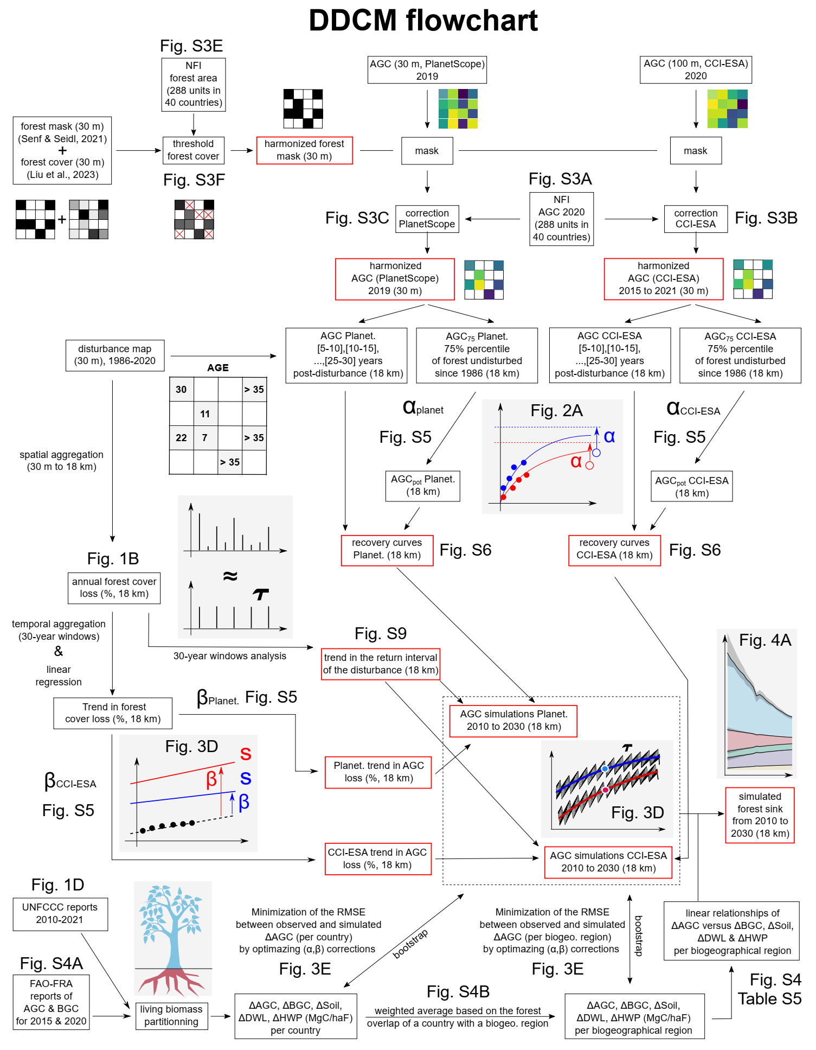Fig. S1. Flowchart of the DDCM procedure. This flowchart explains the DDCM procedure from raw data to forest sink estimates. Computation of the ratio between natural disturbances and harvests has not be shown for clarity (Fig. S12-13), as well at the sensitivity analysis (Fig. S15) or data inconsistencies (Fig. S8). The variable s refers to the percentage of AGC loss, and $τ$ to the return interval of the disturbances (for a 30-year window), both defined at 18 km. The correction factors (α,β) are defined at a country or a biogeographical region scale (see methods).

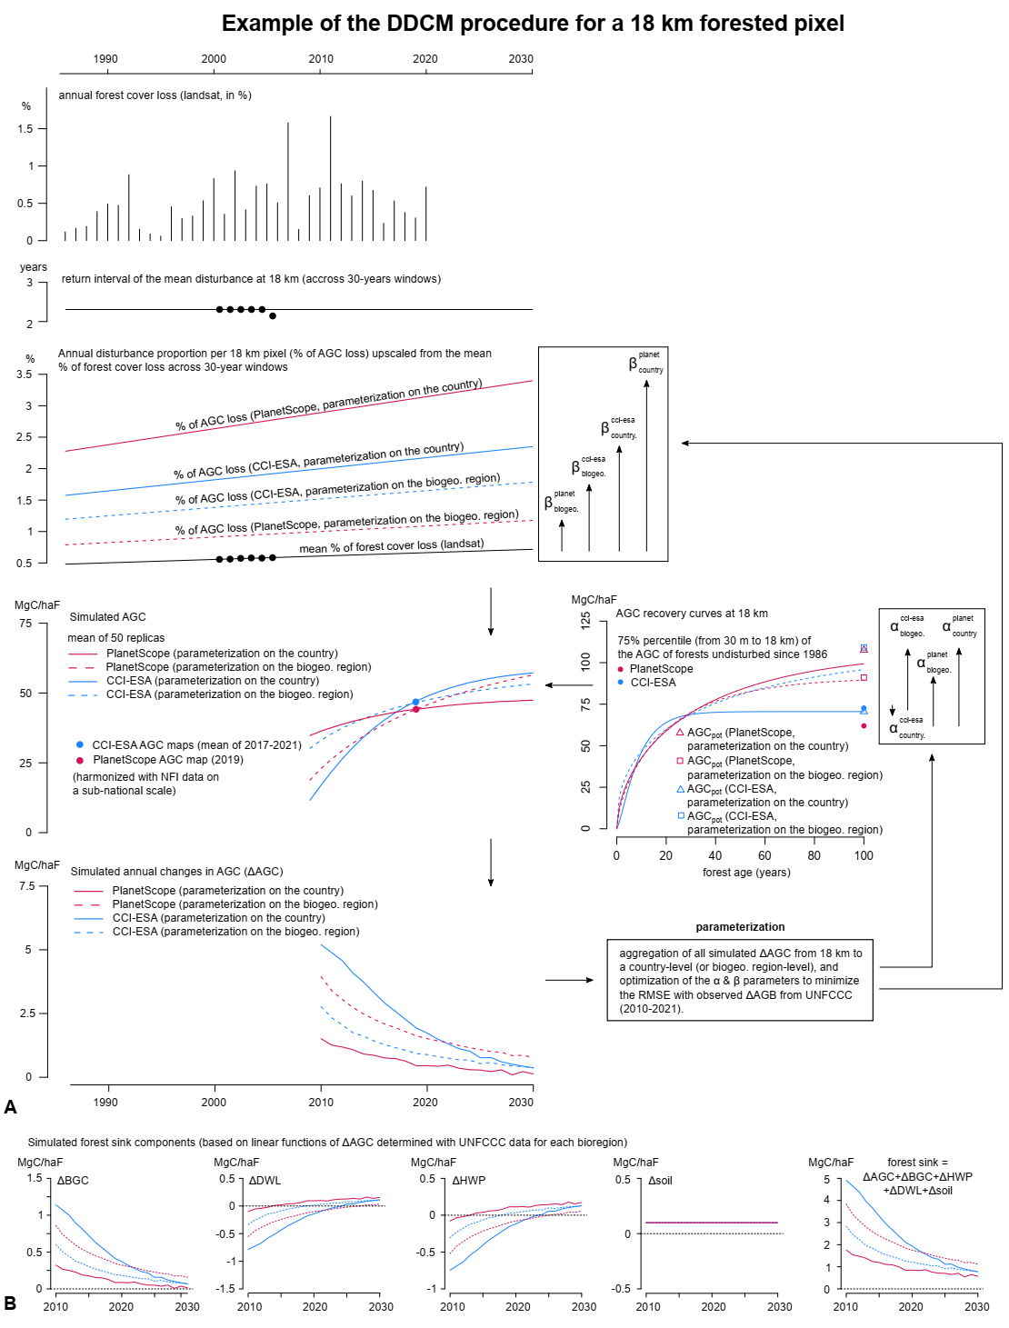
Fig. S2. Detailed example of the DDCM procedure for a given forested pixel at 18 km. Use of the flowchart presented in Fig. S1 on a forested pixel at 18 km. The parametrization is a bootstrap conducted on the scale of a country or a biogeographical region to adjust the correction factors ($α$,$β$) so that the difference between simulated and observed (UNFCCC) annual changes in AGC is minimized across the historical period (2010-2021). Each forest sink component (ΔHWP, ΔSoil, ΔBGC and ΔDWL in panel B) is computed based on ΔAGC with the linear relationships detailed in Fig. S4d-g and Table S5.
 | Belarus | Spain | Finland | United-Kingdom | Croatia | Netherlands | Norway | Poland | Sweden
 | Forest sink ($ΔAGC+ΔBGC+ΔDWL+ΔSoil+ΔHWP$, in MgC per hectare of forest)
2010 | 1.847 | 0.718 | 0.512 | 1.670 | 0.922 | 1.669 | 0.656 | 1.121 | 0.558
2011 | 1.809 | 0.707 | 0.501 | 1.667 | 0.805 | 1.641 | 0.681 | 1.275 | 0.559
2012 | 1.743 | 0.695 | 0.521 | 1.638 | 0.793 | 1.633 | 0.605 | 1.285 | 0.563
2013 | 1.805 | 0.687 | 0.434 | 1.624 | 0.805 | 1.672 | 0.607 | 1.352 | 0.544
2014 | 1.757 | 0.692 | 0.438 | 1.608 | 0.782 | 1.657 | 0.527 | 1.158 | 0.530
2015 | 1.716 | 0.699 | 0.384 | 1.604 | 0.765 | 1.611 | 0.430 | 1.042 | 0.523
2016 | 1.554 | 0.692 | 0.347 | 1.599 | 0.750 | 1.627 | 0.423 | 1.369 | 0.506
2017 | 1.433 | 0.700 | 0.314 | 1.585 | 0.751 | 1.608 | 0.399 | 1.300 | 0.439
2018 | 1.528 | 0.697 | 0.204 | 1.572 | 0.712 | 1.587 | 0.421 | 1.265 | 0.424
2019 | 1.403 | 0.683 | 0.270 | 1.560 | 0.741 | 1.590 | 0.464 | 0.737 | 0.432
2020 | 1.442 | 0.664 | 0.302 | 1.529 | 0.779 | 1.587 | 0.541 | 0.755 | 0.456
2021 | 1.449 | 0.660 | 0.180 | 1.511 | 0.747 | 1.457 | 0.464 | 0.783 | 0.451
slope | -0.0440 | -0.0036 | -0.0306 | -0.0136 | -0.0109 | -0.0128 | -0.0199 | -0.0417 | -0.0136
p-value | < 0.0001 | 0.0017 | < 0.0001 | < 0.0001 | 0.0059 | 0.0015 | 0.0080 | 0.0273 | < 0.0001
 | Forest area ($in kha$)
2010 | 8915.3 | 16683.7 | 21943.1 | 3538.4 | 2361.6 | 374.8 | 12139.1 | 9304.8 | 28081.1
2011 | 8979.8 | 16702.8 | 21928.0 | 3552.8 | 2367.4 | 375.3 | 12139.4 | 9329.2 | 28093.6
2012 | 9083.3 | 16722.0 | 21915.0 | 3566.5 | 2372.2 | 375.9 | 12139.9 | 9353.7 | 28096.9
2013 | 9101.5 | 16746.1 | 21903.6 | 3578.6 | 2379.2 | 373.4 | 12140.5 | 9369.4 | 28108.7
2014 | 9281.1 | 16770.3 | 21893.6 | 3587.4 | 2387.5 | 370.8 | 12140.3 | 9382.6 | 28107.2
2015 | 9402.2 | 16794.5 | 21885.5 | 3590.0 | 2393.6 | 368.3 | 12139.3 | 9395.2 | 28116.2
2016 | 9492.5 | 16860.6 | 21878.1 | 3592.8 | 2395.0 | 365.7 | 12136.8 | 9382.0 | 28119.8
2017 | 9537.3 | 16926.8 | 21871.0 | 3598.3 | 2398.9 | 365.2 | 12134.8 | 9425.7 | 28127.7
2018 | 9575.2 | 16993.0 | 21863.8 | 3606.4 | 2400.7 | 364.8 | 12132.7 | 9434.1 | 28141.9
2019 | 9668.4 | 17059.1 | 21857.8 | 3614.9 | 2401.2 | 364.3 | 12131.1 | 9439.1 | 28156.7
2020 | 9827.6 | 17125.3 | 21851.6 | 3625.2 | 2401.5 | 363.8 | 12129.8 | 9442.9 | 28156.5
2021 | 9933.4 | 17191.4 | 21845.8 | 3635.8 | 2401.9 | 363.3 | 12129.3 | 9450.1 | 28170.6

Table S1. Countries with a small decrease in their forest sink from 2010 to 2021 (UNFCCC data). UNFCCC data used in Fig. 1D to attribute a small decrease in the forest sink of 9 countries in Europe (linear regression, p-value < 0.05, slope between -0.05 and 0 MgC/haF/year with haF standing for hectare of forests).

 | Belgium | Bulgaria | Switzerland | Germany | Denmark | Greece | Italy | Luxembourg | Latvia | Portugal | Romania | Slovakia | Slovenia | Ukraine
 | Forest sink ($ΔAGC+ΔBGC+ΔDWL+ΔSoil+ΔHWP$, in MgC per hectare of forest)
2010 | 0.783 | 0.796 | 0.866 | 1.314 | 1.008 | 0.203 | 1.112 | 0.766 | 0.582 | 0.545 | 1.359 | 0.574 | 1.645 | 0.787
2011 | 0.779 | 0.566 | 0.553 | 1.407 | 1.437 | 0.198 | 1.001 | 1.040 | 0.635 | 0.221 | 1.303 | 0.617 | 1.632 | 0.735
2012 | 0.775 | 0.561 | 0.794 | 1.588 | 1.591 | 0.169 | 0.857 | 1.247 | 0.671 | 0.230 | 1.346 | 0.826 | 1.629 | 0.714
2013 | 0.811 | 0.552 | 0.740 | 1.672 | 1.503 | 0.168 | 1.149 | 1.728 | 0.609 | 0.171 | 1.359 | 0.887 | 1.217 | 0.682
2014 | 0.804 | 0.554 | 0.448 | 1.480 | 1.767 | 0.169 | 1.172 | 1.461 | 0.254 | 0.212 | 1.400 | 0.592 | -0.145 | 0.709
2015 | 0.785 | 0.564 | 0.786 | 1.516 | 1.799 | 0.167 | 1.194 | 1.305 | 0.391 | 0.188 | 1.383 | 0.673 | -0.167 | 0.618
2016 | 0.865 | 0.669 | 0.755 | 1.566 | 1.421 | 0.168 | 1.161 | 1.516 | 0.518 | 0.083 | 1.420 | 0.652 | -0.199 | 0.598
2017 | 0.824 | 0.681 | 0.732 | 1.479 | 1.178 | 0.185 | 0.740 | 1.256 | 0.699 | -0.044 | 1.363 | 0.642 | -0.229 | 0.695
2018 | 0.816 | 0.671 | 0.470 | 1.418 | 0.938 | 0.192 | 1.211 | 0.851 | 0.630 | 0.065 | 1.286 | 0.519 | -0.248 | 0.721
2019 | 0.771 | 0.653 | 0.680 | 1.380 | 1.109 | 0.201 | 1.131 | 1.210 | 0.705 | 0.097 | 1.314 | 0.621 | 0.752 | 0.742
2020 | 0.721 | 0.663 | 0.612 | 1.188 | 0.986 | 0.192 | 0.933 | 1.457 | 0.442 | 0.103 | 1.284 | 0.926 | 0.713 | 0.874
2021 | 0.724 | 0.665 | 0.645 | 1.252 | 1.276 | 0.202 | 0.875 | 1.919 | 0.319 | 0.321 | 1.267 | 0.899 | 0.711 | 0.923
slope | -0.0036 | 0.0040 | -0.0113 | -0.0186 | -0.0331 | 0.0011 | -0.0081 | 0.0398 | -0.0099 | -0.0205 | -0.0064 | 0.0113 | -0.1129 | 0.0108
p-value | 0.3046 | 0.5450 | 0.3267 | 0.1187 | 0.1974 | 0.3966 | 0.5635 | 0.1633 | 0.4639 | 0.1014 | 0.1226 | 0.3671 | 0.0854 | 0.1767
 | Forest area (kha)
2010 | 711.7 | 3892.6 | 1246.1 | 10939.9 | 628.0 | 3440.6 | 8986.4 | 93.3 | 3238.4 | 4336.9 | 6969.4 | 2011.2 | 1206.6 | 10601.1
2011 | 710.4 | 3895.2 | 1248.1 | 10942.5 | 631.3 | 3444.5 | 9031.8 | 93.3 | 3242.8 | 4338.7 | 6974.4 | 2012.3 | 1206.5 | 10611.3
2012 | 709.2 | 3897.9 | 1250.0 | 10945.0 | 632.8 | 3448.4 | 9077.3 | 93.3 | 3247.2 | 4340.6 | 6979.4 | 2014.1 | 1206.4 | 10621.4
2013 | 709.6 | 3900.5 | 1252.0 | 10947.5 | 637.5 | 3452.3 | 9122.7 | 93.3 | 3251.5 | 4341.6 | 6980.7 | 2015.4 | 1206.8 | 10624.2
2014 | 710.1 | 3903.2 | 1253.9 | 10950.0 | 637.6 | 3456.1 | 9168.1 | 93.2 | 3250.2 | 4342.6 | 6981.9 | 2017.1 | 1207.2 | 10630.3
2015 | 710.5 | 3905.8 | 1255.8 | 10952.5 | 637.8 | 3460.0 | 9213.6 | 93.2 | 3248.9 | 4343.5 | 6983.2 | 2020.1 | 1207.7 | 10630.4
2016 | 710.0 | 3908.5 | 1257.7 | 10960.9 | 637.7 | 3463.9 | 9259.0 | 93.2 | 3247.6 | 4343.0 | 6984.4 | 2022.5 | 1208.0 | 10690.4
2017 | 709.4 | 3911.1 | 1259.7 | 10969.2 | 638.9 | 3467.8 | 9304.5 | 93.2 | 3246.2 | 4342.5 | 6985.7 | 2024.4 | 1207.0 | 10711.0
2018 | 708.8 | 3913.8 | 1261.7 | 10977.5 | 639.4 | 3471.6 | 9349.9 | 93.1 | 3244.9 | 4341.9 | 6987.0 | 2026.0 | 1206.0 | 10685.6
2019 | 708.3 | 3916.5 | 1263.7 | 10985.9 | 640.4 | 3475.6 | 9395.3 | 93.1 | 3253.5 | 4341.4 | 6988.2 | 2027.1 | 1205.0 | 10686.8
2020 | 707.8 | 3919.1 | 1265.7 | 10994.1 | 641.6 | 3479.3 | 9440.8 | 93.1 | 3262.1 | 4340.8 | 6989.5 | 2027.9 | 1204.7 | 10689.3
2021 | 707.2 | 3920.2 | 1267.7 | 11003.2 | 646.2 | 3484.3 | 9486.2 | 93.1 | 3270.7 | 4340.3 | 6990.7 | 2028.5 | 1204.3 | 10692.5
Table S2. Countries without significant trend in their forest sink from 2010 to 2021 (UNFCCC data). UNFCCC data used in Fig. 1D to attribute an absence of trend in the forest sink of 14 countries in Europe (linear regression, p-value > 0.05).

 | Austria | Czechia | Estonia | Ireland | Lithuania | France
 | Forest sink ($ΔAGC+ΔBGC+ΔDWL+ΔSoil+ΔHWP$, in MgC per hectare of forest)
2010 | 1.471 | 0.747 | 0.813 | 1.582 | 1.436 | 0.977
2011 | 1.168 | 0.794 | 0.766 | 1.616 | 1.520 | 0.983
2012 | 0.512 | 0.800 | 0.568 | 1.647 | 1.441 | 0.989
2013 | 0.545 | 0.731 | 0.531 | 1.754 | 1.439 | 1.104
2014 | 0.637 | 0.727 | 0.258 | 1.661 | 1.343 | 0.932
2015 | 0.566 | 0.705 | 0.339 | 1.852 | 1.219 | 0.869
2016 | 0.598 | 0.616 | 0.257 | 1.878 | 1.079 | 0.723
2017 | 0.344 | 0.454 | 0.243 | 1.485 | 1.051 | 0.563
2018 | -0.210 | -0.117 | 0.054 | 1.308 | 1.023 | 0.484
2019 | -0.020 | -0.806 | 0.155 | 1.121 | 0.970 | 0.449
2020 | 0.480 | -1.155 | -0.013 | 1.020 | 1.049 | 0.491
2021 | 0.832 | -0.863 | -0.015 | 0.755 | 0.991 | 0.434
slope | -0.0754 | -0.1806 | -0.0752 | -0.0730 | -0.0543 | -0.0648
p-value | 0.0394 | 0.0002 | < 0.0001 | 0.0050 | < 0.0001 | < 0.0001
 | Forest area (kha)
2010 | 3994.5 | 2657.4 | 2442.9 | 731.6 | 2154.0 | 18214.8
2011 | 3996.8 | 2659.8 | 2444.0 | 736.6 | 2162.0 | 18254.1
2012 | 3999.0 | 2661.9 | 2445.3 | 742.5 | 2173.6 | 18294.1
2013 | 4001.3 | 2663.7 | 2446.3 | 747.1 | 2179.5 | 18317.1
2014 | 4003.6 | 2666.4 | 2447.0 | 752.9 | 2187.5 | 18350.0
2015 | 4005.9 | 2668.4 | 2447.4 | 758.4 | 2196.7 | 18384.7
2016 | 4008.2 | 2669.8 | 2447.3 | 764.1 | 2201.9 | 18419.5
2017 | 4010.4 | 2671.7 | 2447.0 | 769.4 | 2209.9 | 18454.7
2018 | 4012.7 | 2673.4 | 2446.8 | 773.2 | 2210.7 | 18492.1
2019 | 4015.0 | 2675.7 | 2446.9 | 776.7 | 2214.3 | 18529.5
2020 | 4017.3 | 2677.3 | 2447.1 | 779.0 | 2221.5 | 18566.9
2021 | 4019.6 | 2678.8 | 2447.4 | 781.0 | 2230.7 | 18604.4

Table S3. Countries with a large decrease in their forest sink from 2010 to 2021 (UNFCCC data). UNFCCC data used in Fig. 1D to attribute a large decrease in the forest sink of 6 countries in Europe (linear regression, p-value < 0.05, slope below -0.05 MgC/haF/year with haF standing for hectare of forests).

 | Hungary | Liechtenstein
 | Forest sink ($ΔAGC+ΔBGC+ΔDWL+ΔSoil+ΔHWP$, in MgC per hectare of forest)
2010 | 0.541 | -0.329
2011 | 0.479 | -0.491
2012 | 0.572 | -0.500
2013 | 0.469 | -0.169
2014 | 0.617 | -0.163
2015 | 0.707 | 0.071
2016 | 0.593 | 0.150
2017 | 0.696 | 0.078
2018 | 0.630 | -0.402
2019 | 0.710 | 0.018
2020 | 0.921 | 0.332
2021 | 0.951 | 0.513
slope | 0.0363 | 0.0697
p-value | 0.0004 | 0.0031
 | Forest area (kha)
2010 | 2170.5 | 6.2
2011 | 2173.2 | 6.2
2012 | 2176.8 | 6.2
2013 | 2183.5 | 6.2
2014 | 2183.6 | 6.2
2015 | 2184.1 | 6.2
2016 | 2180.4 | 6.2
2017 | 2177.0 | 6.2
2018 | 2172.3 | 6.3
2019 | 2171.6 | 6.3
2020 | 2175.7 | 6.3
2021 | 2182.0 | 6.3
Table. S4. Countries with an increase in their forest sink from 2010 to 2021 (UNFCCC data). UNFCCC data used in Fig. 1D to attribute an increase in the forest sink of 2 countries in Europe (linear regression, p-value < 0.05, slope above 0 MgC/haF/year with haF standing for hectare of forests).

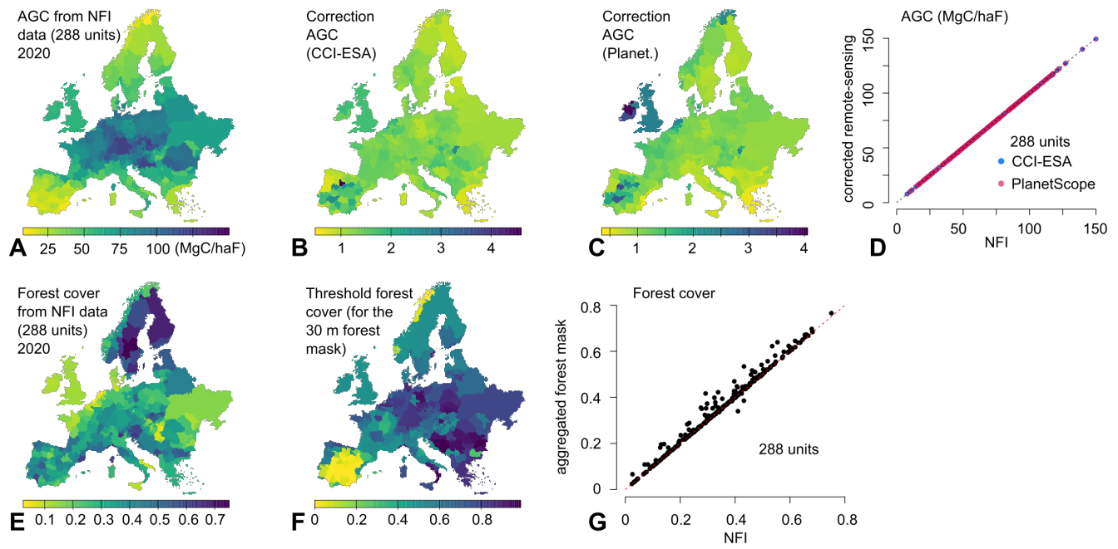
Fig. S3. Harmonization of the 30 m forest mask and the AGC maps from CCI-ESA & PlanetScope with NFI data. A, Above-ground biomass (AGC, in MgC/haF, Megagram Carbon per hectare of forests) for the reference year 2020 from the harmonized NFI dataset on a sub-national scale (288 departmental units distributed among 40 countries). B, Correction factor for the AGC from CCI-ESA maps. C, Correction factor for the AGC from the PlanetScope map. For each unit, the correction is $\frac{{AGB}_{NFI}}{{AGB}_{RS}}$ with ${AGB}_{RS}$ the raw AGC from CCI-ESA (year 2020) or PlanetScope (year 2019), and ${AGB}_{NFI}$ the AGC from the NFI dataset. D, Scatter plot of the corrected AGC maps (aggregation performed per unit) versus the AGC from the NFI dataset. E, Forest cover for the reference year 2020 from the NFI dataset. F, Threshold above which the mean of the forest mask from Senf & Seidl (2021) & Liu et al. (2023) is set to 1 (otherwise 0). This threshold is calculated for each unit so that the aggregated sum of the forest mask at 30 m corresponds to the forest area reported by NFI. G, Scatter plot of the forest cover from the harmonized forest mask at 30 m (aggregation performed per unit) versus the forest cover from the NFI dataset

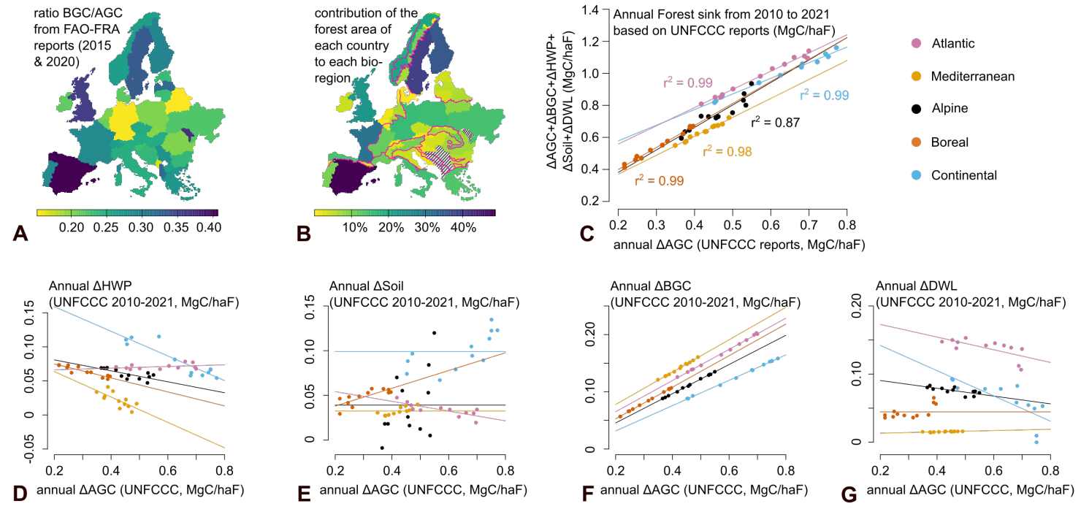
Fig. S4. UNFCCC reports, computation of the BGC & AGC components, and linear relationships between forest sink components and annual changes in AGC. A, Ratio of belowground biomass (BGC) to AGC calculated based on the FAO-FRA reports of 2020 (The year 2015 has been used instead for Serbia, Albania, Portugal and Greece as the year 2020 was not available yet). This ratio is used to partition the annual carbon stock change in living biomass into the annual carbon stock change in AGC & BGC. B, Contribution of the forest area of each country to each bioregion, which allows to calculate each component of the forest sink (from the country reports to UNFCCC) for each biogeographical region. C, Linear relationships obtained from the UNFCCC reports associated with each biogeographical region of the forest sink FS (sum of annual carbon stock changes in AGC, BGC, Harvested Wood Products (HWP), Deadwood and Litter (DWL) and organic and mineral soil (soil)) versus annual carbon stock changes in AGC for 12 data points (years from 2010 to 2021). D,E,F,G, Similar relationships but for ΔHWP, ΔSoil, ΔBGC and ΔDWL versus ΔAGC, respectively. The mean is calculated instead if the relationship is non-significant (p > 0.05). The coefficients from the linear regression are presented in Table S5.

$ΔBGC vs ΔAGC$ | Alpine | Continental | Mediterranean |  | Boreal | Atlantic
slope | 0.2553 | 0.2215 | 0.2832 | 0.2759 |  | 0.2726
intercept  p-value  r² | -0.0055  0.0026  0.9986 | -0.0128  < 0.0001  0.9988 | 0.0211  < 0.0001  0.9958 | -0.0024  0.0023  0.9995 |  | 0.0106  < 0.0001  0.9980
$ΔDWL vs ΔAGC$
slope | -0.0572 | -0.1855 | 0.0094 | 0 |  | -0.0932
intercept  p-value  r² | 0.102  < 0.0001  0.5249 | 0.1792  < 0.0001  0.5688 | 0.0114  < 0.0001  0.6068 | 0.0445  0.2007  NA |  | 0.1916  < 0.0001  0.4613
$ΔHWP vs ΔAGC$
slope | -0.0804 | -0.1810 | -0.1864 | -0.1027 |  | 0.0123
intercept  p-value  r² | 0.0969  < 0.0001  0.5378 | 0.1952  < 0.0001  0.8332 | 0.1009  0.0012  0.5529 | 0.0954  < 0.0001  0.8377 |  | 0.0638  < 0.0001  0.1151
$$ΔSoil vs ΔAGC$$
slope | 0 | 0 | 0 | 0.0993 |  | -0.0545
intercept  p-value  r² | 0.0391  0.2293  NA | 0.0989  0.4160  NA | 0.0325  0.9846  NA | 0.0182  0.0436  0.6061 |  | 0.0651  < 0.0001  0.6172

Table S5. Linear regression summary. Linear regression coefficients obtained for the relationships shown in Fig. S4D-G based on 12 annual points from the UNFCCC reports aggregated from national to regional scale (forest sink components in MgC/haF). If the trend is non-significant (p > 0.05), the intercept is replaced by the mean and the slope is set to 0 ($r^{2}$ has been discarded for clarity reasons).
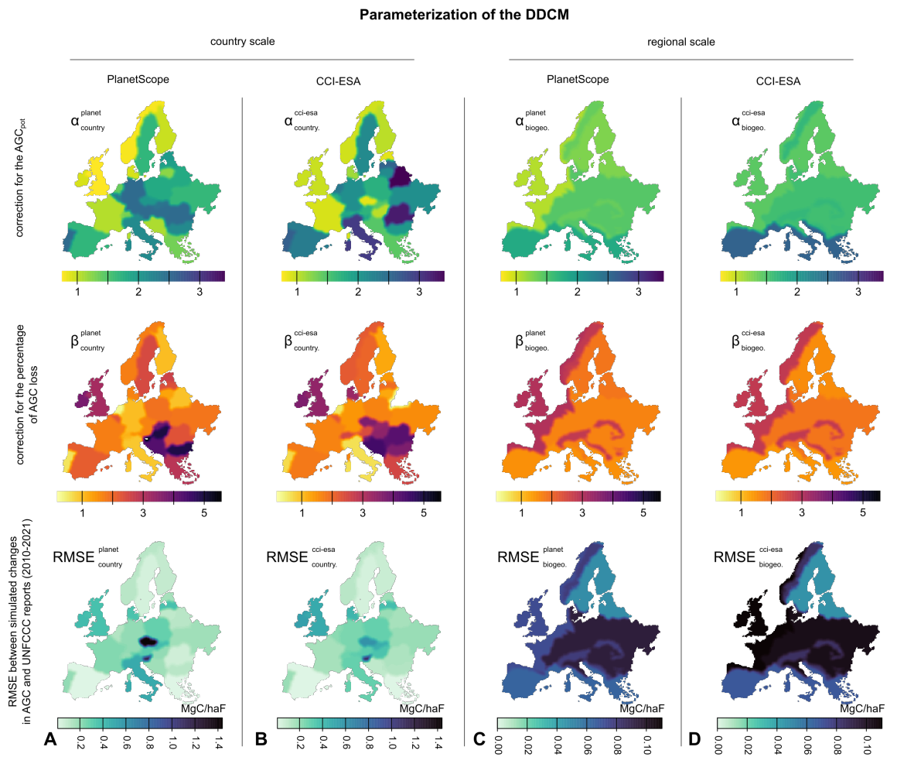
Fig. S5. Parameterization of the DDCM. The parameterization of the DDCM aims to estimate ${AGC}_{pot}$ and the annual percentage of AGC loss ($s\left(y\right)$) based the following scalings: ${AGC}_{pot}= α{AGC}_{75\%}$ and $s\left(y\right)=βf_{loss}(y)$. The variable ${AGC}_{75\%}$ is the 75% percentile of the AGC of all 30 m forests undisturbed since 1986 inside an 18 km pixel and $f_{loss}(y)$ is the linear trend at 18 km in the percentage of forest cover loss (based on six 30 years moving averages of Landsat data). The two corrections factors $α$ and $β$ have been estimated with a bootstrap analysis so that the RMSE between simulated and observed (UNFCCC) ΔAGC is minimized across the historical period (2010-2021). The bootstrap has been conducted on the national (panels A & B) and regional (panels C & D) scales for two different AGC products, CCI-ESA (panels B & D) and PlanetScope (panels A & C). The first row is associated with $α$ values, the second row is associated with$β$ values and the third row with RMSE values.

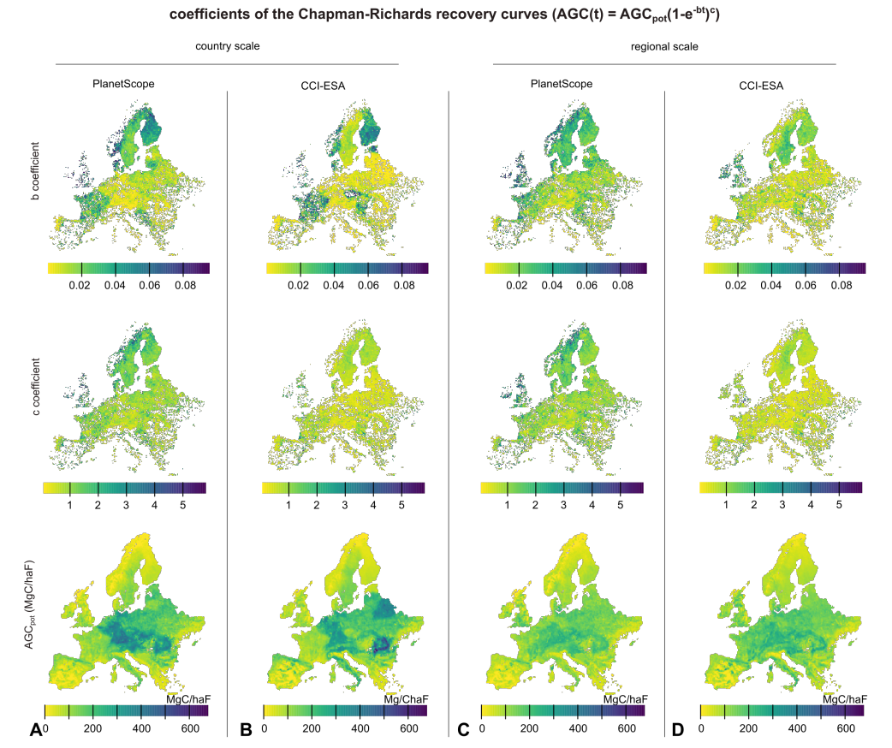
Fig. S6. Chapman-Richards coefficients from the recovery curves. The Chapman-Richards growth function is decribed as $AGC\left(t\right)={AGC}_{pot}{(1-e^{-b})}^{c}$. A, Growth coefficients obtained from the parameterization of the DDCM at a country scale for the PlanetScope AGC map. B, Growth coefficients obtained from the parameterization of the DDCM at a country scale for the CCI-ESA AGC maps. C, growth coefficients obtained from the parameterization of the DDCM at a regional scale for the PlanetScope AGC map. D, growth coefficients obtained from the parameterization of the DDCM at a regional scale for the CCI-ESA AGC maps. Missing values in these maps (Fig. S8) will be filled with spatial interpolations before simulating the AGC from 2010 to 2030.

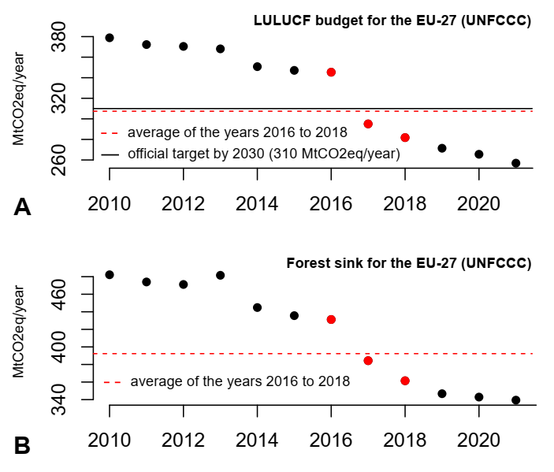
Fig. S7. Estimation of the forest sink target by 2030. A, The reference years 2016, 2017 & 2018 have been used by the European Commission to estimate the LULUCF sink target by 2030 (310 MtCO₂eq/year) as shown with UNFCCC reports of the EU-27 countries. B, Forest sink target of 2030 for the EU-27 (392 MtCO₂eq/year) estimated on the same reference years (2016, 2017 & 2018) but computed instead on the forest sink (sum of net annual carbon stock change in living biomass, deadwood, litter, soils (organic & mineral) and harvested wood products).

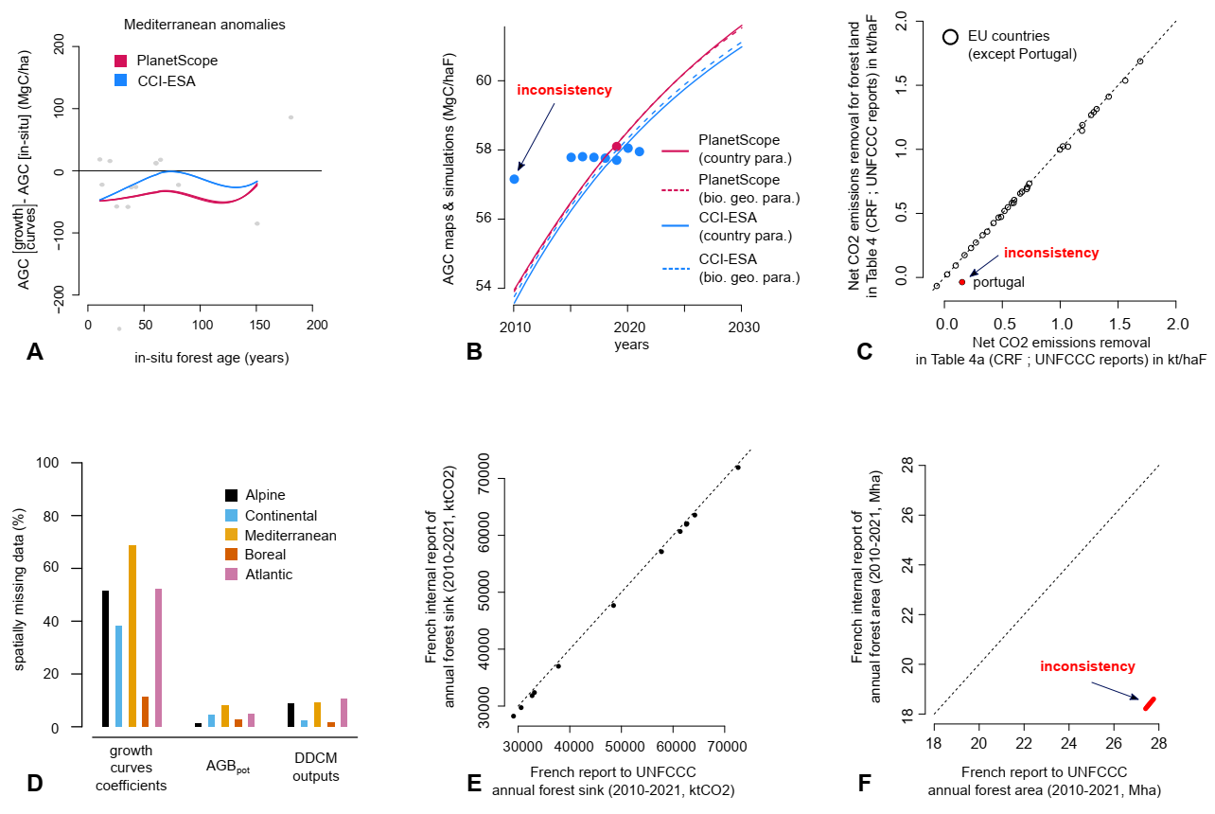
Fig. S8. Inconsistencies & missing values in the datasets used in the study. A, Anomalies between simulated and observed AGC (in-situ age-AGC dataset) for the Mediterranean region, discarded from Fig. 2C because of a small sample size. B, Mean values of AGC maps (bias-corrected with NFI data) across Europe (points). Lines represent AGC simulations from the DCCM with a parametrization conducted at different scales (national, regional) on different AGC maps (CCI-ESA, PlanetScope). Because these simulations are matching the historical trends reported in UNFCCC data from 2010 to 2021, this figure shows that the 2010 CCI-ESA map has a ~6% systematic positive bias across Europe. C, The CRF reports from UNFCCC give details of the forest sink in their Table 4a and details of the LULUCF sink in their Table 4. The net CO₂ removals from “forest land” in their Table 4 must be rigourously the same than the net CO₂ removals in their Table 4a (for the row “total forest land”), which is not the case here for Portugal (we divided by the forest area to allow comparison between countries). The LULUCF budget of Portugal has been therefore corrected based on the forest sink details of their Table 4a. D, Percentage of missing values (at 18 km) for the five different biogeographical regions and three parameters. These missing values have been filled out with spatial interpolations. E and F, France has reported a forest area including overseas territories to UNFCCC. We show this with an internal document of the CITEPA which reported the same forest sink than the UNFCCC report from France (panel E) but for the forest area of metropolitan France (panel F). We corrected the annual forest area of France using this document.

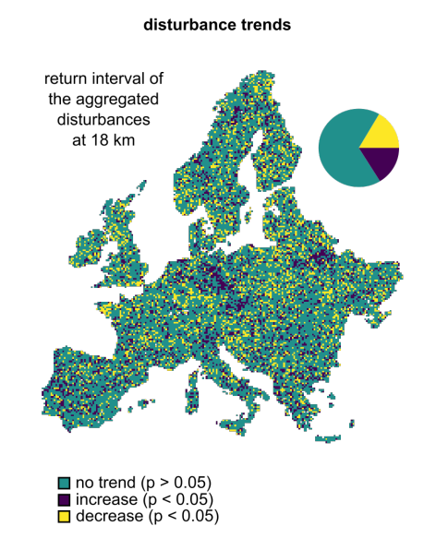
Fig. S9. Linear trends in the return interval of aggregated disturbances at 18 km. A time-series analysis has been conducted on the annual forest loss aggregated from 30 m to 18 km based on Landsat data (see Fig. S2 for a typical time-series). For a given 30-years window, the return interval is the time-series length (30 years) divided by the number of years associated with a forest cover loss above the mean loss. This figure shows the direction of the trends computed for six return intervals from 1986 to 2020 at 18 km. The lack of visible trends is due to two issues: (i) when disturbances are spatially aggregated (here 30 m to 18 km), the return interval of the disturbance partially loses its meaning, and (ii) 30 years are a short period to assess changes in disturbance return intervals. Some extreme events at 30 m have a typical return period of a century.

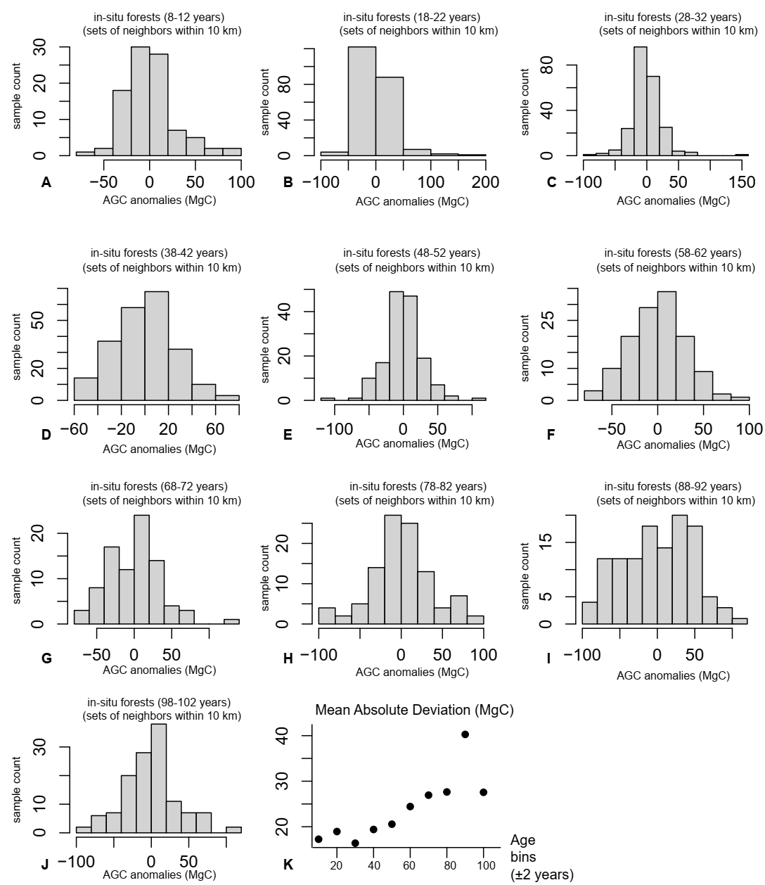
Fig. S10. Analysis of the measurement uncertainties in the age-AGC in-situ dataset. Uncertainties were not provided in the age-AGC in-situ datasets, we therefore conducted an analysis to estimate it. For each area of 100 km² in Europe, we selected tree samples sharing similar age within $±2$ years. Because these trees share similar age at similar locations, we tested the variability in their AGC. To achieve this, we subtracted the mean AGC from each set to produce anomalies. The panels A-J show the stacked anomalies from all available sets, with an age varying from $10±2$ years to 100$±2$ years. Panel K shows the Mean Absolute Deviation for the stacked sets for each age bin. The uncertainty range is therefore estimated between 20 and 30 MgC for each in-situ sample (depending on the age).

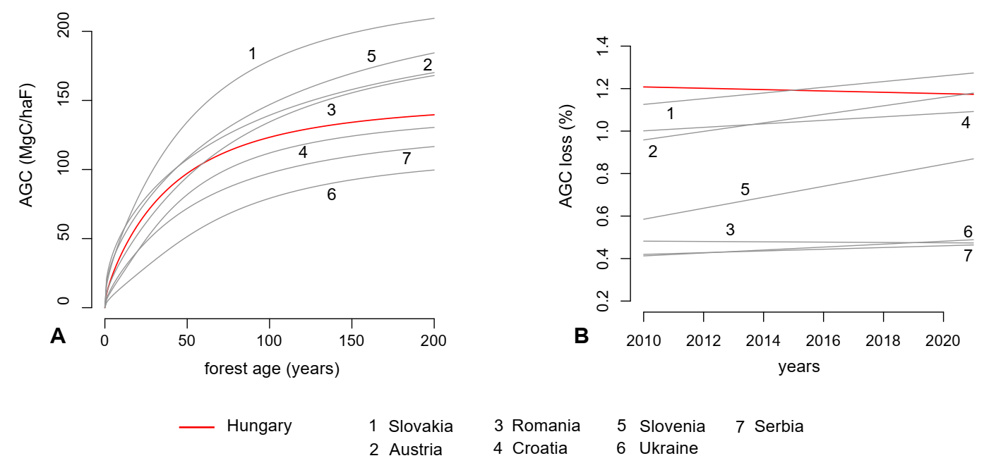
Fig. S11. Case-study: Hungary. A, Mean growth curve of Hungary (in red) compared to its neighbors (Slovakia, Austria, Romania, Croatia, Slovenia, Ukraine and Serbia). B, Mean percentage of AGC loss of Hungary compared to its neighbors. The average is performed across all parameterizations (PlanetScope & CCI-ESA datasets, national & regional scales). Because Hungary shares similar growth rates compared to its neighbors, has slightly higher disturbance rates, and a limited forest area expansion (Fig. 1D), we do not explain the reported increase in the forest sink of Hungary from 2010 to 2021 (UNFCCC, see Fig. S21).

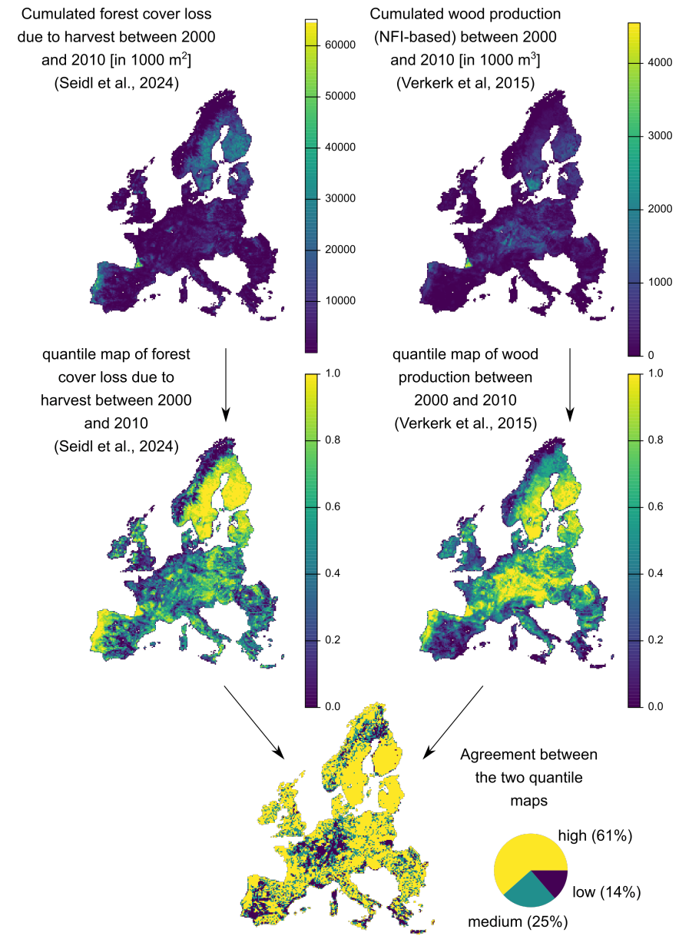
Fig. S12. Comparison of a Landsat-based (Seidl et al., 2024) estimation of forest cover loss due to harvest with an NFI-based (Verkerk et al., 2015) estimation of wood production. We first computed the sum of each product across the same period (2000-2010) and same resolution (18 km). Then we produced a quantile map of each to be able to compare them. We show here that 14% of pixels are associated with a low confidence (disagreement of more than 0.4 in the Landsat-based attribution of harvests). We discarded these pixels when producing Fig. 1C, Fig. 3B-C and Fig. S13.
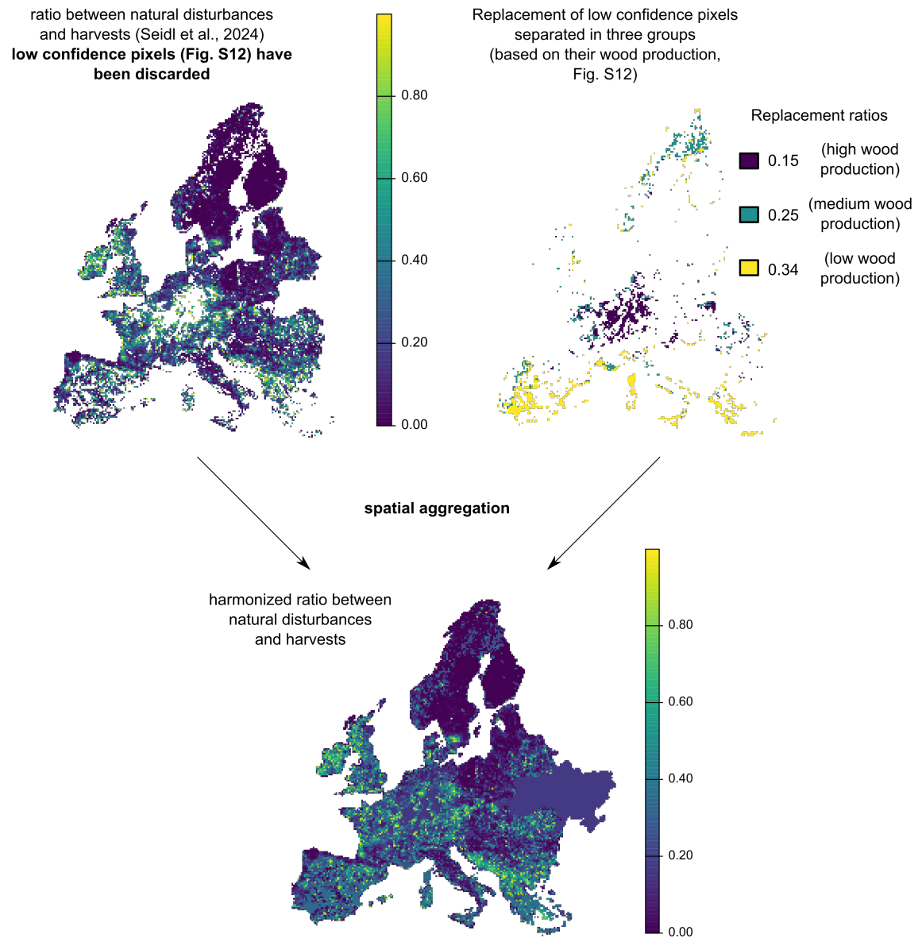
Fig. S13. Creation of a constant ratio between natural disturbances and harvests at 18 km. Using the Landsat-based map of attribution of disturbances to speficic agents (Seidl et al., 2024), severities that are associated with natural disturbances (storms & fires) have been summed in each 18 km pixel, then divided by the sum of severities associated with harvests. We discarded low-confidence pixels (see Fig. S12), and replaced their ratio with the median ratio of pixels sharing similar wood production (Verkerk et al., 2015) but flagged with a high-confidence level (Fig. S12). Finally, Ukraine (missing country) received the median ratio of Europe (R = 17%). This map of ratio has only been used to partition natural & anthropogenic disturbances to calculate an estimate of the percentage of reduction in harvest for the EU-27 to meet their target by 2030.

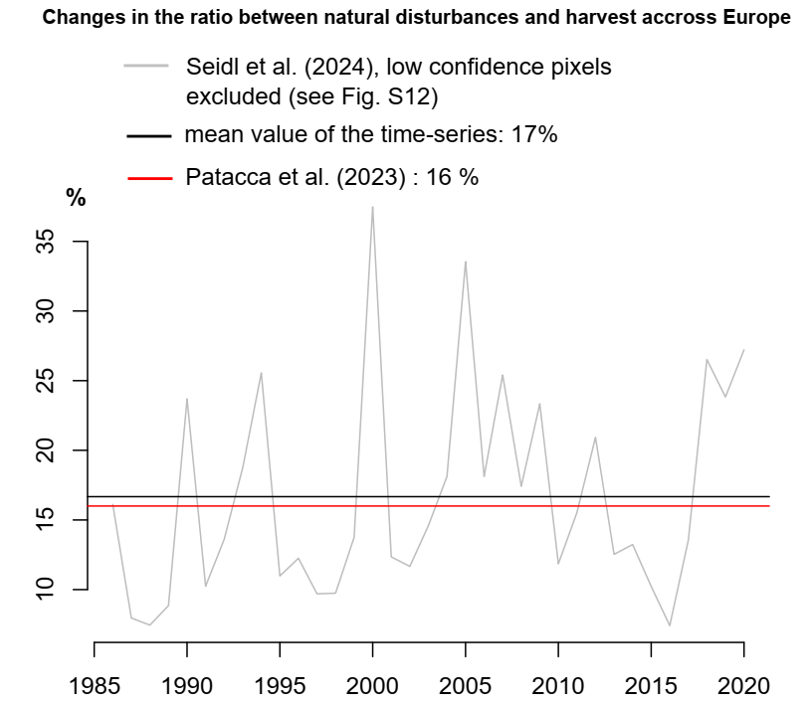
Fig. S14. Annual changes in the ratio between natural disturbances and harvests across Europe. We first discarded low-confidence pixels (Fig. S12), then for each year, we calculated across Europe the aggregated sum of severities associated with natural disturbances (storms & fire) and divided them by the aggregated sum of severities associated with harvests according to the Landsat-based disturbance map of Seidl et al. (2024). The mean value of the timeseries ($R=17\%$) remarkably matches the value reported at a continental scale in the ground-based study of Patacca et al. (2023), 16%. We did not detect a significant trend in the time-series (p = 0.14 > 0.05), which confirms the conclusion of Patacca et al. (2023) that the ratio remains reasonably constant through time.

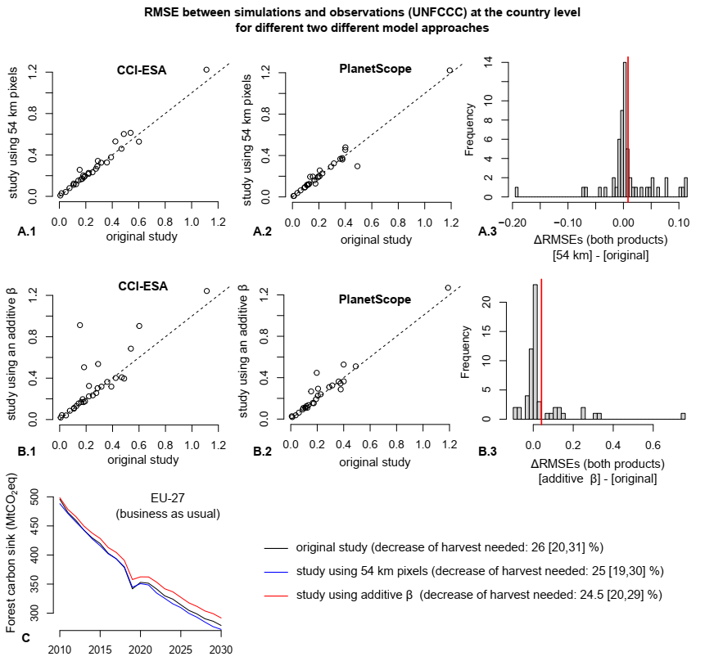
Fig. S15. Sensitivity test of the DDCM to different starting assumptions. The entire DDCM procedure has been run on two different starting assumptions: either (i) Trends in AGC loss estimated at 54 km instead of 18 km (panels A1,A2,A3 and blue curve in panel C), or (ii) Trends in AGC loss estimated with an additive model ($s\left(y\right)=f_{loss}\left(y\right)+β$) instead of the multiplicative model ($s\left(y\right)=βf_{loss}(y)$) used in the main study (panels B1,B2,B3 and red curve in panel C). Results are similar between these three models (panel C), however the original study assumptions have the highest goodness of fit (lowest RMSE) with reported UNFCCC data at the country level (panels A and B). We therefore kept the original approach only.

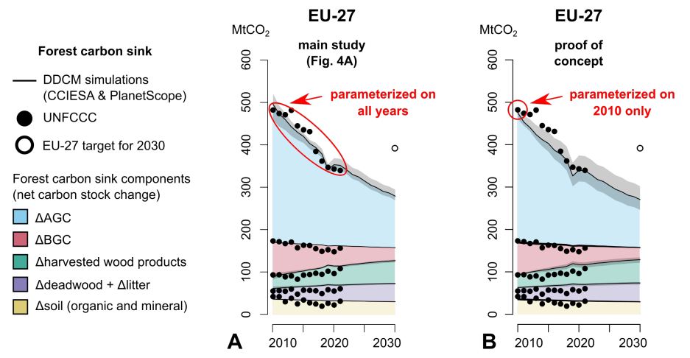
Figure S16. Proof of concept for the DDCM Model. A. Figure extracted from the main study showing the five forest sink components in a business as usual scenario in the EU-27 (Fig. 4A). The minimization between AGC simulations and UNFCCC observations has been performed across the whole historical period (2010-2021). B. Same figure as panel A, except that the minimization between AGC simulations and UNFCCC observations has been performed for the year 2010 only. The model has therefore no knowledge of the decline in the sink from 2011 to 2021, however it manages to capture it (due to the disturbance trends). You can observe that the confidence intervals are minimum in 2010 (year of parametrization) but much larger in 2030 (more uncertainties due to less constraining data).
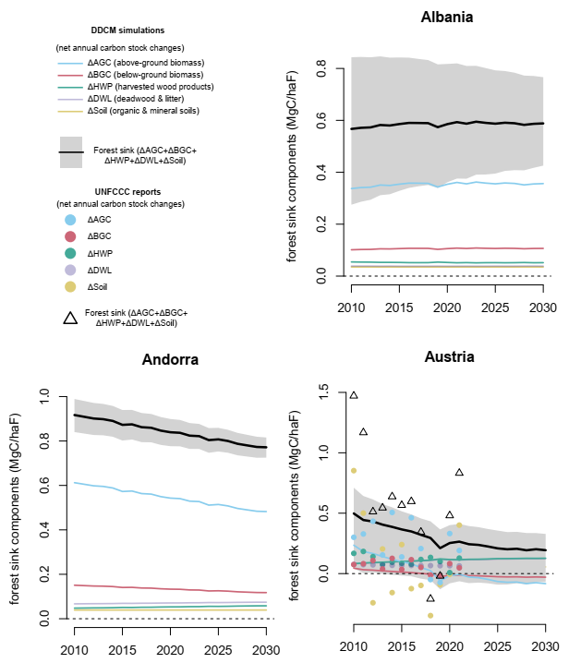
Fig. S17. UNFCCC reports and DDCM simulations for Albania, Andorra, and Austria. Each forest sink component is shown separately, negative values are associated with net sources (C release in the atmosphere). Shaded area shows the range obtained from the different AGC maps with different parameterizations (for the forest sink only for vizualization purposes).

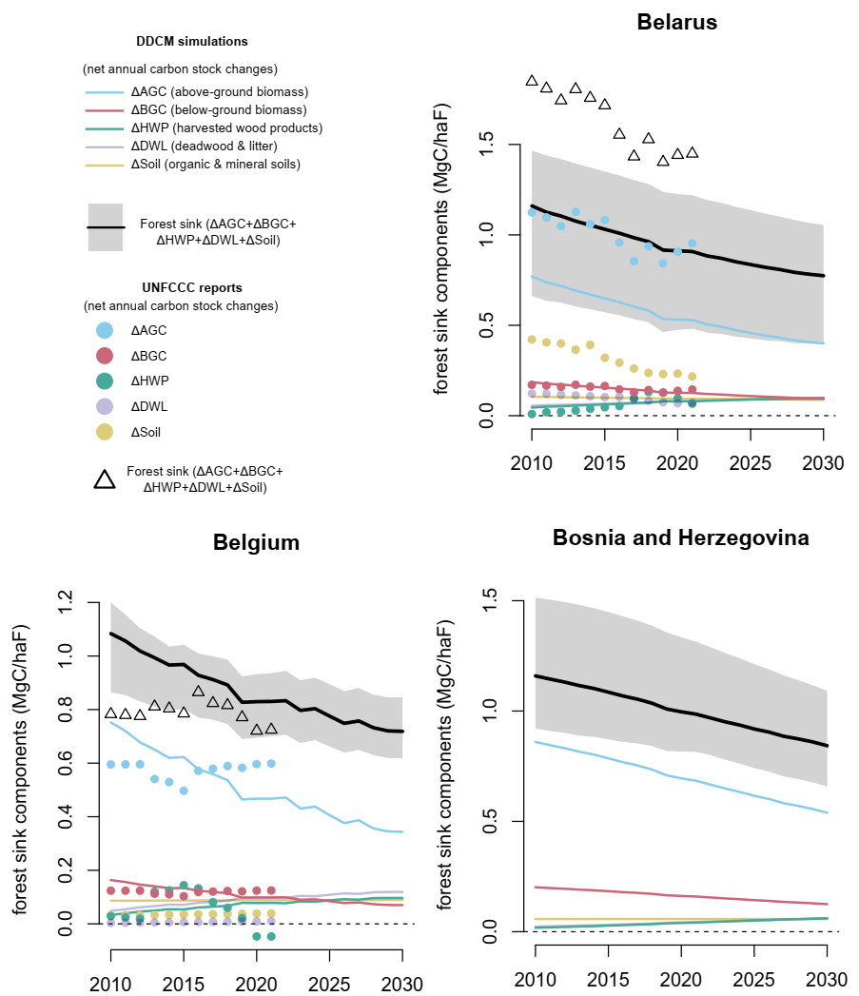
Fig. S18. UNFCCC reports and DDCM simulations for Belarus, Belgium, and Bosnia and Herzegovina. Each forest sink component is shown separately, negative values are associated with net sources (C release in the atmosphere). Shaded area shows the range obtained from the different AGC maps with different parameterizations (for the forest sink only for vizualization purposes).

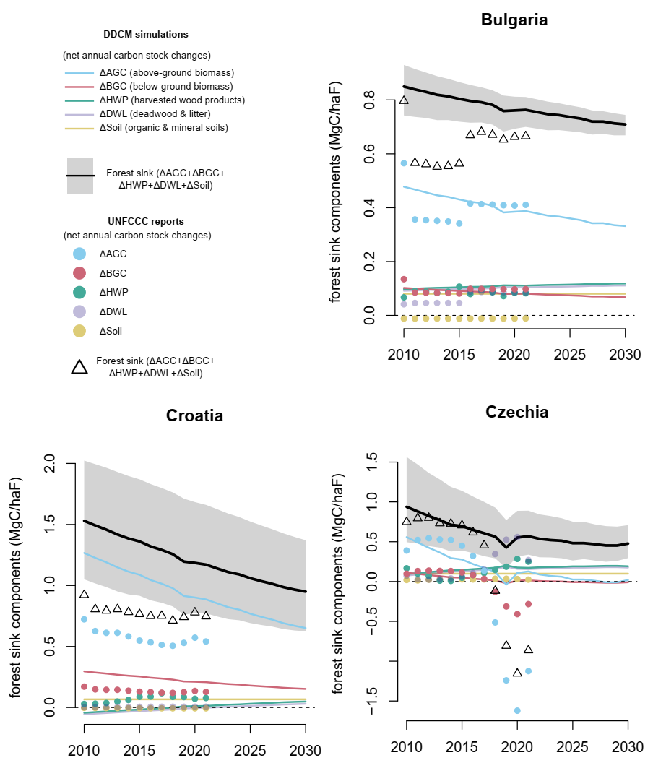
Fig. S19. UNFCCC reports and DDCM simulations for Bulgaria, Croatia, and Czechia. Each forest sink component is shown separately, negative values are associated with net sources (C release in the atmosphere). Shaded area shows the range obtained from the different AGC maps with different parameterizations (for the forest sink only for vizualization purposes).

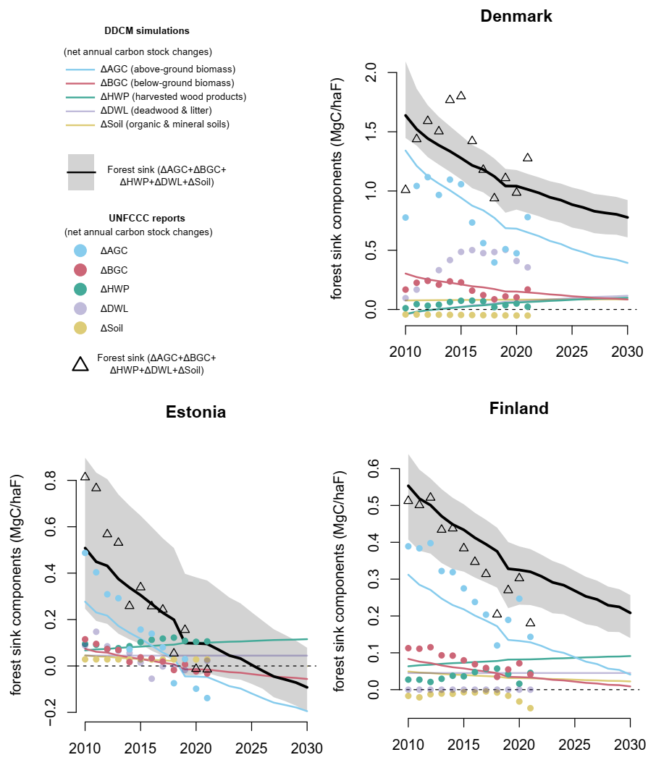
Fig. S20. UNFCCC reports and DDCM simulations for Denmark, Estonia, and Finland. Each forest sink component is shown separately, negative values are associated with net sources (C release in the atmosphere). Shaded area shows the range obtained from the different AGC maps with different parameterizations (for the forest sink only for vizualization purposes).

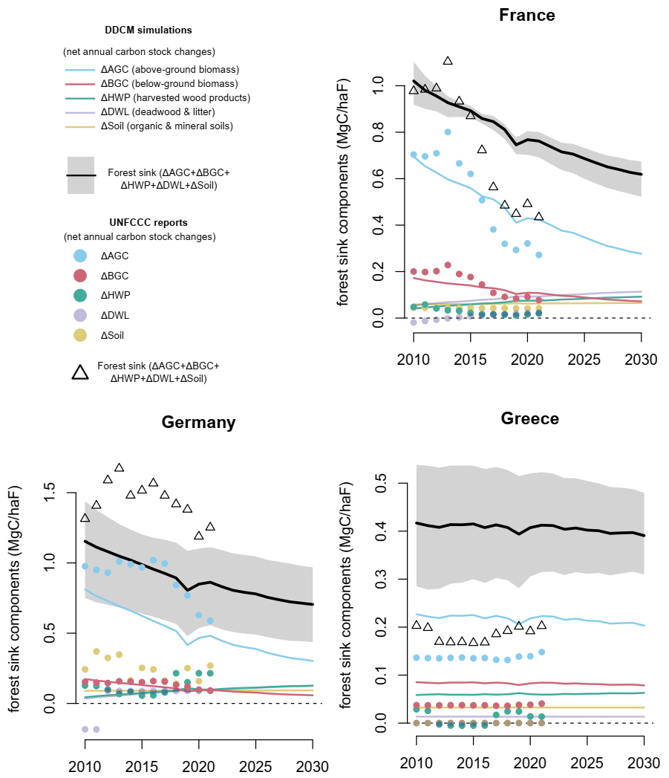
Fig. S21. UNFCCC reports and DDCM simulations for France, Germany, and Greece. Each forest sink component is shown separately, negative values are associated with net sources (C release in the atmosphere). Shaded area shows the range obtained from the different AGC maps with different parameterizations (for the forest sink only for vizualization purposes).

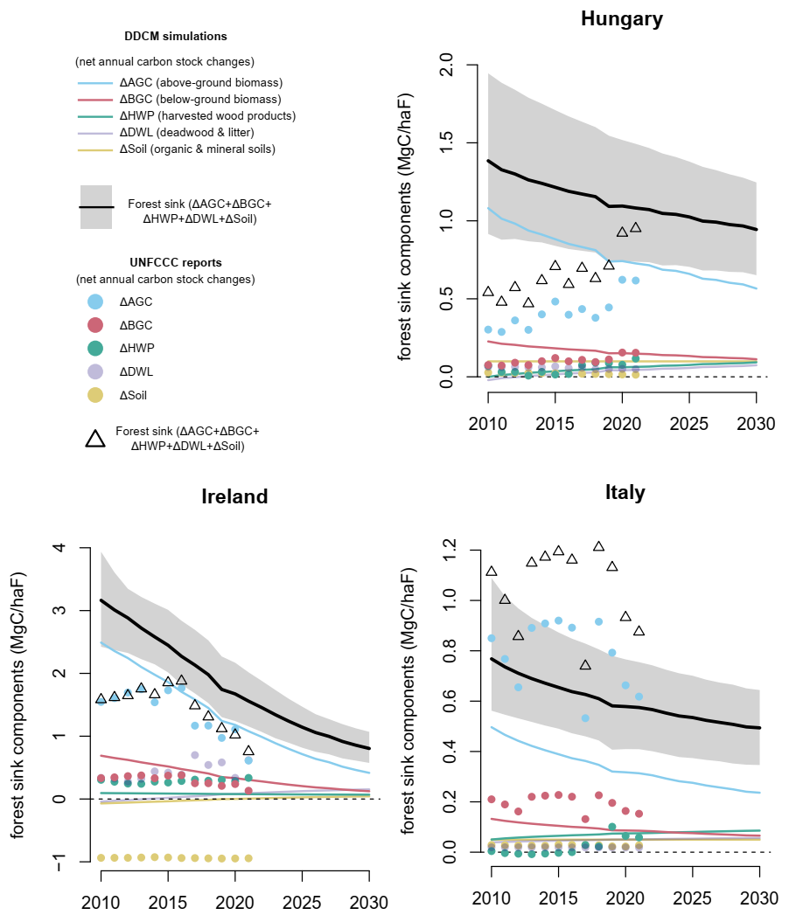
Fig. S22. UNFCCC reports and DDCM simulations for Hungary, Ireland, and Italy. Each forest sink component is shown separately, negative values are associated with net sources (C release in the atmosphere). Shaded area shows the range obtained from the different AGC maps with different parameterizations (for the forest sink only for vizualization purposes).

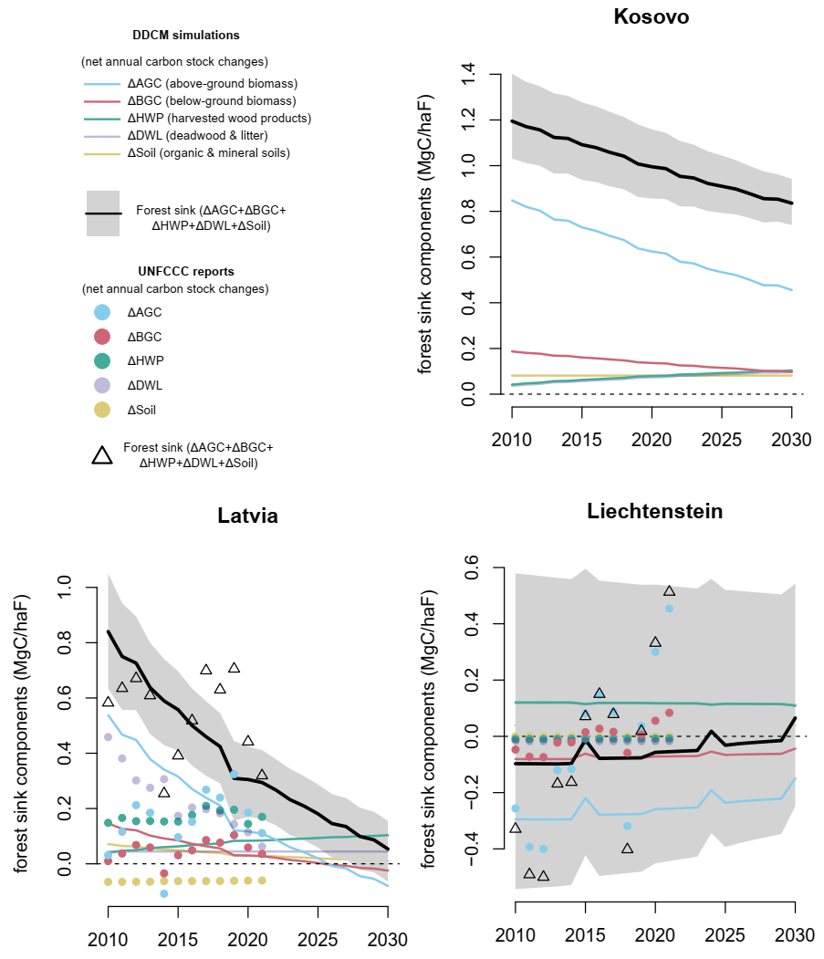
Fig. S23. UNFCCC reports and DDCM simulations for Kosovo, Latvia, and Liechtenstein. Each forest sink component is shown separately, negative values are associated with net sources (C release in the atmosphere). Shaded area shows the range obtained from the different AGC maps with different parameterizations (for the forest sink only for vizualization purposes).

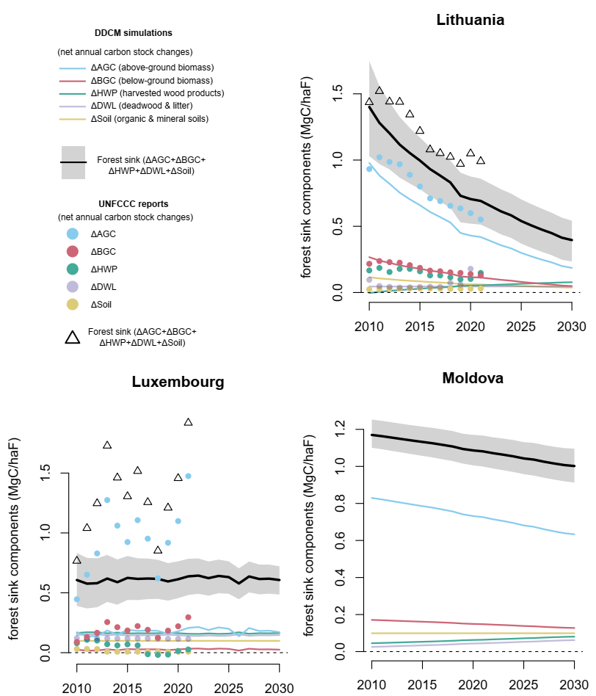

Fig. S24. UNFCCC reports and DDCM simulations for Lithuania, Luxembourg, and Moldova. Each forest sink component is shown separately, negative values are associated with net sources (C release in the atmosphere). Shaded area shows the range obtained from the different AGC maps with different parameterizations (for the forest sink only for vizualization purposes).

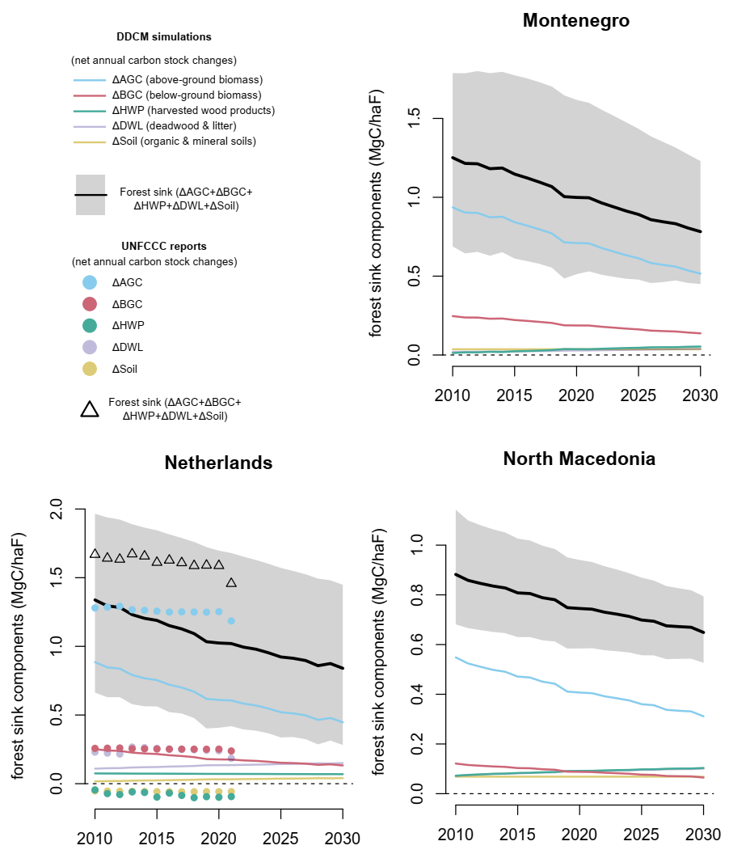
Fig. S25. UNFCCC reports and DDCM simulations for Montenegro, Netherlands, and North Macedonia. Each forest sink component is shown separately, negative values are associated with net sources (C release in the atmosphere). Shaded area shows the range obtained from the different AGC maps with different parameterizations (for the forest sink only for vizualization purposes).

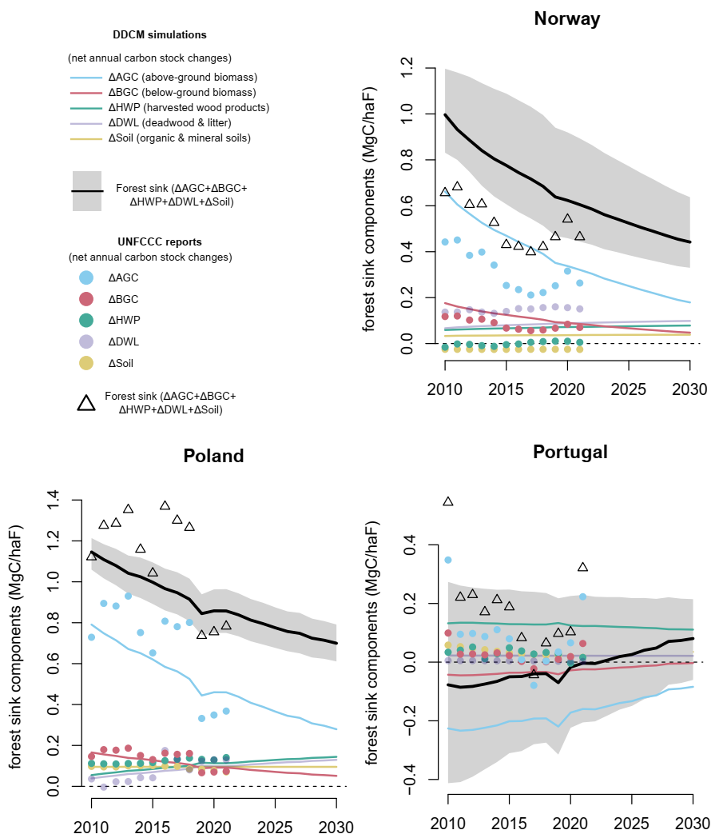
Fig. S26. UNFCCC reports and DDCM simulations for Norway, Poland, and Portugal. Each forest sink component is shown separately, negative values are associated with net sources (C release in the atmosphere). Shaded area shows the range obtained from the different AGC maps with different parameterizations (for the forest sink only for vizualization purposes).

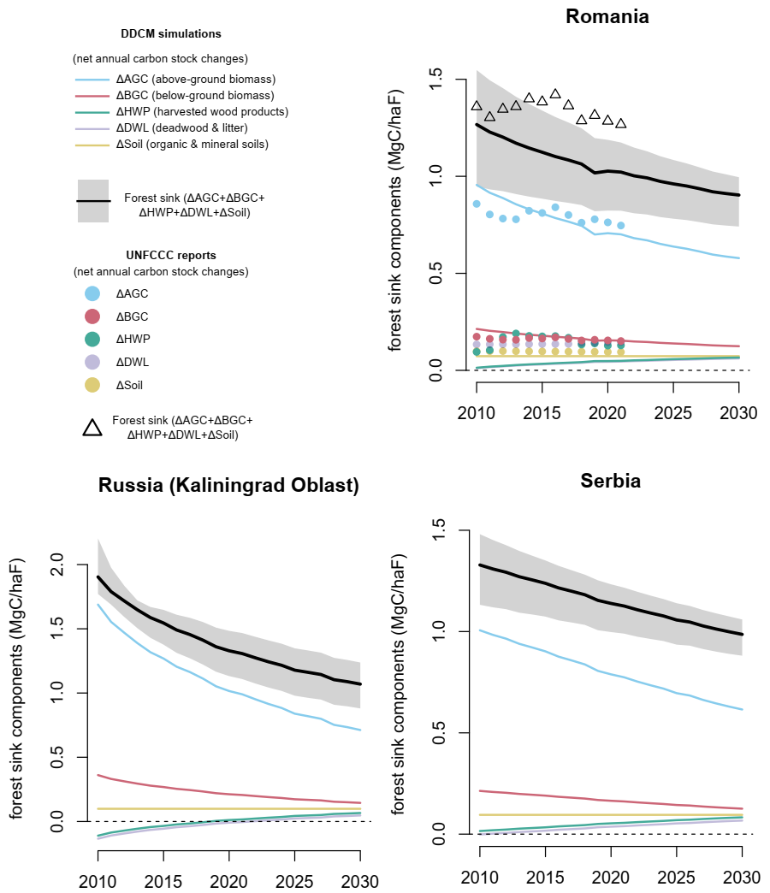
Fig. S27. UNFCCC reports and DDCM simulations for Romania, Russia (Kaliningrad Oblast province), and Serbia. Each forest sink component is shown separately, negative values are associated with net sources (C release in the atmosphere). Shaded area shows the range obtained from the different AGC maps with different parameterizations (for the forest sink only for vizualization purposes).

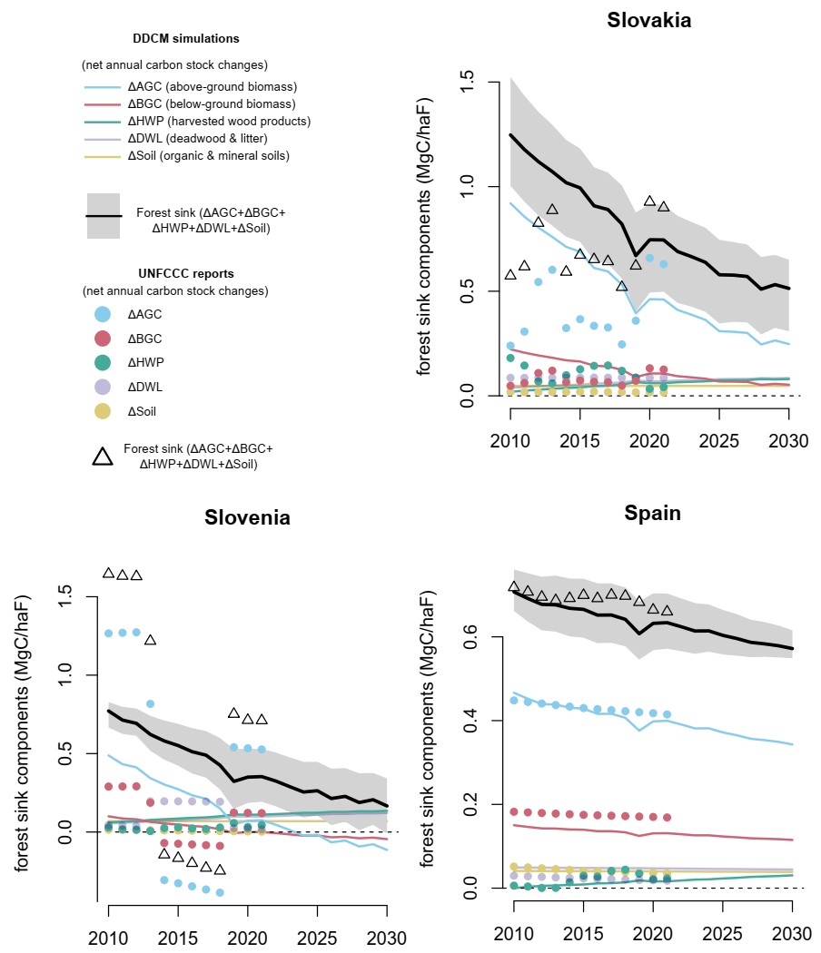
Fig. S28. UNFCCC reports and DDCM simulations for Slovakia, Slovenia, and Spain. Each forest sink component is shown separately, negative values are associated with net sources (C release in the atmosphere). Shaded area shows the range obtained from the different AGC maps with different parameterizations (for the forest sink only for vizualization purposes).

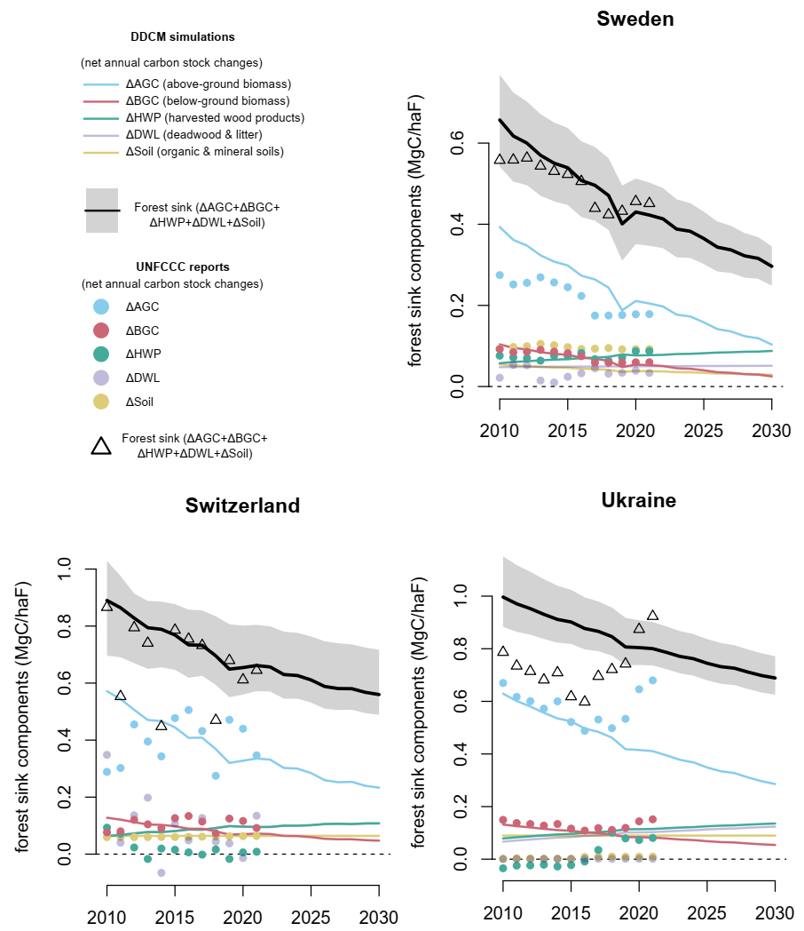
Fig. S29. UNFCCC reports and DDCM simulations for Sweden, Switzerland, and Ukraine. Each forest sink component is shown separately, negative values are associated with net sources (C release in the atmosphere). Shaded area shows the range obtained from the different AGC maps with different parameterizations (for the forest sink only for vizualization purposes).

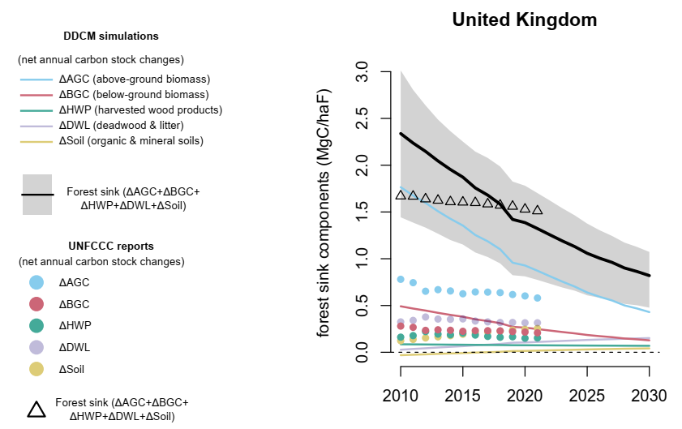
Fig. S30. UNFCCC reports and DDCM simulations for United Kingdom. Each forest sink component is shown separately, negative values are associated with net sources (C release in the atmosphere). Shaded area shows the range obtained from the different AGC maps with different parameterizations (for the forest sink only for vizualization purposes).

