Supporting Information

Single-Source Pulsed Laser Deposited Perovskite Solar Cells
with >19% Stable Efficiency

Tatiana Soto-Montero,¹ Suzana Kralj,¹ Randi Azmi,² Manuel A. Reus,³ Junia S. Solomon,¹ Daniel M. Cunha,¹ Wiria Soltanpoor,¹ Drajad Satrio Utomo,² Esma Ugur,² Badri Vishal,² Martin Ledinsky,⁵ Peter Müller-Buschbaum,^{3,4} Finn Babbe,⁶ Do Kyoung Lee,^{7,8} Carolin M. Sutter-Fella,⁷ Erkan Aydin,² Stefaan De Wolf,² Monica Morales-Masis¹*

¹MESA+ Institute for Nanotechnology, University of Twente, Enschede 7500 AE, The Netherlands
²Physical Sciences and Engineering Division, KAUST Solar Center, King Abdullah University of Science and Technology (KAUST), Thuwal 23955-6900, Kingdom of Saudi Arabia.
³Technical University of Munich, TUM School of Natural Sciences, Department of Physics, Chair for Functional Materials, James-Franck-Str. 1, 85748 Garching, Germany
⁴Technical University of Munich, Heinz Maier-Leibnitz-Zentrum (MLZ), Lichtenbergstr. 1, 85748 Garching, Germany
⁵Institute of Physics, Academy of Science of the Czech Republic, Cukrovarnická 10, Prague 162 00, Czech Republic
⁶Chemical Science Division, Liquid Sunlight Alliance (LiSA), Lawrence Berkeley National Laboratory, Berkeley, California 94720, United States
⁷Molecular Foundry Division, Lawrence Berkeley National Laboratory, 1 Cyclotron Road, Berkeley, California 94710, United States
⁸Nevada Extreme Conditions Laboratory, University of Nevada, Las Vegas (UNLV), Las Vegas, Nevada 89154, United States

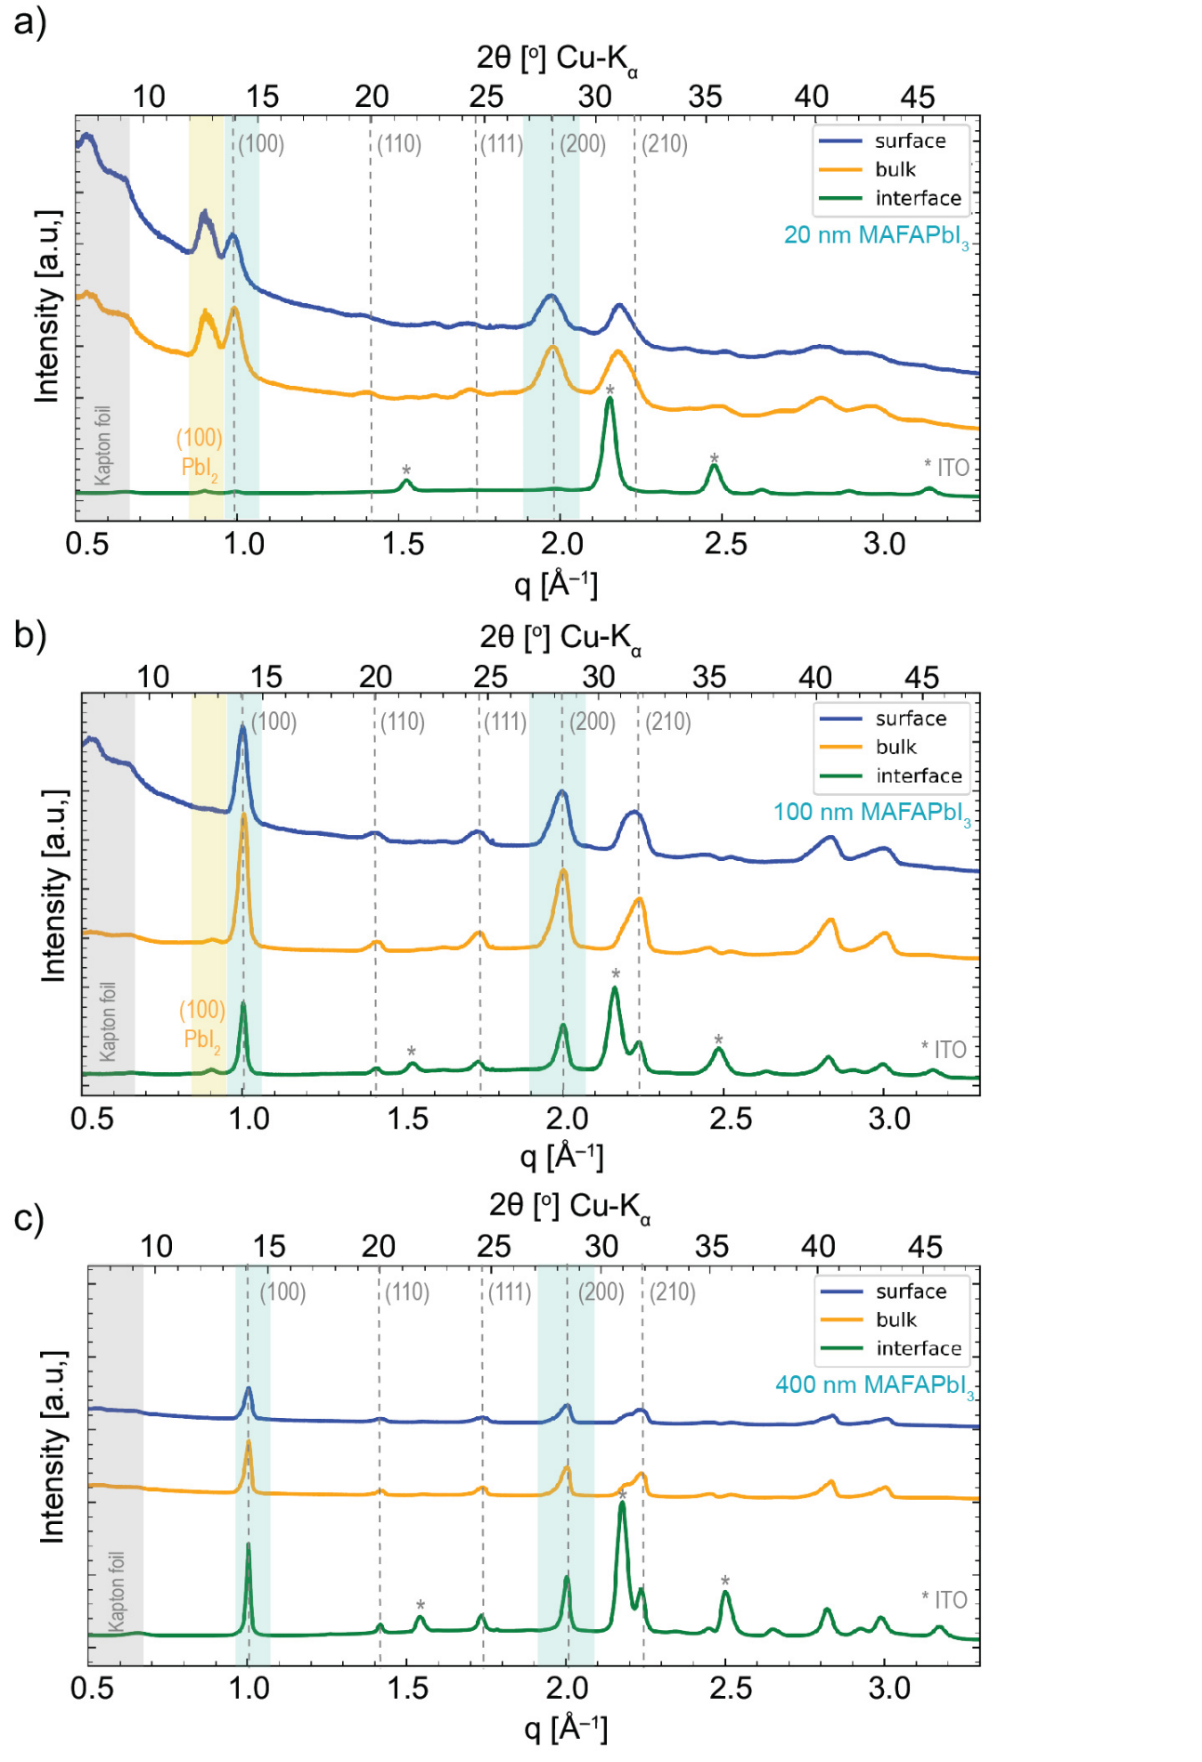

Fig 1. Pseudo XRD of a) 20, b) 100, and c) 400 nm thick films of PLD-grown MA_{1-x}FA_{x}PbI₃ on ITO/2PACz stack measured at three different incident angles.

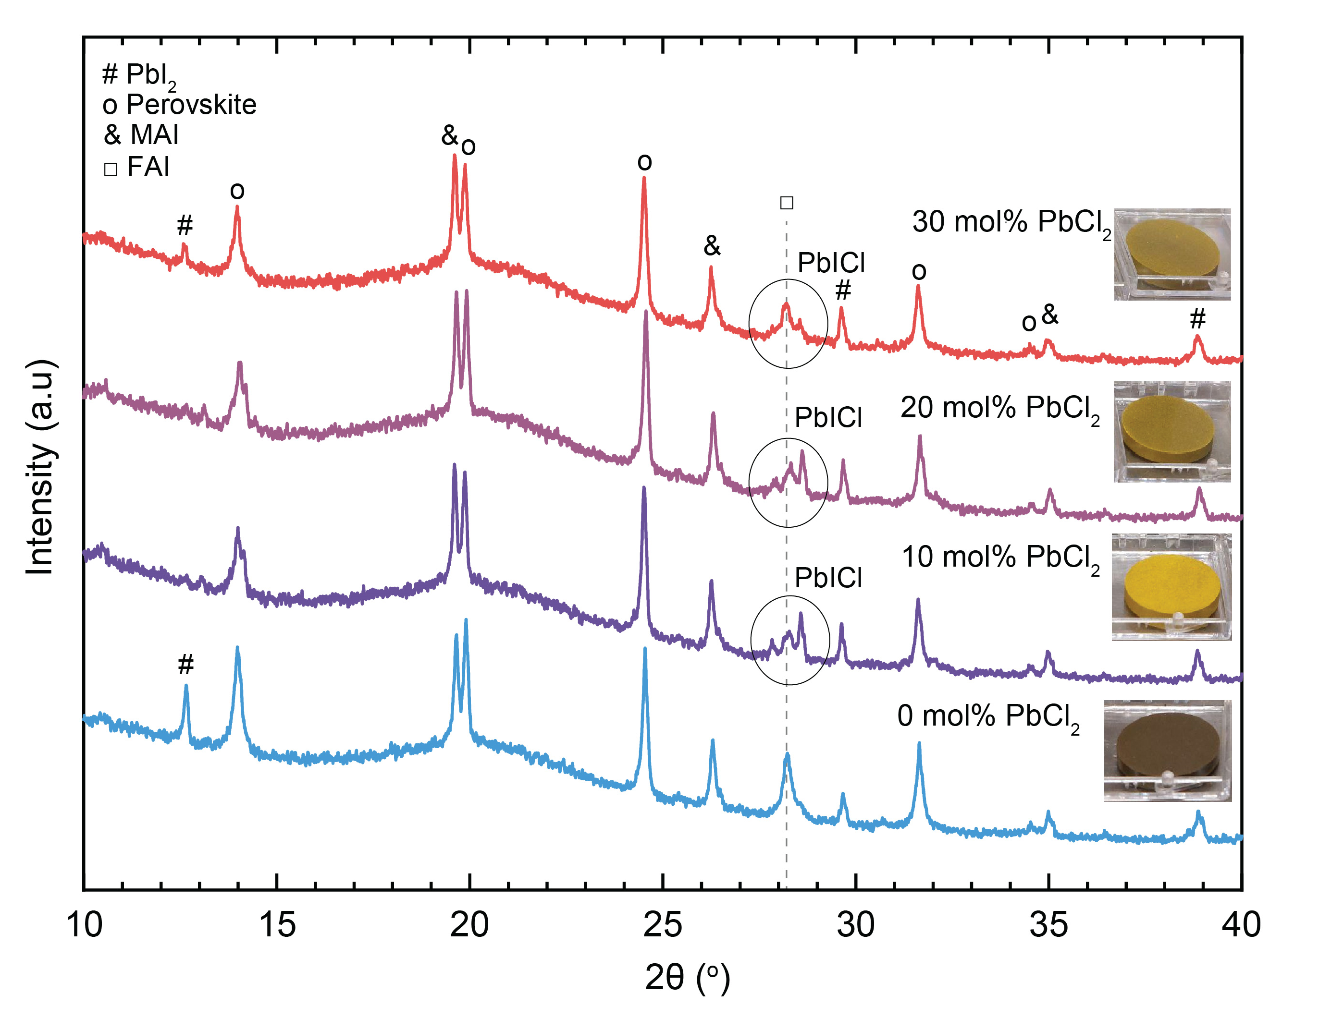
Fig 2. XRD pattern of PLD targets used as single sources to deposit MA_{1-x}FA_{x}PbI₃ thin films containing from 0 to 30 mol% PbCl₂ with respect to PbI₂. Inset photos of the targets with varying color due to the different mol% PbCl₂ content. It is worth noting that the 8: 1 excess of organic : inorganic compounds is the reason of some of the intense signals corresponding to the FAI or MAI precursors.¹
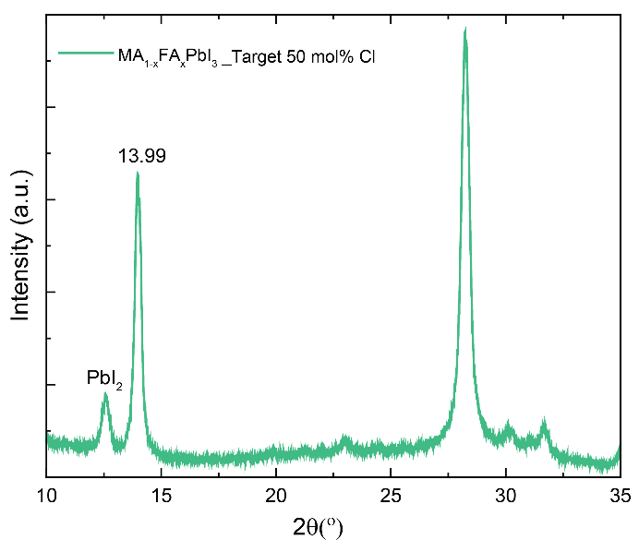

Fig 3. XRD pattern of PLD-grown MA_{1-x}FA_{x}PbI₃ thin film on ITO/2-PACz stack from a source containing 50 mol% PbCl₂.
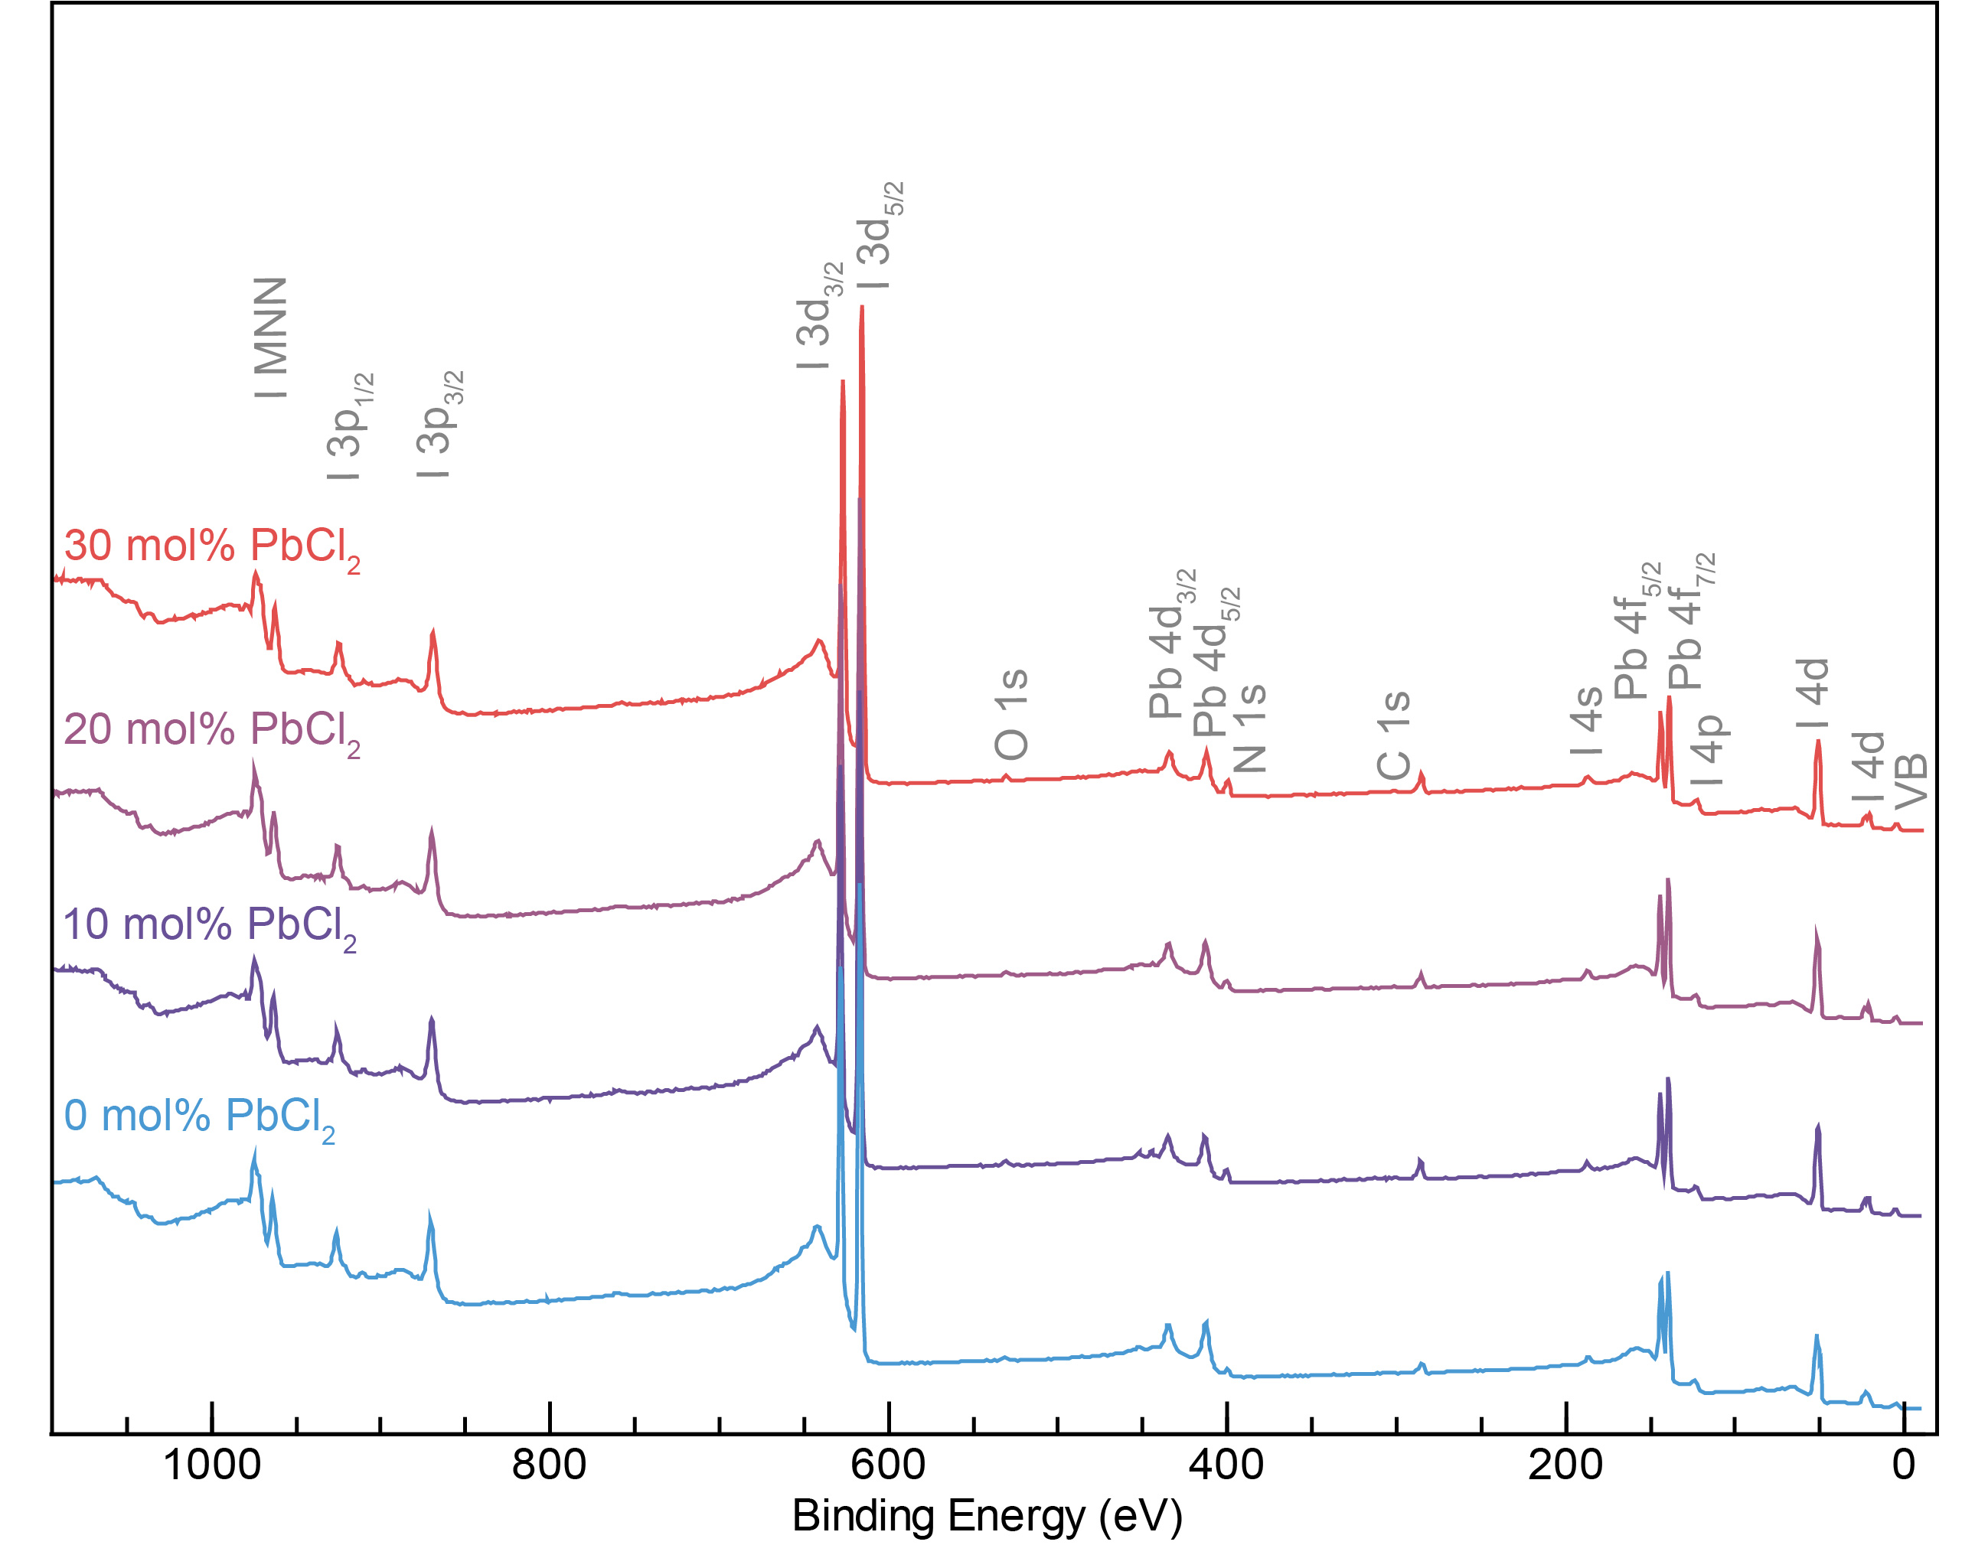
Fig 4. XPS survey spectra displaying major elements (Pb, I, C, and N) and I 3p, I 3d, Pb 4d, N 1s, C 1s, I 4s, Pb 4f, I 4p, and I 4d core levels of MA_{1-x}FA_{x}PbI₃(Cl)_{y} thin films grown from PLD targets with varying mol% PbCl₂.
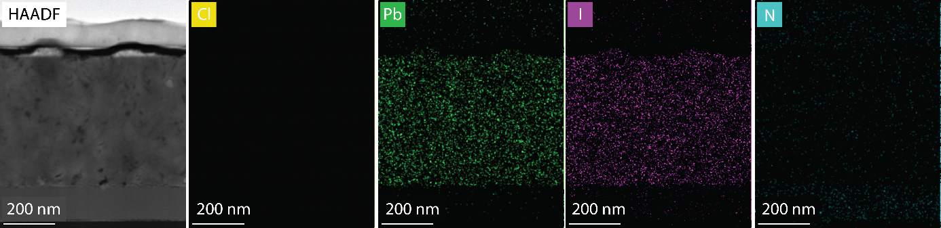
Fig 5. High-angle annular dark-field imaging (HAADF-STEM) image and the corresponding elemental mapping analysis of MA_{1-x}FA_{x}PbI₃(Cl)_{y} thin films grown from a 20 mol% PbCl₂ source.

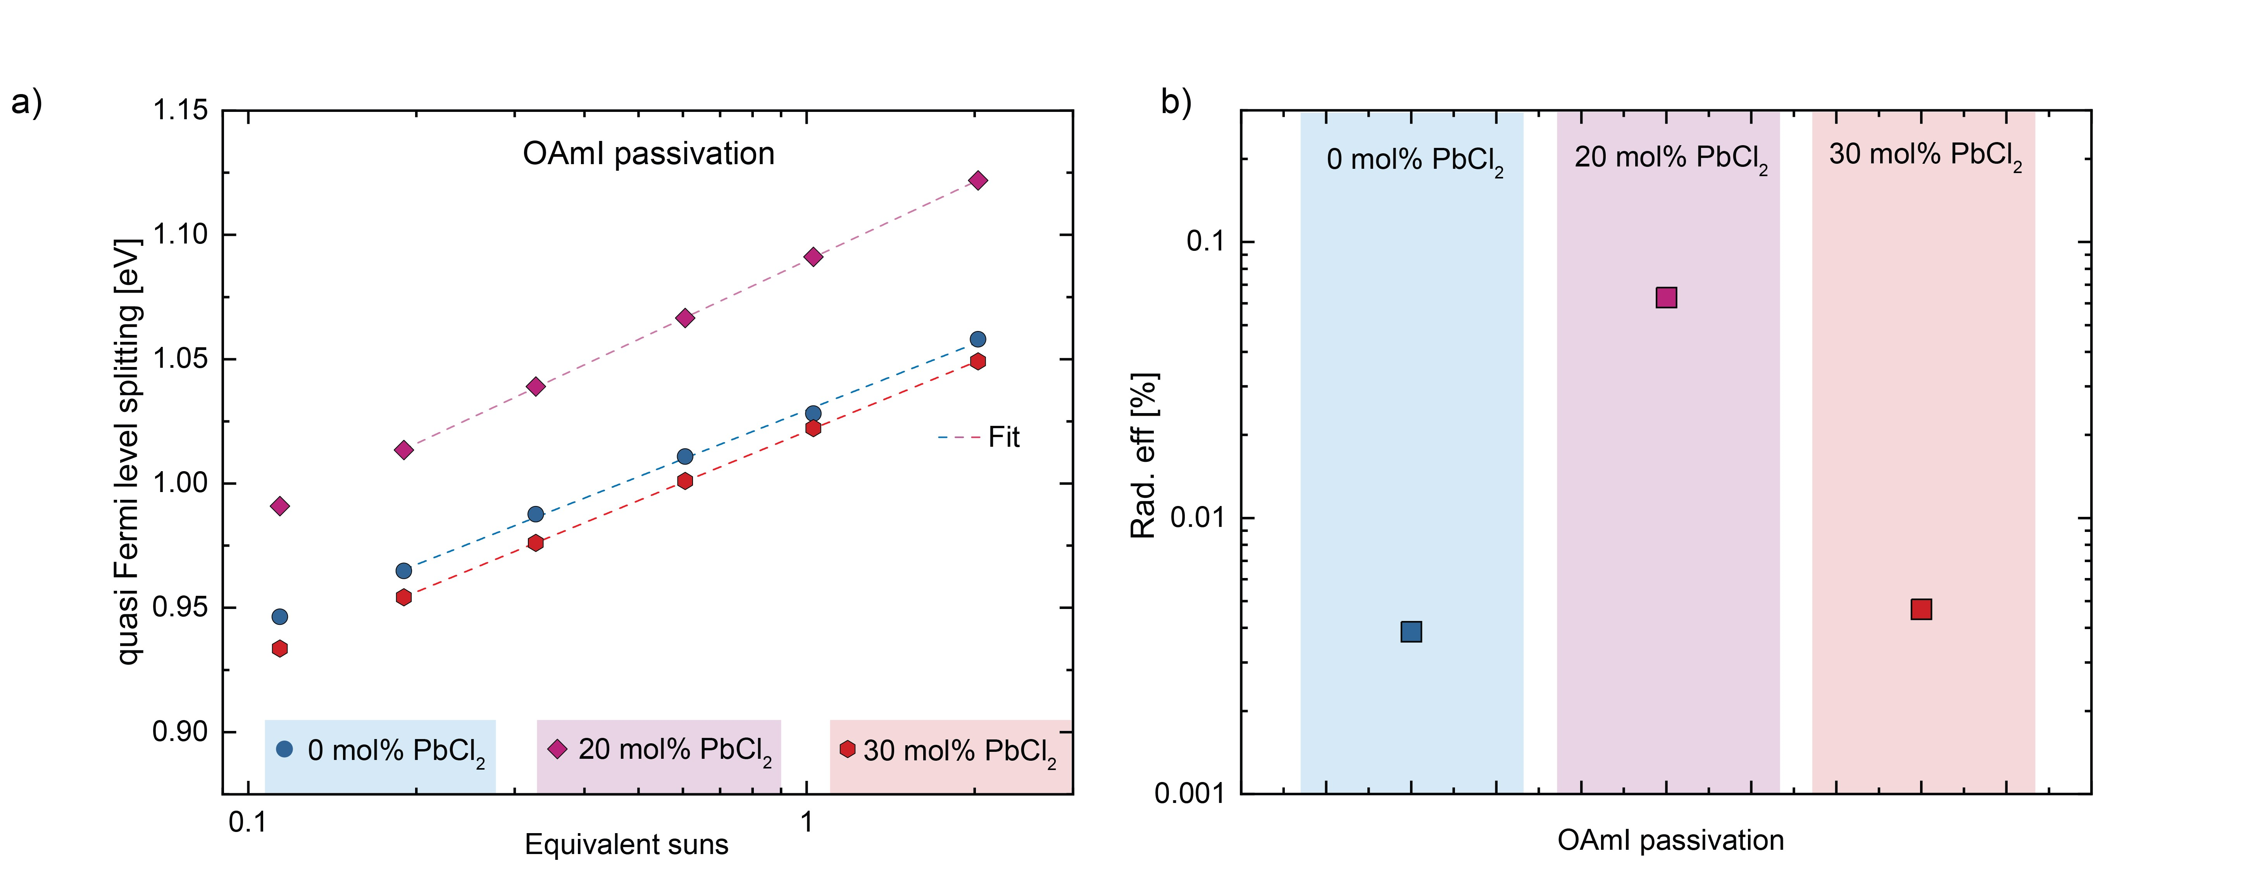
Fig 6. a) QFLS measured at RT for OAmI-passivated PLD-grown samples on glass from targets without and with PbCl₂ plotted over the equivalent illumination used for excitation. b) Calculated radiative efficiency of passivated-PLD grown perovskite films.

Table 1. Spectral features table of MA_{1-x}FA_{x}PbI₃(Cl)_{y} thin films from 0 to 30% mol PbCl₂ PLD targets.^{2,3}
Sample ID |  | Element/  Transition | Peak Energy (eV) | Peak Width (FWHM) (eV) | Sensitivity factor | Peak assignment
0 mol % PbCl₂ |  | Pb 4f_{7/2} | 139.6 | 1.43 | 12.73 | Pb-I
0 mol % PbCl₂ |  | Pb 4f_{5/2} | 144.4 | 1.43 | 10.01 | Pb-I
0 mol % PbCl₂ |  | I 3d_{5/2} | 616.1 | 1.47 | 19.87 | Pb-I
0 mol % PbCl₂ |  | I 3d_{3/2} | 627.4 | 1.47 | 13.77 | Pb-I
0 mol % PbCl₂ |  | C 1s | 285.0 | 2.40 | 1.0 | C-(C-H)
0 mol % PbCl₂ |  | C 1s | 286.7 | 2.40 | 1.0 | NH₃-C-H (MA⁺)
0 mol % PbCl₂ |  | C 1s | 288.7 | 2.40 | 1.0 | NH₂-C-H (FA⁺)
0 mol % PbCl₂ |  | N 1s | 401.4 | 1.86 | 1.8 | NH₃-C-H (MA⁺)
0 mol % PbCl₂ |  | N 1s | 400.0 | 1.86 | 1.8 | NH₂-C-H (FA⁺)
0 mol % PbCl₂ |  | VBM
10 mol % PbCl₂ |  | Pb 4f_{7/2} | 139.5 | 1.72 | 12.73 | Pb-I
10 mol % PbCl₂ |  | Pb 4f_{5/2} | 144.4 | 1.72 | 10.01 | Pb-I
10 mol % PbCl₂ |  | I 3d_{5/2} | 617.0 | 1.40 | 19.87 | Pb-I
10 mol % PbCl₂ |  | I 3d_{3/2} | 628.3 | 1.40 | 13.77 | Pb-I
10 mol % PbCl₂ |  | C 1s | 285.0 | 1.58 | 1.0 | C-(C-H)
10 mol % PbCl₂ |  | C 1s | 286.4 | 1.58 | 1.0 | NH₃-C-H (MA⁺)
10 mol % PbCl₂ |  | C 1s | 288.5 | 1.58 | 1.0 | NH₂-C-H (FA⁺)
10 mol % PbCl₂ |  | N 1s | 401.7 | 1.39 | 1.8 | NH₃-C-H (MA⁺)
10 mol % PbCl₂ |  | N 1s | 400.0 | 1.39 | 1.8 | NH₂-C-H (FA⁺)
10 mol % PbCl₂ |  | VBM
20 mol % PbCl₂ |  | Pb 4f_{7/2} | 139.3 | 1.24 | 12.73 | Pb-I
20 mol % PbCl₂ |  | Pb 4f_{5/2} | 144.1 | 1.24 | 10.01 | Pb-I
20 mol % PbCl₂ |  | I 3d_{5/2} | 617.1 | 1.38 | 19.87 | Pb-I
20 mol % PbCl₂ |  | I 3d_{3/2} | 628.4 | 1.38 | 13.77 | Pb-I
20 mol % PbCl₂ |  | C 1s | 285.1 | 1.64 | 1.0 | C-(C-H)
20 mol % PbCl₂ |  | C 1s | 286.4 | 1.64 | 1.0 | NH₃-C-H (MA⁺)
20 mol % PbCl₂ |  | C 1s | 288.4 | 1.64 | 1.0 | NH₂-C-H (FA⁺)
20 mol % PbCl₂ |  | N 1s | 401.7 | 1.36 | 1.8 | NH₃-C-H (MA⁺)
20 mol % PbCl₂ |  | N 1s | 400.0 | 1.36 | 1.8 | NH₂-C-H (FA⁺)
20 mol % PbCl₂ |  | VBM
30 mol % PbCl₂ |  | Pb 4f_{7/2} | 139.1 | 1.24 | 12.73 | Pb-I
30 mol % PbCl₂ |  | Pb 4f_{5/2} | 144.0 | 1.24 | 10.01 | Pb-I
30 mol % PbCl₂ |  | I 3d_{5/2} | 615.9 | 1.38 | 19.87 | Pb-I
30 mol % PbCl₂ |  | I 3d_{3/2} | 627.2 | 1.38 | 13.77 | Pb-I
30 mol % PbCl₂ |  | C 1s | 285.0 | 1.50 | 1.0 | C-(C-H)
30 mol % PbCl₂ |  | C 1s | 286.3 | 1.50 | 1.0 | NH₃-C-H (MA⁺)
30 mol % PbCl₂ |  | C 1s | 288.3 | 1.50 | 1.0 | NH₂-C-H (FA⁺)
30 mol % PbCl₂ |  | N 1s | 401.3 | 1.35 | 1.8 | NH₃-C-H (MA⁺)
30 mol % PbCl₂ |  | N 1s | 399.6 | 1.35 | 1.8 | NH₂-C-H (FA⁺)
30 mol % PbCl₂ |  | VBM

Table 2. Perovskite solar cells parameters overview for the best pixel and average devices.
 |  | V_{OC} (mV) | J_{SC} (mA/cm²) | FF (%) | Efficiency (%)
MAFA | Best pixel | 985.7 | 21.3 | 70.2 | 14.7
MAFA | Average | 985.4 | 21.3 | 69.3 | 14.5
MAFA(Cl)y | Best pixel | 991.8 | 21.0 | 75.0 | 15.6
MAFA(Cl)y | Average | 995.3 | 20.7 | 75.1 | 15.5
MAFA/2D | Best pixel | 1136.9 | 21.6 | 78.0 | 19.1
MAFA/2D | Average | 1120.1 | 21.3 | 76.6 | 18.3
MAFA(Cl)y/2D | Best pixel | 1155.5 | 21.6 | 79.4 | 19.7
MAFA(Cl)y/2D | Average | 1137.7 | 21.5 | 78.2 | 19.1

Table 3. Single-source vapor deposition methods reporting solar cell devices of different compositions.
Ref. | Method | Composition | Reported PCE (%) | Reported Stability | Reported growth mechanisms insights
a | PLD | MAPbI₃ | 6.7 | X | X
b | PLD | MAPbI₃ | 10.9 | X | X
c | PLD | MAPb(I_{y}Cl_{1-y})₃ | 7.7 | X | X
d | PLD | MA_{x}FA_{1-x}PbI₃ | 9.9, 14.0 | X | ✓
This work | PLD | MA_{x}FA_{1-x}PbI₃ , MA_{x}FA_{1-x}PbI₃(Cl)_{y} | 19.2, 19.7 | ✓ | ✓
e | PLD | CsPbBr₃ | 6.3 | X | X
f | Sputtering | MAPbI₃ , MA_{x}PbI₃(Cl)_{y} | 4.7, 15.2 | X | X
g | Flash evaporation | MAPbI₃ | 10.0 | ✓ | ✓
h | Flash evaporation | MAPbI₃ | 12.2 | X | X
i | Flash evaporation | MAPbI₃ | 16.8 | X | X
j | Flash evaporation | CsPb(I_{y}Br_{1-y})₃ | 12.2 | X | X
k | Thermal evaporation | MAPbI₃ | 9.9 | X | X
l | Thermal evaporation | MAPbI₃ | 10.8 | X | X
m | Thermal evaporation | CsPbBr₃ | 8.7 | ✓ | ✓
n | Thermal evaporation | Cs(Sn_{1-y}Pb_{y})Br₃ | 9.0 | ✓ | X
o | Electron beam evaporation | CsPbBr₃ | 7.8 | X | X
p | RIR-MAPLE | MAPbI₃ | 12.2 | X | X

a11. Soto-Montero, T. et al. Single-Source Pulsed Laser Deposition of MAPbI₃. 2021 IEEE 48th Photovolt. Spec. Conf. 1318–1323 (2021).
b²2. Bansode, U. & Ogale, S. On-axis pulsed laser deposition of hybrid perovskite films for solar cell and broadband photo-sensor applications. J. Appl. Phys. 121, (2017).
c³3. Bansode, U., Naphade, R., Game, O., Agarkar, S. & Ogale, S. Hybrid perovskite films by a new variant of pulsed excimer laser deposition: A roomerature dry process. J. Phys. Chem. C 119, 9177–9185 (2015).
d⁴4. Soto-Montero, T. et al. Single-Source Vapor-Deposition of MA_{1–x}FA_{x}PbI₃ Perovskite Absorbers for Solar Cells. Adv. Funct. Mater. 2300588 (2023).
e55. Wang, H. et al. Pulsed Laser Deposition of CsPbBr₃ Films for Application in Perovskite Solar Cells. ACS Appl. Energy Mater. 2, 2305–2312 (2019).
f⁶6. Gao, B. et al. Organic-Inorganic Perovskite Films and Efficient Planar Heterojunction Solar Cells by Magnetron Sputtering. Adv. Sci. 2102081, 1–10 (2021).
g77. Xu, H. et al. Grain growth study of perovskite thin films prepared by flash evaporation and its effect on solar cell performance. RSC Adv. 6, 48851–48857 (2016).
h⁸8. Longo, G., Gil-Escrig, L., Degen, M. J., Sessolo, M. & Bolink, H. J. Perovskite solar cells prepared by flash evaporation. Chem. Commun. 51, 7376–7378 (2015).
i99. Tai, M. et al. Laser-Induced Flash-Evaporation Printing CH₃NH₃PbI₃ Thin Films for High-Performance Planar Solar Cells. ACS Appl. Mater. Interfaces 10, 26206–26212 (2018).
j1010. Tai, M. et al. Efficient Inorganic Cesium Lead Mixed-Halide Perovskite Solar Cells Prepared by Flash-Evaporation Printing. Energy Technol. 7, 1–6 (2019).
k1111. Peng, H. et al. High-Quality Perovskite CH₃NH₃PbI₃ Thin Films for Solar Cells Prepared by Single-Source Thermal Evaporation Combined with Solvent Treatment. Materials (Basel). 12, (2019).
l¹²12. Fan, P. et al. High-performance perovskite CH₃NH₃PbI₃ thin films for solar cells prepared by single-source physical vapour deposition. Sci. Rep. 6, 1–9 (2016).
m1313. Li, J. et al. Fabrication of efficient CsPbBr₃ perovskite solar cells by single-source thermal evaporation. J. Alloys Compd. 818, 152903 (2020).
n¹⁴14. Abib, M. H. et al. Direct deposition of Sn-doped CsPbBr₃ perovskite for efficient solar cell application. RSC Adv. 11, 3380–3389 (2021).
o1515. Liu, L., Yang, S.-E., Liu, P. & Chen, Y. High-quality and full-coverage CsPbBr₃ thin films via electron beam evaporation with post-annealing treatment for all-inorganic perovskite solar cells. Sol. Energy 232, 320–327 (2022).
p¹⁶16. Dunlap-Shohl, W. A. et al. MAPbI₃ Solar Cells with Absorber Deposited by Resonant Infrared Matrix-Assisted Pulsed Laser Evaporation. ACS Energy Lett. 3, 270–275 (2018).

References
1. Fan, L. et al. Elucidating the role of chlorine in perovskite solar cells. J. Mater. Chem. A 5, 7423–7432 (2017).
2. Major, G. H. et al. Practical guide for curve fitting in x-ray photoelectron spectroscopy. J. Vac. Sci. Technol. A 38, 061203 (2020).
3. Béchu, S., Ralaiarisoa, M., Etcheberry, A. & Schulz, P. Photoemission Spectroscopy Characterization of Halide Perovskites. Adv. Energy Mater. 10, 1–25 (2020).

