Figure A1. Box and whisker plots of raw values by seasons of 21 monitoring parameters at five stations
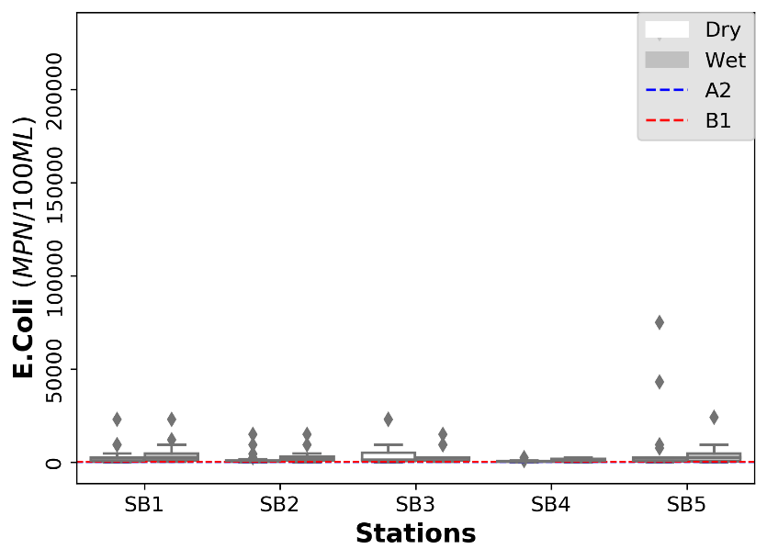 | 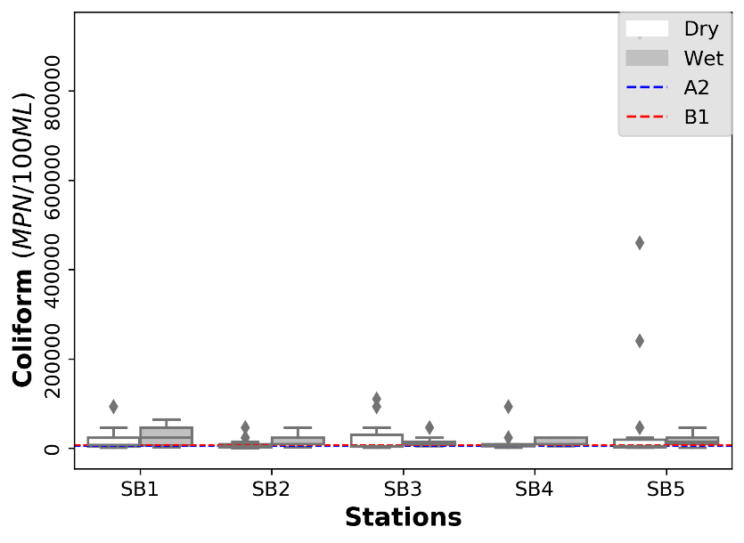 | 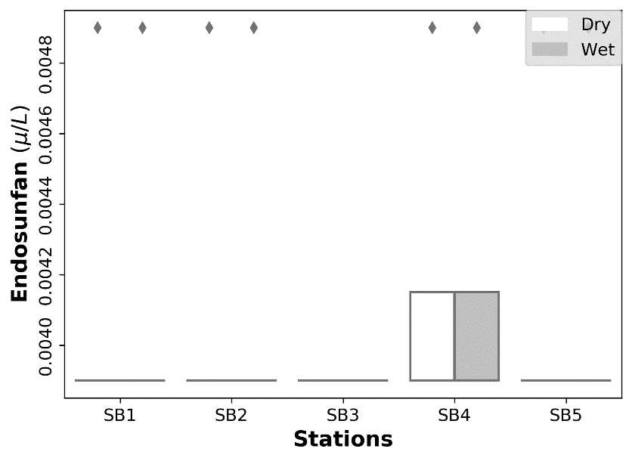 | 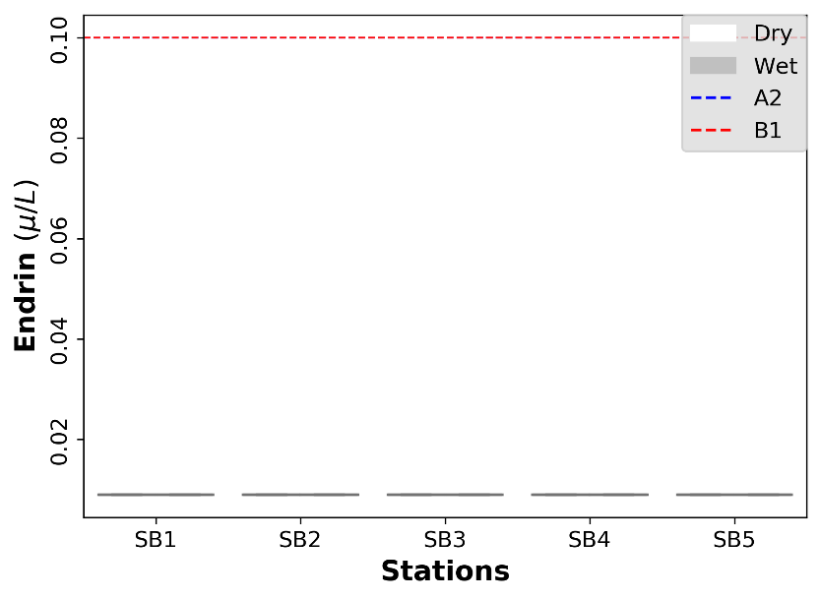
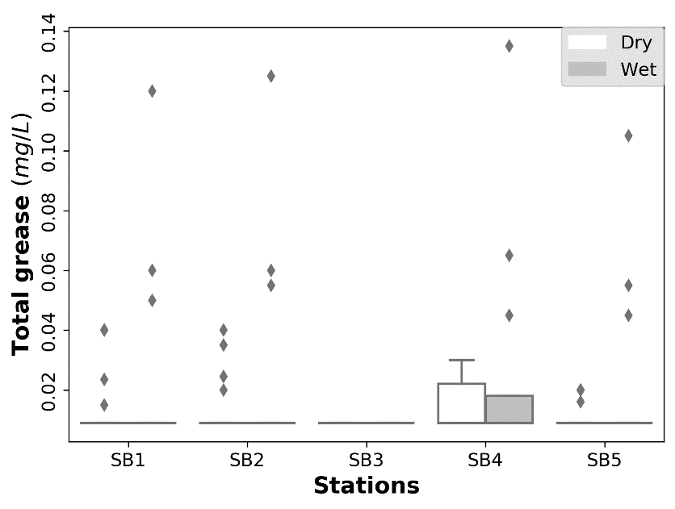 | 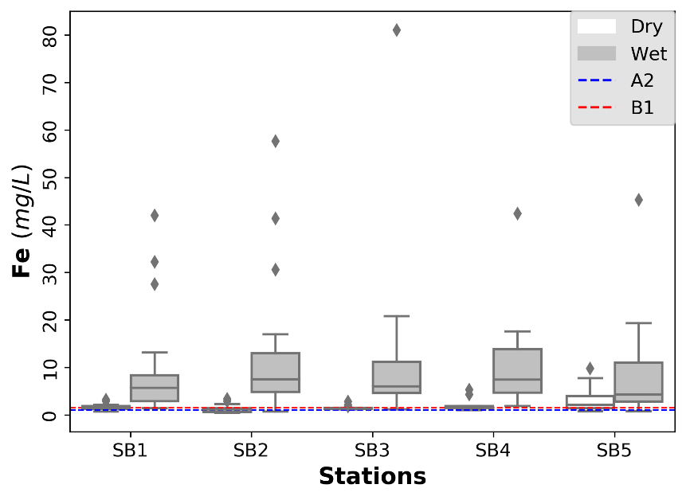 | 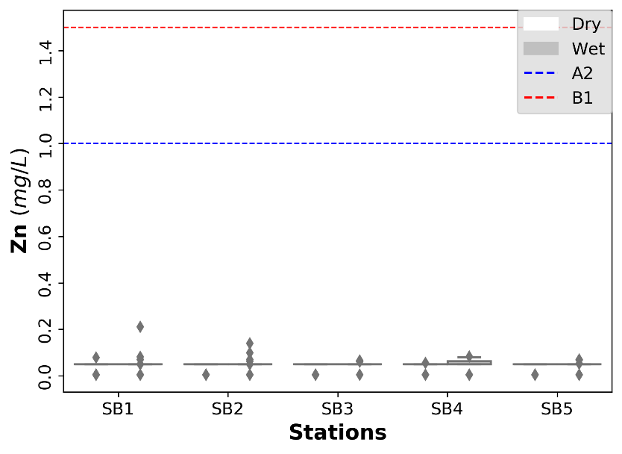 | 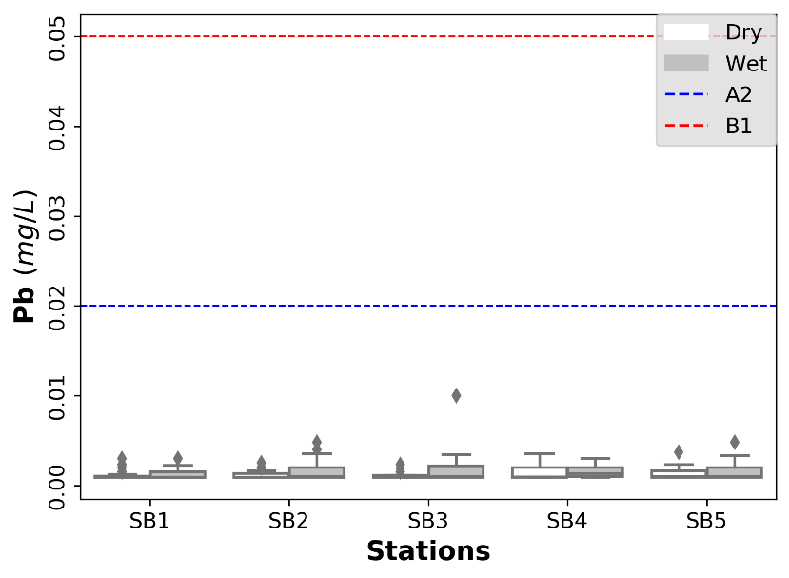
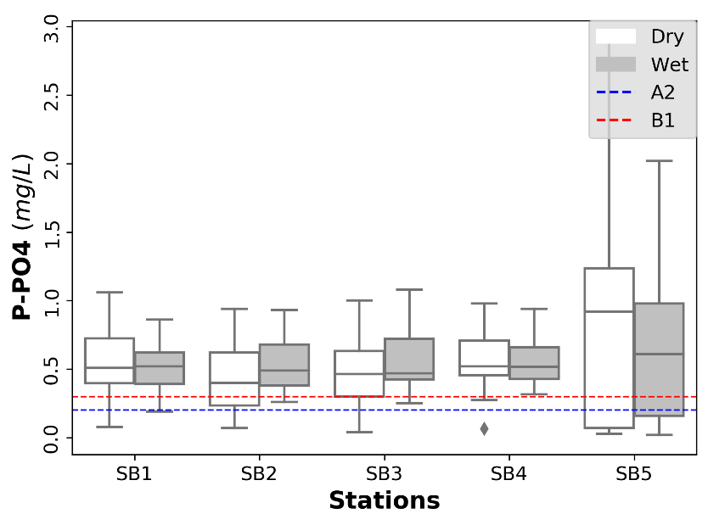 | 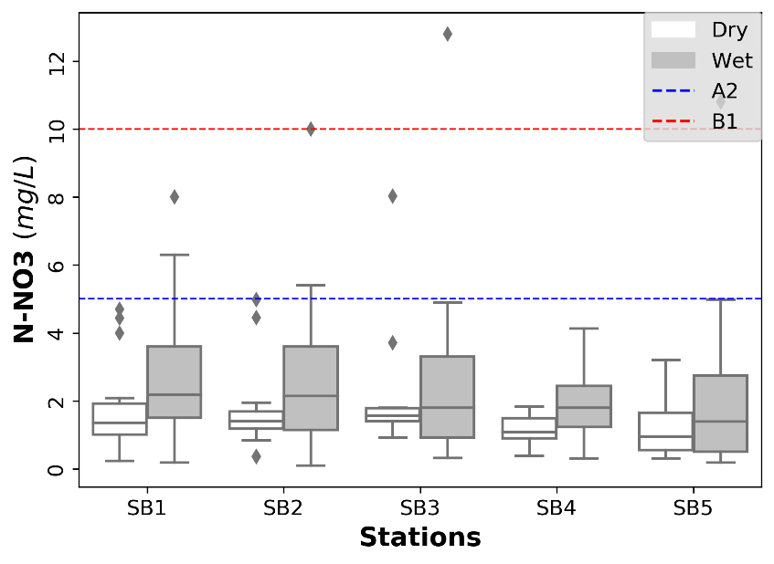 | 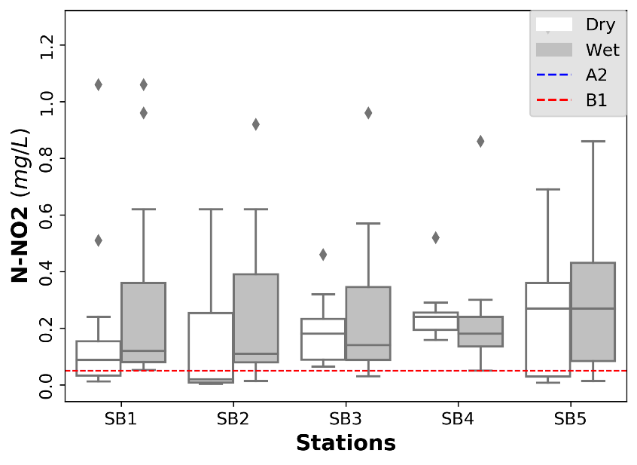 | 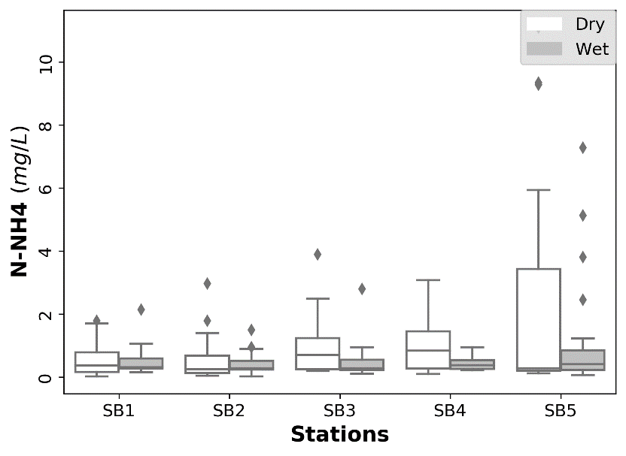
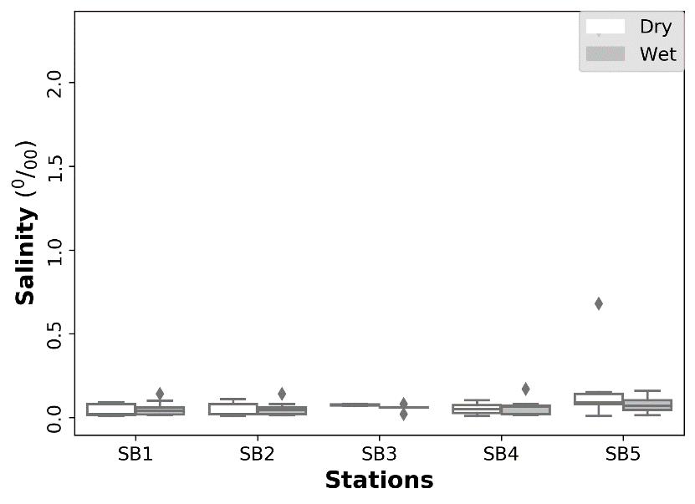 | 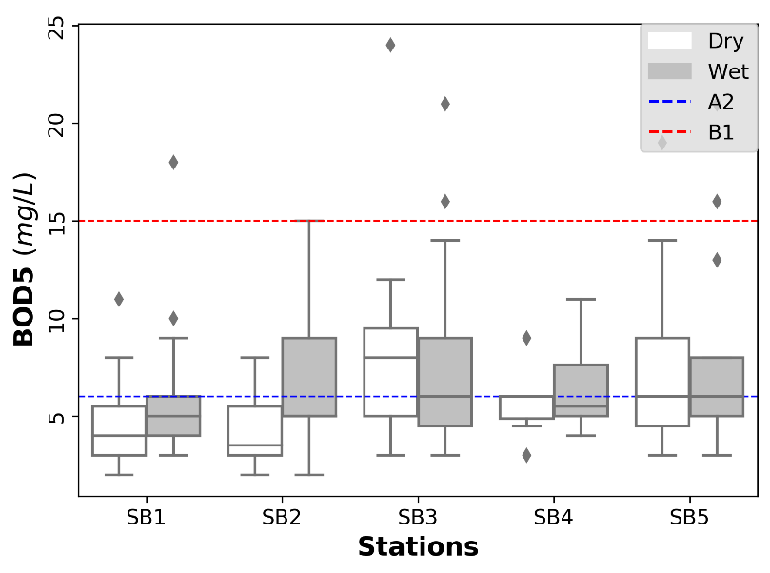 | 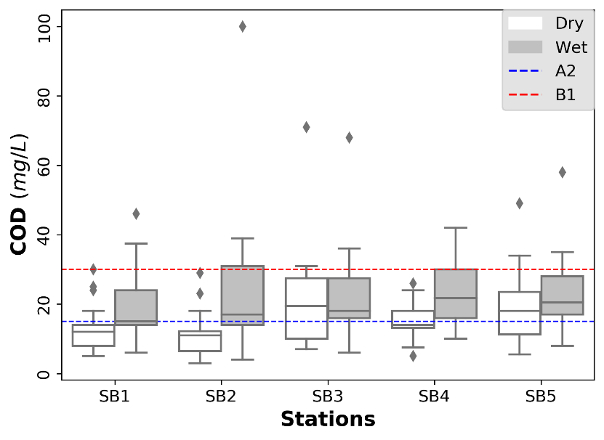 | 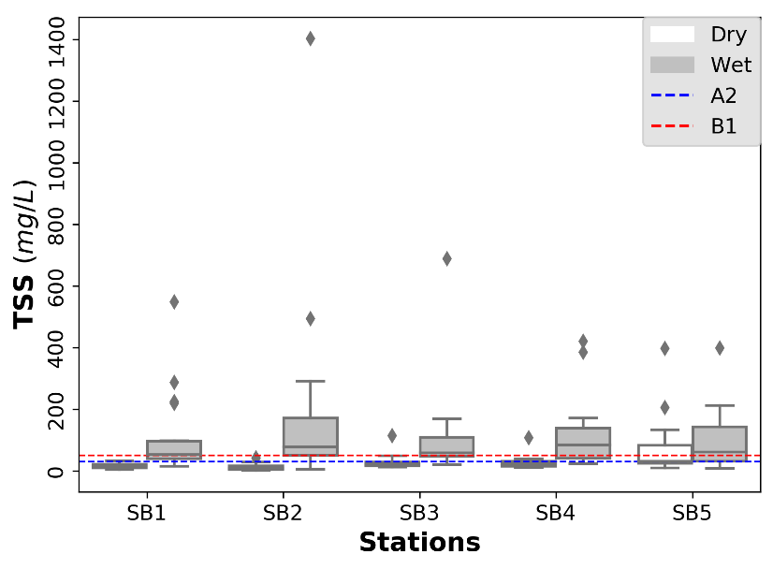
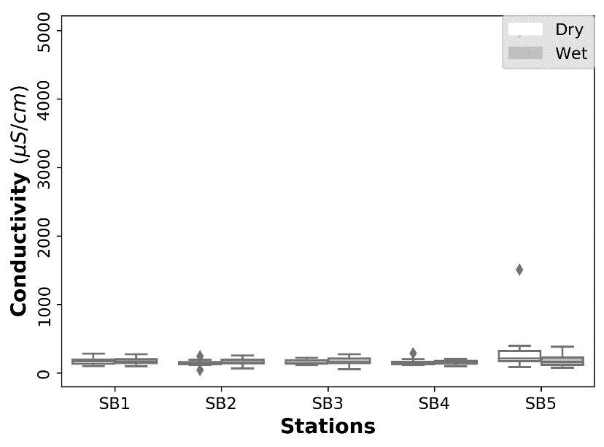 | 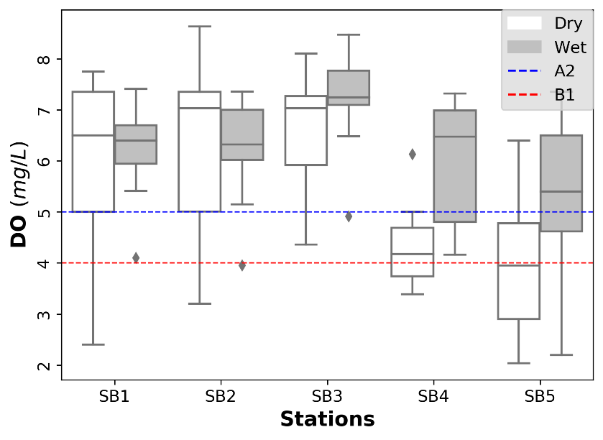 | 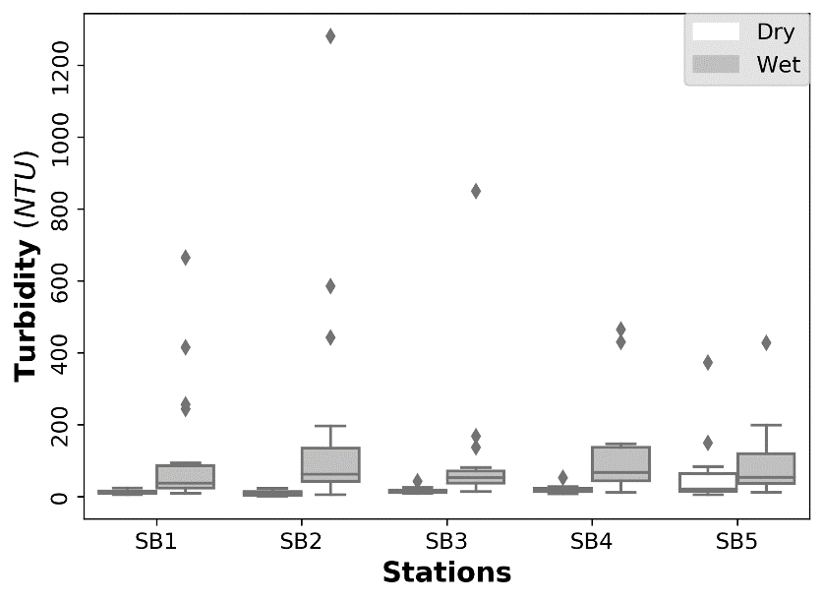 | 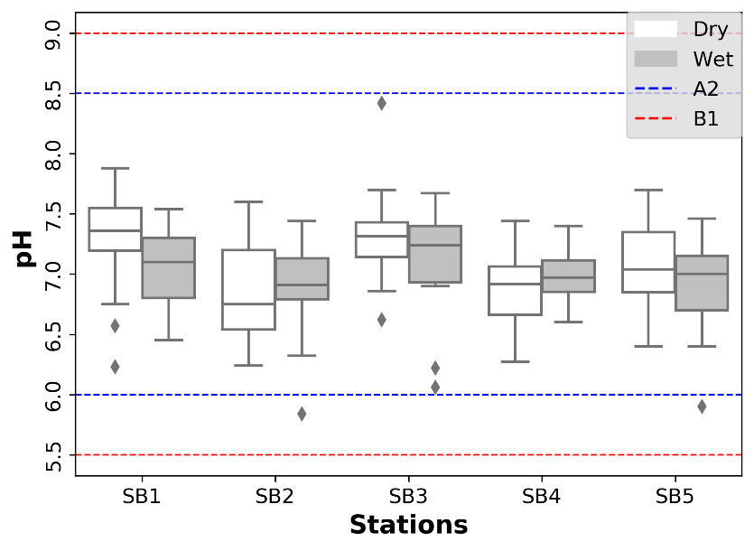
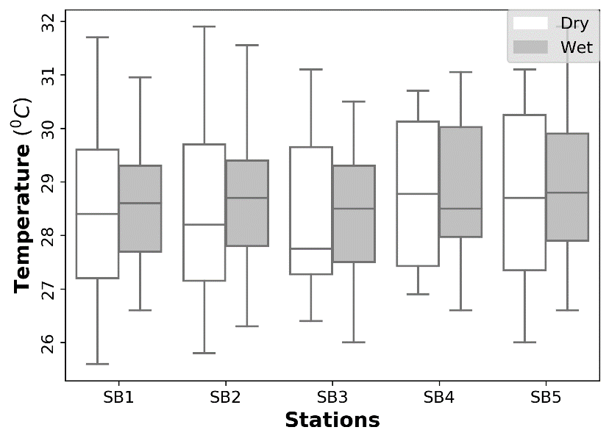

Table A2: Coefficients of determination in selected factors in five monitoring sites (bold underlined numbers highlight correlation higher than 0.40)
 | Monitoring sites
 | SB1 |  | SB2 |  | SB3 |  |  | SB4 |  |  | SB5
Parameters | Factor 1 | Factor 2 | Factor 1 | Factor 3 | Factor 1 | Factor 2 | Factor 3 | Factor 1 | Factor 2 | Factor 3 | Factor 1 | Factor 2 | Factor 4
Temperature | 0.00 | 0.00 | 0.02 | 0.02 | 0.02 | 0.19 | 0.29 | 0.01 | 0.46 | 0.02 | 0.15 | 0.07 | 0.01
Conductivity | 0.10 | 0.28 | 0.10 | 0.45 | 0.15 | 0.39 | 0.17 | 0.01 | 0.19 | 0.03 | 0.01 | 0.37 | 0.03
pH | 0.05 | 0.01 | 0.27 | 0.01 | 0.02 | 0.02 | 0.08 | 0.29 | 0.10 | 0.00 | 0.23 | 0.09 | 0.11
Turbidity | 0.54 | 0.23 | 0.61 | 0.13 | 0.66 | 0.06 | 0.05 | 0.64 | 0.18 | 0.14 | 0.27 | 0.24 | 0.04
TSS | 0.57 | 0.00 | 0.48 | 0.09 | 0.70 | 0.09 | 0.06 | 0.71 | 0.12 | 0.08 | 0.59 | 0.12 | 0.00
DO | 0.10 | 0.09 | 0.26 | 0.00 | 0.04 | 0.42 | 0.01 | 0.44 | 0.24 | 0.07 | 0.03 | 0.65 | 0.01
COD | 0.64 | 0.08 | 0.73 | 0.17 | 0.16 | 0.67 | 0.12 | 0.62 | 0.04 | 0.27 | 0.60 | 0.02 | 0.00
BOD5 | 0.53 | 0.07 | 0.45 | 0.29 | 0.06 | 0.32 | 0.53 | 0.42 | 0.22 | 0.19 | 0.49 | 0.04 | 0.01
NH4 | 0.05 | 0.63 | 0.04 | 0.00 | 0.01 | 0.23 | 0.14 | 0.17 | 0.02 | 0.13 | 0.08 | 0.26 | 0.01
N-NO2 | 0.23 | 0.24 | 0.41 | 0.08 | 0.15 | 0.38 | 0.02 | 0.06 | 0.34 | 0.00 | 0.36 | 0.24 | 0.09
N-NO3 | 0.20 | 0.03 | 0.29 | 0.09 | 0.40 | 0.14 | 0.00 | 0.40 | 0.38 | 0.00 | 0.32 | 0.00 | 0.42
P-PO4 | 0.01 | 0.42 | 0.56 | 0.07 | 0.06 | 0.17 | 0.49 | 0.11 | 0.06 | 0.41 | 0.43 | 0.52 | 0.01
Pb | 0.25 | 0.11 | 0.36 | 0.01 | 0.35 | 0.05 | 0.04 | 0.09 | 0.04 | 0.00 | 0.06 | 0.16 | 0.10
Fe | 0.50 | 0.17 | 0.60 | 0.03 | 0.62 | 0.14 | 0.01 | 0.85 | 0.00 | 0.03 | 0.38 | 0.35 | 0.01
E.Coli | 0.07 | 0.07 | 0.09 | 0.00 | 0.15 | 0.01 | 0.05 | 0.24 | 0.57 | 0.00 | 0.35 | 0.00 | 0.05
Coliform | 0.23 | 0.10 | 0.29 | 0.00 | 0.31 | 0.14 | 0.02 | 0.45 | 0.07 | 0.12 | 0.13 | 0.04 | 0.31

Table A3. Seasonal and pollution intensity profiles of clusters (blue and red numbers present exceeding of A2 and B1 standards respectively, LL and UL stand for lower limit and upper limit respectively)
 |  |  |  |  | Water quality parameters
 | Clusters | Dry season  (%) | Wet season  (%) | CIs | Turbidity  (NTU) | TSS  (mg/L) | Fe  (mg/L) | Temperature  (ºC) | Conductivity  (µS/cm) | DO  (mg/L) | BOD₅  (mg/L) | COD  (mg/L)
A2 |  |  |  |  | - | 30 | 1.0 | - | - | 5 | 6 | 15
B1 |  |  |  |  | - | 50 | 1.5 | - | - | 4 | 15 | 30
SB1 | 1 | 29 | 71 | LL | 36.80 | 52.73 | 4.83 |  |  |  | 5.69 | 18.21
 |  |  |  | UL | 73.86 | 94.08 | 8.38 |  |  |  | 7.64 | 27.99
SB1 | 2 | 63 | 27 | LL | 13.21 | 18.86 | 1.72 |  |  |  | 4.03 | 10.88
 |  |  |  | UL | 21.78 | 30.48 | 2.83 |  |  |  | 4.92 | 14.57
SB2 | 1 | 70 | 30 | LL | 10.75 | 12.13 | 1.26 |  | 138.86 |  | 3.81 | 9.60
 |  |  |  | UL | 25.94 | 28.49 | 3.25 |  | 155.26 |  | 5.24 | 14.02
SB2 | 2 | 28 | 72 | LL | 78.70 | 92.93 | 7.67 |  | 161.03 |  | 5.47 | 20.61
 |  |  |  | UL | 131.96 | 168.05 | 13.44 |  | 209.81 |  | 8.52 | 30.61
SB2 | 3 | 5 | 95 | LL | 10.80 | 28.72 | 1.05 |  | 59.32 |  | 8.87 | 30.36
 |  |  |  | UL | 69.58 | 291.00 | 12.30 |  | 120.18 |  | 14.45 | 39.32
SB3 | 1 | 33 | 67 | LL | 5.85 | 78.14 | 6.40 |  |  | 7.29 | 4.49 | 13.70
 |  |  |  | UL | 100.17 | 155.94 | 17.42 |  |  | 8.20 | 10.86 | 23.03
SB3 | 2 | 50 | 50 | LL | 17.23 | 23.33 | 1.97 |  |  | 7.17 | 3.75 | 8.66
 |  |  |  | UL | 38.16 | 48.25 | 4.70 |  |  | 7.67 | 5.13 | 13.16
SB3 | 3 | 58 | 42 | LL | 17.20 | 25.43 | 1.93 |  |  | 5.88 | 7.19 | 21.31
 |  |  |  | UL | 34.05 | 50.50 | 4.47 |  |  | 6.88 | 9.59 | 26.83
SB4 | 1 | 52 | 48 | LL | 21.33 | 26.44 | 2.76 | 28.06 |  | 4.57 | 5.05 | 14.81
 |  |  |  | UL | 45.54 | 51.57 | 6.22 | 29.35 |  | 5.68 | 6.28 | 21.43
SB4 | 2 | 0 | 100 | LL | 85.50 | 102.00 | 6.29 | 29.76 |  | 4.45 | 9.50 | 33.00
 |  |  |  | UL | 160.27 | 191.20 | 17.40 | 30.85 |  | 6.35 | 13.77 | 40.77
SB5 | 1 | 67 | 33 | LL |  | 38.14 |  |  |  | 3.06 | 6.59 | 18.41
 |  |  |  | UL |  | 78.72 |  |  |  | 3.89 | 8.92 | 24.03
SB5 | 2 | 50 | 50 | LL |  | 19.75 |  |  |  | 5.34 | 3.51 | 9.60
 |  |  |  | UL |  | 27.87 |  |  |  | 6.24 | 5.11 | 17.89
SB5 | 3 | 21 | 79 | LL |  | 115.25 |  |  |  | 5.38 | 6.58 | 20.28
 |  |  |  | UL |  | 191.21 |  |  |  | 6.55 | 11.34 | 28.86

Table A3. (continue)
 |  |  |  |  | Water quality parameters
 | Clusters | Dry season  (%) | Wet season  (%) | CIs | NH4⁺  (mg/L) | NO3⁻  (mg/L) | NO2⁻  (mg/L) | PO4³⁻  (mg/L) | E.Coli  (MPN/100mL) | Coliform  (MPN/100mL)
A2 |  |  |  |  | 0.3 | 5 | 0.05 | 0.2 | 50 | 5000
B1 |  |  |  |  | 0.9 | 10 | 0.05 | 0.3 | 100 | 7500
SB1 | 1 | 29 | 71 | LL | 0.39
 |  |  |  | UL | 0.82
SB1 | 2 | 63 | 27 | LL | 0.34
 |  |  |  | UL | 0.59
SB2 | 1 | 70 | 30 | LL |  |  | 0.08 | 0.35
 |  |  |  | UL |  |  | 0.18 | 0.50
SB2 | 2 | 28 | 72 | LL |  |  | 0.23 | 0.55
 |  |  |  | UL |  |  | 0.54 | 0.68
SB2 | 3 | 5 | 95 | LL |  |  | 0.00 | 0.61
 |  |  |  | UL |  |  | 0.24 | 0.95
SB3 | 1 | 33 | 67 | LL |  | 0.89 |  | 0.42
 |  |  |  | UL |  | 3.93 |  | 1.00
SB3 | 2 | 50 | 50 | LL |  | 0.81 |  | 0.31
 |  |  |  | UL |  | 1.48 |  | 0.44
SB3 | 3 | 58 | 42 | LL |  | 1.64 |  | 0.48
 |  |  |  | UL |  | 2.38 |  | 0.74
SB4 | 1 | 52 | 48 | LL |  | 1.06 |  | 0.46 | 290.00 | 5964.40
 |  |  |  | UL |  | 1.56 |  | 0.66 | 1085.70 | 12259.89
SB4 | 2 | 0 | 100 | LL |  | 2.9 |  | 0.49 | 150.00 | 4300.00
 |  |  |  | UL |  | 4.7 |  | 0.88 | 236.28 | 24923.02
SB5 | 1 | 67 | 33 | LL |  | 1.19 |  | 0.98
 |  |  |  | UL |  | 2.04 |  | 1.44
SB5 | 2 | 50 | 50 | LL |  | 0.48 |  | 0.05
 |  |  |  | UL |  | 1.02 |  | 0.10
SB5 | 3 | 21 | 79 | LL |  | 1.10 |  | 0.57
 |  |  |  | UL |  | 2.98 |  | 0.86

Figure A4. Dendrograms of clustering at five monitoring sites
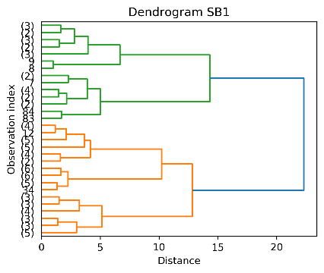 | 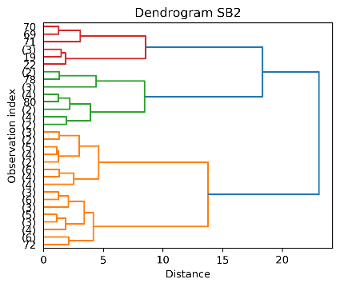 | 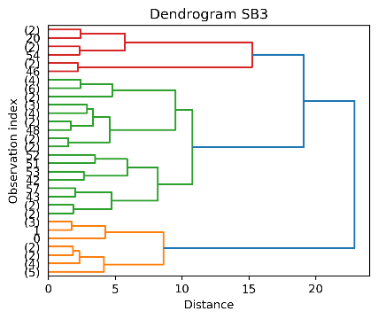
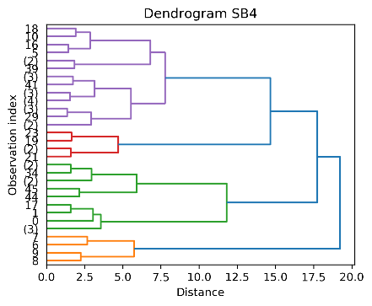 | 