Supplementary Information
Foregone carbon sequestration loss dominates greenhouse gas budget in mariculture associated with coastal wetland conversion

Running head: GHG debt of coastal wetlands converted to mariculture

Junji Yuan¹, Yanhong Dong^{1,2}, Junjie Li^{1,2}, Deyan Liu^{1,3}, Jian Xiang³, Tiehu He¹, Hojeong Kang⁴, Weixin Ding^{1,}*
¹ State Key Laboratory of Soil and Sustainable Agriculture, Institute of Soil Science, Chinese Academy of Sciences, Nanjing 210008, China.
² University of Chinese Academy of Sciences, Beijing 10049, China
³ Co-Innovation Center for Sustainable Forestry in Southern China, Nanjing Forestry University, Nanjing 210037, China
⁴ School of Civil and Environmental Engineering, Yonsei University, Seoul 120–749, Korea

Author for correspondence:
Weixin Ding
Tel: 0086–25–8688–1527; Fax: 0086–25–8688–1000; Email: wxding@issas.ac.cn

Includes:
Supplementary Text 1 (Methods-Extensive)
Supplementary Figure 1 to 5
Supplementary Table 1 to 4

Supplementary Text 1. Methods-Extensive.
Eddy covariance measurement of greenhouse gas fluxes
Ecosystem-scale CH₄ and CO₂ (net ecosystem CO₂ exchange, NEE) fluxes from the S. alterniflora marsh were measured by an eddy covariance (EC) system equipped with a WindMaster 3D anemometer (Gill Instruments, Lymington, UK), an open path CO₂/H₂O infrared gas analyzer (LI7500A, LI-COR, Inc., Lincoln, OR, USA) and an open path CH₄ gas analyzer (LI7700, LI-COR). The lower mirror of CH₄ analyzer was self-cleaned by an automated pumping system at 05:00 every day or once the received-signal-strength indicator dropped below 20%. We also manually cleaned the mirrors of CO₂ and CH₄ analyzers on a biweekly basis to maintain good signal strength. All these sensors were mounted on the EC tower at a height of 4.0 m, about twice the S. alterniflora canopy height during the peak growing season. Canopy of the saltmarsh was relatively homogeneous and flat. Fetch of the sensors was over 400 m in all directions, and footprint analysis indicated that 80% of the fluxes originated from an upwind distance of less than 120 m on average (Supplementary Fig. 1).
All raw data were sampled with a 10 Hz frequency and recorded by a Sutron Xlite 9210 datalogger (Sutron, Sterling, VA, USA). CO₂ and CH₄ fluxes were computed as the covariance between fluctuations in gas mixing ratio and vertical wind velocity over 30 min periods⁷⁰. Several procedures of flux correction and quality control were applied to the high-frequency raw data as summarized in Supplementary Table 3, and the data processing was conducted by Eddypro software (version 6.0, LI-COR). Besides, a data tracking procedure was used to remove spurious values that were outside the physical and/or biologically plausible ranges, especially during rain events. In addition, to ensure well turbulence conditions, data with quality flag of 0 and 1 are retained. The friction velocity (u*) was used as a criterion for atmospheric mixing and discarded fluxes that were obtained when u* was below the thresholds of 0.10 m s^{‒1} (ref. ⁷¹). We only included the half-hourly flux data when at least 80% of the cumulative flux originated from within the available fetch⁷². After these processing, a total of 56.2% and 32.8% of valid NEE and CH₄ fluxes data, respectively, were retained in our final analysis.
We gap-filled the missing NEE by using the marginal distribution sampling algorithm and further partitioned it into gross primary productivity (GPP) and ecosystem respiration (Re) following Reichstein et al.⁷¹. GPP and Re were all presented with positive sign (NEE = Re ‒ GPP). The standard deviation (SD) of each half-hourly flux was determined by comparing the actual and estimated NEE. We computed the annual gap-filling uncertainty following Krauss et al.⁷³. Briefly, the daily uncertainty was scaled based on the mean 30 min SD over 1 day, which was subsequently summed over the whole year to give an estimate of annual uncertainty. All the procedures mentioned above were completed by the ReddyProc package⁷⁴. For CH₄ fluxes, we used the random forest (RF) to fill the data gaps with meteorological variables (e.g., air temperature (T_{air}), soil temperature at 10 cm depth (T_{soil_10}), u*, WD, vapor pressure deficit, and photosynthetic photon flux density) in order to obtain a continuous CH₄ flux time series for constructing annual CH₄ budgets^{75,76}. To avoid diurnal or seasonal biases, original data without gaps were proportionately sampled from a series of k-means clusters for training, testing, and validation of the RF using the “factoextra” package⁷⁷. Several RF architectures with different levels of complexity were tested, and the simplest architecture was selected in which a further increase in complexity yielded <5% reduction in mean square error⁷⁸. The whole procedure was repeated 20 times, and the median value of the RF results was used to fill the CH₄ fluxes gap. The uncertainty of this approach was assessed by the variance of the RF predictions.

Chamber measurement of greenhouse gas fluxes
We measured the N₂O fluxes in S. alterniflora marsh using the static closed chamber technique. Four gas sampling plots were randomly established in the S. alterniflora marsh ~20 m away from the EC tower. Wooden boardwalks were installed in each plot to prevent soil disturbance during sampling. Polyvinyl chloride (PVC) chamber collars (50 cm × 50 cm × 20 cm) that equipped with a water-filled channel were inserted into the soil to a depth of 20 cm along the boardwalks. The transparent Plexiglass chambers (50 cm × 50 cm in area, but height depending on the height of plants) were used to measure N₂O fluxes.
The static closed chamber technique was also used to measure CO₂, CH₄ and N₂O fluxes in mariculture ponds. Four subsites were randomly selected in each pond to minimize the spatial uncertainties of GHG emissions. The specially designed device for supporting PVC chamber collars was installed in each subsite. This device included four stainless steel pegs for fixing the system and two adjustable crossbars. PVC chamber collars (50 cm × 50 cm × 20 cm) were placed on the crossbars and if necessary, the crossbars together with chamber collars were adjusted to water surface level one day before sampling. To facilitate gas sampling, wooden boardwalks were installed in front of the supporting device. The transparent Plexiglass chambers (50 cm × 50 cm × 10 cm) were used for collecting gas samples. See Yuan et al.⁵⁰ for further detailed information of the devices.
In mariculture ponds, GHG fluxes were measured twice weekly during the culturing period and the first month of the drainage period, and then weekly until the next culturing period started. In S. alterniflora marsh, N₂O fluxes were measured twice weekly during the growth season from April to October and weekly during the non-growth season from November to March. Gas sampling was conducted at 08:00–10:00 local time to minimize diurnal variation in the flux pattern. The procedure of fluxes measurement has been described in our previous studies^{17,50}. Briefly, chamber was fitted into the water trough of the chamber collars and chamber gas samples were taken after a deployment time of 0, 10, 20, 30 min. At each sampling event, a 40-ml gas sample was withdrawn in a nylon syringe and injected into a 22-ml pre-evacuated glass vial. Air temperature inside the chamber was simultaneously measured with a mercury thermometer. Concentrations of CO₂, CH₄, and N₂O were determined by a gas chromatograph (Agilent 7890, Santa Clara, CA, USA) and fluxes were calculated by fitting linear regressions between concentration and time. Since transparent chambers were used, the measured CO₂ fluxes in mariculture ponds were recognized as NEE (ref. ⁵⁰).

Environmental data
Micrometeorological instrumentation was deployed in the S. alterniflora marsh to accompany EC measurements. Air temperature (T_{air}) and precipitation were measured by a HMP155 temperature probe (Vaisala, Helsinki, Finland) and a TE525MM rain gauge (Campbell Scientific, Logan, UT, USA), respectively. Soil temperature at 10 cm depth (T_{soil_10}) was measured by a CS655 multiparameter sensor (Campbell Scientific). Water depth (WD) was measured with a HOBO water level logger (Onset, Bourne, MA, USA). Redox potential (Eh) at 10 cm depth was measured weekly using a PHB-6 pH/mv meter (Jiaoyuan Instrument, Yancheng, China). A YSI EXO2 (YSI international, Yellow Springs, OH, USA) water quality probe was installed in a tidal creek about 60 m southeast of the tower for monitoring salinity.
In mariculture ponds, auxiliary parameters were measured simultaneously with gas sampling. The WD was directly measured by a straightedge and water temperature (or soil temperature in drainage period) at 10 cm depth were measured with a portable digital thermometer (JM624, Jinming, Tianjin, China). Salinity and DO of the pond water were measured by a DDBJ-350 conductivity meter (INESA Scientific, Shanghai, China) and a Seven2Go Pro dissolved oxygen meter (Mettler Toledo, Zürich, Switzerland), respectively.
The 0‒10 cm soil samples were collected weekly from the saltmarsh and mariculture ponds for mineral N and dissolved organic C (DOC) measuring. Soil NH₄⁺ and NO₃– were extracted with 2 M KCl solution and analyzed on a SAN++ continuous-flow analyzer (Skalar, Breda, the Netherlands). DOC was extracted with deionized water and measured on a TOC analyzer (TOC Vcph, Shimadzu, Kyoto, Japan). Soil organic C (SOC) and total N (TN) contents were determined by the wet-oxidation method and the Kjeldahl procedure, respectively.
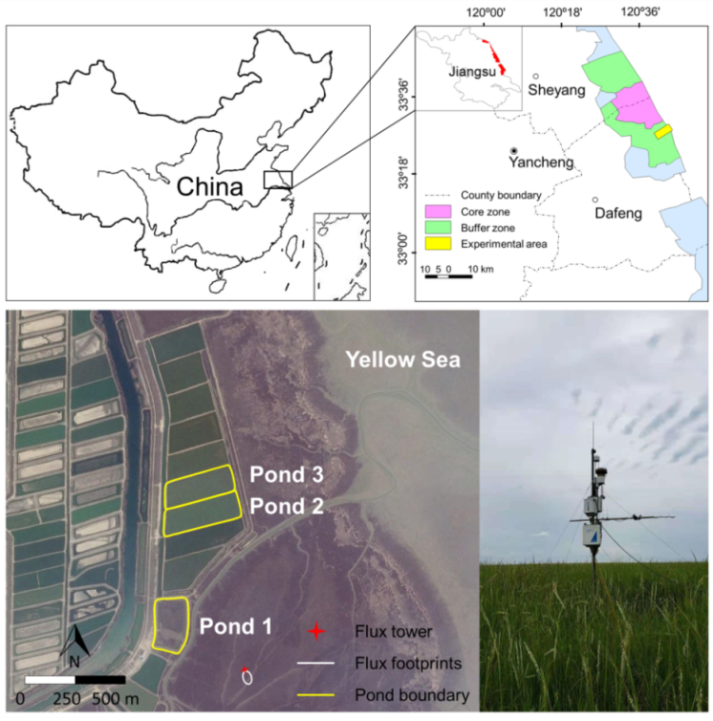
Supplementary Figure 1. Study area within the coast of Yellow Sea, Yancheng City, Jiangsu Province, China (33°23'N, 120°43'E). Three experimental mariculture ponds (Google earth (© 2018 DigitalGlobe), image date: 14 December 2015) were all converted from Spartina alterniflora saltmarsh with different culturing time of 1, 4, and 5 years for Pond 1 (MP1), 2 (MP2) and 3 (MP3), respectively. Flux tower (red star) was established at S. alterniflora marsh, adjacent to the ponds. The contour (white oval) represents the 85% climatological footprint.
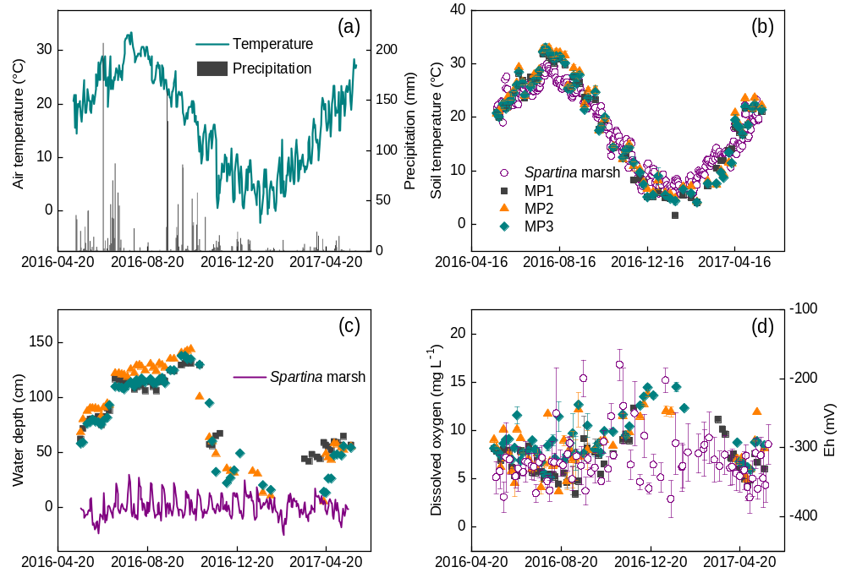
Supplementary Figure 2. Temporal variation of (a) air temperature and precipitation, (b) soil/water temperature at 10 cm depth, (c) water depth, (d) redox potential (Eh) of S. alterniflora marsh and dissolved oxygen concentration in mariculture ponds. Vertical bars are standard errors of the means (n = 4).
Supplementary Table 1. Application rates and characteristics of fertilizers/feeds applied in the mariculture ponds in Yancheng, China.
Fertilizer/feed | Application rate  (kg ha^{–1}) | C  (%) | N  (%) | C input  (kg C ha^{–1}) | N input  (kg N ha^{–1})
Fertilizers
Chicken manure | 680 | 11.3 | 0.70 | 65.9 | 4.77
Urea | 182 | 20.0 | 46.7 | 36.3 | 84.7
Compound fertilizer | 83 | – | 15.0 | – | 12.5
Calcium superphosphate | 160 | – | – | – | –
Amino acid fertilizer | 117 | 2.54 | 2.60 | 2.97 | 3.03
Nutrients for diatom | 45 | 12.0 | – | 5.38 | –
Bio-organic fertilizer | 50 | 2.26 | 0.76 | 1.14 | 0.38
Feeds
Commercial feed | 1978 | 21.4 | 5.12 | 423 | 101
Trash fish | 2273 | 8.41 | 2.69 | 191 | 61.0
Total C/N inputs | – | – | – | 725 | 268

Supplementary Table 2. Management practices in the mariculture ponds in Yancheng, China.
Date  (dd/mm/yy) | Practice details
15/Apr/2016 | Basal manure application
20/Apr/2016 | Hard clam (Mercenaria mercenaria) stocking
20/May/2016 | Swimming crab (Portunus trituberculatus) stocking
7/Jun/2016 | Ridgetail white prawn (Exopalaemon carinicauda) stocking
17/Jun/2016 | Supplemental fertilizing (50%)
27/Aug/2016 | Supplemental fertilizing (50%)
28/Sep/2016 | Crab and prawn harvesting
22/Oct/2016 | Water discharge
2/Dec/2016 | Clam harvesting
24/Dec/2016 | Drainage and exposure
17/Apr/2017 | Water inletting
22/Apr/2017 | Sediment disinfection
For MP1, the drainage and exposure procedure, and inletting of water were started on December 6, 2016 and March 22, 2017, respectively. Chicken manure was applied as basal fertilizer; urea, compound fertilizer and calcium superphosphate were applied as supplemental fertilizers with two splits of 50%:50%.
Supplementary Table 3. Summary of the procedures of flux correction and quality control for high-frequency raw data.
Flux correction and quality control | Reference
Despiking | Vickers and Mahrt⁷⁹
2-D coordinate rotation for anemometer tilt correctio | Wilczak et al.⁸⁰
Covariance maximization of gas analyzer signals and w for time lag correction | Fan et al.⁸¹
Analytical corrections for high-pass and low-pass filtering | Moncrieff et al.^{82,83}
Air density correction | Chamberlain et al.⁸⁴; Webb et al.⁸⁵
Steady states and turbulent conditions (lowquality results are indicated by a flag of 2) | Foken et al.⁸⁶

Reference
70. Baldocchi, D. D. Assessing the eddy covariance technique for evaluating carbon dioxide exchange rates of ecosystems: past, present and future. Global Change Biol. 9, 479‒492 (2003).
71. Reichstein, M. et al. On the separation of net ecosystem exchange into assimilation and ecosystem respiration: review and improved algorithm. Global Change Biol. 11, 1424‒1439 (2005).
72. Chi, J. et al. Effects of climatic conditions and management practices on agricultural carbon and water budgets in the inland Pacific Northwest USA. J. Geophys. Res.-Biogeo. 122, 3142‒3160 (2017).
73. Krauss, K. W. et al. Component greenhouse gas fluxes and radiative balance from two deltaic marshes in Louisiana: Pairing chamber techniques and eddy covariance. J. Geophys. Res.-Biogeo. 121, 1503‒1521 (2016).
74. Wutzler, T. et al. Basic and extensible post-processing of eddy covariance flux data with REddyProc. Biogeosciences 15, 5015‒5030 (2018).
75. Breiman, L. Random forests. Mach. Learn. 45, 5‒32 (2001).
76. Kim, Y. et al. Gap-filling approaches for eddy covariance methane fluxes: A comparison of three machine learning algorithms and a traditional method with principal component analysis. Global Change Biol. 26, 1499‒1518 (2020).
77. Kassambara, A. & Mundt, F. Factoextra: Extract and Visualize the Results of Multivariate Data Analyses. (R package version, 1.0.5, 2020). Available at: https://CRAN.R-project.org/package= factoextra
78. Knox, S. H. et al. Agricultural peatland restoration: effects of land-use change on greenhouse gas (CO₂ and CH₄) fluxes in the Sacramento-San Joaquin Delta. Global Change Biol. 21, 750‒765 (2015).
79. Vickers, D., & Mahrt, L. Quality control and flux sampling problems for tower and aircraft data. J. Atmos. Ocean. T. 14, 512‒526 (1997).
80. Wilczak, J. M., Oncley, S. P., & Stage, S. A. Sonic anemometer tilt correction algorithms. Bound.-Lay. Meteo. 99, 127‒150 (2001).
81. Fan, S. M., Wofsy, S. C., Bakwin P. S, Jacob, D. J. & Fitzjarrald, D. R. Atmosphere-biosphere exchange of CO₂ and O₃ in the central Amazon forest. J. Geophys. Res.-Atmos. 95, 16851‒16864 (1990).
82. Moncrieff, J., Valentini, R., Greco, S., Guenther, S., & Ciccioli, P. Trace gas exchange over terrestrial ecosystems: methods and perspectives in micrometeorology. J. Exp. Bot. 48, 1133‒1142 (1997).
83. Moncrieff, J., Clement, R., Finnigan, J., & Meyers, T. in Handbook of Micrometeorology: A Guide for Surface Flux Measurement and Analysis (eds Lee, X., Massman, W. & Law, B.) pp. 7‒31 (Springer, 2004).
84. Chamberlain, S. D., Verfaillie, J., Eichelmann, E., Hemes, K. S. & Baldocchi, D. D. Evaluation of density corrections to methane fluxes measured by open-path eddy covariance over contrasting landscapes. Bound.-Lay. Meteo. 165, 197‒210 (2017).
85. Webb, E. K., Pearman, G. I. & Leuning, R. Correction of flux measurements for density effects due to heat and water vapour transfer. Q. J. Roy. Meteor Soc. 106, 85‒100 (1980).
86. Foken, T. et al. Post-field data quality control. in Handbook of Micrometeorology: A Guide for Surface Flux Measurement and Analysis (eds Lee, X., Massman, W. & Law, B.) pp. 7‒31 (Springer, 2004).

