APPENDICES
Appendix Figure 1. Participation of PC professionals in the PREDIAPS strategy in the planned implementation sessions (n=10)

Global group
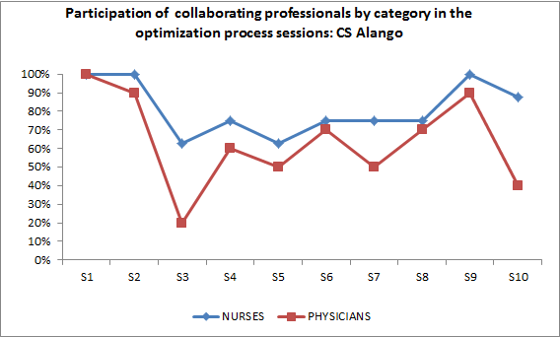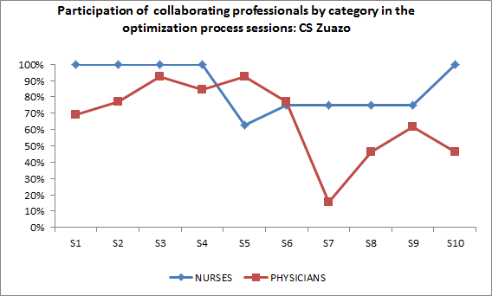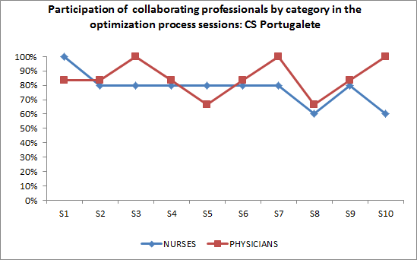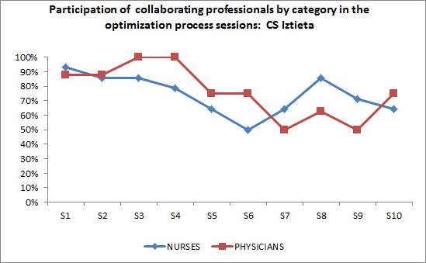
Sequential Group
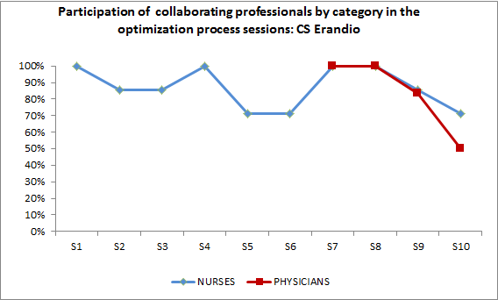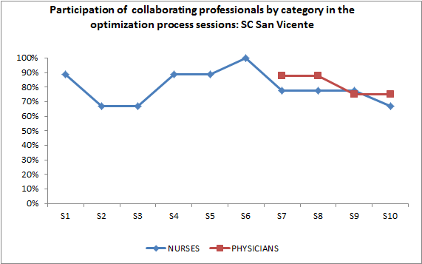
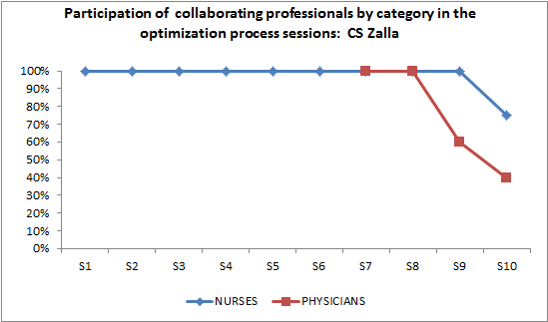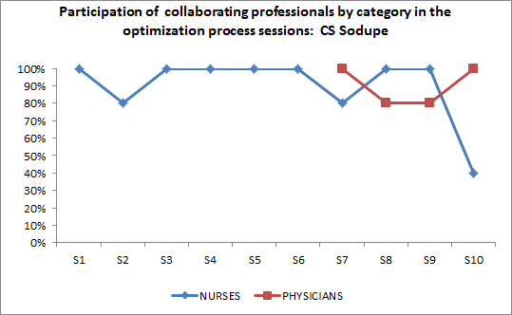

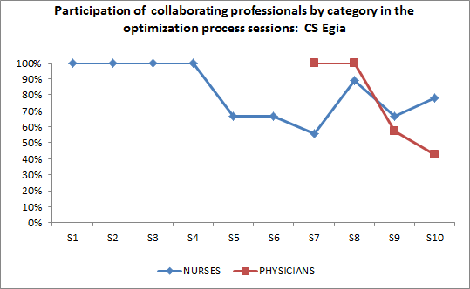

Appendix Table 1. Reporting modifications of the PREDIAPS implementation strategy
- Added actions
Modification/Description | Additional training session in the recommended clinical intervention and in the ICT tool (M₁) | Additional session for physicians’ involvement in the Sequential Group (M₂) | Additional training session in the recommended clinical intervention and in the ICT for new professionals (M₃)
When did the modification occur? | Month 1 of the implementation phase | Month 11 of the implementation phase | Month 20-21 of the implementation phase
Were modifications planned? | Unplanned and reactive | Unplanned and reactive | Unplanned and reactive
Who participated in the decision to modify? Who made the ultimate decision? | Implementation team, formed by healthcare professionals of the center and the external facilitator | Local leader and the external facilitator | Implementation team, formed by healthcare professionals of the center and the external facilitator
What was modified? | The dose of the training component by repeating the former planned action/session | The dose and the actors involved, as the session for “involvement of physicians” (PDSA session #3) was repeated adding the presence of the integrated healthcare organization management staff | An additional training session was to newly incorporated professionals was offered, scheduled and performed
At what level of delivery (for whom/what is the modification made)? | Healthcare professionals of one PC of the Sequential group (Sv) | One PC of the Sequential group (Sv) | Few new professionals from 4 centers: 1 from the Global (A, n=3); 3 from the Sequential (Sv, n=1; Z, n=2; So, n=1)
What is the nature of the content modification? | An additional 90-minute session was performed on the recommended clinical health promotion intervention and the ICT healthy lifestyle promotion tool | An additional 90-minute session with all PC professionals with the participation of representatives of the management of the integrated healthcare organization | An additional 90-minute session was performed on the recommended clinical health promotion intervention and the ICT healthy lifestyle promotion tool
Relationship fidelity/core elements? | Fidelity consistent/core elements or functions preserved | Fidelity consistent/core elements or functions preserved | Unknown
What was the goal? | Increase healthcare professional’s knowledge and skills to provide the recommended clinical intervention | Maximize number of physicians engaged | Train newly incorporated professionals to provide the recommended clinical intervention
What are the reasons for the modifications? | Perceived difficulty of the providing the recommended intervention through the ICT healthy lifestyle promotion tool | Lack of attendance to the planned session | Staff turnover
- Actions not or only partially delivered
Modification/Description | Failed to organize and conduct the planned ongoing supportive training session (M₅) | Failed to attend to regular audits and ongoing facilitation sessions (M₄) | Failed to organize and conduct the planned number of regular audits and ongoing facilitation sessions (M₆₎
When did the modification occur? | Month 20in the post-implementation phase | Months 15,22 and 24 in the post-implementation phase | Post-implementation phase
Were adaptations planned? | Unplanned and reactive | Unplanned and reactive | Unplanned and reactive
Who participated in the decision to modify? Who made the ultimate decision? | Local leader and healthcare professionals of the center | Local leader and healthcare professionals of the center | Implementation team, formed by healthcare professionals of the center and the external facilitator
What was modified? | Planned training session suspended | Planned and scheduled sessions suspended | Planned sessions suspended
At what level of delivery (for whom/what is the modification made)? | 2 centersin the Sequential group (Eg,So) and 2 in the Global group (A,Z) failed | 2 PCin the Sequential group (Eg,Z) and one in the Global group (I) failed once;1PCin the Sequential group (Er) failed twice | All centers
What is the nature of the content modification? | No modification required | No modification required | No modification required
Relationship fidelity/core elements? | Fidelity inconsistent as this was a core element within the planned strategy | Fidelity inconsistent as this was a core element within the planned strategy | Fidelity inconsistent as this was a core element within the planned strategy
What was the goal? | Increase healthcare professionals’ knowledge and skills to provide the recommended clinical intervention | Provide ongoing support and assess progressin the implementation process | Provide ongoing support and assess progress in the implementation process
What are the reasons for the modifications? | Difficulty for scheduling meetings due to work overload or other competing priorities | Difficulty for scheduling meetings due to work overload or other competing priorities | Difficulty for scheduling meetings due to work overload or other competing priorities

Appendix Table 2. Evaluation of ERIC Implementation Strategies related to the optimization process
Strategies in italics were those identified a priori to be used as part of implementation plan
(X) Implementation strategy identified as useful for own professional development
(+) Implementation strategy considered valuable for the optimization process
(B) Implementation strategy needed to foster competence building
(E) Implementation strategy needed to facilitate engagement of professionals
(C) Implementation strategy needed for inter-professional collaboration
(-) Implementation strategy identified as needing improvement
 | Global group |  |  |  | Sequential group
ERIC Strategies | PC1 A | PC2 Zu | PC3Iz | PC4 P | PC5Er | PC6Sv | PC7Eg | PC Za | PC So
Pre-planned ERIC Strategies
5. Audit and provide feedback | + |  | X - |  | B | X + |  | X | +
12. Change record systems
14. Conduct cyclical small tests of change | X + | +
15. Conduct educational meetings | X + | X - | X + | X - | X | X ++ - | X + | X | X - B
17. Conduct local consensus discussions
18. Conduct local needs assessment |  |  | X |  |  |  |  | X | X
19. Conduct on-going training
23. Develop a formal implementation blueprint
27. Develop and organize quality monitoring systems
48. Organize clinician implementation team meetings
51. Promote adaptability |  |  |  |  |  |  |  | +
55. On-going support for implementation
57. Recruit, designate, train for leadership | E |  |  |  |  |  |  | C
59. Revise professional roles | C
Additional ERIC Strategies Perceived
20. Create a learning collaborative |  | X | + | XX + | X |  | + | X | X +
33. Facilitation | X | + |  | + |  | X +
44. Mandate change | E | E |  |  | B

