Supramolecular Polynuclear Clusters Mediated Assembly of Cubic Hydrogen-Bonded Organic Frameworks with Octahedral Cages for Reversible Photochromism
Xiaojun Ding, Jing Chen, and Gang Ye*

Table S1. Crystallographic data and structure refinement data of TCA_NH₄,.
Single crystal | TCA_NH₄
Empirical formula | C₈₄H₈₁N₁₀O₂₇
Formula weight | 1722.67
Temperature/K | 170.00
Crystal system | cubic
Space group | I23
a/Å | 20.9737(2)
b/Å | 20.9737(2)
c/Å | 20.9737(2)
α/° | 90
β/° | 90
γ/° | 90
Volume/Å³ | 9226.2(3)
Z | 4
ρ_{calc} g/cm³ | 1.241
μ/mm⁻¹ | 0.787
F(000) | 3616.0
Crystal size/mm³ | 0.2 × 0.16 × 0.15
Radiation | CuKα (λ = 1.54178)
2Θ range for data collection/° | 10.33 to 132.888
Index ranges | -23 ≤ h ≤ 16, -22 ≤ k ≤ 24, -20 ≤ l ≤ 24
Reflections collected | 21578
Independent reflections | 2724 [R_{int} = 0.1528, R_{sigma} = 0.0642]
Data/restraints/parameters | 2724/0/184
Goodness-of-fit on F² | 1.020
Final R indexes [I>=2σ (I)] | R₁ = 0.0745, wR₂ = 0.2109
Final R indexes [all data] | R₁ = 0.0932, wR₂ = 0.2271
Largest diff. peak/hole / e Å⁻³ | 0.24/-0.31
Flack parameter | 0.2(2)
CCDC number | 2309944

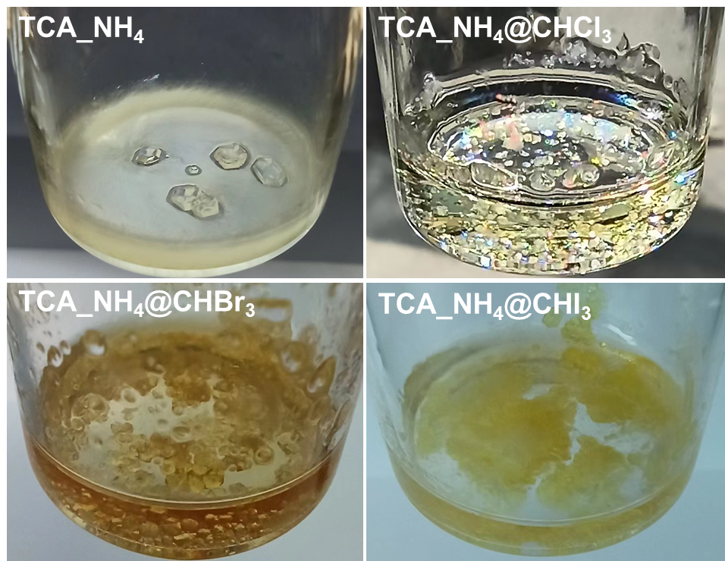
Figure S1. Images of prepared TCA_NH₄, TCA_NH₄@CHCl₃, TCA_NH₄@CHBr₃, and TCA_NH₄@CHI₃.

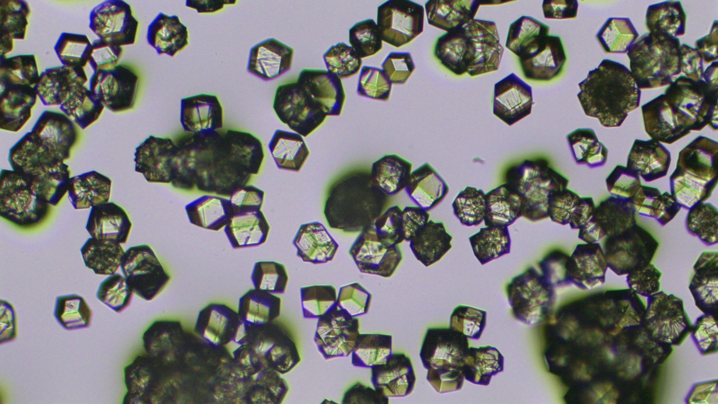
Figure S2. A microscope picture of synthesized cubic TCA_NH₄.

Table S2. Hydrogen bonds parameters in TCA_NH₄.
Donor | H | Acceptor | d(D-H)/ Å |  | d(H-A)/ Å | d(D-A)/ Å | D-H-A/°
N006¹ | H00C | O003 | 0.909 | 1.830 |  | 2.739 | 179.6
N006 | H00F | O004² | 0.911 | 2.509 |  | 3.323 | 148.9
N006 | H00A | O00M³ | 0.910 | 2.477 |  | 3.235 | 140.8
O00M | H00M | O004⁴ | 0.718 | 2.069 |  | 2.756 | 160.9
¹-z,1+x, -y; ²1/2-x, 1/2-y, -1/2+z; ³-1/2+x, 1/2-y, -1/2-z; ⁴1/2-x, -1/2+y, -1/2-z

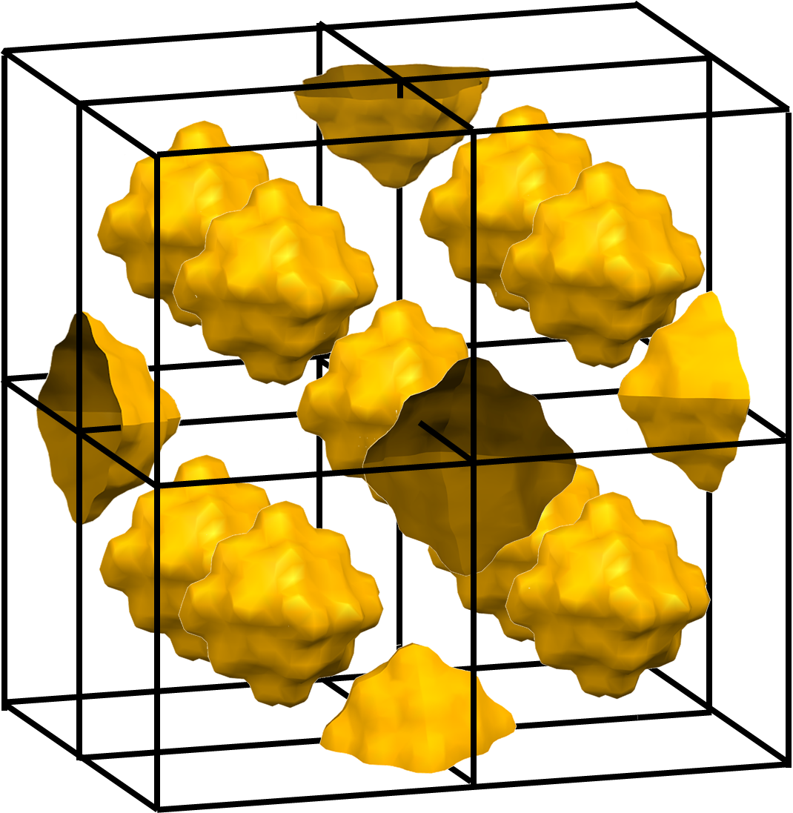
Figure S3. Enclosed octahedral cages with size of about 12 Å in 2×2×2 lattice, depicted by mercury software with probe radius of 1.2 Å. All atoms were omitted for clarity.
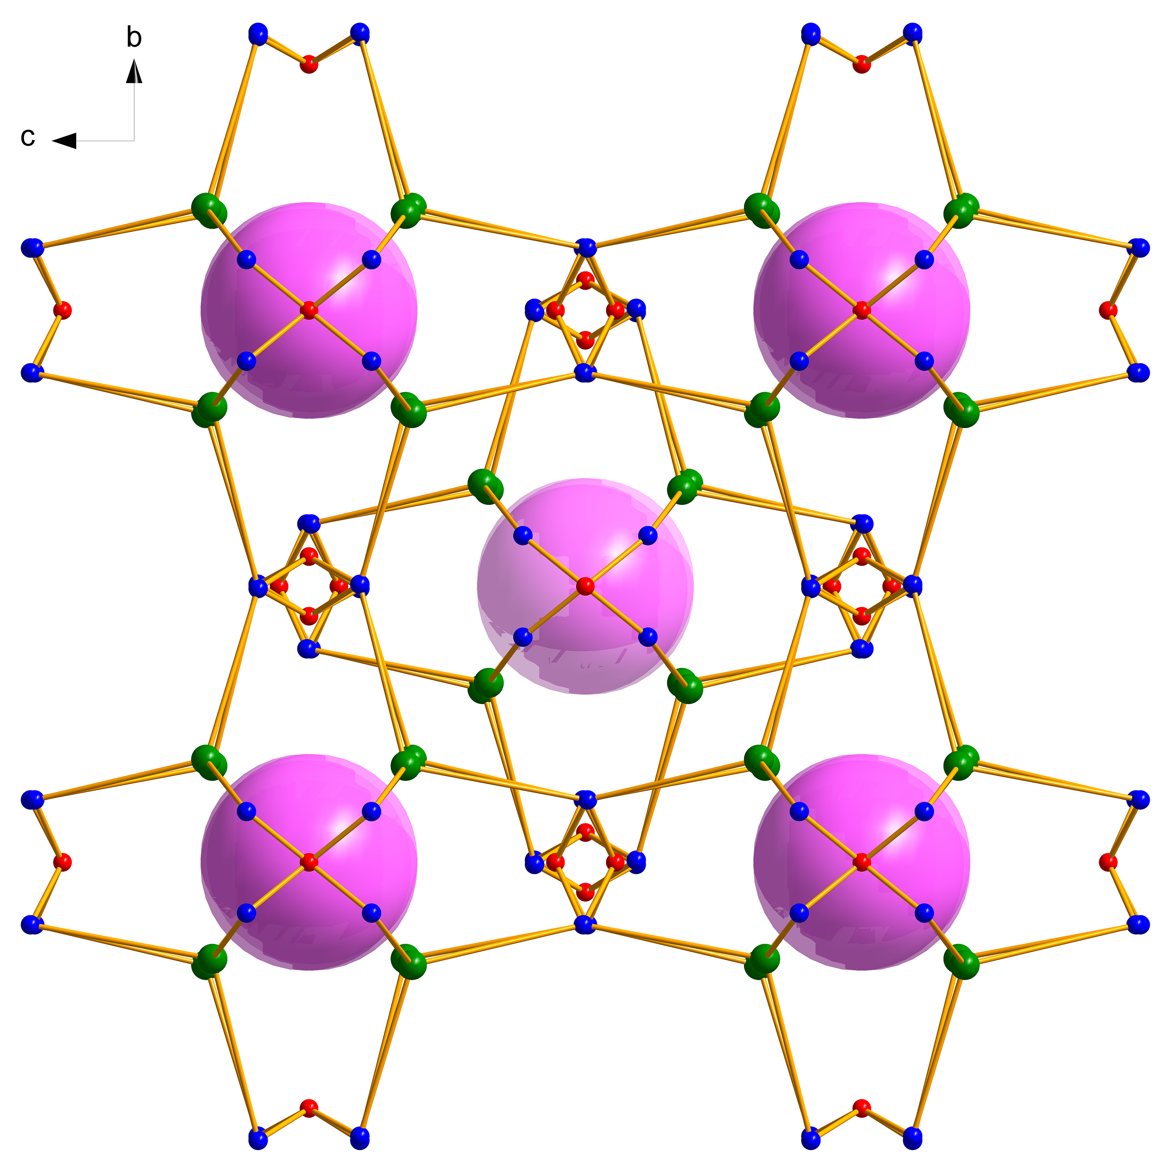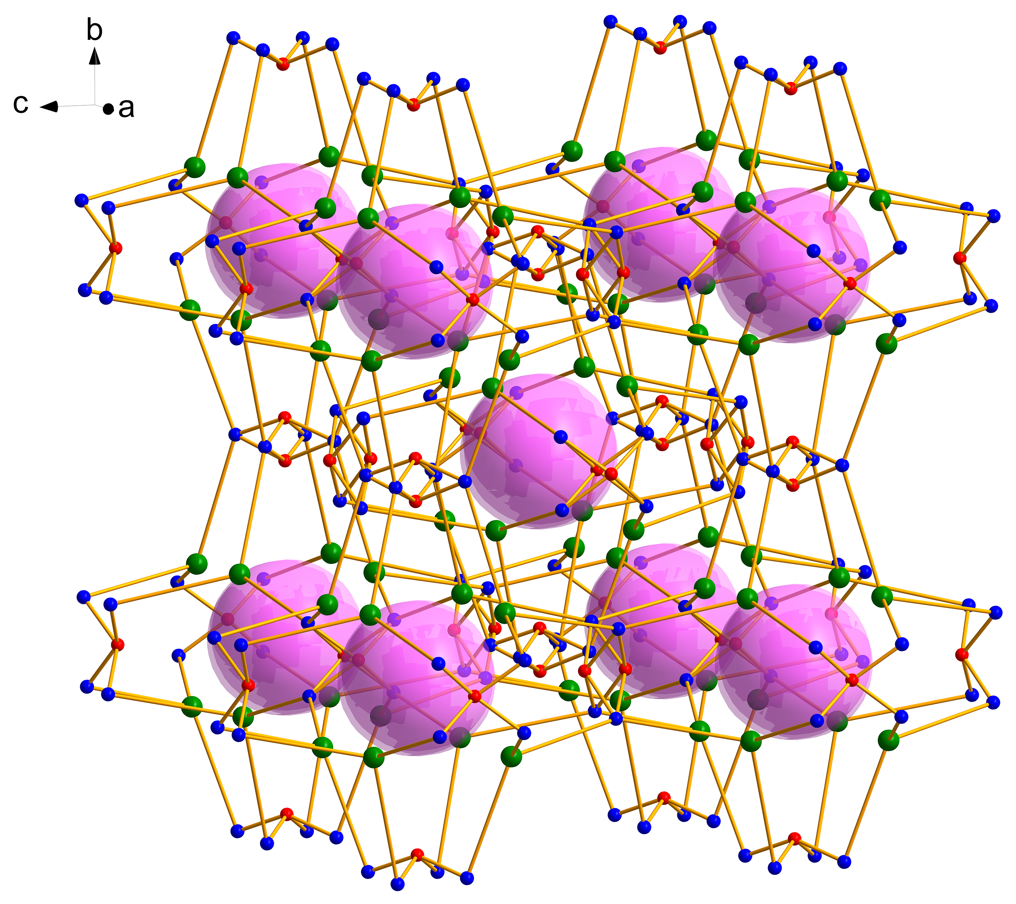
Figure S4. Topological 2×2×2 networks of body-centered cubic TCA_NH₄ crystal lattices with simplified SSBUs connecting adjacent cells along six directions of the plane. Nonhydrogen bonding hydrogen atoms are omitted for clarity.

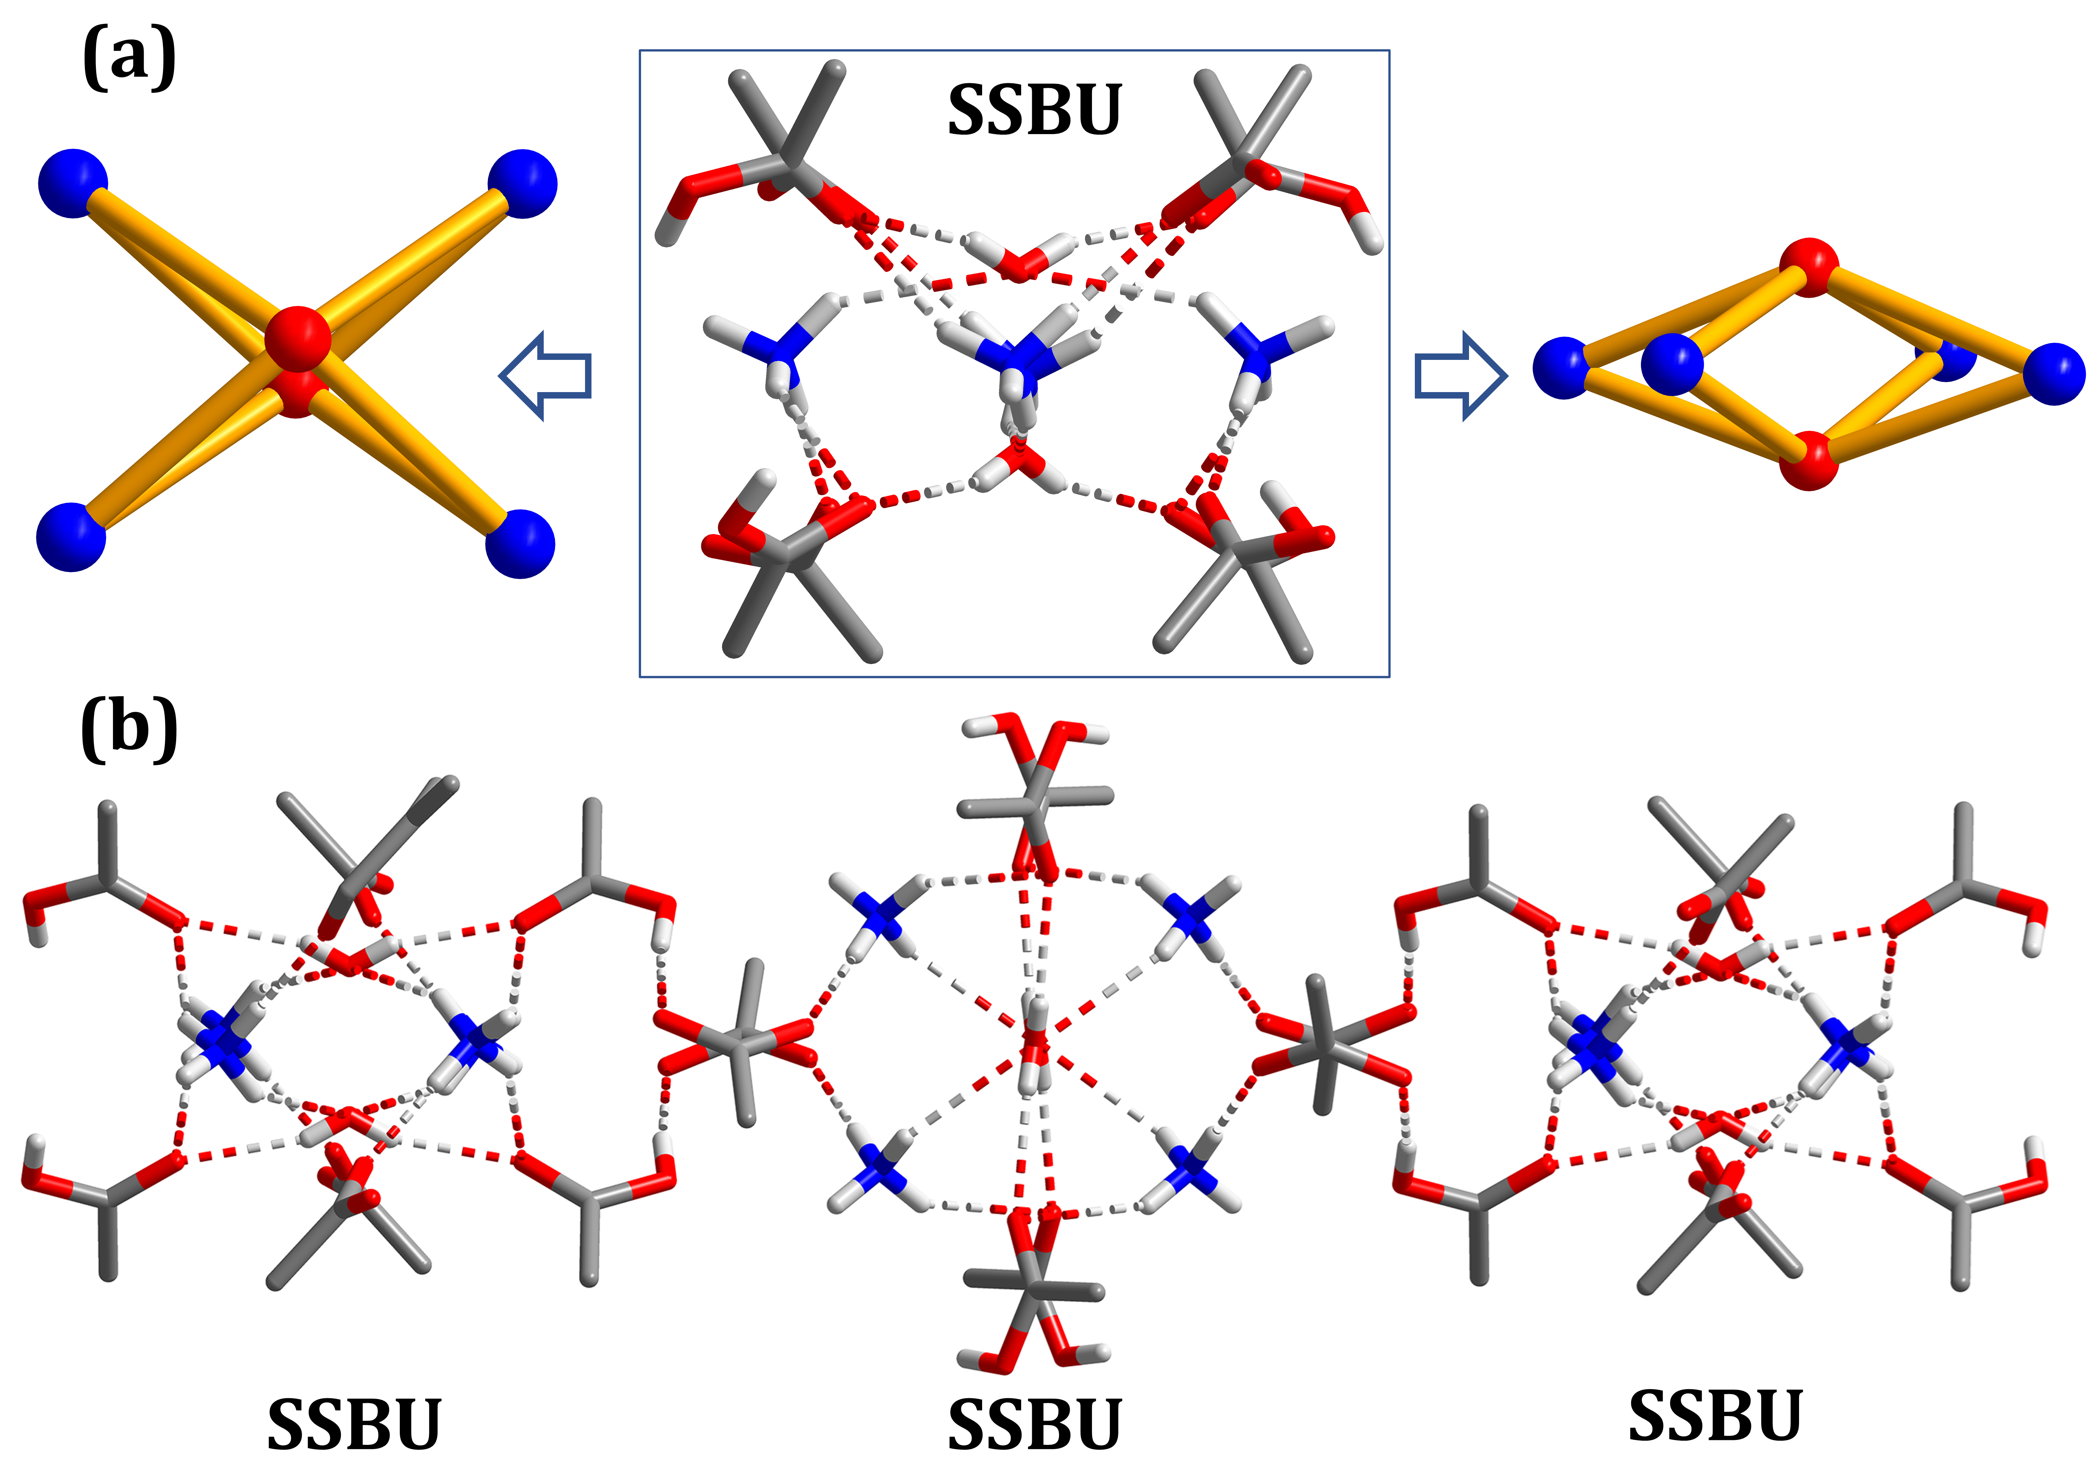

Figure S5. (a) SSBU with concentrated polynuclear clusters and simplified two oxygen four nitrogen model. (b) Orthogonally connected SSBUs through intermolecular carboxylic O-H…O hydrogen bonds as in Figure 1b and Figure S4.

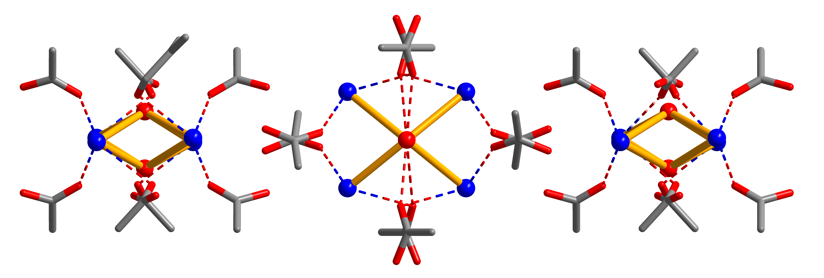
Figure S6. Simplified SSBUs interlaced orthogonally and O-H…O hydrogen bonds were omitted. All hydrogen atoms are also omitted for clarity.

Table S3. C-H…N hydrogen bond parameters of TCA_NH₄@CHCl₃, TCA_NH₄@CHBr₃, and TCA_NH₄@CHI₃.
 | d/C-H…N | θ/C-H…N | Unit Cell Volume
TCA_NH₄ | -- | -- | 9226.2 Å³
TCA_NH₄@CHCl₃ | 2.805 Å | 180° | 9221.2 Å³
TCA_NH₄@CHBr₃ | 3.007 Å | 180° | 9207.7 Å³
TCA_NH₄@CHI₃ | 2.244 Å | 180° | 9204.7 Å³

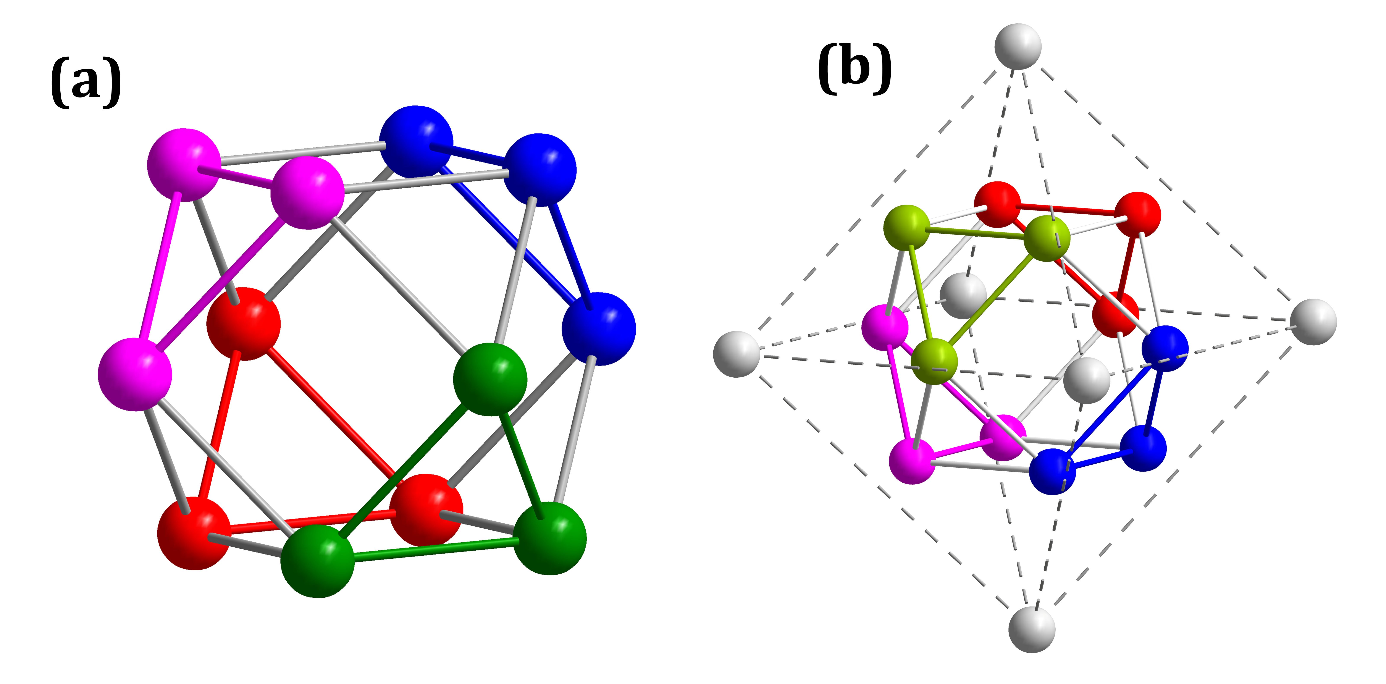
Figure S7. (a) Truncated octahedral configuration and (b) encapsulated truncated octahedron within the cavity four CHX₃ (X=Cl, Br, I)in different colors.

Table S4. C-H…I hydrogen bond parameters of TCA_NH₄@CHI₃.
Donor | H | Acceptor | d(D-H)/ Å |  | d(H-A)/ Å | d(D-A)/ Å | D-H-A/°
C00K¹ | H00K | I1 | 0.930 | 2.817 |  | 3.600 | 142.4
¹1+y, -z, 1-x;

Table S5. Crystal parameters of TCA_NH₄, TCA_NH₄@CHCl₃, TCA_NH₄@CHBr₃, and TCA_NH₄@CHI₃.

 | TCA_NH₄ | TCA_NH₄@CHCl₃ | TCA_NH₄@CHBr₃ | TCA_NH₄@CHI₃
Crystal system | cubic | cubic | cubic | cubic
Space group | I23 | I23 | I23 | I23
a/Å | 20.9737(2) | 20.9699 (4) | 20.9596 (12) | 20.9574 (1)
b/Å | 20.9737(2) | 20.9699 (4) | 20.9596 (12) | 20.9574 (1)
c/Å | 20.9737(2) | 20.9699 (4) | 20.9596 (12) | 20.9574 (1)
α/° | 90 | 90 | 90 | 90
β/° | 90 | 90 | 90 | 90
γ/° | 90 | 90 | 90 | 90
Volume/Å³ | 9226.2(3) | 9221.2 | 9207.7 | 9204.7

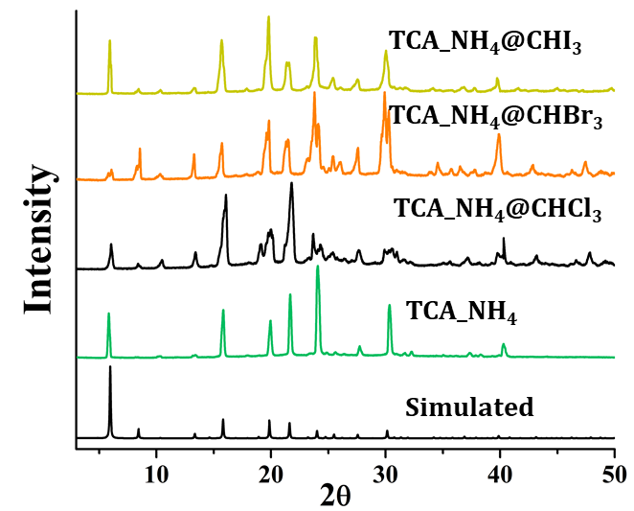
Figure S8. Powder X-ray diffraction of simulated TCA_NH₄, measured TCA_NH₄, TCA_NH₄@CHCl₃, TCA_NH₄@CHBr₃, and TCA_NH₄@CHI₃.

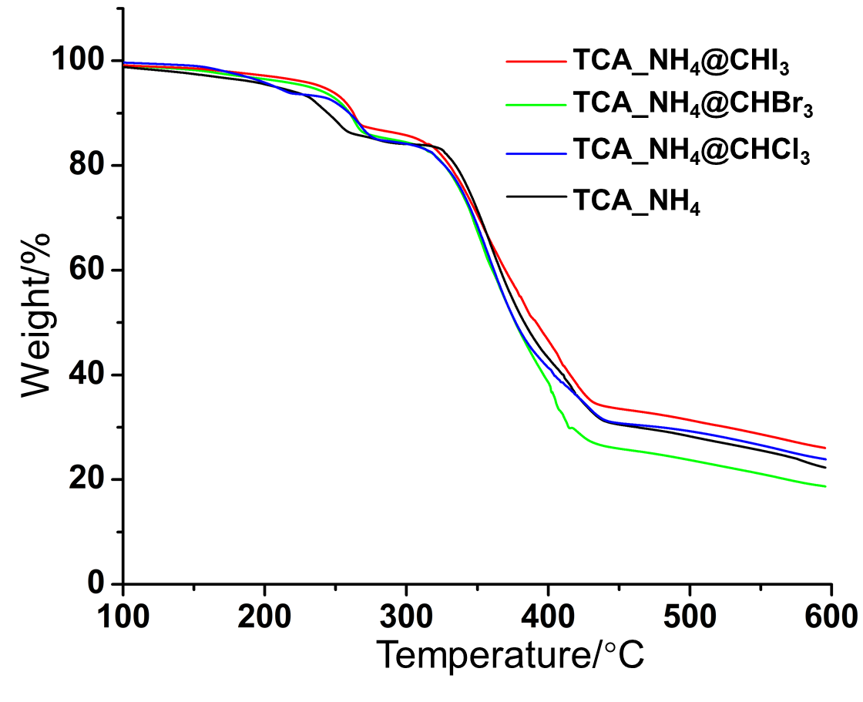
Figure S9. Thermogravimetric analysis of TCA_NH₄, TCA_NH₄@CHCl₃, TCA_NH₄@CHBr₃, and TCA_NH₄@CHI₃ under N₂ gas atmosphere with flow of 10ml/min.

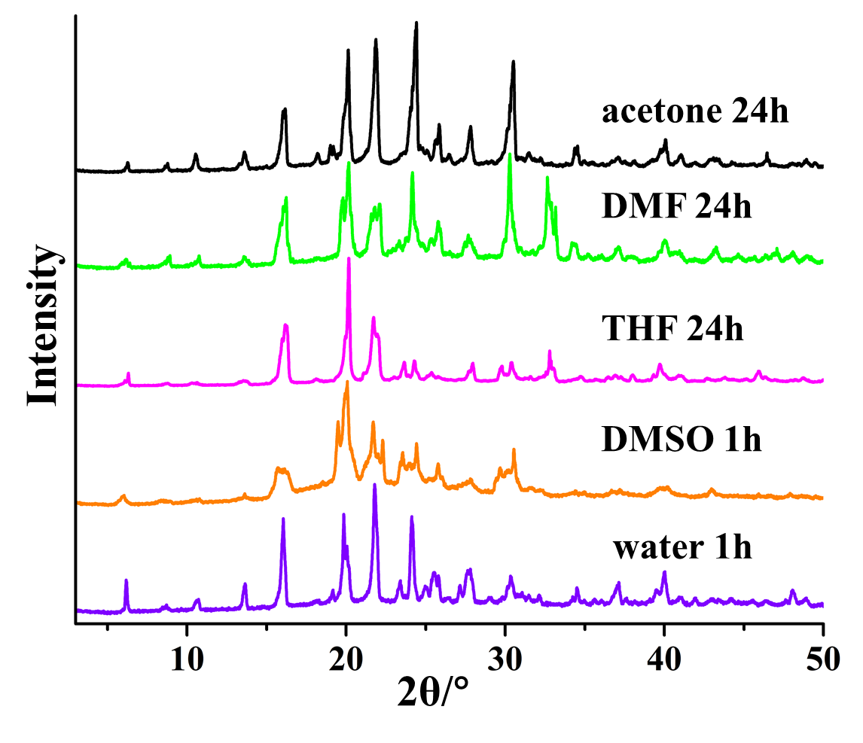
Figure S10. XRD of TCA_NH₄ after immersing in different solvent.

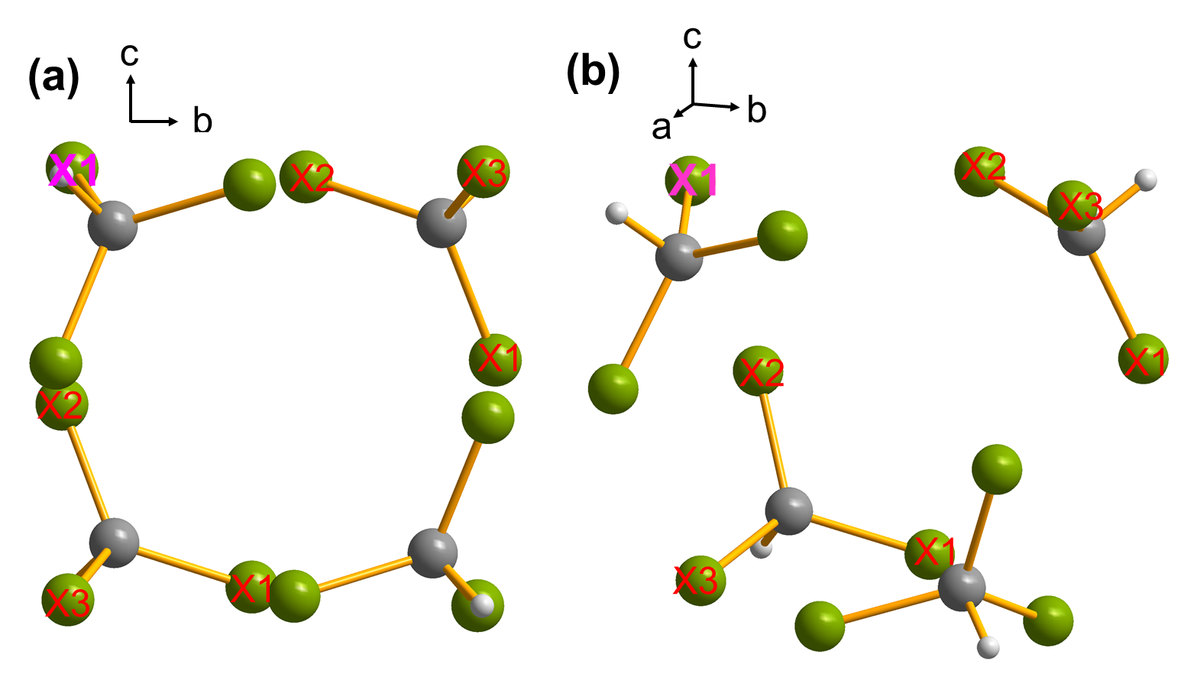
Figure S11. The distances of adjacent halogen atoms with highlighted X1 (X= Cl, Br, I) as center.

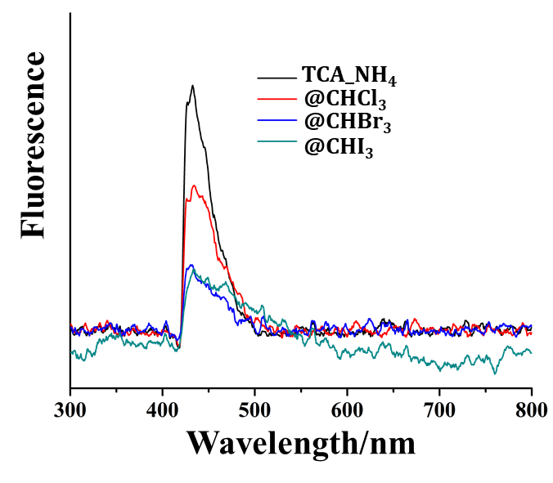
Figure S12. Solid state fluorescence reflection spectra of TCA_NH₄, TCA_NH₄@CHCl₃, TCA_NH₄@CHBr₃, and TCA_NH₄@CHI₃.

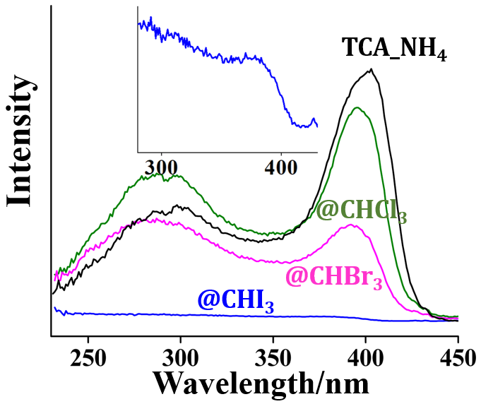
Figure S13. Excitation spectra of TCA_NH₄, TCA_NH₄@CHCl₃, TCA_NH₄@CHBr₃, and TCA_NH₄@CHI₃ emission at 470 nm.

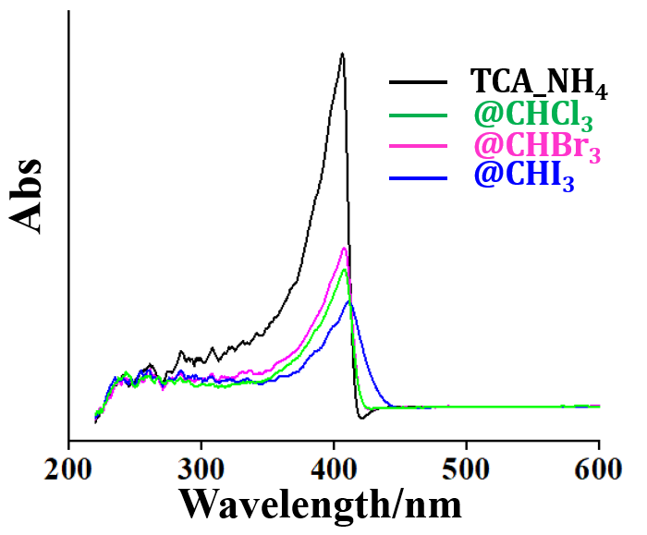
Figure S14. Solid-state absorption spectra of TCA_NH₄, TCA_NH₄@CHCl₃, TCA_NH₄@CHBr₃, and TCA_NH₄@CHI₃.

Table S6. Lifetime fitting of different crystals with time constants (τ), pre-exponential factor (B), and correlation coefficient (χ²).
 | τ/ns | B | A | χ²
TCA_NH₄ | 2.092 | 2046 | 1.575 | 1.093
TCA_NH₄@CHCl₃ | 2.051 | 915.3 | 0.837 | 1.136
TCA_NH₄@CHBr₃ | 1.694 | 806.6 | 0.742 | 1.065
TCA_NH₄@CHI₃ | 2.433 | 998.9 | 0.845 | 1.069
TCA_NH₄@I₂ | 2.369 | 962.5 | 0.977 | 0.978

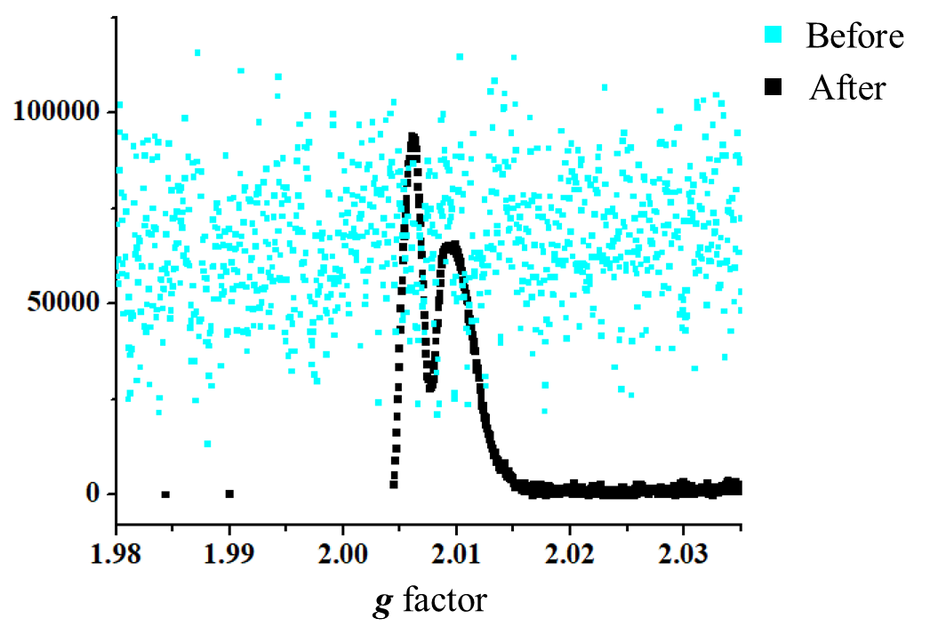
Figure S15. EPR spectrum of TCA_NH₄@CHI₃ before and after irradiation with UV-vis lamp with power density of 200 mW/cm².

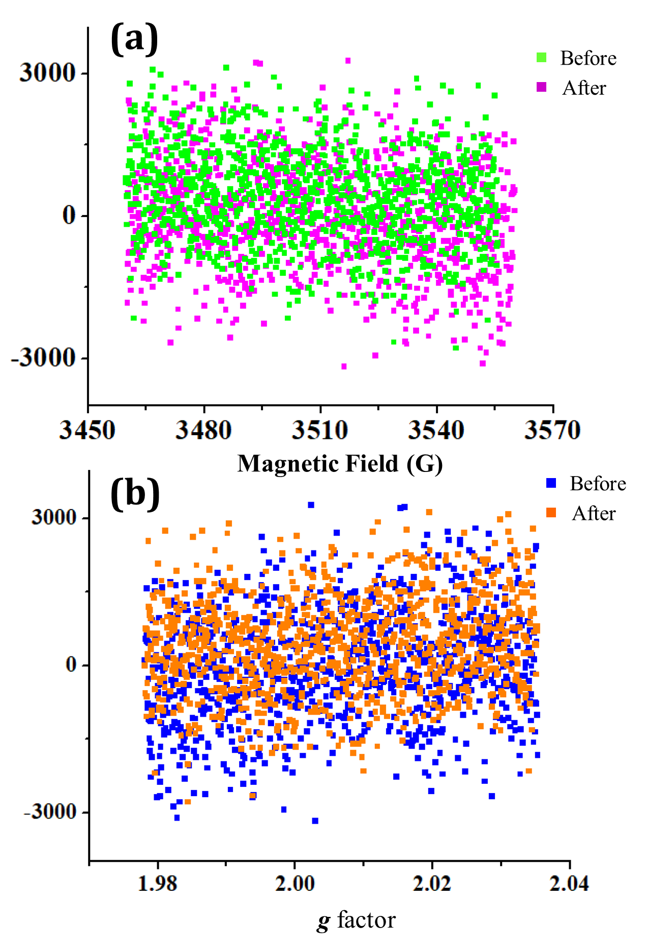
Figure S16. EPR spectrum with magnetic field (a) and value g signals of TCA_NH₄@CHCl₃ before and after irradiation with UV-vis lamp power density of 200 mW/cm².

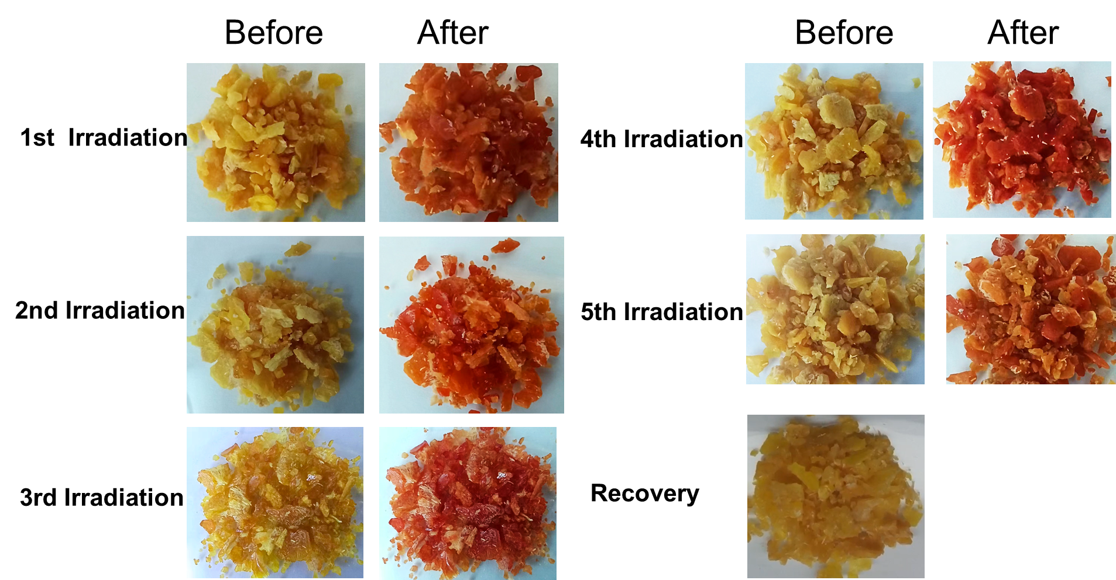
Figure S17. 5 times photochromic images of TCA_NH₄@CHI₃ before irradiation and after irradiation under Xe lamp.

Table S7. Photosensitive efficiency of TCA_NH₄@CHI₃ with different light sources.
Source | λ/nm | light power density/mW cm² | Photochromic time
X ray | 1.54 (CuKα) |  | 30 mins
ultraviolet light | 365 | 5 | 5 mins
sun light | 290-2500 | 100 | 2 mins
LED | 450-460 | 8 | 3 mins
Xe lamp | 400 | 200 | 60 seconds

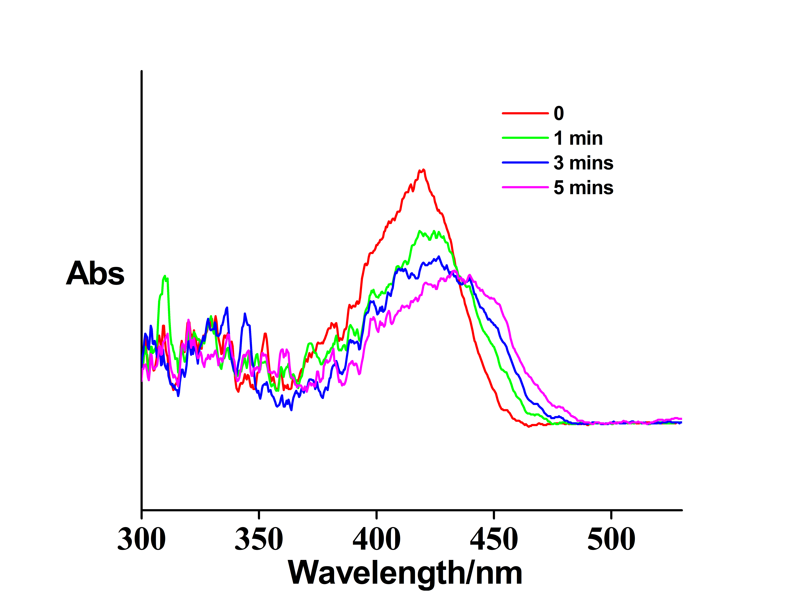
Figure S18. Solid state absorption spectroscopy of photochromic process of TCA_NH₄@CHI₃ after 5 times irradiation and recovery.

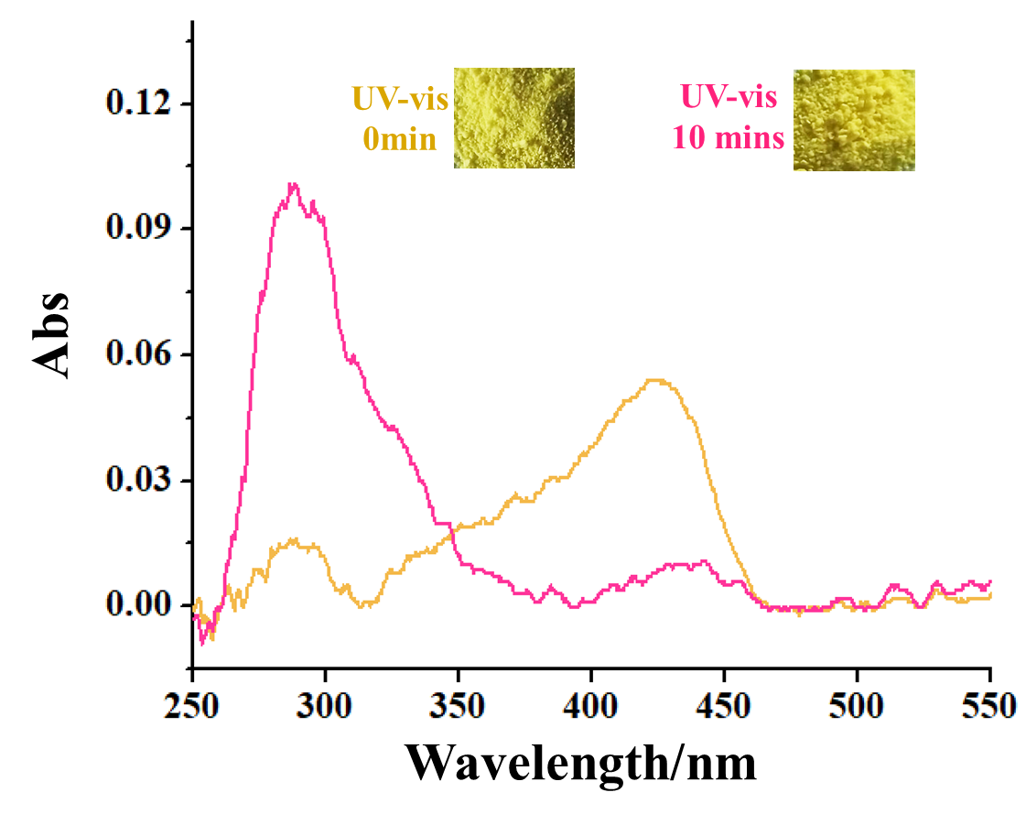
Figure S19. Solid-state absorption spectrum of powder CHI₃ with UV-vis Xe lamp irradiation for 10 minutes.

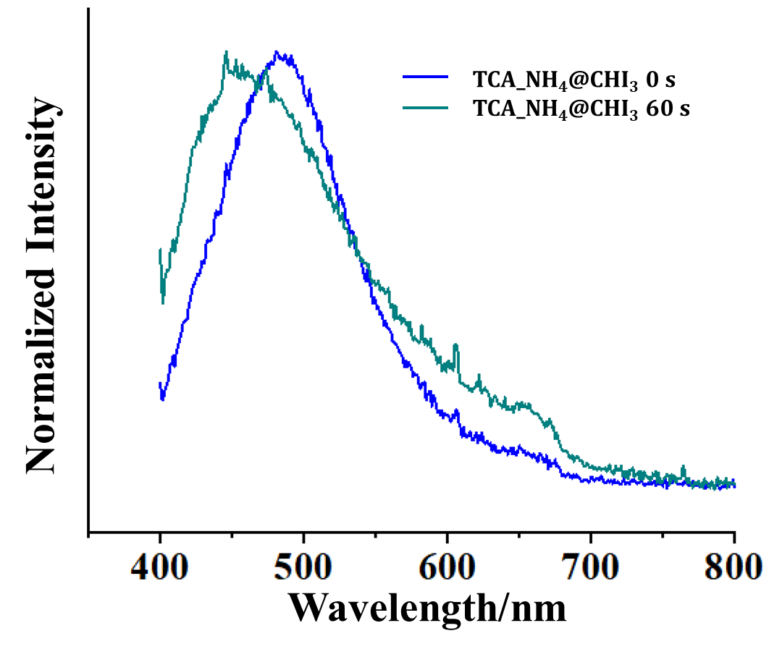
Figure S20. The normalized emission spectrum of TCA_NH₄@CHI₃ before and after Xe lamp irradiation.

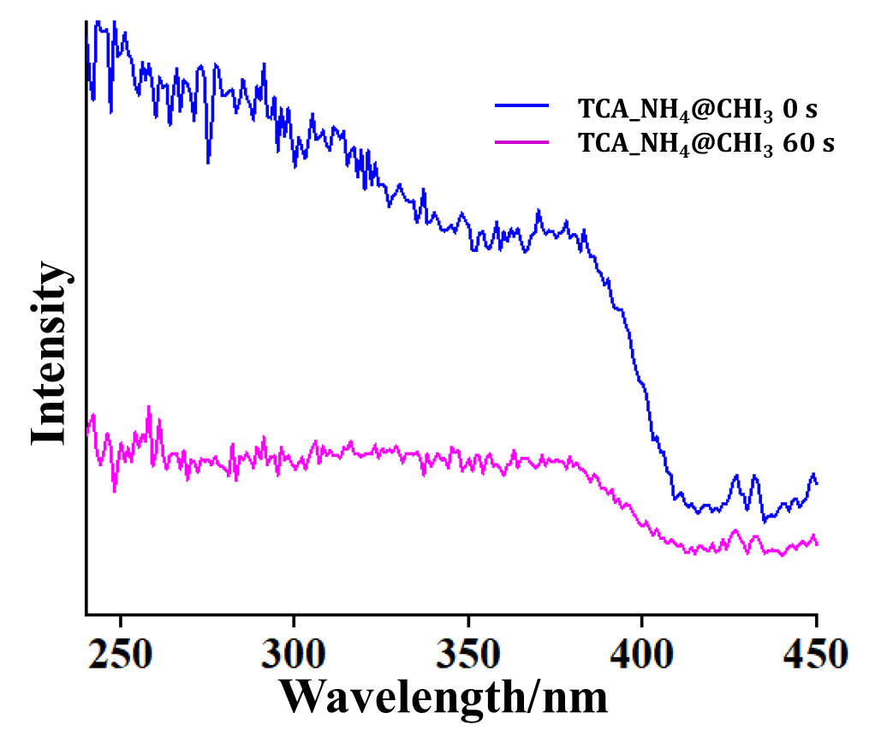
Figure S21. The excitation spectrum of TCA_NH₄@CHI₃ before and after Xe lamp irradiation.

