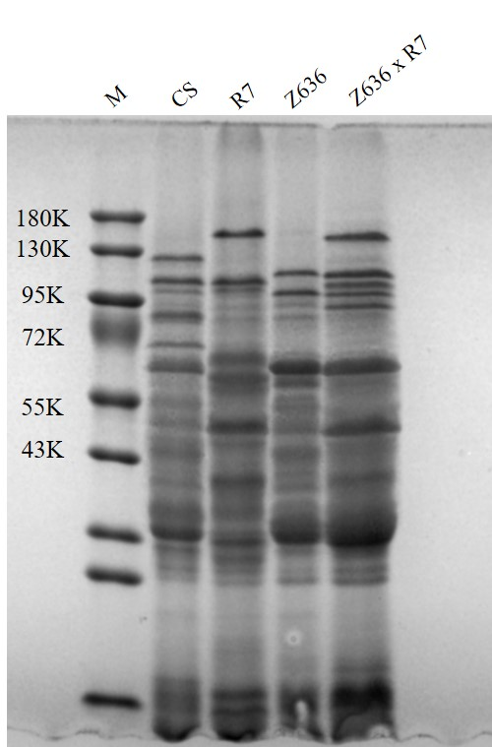
Supplementary 1. The full gel of HMW-GS composition determined by SDS-PAGE

